Welcome Page

IDR Entity Selection Response
Use this form if you were notified that a Notice of IDR Initiation has been submitted.
As the non-initiating party, you will be asked to review the dispute information that has been provided and answer the following questions:
- Do you have a conflict of interest (COI) with the selected certified IDR entity?
- Do you agree to the certified IDR entity selected by the initiating party to handle this dispute?
- If you have a COI or don’t agree to the selected certified IDR entity, review the list of certified IDR entities and select an alternative certified IDR entity. You must not have a conflict of interest and should choose an alternative certified IDR entity with which you do not have a COI.
- Do you agree that the items or services under dispute qualify for the Federal IDR process, and if not, why?
Note: If we don’t receive a response from you within three (3) business days, we’ll proceed with using the certified IDR entity selected by the initiating party for this dispute unless the certified IDR entity has a COI.
Need help? Contact FederalIDRQuestions@cms.hhs.gov if you have any questions about this form.
WARNING: This system contains U.S. Government Data. Unauthorized use of this system is prohibited.
This computer system, including all related equipment, networks, and network devices (specifically including internet access) are provided only for authorized U.S. Government use. U.S. Government computer systems may be monitored for all lawful purposes, including to ensure that their use is authorized, for management of the system, to facilitate protection against unauthorized access, and to verify security procedures, survivability, and operational security. Monitoring includes active attacks by authorized U.S. Government entities to test or verify the security of this system. During monitoring, information may be examined, recorded, copied and used for authorized purposes. All information, including personal information, placed or sent over this system may be monitored.
Use of this computer system, authorized or unauthorized, constitutes consent to monitoring of this system. Unauthorized use may subject you to criminal prosecution. Evidence of unauthorized use collected during monitoring may be used for administrative, criminal, or other adverse action. Use of this system constitutes consent to monitoring for these purposes.
Use of this system implies understanding of these terms and conditions.
*You must read and agree to the Security & Privacy Agreement:
By using the Federal IDR portal and/or forms we provide for use in connection with the Federal Independent Dispute Resolution (IDR) process, you agree to the collection and use of information as described in this Privacy Act Statement.
The Centers for Medicare & Medicaid Services (CMS) ("us," "we," or "our") operates the Federal IDR portal at https://nsa-idr.cms.gov/paymentdisputes,which includes forms to be used by parties to payment disputes. Users may submit the forms electronically by uploading documents to the Federal IDR portal. The information on this page tells you about our policies regarding the collection, use and disclosure of personal information we receive from users of the forms. It also includes specifics about Personal Information and other information that may be collected about you when you use the Federal IDR portal. A separate IDR Website Privacy Policy provides more information about CMS website privacy information for the Federal IDR portal, which you should also read and be aware of how information is collected and used when on the Federal IDR portal.
Permission for information submitted on IDR forms
When submitting IDR forms to the Federal IDR portal or directly to a certified IDR entity, you represent that you are authorized to submit the form, as well as to receive any communications about the payment dispute, its status, or a final decision related to the payment dispute. For example, if you submit the Notice of IDR Initiation, you represent that you are authorized to initiate the dispute on behalf of the health care provider, health care facility, provider of air ambulance services, plan, issuer, or Federal Employees Health Benefits (FEHB) carrier, as applicable, regarding any claim(s) for the qualified IDR item(s) and/or service(s) to the participant’s, beneficiary’s, or enrollee’s plan.
Independent Dispute Resolution Process Privacy Act Statement
The Departments of the Treasury, Labor, and Health and Human Services (CMS is part of the Department of Health and Human Services) (collectively, the Departments), are authorized to collect the information on this form and any supporting documentation under the No Surprises Act at Internal Revenue Code sections 9816(c) and 9817(b), Employee Retirement Income Security Act (ERISA) sections 716(c) and 717(b), Public Health Service Act (PHS) sections 2799A-1(c) and 2799A-2(b), and their implementing regulations and FEHB contracting authority consistent with 5 U.S.C. 8902(p), as applicable. This law directs the Departments to establish a process to restrict surprise billing for participants, beneficiaries, and enrollees of group health plans, health insurance issuers offering group or individual health insurance coverage, and FEHB carriers, who receive emergency services from nonparticipating health care providers or health care facilities, non-emergency services from nonparticipating health care providers at participating health care facilities, and air ambulance services from nonparticipating health care providers of air ambulance services. CMS implements this Federal IDR process.
The information will be used to verify the eligibility of disputes for the Federal IDR process. The Departments have established, and CMS operates a Federal IDR portal to administer the Federal IDR process, available at https://www.nsa-idr.cms.gov. The Federal IDR portal must be used to initiate the Federal IDR process, select a certified IDR entity, and submit offers. The initiating party must furnish the Notice of IDR Initiation to the Departments by submitting the notice to CMS through the Federal IDR portal at https://www.nsa-idr.cms.gov and the IDR entity selection response at [https://www.nsa-idr.cms.gov/idrentityselectionresponse]. If a dispute is eligible, the contact information provided on the Notice of IDR Initiation will be used to send the parties a notice identifying and/or confirming the certified IDR entity assigned to the dispute. This information provided will be shared with the certified IDR entity for consideration and for the purpose of enabling the certified IDR entity to make a payment determination. The Departments will also use the information as part of the ongoing operation of the Federal IDR process, including managing and reporting on the Federal IDR process, and performing oversight and quality control activities in relation to certified IDR entities. The Departments may also use the information to evaluate whether a certified IDR entity or its staff have any conflicts of interest that would preclude it from making a payment determination. The information may further be used to combat fraud and noncompliance within the Federal IDR process and respond to any concerns about the security or confidentiality of the information.
Providing the requested information is voluntary. If any plan, issuer, FEHB carrier, health care provider, health care facility, provider of air ambulance services knowingly fails to provide correct information on this form or knowingly and willfully provides false or fraudulent information, they may be subject to penalties and other enforcement actions.
In order to process disputes within the Federal IDR process, CMS may need to share with persons or entities outside of the Departments selected information you provide, including with:
1. A certified IDR entity, which the Departments have certified to make payment determinations. The certified IDR entity will use this information only for the purpose of determining their eligibility to conduct a determination for the parties involved, and making payment determinations;
2. Contractors engaged to perform functions related to or in support of the Federal IDR process, including contractors that will support the collection of certified IDR entity fees and administrative fees;
3. All parties to a dispute and their authorized representatives;
4. Other Federal agencies that are responsible for implementing and overseeing plans that are subject to the Federal IDR process, including the Departments and OPM; and
5. Anyone else as required by law or allowed under the Privacy Act System of Records Notice associated with this collection entitled, “Complaints Against Health Insurance Issuers and Health Plans (CAHII),” System No. 09-70-9005, 66 FR 9858 (Feb. 12, 2001), as amended, 83 FR 6591 (Feb. 14, 2018).
This statement provides the notice required by the Privacy Act of 1974 (5 U.S.C. § 552a(e)(3)). You can learn more about how we handle your information at: https://www.cms.gov/nosurprises/privacy.

Contact us
If you have any questions about this Privacy Act Statement, contact us at Privacy@cms.hhs.gov.
Checkbox - * I hereby agree to the terms and conditions expressed in the security and privacy agreement.
Button – Continue
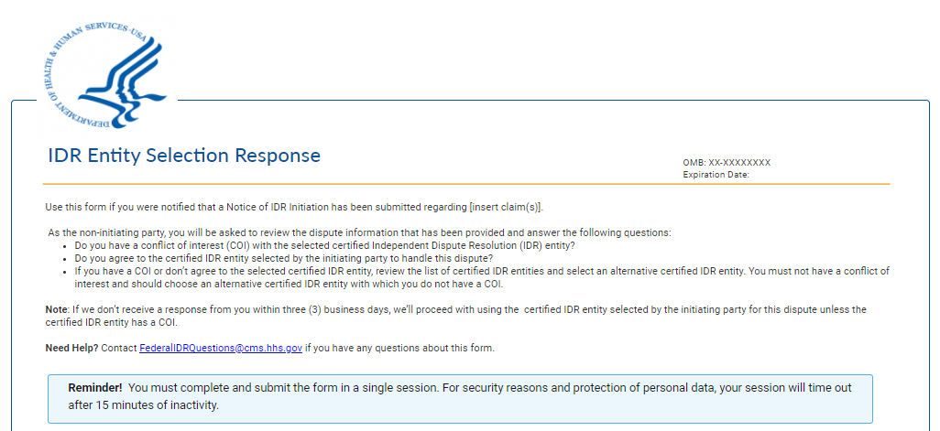
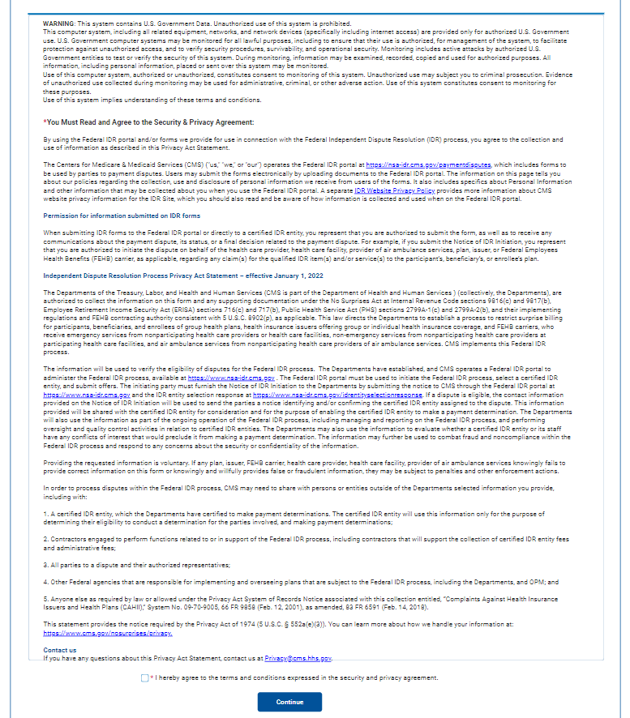

Dispute ID Validation Page

Enter Your Dispute Reference Number
To access the Certified IDR Entity Selection Response Form, enter your dispute reference number and select Continue. You can find your dispute reference number in the email you received from auto-reply-federalidrquestions@cms.hhs.gov with the subject line: "Action Required: Certified IDR entity selection agreement or disagreement needed.”
Field: Dispute reference number
Button: Continue
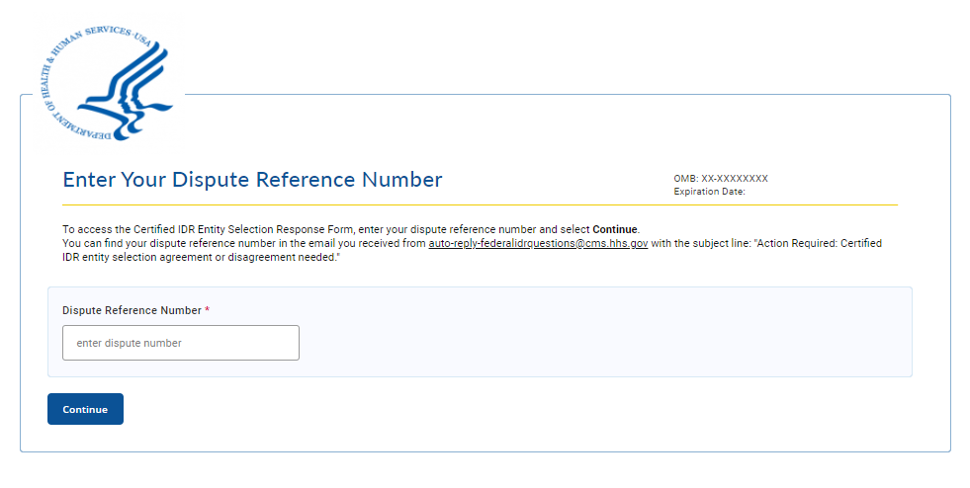

IDR Entity Selection Response page 1
The below form contains key information from the Notice of the Initiation form and required attestations related to conflict of interest, federal IDR process applicability and federal IDR process requirements. Please update the key information as appropriate and complete the required fields. A * indicates a required field. If a field that you would like to change a field that is not editable, please ask the certified IDR entity to update this information in the federal IDR portal.
* Indicates a required field

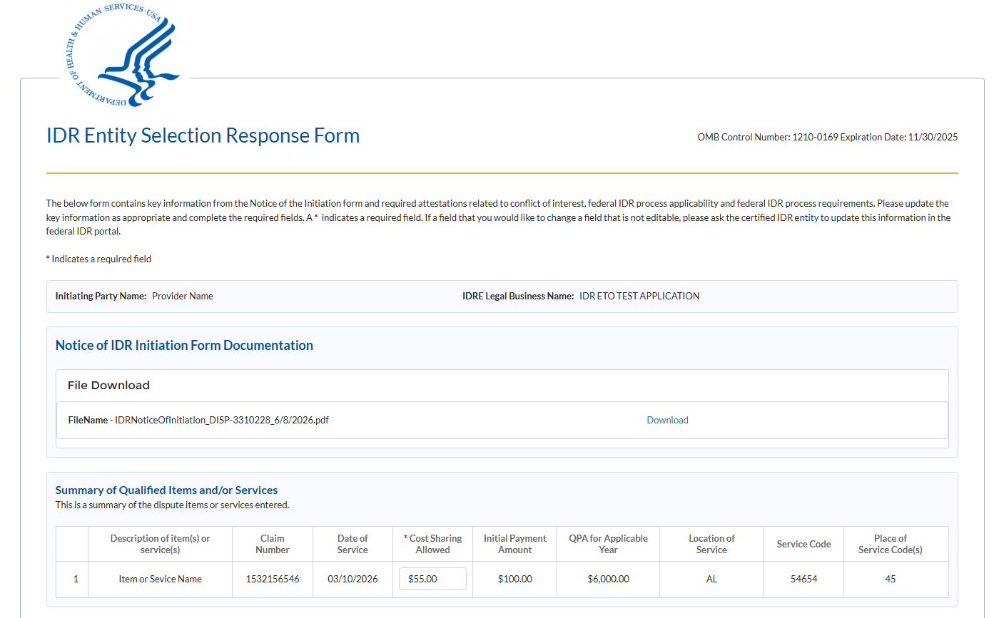

Dispute Details Information Callout:
Information Status
Above is a summary of the dispute items or services entered by the initiating party. Review the information and update values as needed.
Note: If you are a health plan or issuer, please review the Health Plan Type and respond to the questions below.

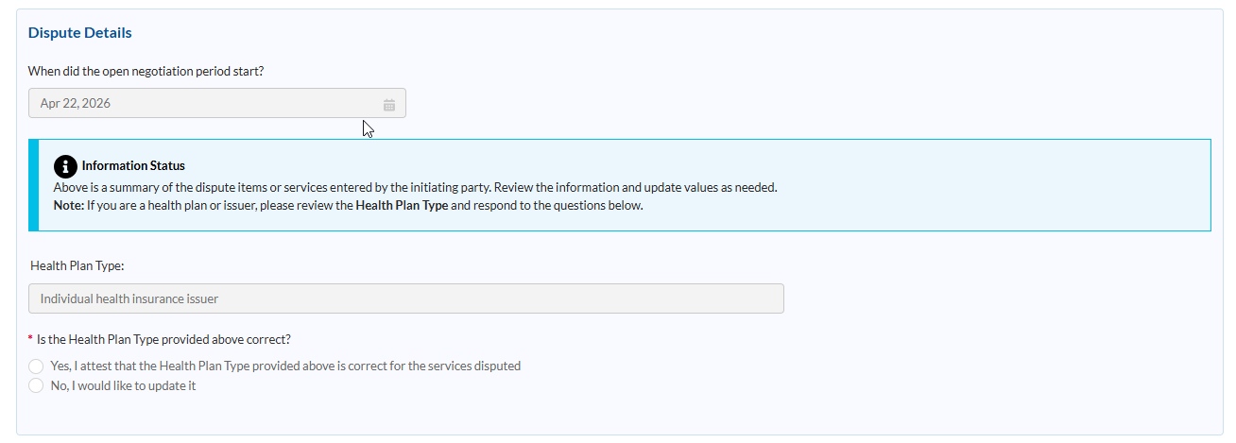
Group Health Plan / Health Insurance Issuer / FEHB Carrier Information or TPA
Confirm the information for the group health plan, health insurance issuer, or FEHB carrier in the section below. Confirm that the email address for the organization handling the payment dispute is listed in the required email field below. The organization handling the payment dispute may be the entity named in the dispute or another organization, such as a third-party administrator. If there are other contacts that should be included in communications related to the dispute, you can add them in the primary and secondary points-of-contact sections.
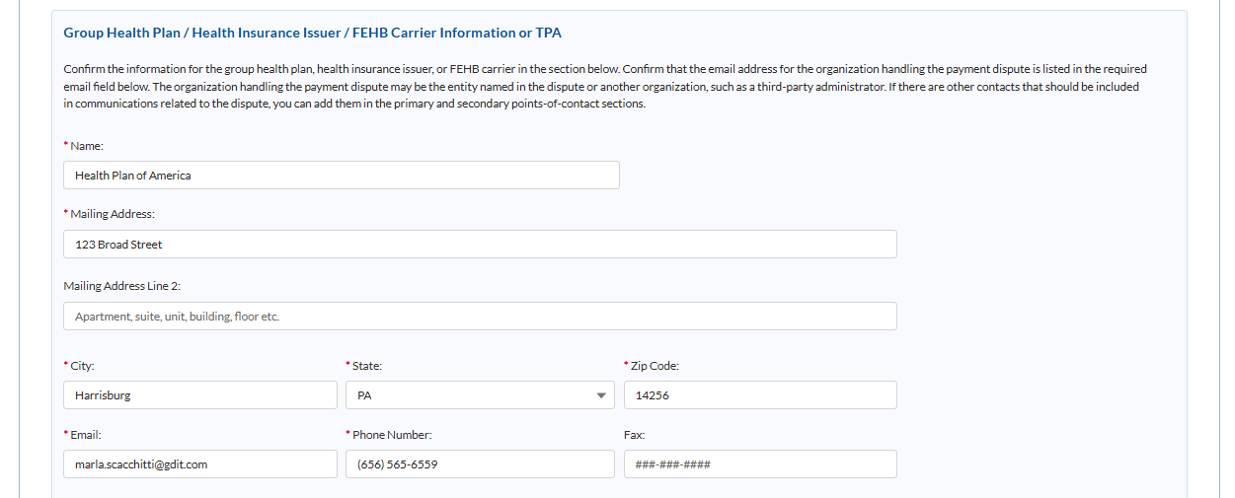
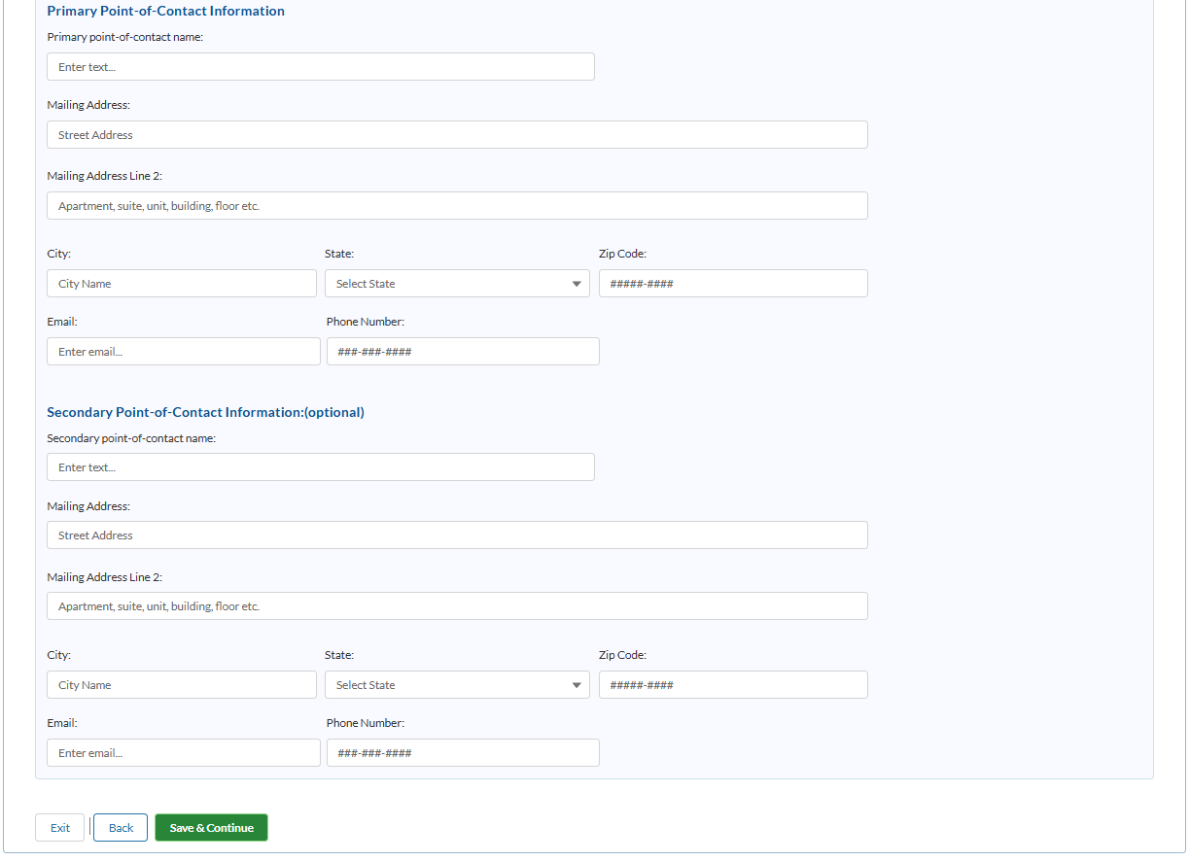

IDR Entity Selection Response page 2

Do you have a conflict of interest (COI) with the selected certified IDR entity? Yes/no (radio button) (required).
Do you agree to the certified IDR entity selected by the initiating party to handle this dispute? Yes/No (radio button)
Alternative certified IDR entity
Select a certified IDR entity from the dropdown list below. Learn more about certified IDR entities.
Certified IDR entity legal business name: (dropdown)

Conflict of Interest Attestation
* As the non-initiating party, you must attest to the following: *
Checkboxes (chose one):
I (We), the undersigned non-initiating party, attest that to the best of my (our) knowledge the selected certified IDR entity doesn’t have a disqualifying conflict of interest.
I (We), the undersigned non-initiating party, attest that to the best of my (our) knowledge the alternative certified IDR entity doesn’t have a disqualifying conflict of interest.
Federal IDR Process Applicability Attestation
Checkboxes (chose one):
I (We), the undersigned non-initiating party, attest that the item(s) and/or service(s) at issue are qualified IDR item(s) and/or service(s) within the scope of the Federal IDR process.
I (We), the undersigned non-initiating party, attest that the Federal IDR process is NOT applicable to the items and services under dispute.
If you attested to this statement, provide a written justification to support why the items and services under dispute do not belong in the Federal IDR Process. (text box below)

Signature and date blocks
Buttons: Back, Continue, Exit

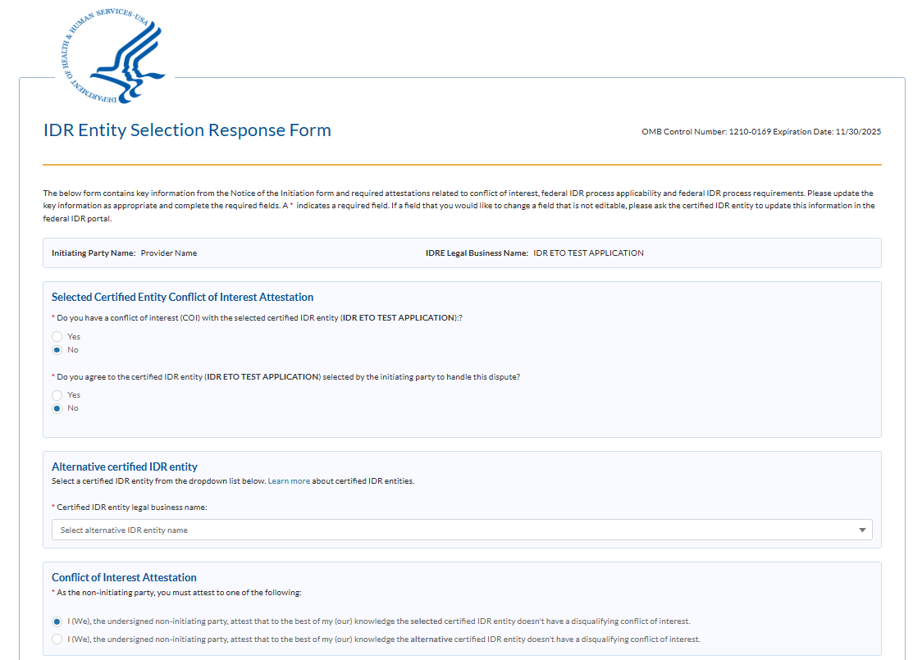
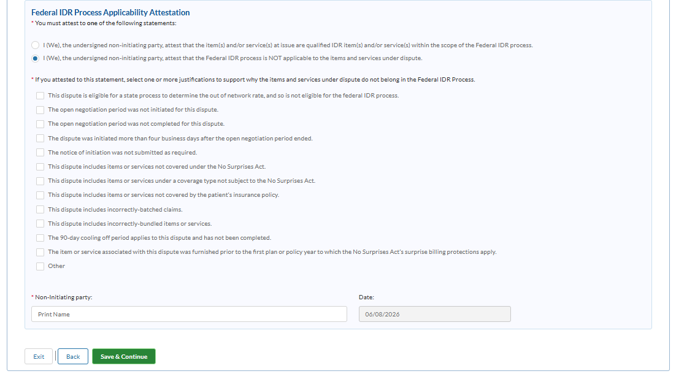

Session Time Out
Session expiring!
Your session is about to expire. Do you need more time?
Buttons – No, Yes
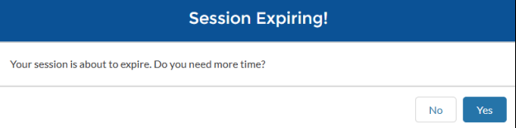

Exit Modal
Need to Leave?
All information you have entered up to this point will be lost and the session will be closed. Use the original link you were provided in the email to access the web form again and fill out the form from the beginning.
Are you sure you want to exit?
Buttons – Exit, Cancel

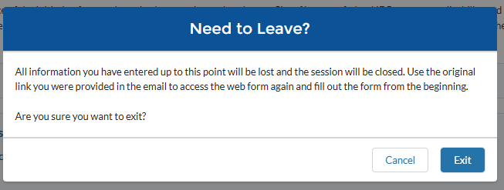

Sign & Submit
I agree to:
- pay the $15 administrative fee.
- pay the outstanding amount (if any) of the out-of-network rate determined by the certified IDR entity.
- I also understand that the determination made by a certified IDR entity is binding upon the parties and not subject to judicial review except under certain circumstances.
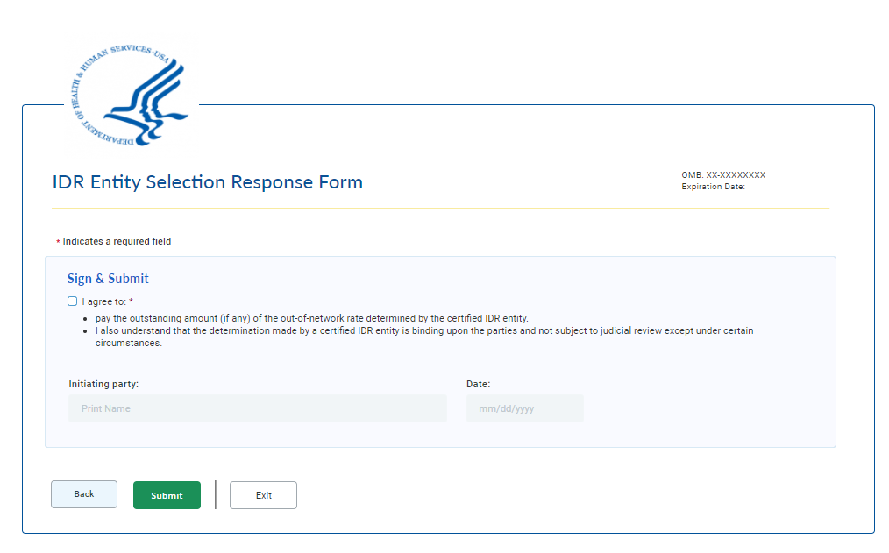

Confirmation
You have submitted the Certified IDR Entity Selection Response form to the Departments.
Next steps:
- You’ll receive an email confirming the selection of the certified IDR entity. If an alternative certified IDR entity has been selected, you will be given the opportunity to accept or deny the alternate selection.
- After a final certified IDR entity has been selected you will be notified of the selection and will be provided with information regarding the next steps, including how to submit your offers to the certified IDR entity and how to submit the administrative and certified IDR entity fees.
- To exit the web form, select Exit.
Buttons – Exit
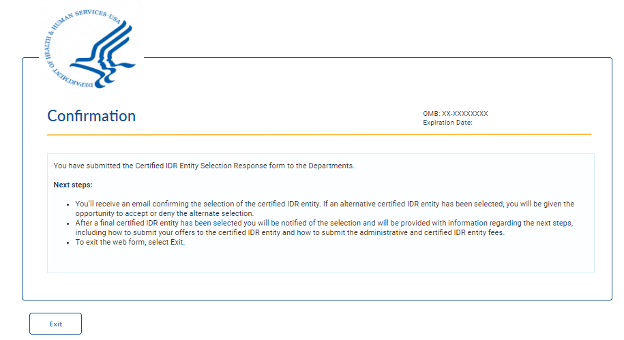

Error Messages
- You must sign and attest to the conflict-of-interest statement.
- You must select an alternative certified IDR entity from the dropdown list. You had a conflict-of-interest with or did not agree with the initiating party’s selection of a certified IDR entity to handle your dispute.
- Sorry. We can’t find this dispute reference number. Confirm you have the correct dispute reference number by reviewing the email you received from auto-reply-FederalIDRQuestions@cms.hhs.gov with the subject line of "Action Required: Certified IDR entity selection agreement or disagreement.”

