SPECIFICATIONS FOR CREATING THE CHILD FILE

For each submission period, the state submits the Child File, the Agency File, and the state commentary.
The data collection year for a submission period follows the FFY, October 1 through September 30. All reports with a disposition date within that 12-month period are submitted. The Child File contains records of case-level data on children (victims and nonvictims) who are the subject of a report of alleged child abuse or neglect. The Child File consists of child records, each record having the same format. Each child record contains information about only one child, and information about the associated abuse report. For each child record, there are numerous data elements grouped into various data categories (e.g., all child demographics are grouped into the Child Data section).

ESSENTIAL CONCEPTS OF THE CHILD FILE

Reports, Records, RC pairs, and the Child File
When a CPS agency receives an initial notification—called a referral—alleging child maltreatment, the agency hotline or intake units conduct the screening response to determine whether a referral is appropriate for further action. Referrals that meet CPS agency criteria are screened in (and called reports) and receive an investigation or alternative response from the agency. Referrals that do not meet agency criteria are screened out or diverted from CPS to other community agencies and are reported in the Agency File. If the agency decides to open the case, the agency creates a new report or incident within their computer system and identifies the report with a report ID. Each child in the report is identified with a child ID, newly assigned if the child is new to the system, or identical to the existing child identifier if the child has previously been in the system. The information collected about a given child in this unique report will create one NCANDS record in the Child File, as illustrated below. There may have been multiple children reported at the same time by the reporting source. If there were two children in the report, there would be two records in the Child File with the same report ID. The combination of the report ID and the child ID together identifies a report-child pair (RC pair) and forms the unique primary key field of the Child File. The data associated with an RC pair represent all the information about the allegations concerning that child in this report.



1
2
3
4
A
B B C

01
01
02
01
Child File
Record #
Report ID
Child ID

Each record contains significant information concerning the:
    - report
    - child
    - maltreatments
    - child and caregiver risk factors
    - services
    - staff data
    - perpetrators
    - additional fields

Victims, Nonvictims, and the Report Disposition
A child record allows for recording up to four NCANDS maltreatment types. Each of the four maltreatment types has an associated maltreatment level as to whether the alleged maltreatments were: substantiated, indicated, alternative response (AR) victim, AR nonvictim, unsubstantiated, unsubstantiated due to intentionally false reporting, closed with no finding, or no alleged maltreatment.

Every record in the Child File represents a child who can be classified as a victim or a nonvictim for each RC-pair. The determination of whether a child is a victim or not is computed from the information in the record. A child may be a victim in one report and a nonvictim in another report. For any RC-pair, being a victim depends upon the four maltreatment levels linked to the four maltreatment types. A child is a victim in the RC-pair if any of the maltreatment level fields are coded as substantiated or indicated. If the maltreatment death field is coded “yes,” at least one maltreatment type must have an associated maltreatment level of substantiated or indicated. A child is classified as a victim or nonvictim based on only that child’s maltreatment levels, not other children in the same report, so a child can be classified as a victim in a report even when all the other children are classified as nonvictims.

Each report in the Child File has a report disposition. The report disposition is based on the lowest maltreatment level code value across all maltreatment levels in the report. A report in which the lowest numeric (most severe) maltreatment level code value is 01-substantiated is assigned a substantiated report disposition. A report in which the lowest numeric maltreatment level code value is 02-indicated is assigned an indicated report disposition.

Significant Data Errors
This section discusses several important error conditions that a state should take steps to avoid. The error conditions include the following:
- A child cannot be associated more than once with the same report. A child ID cannot be associated more than once with the same report ID. In other words, a Child File record cannot have the same combination of report ID-child ID as any other Child File record. If this condition occurs, all records with the same report ID-child ID are deleted during validation.
- Investigation and assessment maltreatment levels are not allowed within a single report. If this error is detected, the entire report will be removed from the file. The maltreatment level of “No Alleged Maltreatment” can be used in either an investigation or assessment report.
- All children in a report cannot have “no alleged maltreatments.” Some states investigate or assess all children in a family when there are allegations of maltreatment against one child, even if other children do not have allegations of maltreatment. These other children in a report can receive a code of No Alleged Maltreatment. When No Alleged Maltreatment is used, it is both a maltreatment type and a maltreatment level. If all children in a report have No Alleged Maltreatment, this is considered an error and the entire report is removed during validation. For additional information, reporting guidance, and validation rules about No Alleged Maltreatment, please see Technical Bulletin #13.
- A perpetrator cannot have all perpetrator maltreatment fields coded as no. If this error is found, all data associated with that perpetrator in the specific record are deleted during validation. If the perpetrator is not positively linked to any of the maltreatments, the state should not provide perpetrator data.

Required Child File Fields
There are fields required as part of a complete Child File. Additionally, the AFCARS ID field is required for the CFSR. Required fields are indicated on the mapping forms.

Required Child File Fields
Field Number | Long Name | Short Name
1 | submission year | SUBYR
2 | state territory | STATERR
3 | report ID | RPTID
4 | child ID | CHID
6 | report date | RPTDT
9 | report disposition | RPTDISP
10 | report disposition date | RPDISPDT
26 | maltreatment-1 type | CHMAL1
27 | maltreatment-1 disposition level | MAL1LEV
145 | AFCARS ID | AFCARSID

Child File Validation Rules
The data in the Child File is validated within the NCANDS Website after uploading. There are rules which govern how this validation process is accomplished. With many of the validation rules, there are associated consequences if the application of the rule fails. These rules and consequences are defined in the mapping forms for the Child File. There are several levels of consequences related to the validation rules. Minor consequences will involve noting the error and taking no action. At times, the error detected in the field will require the entire record to be dropped from the file. The most severe consequences will necessitate dropping all records associated with that Report ID from the file.

OVERVIEW OF THE CHILD FILE RECORD
The Child File is a single, flat “text” (.txt) file, also referred to as an American Standard Code for Information Interchange (ASCII) file. All records should be the same length, with the exact number of blank characters being used to replace any data fields where data are not available. Each of the records must conform to the record layout for the NCANDS Child File, where each field in the record layout has a fixed length, as defined in Appendix C Child File Record Layout. There should be a delimiter, a carriage return (CR) and line feed (LF) at the end of each record. Each record consists of the 152 fields as defined in Appendix C Child File Record Layout. The total child record length is 338 characters. The record layout is the same for all records in the data file.

Each record in the Child File allows for the reporting of information about a child associated with a report of alleged child abuse or neglect. All the data elements in the record are grouped into these data sections, including:

    - Report Data (characteristics)
    - Child Data (demographics)
    - Maltreatment Data
    - Child Risk Factors
    - Caregiver Risk Factors
    - Services Provided (to the child/family)
    - Staff Data
    - Perpetrator Data (demographics, maltreatment data)
    - Additional Fields

The state should always submit data for all appropriate data sections (fields 1–87, 145–152). Data for the Perpetrators section (fields 88–144) should be submitted only if the child in the record is a substantiated or indicated victim. A complete list of the data elements within these categories can be found in the Child and Agency Data Element Lists.

Report Data (Fields 1-11): The Report Data section contains the two identifying fields (submission year and state ID) and general information about the report. The first identifying field for the record is the report ID. The second identifying field for the record is the Child ID. All remaining fields in the Report Data section are attributes related to the report ID.

Child Data (Fields 12–25): The Child Data section contains general information about the specific child in the record. All fields in this section are attributes related to the child ID.

Maltreatment Data (Fields 26–34): The fields in the Maltreatment Data section include information about maltreatment types and maltreatment disposition levels. Up to four allegations of maltreatment are coded with the decision regarding the allegation. The Maltreatment Death field is also included in this section. If the maltreatment death field is coded “yes,” at least one maltreatment type must have an associated maltreatment level of substantiated or indicated.

Child Risk Factors Data (Fields 35–43): The fields in the Child Risk Factors section indicate whether the child suffered from one or more disabilities or problems.

Caregiver Risk Factors Data (Fields 44–55): The fields in the Caregiver Risk Factors section indicate whether the child's family or caregiver(s) experienced one or more disabilities, substance abuse, medical conditions, domestic violence, financial problems, and housing problems.

Postinvestigation Services Data (Fields 56–85): The fields in the Services Data section contain information about postresponse services, which are provided for the child or family. A service must continue after the report disposition date to be counted as a postresponse service. A service can start at any time prior to the report disposition date provided it is associated with the CPS response. Exhibit 1 Allowable Service Patterns demonstrates critical timelines associated with service delivery.
Postresponse services should be reported if they are delivered between the report date and 90 days after the report disposition date. A service can be reported when started prior to report date, if associated with the current investigation.

Exhibit 1. Allowable Service Patterns

Green lines indicate acceptable service start and end dates for the Child File. Red lines indicate services not to be included in the Child File.
Report Date
Report Disposition Date
90 Days After Disposition Date

There are three foster care related fields: foster care services, removal date, and foster care discharge date. All three fields are used to determine if a child received foster care services related to the CPS response. Because foster care is a postresponse service, it must follow the same rules as other postresponse services. See Exhibit 1, Allowable Service Patterns.

The removal date indicates whether the foster care service is related to the current CPS response. If a child was removed from home prior to the current CPS response (already in care), the date of the most recent removal should be reported. If a child has been removed more than once, related to the current CPS response, the removal date is the most recent removal resulting from this CPS response. It may be the same as the report date or shortly after.

It is important to note that there are separate sets of rules regarding foster care removal dates. For purposes of validation, removal dates prior to the report date are accepted. However, only records with removal dates occurring between the report date and 90 days after the report disposition date are included when reporting the number of victims and nonvictims removed from the home because of the investigation in the Child Maltreatment report. See Exhibit 2, Allowable Removal Date Patterns for Analysis.

Exhibit 2. Allowable Removal Date Patterns for Analysis
Arrows are removal dates. Removal Dates on the green line are allowed in the Child File. Removal Dates on the red lines are not allowed in the Child File.
Report Date
Disposition Date
Disposition Date + 90 Days

The foster care discharge date must occur after the foster care removal date and is used to confirm that the foster care service continued past the report disposition date. Exhibit 3, Allowable Discharge Dates Patterns demonstrates critical timelines associated with foster care discharge dates. The green line indicates acceptable foster care discharge dates. When foster care discharge dates occur along the red lines, the NCANDS Website blanks the three foster care fields (foster care service, removal date, discharge date). If the child was not discharged from foster care, the removal date should contain a valid date and the foster care discharge field will be blank.

Exhibit 3. Allowable Discharge Dates Patterns

Arrows are foster care discharge dates.

Foster Care Services with discharge dates on the green line are allowed in the Child File. Foster Care Services with discharge dates on the red lines are not allowed in the Child File.
Report Date
Report Disposition Date
Removal Date

Staff Data (Fields 86-87): These fields contain identification information about the CPS worker and the CPS worker's supervisor who were associated with the child on the date of the report disposition.

Perpetrator Data (Fields 88-144): The fields in the Perpetrator Data section allow for the submission of information on a maximum of three persons who are found to be perpetrators of maltreatment. If the child was not found to be a substantiated or indicated victim of maltreatment, the Perpetrator Data section is left blank. The four perpetrator maltreatment fields for each perpetrator should be linked by the state to the four sets of maltreatment type and maltreatment disposition level fields reported for the child victim (fields 26–33).

Additional Fields (Fields 145-152): The Child File record layout is periodically revised. As new fields are added, they are appended to the end of the Child File in the Additional Fields section. When current fields are modified, new code values are added without adjusting existing code values. Please refer to the Child File Data Elements for a complete list of fields in this section

THE IMPORTANCE OF UNIQUE IDENTIFIERS
Unique identifiers provide the ability to specifically identify a report, child, worker, supervisor, or perpetrator via an identifier field. The Children’s Bureau uses unique identifiers for identifying repeat children for the CFSR. Additionally, most analyses in the Child Maltreatment report are computed using unique identifiers. The identifier fields are:
    - report ID
    - child ID
    - worker ID
    - supervisor ID
    - perpetrator ID
    - AFCARS ID

The following basic concepts are applied to the use and assignment of unique identifiers, regardless of the field:
    - The same report (child, perpetrator, etc.) is never assigned an additional identifier, causing multiple identifiers.
    - The same identifier is never assigned to a different report (child, perpetrator, etc.), causing shared identifiers.
Other key concepts are:
    - The report identifier should be the same for all child records involved in the same report. However, a given child identifier should only be associated once with a specific report ID.
    - The combination of the Report ID and Child ID form a unique identifier for a child in a report. This combination is referred to as the Report Child Pair and should not be duplicated within the submission year or across submission years.
    - If a worker or supervisor changes roles (e.g., from a worker to a supervisor), the person should retain the originally assigned identifier.
    - A unique perpetrator identifier might occur in any one of the three perpetrator ID fields in a record. The same perpetrator might be identified by perpetrator-1 ID in one record and perpetrator-2 ID or perpetrator-3 ID in another record but must maintain the same identifier in each instance. However, a perpetrator identifier should only appear once within a single child record.
    - The AFCARS ID is assigned to only one specific child. If the same child is involved in multiple reports, the child should be assigned the same AFCARS ID for all those reports.

ENCRYPTION OF IDENTIFICATION FIELDS
As data are submitted to NCANDS, the confidentiality of all persons and reports in the data must be strictly preserved. To maintain this confidentiality, appropriate identifier encryption must be applied by the state to all identification fields within the Child File. Encryption is a process that changes (encodes) data from the original state into an “encrypted” state. The purpose of encryption is to prevent unauthorized persons from seeing or deriving the original data that were encrypted. The opposite process of encryption is “decryption.” This process allows the encrypted data to be “un-encrypted” back into its original state. This decryption is used to retrieve the original data from the encrypted state. It is therefore important for the state to completely and privately document its identifier encryption and decryption methodologies.

Key policies:
- The same encryption methodology should be used year after year for data submissions to ensure ID integrity across years for purposes of analysis.
- The encryption methodology used to encrypt the NCANDS AFCARS ID field must be the same methodology that is used for the record number in the AFCARS File.
- Each identifier for report, child, worker, supervisor, perpetrator, and AFCARS ID must be encrypted by the state into a new unique identifier before uploading the Child File to the NCANDS Website for validation.
- States must verify that NCANDS Child File data are encrypted prior to upload and submission.

To protect confidentiality and make all states’ data available to researchers through the National Data Archive on Child Abuse (NDACAN), a double- encryption process is applied to all records in approved data submissions to systematically de-identify the unique identifiers associated with the report, child, perpetrator, worker, and supervisor. This process ensures data security and allows researchers to conduct analyses across years.

States needing assistance with encryption methodology should contact the Federal Regional Office or the Children's Bureau for further information.

USE OF ALTERNATIVE RESPONSE
Many state CPS units have differential responses to referrals received from mandated and other reporters. Some states focus on providing services to screened-out referrals, while others have developed alternatives to investigations as their response to a screened-in referral. In NCANDS, counts of screened-out referrals are reported in the Agency File. They are not reported in the Child File.

States report screened-in referral data to NCANDS in the Child File for both types of responses— investigation response (IR) and alternative response (AR). NCANDS uses AR as a generic term referring to a CPS response to screened-in referrals, which may have different procedural and conclusory elements from an IR. States may use the term differential response, family assessment response, or non-investigation response for what is called AR in NCANDS. For NCANDS reporting purposes, states are given the option of using report dispositions and maltreatment levels of AR victim and AR nonvictim. (States are asked to provide specifics on AR programs in commentary.)

To bring NCANDS in line with child welfare practice and federal performance outcomes, as of 2015 NCANDS no longer includes AR victim dispositions in the victim counts.

Certain Child File data fields require additional guidance as they apply to an alternative response. These terms and their usage for AR are listed in Exhibit 4.

Exhibit 4. Use of Alternative Response within Select Child File Fields
Field | Use in AR
Report Date | In AR, this is the date that the referral was received by CPS. It does not refer to a decision to screen in or screen out, or a decision to investigate or provide AR.
Investigation Start Date | First face-to-face contact with a child in the family who receives a response from CPS. If this face-to-face contact is not possible, the date would be when CPS initially contacted any party who could provide information essential to the assessment.
Report Disposition Date | Point in time at the end of the assessment when a CPS worker makes a final determination (disposition about whether the alleged maltreatment occurred.
Maltreatment Level | Must be all related to AR. A single record cannot contain both IR and AR maltreatment levels and a single report cannot have multiple records where one record has IR maltreatment levels, and another record has AR maltreatment levels. If a family receives both IR and AR, two different reports need to be included in the Child File.
Perpetrator | Children in an AR are not associated with perpetrator data.
Post Response Services | Flags whether the family or a child receives services after the completion of the CPS response.
Service Date | Refers to the start of services because of the CPS response.

CHILD FILE EXTRACTION COMPUTER PROGRAMMING CONSIDERATIONS
The following information is provided for the state IT staff to assist in the development of the state Child File Data Extraction Program. The IT staff should refer to Child File Record Layout. Although many of the conversion operations will be relatively straightforward, the following eight topics will require special programming attention:
- The Child File is generated via the execution of the state-prepared computer program, typically based on the state completed Child File mapping forms.
- The Child File is a fixed-length record file. All field and record lengths in this file must be strictly followed to avoid data loss. The column positions of each field in the child record must be strictly followed. The data submitted by the state are delimited. A delimiter is inserted after column 338 in each record.
- Fields being submitted with no data in them should always contain blank information, containing the exact number of blanks to match the length of the field.
- Special care must be taken with the AFCARS ID field. For a child, the value that is placed into the NCANDS AFCARS ID field must be the same value that the state uses or would use for the Record Number field in the AFCARS File for that specific child. The AFCARS ID field must be encrypted with the same encryption algorithm as is used for the Record Number field in the state AFCARS file. Care should also be taken in all the encryption processing, so the AFCARS ID is not double encrypted (an encryption of an encrypted ID).
- No report ID, child ID, worker ID, supervisor ID, perpetrator ID, or AFCARS ID is to be transferred directly into the child record from the state database. These identifiers must be encrypted to protect the actual identity of the individual. The state should use the same encryption method consistently from year to year.
- If the state algorithm for generating the report ID, child ID, worker ID, supervisor ID, perpetrator ID, or AFCARS ID does not deliver a full NCANDS length field, the identifier field should be left-filled with zeroes to provide the exact number of characters needed for the field.
- The state Child File data extraction program should adhere strictly to the state's defined specification in the mapping forms. Deviations from the mapping specification could result in validation errors. The mapping forms list all error conditions associated with each specific field.
- While it is not a requirement, it is a good policy to sort the Child File sequentially by RC pairs (i.e., sort first by report ID, then by child ID).

SELECTION OF RECORDS FOR THE CHILD FILE
This section is directed to the state IT staff responsible for writing the data extraction program. One of the most difficult tasks in preparing the data extraction program is the proper selection of records for the Child File. Because state databases vary, data may be stored according to a variety of different data models across the states. These data models might focus upon storing data by event, by child profile, etc. Exhibit 4, Child Record Selection Tips, shows the high-level criteria needed to make the appropriate record selections for the Child File records.

Exhibit 4. Child Record Selection Tips

Selected report has a report disposition

Selected report has report disposition date in NCANDS submission year

Selected child is a child within a selected report

Selected child has a maltreatment disposition level

Selected maltreatments are the four most significant maltreatments for a selected child

Selected child risks are all indicated risks of selected child

Selected caregivers are all caregivers of selected child

Selected caregiver risks are all indicated caregiver risks of selected caregiver

Selected services are all services to child or family provided according to exhibit 5–2 allowable service patterns

Selected caseworker is most recent worker

Selected supervisor is supervisor of most recent worker

Selected perpetrators are perpetrators associated with the selected child where at least one child maltreatment disposition level is “substantiated,” or “indicated”

Selected AFCARS ID of selected child

Incident Date of selected child for selected report

State has conducted the investigation or has been involved in the investigation, regardless of who has jurisdiction, e.g., tribal or military investigation

CHILD FILE RECORD EXAMPLES
This section contains examples to help the state further understand the general principles used for the construction of records in the Child File. The reader should review the general disposition information prior to studying this section.

Step 1: A report can pertain to more than one child. There is no limit to the number of children in each report.
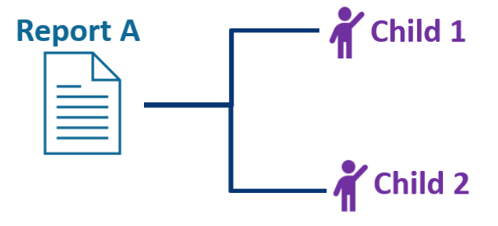
Step 2: A child can be the subject of more than one report in the reporting period. This represents a child that is the subject of multiple allegations of abuse in the Child File over time. A child appears in a report as a single record.
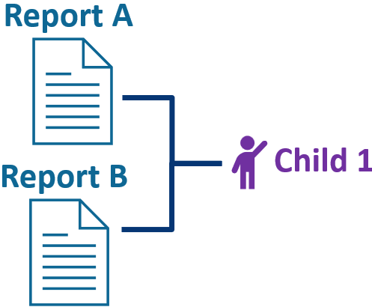

Step 3: A child in a report can have up to four maltreatments. All maltreatments for a child must be of a different type. All of these maltreatments reside in a single record with the child. Each maltreatment type has its own maltreatment level, which is the disposition or finding associated with that specific maltreatment type.
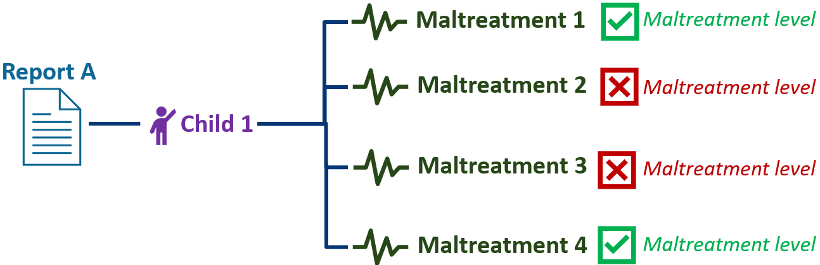

Step 4: Up to three perpetrators can be reported per child in a report. A perpetrator cannot appear more than one time in a child record. For example, two Perpetrator B’s cannot occur in one child record. The three perpetrator data sections all reside in a single record with the child.

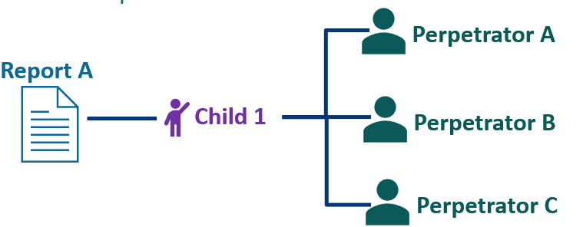

Step 5: A perpetrator can be associated with more than one report and more than one child in a report. The NCANDS Website will remove all perpetrator data if all perpetrator maltreatment fields are coded as no or use a combination of no and blank because this indicates the perpetrator was not responsible for any maltreatments. As seen above, no Perpetrator data should be submitted for records where the child has no maltreatment disposition level of substantiated or indicated. Additionally, no alleged perpetrator should be included in the record if it is known that the person is not associated with a substantiated or indicated maltreatment disposition level.
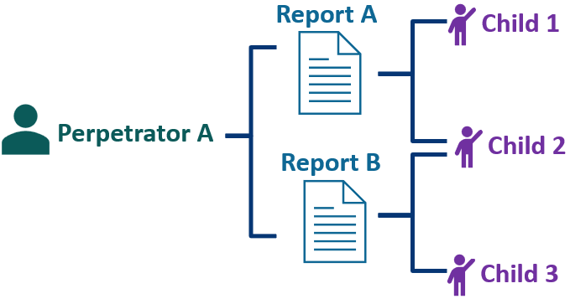

Step 6: For a child in a report, each substantiated maltreatment type, can be linked to a specific perpetrator through the perpetrator maltreatment fields. To link a perpetrator to a maltreatment, code the associated perpetrator maltreatment field to “yes.” For example, to link perpetrator 1 to maltreatment type 1, first check to see if maltreatment type 1 is substantiated or indicated. If it is, then code perpetrator 1 maltreatment 1 to “yes.” This can be repeated for each substantiated or indicated maltreatment and each perpetrator. In the figure below, the Perpetrator A is linked to substantiated maltreatments 1, 2, and 3, but is not linked to substantiated maltreatment 4. Code the perpetrator maltreatment fields for Perpetrator A to “1-yes” for substantiated maltreatments 1, 2, and 3, and “2-no” for substantiated maltreatment 4.

