Plan-Do-Study-Act (PDSA) Cycle Journey - CQIC
Tribal Home Visiting (THV)

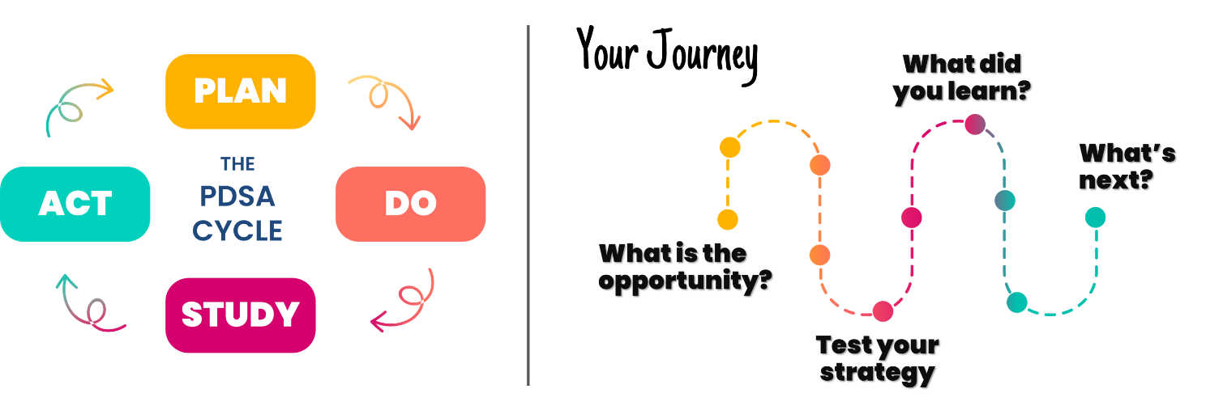

THV Grant Recipient Name:
Team Positions and Roles on the PDSA Cycle (no names):
- Example: Home Visitor – testing strategy with referral partner

Plan Stage: Where’s the opportunity to improve and how do you propose improving it?
What Primary (PD) and Secondary (SD) Drivers will your team focus on from the Playbook?
PD:
SD:
What goal (SMART Aim Statement) is your team working toward?
Your response
How will you know if the strategy tested was an improvement? What information will you track/collect?
- Your response (list questions, items, and measures)

What strategy will your team test (pull from Playbook or develop your own)?
Your response

Do Stage: Test your strategy.
Notes/ important observations about your journey:
- Your response (list notes or observations)

Study Stage: What did you learn?
Did the team make progress toward your goal (SMART Aim Statement)?
☐Yes
☐No
Information/observations/data used to understand how the test went (can be numbers/text):
Questions/ Items/ Measures (List) | Baseline (before test) | Results (after test)

What did the team learn?
SUCCESSES (things that went well):
- Your response

CHALLENGES (things that were hard):
- Your response

OTHER LESSONS LEARNED (anything else that your team noticed or learned):
- Your response

Act Stage: How will you move forward?
Will you adopt, adapt, expand, or abandon your Improvement Theory (strategy tested)?
☐Adopt (Strategy tested worked and will be implemented as tested.)
☐Adapt (Strategy tested worked in some ways; strategy will be tweaked and tested through another PDSA cycle.)
☐Expand (Strategy tested worked and will be tested again under another condition [e.g. another home visitor, another family, during a different timeframe, with another referral partner, etc.] to ensure it works again.)
☐Abandon (Strategy tested did not work. The team will conclude this PDSA cycle and revisit the opportunity to tackle a different root cause and/or try out another strategy.)
Why did you pick that response?
Your response

How does your team plan to sustain the gains from your PDSA cycle?
Your response

How did this experience inform your next PDSA cycle?
Your response

