National ALS Registry
Survey burden table calculation
Created: 6/2022

Preface to recalculating time burden
The original voluntary survey modules, which consist of 17 one-time surveys, are estimated to take approximately 85 minutes for a respondent to complete (Table 1).
Table 1. Part of the previously approved burden table (2019).
Type of Respondents | Form Name | No. of Respondents | No. of Responses per Respondent | Average Burden per Response  (in hours) | Total Burden  (in hours)
Person with ALS/Registry | ALS Case Validation Questions | 1,670 | 1 | 2/60 | 56
Person with ALS/Registry | ALS Case Registration Form | 1,500 | 1 | 10/60 | 250
Person with ALS/Registry | Voluntary Survey Modules | 750 | 1 | 85/60 | 1,063
Person with ALS/Registry | Disease Progression Survey* | 750 | 3 | 5/60 | 188

Based on this previously estimated average time burden of 85 minutes for the 17 survey questions, we have estimated the time burden for each question by evaluating each survey (Table 2).
Table 2. Number of questions in each survey evaluated for time burden estimation.
Survey module | Survey description | Number of questionsª counted toward time burden evaluation | % of survey | Time to complete survey (min)
Survey1 | Demographics | 13 | 2.3% | 1.94
Survey2 | Occupation | 9 | 1.6% | 1.34
Survey3 | Military | 4 | 0.7% | 0.60
Survey4 | Smoking and alcohol | 10 | 1.8% | 1.49
Survey5 | Physical activity | 19 | 3.3% | 2.83
Survey6 | Family history of neurodegenerative disease | 19 | 3.3% | 2.83
Survey6b | Brother | 9 | 1.6% | 1.34
Survey6s | Sister | 9 | 1.6% | 1.34
Survey6c | Children | 10 | 1.8% | 1.49
Survey8 | Lifetime residential | 9 | 1.6% | 1.34
Survey9 | Environmental exposure | 78 | 13.6% | 11.59
Survey10 | Personal environmental exposure | 25 | 4.4% | 3.72
Survey11 | Occupational/Hobby exposure | 80 | 14.0% | 11.91
Survey12 | Women’s reproductive history | 10 | 1.8% | 1.49
Survey13 | Caffeine consumption | 35 | 6.1% | 5.21
Survey14 | Injuries | 44 | 7.7% | 6.55
Survey15 | Health insurance | 1 | 0.2% | 0.15
Survey16 | Open ended etiological questions | 2 | 0.4% | 0.30
Survey17 | Clinical data and symptom onset | 33 | 5.8% | 4.91
Survey18 | Sports history | 153 | 26.8% | 22.78
Total |  | 572 |  | 85.00
ªQuestions in each survey counted toward time burden estimation does not necessarily equate to the total number of questions in the survey.
According to Table 2, a total of 572 questions were counted toward time burden calculation. Based on the proportion of questions each survey contributes to the total time estimate, it can take as little as less than a minute to ~23 minutes for a respondent to complete the survey.
For the purpose of estimating time burden for each question, calculation is based on two assumptions:
- We assume each question is applicable to all respondents.
- We assume each question has same level of difficulty to respond, thus equal time burden.
There are also exceptions:
- A male respondent would not take Survey 12 (Women’s reproductive history), so his estimated total time burden would be less than a female respondent who selects to complete the survey.
- Any respondent who selects “Other” response by manually typing in the provided field would have greater estimated total time burden.
If a respondent would take an average of 85 minutes to complete 17 one-time survey modules, which consist of 572 questions, each question would take about 0.15 minutes.
Reorganization of 17 one-time survey modules
Newly structured survey format consists of an Essential Questionnaire (EQ) and four Follow-up Questions modules (Table 3). Questions from 17 one-time surveys deemed critical to capture at the time of Registry enrollment are selected for Essential Questionnaire while remaining questions were further examined and classified into one of four categories as Follow-up Questions. Several questions were tagged as “Miscellaneous” and omitted from classification due to duplicate status (i.e. asked elsewhere during registration).
In addition, the respondents are also asked to complete the first of 3 longitudinal assessments of ALS-related functional status (Disease Progression module) at the time of registry enrollment.
Table 3. Reorganization of original surveys into different categories of Follow-up Questions modules
Appendix | Description and reorganization |  | Number of questions | Estimated burden (minutes)
E1 | Essential Questionnaire |  | 111 | 16.65
 | Select questions from Surveys 1-17
 | Survey16 | Open ended etiological questions
E2 | Disease Progression module
 | Survey7 | (Frist of three is administered with the Essential Questionnaire)
E3 | Follow-up Questions - Demography |  | 10 | 1.5
 | Survey1 | Demographics
 | Survey12 | Women’s reproductive history
E4 | Follow-up Questions - Lifestyle Factors |  | 241 | 36.15
 | Survey4 | Smoking and alcohol
 | Survey5 | Physical activity
 | Survey13 | Caffeine consumption
E5 | Follow-up Questions - Environmental Factors |  | 159 | 23.85
 | Survey2 | Occupation
 | Survey3 | Military
 | Survey8 | Lifetime residential
 | Survey9 | Environmental exposure
 | Survey10 | Personal environmental exposure
 | Survey11 | Occupational/Hobby exposure
 | Survey14 | Injuries
 | Survey18 | Sports history
E6 | Follow-up Questions - ALS-associated and Clinical Factors |  | 47 | 7.05
 | Survey6 | Family history of neurodegenerative disease
 | Survey6b | Brother
 | Survey6s | Sister
 | Survey6c | Children
 | Survey15 | Health insurance
 | Survey17 | Clinical data and symptom onset
 | Miscellaneous |  | 4 | 0.6
 | Total |  | 572 | 85.8

Following the classification of each question in the original voluntary survey modules into the newly formatted categories, questions for each section were further re-evaluated.

Combination and simplification of questions
In the process, we have identified several stand-alone questions that can be combined and merged due to similarity in the topic of question and its wording and format (Figure 1).
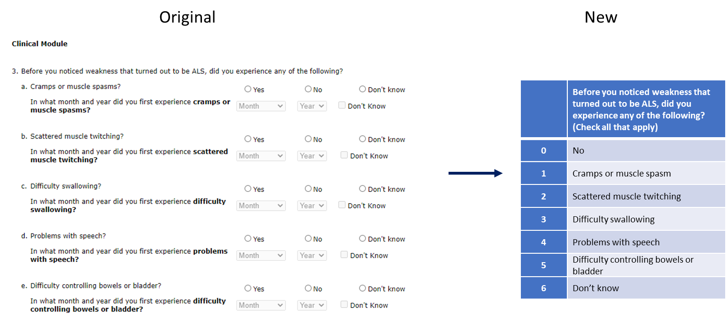
Figure 1. Example of question combination and simplification from the “original” to “new” to ease respondent's time burden to provide response.

For this assessment, we have reviewed questions in the new categories and identified whether they were eligible for merging (Table 4). Merging of eligible questions reduced number of questions in EQ and 2 of 4 Follow-up Questionnaire modules and decreased estimated time burden. In addition to the questions omitted from the classification due to duplicate status, there were several questions in EQ and Follow-up Questions: Environmental Factors where the responses are auto-filled due to reformat (further explained below), thus resulting in further reduction to the overall time burden estimate.

Table 4. Number of items from one-time surveys combined and merged to reduce estimated time burden in newly formatted survey structure
Form name | No. of Questions from the original modules | Estimated time as it stands without reformatting (minutes) | No. of Questions eligible for combination | No. of Questions merged | Time saved from combining questions (minutes)ª
Essential Questionnaire | 111 | 16.65 | 90 | 70 | 10.5
Follow-up Questions - Demography | 10 | 1.5 | 0 | 0 | 0
Follow-up Questions - Lifestyle Factors | 241 | 36.15 | 35 | 27 | 4.05
Follow-up Questions - Environmental Factors | 159 | 23.85 | 8 | 4 | 0.6
Follow-up Questions - ALS-associated and Clinical Factors | 47 | 7.05 | 0 | 0 | 0
Miscellaneous^{b} | 4 | 0.6 | 0 | 0 | 0
Total | 572 | 85.8 | 133 | 101 | 15.15
ªCalculation: No. of questions merged x 0.15 minutes; Estimated time burden for each question is 0.15 minutes
^{b}Questions asked during registration, thus not categorized, and eliminated from EQ or the Followup Questions

Reducing unnecessary physical burden and effort
By simplifying the question format through combination and merge, certain responses are “auto-filled” in the new format, that’d otherwise require the respondent to manually select. Taking Figure 1 as an example, by selecting [1. Cramps or muscle spasm] and [2. Scattered muscle twitching] in the new format, respondent is relieved from physically selecting “no” to other possible responses. Instead, the system will internally recognize the unselected response and will record “no”. This results in additional decrease in the estimated time burden (Table 5). At the end of completion of EQ or other modules, the respondent has a chance to review and correct the response if necessary.
Table 5. Number of auto-completed items in the new format that results in reduced estimated time burden
Form name | Questions auto-completed | Time saved (minutes) ª
Essential Questionnaire | 6 | 0.9
Disease progression module | 0 | 0
Follow-up Questions - Demography | 0 | 0
Follow-up Questions - Lifestyle Factors | 0 | 0
Follow-up Questions - Environmental Factors | 4 | 0.6
Follow-up Questions - ALS-associated and Clinical Factors | 0 | 0
Total | 10 | 1.5
ªCalculation: Number of auto-completed x 0.15 minutes; Estimated time burden for each question is 0.15 minutes

Collectively, restructuring the original volunteer survey modules into Essential Questionnaire and Follow-up Question modules, an estimated average time burden per respondent is reduced by 17.25 minutes (Table 6).
Table 6. Total time saved in the newly organized survey format.
 | Time saved per respondent (minutes)
Table 4 – Combination and merge | 15.15
Table 5 – Auto-completion | 1.5
Miscellaneous – Duplicate status | 0.6
Total | 17.25

Table 7. Recalculation of total burden (in hours) in a newly formatted survey structure.
Type of Respondents | Form Name | No. of Respondents | No. of Responses per Respondent | Average Burden per Response (in hours) | Total Burden (in hours)
Person with ALS/Registry | ALS Case Validation Questions | 1,670 | 1 | 2/60 | 56
Person with ALS/Registry | ALS Case Registration Form | 1,500 | 1 | 10/60 | 250
Person with ALS/Registry | Essential Questionnaire | 750 | 1 | 6/60 | 75
Person with ALS/Registry | Disease Progression Survey (1st time) | 750 | 1 | 5/60 | 63
Person with ALS/Registry | Disease Progression Survey (2nd and 3rd time) | 750 | 2 | 5/60 | 125
Person with ALS/Registry | Follow-up Questions - Demography | 750 | 1 | 2/60 | 25
Person with ALS/Registry | Follow-up Questions - Lifestyle Factors | 750 | 1 | 32/60 | 400
Person with ALS/Registry | Follow-up Questions - Environmental Factors | 750 | 1 | 23/60 | 288
Person with ALS/Registry | Follow-up Questions - ALS-associated and Clinical Factors | 750 | 1 | 7/60 | 88
Total | EQ + 4 Follow-up Question modules |  |  |  | 876

As a result, compared to the original volunteer survey that would have taken 85 minutes per respondent to complete, the newly structured format would take approximately 58 minutes. Should 750 respondents take this newly formatted survey, the estimated total burden (in hours) would be 876 instead of 1,063. This is a reduction of 188 hours in the estimated time burden.

