Justification of Non-Material Change
Form 56, Notice Concerning Fiduciary Relationship
1545-0013

IRS is submitting a non-material change request to make a slight change to Form 56. The change does not materially alter the information already approved for use by the Office of Management and Budget.

IRS is only providing clarification to Section A, Line 2 of the form. IRS is making this modification to allow respondents to more easily reflect that assets are in the custody of the court and list which assets are court held. Previously Line 2 allowed respondents to enter this information as a narrative. The modification will not change the burden estimates.

Section A, Line 2 as currently OMB approved:
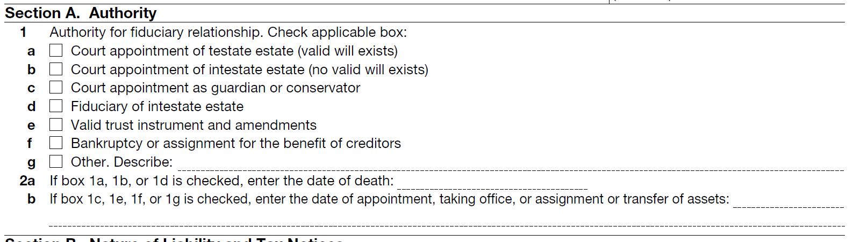

Section A, Line 2 as the planned modification:
