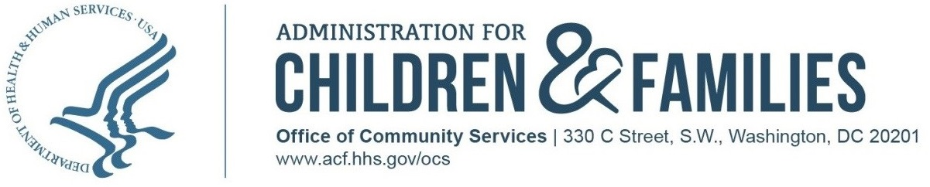

Low Income Home Energy Assistance Program

Action Transmittal
AT#: ACF-OCS-LIHEAP-AT-2025-XX
DATE: May 29, 2026
TO: Low Income Home Energy Assistance Program (LIHEAP) State Grant Recipients and the District of Columbia
SUBJECT: Reinstatement with Changes of the 2024-2025 Residential Energy Consumption Survey (RECS) LIHEAP Data Match — Project Announcement and Data Request
ATTACHMENT(S): Basic Technical Specifications for 2024-2025 RECS-LIHEAP Administrative Data Match

RELATED REFERENCES:

Sections 2605(b)(14) and 2610 of the Low Income Home Energy Assistance Act of 1981, as amended, 42 U.S, C. §§ 8624(b)(14) & 8629.

PURPOSE:

To request that states furnish federal Fiscal Year 2024 (FY24) and FY25 Low Income Home Energy Assistance Program (LIHEAP) household-level data for matching LIHEAP recipients with the 2024 Residential Energy Consumption Survey (RECS) respondent households. This data collection effort has been reinstated with changes by the Office of Management and Budget (OMB), under OMB Control No. 0970-0486, after the previous Information Collection Request expired June 30, 2023 and which OMB reinstated on [insert].

BACKGROUND:

The U.S. Department of Energy (DOE) Energy Information Administration (EIA) conducts this survey approximately every five years to provide periodic national and regional data on residential energy use in the United States. OCS uses RECS data to furnish Congress and the Administration with important national and regional descriptive data on the energy needs of households with low incomes.

EIA conducted the last completed RECS (the 2020 RECS) in 2020 and 2021. At that time, the Administration for Children and Families (ACF) conducted a post-survey administrative records matching effort to identify RECS respondents that were LIHEAP recipients. This effort was developed and implemented with the cooperation of LIHEAP state grant recipients. As a result of this effort, ACF was able to examine information and develop statistics from RECS that were specific to the LIHEAP recipient population, including information related to benefits targeting, energy usage, and energy insecurity.

ACF is implementing a similar effort for the 2024 RECS to update the funding formula and support analysis of LIHEAP data for the annual Report to Congress, the annual LIHEAP Home Energy Notebook, and additional research and analysis of LIHEAP program impacts.

Data is needed on regular and crisis fuel assistance benefits for FY24 and FY25. We seek data for both years to ensure that it covers the entire period covered by the 2024 RECS. Please note that this is the same data needed to generate programmatic summary statistics for your state’s annual LIHEAP Household Report Form and the LIHEAP Performance Data Form. Your application client waiver language allows you to share information with ACF and its contractors. For the prior effort, all states and the District of Columbia successfully submitted data.

ACF has contracted with the Applied Public Policy Research Institute for Study and Evaluation (APPRISE) to manage this project. APPRISE staff will contact you soon with basic technical specifications for this data collection effort. The confidentiality of client data will be strictly protected as part of the project. OCS plans to maximize rapid file transfer technology by using a secure internet site that employs File Transfer Protocol. APPRISE and its predecessors have been collecting state LIHEAP data since 2001. During this time, due to maintaining high security standards, no data breach has ever occurred.

Your cooperation in this effort is greatly appreciated. Contact Lauren Christopher, Senior Advisor, at liheap@acf.hhs.gov if you have any questions, concerns, or problems in providing the data.

THE PAPERWORK REDUCTION ACT OF 1995 (Public Law 104-13) Statement:

Public reporting burden for this collection of information is estimated to average 16 hours per response/respondent, including the time for reviewing instructions, gathering and maintaining the data needed, and reviewing the collection of information.

An agency may not conduct or sponsor, and a person is not required to respond to, a collection of information unless it displays a currently valid OMB control number.

ACTION:

ACF’s contractor, APPRISE, will ask your state to complete the steps described below.

Step 1:
Provide ACF’s contractor, APPRISE, a file of LIHEAP households that received fuel assistance in FY24 and FY25 for one of the following data populations:
- All FY24 and FY25 LIHEAP recipients for your entire state or service area
- All FY24 and FY25 LIHEAP recipients only in the counties from your state that are part of the RECS sample (a list will be provided separately)
- All FY24 and FY25 LIHEAP recipients only in the ZIP codes from your state that are part of the RECS sample (a list will be provided separately)

Step 2:
Provide ACF’s contractor, APPRISE, the data needed to facilitate the 2024 RECS LIHEAP Supplement through one of the following two steps.

Option A: One-Step Approach

Provide ACF’s contractor, APPRISE, a file with all of the required data items noted below, and as many of the optional data items as you have available, for all of your FY24 and FY25 LIHEAP recipient households at whatever level you choose (see options 1, 2, and 3, above).

Option B: Two-Step Approach

Provide ACF’s contractor, APPRISE, a file of LIHEAP households that provides only the address (including ZIP code) of all FY24 and FY25 LIHEAP recipients at whatever level you choose (see options 1, 2, and 3, above).

Later, you will also provide ACF’s contractor, APPRISE, a second file that lists a subset of these LIHEAP recipients who completed a RECS interview. That second file must include all of the required data items noted below, and as many of the optional data items as you have available, for those households.

Required Data Items:

- Address (must include ZIP code)
- Gross Income
- Household or Client ID
- Household Size
- Heating assistance awarded
- Amount of heating assistance
- Cooling assistance awarded
- Amount of cooling assistance
- Crisis assistance awarded
- Amount of crisis assistance
- Presence of children 5 or younger
- Presence of adult 60 or older
- Presence of member with a disability

The following are additional optional data items that grantees can provide if the data are already available in your database:

- Tenancy (i.e., own or rent)
- Type(s) of fuel used
- Heat included in rent
- LIHEAP benefit restored energy service
- LIHEAP benefit prevented loss of energy service

Data Format:
Provide the data noted above in one of the following acceptable formats:

- Microsoft Excel
- Microsoft Access
- SAS
- STATA

If you are unable to submit data in one of these four formats, you must provide a written explanation of why submission in a different format is necessary and the format you intend to use. OCS will then determine if we have the ability to accept the data in the suggested format.

Thank you for your attention to these matters. OCS looks forward to continuing to provide high-quality services to OCS partners.

/s/
Janelle George
Deputy Director
Office of Community Services

