nFORM Screens to Collect Information

on Services Provided to Participants

Proposed changes to screens for the next HMRF cohort are indicated where applicable. Screen shots include fictional names for illustrative purposes.

H1. Home page (displays after secure log-in to system)
Proposed changes: The PRA statement and nFORM logo will be updated.

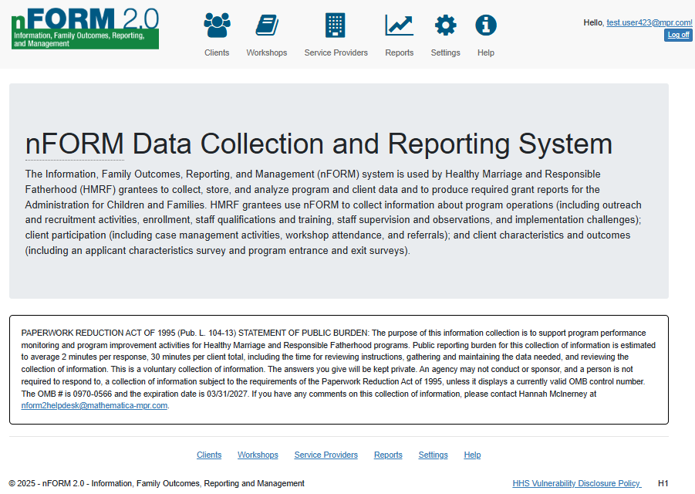

C1-C6. Client Level Data on Service Contacts, Referrals, Incentives, and Workshops

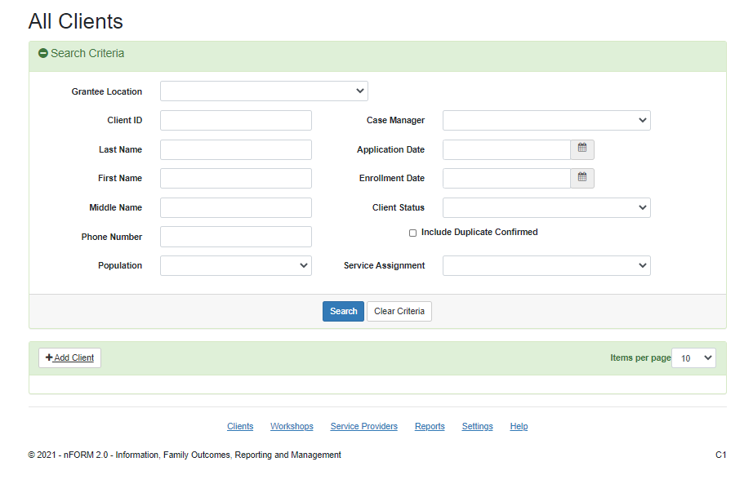

Proposed changes to C3 Client Profile:
- Add Primary Language to Client Information box
- Add new tab for 'Outreach'
- Rename Grantee Location to Grant Location
- Remove client agrees to be contacted by text from Client Info box
- Remove Applicant Characteristics Survey row from Client Surveys box

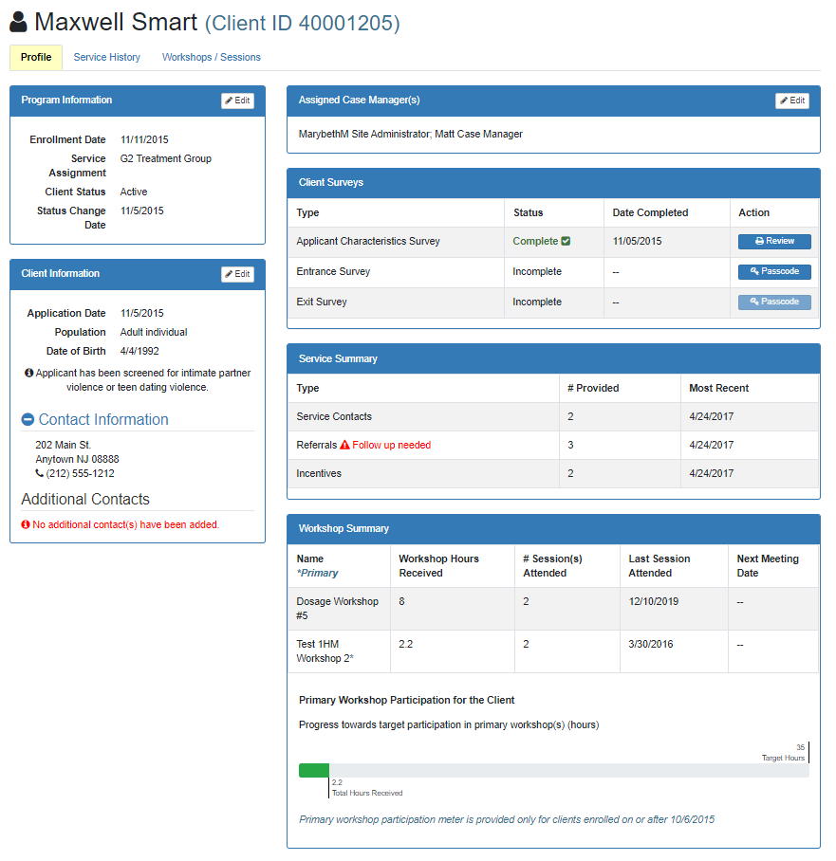
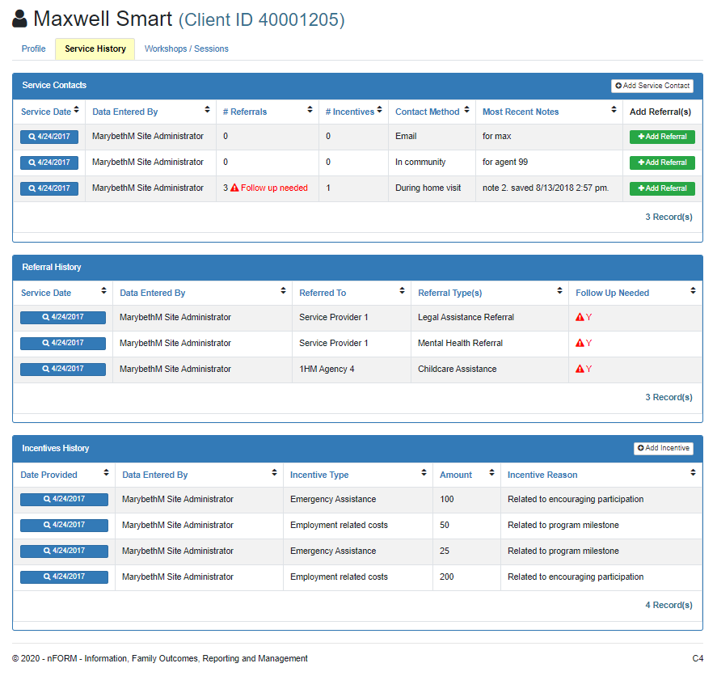

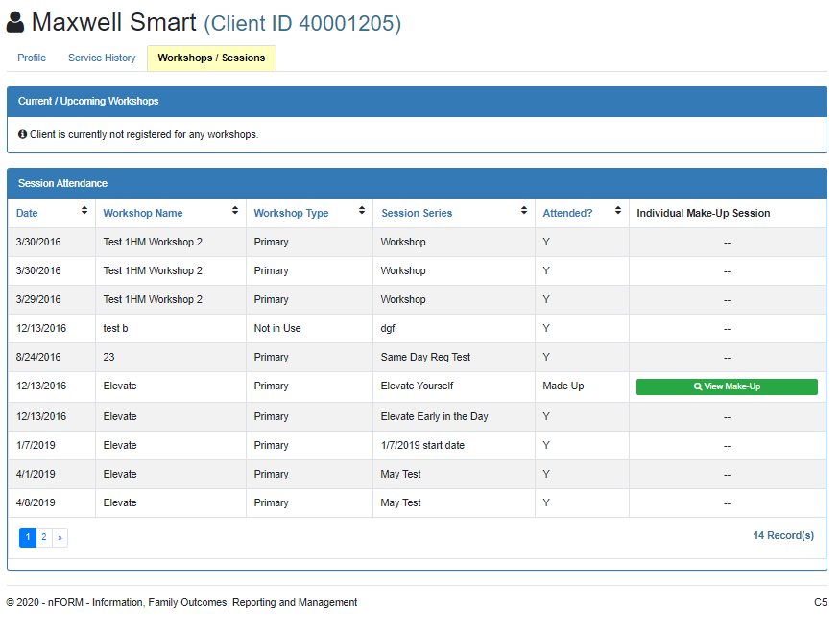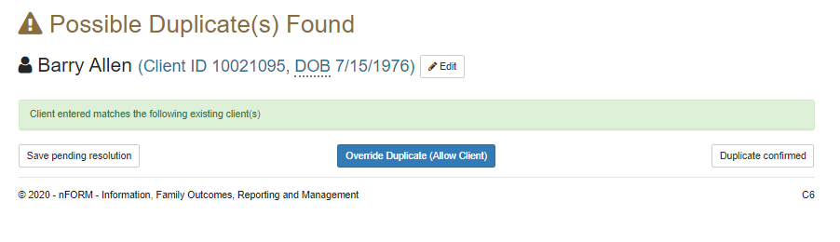

C21. Outreach Level Data on Contacts and Referrals Prior to Enrollment
This new screen C21 will be added to allow grant staff to begin capturing application data before potential applicants are ready to enroll.
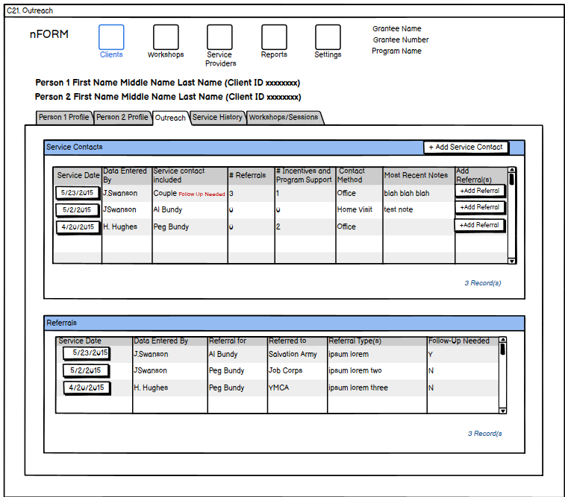
C7/C12/C13. Add/Edit Client Service Contacts, Referrals, and Incentives
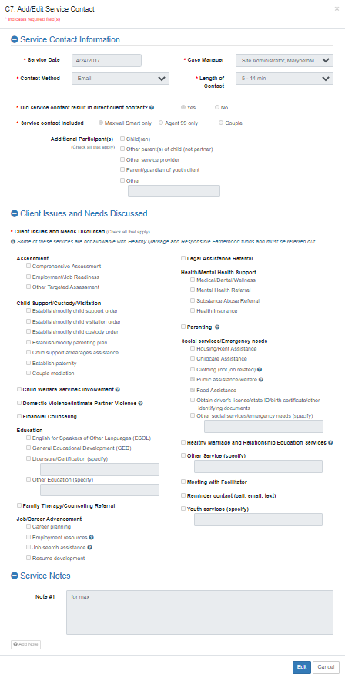
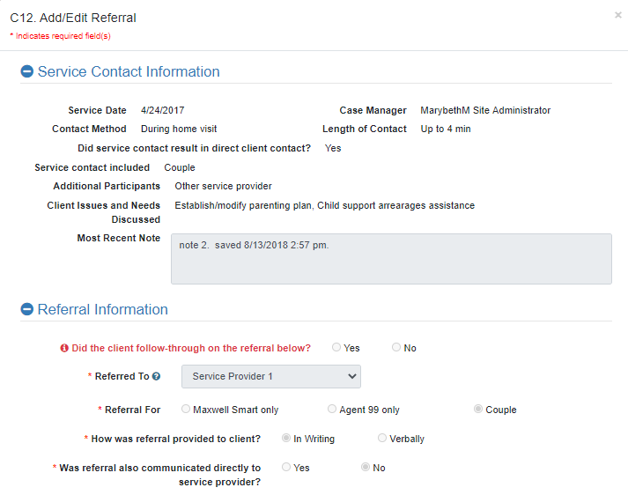
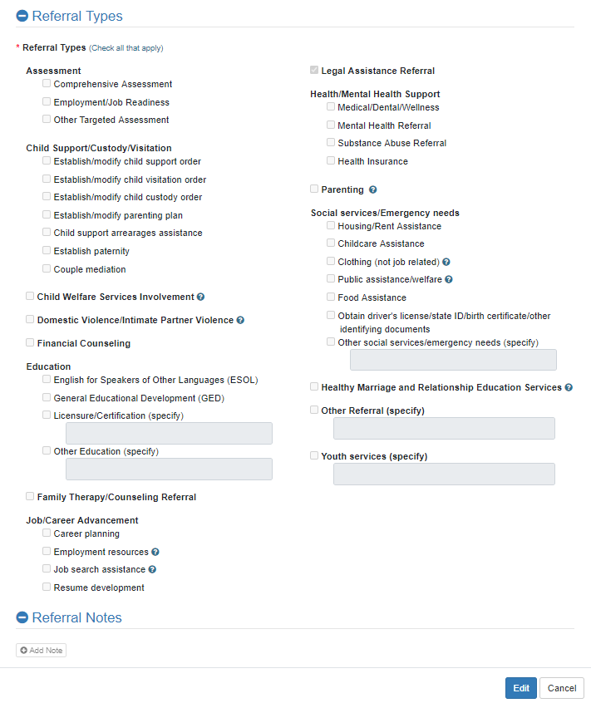
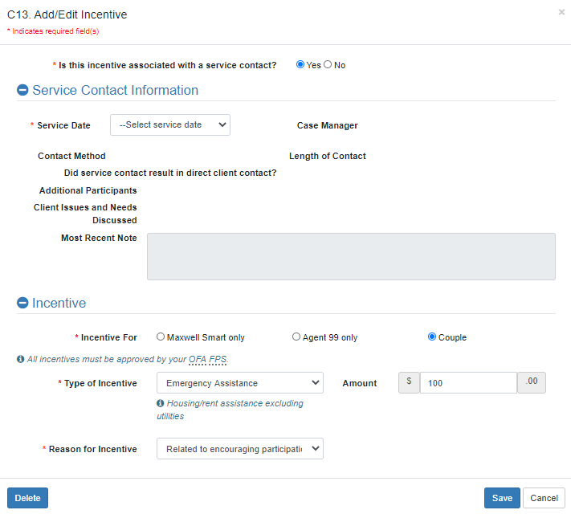

W1. Workshop List
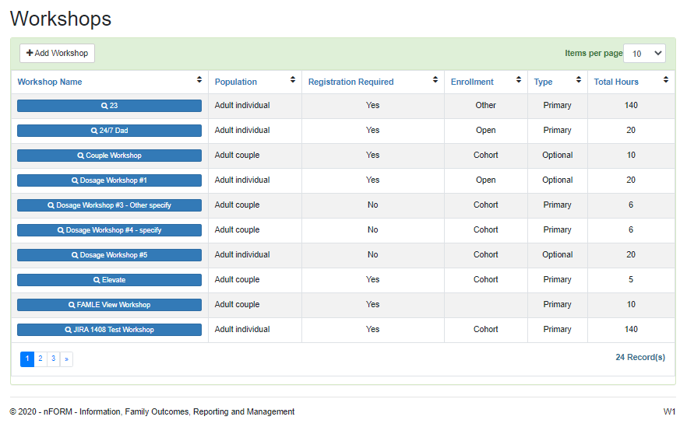

W2. Add/Edit Workshop
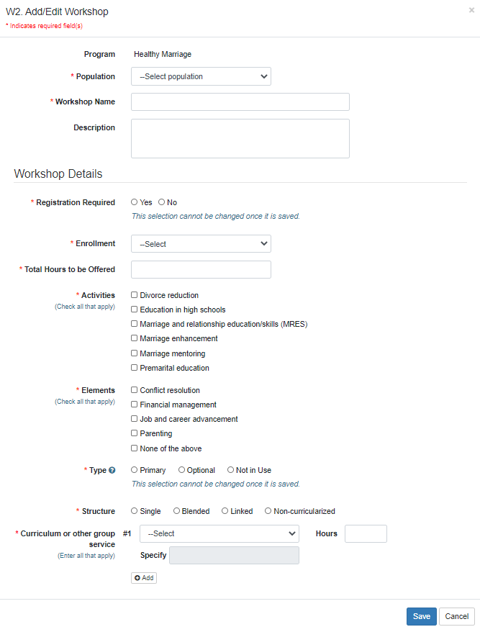
W5. Add/Edit Workshop Session Series

Proposed changes: New radio button selections will be added for Delivery Mode in Session Series Details section and for Primary Setting in Location section.
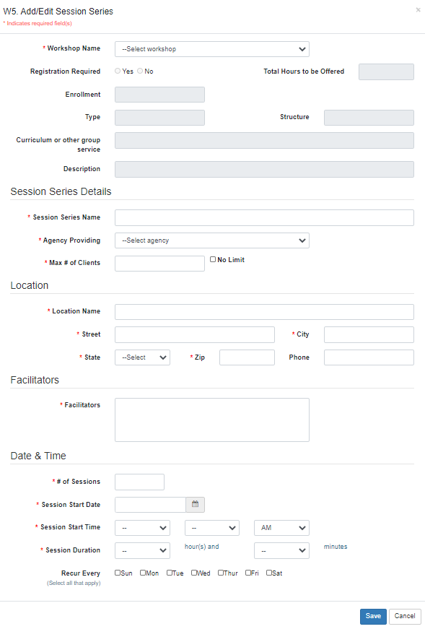

W4/W8. Manage Session Series and Client Registration

Proposed changes: A search filter will be added to W4 for Delivery Mode. Delivery Mode and Primary Setting in Series will be displayed in metadata at the top of W8.

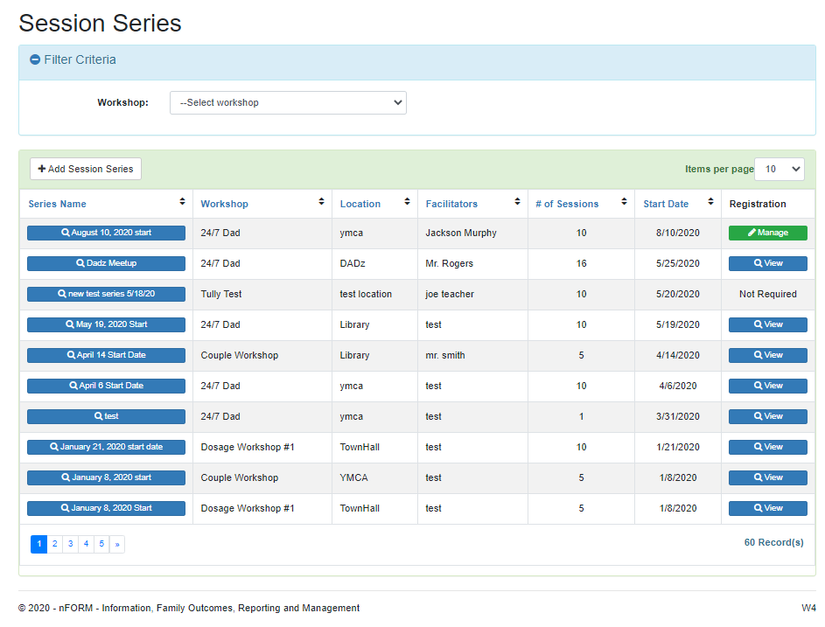

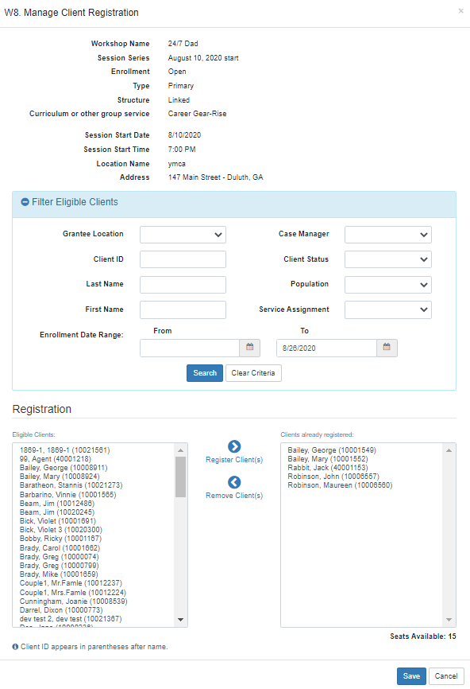
W7/W9/C11. Manage Session Occurrences and Attendance
