Awardee Lead Profile Assessment (ALPA) User Guide

March 2026

Introduction
The purpose of the Awardee Lead Profile Assessment (ALPA) is to collect information about childhood lead poisoning-related laws and guidance, surveillance and prevention strategies, and program services including at what blood lead levels (BLLs) various case management activities are performed.
This information collection will help CDC to identify specific factors that may support or hinder the efforts of public health agencies engaged in lead poisoning prevention. CDC will use the collected information to inform guidance, resource development, and technical assistance activities to support lead hazard elimination.
You have been asked to take part in this assessment in your official capacity as someone who is knowledgeable about their state, tribal, local, and territorial childhood lead poisoning prevention program (CLPPP). The data will be kept secure throughout the analysis and reporting process.
This assessment should take no more than 53 minutes to complete. You may stop taking the assessment and finish it at a later time. To re-enter the assessment, you will just click on the original link you were sent via email.
Please complete the assessment by [SPECIFIC DATE TO BE PROVIDED – 2 WEEKS AFTER THE SURVEY IS SENT OUT.
Participation is required for satisfactory performance under the current Notice of Award. No individually identifiable information will be requested. If you have programmatic questions, you can contact CDC via your Project Officer.

1. Program Information
The first section of the survey is program information and contains four questions. All fields in this section are required.
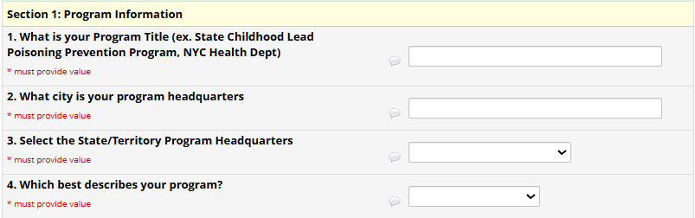
Question 1 and 2 are free text fields.
Question 3 and 4 are drop-down fields. If you do not see your applicable response from the list, please select “other” and type in your response in the text box.

2. Governance
The second section asks about governance and contains questions 5-20.
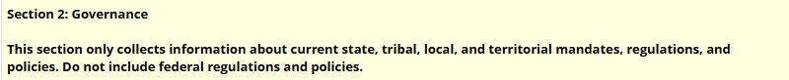
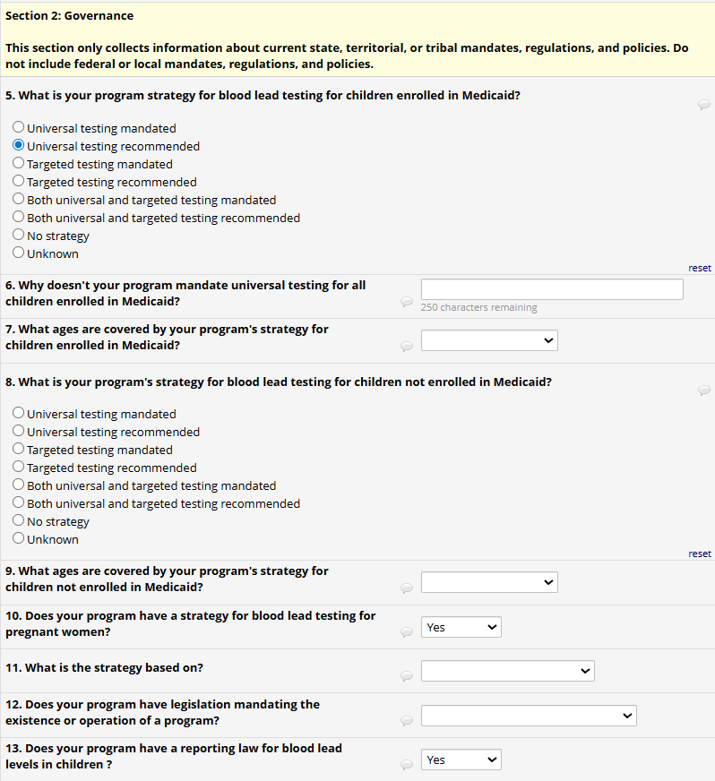
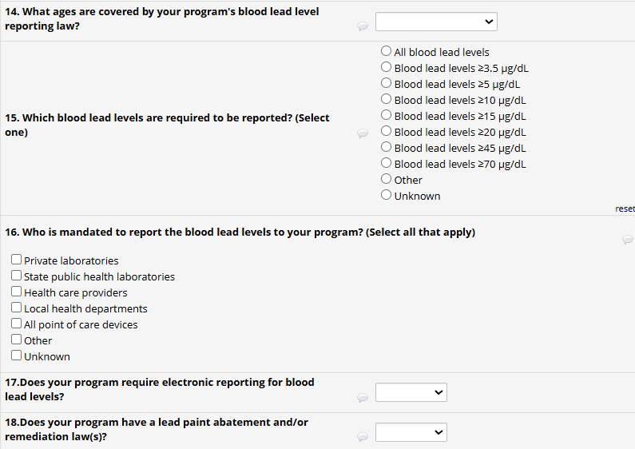
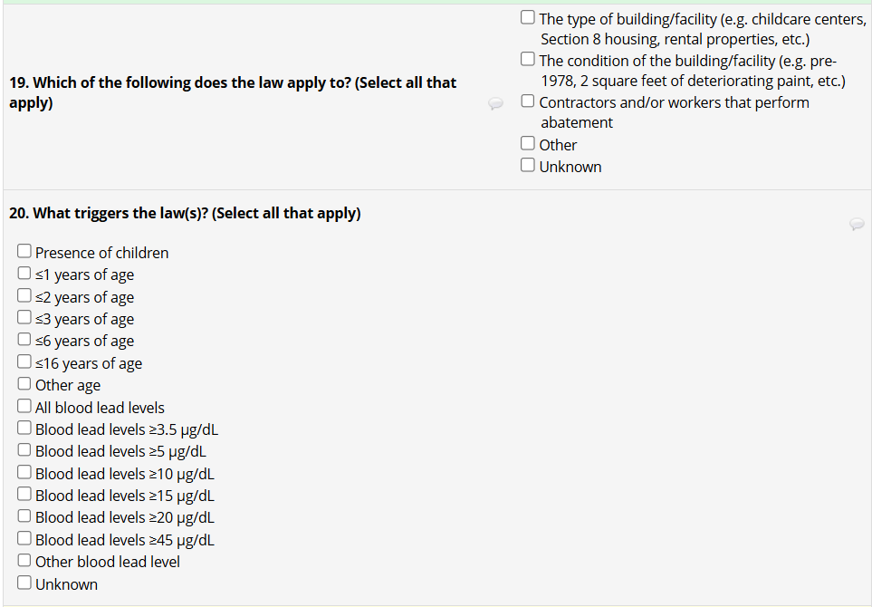
For local programs funded to conduct surveillance (New York City or Los Angeles County), fill out this section according to your local mandates, regulations, and policies.
Question 5 has skip logic. If you select “universal testing mandated” or “both universal and targeted testing mandated,” the survey will skip to question 7. If you select “unknown,” the survey will skip to question 8.
Question 10 has skip logic. If you select “no” or “unknown,” the survey will skip to question 12.
Question 13 has skip logic. If you select “no” the survey will skip to question 18.
Question 18 has skip logic. If you select "no” the survey will skip to question 21.

3. Surveillance, Testing and Prevention
The third section asks about surveillance, testing, and prevention and contains questions 21-32.
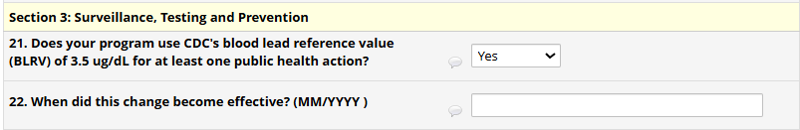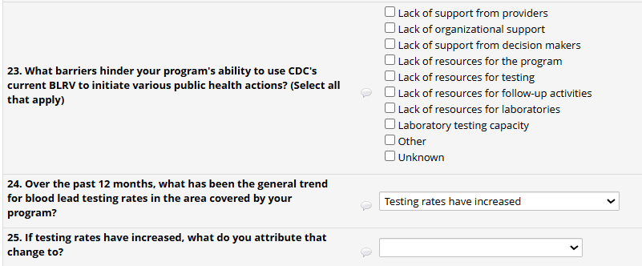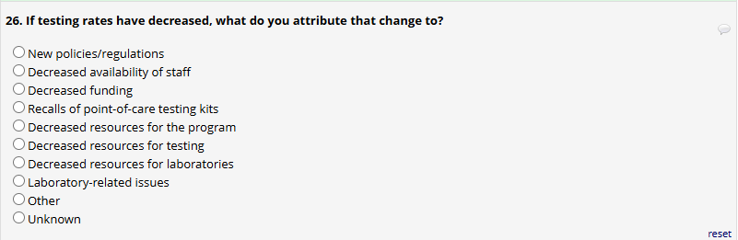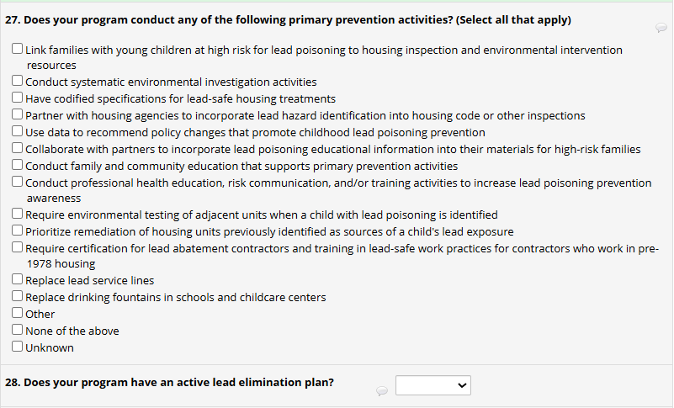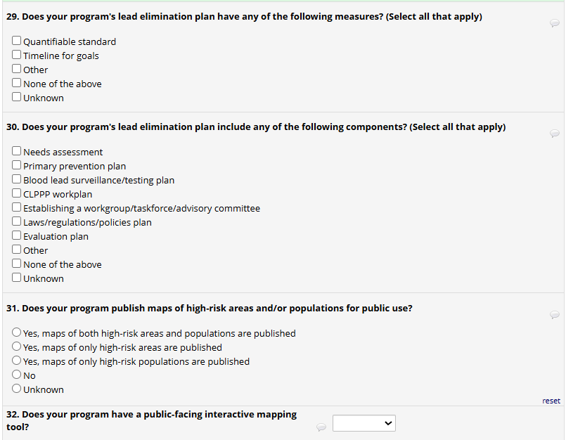
Question 21 has skip logic. If you select "no,” question 23 will show. If you select "unknown,” question 24 will show.
Question 22 is a free text field for (MM/YYYY). If you don’t know all or part of the date, use 9s for unknown.
Question 24 has skip logic. If “testing rates have decreased” is selected, question 26 will show. If "testing rates have remained relatively consistent” or “unknown” are selected, question 27 will show.
For question 27, the option “Conduct systematic environmental investigation activities” includes things such as lead dust wipes, visual inspections, and paint chip and soil analysis based on housing characteristics (i.e. pre-1978 housing in poor condition) and making data available electronically.
Question 28 has skip logic. If you select “no” or “unknown,” the survey will skip to question 31.

4. Case Management
The fourth section asks about case management and contains questions 33-38.
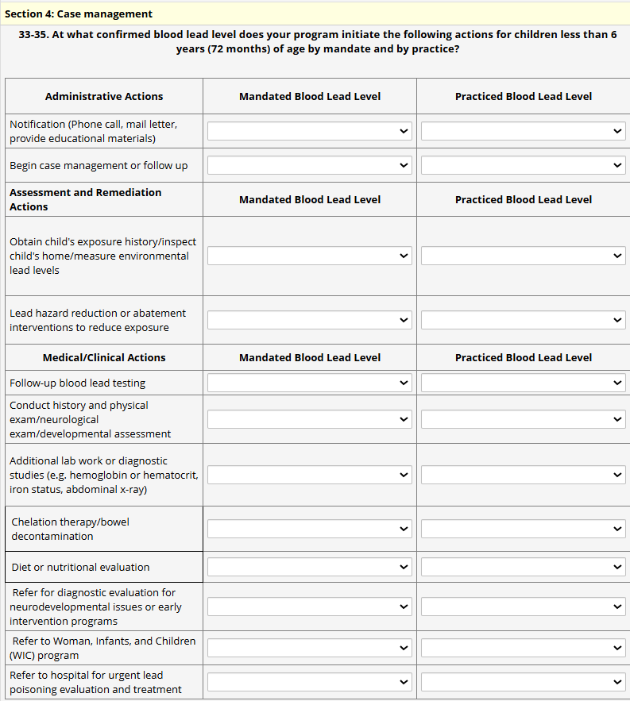
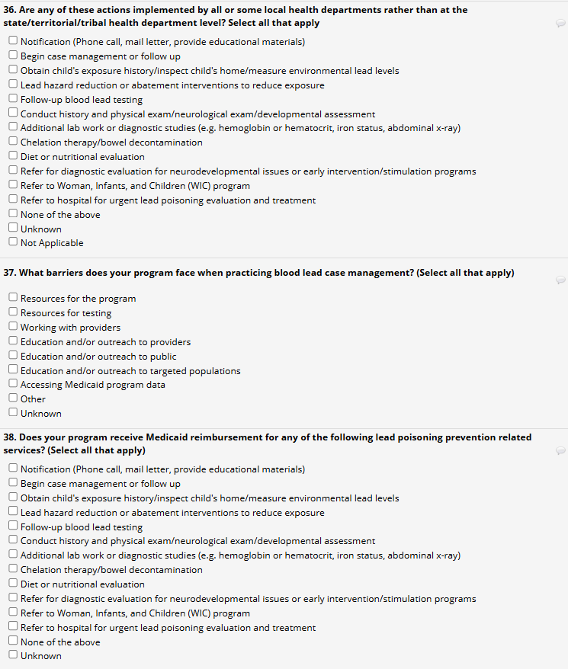
Note that on the table under the Assessment and Remediation Actions section, “Obtaining child’s exposure history/ inspect child’s home/ measure environmental lead levels” includes inspection and measurement in other frequently visited sites in addition to the home, such as a grandparent’s home.
Note that on the table under the Medical/Clinical Actions section and in questions 36 and 38, “Diet or nutritional evaluation” also includes referrals.

Submitting the survey
Once the data have been entered and completed, you can save a copy of your responses by right clicking anywhere on the survey page, clicking print, and then saving as a PDF. Please do this step before submitting if you want to have a copy of your responses. After saving, please click on submit.

