Collection Instrument Cross walk

ABCs
Cross walk of 2026 form changes
- ABCs Case Report Form (ABC.100.1)
2025 Form | 2026 Form (Changes in yellow highlight)
 | Updated header to reflect surveillance year  

Lab Repeating Group section T1. Test Type
2025 Case Report Form | 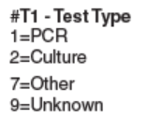
2026 Case Report Form | Updated label for response options from 1=PCR and 7=Other to 1=NAAT and 7=Other (specify).  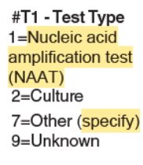

Lab Repeating Group section T3. Test Method (non-culture)
2025 Case Report Form | 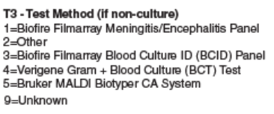
2026 Case Report Form | Added additional response options for T3. Test method & added new set of variables to allow for ‘other’ to be specified.  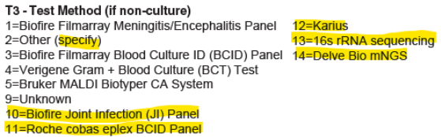

Q27d. Other Substances
2025 Case Report Form | 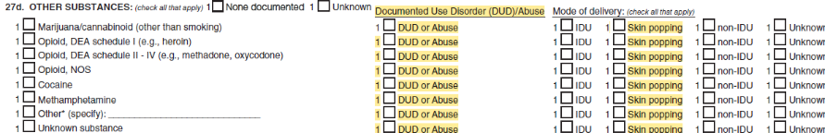
2026 Case Report Form | Removed check boxes to capture Documented Use Disorder/Abuse and Skin popping under Mode of delivery for all substances listed under Q27d Other substances.  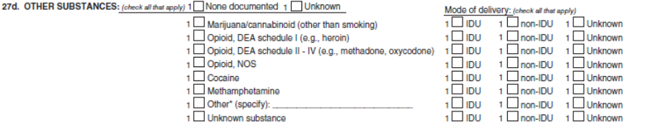

- ABCs Neonatal Infection Expanded Tracking Form (ABC.100.5)
2025 Case Report Form | 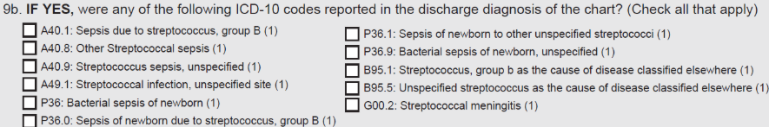
2026 Case Report Form | Added 3 additional ICD-10 codes to Q9b.  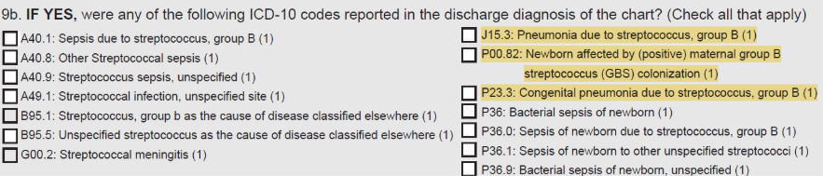

FluSurv-NET
- FluSurv-NET Influenza Surveillance Project Case Report Form (FSN 300.1)
Question on 2025-26 Form | Question on 2026-27 Form
- C. Enrollment Information  - 1. Case Classification:  - Surveillance Discharge Audit | C. Enrollment Information  - Case Classification:  - Surveillance Discharge Audit  - Observation Only
- C. Enrollment Information  11. Pregnant (15-49 years of age)?  - Yes  - No  - Not applicable (male/pregnant outside of applicable age range) | C. Enrollment Information  11. Pregnant (15-49 years of age)?  - Yes  - No
D. Influenza Testing Results  Influenza Result 1-3:  - Flu A (no subtype)  - 2009 H1N1  - H1, Unspecified  - H1, Seasonal  - H1  - H3  - Flu A, Unsubtypable  - Flu B (no lineage)  - Flu B, Victoria  - Flu B, Yamagata  - Flu A & B  - Flu A/B (not distinguished)  - Unknown Type  - Negative  - H3N2v  - Other, please specify | D. Influenza Testing Results  Influenza Result 1-3:  - Flu A (no subtype)  - 2009 H1N1  - H1  - H3  - H5  - Flu A, Unsubtypable  - Flu B (no lineage)  - Flu B, Victoria  - Flu B, Yamagata  - Flu A & B  - Flu A/B (not distinguished)  - Unknown Type  - Negative  - H3N2v  - Other, please specify
F. Outcome  - If patient discharged alive, please indicate to where:  - Private residence  - Private residence with services  - Homeless/Shelter/Temporary housing  - Nursing home/Skilled nursing facility  - Substance abuse treatment center  - Rehabilitation facility  - Corrections facility  - Hospice  - Assisted living/Residential care  - LTACH  - Group/Retirement home  - Psychiatric/Behavioral Health Facility  - Other long term care facility  - Against medical advice (AMA)  - Discharged to another hospital  - Other, specify  - Unknown | F. Outcome  2. If patient discharged alive, please indicate to where:  - Private residence  - Private residence with services  - Homeless/Shelter/Temporary housing  - Nursing home/Skilled nursing facility  - Substance abuse treatment center  - Rehabilitation facility  - Corrections facility  - Hospice  - Assisted living/Residential care  - LTACH  - Group/Retirement home  - Psychiatric/Behavioral Health Facility  - Other long term care facility  - Against medical advice (AMA)/Elopement  - Discharged to another hospital  - Other, specify  - Unknown
G. Admission and Patient History  3. Date of onset of acute respiratory symptoms (within 2 weeks before a positive test): ___/___/____  - Unknown  - Not applicable | G. Admission and Patient History  3. Date of onset of fever or acute respiratory symptoms (within 2 weeks before a positive test), whichever is earlier: __/__/____  - Approximate date entered  - Unknown  - Not applicable
H. Underlying Medical Conditions  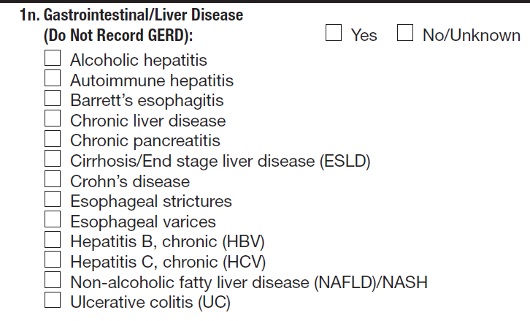 | H. Underlying Medical Conditions  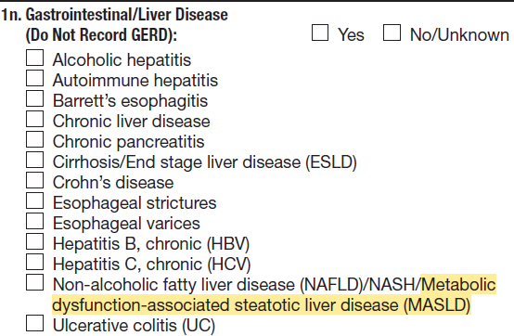
H. Underlying Medical Conditions  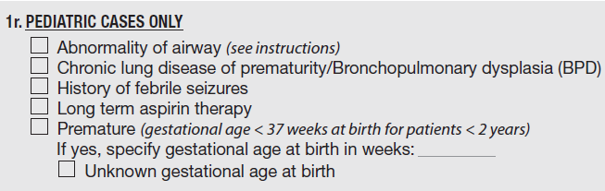 | H. Underlying Medical Conditions  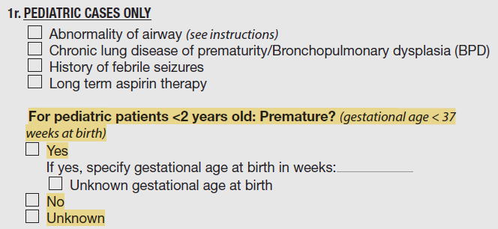
I. Viral Pathogens  1. Was patient tested for any of the following viral respiratory pathogens within 14 days prior to admission or ≤ 3 days after admission?  1a. RSV  [] Yes, positive [] Yes, negative [] Not tested/Unknown  Date: __/__/____  1b. Coronavirus SARS-CoV-2  [] Yes, positive [] Yes, negative [] Not tested/Unknown  Date: __/__/____  1c. Adenovirus  [] Yes, positive [] Yes, negative [] Not tested/Unknown  Date: __/__/____  1d. Parainfluenza 1  [] Yes, positive [] Yes, negative [] Not tested/Unknown  Date: __/__/____  1e. Parainfluenza 2  [] Yes, positive [] Yes, negative [] Not tested/Unknown  Date: __/__/____  1f. Parainfluenza 3  [] Yes, positive [] Yes, negative [] Not tested/Unknown  Date: __/__/____  1g. Parainfluenza 4  [] Yes, positive [] Yes, negative [] Not tested/Unknown  Date: __/__/____  1h. Human metapneumovirus  [] Yes, positive [] Yes, negative [] Not tested/Unknown  Date: __/__/____  1i. Rhinovirus/Enterovirus  [] Yes, positive [] Yes, negative [] Not tested/Unknown  Date: __/__/____  1j. Coronavirus 229E  [] Yes, positive [] Yes, negative [] Not tested/Unknown  Date: __/__/____  1k. Coronavirus HKU1  [] Yes, positive [] Yes, negative [] Not tested/Unknown  Date: __/__/____  1l. Coronavirus NL63  [] Yes, positive [] Yes, negative [] Not tested/Unknown  Date: __/__/____  1m. Coronavirus OC43  [] Yes, positive [] Yes, negative [] Not tested/Unknown  Date: __/__/____  1n. Coronavirus (not further specified)  [] Yes, positive [] Yes, negative [] Not tested/Unknown  Date: __/__/____ | I. Viral Pathogens  1. Was patient tested for any of the following viral respiratory pathogens within 14 days prior to admission or ≤ 3 days after admission?  1a. RSV  [] Yes, positive [] Yes, negative [] Not tested/Unknown  Date: __/__/____  1b. Coronavirus SARS-CoV-2  [] Yes, positive [] Yes, negative [] Not tested/Unknown  Date: __/__/____  1c. Adenovirus  [] Yes, positive [] Yes, negative [] Not tested/Unknown  Date: __/__/____  1d. Parainfluenza 1  [] Yes, positive [] Yes, negative [] Not tested/Unknown  Date: __/__/____  1e. Parainfluenza 2  [] Yes, positive [] Yes, negative [] Not tested/Unknown  Date: __/__/____  1f. Parainfluenza 3  [] Yes, positive [] Yes, negative [] Not tested/Unknown  Date: __/__/____  1g. Parainfluenza 4  [] Yes, positive [] Yes, negative [] Not tested/Unknown  Date: __/__/____  1h. Parainfluenza (not further specified)  [] Yes, positive [] Yes, negative [] Not tested/Unknown  Date: __/__/____  1i. Human metapneumovirus  [] Yes, positive [] Yes, negative [] Not tested/Unknown  Date: __/__/____  1j. Rhinovirus/Enterovirus  [] Yes, positive [] Yes, negative [] Not tested/Unknown  Date: __/__/____  1k. Coronavirus 229E  [] Yes, positive [] Yes, negative [] Not tested/Unknown  Date: __/__/____  1l. Coronavirus HKU1  [] Yes, positive [] Yes, negative [] Not tested/Unknown  Date: __/__/____  1m. Coronavirus NL63  [] Yes, positive [] Yes, negative [] Not tested/Unknown  Date: __/__/____  1n. Coronavirus OC43  [] Yes, positive [] Yes, negative [] Not tested/Unknown  Date: __/__/____  1o. Coronavirus (not further specified)  [] Yes, positive [] Yes, negative [] Not tested/Unknown  Date: __/__/____
L. Discharge Summary  - Did the patient have any of the following new diagnoses at discharge? (select all that apply)    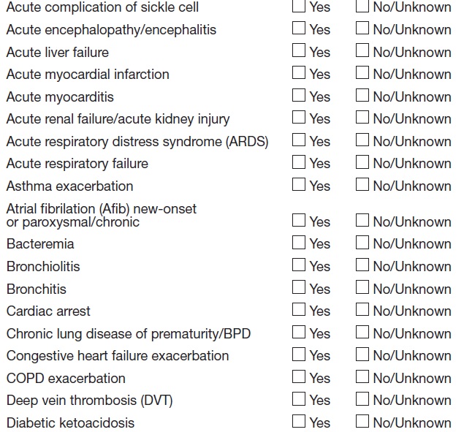  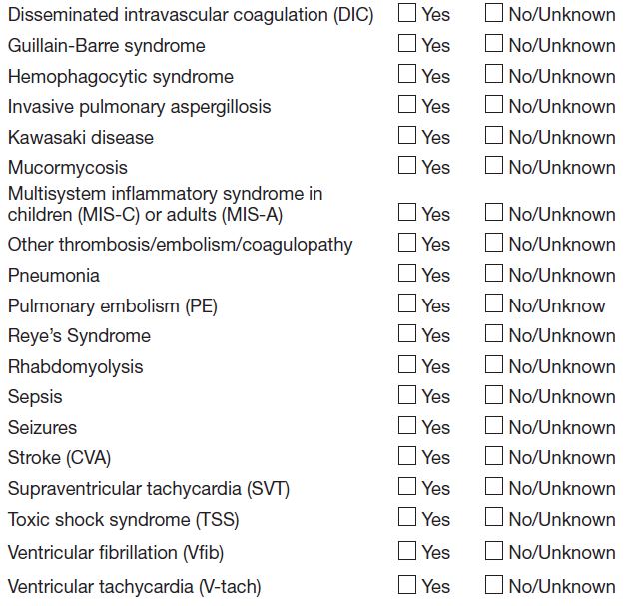 | L. Discharge Summary  - Did the patient have any of the following new diagnoses at discharge? (select all that apply)  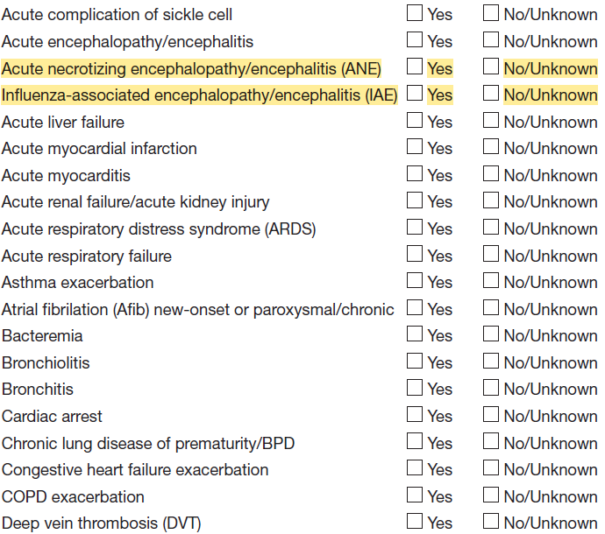  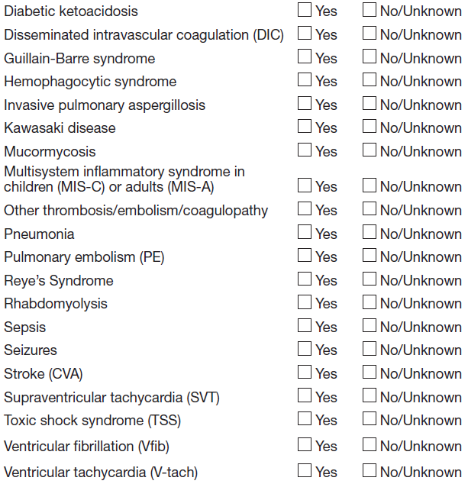
P. Additional Comments | P. Additional Comments (For site use only)

- FluSurv-NET Laboratory Survey (FSN 300.4)
Question on 2025-26 Form | Question on 2026-27 Form
Testing facility name:_______  Testing facility ID: ________  Name of person responding to questions from laboratory: _________  Title: ________________  Date: ________________ | Testing facility name:_______  Testing facility ID: ________  Name of person responding to questions from laboratory: _________  Date: ________________
3. Does the laboratory perform diagnostic testing for influenza on-site?  - Yes -> Answer question 4  - No -> Skip to question 7 | 3. Does the laboratory perform diagnostic testing for influenza on-site?  - Yes -> Answer question 4  - No -> Skip to question 8
4a. Select the kit name(s) (manufacturer) for the rapid influenza antigen diagnostic test(s) performed or planned to be used at the laboratory: (Check all that apply) 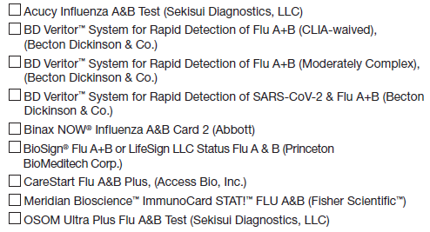  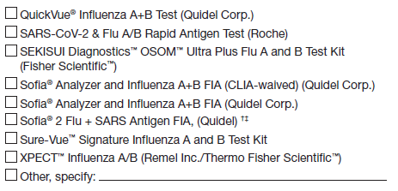 | 4a. Select the kit name(s) (manufacturer) for the rapid influenza antigen diagnostic test(s) performed or planned to be used at the laboratory: (Check all that apply)  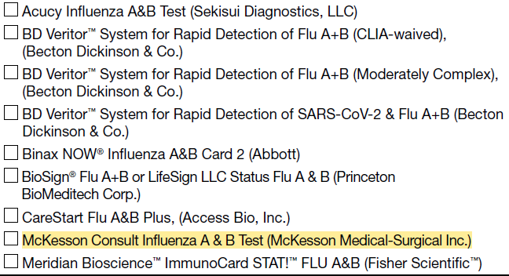  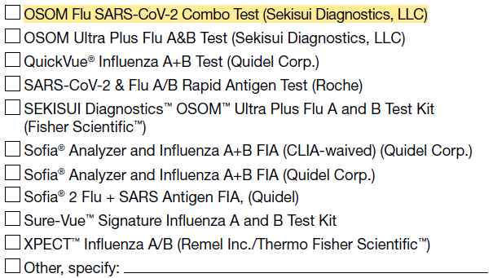
5. Does the laboratory perform molecular assays (including rapid molecular, RT-PCRs, RVPs) for influenza?  - Yes -> Answer questions 5a-5c  - No -> Skip to question 6 | 5. Does the laboratory perform molecular assays (including rapid molecular, RT-PCRs, RVPs) for influenza?  - Yes -> Answer questions 5a-5b  - No -> Skip to question 6
5a. Select kit name(s) (manufacturer) for all molecular assays performed or planned to be used at the laboratory: (Check all that apply)  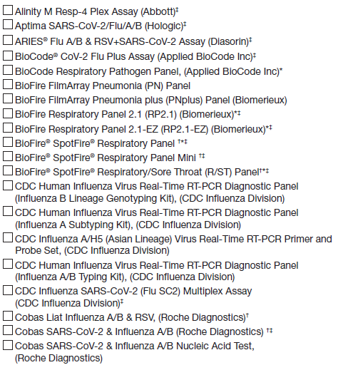  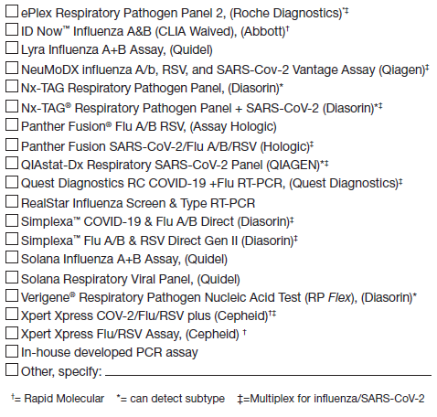 | 5a. Select kit name(s) (manufacturer) for all molecular assays performed or planned to be used at the laboratory: (Check all that apply)  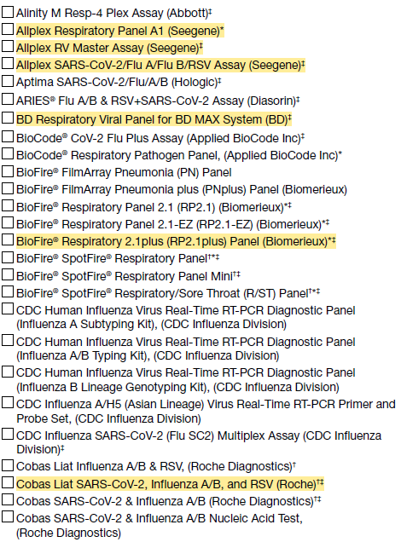  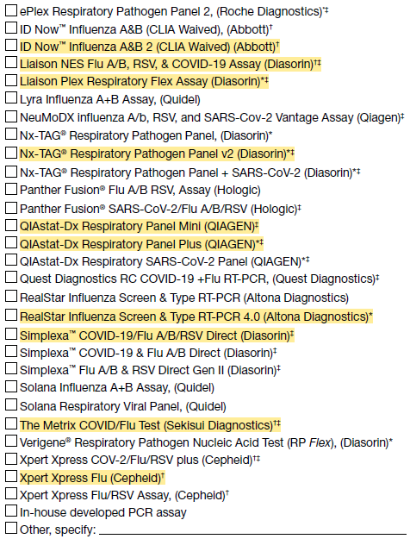
5b. If more than one kit is selected above, please select the one kit that is (or will be) used most frequently for molecular assay at the laboratory during the current influenza season: | 5b. If more than one kit is selected above, please select the one kit that is (or will be) used most frequently for molecular assay at the laboratory during the current influenza season:
5c. Does the laboratory perform influenza A subtyping? | 5b. Does the laboratory perform influenza A subtyping?
6a. Which influenza test method does the laboratory perform most frequently for hospitalized pediatric patients (aged 0-17 years)? (Select one)  - Rapid influenza antigen diagnostic test (rapid test, RIDT)  - Rapid Molecular assay – singleplex (influenza only)†  - Rapid Molecular assay – dualplex/multiplex†  - Standard Molecular assay (e.g. RT-PCR, NAAT) – singleplex (influenza only)  - Standard Molecular assay (e.g. RT-PCR, NAAT) – dualplex/multiplex/ respiratory viral panel (RVP)  - Not applicable (no pediatric testing) | 6. Of the kits selected in 4a and 5a, which influenza test kit does the laboratory perform most frequently for hospitalized and ED pediatric patients (aged 0-17 years)? (Select one)  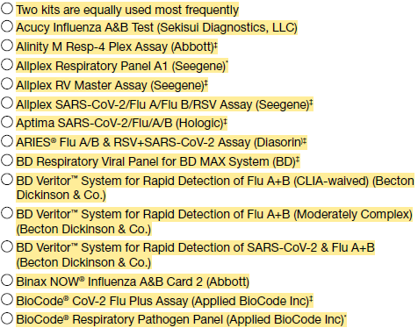  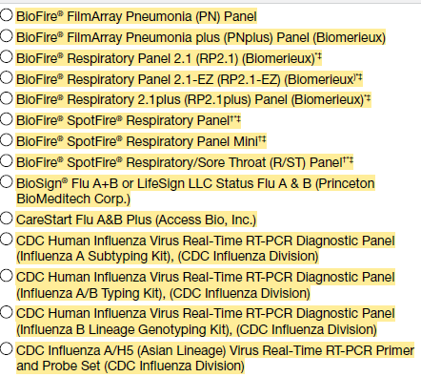  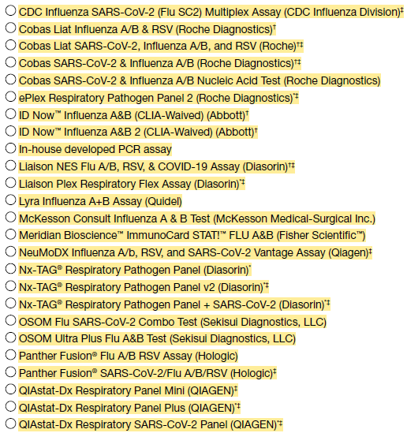  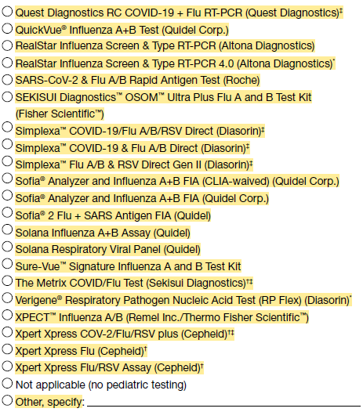  6a. If you responded to 6 that two kits are used with equal frequency for pediatric testing, please select the two kits. If not applicable, skip to question 7.  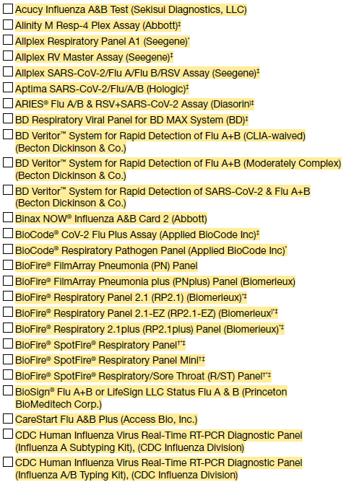  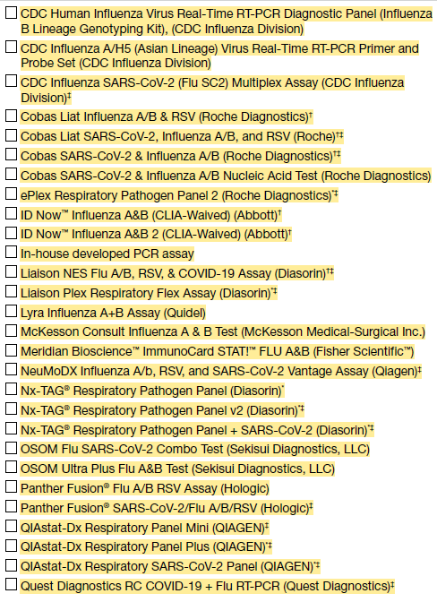  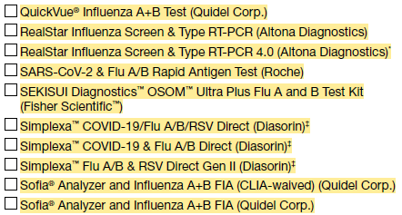  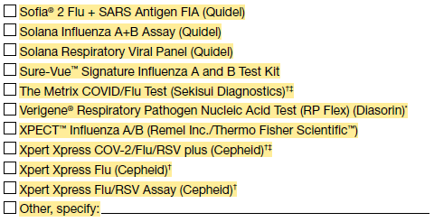
6b. Which influenza test method does the laboratory perform most frequently for hospitalized adult patients (aged ≥18 years)? (Select one)  - Rapid influenza antigen diagnostic test (rapid test, RIDT)  - Rapid Molecular assay – singleplex (influenza only)†  - Rapid Molecular assay – dualplex/multiplex†  - Standard Molecular assay (e.g. RT-PCR, NAAT) – singleplex (influenza only)  - Standard Molecular assay (e.g. RT-PCR, NAAT) – dualplex/multiplex/ respiratory viral panel (RVP)  - Not applicable (no pediatric testing) | 7. Of the kits selected in 4a and 5a, which influenza test kit does the laboratory perform most frequently for hospitalized and ED adult patients (aged ≥18 years)? (Select one)  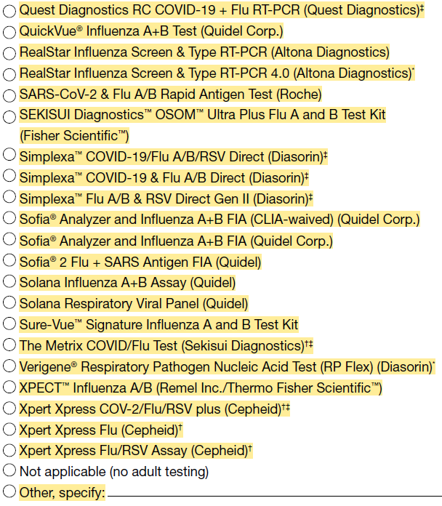  7a. If you responded to 7 that two kits are used with equal frequency for adult testing, please select the two kits. If not applicable, skip to question 8.
7. Does the lab send specimens to other labs for clinical testing of influenza?  - Yes -> Answer question 7a  - No -> Skip to question 8 | 8. Does the lab send specimens to other labs for clinical testing of influenza?  - Yes -> Answer question 8a  - No -> Skip to question 9
7a. Select all that apply: (optional)  - Commercial lab(s): List names of all labs: ____________  - Public Health lab(s): List names of all labs: ____________  - Other lab(s): List names of all labs: ____________ | 8a. Select all that apply: (optional)  - Commercial lab(s): List names of all labs: ____________  - Public Health lab(s): List names of all labs: ____________  - Other lab(s): List names of all labs: ____________
8. Laboratory Comments: | 9. Laboratory Comments:
9. List all in-catchment FluSurv-NET hospital IDs (hosp_TX) associated with this testing facility. (Do not include names – CDC receives this info) | 10. List all in-catchment FluSurv-NET hospital IDs (hosp_TX) associated with this testing facility. (Do not include names – CDC receives this info)

HAIC
HAIC.400.1 MuGSI Case Report Form- 2027 changes crosswalk
Existing question | Modified question
Title:  2026 Multi-site Gram-Negative Surveillance Initiative (MuGSI)  Healthcare-Associated Infections Community Interface (HAIC) Case Report | Title:  2027 Multi-site Gram-Negative Surveillance Initiative (MuGSI)  Healthcare-Associated Infections Community Interface (HAIC) Case Report
19. Substance Use  Other substances (check all that apply)  Opioid use disorder  Injection drug use  None documented  Unknown | 19. Substance Use  Other substances  Yes  None documented  Unknown  If yes, check all the apply:  Marijuana  Opioid use disorder  Injection drug use

HAIC.400.3 MuGSI SO Survey changes crosswalk
2025 Survey Question | 2026 Survey Question
2025 HAIC Multi-site Gram-negative Surveillance Initiative (MuGSI) Supplemental Surveillance Officer Survey | 2026 HAIC Multi-site Gram-negative Surveillance Initiative (MuGSI) Supplemental Surveillance Officer Survey
Please answer the following questions for the year 2025, unless otherwise specified. The purpose of the survey is to verify and document current surveillance procedures, including isolate collection and testing methods at clinical laboratories. Please enter your responses into the corresponding REDCap database. If you have questions, please contact Joshua Brandenburg (ode4@cdc.gov) and the MuGSI Inbox (mugsi@cdc.gov). | Please answer the following questions for the year 2026, unless otherwise specified. The purpose of the survey is to verify and document current surveillance procedures, including isolate collection and testing methods at clinical laboratories. Please enter your responses into the corresponding REDCap database. If you have questions, please contact Joshua Brandenburg (ode4@cdc.gov) and the MuGSI Inbox (mugsi@cdc.gov).
- Did any laboratories drop out of participation in 2024? _______ yes _______ no | - Did any laboratories drop out of participation in 2025? _______ yes _______ no
- 3. In 2024, did you identify additional laboratories, regardless of location, which identify MuGSI isolates from persons who are residents of the MuGSI surveillance area at your site?  _______ yes _______ no | - 3. In 2025, did you identify additional laboratories, regardless of location, which identify MuGSI isolates from persons who are residents of the MuGSI surveillance area at your site?  _______ yes _______ no
4. Did your site send any MuGSI isolates to CDC for characterization in calendar year 2024?  _______ yes _______ no | 4. Did your site send any MuGSI isolates to CDC for characterization in calendar year 2025?  _______ yes _______ no
5. How many isolates with a specimen collection date in 2024 did you expect to be able to collect from the clinical laboratories?  _______ CRE; _______ CRAB; _______ ESBL; ________iEC | 5. How many isolates with a specimen collection date in 2025 did you expect to be able to collect from the clinical laboratories?  _______ CRE; _______ CRAB; _______ ESBL; ________iEC
6. What was the total number of isolates with a specimen collection date in 2024 that were collected from the clinical laboratories?  _______ CRE; _______ CRAB; _______ ESBL; _______iEC | 6. What was the total number of isolates with a specimen collection date in 2025 that were collected from the clinical laboratories?  _______ CRE; _______ CRAB; _______ ESBL; _______iEC
Laboratory Participation and Isolate Testing – Part 2  Please complete the following information for each clinical laboratory participating in MuGSI surveillance at your site in 2024 | Laboratory Participation and Isolate Testing – Part 2  Please complete the following information for each clinical laboratory participating in MuGSI surveillance at your site in 2025
2. In 2024, did your site update its inventory of facilities within the MuGSI surveillance area? _______ yes _______ no | 2. In 2025, did your site update its inventory of facilities within the MuGSI surveillance area? _______ yes _______ no
4. Did your site geocode MuGSI cases in 2025? _____ yes ______ no | 4. Did your site geocode MuGSI cases in 2025? _____ yes ______ no
5. Did your site match MuGSI cases to the state vital statistics death registry in 2024?  _____ yes ______ no | 5. Did your site match MuGSI cases to the state vital statistics death registry in 2025?  _____ yes ______ no
6. Did your site complete CRF re-abstractions in 2024? _____ yes ______ no | 6. Did your site complete CRF re-abstractions in 2025? _____ yes ______ no

HAIC.400.4 iSA Case Report Form changes crosswalk
Question on original 2026 form | Question on 2027 form
Invasive Staphylococcus aureus Healthcare-Associated Infections Community Interface (HAIC) Case Report - 2026 | Invasive Staphylococcus aureus Healthcare-Associated Infections Community Interface (HAIC) Case Report - 2027
Q34a Did the patient have a positive test(s) for SARS-CoV-2 (molecular assay, antigen or other viral test; excluding serology) in the 90 days before or after the DISC?  □ Yes □ No □ Unknown  Specimen collection dates for positive tests in the 90 days before or day of DISC:  First positive test: __-__-____ □ Unknown  Most recent positive test: __-__-____ □ Unknown  COVID-NET CASE ID in the year before or day of the DISC:  ______________________ □ Unknown | Removed
36. Does this case have recurrent MRSA/MSSA disease?  □ Yes □ No □ Unknown  If yes, previous (1st) STATE ID: _________ | Removed

HAIC.400.5 iSA Lab Survey changes crosswalk
Question on original 2026 form | Question on 2027 form
Thank you for completing this survey. We are asking you to complete this survey because your laboratory serves the catchment area for the Emerging Infections Program’s (EIP) culture-based invasive S. aureus/MRSA surveillance program. Our aim for this survey is to understand how S. aureus/MRSA are identified from normally sterile site specimens in your lab. We also aim to understand circumstances in which identification of S. aureus/MRSA in a normally sterile site specimen may not be reported to EIP staff, potentially resulting in a missed surveillance case (e.g., if only positive cultures/isolates are reported in the line list, and a culture-independent diagnostic test is used). PLEASE NOTE THAT ALL OF THE QUESTIONS APPLY TO TESTING OF SPECIMENS FROM NORMALLY STERILE SITES (e.g., blood, CSF, bone, peritoneal fluid, etc.). (Do NOT include testing procedures for non-sterile site colonization, such as nasal or rectal swabs.) | Thank you for completing this survey. We are asking you to complete this survey because your laboratory serves the catchment area for the Emerging Infections Program’s (EIP) culture-based S. aureus/MRSA bacteremia surveillance program. Our aim for this survey is to understand how S. aureus/MRSA are identified from blood specimens in your lab. We also aim to understand circumstances in which identification of S. aureus/MRSA in a blood specimen may not be reported to EIP staff, potentially resulting in a missed surveillance case (e.g., if only positive cultures/isolates are reported in the line list, and a culture-independent diagnostic test is used). PLEASE NOTE THAT ALL OF THE QUESTIONS APPLY TO TESTING OF BLOOD SPECIMENS.
3. Do you routinely set up culture for sterile site (blood, CSF, bone, etc.) specimens on site (in-house) at your laboratory? | 3. Do you routinely set up blood cultures on site (in-house) at your laboratory?
Question 4 asks about methods for identifying S. aureus or MRSA from a positive sterile site (blood, CSF, bone, etc.) culture. | [deleted]
4. If a culture is positive, is an isolate always obtained? | 4. If a blood culture is positive for S. aureus, is an isolate always obtained?
4b. Are any tests used to identify S. aureus performed offsite? | 4b. Are any tests used to identify S. aureus from a positive blood culture performed offsite?
4c. If a culture is positive, how do you identify it as S. aureus? (Check all that apply) | 4c. If a blood culture is positive, how do you identify it as S. aureus? (Check all that apply)
4d. Which molecular tests are used? Please check all that apply. | 4d. Which molecular tests are used to identify S. aureus from a positive blood culture? Please check all that apply.
4e. Do you anticipate any changes to testing/identification processes for S. aureus or MRSA from a positive sterile source culture within the next year? | 4e. Do you anticipate any changes to testing/identification processes for S. aureus or MRSA from a positive blood culture within the next year?
Question 5 asks about testing performed directly on sterile site specimens (a positive culture is not required to perform these tests).  5. Do you routinely run any tests on site (in-house) or at another lab that detect S. aureus directly from a normally sterile site specimen (e.g., blood, CSF) without a culture (i.e., culture independent diagnostic test)?  □ Yes – GO TO Q5a □ No - GO TO Q5e | Question 5 asks about testing performed directly on blood specimens (a positive culture is not required to perform these tests).  5. Do you routinely run any tests on site (in-house) or at another lab that detect S. aureus directly from a blood specimen without a culture (i.e., culture independent diagnostic test)?  □ Yes – GO TO Q5a □ No - GO TO Q5g
5. Do you routinely run any tests on site (in-house) or at another lab that detect S. aureus directly from a normally sterile site specimen (e.g., blood, CSF) without a culture (i.e., culture independent diagnostic test)?  □ Yes – GO TO Q5a □ No - GO TO Q5e  5a. [If yes] Which tests are used to detect S. aureus directly from a normally sterile site specimen without culture (sterile site sources only, i.e. blood, CSF, pleural fluid, bone, etc.)? Please check all that apply.  □ T2Bacteria® Panel…Date started__________  □ Other FDA-approved test, Specify_______...Date started__________  Method: □ PCR □ Next generation sequencing (NGS) □ Other, specify: __________  □ Karius TestTM…Date started__________  □ Other, Lab Developed Test (detects MRSA or SA)… Date started ____________________  Method: □ PCR □ Next generation sequencing (NGS) □ Other, specify: __________  5b. [If yes] Where is this testing completed?  □ On-site □ Send out, please specify lab __________________  5c. Do you still obtain an isolate for S. aureus or MRSA if these tests are used?  □ Yes □ No □ Other, specify: ___________  5d. Do positive culture-independent diagnostic tests directly from normally sterile specimens appear in the S. aureus surveillance laboratory line lists (even if no positive associated culture)?  □ Yes □ No | 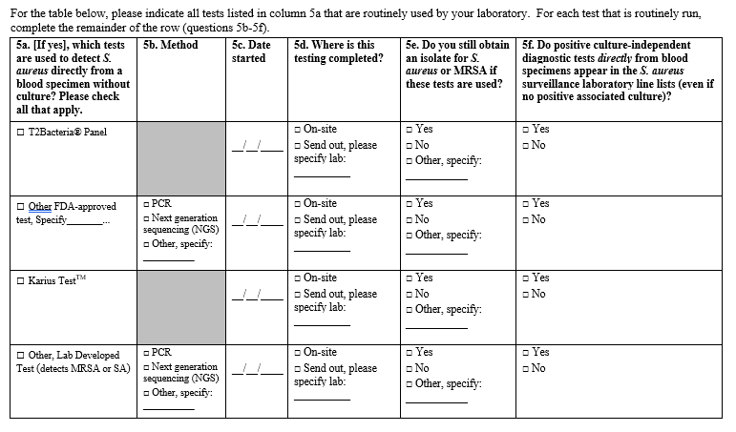
5e. Do you plan to start offering any new tests that you are not currently using for detection of S. aureus or MRSA directly from a sterile source within the next year?  □ Yes – GO TO Q5f □ No – END SURVEY | 5g. Do you plan to start offering any new tests that you are not currently using for detection of S. aureus or MRSA directly from blood within the next year?  □ Yes – GO TO Q5h □ No – END SURVEY
5f. If yes, which tests do you plan to use to detect S. aureus directly from a sterile site source without culture? (sterile site sources only, i.e. blood, CSF, pleural fluid, bone, etc.)? Please check all that apply.  □ T2Bacteria® Panel  □ Other FDA-approved test, Specify_______  □ Karius TestTM  □ Other, Lab Developed Test (detects MRSA or SA)  5g. When do you plan to start offering these tests? Month/Year: ____/____  5h. Where do you plan to have these tests performed?  □ On-site □ Send out, please specify lab __________________  5i. Will all positive tests directly from sterile sources (without positive culture) appear in the S. aureus surveillance laboratory line lists?  □ Yes □ No □ Unknown  5j. Will you still obtain an isolate for S. aureus or MRSA if these tests are used?  □ Yes – END SURVEY □ No – END SURVEY  □ Unknown – END SURVEY | 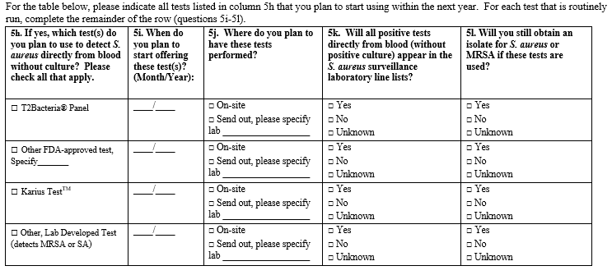

HAIC.400.7 CDI Case Report Form crosswalk
Existing question | Modified question
23a. Smoking  Tobacco  E-Nicotine delivery system  Marijuana  None documented  Unknown | 23a. Smoking  Tobacco  E-Nicotine delivery system  None documented  Unknown
23c. Other substances (check all that apply)  Opioid use disorder  Injection drug use  None documented  Unknown | 23c. Other substances  Yes  If yes, check all the apply:  Marijuana  Opioid use disorder  Injection drug use  None documented  Unknown

HAIC.400.8 Annual Survey of Laboratory Testing Practices for C. difficile Infections crosswalk
Existing question | Modified question
Was this a new laboratory in 2025? | Was this a new laboratory in 2026?
Did this lab participate in surveillance in 2025? | Did this lab participate in surveillance in 2026?
How often did you receive line lists from this lab in 2025? | How often did you receive line lists from this lab in 2026?
How did you receive line lists from this lab in 2025? | How did you receive line lists from this lab in 2026?
Did you receive specimens from this lab in 2025? | Did you receive specimens from this lab in 2026?
Was this lab audited in 2025? | Was this lab audited in 2026?
Types of facilities in your catchment area served by this lab in 2025 | Types of facilities in your catchment area served by this lab in 2026
Did your laboratory ever send specimens off-site for Clostridioides difficile testing in 2025? | Did your laboratory ever send specimens off-site for Clostridioides difficile testing in 2026?
2a. Which testing method(s) for Clostridioides difficile (C. difficile) did your laboratory perform in 2025? | 2a. Which testing method(s) for Clostridioides difficile (C. difficile) did your laboratory perform in 2026?
Did your laboratory use this testing method for Clostridioides difficile (C. difficile) in 2025? | Did your laboratory use this testing method for Clostridioides difficile (C. difficile) in 2026?
Did you use this testing method in this way for all of 2025? | Did you use this testing method in this way for all of 2026?
3a. Which EIA test kit was used by your laboratory in 2025? | 3a. Which EIA test kit was used by your laboratory in 2026?
3b. Which Nucleic Acid Amplification test was used by your laboratory in 2025? | 3b. Which Nucleic Acid Amplification test was used by your laboratory in 2026?
4a. If your laboratory used a multiplexed molecular diagnostic (e.g., Biofire Filmarray GI Panel, Luminex xTAG GPP) to test for several GI pathogens in 2025, did your laboratory suppress the C. difficile result so that clinicians could not see it? | 4a. If your laboratory used a multiplexed molecular diagnostic (e.g., Biofire Filmarray GI Panel, Luminex xTAG GPP) to test for several GI pathogens in 2026, did your laboratory suppress the C. difficile result so that clinicians could not see it?
4b. If your laboratory used a multiplexed diagnostic in 2025 and the result was suppressed, where does the suppression occur? | 4b. If your laboratory used a multiplexed diagnostic in 2026 and the result was suppressed, where does the suppression occur?
5a. If your laboratory used a nucleic acid amplification test (NAAT) (e.g., Cepheid Xpert C. difficile) as first line testing followed by a toxin EIA test (whenever NAAT result is positive) in 2025, did your laboratory suppress the positive NAAT result so that clinicians could not see it? | 5a. If your laboratory used a nucleic acid amplification test (NAAT) (e.g., Cepheid Xpert C. difficile) as first line testing followed by a toxin EIA test (whenever NAAT result is positive) in 2026, did your laboratory suppress the positive NAAT result so that clinicians could not see it?
5b. If your laboratory used NAAT as first line testing followed by confirmatory toxin EIA testing in 2025, and both the NAAT and toxin EIA results were released to the clinician, did your laboratory provide any comments to help the clinician interpret the test results (e.g., NAAT-positive only result might represent colonization, etc.)? | 5b. If your laboratory used NAAT as first line testing followed by confirmatory toxin EIA testing in 2026, and both the NAAT and toxin EIA results were released to the clinician, did your laboratory provide any comments to help the clinician interpret the test results (e.g., NAAT-positive only result might represent colonization, etc.)?
6. What are the LOINC or internal testing codes associated with the tests your lab used in 2025 (e.g. LOINC codes 13957-6, 34713-8, or 54067-4)? | 6. What are the LOINC or internal testing codes associated with the tests your lab used in 2026 (e.g. LOINC codes 13957-6, 34713-8, or 54067-4)?
7. Did your lab have a policy to reject stool specimens for C. difficile testing in 2025? | 7. Did your lab have a policy to reject stool specimens for C. difficile testing in 2026?
7a. Did your rejection policy for stool specimens change between January 1, 2025 and December 31, 2025? | 7a. Did your rejection policy for stool specimens change between January 1, 2026 and December 31, 2026?
8. How many stool samples did you test for C. difficile each month in 2025? | 8. How many stool samples did you test for C. difficile each month in 2026?

HAIC.400.9 CDI Annual Surveillance Officers Survey changes crosswalk
Existing question | Modified question
2. In 2025, did any laboratories drop out of participation? | 2. In 2026, did any laboratories drop out of participation?
3. In 2025, did you identify any additional laboratories inside or outside of your catchment area which identify C.diff assays from persons who are residents of your catchment area? | 3. In 2026, did you identify any additional laboratories inside or outside of your catchment area which identify C.diff assays from persons who are residents of your catchment area?
10. Did your site complete a physician/outpatient provider survey in 2025? | 10. Did your site complete a physician/outpatient provider survey in 2026?
13. For each facility that treated a case in 2025, please provide the following | 13. For each facility that treated a case in 2026, please provide the following

