Explanation for Program Changes or Adjustments
There are 11 total forms being changed as a part of this non substantive change request. This change request includes minor revised language, formatting and re-wording to improve clarity and readability of the data collection forms.
In response to the Notice of Decision published in the Federal Register on March 29, 2024 regarding the update of the Statistical Policy Directive No. 15: Standards for Maintaining, Collecting, and Presenting Federal Data on Race and Ethnicity (SPD 15), the EIP programs (ABCs, FoodNet, FluSurv-NET, and HAIC) under OMB 0920-0978 will comply with the updated standards set for Federal data on Race and Ethnicity by and/or before the March 2029 deadline.
FluSurv-NET has incorporated the updated race and ethnicity (R/E) data standards in their data collection forms as part of a recently approved Revision. The remaining 3 EIP programs (ABCs, FoodNET, and HAIC) will update the R/E variable in a subsequent non-substantive by and/or before the March 2029 deadline in efforts to maintain data integrity. Maintaining data integrity and consistency is paramount to quality data analysis therefore, waiting to incorporate the race and ethnicity changes for ABCs, FoodNET and HAIC would ensure that the race ethnicity data variable will possess consistent parameters and easier for analysis. Within this change request a few of the data collection tools have updated the R/E variable. The remaining data collection tools will be ultimately updated before the March 2029 deadline.
Details of each collection instrument are as follows:

ABCs:
This non-substantive change request includes minor proposed changes to 2 approved data collection tools (form/s) detailed below:

Approved Forms:
1) ABCs Case Report Form (ABC.100.1)
2) ABCs Neonatal Infection Expanded Tracking Form (ABC.100.5)

ABCs Case Report Form (ABC.100.1)
Type of Change | Itemized Changes / Justification | Impact to Burden
Revision | 2026 Active Bacterial Core surveillance (ABCs) Case Report  Justification: Updated header to reflect surveillance year | No change to burden
Revision | T1 – Test Type  1=Nucleic acid amplification test (NAAT)  2=Culture  7=Other (specify)  9=Unknown  Justification: The label for the T1 test-type category has been updated from 1=PCR to 1=NAAT to more accurately reflect the data captured under this category. This change improves data accuracy, reduces misclassification, and aligns the CRF with current diagnostic practices across ABCs laboratories. In addition, the label for 7=Other has been revised to 7=Other (specify) to clearly indicate that additional details should be provided when this option is selected. | No change to burden
Revision | T3 – Test Method  1=Biofire Filmarray Meningitis/Encephalitis Panel  2=Other (Specify)  3=Biofire Filmarray Blood Culture (BCID) Panel  4=Verigene Gram + Blood Culture (BCT) Test  5=Bruker MALDI Biotyper CA System 9=Unknown  10=Biofire Joint Infection (JI) Panel  11=Roche cobas eplex BCID Panel  12=Karius  13=16s rRNA sequencing  14=Delve Bio mNGS  Justification: The test-method value set was expanded to incorporate additional diagnostics increasingly used across ABCs sites but not previously captured in a systematic manner. These additions allow for more complete and accurate reporting of CIDT methods that have emerged. In addition, an option to specify the test when “Other” is selected was added to ensure that novel, uncommon, or evolving diagnostic methods can be consistently documented. This change improves data quality by reducing reliance on freetext comments and better supports ongoing efforts to track new testing technologies and trends across sites. | No change to burden
Deletion | Q27d. Other Substances:  Documented Use Disorder (DUD/Abuse)  Justification: The checkbox for indicating documented use disorder or abuse for other substances such as marijuana, opioids, cocaine, and methamphetamine is being removed as it has contributed little analytic value while adding abstraction burden. Removing this field simplifies data collection and ensures that substance use information focuses on variables that are reliably captured and directly used in analysis. | No change to burden
Deletion | Q27d. Other Substances:  Mode of delivery: Skin popping  Justification: “Skin popping” is being removed as a standalone response option because it represents a specific form of injection drug use (IDU), and distinguishing it separately has not been necessary for ABCs analyses. | No change to burden
ABCs Neonatal Infection Expanded Tracking Form (ABC.100.5)
Type of Change | Itemized Change / Justification | Impact to Burden
Revision | Q9b. IF YES, were any of the following ICD-10 codes reported in the discharge diagnosis of the chart? (Check all that apply)  ​​☐​ A40.1: Sepsis due to streptococcus, group B  ​☐​ A40.8: Other Streptococcal sepsis  ​☐​ A40.9: Streptococcus sepsis, unspecified  ​☐​ A49.1: Streptococcal infection, unspecified site  ​☐​ B95.1: Streptococcus, group b as the cause of disease classified elsewhere  ​☐​ B95.5: Unspecified streptococcus as the cause of disease classified elsewhere  ​☐​ G00.2: Streptococcal meningitis  ​☐​ J15.3: Pneumonia due to streptococcus, group B  ​☐​ P00.82: Newborn affected by (positive) maternal group B streptococcus (GBS) colonization  ​☐​ P23.3: Congenital pneumonia due to streptococcus, group B  ​☐​ P36: Bacterial sepsis of newborn  ​☐​ P36.0: Sepsis of newborn to due to streptococcus, group B  ​☐​ P36.1: Sepsis of newborn to other unspecified streptococci  ​☐​ P36.9: Bacterial sepsis of newborn, unspecified  Justification: To ensure more complete and accurate identification of Group G Streptococcus (GBS)–related hospitalizations, we added three additional ICD10 codes (J15.3, P00.82, P23.3) to the existing discharge diagnosis question. These additional codes helps ensure that all GBS-related discharge diagnoses that may appear in the medical record are captured. This change does not increase burden for surveillance staff. Sites are already reviewing discharge diagnoses during chart abstraction, and the expanded list simply clarifies which codes should be recorded when present. | No change to burden
FluSurv-NET
This non-substantive change request includes minor proposed changes to 2 approved data collection tools (form/s) detailed below:

Approved Forms:
- FSN 300.1 2024-25 Influenza Hospitalization Surveillance Network (FluSurv-NET) Case Report Form
- FSN 300.4 2024-25 Influenza Hospitalization Surveillance Network (FluSurv-NET) Lab Survey
Influenza Hospitalization Surveillance Network (FluSurv-NET) Case Report Form (FSN 300.1)
Type of Change | Itemized Changes / Justification | Impact to Burden
Non-substantive change (clarification) | C. Enrollment Information  1. Case Classification:  - Surveillance Discharge Audit  - Observation Only  Justification  - Clarifying the type of case by adding the observation status to the case report form could better characterize the severity of influenza-associated hospitalizations. This field of “Observation Only” was collected in previous seasons. | No change to burden
Non-substantive change (simplification) | C. Enrollment Information  11. Pregnant (15-49 years of age)?  - Yes  - No  - Not applicable (male/pregnant outside of applicable age range)  Justification  - Branching logic could be applied to streamline this question in the database, so that this option “Not applicable (male/pregnant outside of applicable age range” could be removed. | No change to burden
Non-substantive change (clarification) | D. Influenza Testing Results  Test Results 1-4:  - Flu A (no subtype)  - 2009 H1N1  - H1, Unspecified  - H1, Seasonal  - H1  - H3  - H5  - Flu A, Unsubtypable  - Flu B (no lineage)  - Flu B, Victoria  - Flu B, Yamagata  - Flu A & B  - Flu A/B (not distinguished)  - Unknown Type  - Negative  - H3N2v  - Other, please specify  Justification  - Checkboxes “H1, Unspecified” and “H1, Seasonal” were removed because they are rarely applicable and are confusing terms for data collection. Added “H5” reflects what can be identified in current laboratory results. | No change to burden
Non-substantive change (clarification) | F. Outcome  2. If patient discharged alive, please indicate to where:  - Private residence  - Private residence with services  - Homeless/Shelter/Temporary housing  - Nursing home/Skilled nursing facility  - Substance abuse treatment center  - Rehabilitation facility  - Corrections facility  - Hospice  - Assisted living/Residential care  - LTACH  - Group/Retirement home  - Psychiatric/Behavioral Health Facility  - Other long term care facility  - Against medical advice (AMA)/Elopement  - Discharged to another hospital  - Other, specify  - Unknown  Justification  - Including “elopement” as a clarification to the existing “against medical advice (AMA)” option reflects common language used for this discharge scenario in medical records. | No change to burden
Non-substantive change (clarification) | G. Admission and Patient History  3. Date of onset of fever or acute respiratory symptoms (within 2 weeks before a positive test), whichever is earlier: __/__/____  - Approximate date entered  - Unknown  - Not applicable  Justification  - Fever was the most common non-respiratory symptom recorded among influenza-associated hospitalizations. Additionally, pediatric influenza-associated hospitalizations often present with fever first or may lack other respiratory symptoms. Thus, clarifying the date of onset of acute respiratory symptoms to include fever is anticipated to more accurately capture symptom onset date related to an acute influenza illness, particularly for children.  - Clarified whether the date of fever or acute respiratory symptom onset reflects an exact or approximate date to increase capture of symptom onset dates and also allow refinement to those with an exact symptom onset date for relevant data analyses, including the impact of timely antiviral treatment. | No change to burden
Non-substantive change (clarification) | H. Underlying Medical Conditions  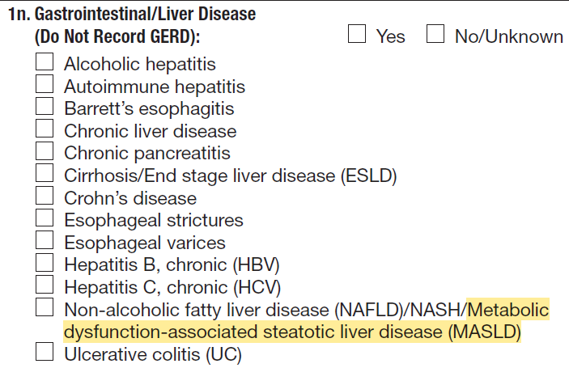  Justification  - Clarifying underlying medical condition terminology of NAFLD/NASH to include metabolic dysfunction-associated steatotic liver disease (MASLD) updates the current medical terminology for the condition. | No change to burden
Non-substantive change (clarification) | H. Underlying Medical Conditions  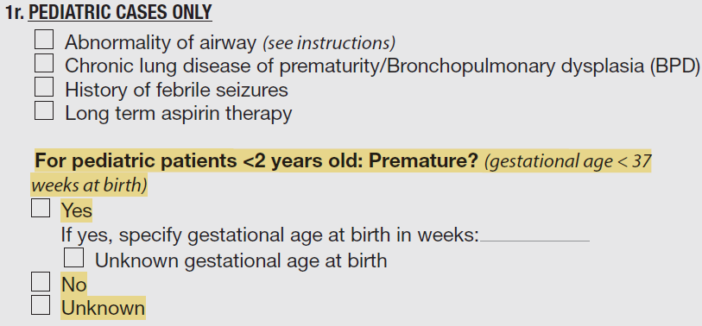  Justification  - Clarifies question language to minimize confusion. Adding “No” and “Unknown” allows for complete capture of all possible answers. | No change to burden
Non-substantive change (clarification) | I. Viral Pathogens  1. Was the patient tested for any of the following viral respiratory pathogens within 14 days prior to admission or ≤ 3 days after admission?  1a. RSV  1b. Coronavirus SARS-CoV-2  1c. Adenovirus  1d. Parainfluenza 1  1e. Parainfluenza 2  1f. Parainfluenza 3  1g. Parainfluenza 4  1h. Parainfluenza (not further specified)  1i. Human metapneumovirus  1j. Rhinovirus/Enterovirus  1k. Coronavirus 229E  1l. Coronavirus HKU1  1m. Coronavirus NL63  1n. Coronavirus OC43  1o. Coronavirus (not further specified)  Justification  - Clarifies available options for hospital lab diagnostic test results. | No change to burden
Non-substantive change (clarification) | L. Discharge Summary  - Did the patient have any of the following new diagnoses at discharge? (select all that apply)  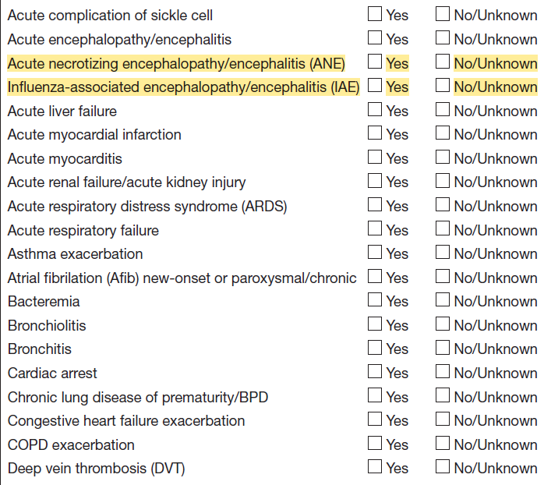  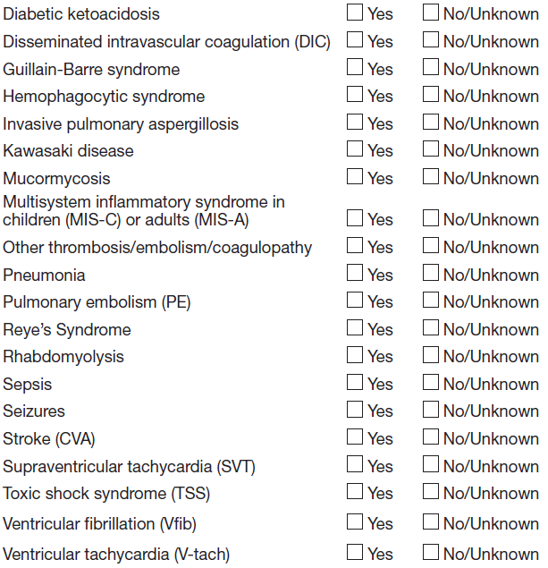  Justification  - Adding acute necrotizing encephalopathy/encephalitis (ANE) and acute influenza-associated encephalopathy/encephalitis (IAE) clarifies more specific types of acute encephalopathy/encephalitis could be identified, though these types of encephalopathy/encephalitis have been rare. Due to recent increased attention and awareness of these rare influenza-associated complications in children hospitalized with influenza, monitoring the occurrences of these complications is a priority for our program. | No change to burden
Non-substantive change (clarification) | P. Additional Comments (For site use only)  Justification  - “Additional Comments” field has been established as site-use only for multiple seasons. Updating field to state “for site use only” would clarify the purpose of the field. | No change to burden

Influenza Hospitalization Surveillance Network (FluSurv-NET) Lab Survey (FSN 300.4)
Type of Change | Itemized Changes / Justification | Impact to Burden
Non-substantive change (simplification) | Testing facility name:_______  Testing facility ID: ________  Name of person responding to questions from laboratory: _________  Title:_______________  Date: ________________  Justification  - The “Title” field is redundant with later form question asking the role of the person completing the survey. Removing the field removes redundancy. | Reduction in burden
Non-substantive change (correction) | 3. Does the laboratory perform diagnostic testing for influenza on-site?  - Yes -> Answer question 4  - No -> Skip to question 8  Justification:  - Correction of the skip logic due to the renumbering of later questions in the survey. This is needed to ensure accuracy of the question numbering of the survey. | No change to burden
Non-substantive change (clarification) | 4a. Select the kit name(s) (manufacturer) for the rapid influenza antigen diagnostic test(s) performed or planned to be used at the laboratory:  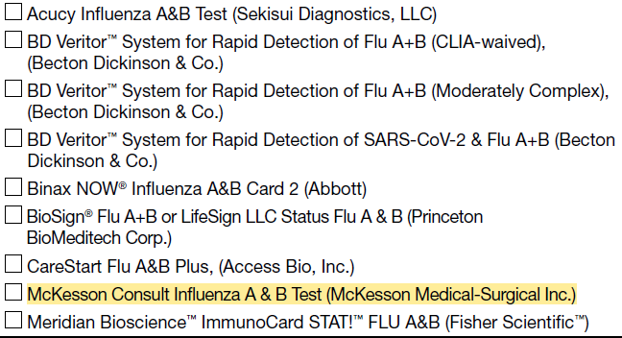  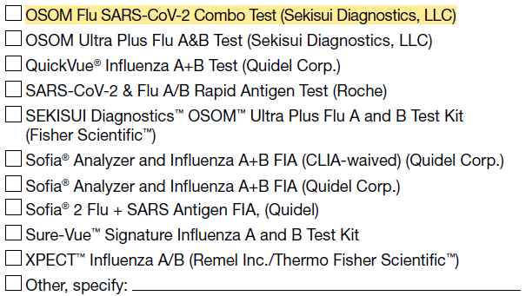  Justification  - Updating checkboxes to reflect new kit names eliminates the need to complete write-in field and lessens burden on surveillance officers and lab staff completing the survey. | No change to burden
Non-substantive change (correction) | 5. Does the laboratory perform molecular assays (including rapid molecular, RT-PCR, RVPs) for influenza?  - Yes -> Answer questions 5a-5b  - No -> Skip to question 6  Justification  - Correction of the skip logic due to the removal of question 5b (listed later in the explanation of changes). This is needed to ensure accuracy of which questions to complete. | No change to burden
Non-substantive change (clarification) | 5a. Select the kit name(s) (manufacturer) for all molecular assays performed or planned to be used at the laboratory:  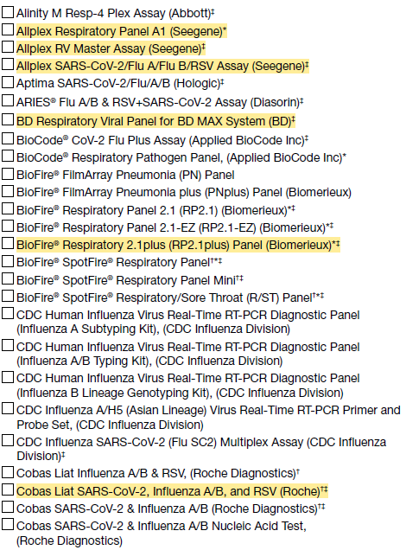  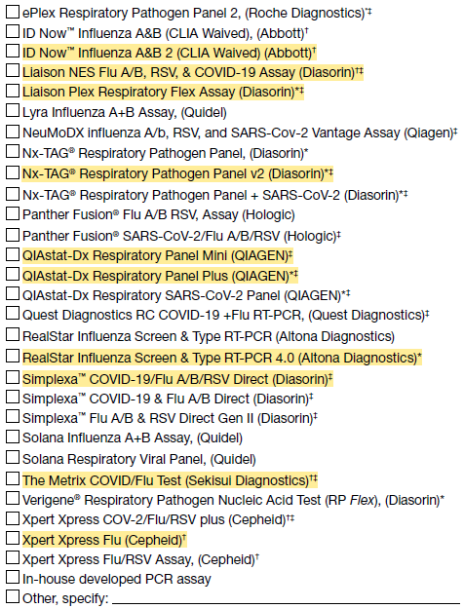  Justification  - Updating checkboxes to reflect new kit names eliminates the need to complete write-in field and lessens burden on surveillance officers and lab staff completing the survey. | No change to burden
Non-substantive change (simplification) | 5b. If more than one kit is selected above, please select the one kit that is (or will be) used most frequently for molecular assay at the laboratory during the current influenza season  Justification  - The relevant information is more appropriately collected through existing questions, so this question can be removed from the form. | Reduction in burden
Non-substantive change (correction) | 5b. Does the laboratory perform influenza A subtyping?  Justification:  - Correction of the question number due to the removal of the original 5b question. This is needed to ensure accuracy of the question numbering of the survey. | No change to burden
Non-substantive change (clarification) | 6. Of the kits selected in 4a and 5a, which influenza test kit does the laboratory perform most frequently for hospitalized and ED pediatric patients (aged 0-17 years)? (Select one)  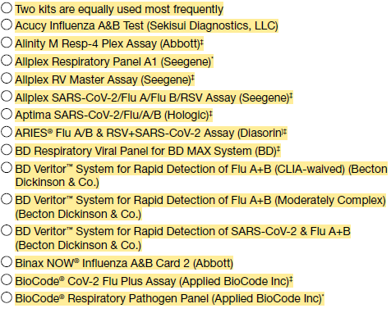  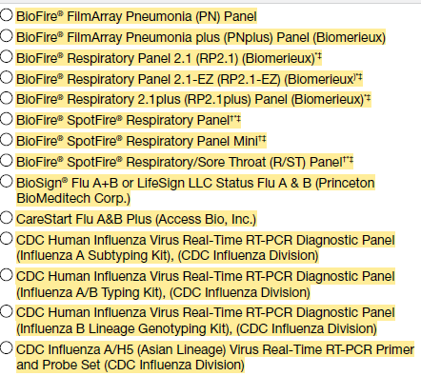  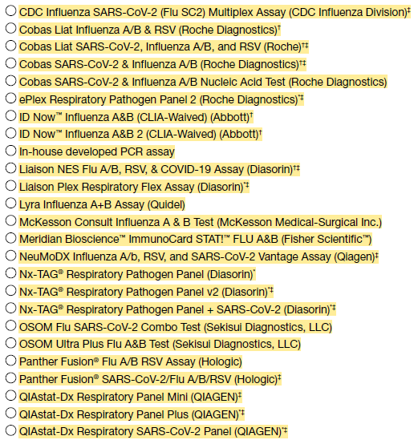  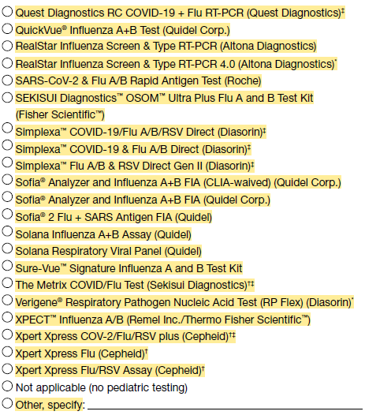  Justification  - Clarifies which kits and patient group should be referred to for answering the question. Updating the answer choices to the list of kits eliminates burden of survey respondents classifying the kit by type and number of targets. | Reduction in burden
Non-substantive change (clarification) | 6a. If you responded to 6 that two kits are used with equal frequency for pediatric testing, please select the two kits. If not applicable, skip to question 7.  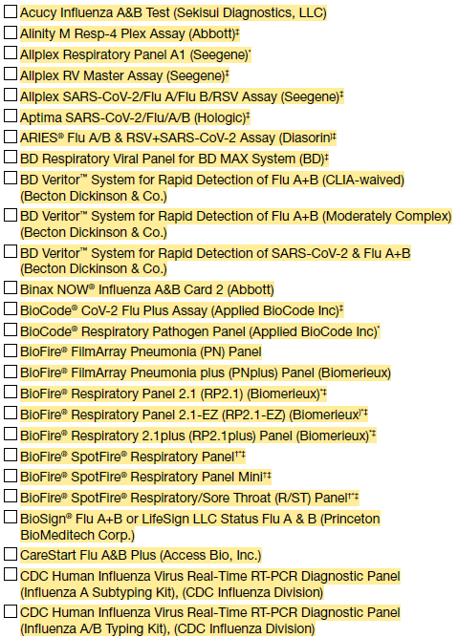  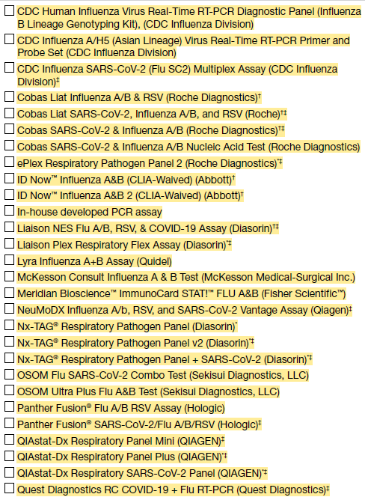  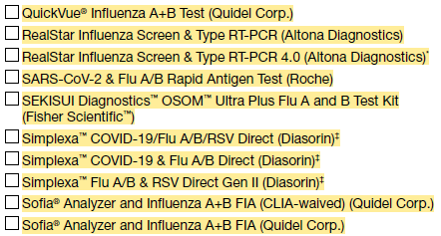  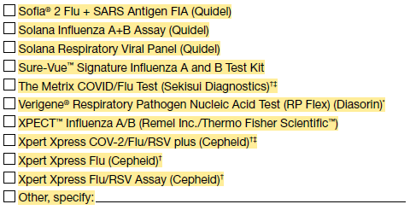  Justification  - Clarifies which two kits are used most frequently only for labs that use two kits equally for pediatric testing. | No change to burden
Non-substantive change (clarification) | 7. Of the kits selected in 4a and 5a, which influenza test kit does the laboratory perform most frequently for hospitalized and ED adult patients (aged ≥18 years)? (Select one)  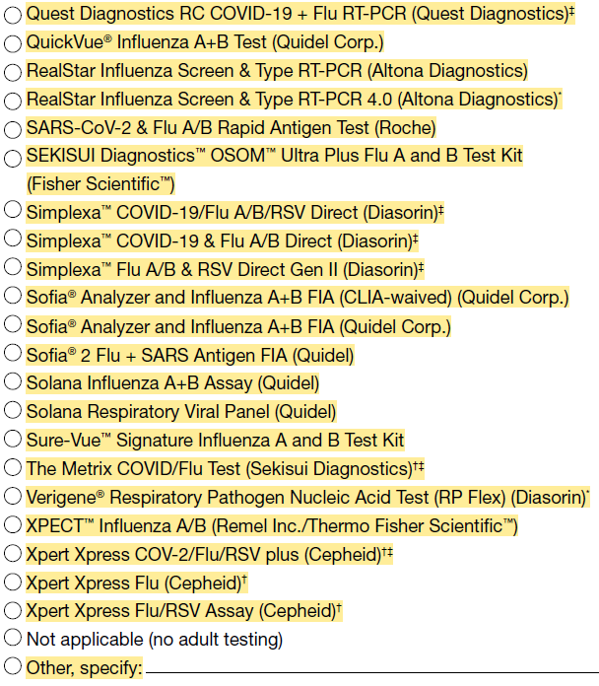  Justification  - Clarifies which kits and patient group should be referred to for answering the question. Updating the answer choices to the list of kits eliminates burden of survey respondents classifying the kit by type and number of targets. | Reduction in burden
Non-substantive change (clarification) | 7a. If you responded to 7 that two kits are used with equal frequency for adult testing, please select the two kits. If not applicable, skip to question 8.  Justification  - Clarifies which two kits are used most frequently only for labs who use two kits equally for adult testing. | No change to burden
Non-substantive change (correction) | 8. Does the lab send specimens to other labs for clinical testing of influenza? (optional)  - Yes -> Answer question 8a  - No -> Skip to question 9  Justification  - Correction of the question number and skip logic due to the renumbering of previous questions and addition of a question above. This is needed to ensure accuracy of the question numbering of the survey. | No change to burden
Non-substantive change (correction) | 8a. Select all that apply (optional)  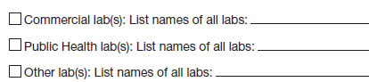  Justification:  - Correction of the question number due to the renumbering of previous questions. This is needed to ensure accuracy of the question numbering of the survey. | No change to burden
Non-substantive change (correction) | 9. Laboratory Comments:  Justification:  - Correction of the question number due to the renumbering of previous questions. This is needed to ensure accuracy of the question numbering of the survey. | No change to burden
Non-substantive change (correction) | 10. List all in-catchment FluSurv-NET hospital IDs (hosp_TX) associated with this testing facility. (Do not include names – CDC receives this info)  Justification:  - Correction of the question number due to the renumbering of previous questions. This is needed to ensure accuracy of the question numbering of the survey. | No change to burden

HAIC
This non-substantive change request includes minor proposed changes to 7 approved data collection tools (form/s) detailed below:

Approved Forms:
1) HAIC.400.1 Multi-Site Gram-Negative Surveillance Initiative (MuGSI) Case Report Form
2) HAIC.400.3 HAIC MuGSI Supplemental Surveillance Officer Survey
3) HAIC.400.4 Invasive Staphylococcus aureus Healthcare-Associated Infections Community Interface (HAIC) Case Report - 2027
4) HAIC.400.5 Healthcare-Associated Infections Community Interface (HAIC) Staphylococcus aureus Laboratory Survey
5) HAIC 400.7 CDI Case Report Form - 2027
6) HAIC.400.8 Annual Survey of Laboratory Testing Practices for C. difficile Infections
7) HAIC.400.9 CDI Annual Surveillance Officers Survey

HAIC.400.1 Multi-site Gram-Negative Surveillance Initiative (MuGSI) Case Report Form (CRF)
Type of Change | Itemized Changes / Justification | Impact to Burden
Administrative | 2027 Multi-site Gram-Negative Surveillance Initiative (MuGSI) Healthcare-Associated Infections Community Interface (HAIC)  Case Report From  Changes:  - Updated year to 2027  Justification: Updated to reflect the surveillance year. | None
Administrative/Language Modification & Addition of Response Option | Question 19. Substance Use:  Changes:  - Relocated the “Smoking” response option “Marijuana” to the “Other Substances” category  - Added “Yes” as a response option under “Other Substances” to clearly delineate when there is documented use of an “Other Substance”  Justification: The previous iteration of this question was ambiguous and caused confusion for respondents. This change adds no burden, and instead, clarifies the intended data capture. | None
HAIC.400.3 MuGSI Supplemental Surveillance Officer Survey
Type of Change | Itemized Change / Justification | Impact to Burden
Administrative | 2026 HAIC Multi-site Gram-negative Surveillance Initiative (MuGSI) Supplemental Surveillance Officer Survey  Changes:  - Updated year to 2026  Justification: Updated to reflect the correct years in question | None
Administrative | Please answer the following questions for the year 2026, unless otherwise specified. The purpose of the survey is to verify and document current surveillance procedures, including isolate collection and testing methods at clinical laboratories. Please enter your responses into the corresponding REDCap database. If you have questions, please contact Joshua Brandenburg (ode4@cdc.gov) and the MuGSI Inbox (mugsi@cdc.gov).  Changes:  - Update year to 2026  - Removed staff whom left; replaced with a functional email inbox  Justification: Previous contact no longer supports the program | None
Administrative | Laboratory Participation and Isolate Testing – Part 1  Question 2: Did any laboratories drop out of participation in 2025?  Changes:  - Updated the year from 2024 to 2025  Justification: Specifying the timeframe relative to the question | None
Administrative | Laboratory Participation and Isolate Testing – Part 1  Question 3: In 2025, did you identify additional laboratories, regardless of location, which identify MuGSI isolates from persons who are residents of the MuGSI surveillance area at your site?  Changes:  - Updated the year from 2024 to 2025  Justification: Specifying the timeframe relative to the question | None
Administrative | Laboratory Participation and Isolate Testing – Part 1  Question 4: Did your site send any MuGSI isolates to CDC for characterization in calendar year 2025?  Changes:  - Updated the year from 2024 to 2025  Justification: Specifying the timeframe relative to the question | None
Administrative | Laboratory Participation and Isolate Testing – Part 1  Question 5: How many isolates with a specimen collection date in 2025 did you expect to be able to collect from the clinical laboratories?  Changes:  - Updated the year from 2024 to 2025  Justification: Specifying the timeframe relative to the question | None
Administrative | Laboratory Participation and Isolate Testing – Part 1  Question 6: What was the total number of isolates with a specimen collection date in 2025 that were collected from the clinical laboratories?  Changes:  - Updated the year from 2024 to 2025  Justification: Specifying the timeframe relative to the question | None
Administrative | Laboratory Participation and Isolate Testing – Part 2  Please complete the following information for each clinical laboratory participating in MuGSI surveillance at your site in 2025  Changes:  - Updated the year from 2024 to 2025 for the section’s instructions  Justification: Specifying the timeframe relative to the instructions for the section. | None
Administrative | Additional information on MuGSI surveillance activities  Question 2: In 2025, did your site update its inventory of facilities within the MuGSI surveillance area?  Changes:  - Updated the year from 2024 to 2025  Justification: Specifying the timeframe relative to the question | None
Administrative | Question 4: Did your site geocode MuGSI cases in 2025?  Changes:  - Updated the year from 2024 to 2025  Justification: Specifying the timeframe relative to the question | None
Administrative | Question 5. Did your site match MuGSI cases to the state vital statistics death registry in 2025?  Changes:  - Updated the year from 2024 to 2025  Justification: Specifying the timeframe relative to the question | None
Administrative | Question 6: Did your site complete CRF re-abstractions in 2025?  Changes:  - Updated the year from 2024 to 2025  Justification: Specifying the timeframe relative to the question | None
HAIC.400.4 Invasive Staphylococcus aureus Healthcare-Associated Infections Community Interface (HAIC) Case Report - 2027
Type of Change | Itemized Change / Justification | Impact to Burden
Wording Change | Invasive Staphylococcus aureus Healthcare-Associated Infections Community Interface (HAIC) Case Report – 2027  Change: Updated year to 2027  Justification: Updated to reflect surveillance year | None
Removed Question | Change:  - Removed Q 34a  Q34a Did the patient have a positive test(s) for SARS-CoV-2 (molecular assay, antigen or other viral test; excluding serology) in the 90 days before or after the DISC?  □ Yes □ No □ Unknown  Specimen collection dates for positive tests in the 90 days before or day of DISC:  First positive test: __-__-____ □ Unknown  Most recent positive test: __-__-____  □ Unknown  COVID-NET CASE ID in the year before or day of the DISC:  ______________________ □ Unknown  Justification: Data are no longer being utilized | 45 second decrease
Removed Question | Change:  - Removed Q36  36. Does this case have recurrent MRSA/MSSA disease?  □ Yes □ No □ Unknown  If yes, previous (1st) STATE ID: _________  Justification: Data field no longer being analyzed; can be determined using the dataset | 15 second decrease
HAIC.400.5 CDC’s Healthcare-Associated Infections Community Interface (HAIC) Staphylococcus aureus Laboratory Survey
Type of Change | Itemized Changes / Justification | Impact to Burden
Wording Change | Thank you for completing this survey. We are asking you to complete this survey because your laboratory serves the catchment area for the Emerging Infections Program’s (EIP) culture-based S. aureus/MRSA bacteremia surveillance program. Our aim for this survey is to understand how S. aureus/MRSA are identified from blood specimens in your lab. We also aim to understand circumstances in which identification of S. aureus/MRSA in a blood specimen may not be reported to EIP staff, potentially resulting in a missed surveillance case (e.g., if only positive cultures/isolates are reported in the line list, and a culture-independent diagnostic test is used). PLEASE NOTE THAT ALL OF THE QUESTIONS APPLY TO TESTING OF BLOOD SPECIMENS.  Changes:  - Removed references to normally sterile sites/invasive S. aureus and updated to blood/bacteremia  Justification: Reflects changes to surveillance (moving from normally sterile sites/invasive S. aureus to blood isolates only/bacteremia) | None
Wording Change | - During the past year (i.e., in the past 12 months or since the completion of the last lab survey), has your lab changed testing methods used to detect MRSA or S. aureus from blood specimens?  Changes:  - Removed references to normally sterile sites  Justification: Reflects changes to surveillance (moving to blood isolates only) | None
Wording Change | - Do you routinely set up blood cultures on site (in-house) at your laboratory?  Changes:  - Removed references to normally sterile sites  Justification: Reflects changes to surveillance (moving to blood isolates only) | None
Wording Change and Removed Explanatory Language | - If a blood culture is positive for S. aureus, is an isolate always obtained?  Changes:  - Removed instructional text: Question 4 asks about methods for identifying S. aureus or MRSA from a positive sterile site (blood, CSF, bone, etc.) cultures.  - Clarified Q4 by specifying blood culture for S. aureus  Justification: Reflects changes to surveillance (moving to blood isolates only) | None
Wording Change | 4b. Are any tests used to identify S. aureus from a positive blood culture performed offsite?  Changes:  - Added “from a positive blood culture”  Justification: Reflects changes to surveillance (moving to blood isolates only) | None
Wording Change | 4c. If a blood culture is positive, how do you identify it as S. aureus?  Changes:  - Added “blood”  Justification: Reflects changes to surveillance (moving to blood isolates only) | None
Wording Change | 4d. Which molecular tests are used to identify S. aureus from a positive blood culture?  Changes:  - Added “to identify S. aureus from a positive blood culture”  Justification: Reflects changes to surveillance (moving to blood isolates only) | None
Wording Change | 4e. Do you anticipate any changes to testing/identification processes for S. aureus or MRSA from a positive blood culture within the next year?  Changes:  - Added “blood”  Justification: Reflects changes to surveillance (moving to blood isolates only) | None
Wording Change | Question 5 asks about testing performed directly on blood specimens (a positive culture is not required to perform these tests).  Changes:  - Removed “sterile site” and replaced with “blood”  Justification: Reflects changes to surveillance (moving to blood isolates only) | None
Wording Change and Number Change | - Do you routinely run any tests on site (in-house) or at another lab that detect S. aureus directly from a blood specimen without a culture (i.e., a culture independent diagnostic test)?  □ Yes – GO TO Q5a □ No - GO TO Q5g  Changes:  - Removed “normally sterile site” and replaced with “blood”  - Removed (e.g., blood, CSF)  - Changed No – GO TO Q5e to No – GO TO Q5h  Justification: Reflects changes to surveillance (moving to blood isolates only) and updated skip pattern due to question reformatting | None
Added Explanatory Language | For the table below, please indicate all tests listed in column 5a that are routinely used by your laboratory. For each test that is routinely run, complete the remainder of the row (questions 5b-5f).  Changes:  - Added instructions for completing questions  - Reformatted questions 5a-5f from a list of questions to a table  Justification: Formatting of questions 5a-5f has been updated from previous years. The added text provides background on the question; the question format was changed so that 5b-5f are can easily be associated with a test type in analysis. | None
Wording Change | 5a. [If yes], which tests are used to detect S. aureus directly from a blood specimen without a culture?  Changes:  - Removed “a normally sterile specimen” and “(sterile site sources only, i.e. blood, CSF, pleural fluid, bone, etc)” and replaced with “blood”  Justification: Reflects changes to surveillance (moving to blood isolates only) | None
Number Change | 5b. Method  Changes:  - Added question number (5b)  Justification: Formatting of questions 5a-5f has been updated from previous years. | None
Number Change | 5c: Date Started  Changes:  - Added question number (5c)  Justification: Formatting of questions 5a-5f has been updated from previous years. | None
Number Change | 5d: Where is this testing completed?  Changes:  - Updated question number from 5b to 5d  Justification: Formatting of questions 5a-5f has been updated from previous years. | None
Number Change | 5e: Do you still obtain an isolate for S. aureus or MRSA if these tests are used?  Changes:  - Updated question number from 5c to 5e  Justification: Formatting of questions 5a-5f has been updated from previous years. | None
Wording Change and Number Change | 5f: Do positive culture-independent diagnostic tests directly from blood specimens appear in the S. aureus surveillance laboratory line lists (even if not positive associated culture)?  Changes:  - Updated question number from 5d to 5f  - Replaced “normally sterile specimens” with “blood”  Justification: Formatting of questions 5a-5f has been updated from previous years; Reflects changes to surveillance (moving to blood isolates only) | None
Wording Change and Number Change | 5g. Do you plan to start offering any new tests that you are not currently using for detection of S. aureus or MRSA directly from blood within the next year?  □ Yes – GO TO Q5h □ No – END SURVEY  Changes:  - Updated question number from 5e to 5g  - Replaced “a sterile source” with “blood”  - Changed Yes – GO TO Q5f to Yes – GO TO Q5h  Justification: Formatting of questions 5a-5f has been updated from previous years; Reflects changes to surveillance (moving to blood isolates only) | None
HAIC 400.7 CDI Case Report Form - 2027
Type of Change | Itemized Changes / Justification | Impact to Burden
Response options | 23a. Smoking  Change: Removed marijuana from smoking section  Justification: Challenging to capture marijuana under smoking when mode of delivery is often unavailable in the medical record | None
Response options | 23c. Other substances  Change: Added marijuana as an option under the other substances section  Justification: This change will allow us to collect data on marijuana use regardless of the mode of delivery | None
HAIC.400.8 Annual Survey of Laboratory Testing Practices for C. difficile Infections
Type of Change | Itemized Change / Justification | Impact to Burden
Administrative | Section 1:  Was this a new laboratory in 2026?  Did this lab participate in surveillance in 2026?  How often did you receive line lists from this lab in 2026?  How did you receive line lists from this lab in 2026?  Did you receive specimens from this lab in 2026?  Was this lab audited in 2026?  Types of facilities in your catchment area served by this lab in 2026  Section 2:  Questions 1, 2a, 3a, 3b, 4a, 4b, 5a, 5b, 6, 7, 7a, 8  Change: Updated year to 2026  Justification: Updated to reflect the appropriate year of data collection | None
HAIC.400.9 CDI Annual Surveillance Officers Survey
Type of Change | Itemized Change / Justification | Impact to Burden
Administrative | Questions 2, 3, 10, 13  Change: Updated year to 2026  Justification: Updated to reflect the appropriate year of data collection | None

