Form Approved
OMB No. 0920-1260
Exp. Date 04/30/2022

The Vessel Sanitation Program does not require a standard form for this information; however, the requirement to collect and maintain this information is documented in the Vessel Sanitation Program 2018 Operations Manual.
CDC estimates the average reporting burden for this collection of information as 8,760 hours (12 months) per response, including the time for reviewing instructions, searching existing data/information sources, gathering and maintaining the data/information needed, and completing and reviewing the collection of information. An agency may not conduct or sponsor, and a person is not required to respond to a collection of information unless it displays a currently valid OMB Control Number. Send comments regarding this burden estimate or any other aspect of this collection of information, including suggestions for reducing this burden to CDC/ATSDR Information Collection Review Office, 1600 Clifton Road, NE, MS D-74, Atlanta, Georgia 30333; ATTN: PRA (0920-1260).

5.0 Potable Water
5.1 Source
5.1.1 Bunkering
5.1.1.2 Microbiologic Sample Reports
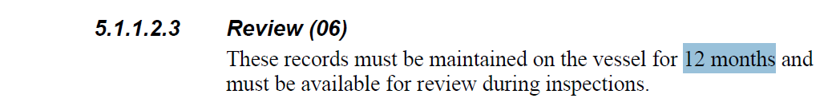

5.2 Bunkering and Production Halogenation and pH Control
5.2.1 Procedures
5.2.1.2 Monitoring
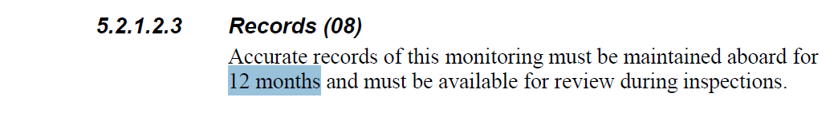

5.3 Potable Water System
5.3.4 Potable Water System Contamination
5.3.4.1 Cleaning and Disinfection
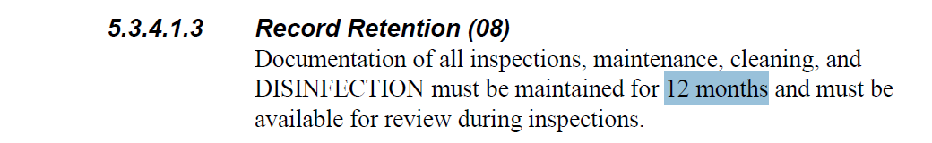

5.5 Potable Water System Halogen Monitoring
5.5.2 Halogen Analyzer Charts
5.5.2.2 Operation
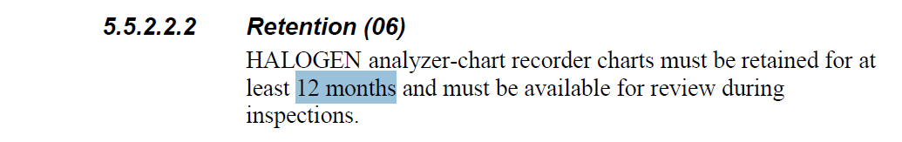

5.5.3 Manual Halogen Monitoring
5.5.3.1 Equipment Failure
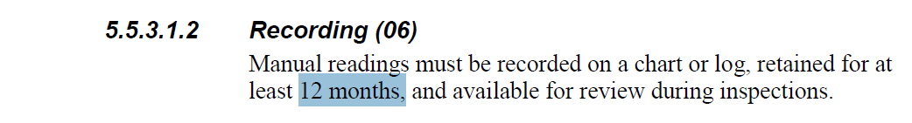
5.6 Microbiologic Monitoring
5.6.1 Sampling and Analysis
5.6.1.2 Records
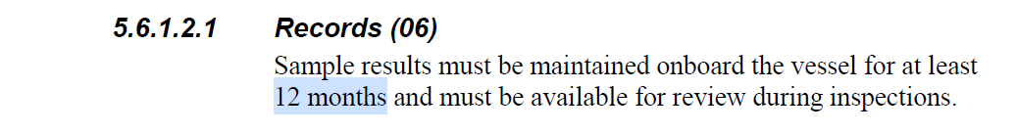

5.7 Water Distribution System Protection
5.7.2 Backflow Prevention Device Inspection and Testing
5.7.2.2 Inspection and Service
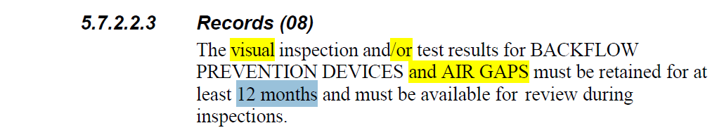

6.0 Recreational Water Facilities (RWFs)
6.3 Recirculating RWFs
6.3.2 Halogenation
6.3.2.2 Residual Halogen and pH Monitoring
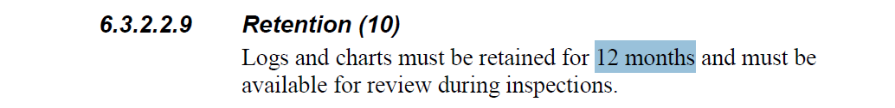

6.4 Whirlpool Spas and Spa Pools
6.4.2 Halogenation
6.4.2.1 Residual Halogen


6.6 Private Cabin Operations (Private Whirlpool Spas)
6.6.1 Maintenance
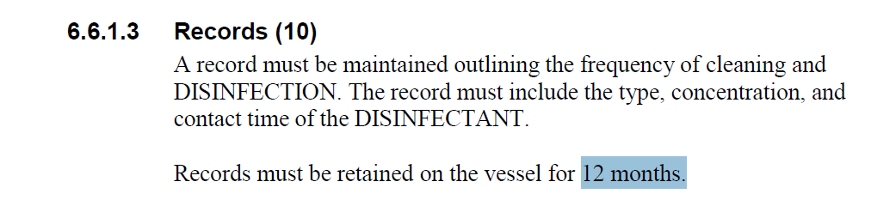

6.7 Individual Hydrotherapy Pools
6.7.1 Maintenance
