Resources and Services Database of the National Prevention Information Network

OMB No. 0920-0255
Exp. 3/31/2026

Change Request

June 12/2024

CONTACT:

Holly I. Gay, MA
Health Communication Science Office
National Center for HIV/AIDS, Viral Hepatitis, STI, TB Prevention
Centers for Disease Control and Prevention
Phone: 404.639.5048
UWW8@cdc.gov

Change Request
Resources and Services Database of the CDC National Prevention Information Network (NPIN)
(OMB No. 0920-0255, Expiration Date 03/31/2026)

Summary
The resources and Services Database of the CDC National Prevention Information Network (NPIN) is submitting this non-substantive change request for two needed updates to the NPIN Questionnaire: adding one term regarding the service Doxy PEP to the NPIN questionnaires and online form (https://npin.cdc.gov/organization/submit) and adding one term regarding Free mpox vaccine to the NPIN questionnaires and online form.

Attachments
Att. 3A_NPIN Questionnaire for New Organizations
Att. 3A_NPIN Questionnaire for New Organizations Free mpox vaccine and Doxy PEP terms added.docx
Att. 3B_NPIN Questionnaire for Annual Updates
Att. 3B_NPIN Questionnaire for Annual Updates Free mpox vaccine and Doxy PEP terms added.docx
Att. 4_Screen_Shots_NPIN Online Questionnaire.docx
Att. 4_Screen_Shots_NPIN Online Questionnaire Free mpox Vaccine and Doxy PEP terms added.docx

Background and Justification
The National Prevention Information Network (NPIN) is a service of the CDC National Center for HIV/AIDS, Viral Hepatitis, STD, and TB Prevention (NCHHSTP). NPIN is a program of NCHHSTP that supports NCHHSTP’s efforts to prevent and control human immunodeficiency virus (HIV) infection, viral hepatitis, sexually transmitted diseases (STD/STI), and tuberculosis (TB), which continue to present major public health challenges to the United States.
NPIN collects information from and about organizations that provide services related to HIV/AIDS, viral hepatitis, STD/STI, and TB at the local, state, and national level. The intended use of the resulting data is to support a resource for referrals, and to facilitate partnerships and coordination among program dealing with HIV/AIDS, viral hepatitis, STD/STI, and TB.

Doxy PEP is a sexual health tool that involves taking the antibiotic doxycycline after sex to prevent getting certain sexually transmitted infections (syphilis, gonorrhea, and chlamydia). Doxy PEP has proven to reduce the risk of getting a bacterial STI for gay, bisexual, and other men who have sex with men and transgender women at increased risk for these infections. CDC recommends healthcare providers discuss doxy PEP with all gay, bisexual, and other men who have sex with men and transgender women with a history of at least one bacterial STI (syphilis, chlamydia, gonorrhea) in the last 12 months. If offering doxy PEP, healthcare providers should write a prescription for self-administration of 200 mg of doxycycline within 72 hours of sex. Doxy PEP represents the first new STI prevention tool in decades (https://www.cdc.gov/sti/php/from-the-director/doxy-pep-sti-prevention-strategy.html).
Vaccination is an important tool in preventing the spread of mpox. On June 28, 2022, the federal government announced an enhanced nationwide strategy to vaccinate and protect people at risk for mpox. The Resources and Services Database of the CDC National Prevention Information Network (NPIN) supported expanding vaccination accessibility and reaching populations who are at an elevated risk of contracting mpox, by providing searchable information about organizations offering the mpox vaccine by adding the term Mpox vaccine to its forms. However, as of April 1, 2024, the JYNNEOS mpox vaccine is commercially available (https://aspr.hhs.gov/Mpox). As part of NPIN ongoing coordination efforts NPIN will like to find out if organizations will continue to offer mpox vaccine, and if so if it will be free for consumers.
NPIN is planning on capturing the services by adding the term Free mpox vaccine to the Fee Section and Doxy PEP to the Care and Treatment Services section of the NPIN questionnaires and online form. Capturing the information will strengthen the utility of NPIN by helping users find detailed information about the services they need.
Effect of Proposed Changes on Currently Approved Instruments
The effect on currently approved instruments will be minimal as only two new term one will be added to the existing list of Care and Treatment Services
Form | Current Question/Item | Requested Change
NPIN Online Questionnaire (OMB 0920-0255 Att. 4) | 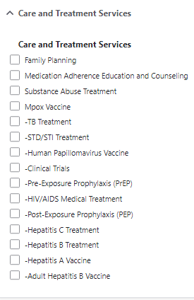  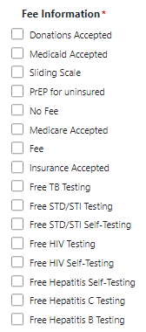 | 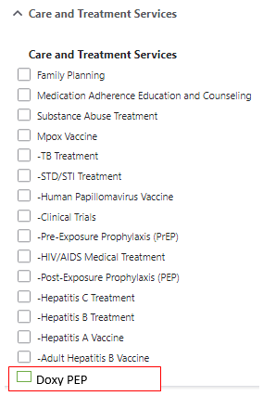  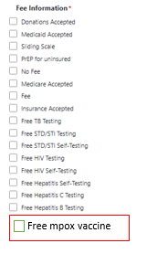
NPIN Initial Questionnaire for New Organizations (OMB 0920-0255 Att.3A) | 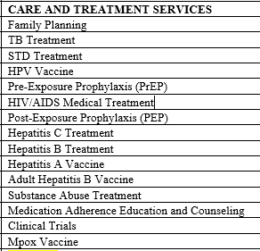  Next, ask to speak to the HIV program director/coordinator, outreach staff OR the nursing supervisor to verify the following. When possible, confirm this information from the website first:  - Fees for services  - Testing fees  - Vaccine Fees.  - Fees for other services | 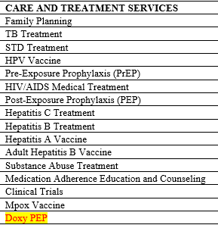  Next, ask to speak to the HIV program director/coordinator, outreach staff OR the nursing supervisor to verify the following. When possible, confirm this information from the website first:  - Fees for services  - Testing fees  - Vaccine Fees.  - Free mpox vaccine  - Fees for other services
NPIN Questionnaire for Annual Updates (OMB 0920-0255 Att.3B) | 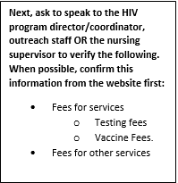 | 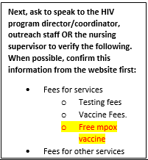
Effect on Burden Estimate
There is no effect on the current Burden Estimate. We have only added one new term, with checkboxes for the answer.

