OMB No.: 0915-0285. Expiration Date: XX
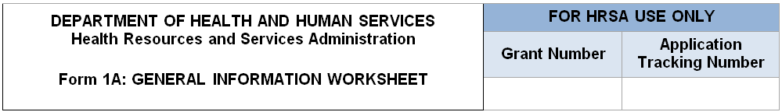

- Applicant Information
Applicant Name
Fiscal Year End Date | Select from drop-down menu (e.g., January 31, March 31)
Application Type
Grant Number
Business Entity  (Select one) | [_] Tribal  [_] Urban Indian  [_] Private, non-profit (non-Tribal or Urban Indian)  [_] Public (non-Tribal or Urban Indian)
Organization Type  (Select all that apply) | [_] Faith based  [_] Hospital  [_] State government  [_] City/County/Local Government or Municipality  [_] University  [_] Community based organization  [_] None of the above Specify: __________
Proposed Service Area (not included in NTAP or PCA applications)
Note: Applicants applying for Community Health Center (CHC) funding in Section A of the SF-424A: Budget Information form must serve at least one MUA or MUP. Provide the IDs for all MUAs and/or MUPs within the service area proposed in this application.
2a. Service Area Designation (not included in NTAP or PCA applications)
Select MUA/MUP  (Each ID must be a 5 to 12 digits. Use commas to separate multiple IDs, without spaces.)  Find an MUA/MUP (http://muafind.hrsa.gov/) | [_] Medically Underserved Area (MUA): ID#____  [_] Medically Underserved Population (MUP): ID#____  [_] Medically Underserved Area Application Pending: ID#____  [_] Medically Underserved Population Application Pending: ID#____

2b. Service Area Type (SAC only; not included in NTAP or PCA applications)
Choose Service Area Type  You must select Urban or Rural Refer to the Service Area Type in the Service Area Announcement Table (SAAT) to see how HRSA defines the service area. | [_] Urban  [_] Rural
If your selection differs from what is listed on the SAAT, please explain why using publicly available data (max. 3,000 characters).
If your selection matches what is listed on the SAAT, write “N/A”.

Unmet Need Score (UNS) (Look-alike ID only)
Enter Your Organization’s Unmet Need Score (UNS) as manually generated after entering all zip codes on Form 5B | Unmet Need Score: (Value ranging from 0 to 100).

2c. Patients (not included in NTAP or PCA applications or LAL-RD)
Unduplicated Patients by Population Type
How many unduplicated patients do you project to serve in the assessment period?

Population Type | UDS/Baseline Value | Projected in the assessment period  (January 1 – December 31)
Population Type | Patients | Patients
Total |  | Pre-populated from above
Medically Underserved Populations (CHC) (Includes all patients/visits not reported in the rows below.)
Migratory and Seasonal Agricultural Workers (MSAW)
Residents of Public Housing (RPH)
Homeless Population (HP)
Patients by Service Type (not included in NTAP or PCA applications)
Service Type | UDS/Baseline Value |  | Projected in the assessment period  (January 1 – December 31)
Service Type | Patients |  | Patients
Total Medical Services
Total Dental Services
Behavioral Health Services
Total Mental Health Services
Total Substance Use Disorder
Services
Total Vision Services
Total Patient Support Services

- NTAP Type (NTAP-only)
Select the NTTAP Type For Which you are applying | Applicants select one NTAP type they are applying for funding from drop down menu with NTAP types
- Budget Information (NTAP and PCA Only)
Maximum Annual Federal Amount that can be requested based on the NTAP Type selected in this application, and “new” or “competing continuation” applicant status | [Prepopulated based on Application Type prepopulated and NTAP Type selected in this form]
Total Annual Federal Budget Requested in this application | [Prepopulated from the SF-424 Budget Summary Form]

Health centers (section 330 grant funded and Federally Qualified Health Center look-alikes) are patient-directed organizations that deliver affordable, accessible, quality, and cost-effective primary health care services to patients and adjust fees based on income and family size. The Health Center Program application forms provide essential information to HRSA staff and objective review committee panels for application evaluation; funding recommendation and approval; designation; and monitoring. An agency may not conduct or sponsor, and a person is not required to respond to, a collection of information unless it displays a currently valid OMB control number. The OMB control number for this information collection is 0915-0285 and it is valid until XX/XX/202X. This information collection is mandatory under the Health Center Program authorized by section 330 of the Public Health Service (PHS) Act (42 U.S.C. 254b). Public reporting burden for this collection of information is estimated to average 0.75 hours per response, including the time for reviewing instructions, searching existing data sources, and completing and reviewing the collection of information. Send comments regarding this burden estimate or any other aspect of this collection of information, including suggestions for reducing this burden, to HRSA Information Collection Clearance Officer, 5600 Fishers Lane, Room 13N82, Rockville, Maryland, 20857 or paperwork@hrsa.gov. Please see https://www.hrsa.gov/about/508-resources for the HRSA digital accessibility statement.

