Privacy act warning when first accessing the WIC Overseas site.
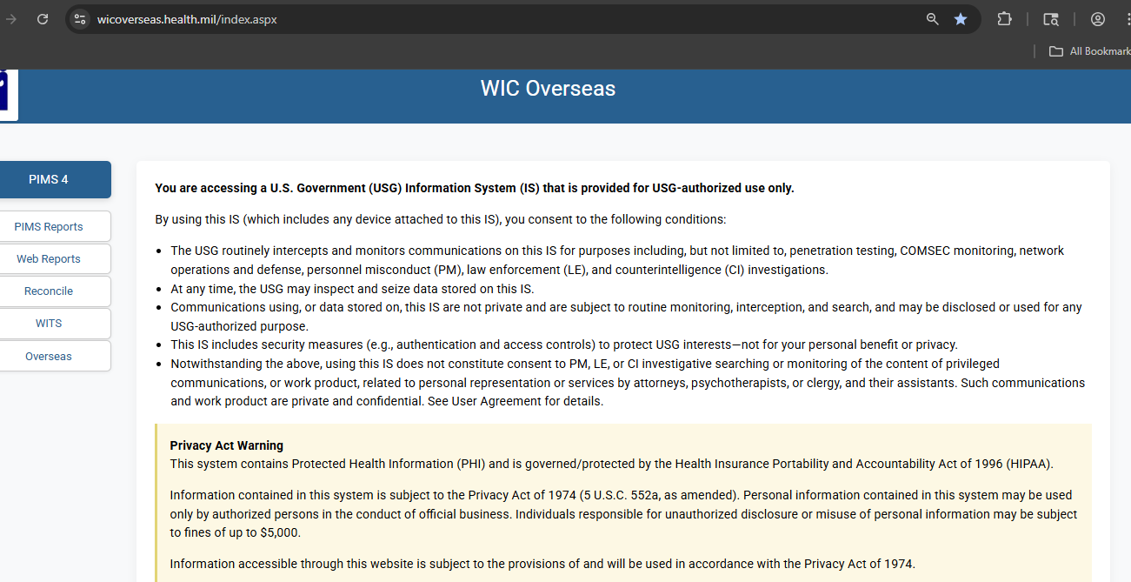

Privacy Notice and Consent banner when accessing PIMS.
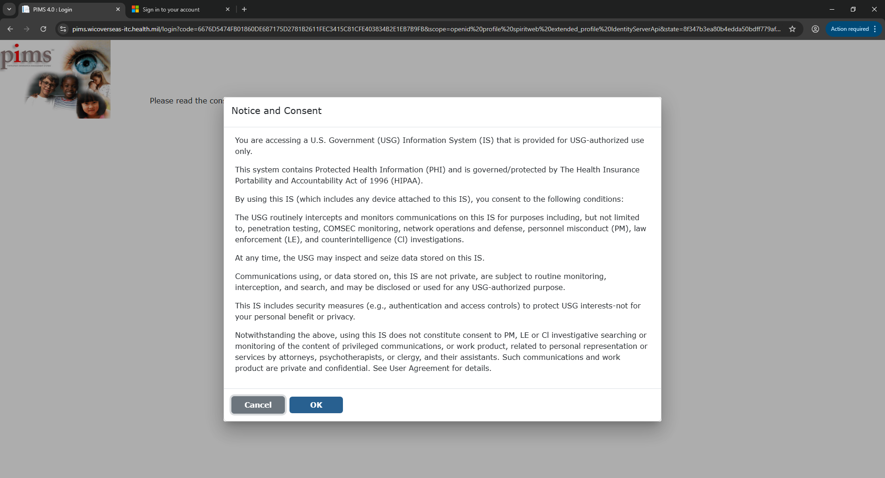

Data used to find a participant within PIMS.
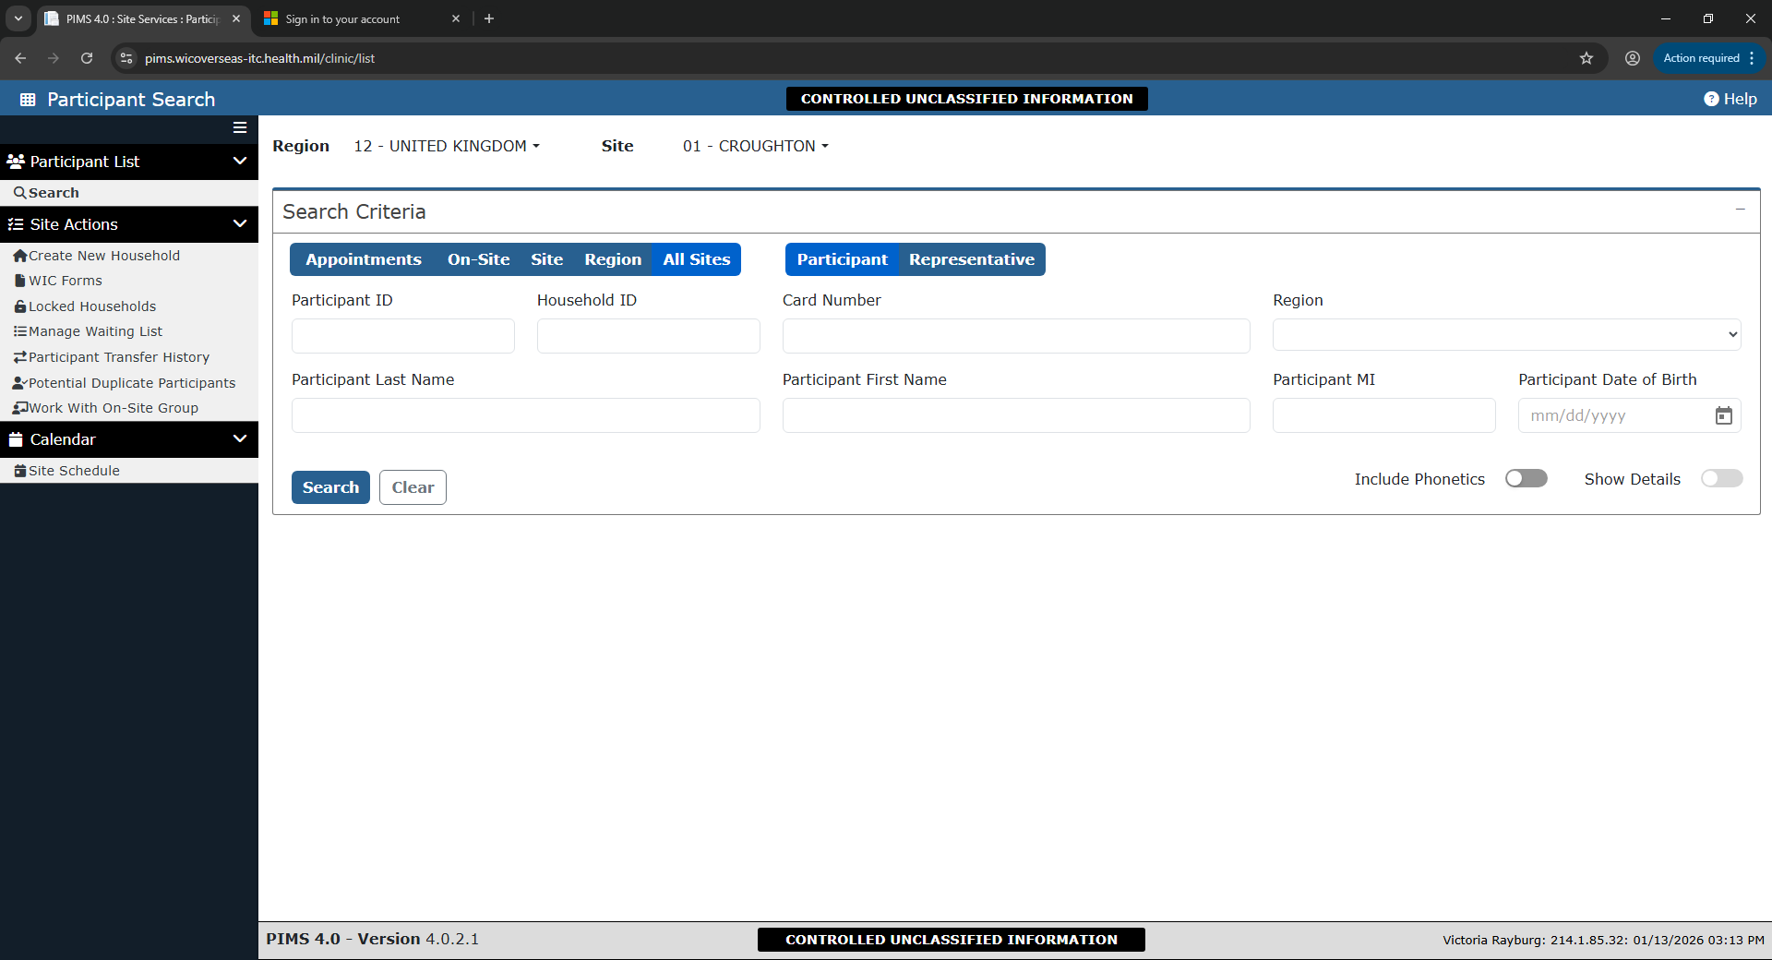
Applicant Prescreen with information filled in.
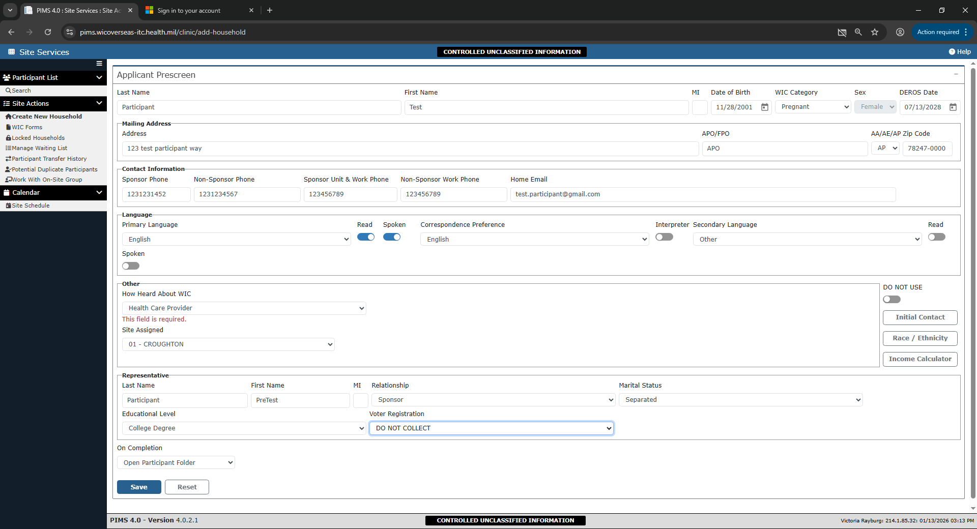
The Demographics page with sample data.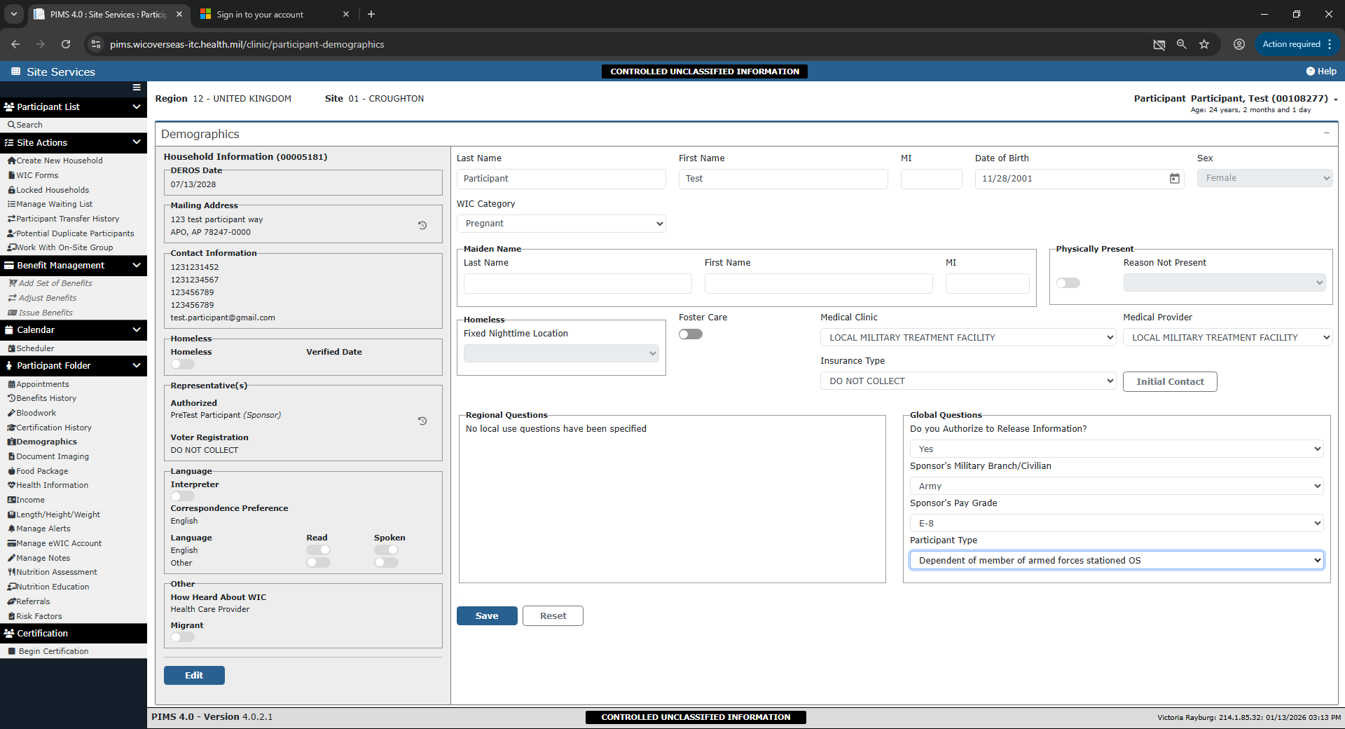
Proof for residence and identification that was presented during the appointment.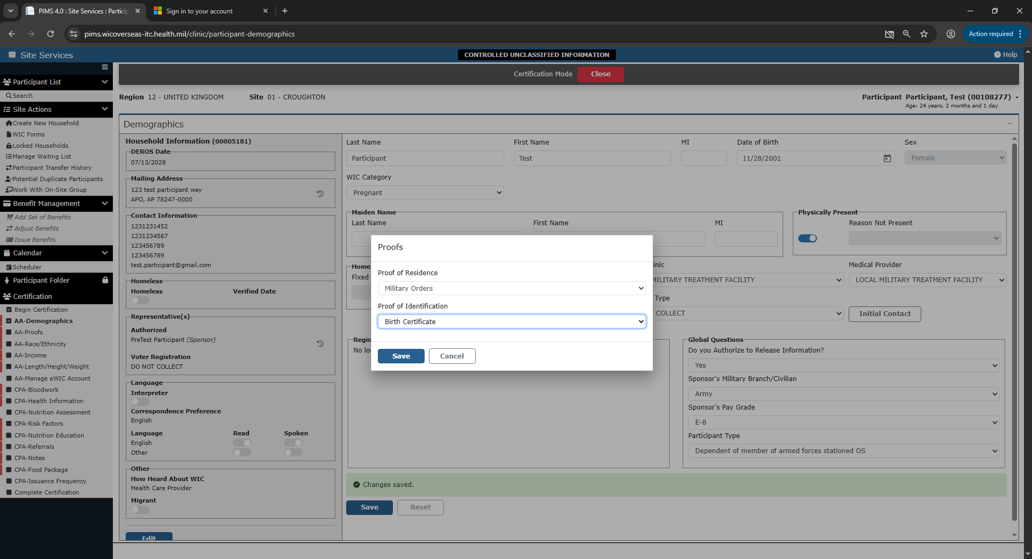
The following page captures the participant’s race/ethnicity.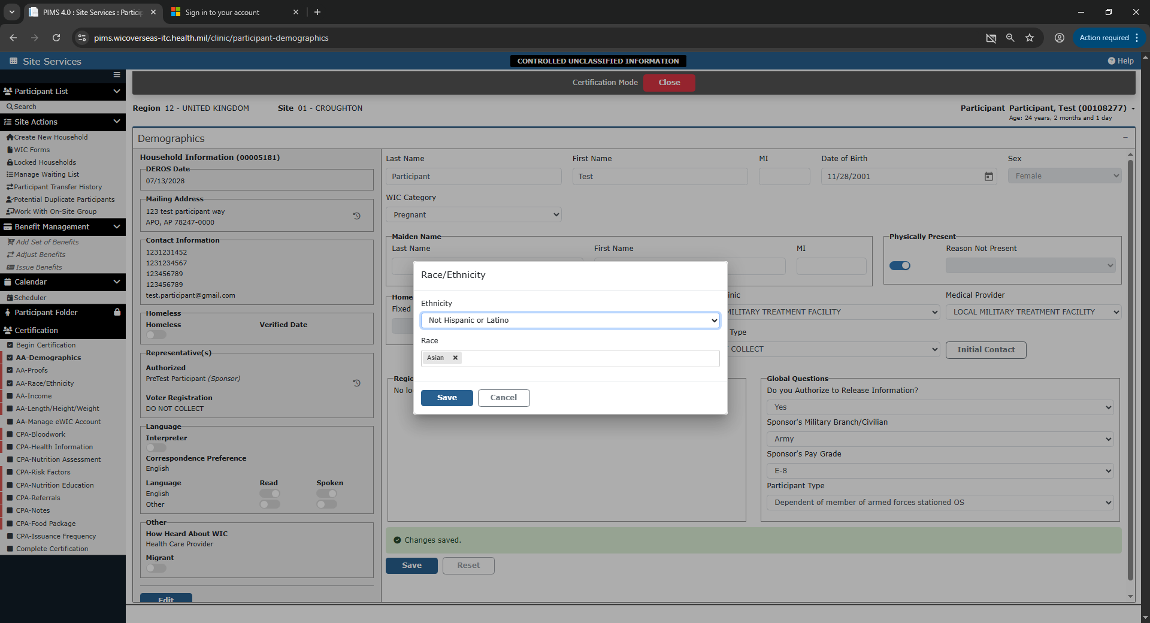
Household size and Income page.
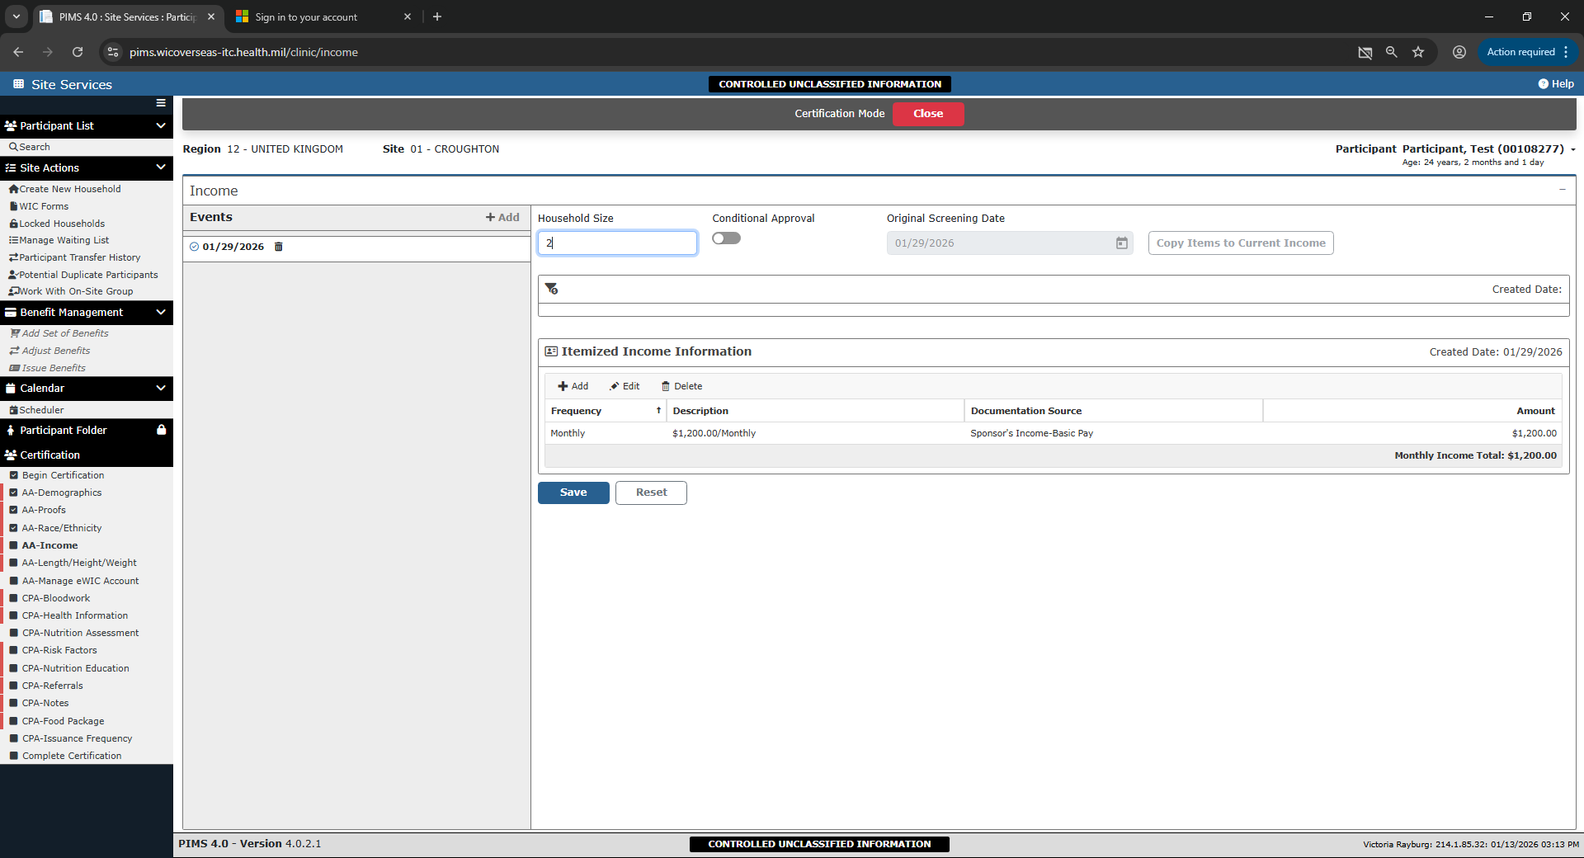
The Height and Weight collection.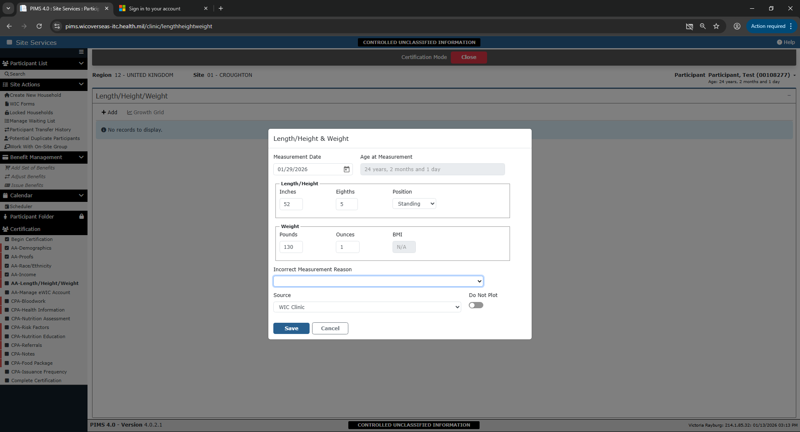
The representative who will be using the benefits card.
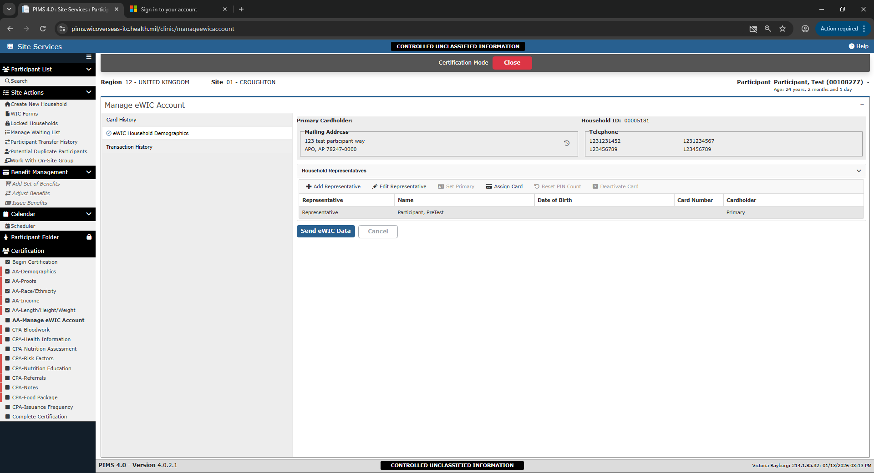
Participant lab/bloodwork page.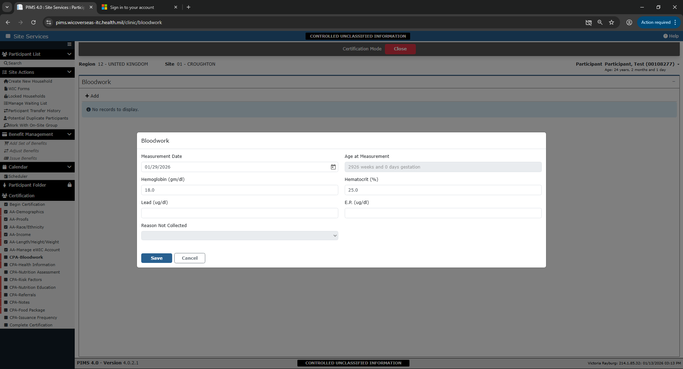
Sample health information taken for a pregnant participant.
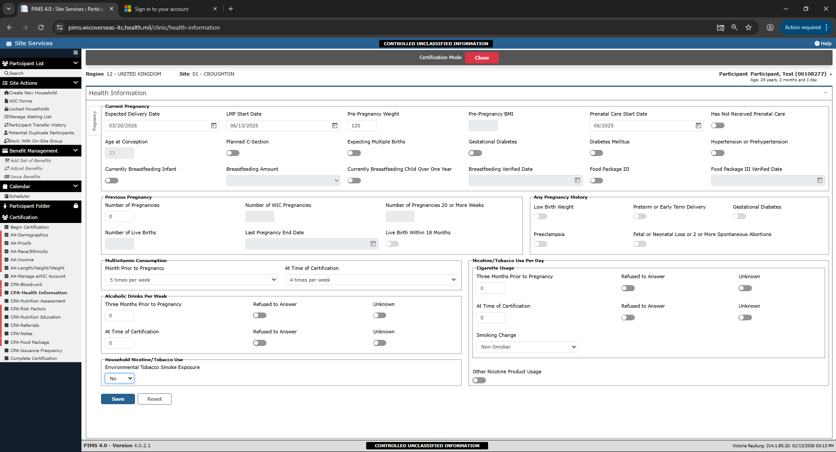
Sample data for nutrition/health assessment questions.