Coral Reef At Sea Notifications
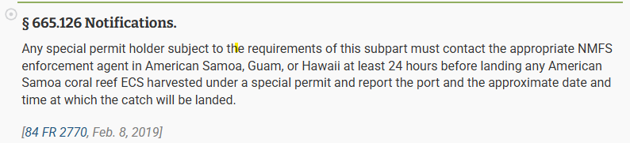

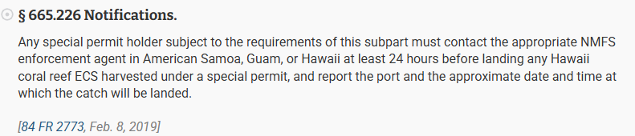

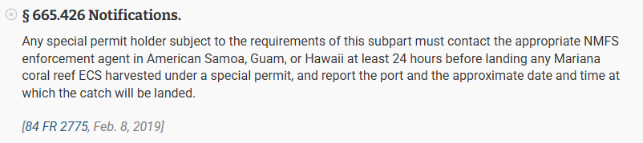

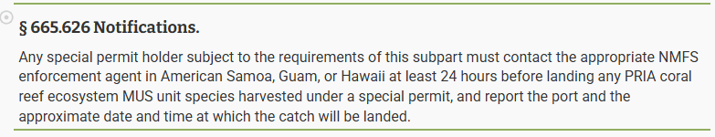

We estimate that completing the coral reef at sea notifications will take 3 minutes on average. Send comments regarding this burden estimate or any other aspect of this collection of information, including suggestions for reducing this burden, to NOAA, Nate Chan, Nathan.chan@noaa.gov. This collection has been approved by the Office of Management and Budget (OMB). The eight-digit OMB approval number that appears at the upper left of the form confirms this approval. If this number were not displayed, we could not conduct this information collection.

