Attachment C

Department of Commerce
United States Census Bureau
OMB Information Collection Request
Annual Integrated Economic Survey
OMB Control Number 0607-1024

2025 AIES Letters and Emails

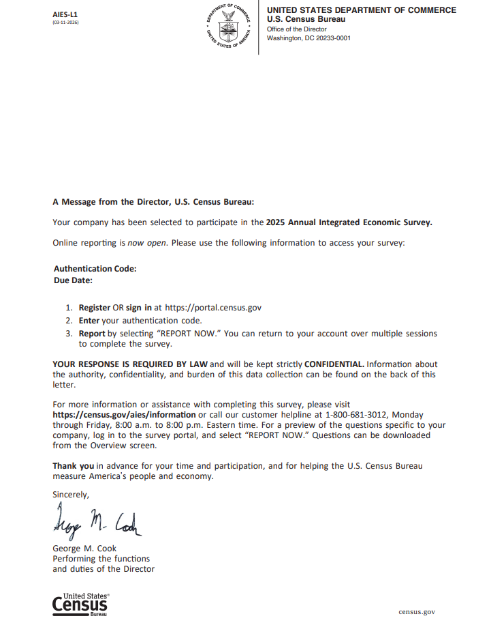

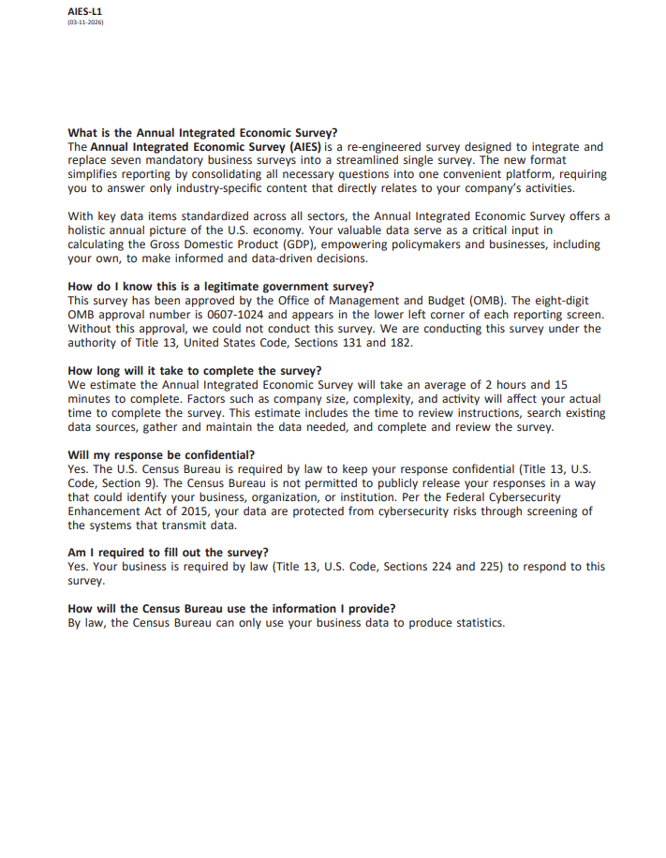

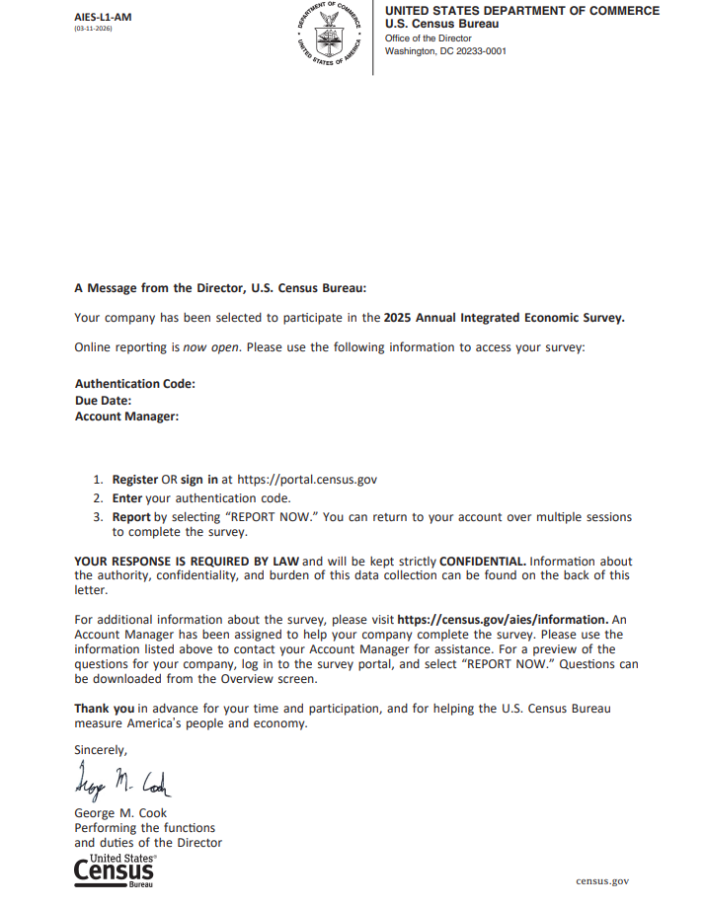

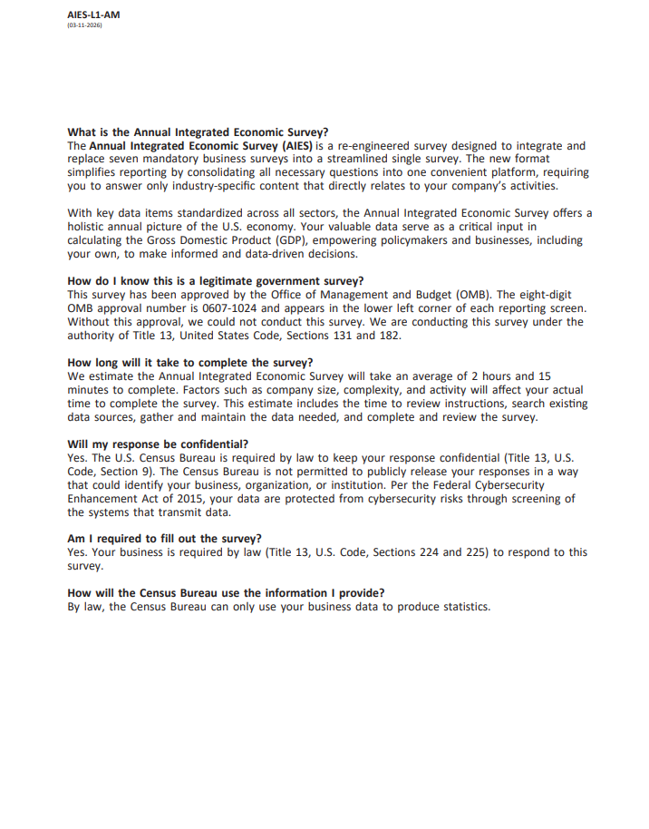

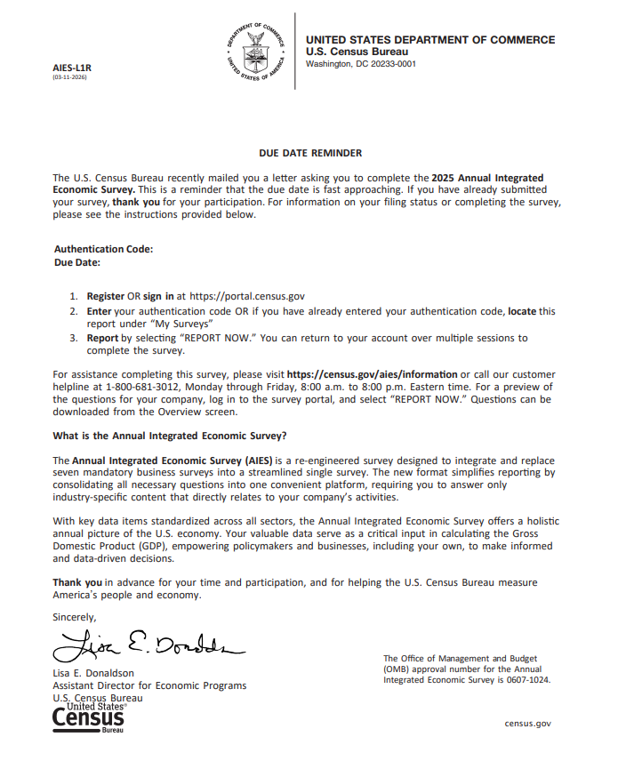

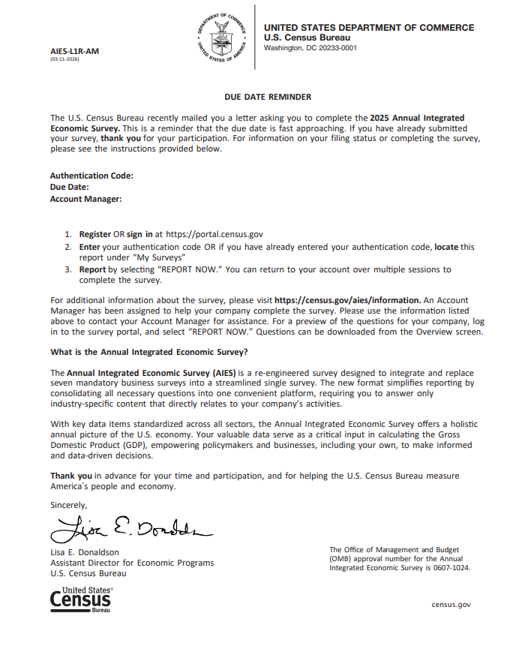

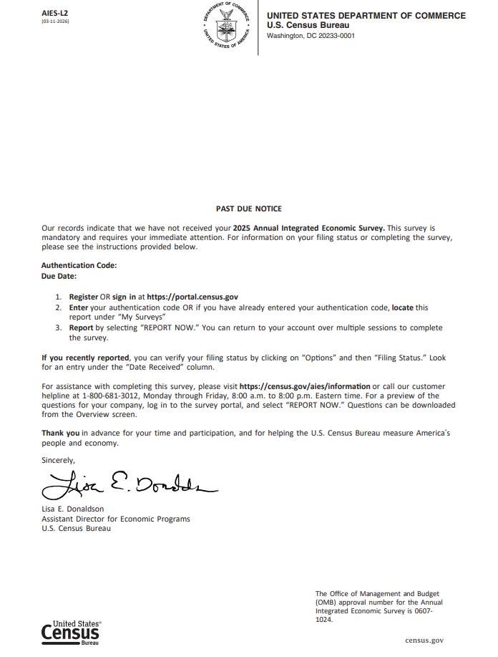

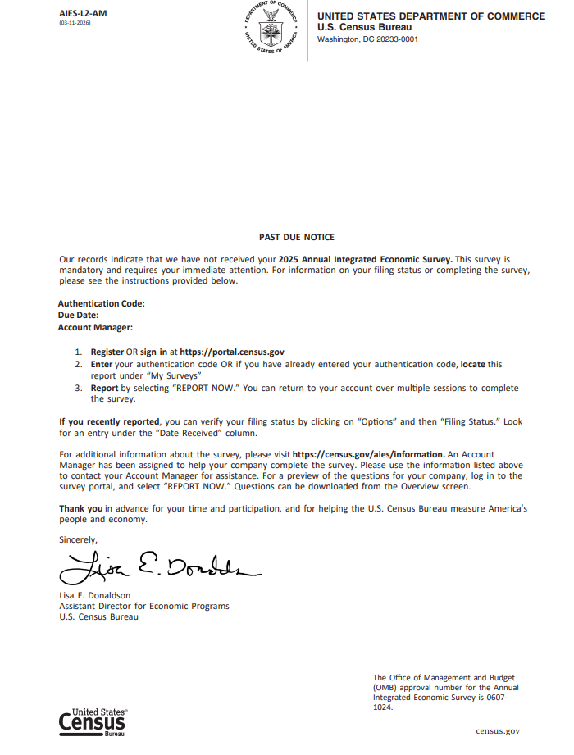

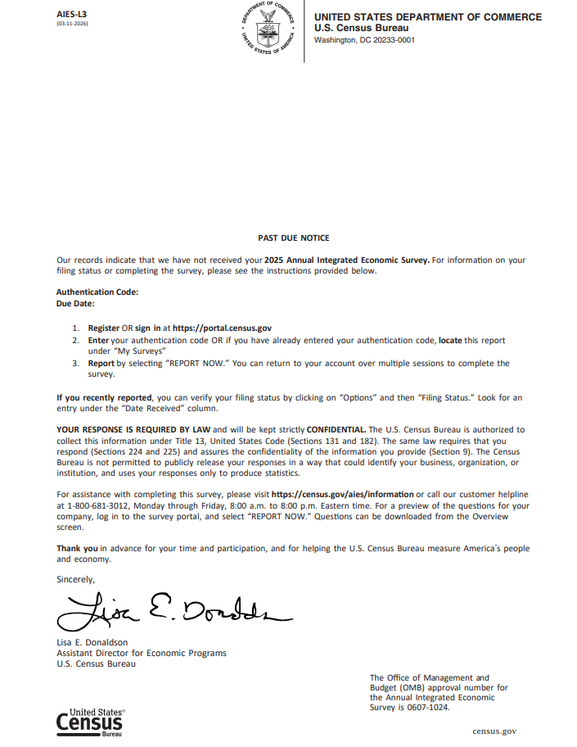

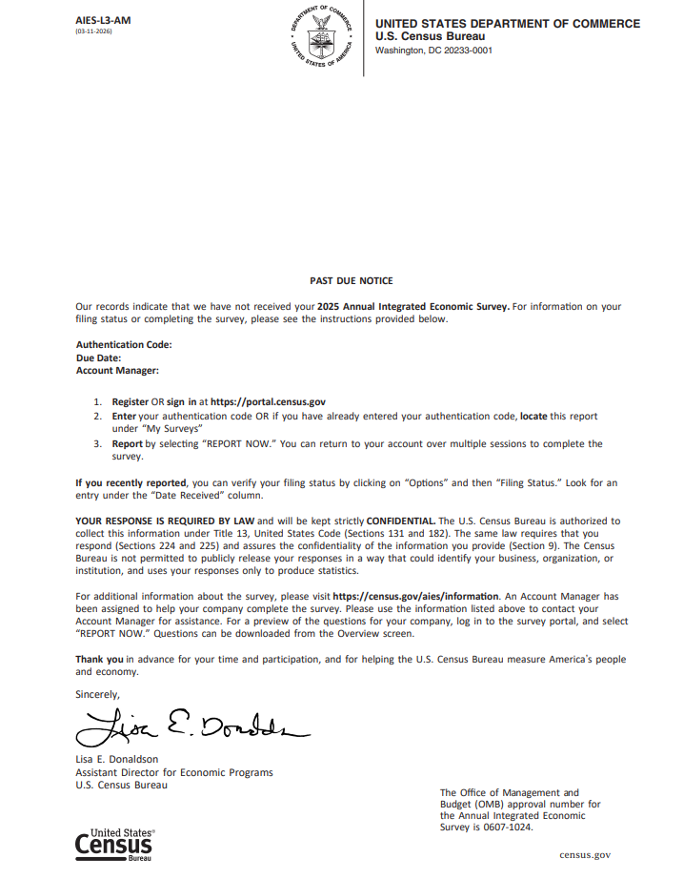

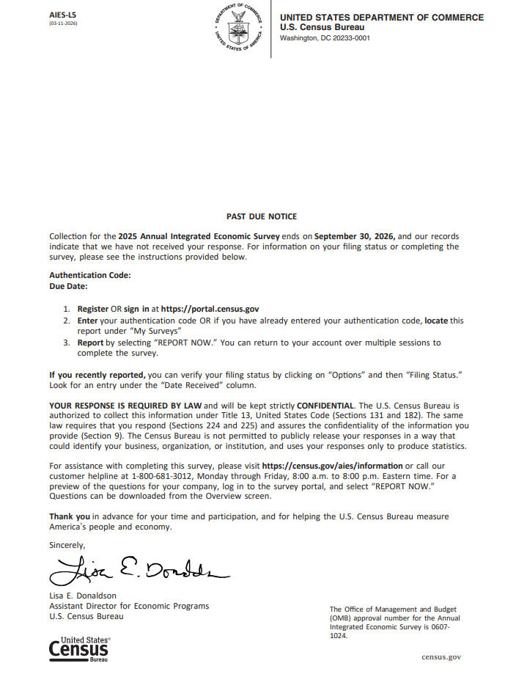

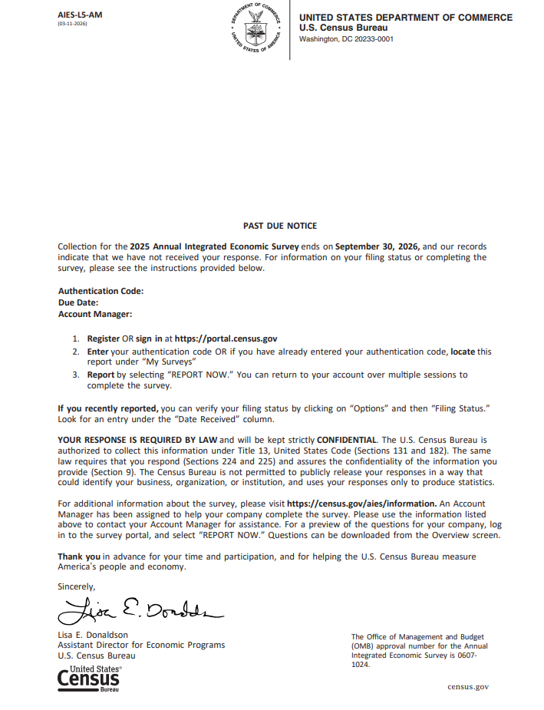

Subject: ONLINE REPORTING OPEN: Annual Integrated Economic Survey

ANNUAL INTEGRATED ECONOMIC SURVEY

Online Reporting Open

Check our email address – it’s official if it ends in census.gov

ATTN

COMPANY

Your company has been selected to participate in the 2025 Annual Integrated Economic Survey.

Online reporting is now open. Please use the following information to access your survey:
______________________________________________________________________________

Due Date: DUE DATE

- Register or sign in at https://portal.census.gov
- Enter your authentication code: XXXX-XXXX-XXXX
Case-sensitive; if you copy and paste, ensure no blank spaces are captured.
- Report by selecting “REPORT NOW.” You can return to your account over multiple sessions to complete the survey.
______________________________________________________________________________

YOUR RESPONSE IS REQUIRED BY LAW and will be kept strictly CONFIDENTIAL. Information about the authority, confidentiality, and burden of this data collection can be found at the bottom of this email.

Please do not reply directly to this automated email. For more information or assistance with completing this survey, please visit https://census.gov/aies/information or call our customer helpline at 1-800-681-3012, Monday through Friday, 8:00 a.m. to 8:00 p.m. Eastern time. For a preview of the questions specific to your company, log in to the survey portal, and select “REPORT NOW.” Questions can be downloaded from the Overview screen.

Thank you in advance for your time and participation, and for helping the U.S. Census Bureau measure America’s people and economy.
Sincerely,

Deirdre Dalpiaz Bishop
Associate Director for Economic Programs
U.S. Census Bureau

What is the Annual Integrated Economic Survey?
The Annual Integrated Economic Survey (AIES) is a re-engineered survey designed to integrate and replace seven mandatory business surveys into a streamlined single survey. The new format simplifies reporting by consolidating all necessary questions into one convenient platform, requiring you to answer only industry-specific content that directly relates to your company’s activities.

With key data items standardized across all sectors, the Annual Integrated Economic Survey offers a holistic annual picture of the U.S. economy. Your valuable data serve as a critical input in calculating the Gross Domestic Product (GDP), empowering policymakers and businesses, including your own, to make informed and data-driven decisions.

How do I know this is a legitimate government survey?
This survey has been approved by the Office of Management and Budget (OMB). The eight-digit OMB approval number is 0607-1024 and appears in the lower left corner of each reporting screen. Without this approval, we could not conduct this survey. We are conducting this survey under the authority of Title 13, United States Code, Sections 131 and 182.

How long will it take to complete the survey?
We estimate the Annual Integrated Economic Survey will take an average of 2 hours and 15 minutes to complete. Factors such as company size, complexity, and activity will affect your actual time to complete the survey. This estimate includes the time to review instructions, search existing data sources, gather and maintain the data needed, and complete and review the survey.

Will my response be confidential?
Yes. The U.S. Census Bureau is required by law to keep your response confidential (Title 13, U.S. Code, Section 9). The Census Bureau is not permitted to publicly release your responses in a way that could identify your business, organization, or institution. Per the Federal Cybersecurity Enhancement Act of 2015, your data are protected from cybersecurity risks through screening of the systems that transmit data.

Am I required to fill out the survey?
Yes. Your business is required by law (Title 13, U.S. Code, Sections 224 and 225) to respond to this survey.

How will the Census Bureau use the information I provide?
By law, the Census Bureau can only use your business data to produce statistics.

ID: XXXXXXXXXXXX

This email is sent by a computer. Please do not reply.

Subject: ONLINE REPORTING OPEN: Annual Integrated Economic Survey

ANNUAL INTEGRATED ECONOMIC SURVEY

Online Reporting Open

Check our email address – it’s official if it ends in census.gov

ATTN

COMPANY

Your company has been selected to participate in the 2025 Annual Integrated Economic Survey.

Online reporting is now open. Please use the following information to access your survey:
______________________________________________________________________________

Due Date: DUE DATE

- Register or sign in at https://portal.census.gov
- Enter your authentication code: XXXX-XXXX-XXXX
Case-sensitive; if you copy and paste, ensure no blank spaces are captured.
- Report by selecting “REPORT NOW.” You can return to your account over multiple sessions to complete the survey.
______________________________________________________________________________

YOUR RESPONSE IS REQUIRED BY LAW and will be kept strictly CONFIDENTIAL. Information about the authority, confidentiality, and burden of this data collection can be found at the bottom of this email.

Please do not reply directly to this automated email. For additional information about the survey, please visit https://census.gov/aies/information. An Account Manager has been assigned to help your company complete the survey. You can reach out directly by phone to <account manager name> at <account manager’s number> or send a secure message after logging in to the portal linked above. For a preview of the questions for your company, log in to the survey portal, and select “REPORT NOW.” Questions can be downloaded from the Overview screen.

Thank you in advance for your time and participation, and for helping the U.S. Census Bureau measure America’s people and economy.
Sincerely,

Deirdre Dalpiaz Bishop
Associate Director for Economic Programs
U.S. Census Bureau

What is the Annual Integrated Economic Survey?
The Annual Integrated Economic Survey (AIES) is a re-engineered survey designed to integrate and replace seven mandatory business surveys into a streamlined single survey. The new format simplifies reporting by consolidating all necessary questions into one convenient platform, requiring you to answer only industry-specific content that directly relates to your company’s activities.

With key data items standardized across all sectors, the Annual Integrated Economic Survey offers a holistic annual picture of the U.S. economy. Your valuable data serve as a critical input in calculating the Gross Domestic Product (GDP), empowering policymakers and businesses, including your own, to make informed and data-driven decisions.

How do I know this is a legitimate government survey?
This survey has been approved by the Office of Management and Budget (OMB). The eight-digit OMB approval number is 0607-1024 and appears in the lower left corner of each reporting screen. Without this approval, we could not conduct this survey. We are conducting this survey under the authority of Title 13, United States Code, Sections 131 and 182.

How long will it take to complete the survey?
We estimate the Annual Integrated Economic Survey will take an average of 2 hours and 15 minutes to complete. Factors such as company size, complexity, and activity will affect your actual time to complete the survey. This estimate includes the time to review instructions, search existing data sources, gather and maintain the data needed, and complete and review the survey.

Will my response be confidential?
Yes. The U.S. Census Bureau is required by law to keep your response confidential (Title 13, U.S. Code, Section 9). The Census Bureau is not permitted to publicly release your responses in a way that could identify your business, organization, or institution. Per the Federal Cybersecurity Enhancement Act of 2015, your data are protected from cybersecurity risks through screening of the systems that transmit data.

Am I required to fill out the survey?
Yes. Your business is required by law (Title 13, U.S. Code, Sections 224 and 225) to respond to this survey.

How will the Census Bureau use the information I provide?
By law, the Census Bureau can only use your business data to produce statistics.

ID: XXXXXXXXXXXX

This email is sent by a computer. Please do not reply.

Subject: Due Date Reminder: Annual Integrated Economic Survey

ANNUAL INTEGRATED ECONOMIC SURVEY

Due Date Reminder

Check our email address – it’s official if it ends in census.gov

ATTN

COMPANY

The U.S. Census Bureau recently mailed you a letter asking you to complete the 2025 Annual Integrated Economic Survey. This is a reminder that the due date is fast approaching. For information on your filing status or completing the survey, please see the instructions provided below.
______________________________________________________________________________

Due Date:

- Register or sign in at https://portal.census.gov
- Enter your authentication code: XXXX-XXXX-XXXX OR if you have already entered your authentication code, locate this report under “My Surveys”
Case-sensitive; if you copy and paste, ensure no blank spaces are captured.
- Report by selecting “REPORT NOW.” You can return to your account over multiple sessions to complete the survey.
______________________________________________________________________________

Please do not reply directly to this automated email. For assistance completing this survey, please visit https://census.gov/aies/information or call our customer helpline at 1-800-681-3012, Monday through Friday, 8:00 a.m. to 8:00 p.m. Eastern time. For a preview of the questions for your company, log in to the survey portal, and select “REPORT NOW.” Questions can be downloaded from the Overview screen.

What is the Annual Integrated Economic Survey?

The Annual Integrated Economic Survey (AIES) is a re-engineered survey designed to integrate and replace seven mandatory business surveys into a streamlined single survey. The new format simplifies reporting by consolidating all necessary questions into one convenient platform, requiring you to answer only industry-specific content that directly relates to your company’s activities.

With key data items standardized across all sectors, the Annual Integrated Economic Survey offers a holistic annual picture of the U.S. economy. Your valuable data serve as a critical input in calculating the Gross Domestic Product (GDP), empowering policymakers and businesses, including your own, to make informed and data-driven decisions.

Thank you in advance for your time and participation, and for helping the U.S. Census Bureau measure America’s people and economy.
Sincerely,

Lisa E. Donaldson
Assistant Director for Economic Programs
U.S. Census Bureau

Office of Management and Budget (OMB) Number: 0607-1024
Expires: 03/31/2029

ID: XXXXXXXXXXXX

This email is sent by a computer. Please do not reply.

Subject: Due Date Reminder: Annual Integrated Economic Survey

ANNUAL INTEGRATED ECONOMIC SURVEY

Due Date Reminder

Check our email address – it’s official if it ends in census.gov

ATTN

COMPANY

The U.S. Census Bureau recently mailed you a letter asking you to complete the 2025 Annual Integrated Economic Survey. This is a reminder that the due date is fast approaching. For information on your filing status or completing the survey, please see the instructions provided below.
______________________________________________________________________________

Due Date:

- Access your Census Bureau account at https://portal.census.gov and locate your survey under “My Surveys.”
- Click on “REPORT NOW” to begin or resume reporting.
- Submit your responses once you reach the end of the reporting instrument.
______________________________________________________________________________

Please do not reply directly to this automated email. For assistance completing this survey, please visit https://census.gov/aies/information or call our customer helpline at 1-800-681-3012, Monday through Friday, 8:00 a.m. to 8:00 p.m. Eastern time. For a preview of the questions for your company, log in to the survey portal, and select “REPORT NOW.” Questions can be downloaded from the Overview screen.

What is the Annual Integrated Economic Survey?

The Annual Integrated Economic Survey (AIES) is a re-engineered survey designed to integrate and replace seven mandatory business surveys into a streamlined single survey. The new format simplifies reporting by consolidating all necessary questions into one convenient platform, requiring you to answer only industry-specific content that directly relates to your company’s activities.

With key data items standardized across all sectors, the Annual Integrated Economic Survey offers a holistic annual picture of the U.S. economy. Your valuable data serve as a critical input in calculating the Gross Domestic Product (GDP), empowering policymakers and businesses, including your own, to make informed and data-driven decisions.

Thank you in advance for your time and participation, and for helping the U.S. Census Bureau measure America’s people and economy.
Sincerely,

Lisa E. Donaldson
Assistant Director for Economic Programs
U.S. Census Bureau

Office of Management and Budget (OMB) Number: 0607-1024
Expires: 03/31/2029

ID: XXXXXXXXXXXX

This email is sent by a computer. Please do not reply.

Subject: Due Date Reminder: Annual Integrated Economic Survey

ANNUAL INTEGRATED ECONOMIC SURVEY

Due Date Reminder

Check our email address – it’s official if it ends in census.gov

ATTN

COMPANY

The U.S. Census Bureau recently mailed you a letter asking you to complete the 2025 Annual Integrated Economic Survey. This is a reminder that the due date is fast approaching. For information on your filing status or completing the survey, please see the instructions provided below.
______________________________________________________________________________

Due Date: DUE DATE

- Register or sign in at https://portal.census.gov
- Enter your authentication code: XXXX-XXXX-XXXX OR if you have already entered your authentication code, locate this report under “My Surveys”
Case-sensitive; if you copy and paste, ensure no blank spaces are captured.
- Report by selecting “REPORT NOW.” You can return to your account over multiple sessions to complete the survey.
______________________________________________________________________________

Please do not reply directly to this automated email. For additional information about the survey, please visit https://census.gov/aies/information. An Account Manager has been assigned to help your company complete the survey. You can reach out directly by phone to <account manager name> at <account manager’s number> or send a secure message after logging in to the portal linked above. For a preview of the questions for your company, log in to the survey portal, and select “REPORT NOW.” Questions can be downloaded from the Overview screen.

What is the Annual Integrated Economic Survey?

The Annual Integrated Economic Survey (AIES) is a re-engineered survey designed to integrate and replace seven mandatory business surveys into a streamlined single survey. The new format simplifies reporting by consolidating all necessary questions into one convenient platform, requiring you to answer only industry-specific content that directly relates to your company’s activities.

With key data items standardized across all sectors, the Annual Integrated Economic Survey offers a holistic annual picture of the U.S. economy. Your valuable data serve as a critical input in calculating the Gross Domestic Product (GDP), empowering policymakers and businesses, including your own, to make informed and data-driven decisions.

Thank you in advance for your time and participation, and for helping the U.S. Census Bureau measure America’s people and economy.
Sincerely,

Lisa E. Donaldson
Assistant Director for Economic Programs
U.S. Census Bureau

Office of Management and Budget (OMB) Number: 0607-1024
Expires: 03/31/2029

ID: XXXXXXXXXXXX

This email is sent by a computer. Please do not reply.

Subject: Due Date Reminder: Annual Integrated Economic Survey

ANNUAL INTEGRATED ECONOMIC SURVEY

Due Date Reminder

Check our email address – it’s official if it ends in census.gov

ATTN

COMPANY

The U.S. Census Bureau recently mailed you a letter asking you to complete the 2025 Annual Integrated Economic Survey. This is a reminder that the due date is fast approaching. For information on your filing status or completing the survey, please see the instructions provided below.
______________________________________________________________________________

Due Date: DUE DATE

- Access your Census Bureau account at https://portal.census.gov and locate your survey under “My Surveys.”
- Click on “REPORT NOW” to begin or resume reporting.
- Submit your responses once you reach the end of the reporting instrument.
______________________________________________________________________________

Please do not reply directly to this automated email. For additional information about the survey, please visit https://census.gov/aies/information. An Account Manager has been assigned to help your company complete the survey. You can reach out directly by phone to <account manager name> at <account manager’s number> or send a secure message after logging in to the portal linked above. For a preview of the questions for your company, log in to the survey portal, and select “REPORT NOW.” Questions can be downloaded from the Overview screen.

What is the Annual Integrated Economic Survey?

The Annual Integrated Economic Survey (AIES) is a re-engineered survey designed to integrate and replace seven mandatory business surveys into a streamlined single survey. The new format simplifies reporting by consolidating all necessary questions into one convenient platform, requiring you to answer only industry-specific content that directly relates to your company’s activities.

With key data items standardized across all sectors, the Annual Integrated Economic Survey offers a holistic annual picture of the U.S. economy. Your valuable data serve as a critical input in calculating the Gross Domestic Product (GDP), empowering policymakers and businesses, including your own, to make informed and data-driven decisions.

Thank you in advance for your time and participation, and for helping the U.S. Census Bureau measure America’s people and economy.
Sincerely,

Lisa E. Donaldson
Assistant Director for Economic Programs
U.S. Census Bureau

Office of Management and Budget (OMB) Number: 0607-1024
Expires: 03/31/2029

ID: XXXXXXXXXXXX

This email is sent by a computer. Please do not reply.

Subject: PAST DUE NOTICE: Annual Integrated Economic Survey

ANNUAL INTEGRATED ECONOMIC SURVEY

Past Due Notice

Check our email address – it’s official if it ends in census.gov

ATTN

COMPANY

Our records indicate that we have not received your 2025 Annual Integrated Economic Survey. This survey is mandatory and requires your immediate attention. For information on your filing status or completing the survey, please see the instructions provided below.
______________________________________________________________________________

- Register or sign in at https://portal.census.gov
- Enter your authentication code: XXXX-XXXX-XXXX OR if you have already entered your authentication code, locate this report under “My Surveys”
Case-sensitive; if you copy and paste, ensure no blank spaces are captured.
- Report by selecting “REPORT NOW.” You can return to your account over multiple sessions to complete the survey.

______________________________________________________________________________

If you recently reported, you can verify your filing status by clicking on “Options” and then “Filing Status.” Look for an entry under the “Date Received” column.

YOUR RESPONSE IS REQUIRED BY LAW and will be kept strictly CONFIDENTIAL. The U.S. Census Bureau is authorized to collect this information under Title 13, United States Code (Sections 131 and 182). The same law requires that you respond (Sections 224 and 225) and assures the confidentiality of the information you provide (Section 9). The Census Bureau is not permitted to publicly release your responses in a way that could identify your business, organization, or institution, and uses your responses only to produce statistics.

Please do not reply directly to this automated email. For assistance completing this survey, please visit https://census.gov/aies/information or call our customer helpline at 1-800-681-3012, Monday through Friday, 8:00 a.m. to 8:00 p.m. Eastern time. For a preview of the questions for your company, log in to the survey portal, and select “REPORT NOW.” Questions can be downloaded from the Overview screen.

Thank you in advance for your time and participation, and for helping the U.S. Census Bureau measure America’s people and economy.
Sincerely,

Lisa E. Donaldson
Assistant Director for Economic Programs
U.S. Census Bureau

Office of Management and Budget (OMB) Number: 0607-1024
Expires: 03/31/2029

ID: XXXXXXXXXXXX

This email is sent by a computer. Please do not reply.

Subject: PAST DUE NOTICE: Annual Integrated Economic Survey

ANNUAL INTEGRATED ECONOMIC SURVEY

Past Due Notice

Check our email address – it’s official if it ends in census.gov

ATTN

COMPANY

Our records indicate that we have not received your 2025 Annual Integrated Economic Survey. This survey is mandatory and requires your immediate attention. For information on your filing status or completing the survey, please see the instructions provided below.
______________________________________________________________________________

- Access your Census Bureau account at https://portal.census.gov and locate your survey under “My Surveys.”
- Click on “REPORT NOW” to begin or resume reporting.
- Submit your responses once you reach the end of the reporting instrument

______________________________________________________________________________

If you recently reported, you can verify your filing status by clicking on “Options” and then “Filing Status.” Look for an entry under the “Date Received” column.

YOUR RESPONSE IS REQUIRED BY LAW and will be kept strictly CONFIDENTIAL. The U.S. Census Bureau is authorized to collect this information under Title 13, United States Code (Sections 131 and 182). The same law requires that you respond (Sections 224 and 225) and assures the confidentiality of the information you provide (Section 9). The Census Bureau is not permitted to publicly release your responses in a way that could identify your business, organization, or institution, and uses your responses only to produce statistics.

Please do not reply directly to this automated email. For assistance completing this survey, please visit https://census.gov/aies/information or call our customer helpline at 1-800-681-3012, Monday through Friday, 8:00 a.m. to 8:00 p.m. Eastern time. For a preview of the questions for your company, log in to the survey portal, and select “REPORT NOW.” Questions can be downloaded from the Overview screen.

Thank you in advance for your time and participation, and for helping the U.S. Census Bureau measure America’s people and economy.
Sincerely,

Lisa E. Donaldson
Assistant Director for Economic Programs
U.S. Census Bureau

Office of Management and Budget (OMB) Number: 0607-1024
Expires: 03/31/2029

ID: XXXXXXXXXXXX

This email is sent by a computer. Please do not reply.

Subject: PAST DUE NOTICE: Annual Integrated Economic Survey

ANNUAL INTEGRATED ECONOMIC SURVEY

Past Due Notice

Check our email address – it’s official if it ends in census.gov

ATTN

COMPANY

Our records indicate that we have not received your 2025 Annual Integrated Economic Survey. This survey is mandatory and requires your immediate attention. For information on your filing status or completing the survey, please see the instructions provided below.
______________________________________________________________________________

- Register or sign in at https://portal.census.gov
- Enter your authentication code: XXXX-XXXX-XXXX OR if you have already entered your authentication code, locate this report under “My Surveys”
Case-sensitive; if you copy and paste, ensure no blank spaces are captured.
- Report by selecting “REPORT NOW.” You can return to your account over multiple sessions to complete the survey.
______________________________________________________________________________

If you recently reported, you can verify your filing status by clicking on “Options” and then “Filing Status.” Look for an entry under the “Date Received” column.

YOUR RESPONSE IS REQUIRED BY LAW and will be kept strictly CONFIDENTIAL. The U.S. Census Bureau is authorized to collect this information under Title 13, United States Code (Sections 131 and 182). The same law requires that you respond (Sections 224 and 225) and assures the confidentiality of the information you provide (Section 9). The Census Bureau is not permitted to publicly release your responses in a way that could identify your business, organization, or institution, and uses your responses only to produce statistics.

Please do not reply directly to this automated email. For additional information about the survey, please visit https://census.gov/aies/information. An Account Manager has been assigned to help your company complete the survey. You can reach out directly by phone to <account manager name> at <account manager’s number> or send a secure message after logging in to the portal linked above. For a preview of the questions for your company, log in to the survey portal, and select “REPORT NOW.” Questions can be downloaded from the Overview screen.

Thank you in advance for your time and participation, and for helping the U.S. Census Bureau measure America’s people and economy.
Sincerely,

Lisa E. Donaldson
Assistant Director for Economic Programs
U.S. Census Bureau

Office of Management and Budget (OMB) Number: 0607-1024
Expires: 03/31/2029

ID: XXXXXXXXXXXX

This email is sent by a computer. Please do not reply.

Subject: PAST DUE NOTICE: Annual Integrated Economic Survey

ANNUAL INTEGRATED ECONOMIC SURVEY

Past Due Notice

Check our email address – it’s official if it ends in census.gov

ATTN

COMPANY

Our records indicate that we have not received your 2025 Annual Integrated Economic Survey. This survey is mandatory and requires your immediate attention. For information on your filing status or completing the survey, please see the instructions provided below.
______________________________________________________________________________

- Access your Census Bureau account at https://portal.census.gov and locate your survey under “My Surveys.”
- Click on “REPORT NOW” to begin or resume reporting.
- Submit your responses once you reach the end of the reporting instrument

______________________________________________________________________________

If you recently reported, you can verify your filing status by clicking on “Options” and then “Filing Status.” Look for an entry under the “Date Received” column.

YOUR RESPONSE IS REQUIRED BY LAW and will be kept strictly CONFIDENTIAL. The U.S. Census Bureau is authorized to collect this information under Title 13, United States Code (Sections 131 and 182). The same law requires that you respond (Sections 224 and 225) and assures the confidentiality of the information you provide (Section 9). The Census Bureau is not permitted to publicly release your responses in a way that could identify your business, organization, or institution, and uses your responses only to produce statistics.

Please do not reply directly to this automated email. For additional information about the survey, please visit https://census.gov/aies/information. An Account Manager has been assigned to help your company complete the survey. You can reach out directly by phone to <account manager name> at <account manager’s number> or send a secure message after logging in to the portal linked above. For a preview of the questions for your company, log in to the survey portal, and select “REPORT NOW.” Questions can be downloaded from the Overview screen.

Thank you in advance for your time and participation, and for helping the U.S. Census Bureau measure America’s people and economy.
Sincerely,

Lisa E. Donaldson
Assistant Director for Economic Programs
U.S. Census Bureau

Office of Management and Budget (OMB) Number: 0607-1024
Expires: 03/31/2029

ID: XXXXXXXXXXXX

This email is sent by a computer. Please do not reply.

Subject: PAST DUE NOTICE: Annual Integrated Economic Survey

ANNUAL INTEGRATED ECONOMIC SURVEY

Past Due Notice

Check our email address – it’s official if it ends in census.gov

ATTN

COMPANY

Collection for the 2025 Annual Integrated Economic Survey ends on September 30, 2026, and our records indicate that we have not received your response. For information on your filing status or completing the survey, please see the instructions provided below.
______________________________________________________________________________

- Register or sign in at https://portal.census.gov
- Enter your authentication code: XXXX-XXXX-XXXX OR if you already entered your authentication code, locate this report under “My Surveys”
Case-sensitive; if you copy and paste, ensure no blank spaces are captured.
- Report by selecting “REPORT NOW.” You can return to your account over multiple sessions to complete the survey.
______________________________________________________________________________

If you recently reported, you can verify your filing status by clicking on “Options” and then “Filing Status.” Look for an entry under the “Date Received” column.

YOUR RESPONSE IS REQUIRED BY LAW and will be kept strictly CONFIDENTIAL. The U.S. Census Bureau is authorized to collect this information under Title 13, United States Code (Sections 131 and 182). The same law requires that you respond (Sections 224 and 225) and assures the confidentiality of the information you provide (Section 9). The Census Bureau is not permitted to publicly release your responses in a way that could identify your business, organization, or institution, and uses your responses only to produce statistics.

Please do not reply directly to this automated email. For assistance with completing this survey, please visit https://census.gov/aies/information or call our customer helpline at 1-800-681-3012, Monday through Friday, 8:00 a.m. to 8:00 p.m. Eastern time. For a preview of the questions for your company, log in to the survey portal, and select “REPORT NOW.” Questions can be downloaded from the Overview screen.

Thank you in advance for your time and participation, and for helping the U.S. Census Bureau measure America’s people and economy.
Sincerely,

Lisa E. Donaldson
Assistant Director for Economic Programs
U.S. Census Bureau

Office of Management and Budget (OMB) Number: 0607-1024
Expires: 03/31/2029

ID: XXXXXXXXXXXXX

This email is sent by a computer. Please do not reply.

Subject: PAST DUE NOTICE: Annual Integrated Economic Survey

ANNUAL INTEGRATED ECONOMIC SURVEY

Past Due Notice

Check our email address – it’s official if it ends in census.gov

ATTN

COMPANY

Collection for the 2025 Annual Integrated Economic Survey ends on September 30, 2026, and our records indicate that we have not received your response. For information on your filing status or completing the survey, please see the instructions provided below.
______________________________________________________________________________

- Access your Census Bureau account at https://portal.census.gov and locate your survey under “My Surveys.”
- Click on “REPORT NOW” to begin or resume reporting.
- Submit your responses once you reach the end of the reporting instrument.
______________________________________________________________________________

If you recently reported, you can verify your filing status by clicking on “Options” and then “Filing Status.” Look for an entry under the “Date Received” column.

YOUR RESPONSE IS REQUIRED BY LAW and will be kept strictly CONFIDENTIAL. The U.S. Census Bureau is authorized to collect this information under Title 13, United States Code (Sections 131 and 182). The same law requires that you respond (Sections 224 and 225) and assures the confidentiality of the information you provide (Section 9). The Census Bureau is not permitted to publicly release your responses in a way that could identify your business, organization, or institution, and uses your responses only to produce statistics.

Please do not reply directly to this automated email. For assistance completing this survey, please visit https://census.gov/aies/information or call our customer helpline at 1-800-681-3012, Monday through Friday, 8:00 a.m. to 8:00 p.m. Eastern time. For a preview of the questions for your company, log in to the survey portal, and select “REPORT NOW.” Questions can be downloaded from the Overview screen.

Thank you in advance for your time and participation, and for helping the U.S. Census Bureau measure America’s people and economy.
Sincerely,

Lisa E. Donaldson
Assistant Director for Economic Programs
U.S. Census Bureau

Office of Management and Budget (OMB) Number: 0607-1024
Expires: 03/31/2029

ID: XXXXXXXXXXXXX

This email is sent by a computer. Please do not reply.

Subject: PAST DUE NOTICE: Annual Integrated Economic Survey

ANNUAL INTEGRATED ECONOMIC SURVEY

Past Due Notice

Check our email address – it’s official if it ends in census.gov

ATTN

COMPANY

Collection for the 2025 Annual Integrated Economic Survey ends on September 30, 2026, and our records indicate that we have not received your response. For information on your filing status or completing the survey, please see the instructions provided below.
______________________________________________________________________________

- Register or sign in at https://portal.census.gov
- Enter your authentication code: XXXX-XXXX-XXXX OR if you have already entered your authentication code, locate this report under “My Surveys.”
Case-sensitive; if you copy and paste, ensure no blank spaces are captured.
- Report by selecting “REPORT NOW.” You can return to your account over multiple sessions to complete the survey.
______________________________________________________________________________

If you recently reported, you can verify your filing status by clicking on “Options” and then “Filing Status.” Look for an entry under the “Date Received” column.

YOUR RESPONSE IS REQUIRED BY LAW and will be kept strictly CONFIDENTIAL. The U.S. Census Bureau is authorized to collect this information under Title 13, United States Code (Sections 131 and 182). The same law requires that you respond (Sections 224 and 225) and assures the confidentiality of the information you provide (Section 9). The Census Bureau is not permitted to publicly release your responses in a way that could identify your business, organization, or institution, and uses your responses only to produce statistics.

Please do not reply directly to this automated email. For additional information about the survey, please visit https://census.gov/aies/information. An Account Manager has been assigned to help your company complete the survey. You can reach out directly by phone to <account manager name> at <account manager’s number> or send a secure message after logging in to the portal linked above. For a preview of the questions for your company, log in to the survey portal, and select “REPORT NOW.” Questions can be downloaded from the Overview screen.

Thank you in advance for your time and participation, and for helping the U.S. Census Bureau measure America’s people and economy.
Sincerely,

Lisa E. Donaldson
Assistant Director for Economic Programs
U.S. Census Bureau

Office of Management and Budget (OMB) Number: 0607-1024
Expires: 03/31/2029

ID: XXXXXXXXXXXX

This email is sent by a computer. Please do not reply.

Subject: PAST DUE NOTICE: Annual Integrated Economic Survey

ANNUAL INTEGRATED ECONOMIC SURVEY

Past Due Notice

Check our email address – it’s official if it ends in census.gov

ATTN

COMPANY

Collection for the 2025 Annual Integrated Economic Survey ends on September 30, 2026, and our records indicate that we have not received your response. For information on your filing status or completing the survey, please see the instructions provided below.
______________________________________________________________________________

- Access your Census Bureau account at https://portal.census.gov and locate your survey under “My Surveys.”
- Click on “REPORT NOW” to begin or resume reporting.
- Submit your responses once you reach the end of the reporting instrument.
______________________________________________________________________________

If you recently reported, you can verify your filing status by clicking on “Options” and then “Filing Status.” Look for an entry under the “Date Received” column.

YOUR RESPONSE IS REQUIRED BY LAW and will be kept strictly CONFIDENTIAL. The U.S. Census Bureau is authorized to collect this information under Title 13, United States Code (Sections 131 and 182). The same law requires that you respond (Sections 224 and 225) and assures the confidentiality of the information you provide (Section 9). The Census Bureau is not permitted to publicly release your responses in a way that could identify your business, organization, or institution, and uses your responses only to produce statistics.

Please do not reply directly to this automated email. For additional information about the survey, please visit https://census.gov/aies/information. An Account Manager has been assigned to help your company complete the survey. You can reach out directly by phone to <account manager name> at <account manager’s number> or send a secure message after logging in to the portal linked above. For a preview of the questions for your company, log in to the survey portal, and select “REPORT NOW.” Questions can be downloaded from the Overview screen.

Thank you in advance for your time and participation, and for helping the U.S. Census Bureau measure America’s people and economy.
Sincerely,

Lisa E. Donaldson
Assistant Director for Economic Programs
U.S. Census Bureau

Office of Management and Budget (OMB) Number: 0607-1024
Expires: 03/31/2029

ID: XXXXXXXXXXXX

This email is sent by a computer. Please do not reply.

Subject: EXPIRING TIME EXTENSION: Annual Integrated Economic Survey

ANNUAL INTEGRATED ECONOMIC SURVEY

Expiring Time Extension

Check our email address – it’s official if it ends in census.gov

ATTN

COMPANY

This is a reminder that your time extension for the U.S. Census Bureau’s 2025 Annual Integrated Economic Survey will be expiring soon. Please follow these instructions to access, complete, and submit your responses before your time extension expires.
______________________________________________________________________________

- Access your Census Bureau account at https://portal.census.gov and locate your survey under “My Surveys.”
- Click on “REPORT NOW” to begin or resume reporting.
- Submit your responses once you reach the end of the reporting instrument.
______________________________________________________________________________

Please do not reply directly to this automated email. For additional information about the survey, please visit https://census.gov/aies/information. An Account Manager has been assigned to help your company complete the survey. You can reach out directly by phone to <account manager name> at <account manager’s number> or send a secure message after logging in to the portal linked above. For a preview of the questions for your company, log in to the survey portal, and select “REPORT NOW.” Questions can be downloaded from the Overview screen.

Thank you in advance for your time and participation, and for helping the U.S. Census Bureau measure America’s people and economy.
Sincerely,

Lisa E. Donaldson
Assistant Director for Economic Programs
U.S. Census Bureau

Office of Management and Budget (OMB) Number: 0607-1024
Expires: 03/31/2029

ID: XXXXXXXXXXXX

This email is sent by a computer. Please do not reply.

Subject: EXPIRING TIME EXTENSION: Annual Integrated Economic Survey

ANNUAL INTEGRATED ECONOMIC SURVEY

Expiring Time Extension

Check our email address – it’s official if it ends in census.gov

ATTN

COMPANY

This is a reminder that your time extension for the U.S. Census Bureau’s 2025 Annual Integrated Economic Survey will be expiring soon. Please follow these instructions to access, complete, and submit your responses before your time extension expires.
______________________________________________________________________________

- Access your Census Bureau account at https://portal.census.gov and locate your survey under “My Surveys.”
- Click on “REPORT NOW” to begin or resume reporting.
- Submit your responses once you reach the end of the reporting instrument.
______________________________________________________________________________

Please do not reply directly to this automated email. For more information or assistance with completing this survey, please visit https://census.gov/aies/information or call our customer helpline at 1-800-681-3012, Monday through Friday, 8:00 a.m. to 8:00 p.m. Eastern time. For a preview of the questions for your company, log in to the survey portal, and select “REPORT NOW.” Questions can be downloaded from the Overview screen.

Thank you in advance for your time and participation, and for helping the U.S. Census Bureau measure America’s people and economy.
Sincerely,

Lisa E. Donaldson
Assistant Director for Economic Programs
U.S. Census Bureau

Office of Management and Budget (OMB) Number: 0607-1024
Expires: 03/31/2029

ID: XXXXXXXXXXXX

This email is sent by a computer. Please do not reply.

