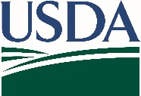
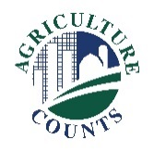
United States Department of Agriculture
OMB No, 0535-0220 Exp. Date 0x/xx/20xx
National Agricultural Statistics Service

July X, 20XX
What should I do when I receive my questionnaire?
Complete your survey in one of the following ways:

Online at agcounts.usda.gov. Online reporting is fast and secure. All you need is the survey code on the questionnaire to begin.
By mail or fax. Complete the questionnaire and mail it back in the prepaid envelope provided or fax it to 855-415-3687.

Why am I getting this letter?

Beginning next month, USDA’s National Agricultural Statistics Service (NASS) will collect cotton gin data throughout the ginning season (generally every two weeks). Your information is important, and we know your time is valuable, so we offer several options to respond. We recommend you respond online using the Respondent Portal at agcounts.usda.gov.

How will the data be used?

Cotton Ginnings reports provide a measure of the size of production or inventories so that prices can move in line with supply. Without good information, business risks and costs can increase. Once you and your fellow ginners respond, NASS will publish the combined results in Cotton Ginnings reports every two weeks during the survey season. All NASS reports are available online at nass.usda.gov.

You may receive an email reminder to complete the survey. The information you provide will be used for statistical purposes only. In accordance with federal law, your responses will be kept confidential and will not be disclosed in identifiable form.

Thank you for your participation and support of U.S. agriculture. If you have any questions, please contact us at 888-424-7828.
We are once again offering free copies of the Cotton Ginnings Record Book. If you would like one or more copies, please use the enclosed “Ginnings Record Book Order” form and envelope to place your order. If you prefer to make your request by email, send your mailing info to Kimberly Goeke at kimberly.goeke@usda.gov.

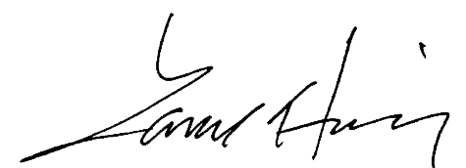
Sincerely,
Lance Honig
Chair, Agricultural Statistics Board
National Agricultural Statistics Service
U.S. Department of Agriculture
Enclosure
According to the Paperwork Reduction Act of 1995, an agency may not conduct or sponsor, and a person is not required to respond to a collection of information unless it displays a valid OMB control number. The valid OMB number is 0535-0220. The time required to complete this information collection is estimated to average 10 minutes, including the time for reviewing instructions, searching existing data sources, gathering, and maintaining the data needed, and completing and reviewing the collection of information.

COTTON GINNINGS RECORD BOOK ORDER

​ YES - Please provide me with ____________ copies of the Cotton Ginnings Record Book.

​ YES - Please provide me with a digital copy of the Cotton Ginnings 2023 Summary by email.

Please enter the address where you would like the books sent:
Operation / Name: __________________________________________
Street Address: ____________________________________________
City _______________________State _________Zip_____________
Phone: [______] ________ - __________
Email: ____________________________

