Appendix A Instrument Index
Reference from Part 810 | Description
Specific Authorization Request
§810.11(a)(1) | - Applicant  - Name  - Address  - Citizenship  - Corporate information as needed:  - Complete disclosure of all real parties in interest  - Location of incorporation or organization  - Location of its principal office  - Degree of any control or ownership by any foreign individual, corporation, partnership, firm, association, trust, estate, public or private institution or government agency
§810.11(a)(2) | - Person or Entity to receive the assistance or technology:  - Name  - Address  - Country  - Facility or Project:  - Name  - Location, including Country
§810.11(a)(3) | A description of the assistance or technology to be provided, including:  - Complete description of the proposed activity,  - Approximate monetary value  - Detailed description of any specific project to which the activity relates as specified in §§ 810.9(b)(7), (8), and (9)
Specific Authorization Request, Deemed Export
§810.11(b)(1) | A description of the technology that would be made available to the foreign national
§810.11(b)(2) | - Purpose of the proposed transfer  - Description of the applicant’s technology control program  - Any Nuclear Regulatory Commission standards applicable to the employer’s grant of access to the technology
§810.11(b)(3) | A copy of any confidentiality agreement to safeguard the technology from unauthorized use or disclosure between the applicant and the foreign national
§810.11(b)(4) | Background information about the foreign national, including:  - the individual’s citizenship  - All countries where the individual has resided for more than six months  - Training or educational background of the individual  - All work experience  - Any other known affiliations with persons engaged in activities subject to this part  - Any current immigration or visa status in the United States
§810.11(b)(4) | A statement signed by the foreign national that he/she will comply with the regulations under this part; will not disclose the applicant’s technology without DOE’s prior written authorization; and will not, at any time during or after his/her employment with the applicant, use the applicant’s technology for any nuclear explosive device, for research on or development of any nuclear explosive device, or in furtherance of any military purpose.
§810.11(c) | An applicant for a specific authorization related to the enrichment of fissile material must submit information that demonstrates that the proposed transfer will avoid, so far as practicable, the transfer of enabling design or manufacturing technology associated with such items; and that the applicant will share with the recipient only information required for the regulatory purposes of the recipient country or to ensure the safe installation and operation of a resulting enrichment facility, without divulging enabling technology.
Reports on Specifically Authorized Activity
§810.12(a)(1) | - Exporter  - Name  - Address  - Citizenship
§810.12(a)(2) | - Person or Entity receiving the assistance or technology:  - Name  - Address  - Country
§810.12(a)(3) | - A description of the activity  - Date it began  - Location  - Status  - Anticipated date of completion
§810.12(a)(4) | A copy of the DOE letter authorizing the activity
§810.12(d) | DOE may require reports to include such additional information that may be required by applicable U.S. law, regulation, or policy with respect to the specific nuclear activity or country for which specific authorization is required
Reports on Generally Authorized Activity
§810.12(c)(1) | - Exporter  - Name  - Address  - Citizenship
§810.12(c)(2) | - Person or Entity receiving the assistance or technology:  - Name  - Address  - Country
§810.12(c)(3) | - A description of the activity  - Date it began  - Location  - Status  - Anticipated date of completion
§810.12(c)(4) | A written assurance that the applicant has an agreement with the recipient ensuring that any subsequent transfer of materials, equipment, or technology transferred under general authorization under circumstances in which the conditions in § 810.6 would not be met will take place only if the applicant obtains DOE’s prior written approval

For applications not submitted via e810, no specific form or format is required for the information in each type of submittal. NNSA works with each applicant to assure that sufficient and accurate data is provided.
E810 provides more structure and the ability to reuse information for repetitive reporting. Screen shots of relevant data gathering are shown in Figure 1 to Figure 5. The Cross reference to the regulation is included below each figure. However, much of the requirement information is not amenable to form style data gathering and is handled in e810 via attached documents.

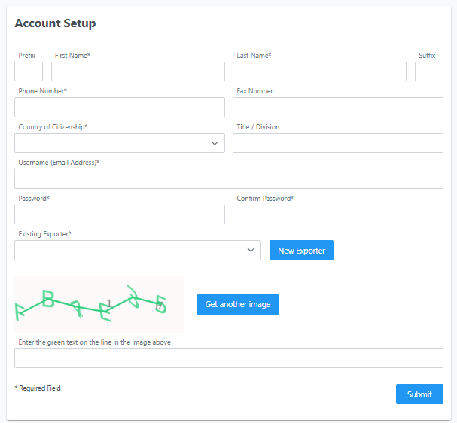
Figure 1A - Account Creation in e810 User Information Input

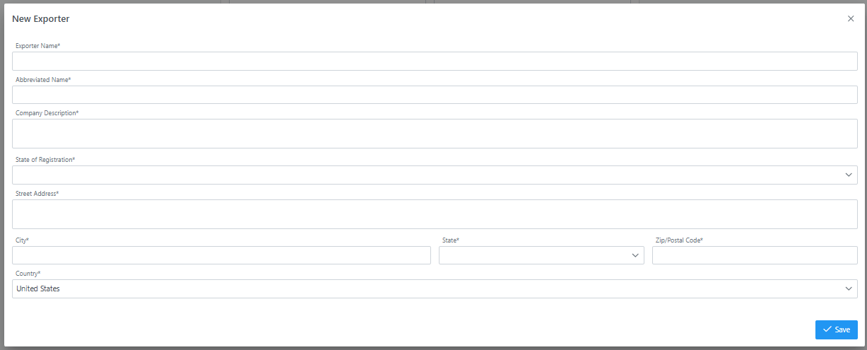
Figure 1 B - Account Creation in e810 New Exporter Information Input
The data required in Figure 1A and Figure 1B fulfills the requirements described in §§ 810.11(a)(1), 810.12(a)(1), and 810.12(c)(1). This form cannot handle the intricacies of corporate control, which would be required to be submitted as an attached file to any actual submittals. There are 11 text fields to be filled out with information readily available to any exporter in this industry. And One drop down selection to establish the state of residence of the export. Once this is completed within e810 it would only have to be addressed if information changes.

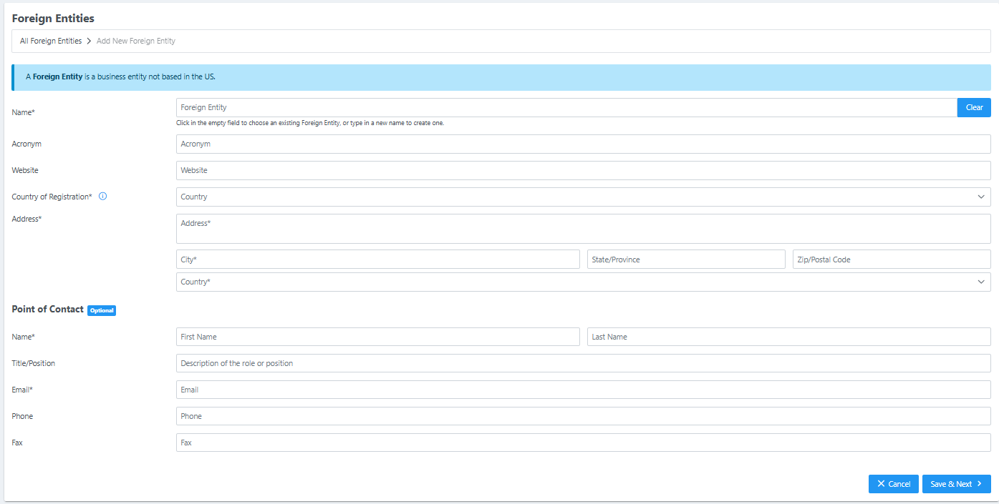
Figure 2 - Foreign entity in e810
The data required in Figure 2 on the left side fulfills the requirements described in §§810.11(a)(2), 810.12(a)(2), and 810.12(c)(2). The additional required information on the right is asked only for specific authorizations and is not explicitly within the rule. This information is to provide other government agencies information to allow the request processing to be done more quickly.

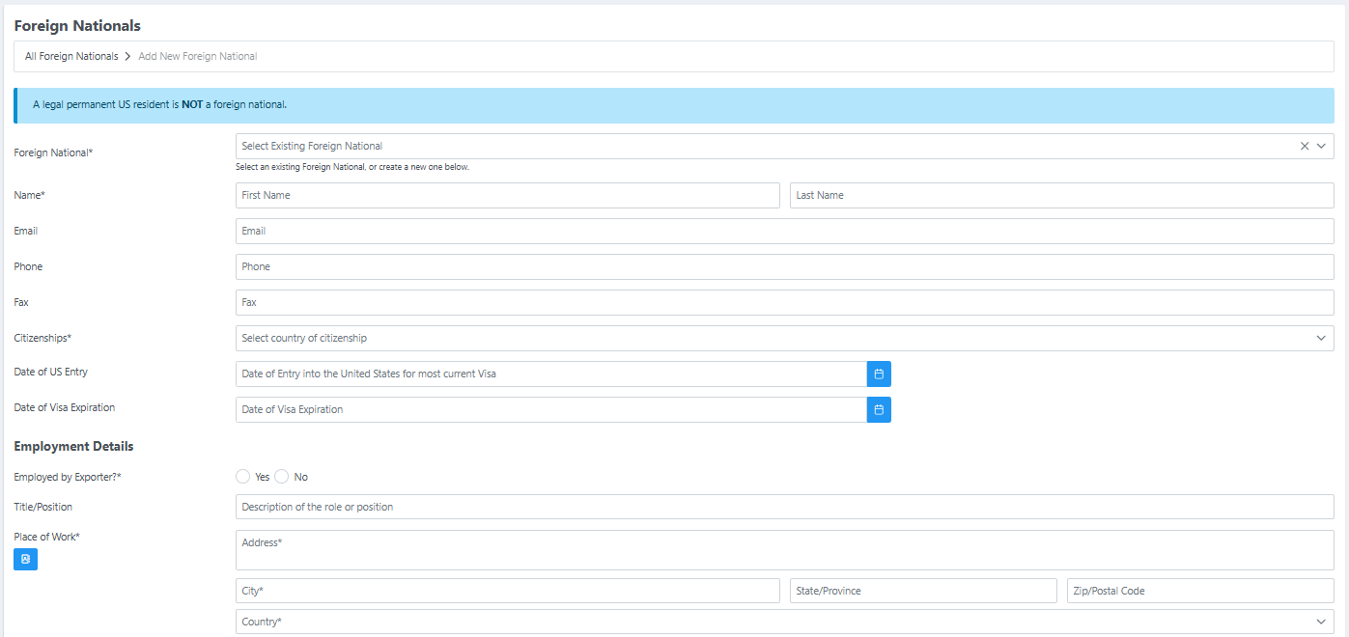
Figure 3 - Foreign National in e810
The data required in Figure 3 fulfills the requirements described in §810.11(b)(1), and partially fulfills the requirements in §810.11(b)(4). The additional information required in §810.11(b) is too complex for a simple form and is handle via document attachment in e810.

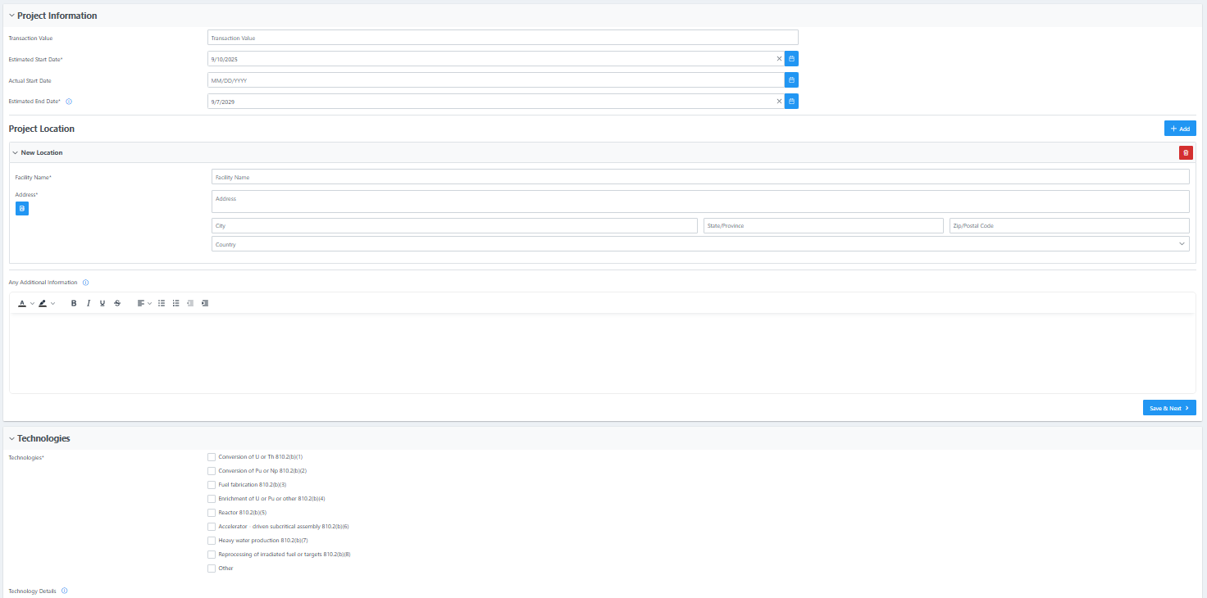
Figure 4 – Transaction and contract information in e810
The information requested in Figure 4 fulfill the requirements in §810.11(a)(3). The checkbox list of technology is directly from relevant sections of the rule and simplify the exporter application by clarifying what specific area of the regulation they believe applies. Where possible, suggested dropdown lists limit free form typing and create more consistency. However, the exporter is always allowed an “other” option with freeform text to explain.

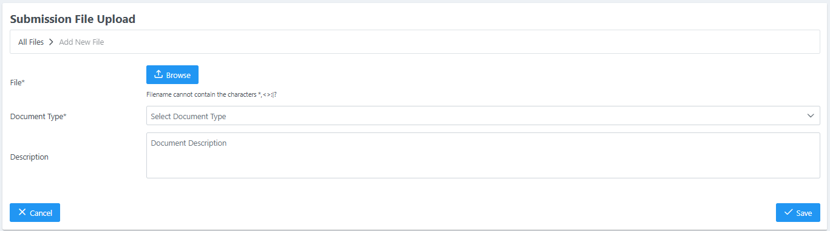
Figure 6 - File upload in e810
To allow the users flexibility in providing the more complex information needed to process Part 810 submittals, free form documents can be attached either via e-mail or within the e810 system. Figure 6 depicts the upload screen.

