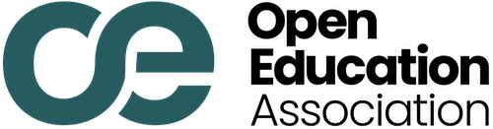
1930 18th St NW, Suite B2-2468 • Washington, DC 20009 opened.org • (202) 750-1637 • contact@opened.org

April 24, 2026

Comment on Docket ID ED2026SCC0298 Submitted via Regulations.gov
The Open Education Association submits this comment in response to the Department of Education's request for public comment on the Cash Management Contract URL Collection under 34 CFR § 668.164 OMB Control No. 18450147.
The Open Education Association is a national membership organization that works to expand the use of openly licensed educational materials and practices across U.S. higher education.
As the Department evaluates the utility of this collection (question 4, we offer a related transparency gap for its consideration. The rationale for the collection of contract URLs under § 668.164(e) and (f) is that it helps ensure accountability and encourages practices that serve students. The same rationale supports disclosure of the third-party arrangements allowed under subsection (c) for books and supplies.
Section 668.164(c)(2)(i) permits institutions to automatically bill students for books and supplies as part of tuition and fees, provided the institution has “an arrangement with a book publisher or other entity that enables it to make those books or supplies available to students below competitive market rates.ˮ This provision was intended to protect students from being overcharged.¹
A 2024 analysis by the Student Public Interest Research Groups reviewed 171 automatic textbook billing contracts from 92 public institutions and found that in many cases savings are difficult to evaluate and some contracts may provide no savings at all.² It also found that some arrangements charge students a per-credit-hour fee regardless of the cost of the studentʼs actual materials, in some cases billing students for openly licensed resources that should be free—or for courses that use no materials at all.

¹ https://docs.defendstudents.org/peer/202343PEERReturns-Textbooks-FNL.pdf
² https://studentpirgs.org/assets/uploads/2024/06/PIRGAutomatic-Textbook-Billing-June-2024.pdf

Without a systematic disclosure process, neither the Department nor the public can assess whether institutions are charging students unfairly for books and supplies or whether they meet the below-market-rate standard that federal regulations require.
As the Department reviews this collection with respect to campus banking contracts under § 668.164, we encourage it to consider a similar collection for the automatic textbook billing arrangements allowed under the same section.
FSA Response: We thank the commenter for their comment. This information collection is limited to the requirements under 34 CFR 668.164(e)(2)(viii) and 34 CFR 668.164(f)(4)(iii)(B) and does not encompass arrangements described under 34 CFR 668.164(c)(2). While the Department recognizes the policy considerations raised, expansion of disclosure requirements to arrangements under 34 CFR 668.164(c)(2) is outside the scope of this collection. No change made to the information collection.
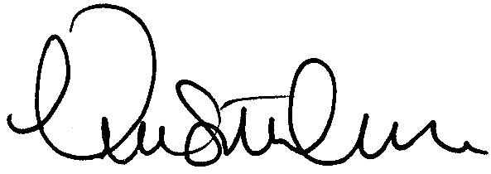
We appreciate the opportunity to comment. Sincerely,
Nicole Allen Board President
Open Education Association

