Influx Transfer Manual and Prescreen Criteria Review (Form P-17)

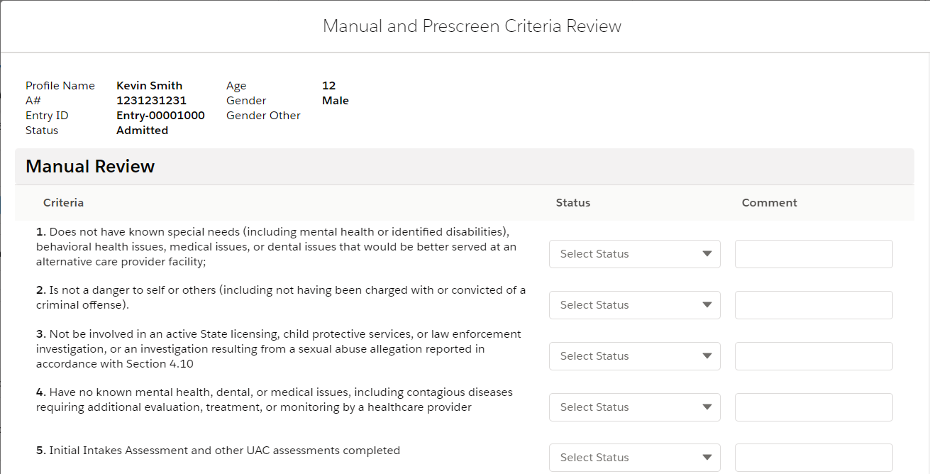
Sex
Options for all dropdown fields in the Prescreen Criteria section are:
- Pass
- Fail
Options for all dropdown fields in the Manual Review section are:
- Pass
- Fail
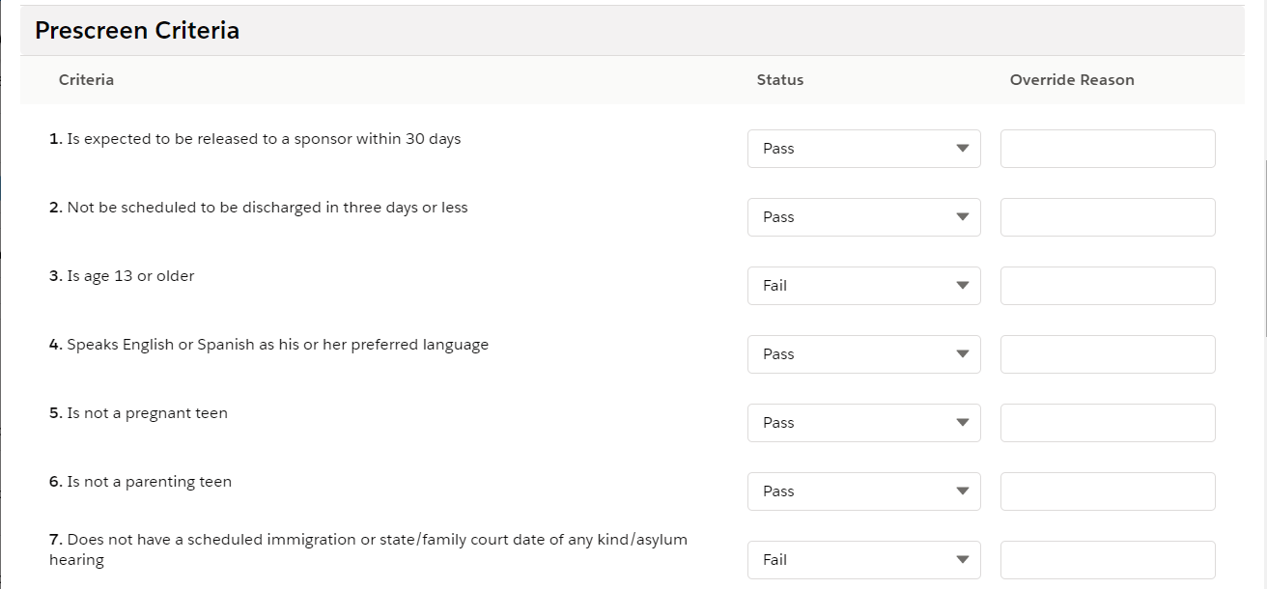
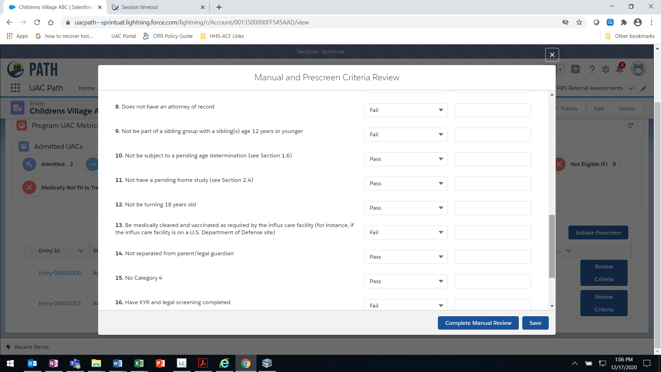

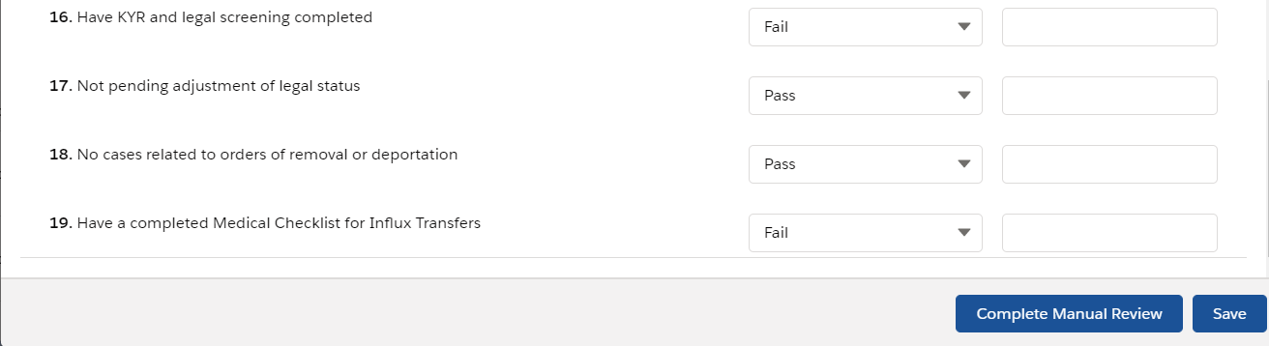
OMB 0970-0554 [valid through MM/DD/YYYY]
THE PAPERWORK REDUCTION ACT OF 1995 (Pub. L. 104-13) STATEMENT OF PUBLIC BURDEN: The purpose of this information collection is to evaluate each UAC’s eligibility to be transferred to an influx care facility. Care provider staff review and update information on daily during times of influx. Public reporting burden for this collection of information is estimated to average 0.5 hours per response, including the time for reviewing instructions, gathering and maintaining the data needed, and reviewing the collection of information. This is a mandatory collection of information (Homeland Security Act, 6 U.S.C. 279). An agency may not conduct or sponsor, and a person is not required to respond to, a collection of information subject to the requirements of the Paperwork Reduction Act of 1995, unless it displays a currently valid OMB control number. If you have any comments on this collection of information please contact UACPolicy@acf.hhs.gov.
P-17 [Rev. MM/DD/YYYY]

