Enhancing Data-driven Disease Detection in Newborns (ED3N)
  - OMB Control No. 0920- 1391 Exp. Date 4/30/2026
Type of ICR - EXTENSION

  - Supporting Statement Part B –
  - Collections of Information Employing Statistical Methods

  - Program Official/Project Officer:
  - Title: Carla Cuthbert, PhD, FACMG
  - Phone: 770-488-7571
  - Email: ccuthbert@cdc.gov
  - Fax: 770-488-4520

Date: December 10, 2025
Table of Contents
B.1. Respondent Universe and Sampling Methods 3
B.2. Procedures for the Collection of Information 3
B.3. Methods to Maximize Response Rates and Deal with No Response 4
B.4. Test of Procedures or Methods to be Undertaken 4
B.5. Individuals Consulted on Statistical Aspects and Individuals Collecting and/or Analyzing Data 5

Part B. Collections of Information Employing Statistical Methods

B.1. Respondent Universe and Sampling Methods

Respondents will include all 53 state NBS programs and data collected will include data on all babies born and screened throughout the United States. It is necessary to include data on all babies so as to ensure coverage of the diversity of babies screened, to be able to make appropriate risk assessments, and owing to the nature of the rare diseases being screened for, many of which have population birth prevalences of <1:100,000. We expect all NBS programs to participate in this work and are utilizing electronic and automated data collection methods to reduce participant burden.

B.2. Procedures for the Collection of Information

Data sources for ED3N are existing newborn screening records from participating NBS programs. The data elements that will be collected and shared with CDC are listed below. It is anticipated that data collection methods will utilize electronic data transfer mechanisms including flat file uploads, Health Level Seven International (HL7) 2.5, and/or Fast Healthcare Interoperability Resources (FHIR), if available. Owing to the nature of ED3N and NBS programs, data collection will occur daily, but burden should be minimized through the utilization of an automated electronic mechanism.
The system will collect, store, or share the following types of information (Attachments 3a and 3b):
• Infant Demographics (date of birth, time of birth, sex, birthweight, gestational age, etc.)
• Parental Demographics (race, ethnicity, education, age, etc.)
• Specimen Information (age of infant at time of collection, time of collection, collection source, etc.)
• Molecular Results (instrument used, sequencing methodology, regions analyzed, single gene variant data)
• Biochemical Results (instrument used, state screening cutoffs and algorithms values, biochemical analyte values, daily mean or median of analytes)
• Follow-up/Clinical/Diagnostic Information (age at diagnosis, age at treatment, diagnostic biochemical analyte values, diagnostic single gene variant data, etc.)
• Program Information (one screen vs. two screen states, years started testing for the disorder, combinations seen by the state, etc.)

Upon collection, data will be used to:

• Create analytic solutions (e.g., machine learning algorithms) for biochemical analytes to help newborn screening programs identify at-risk newborns.
• Curate and interpret molecular variants found through newborn screening.
• Evaluate program performance metrics (e.g., false positive and negative rates, positive predictive value, etc.).
• Understand genotype-phenotype relationships in rare diseases detected through newborn screening.

B.3. Methods to Maximize Response Rates and Deal with No Response

Utilization of electronic and automated data collection methods should maximize response rates. The system will contain a number of validation constraints to flag issues of potential data integrity or non-response. Programs will enter into Data Use/Sharing Agreements (Attachment 4b) with CDC that outline the expectations of data collection and processes to be utilized should data collection not occur or issues with data collection arise.
This project is ongoing and is intended to be used by programs during their daily required screening processes. As such, there is not an estimated response rate or timeline to achieve a specific response rate. However, data collection of quality indicators from state NBS programs has illustrated an over 90% response rate by states using a much more burdensome data collection process, so it is expected that this project will see at least this response rate given the streamlined and electronic processing being utilized.

B.4. Test of Procedures or Methods to be Undertaken

The ED3N platform utilizes an iterative approach to development and pilot testing. Pilot tests have been conducted with 9 or less NBS programs. Please see figure below for further details:

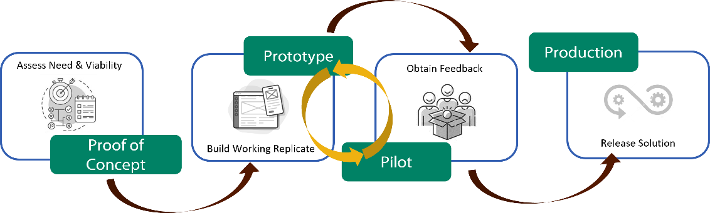.
For the machine learning component of ED3N, retrospective data from NBS programs will be utilized to create and train the algorithms using standard analytical processes. To validate outcomes, the results from the machine learning output will be compared with the results generated from the NBS programs.

B.5. Individuals Consulted on Statistical Aspects and Individuals Collecting and/or Analyzing Data

Table 1. Personnel Consulted on Statistical Design

Name | Title | Affiliation
FEDERAL AGENCY
Hubert Vesper, PhD | Sup. Research Chemist | NCEH
ACADEMIC INSTITUTIONS
Andreas Rohrwasser, PhD | Director | Utah Public Health Laboratory
Joseph Orsini, PhD | Director | Wadsworth Center
Steven Hawken, PhD | Asst Professor | University of Ottawa
Matthew Henderson | Asst Professor | University of Ottawa
Bryce Asay, PhD | Data Analyst | Utah Public Health Laboratory
Curt Scharfe | Assoc Professor | Yale

Table 2. Personnel Responsible for Collection and Analysis of Information

Name | Title | Affiliation
Kostas Petritis, PhD | Laboratory Chief/Lead Biologist | NCEH
Andrew Chiang, PhD | Developer | Booz Allen Hamilton
Clare Grazal, PhD | Bioinformatician | Booz Allen Hamilton

