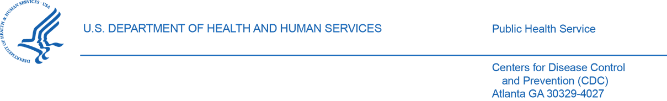

April 19, 2023

VIA ELECTRONIC TRANSMISSION

Stacey Y. Brayboy
Senior Vice President, Public Policy &
Government Affairs
March of Dimes

Re: Agency/Docket Number 30Day-23-1273

Dear Stacey Brayboy:

Thank you for the letter to Centers for Disease Control and Prevention (CDC) Director Rochelle P. Walensky, regarding the Pregnancy Risk Assessment Monitoring System (PRAMS). I am responding on Dr. Walensky’s behalf.

Since its inception in 1987, PRAMS has collected site-specific, population-based data on maternal attitudes and experiences before, during, and shortly after pregnancy, which inform many programs and policies. PRAMS surveillance currently operates in 50 sites (46 states, two cities, and two territories); these jurisdictions represent about 81% of all U.S. births.

We appreciate your comment regarding PRAMS use of a response rate threshold to determine which sites’ annual data will be released to researchers and the public. One advantage of this approach is that it motivates sites to maintain adherence to the data collection protocol, including making multiple attempts to contact sampled women. This in turn helps ensure that the PRAMS data released are high-quality and representative of their respective study populations. The PRAMS median response rate, which was 57.5% most recently in 2020, consistently exceeds that of most other federally sponsored surveys.

Additionally, it is important to note that the vast majority of PRAMS sites (84%) met or exceeded the response rate threshold of 50% for 2020. On average, about 75% of PRAMS sites meet the threshold annually, and thus their data are included in data files made available upon request to researchers; additionally, these data are included in CDC annual reports of selected aggregate maternal and child health (MCH) indicators estimates. While data from PRAMS sites not meeting the response rate threshold are not included in the multi-site data set released by CDC, these sites do nevertheless receive a data file with their own data, which has been cleaned and weighted by CDC.

The primary disadvantage of the response rate threshold requirement is that critical MCH data for some sites and years are not available for use by researchers or public dissemination. This exclusion includes sites that have high levels of maternal and infant morbidity and mortality where data to inform action is important. In addition, resources committed to data collection and processing efforts by both CDC and jurisdictions are not fully utilized. To that end, CDC is currently conducting comprehensive nonresponse bias assessments for the 2019 and 2020 PRAMS birth cohorts and will continue to conduct similar assessments with future birth cohorts. These assessments will inform decisions about potentially enabling the release of additional site data by CDC without requiring a specific response rate, while yet maintaining data validity and reliability. CDC will keep PRAMS grantees and MCH partners, including March of Dimes, apprised of progress and decisions in this area.

CDC is currently engaged in several other PRAMS updates to improve data quality, completeness, efficiency, and timeliness. In 2023, PRAMS is expanding the current modes of data collection, beyond mail and telephone, to include an option for web-based survey completion. Preliminary analysis of this effort indicates it has the potential to increase response rates and reduce resources needed for data collection. Also in 2023, PRAMS is transitioning to a new process for researchers to access PRAMS data, which will make it easier and faster to obtain PRAMS data for analyses. Researchers will be able to visit a secure portal to download PRAMS data, after providing some basic information (e.g., name, title, organization) and agreeing to the terms in a CDC Data Sharing Agreement via CDC’s Secure Access Management System.

For 2022 births, PRAMS fielded a supplement on Social Determinants of Health (SDOH) that included questions such as food, housing, and transportation insecurity and experiences of racism and discrimination. These data will be available as part of the 2022 birth cohort PRAMS data release in early 2024. PRAMS will be launching a new (Phase 9) questionnaire in the summer of 2023 that will include core and standard questions related to respectful care and SDOH. These data will be collected with the 2023 birth cohort and will be completed through late 2024. Data on COVID-19 Experiences and Vaccine supplements are currently available to researchers upon request through the PRAMS data application process.

Thank you for your interest in PRAMS. We value March of Dimes’ continued partnership in optimizing the health and well-being of mothers and their children.

Sincerely,

Karen Hacker, MD, MPH
Director, National Center for Chronic Disease
Prevention and Health Promotion, CDC

https://www.cdc.gov/prams/prams-data/selected-mch-indicators.html
https://www.cdc.gov/prams/prams-data/researchers.htm

