Attachment 2a
0920-1389
03/31/2026

NCEH DLS Quality Assurance Programs Information Collection Request 60-Day Federal Register Notice Public Comment Summary
Number of Comments Received: 1
Public Comment on CDC-2025-0586
OMB 0920-1389
Subject: NCEH DLS Quality Assurance Programs
https://www.regulations.gov/comment/CDC-2025-0586-0002
PROPIN CONFIDENTIAL
CDC-2025-0586
OMB 0920-1389
NCEH DLS Quality Assurance Programs
I am authorizing the Attorney General and the Chief of Counsel under the Centers for Disease Control and Prevention, HCEH to determine whether a public hearing or public meeting should occur, on my behalf and request to ensure the compliance standards were followed by proper procedures and guidelines for the reporting generated from this process. This type of collection by the Division of Laboratory Science for quality assurance should review the accuracy of what has been reported and determine if there are discrepancies between the original data set. There should also be transparency through disclosure requirements and procedures to ensure this data collection’s integrity and value for future research studies.
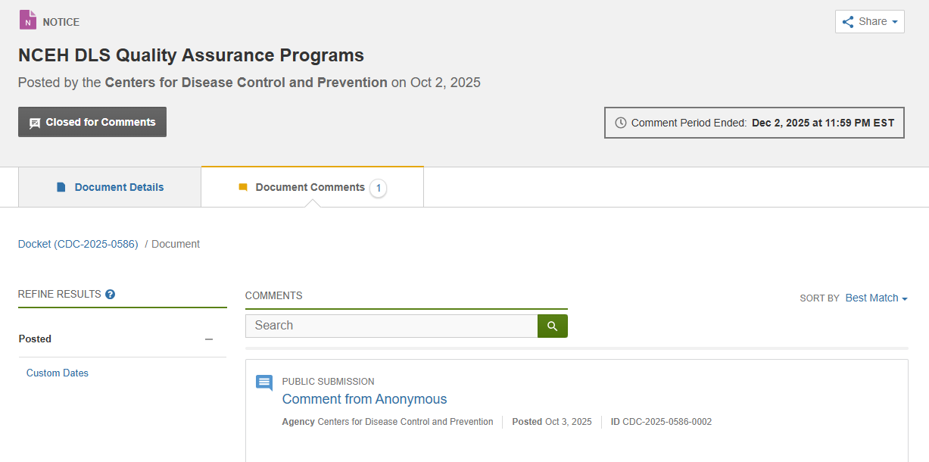

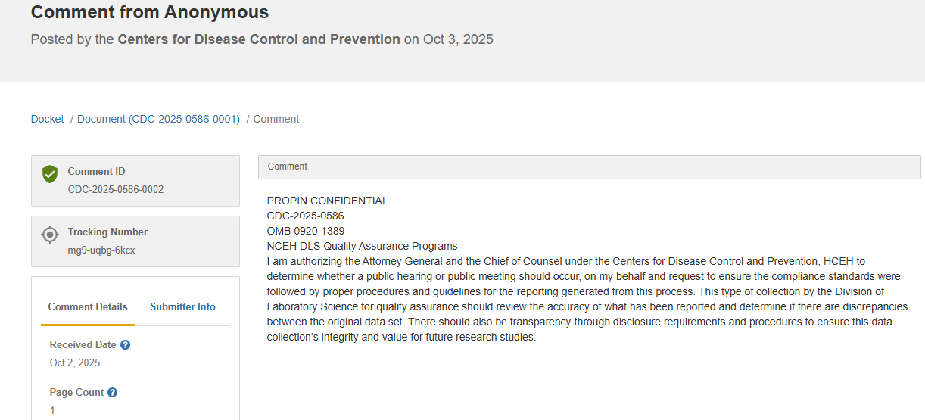
Program response to anonymous public comment:
The Centers for Disease Control and Prevention (CDC), through the National Center for Environmental Health (NCEH) and its Division of Laboratory Sciences (DLS), thanks the commenter for their input regarding quality assurance and data transparency in laboratory reporting. NCEH/DLS agrees that compliance with established procedures and maintaining data integrity are critical to ensuring accurate and reliable results. NCEH/DLS Quality Assurance Programs include rigorous internal and external review processes that align with federal standards and oversight requirements.
Decisions about public hearings or meetings are guided by applicable laws and agency procedures. CDC and NCEH/DLS remain committed to transparency and accountability through compliance with the Paperwork Reduction Act and ongoing evaluation of data collection and reporting practices to strengthen the accuracy, integrity, and value of laboratory data for research and public health programs.

