Privacy Policy Statement and PRA Statement 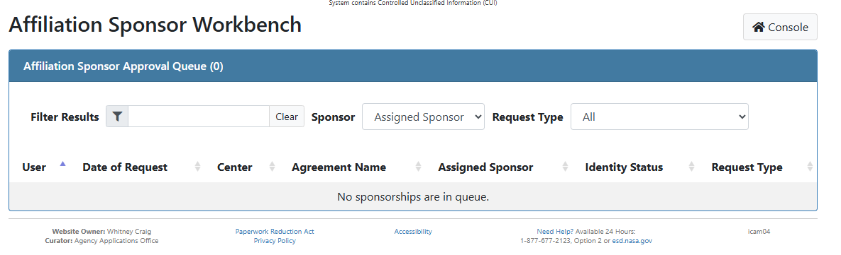

Privacy Policy Statement
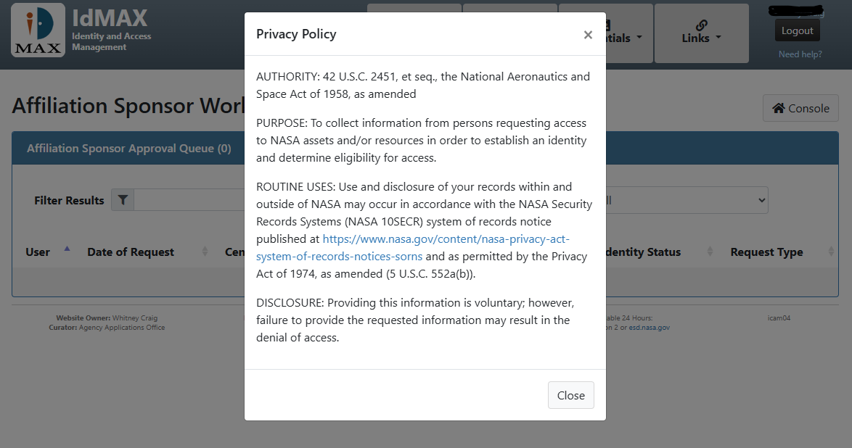

PRA Statement
