EDA - Regional Impact v4 FINAL

Survey Flow
Block: Coalition Progress (11 Questions)
Standard: Accelerating Innovation in Emerging Technologies (7 Questions)
Standard: Help workers access new job opportunities and training (8 Questions)
Standard: Increase new business growth and entrepreneurial activity (9 Questions)
Standard: Building critical enabling infrastructure (11 Questions)
Standard: Help businesses adopt new technologies and enter new markets (11 Questions)
Standard: Sustain regional governance (8 Questions)
EndSurvey: Advanced
Page Break

Start of Block: Coalition Progress

. OMB Control Number: 0610-0110
This survey was prepared by the Purdue Center for Regional Development using Federal funds under award ED22HDQ3070082 from the Economic Development Administration, U.S. Department of Commerce. The statements, findings, conclusions, and recommendations are those of the author(s) and do not necessarily reflect the views of the Economic Development Administration or the U.S. Department of Commerce.

. Coalition Contact Information and Progress

a. Dear Build Back Better Regional Challenge (BBBRC) Coalition:
When responding to these questions please keep in mind only your BBBRC region, all component projects from your coalition funded via the BBBRC program, and direct impacts from the coalition's work over the past quarter. As the intent of BBBRC investments is to spur additional coalition progress, answers in the first section (Q1-Q7) may include information about component projects that EDA was unable to fund or about highly complementary activities in the region.
Rural areas refer to or can include those that are outside urban areas. A list of areas that meet Census’s 2020 definition of “urban” can be found here (scroll to the bottom).

a1 Please provide the contact information of the person filling out this survey.
- Full Name (First and Last) (1) __________________________________________________
- Email: (2) __________________________________________________
- Organization (3) __________________________________________________

Q1 Regarding your coalition's implementation/progress over the past quarter:
How much PUBLIC investment from federal, state, and local governments as well as philanthropy was secured (roundup dollars, no decimals) by type for projects directly related to the BBBRC coalition? If none, use 0 (zero).
Please note that PRIVATE investment, if any, is asked for on Q18 under the increasing new business growth and entrepreneurial activity section.
Dollars (1)
Federal (1)
State (2)
Regional (3)
Local (4)
Other (5)

Q2 How many jobs were retained? Job should be considered retained if they would have been lost if not for this EDA investment. If none, use 0 (zero).
Please note jobs created is asked for on Q19 under the increasing new business growth and entrepreneurial activity section.
________________________________________________________________

Q3 Has your coalition had any accomplishments this past quarter? If so, please share details. Accomplishments may be at the coalition level and not tied to a specific component project.
________________________________________________________________
________________________________________________________________
________________________________________________________________
________________________________________________________________
________________________________________________________________

Q4 Has your coalition encountered any barriers/challenges this past quarter? If so, please share details. Barriers/challenges may be at the coalition level and not tied to a specific component project.
________________________________________________________________
________________________________________________________________
________________________________________________________________
________________________________________________________________
________________________________________________________________

Q5 Has your coalition needed any additional resources, assistance, or information this past quarter? If so, please share details.
________________________________________________________________
________________________________________________________________
________________________________________________________________
________________________________________________________________
________________________________________________________________

Q6 Does your coalition have a success story you would like to share with us regarding your BBBRC work this past quarter?
________________________________________________________________
________________________________________________________________
________________________________________________________________
________________________________________________________________
________________________________________________________________

Q7 Does your coalition have anything else to add regarding your BBBRC work this past quarter?
________________________________________________________________
________________________________________________________________
________________________________________________________________
________________________________________________________________
________________________________________________________________

End of Block: Coalition Progress

Start of Block: Accelerating Innovation in Emerging Technologies

. Accelerating Innovation in Emerging Technologies

b. This section will ask about accelerating innovation in emerging technologies (e.g., description of activities/work completed, patents filed, and amount of research & development dollars invested).
When responding to these questions please keep in mind only your BBBRC region, all component projects from your coalition funded via the BBBRC program, and direct impacts from the coalition's work over the past quarter.
Rural areas refer to or can include those that are outside urban areas. A list of areas that meet Census’s 2020 definition of “urban” can be found here (scroll to the bottom).
Does your coalition have any activities to report regarding accelerating innovation in emerging technologies this past quarter?
- Yes (1)
- No (2)

Display This Question:
If b. = Yes

Q8 Describe any activities/work completed toward accelerating innovation in emerging technologies this past quarter by your coalition. Please specify projects and organizations involved.
________________________________________________________________
________________________________________________________________
________________________________________________________________
________________________________________________________________
________________________________________________________________

Display This Question:
If b. = Yes

Q9 During this past quarter, how many invention disclosures, patents, licensing deals or other commercialization activities were filed? If none, use 0 (zero).
No. (1)
Disclosures (4)
Patents (5)
Licensing deals (6)
Other (7)

Display This Question:
If b. = Yes

Q10 During this past quarter, how many dollars were spent in research & development (roundup dollars, no decimals) by organizations (such as businesses, public/private universities, etc.) directly related to the BBBRC efforts? If none, use 0 (zero).
________________________________________________________________

Display This Question:
If If During this past quarter, how many dollars were spent in research &; development (roundup dollars, no decimals) by organizations (such as businesses, public/private universities, etc.) directly ... Text Response Is Greater Than 0

Display This Question:
If If During this past quarter, how many dollars were spent in research &; development (roundup dollars, no decimals) by organizations (such as businesses, public/private universities, etc.) directly ... Text Response Is Greater Than 0

Q11 Can you share with us some outcomes that were a direct result of these innovations? If none for now, you can leave blank.
________________________________________________________________
________________________________________________________________
________________________________________________________________
________________________________________________________________
________________________________________________________________

End of Block: Accelerating Innovation in Emerging Technologies

Start of Block: Help workers access new job opportunities and training

. Help workers access new job opportunities and training

c. This section will ask about helping workers access new job opportunities and training (e.g., description of activities/work completed, number of programs/trainings developed/implemented, number of participants gaining/upgrading skills, and number of workers placed in new jobs). Note that workers are inclusive of laborers currently employed, not employed but actively searching, and discouraged workers who are not actively searching and out of the labor force for various reasons.
When responding to these questions please keep in mind only your BBBRC region, all component projects from your coalition funded via the BBBRC program, and direct impacts from the coalition's work over the past quarter.
Rural areas refer to or can include those that are outside urban areas. A list of areas that meet Census’s 2020 definition of “urban” can be found here (scroll to the bottom).
Does your coalition have any activities to report regarding helping workers access new job opportunities and training this past quarter?
- Yes (1)
- No (2)

Display This Question:
If c. = Yes

Q12 Describe any activities/work completed toward helping workers access new job opportunities and training this past quarter by your coalition. Please specify projects and organizations involved.
________________________________________________________________
________________________________________________________________
________________________________________________________________
________________________________________________________________
________________________________________________________________

Display This Question:
If c. = Yes

Q13 Provide the counts of participants and completions in workforce training programs by length of program in the table below. Workforce training programs may include any activity (training, course, credential program, etc.) that aims to increase the knowledge and skills of program participants in a vocation.
Participants should include any newly enrolled participant in any activity including but not limited to a training, course, or credential program. If programming began and ended within this past quarter, please include count in both columns.
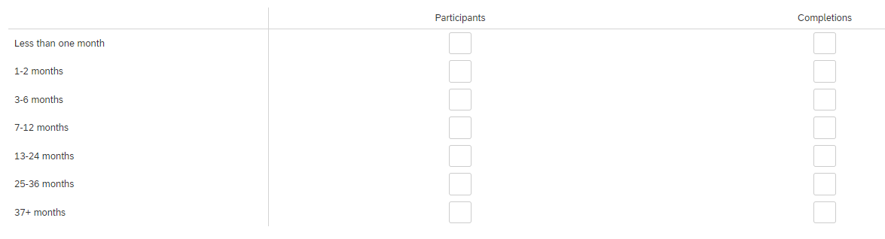

Display This Question:
If c. = Yes
Q14 How many participants were placed (jobs placed are jobs that had or will have vacancies prior to and after the EDA grant funding and, due to EDA investments, now have workers matched or places into those jobs) in jobs this past quarter? If none, use 0 (zero).
________________________________________________________________

End of Block: Help workers access new job opportunities and training

Start of Block: Increase new business growth and entrepreneurial activity

. Increase new business growth and entrepreneurial activity

d. This section will ask about increasing new business growth and entrepreneurial activity (e.g., description of activities/work completed, prototypes, licensing deals, number of businesses formed, amount of venture capital funds secured, amount of angel investment funds secured, amount of other private investment secured, number of new jobs created, and number of employees obtaining a promotion).
When responding to these questions please keep in mind only your BBBRC region, all component projects from your coalition funded via the BBBRC program, and direct impacts from the coalition's work over the past quarter.
Rural areas refer to or can include those that are outside urban areas. A list of areas that meet Census’s 2020 definition of “urban” can be found here (scroll to the bottom).
Does your coalition have any activities to report regarding increasing new business growth and entrepreneurial activity this past quarter?
- Yes (1)
- No (2)

Display This Question:
If d. = Yes

Q15 Describe any activities/work completed toward increasing new business growth and entrepreneurial activity this past quarter by your coalition directly related to BBBRC efforts. Please specify projects and organizations.
________________________________________________________________
________________________________________________________________
________________________________________________________________
________________________________________________________________
________________________________________________________________

Display This Question:
If d. = Yes

Q16 How many new businesses were formed as a result of the BBBRC coalition work this past quarter? If none, use 0 (zero).
________________________________________________________________

Display This Question:
If If How many new businesses were formed as a result of the BBBRC coalition work this past quarter? If... Text Response Is Greater Than 0

Q16b Please share number of businesses formed and its primary six-digit NAICS code
Number of businesses (1)
Six-digit NAICS Code (1)
Six-digit NAICS Code (2)
Six-digit NAICS Code (3)
Six-digit NAICS Code (4)
Six-digit NAICS Code (5)
Six-digit NAICS Code (6)
Six-digit NAICS Code (7)
Six-digit NAICS Code (8)
Six-digit NAICS Code (9)
Six-digit NAICS Code (10)
Other 1 (please specify product or service) (11)
Other 2 (please specify product or service) (12)

Display This Question:
If d. = Yes

Q17 How much PRIVATE investment was secured (roundup dollars, no decimals) by type for projects directly related to the BBBRC coalition? If none, use 0 (zero). Please note that investments by philanthropy, local, state, regional, and federal government is asked for on Q1 under the coalition progress section.
Dollars (1)
Venture/Angel (1)
Other private (please specify) (3)

Display This Question:
If If How much PRIVATE investment was secured (roundup dollars, no decimals) by type directly related to the BBBRC effort over the past quarter? If none, use 0 (zero). Please note that investments by ph... Text Response Is Greater Than 0
Or Or How much PRIVATE investment was secured (roundup dollars, no decimals) by type directly related to the BBBRC effort over the past quarter? If none, use 0 (zero). Please note that investments by ph... Text Response Is Greater Than 0

Display This Question:
If d. = Yes

Q18 How many new jobs (new jobs that are directly or indirectly generated from EDA grant funding or associated follow-on private investments) were created this past quarter? If none, use 0 (zero).
Please do not include jobs generated by the construction and/or renovation/upgrade of critical infrastructure. These are asked for on Q20a and Q21a under the building, using, or enabling critical infrastructure section.
________________________________________________________________

End of Block: Increase new business growth and entrepreneurial activity

Start of Block: Building critical enabling infrastructure

. Building critical enabling infrastructure

e. This section will ask about building, using, or enabling critical infrastructure (e.g., description of activities/work completed, number of buildings/facilities built, number of building/facilities renovated/upgraded, number of business/industrial parks built/upgraded, etc.).
When responding to these questions please keep in mind only your BBBRC region, all component projects from your coalition funded via the BBBRC program, and direct impacts from the coalition's work over the past quarter.
Rural areas refer to or can include those that are outside urban areas. A list of areas that meet Census’s 2020 definition of “urban” can be found here (scroll to the bottom).
Does your coalition have any activities to report regarding building, using, or enabling critical infrastructure this past quarter?
- Yes (1)
- No (2)

Display This Question:
If e. = Yes

Q19 Describe any activities/work completed towards building or enabling critical infrastructure this past quarter by your coalition. Please specify projects and organizations involved. Make sure to include the approximate value of related purchased equipment.
________________________________________________________________
________________________________________________________________
________________________________________________________________
________________________________________________________________
________________________________________________________________

Display This Question:
If e. = Yes

Q20 During this past quarter, how many buildings/facilities were built? If none, use 0 (zero).
________________________________________________________________

Display This Question:
If If During this past quarter, how many buildings/facilities were built? If none, use 0 (zero). Text Response Is Greater Than 0

Q20a How many jobs were created during the construction of these facilities?
Please note that all other (non-construction and/or renovation jobs) new jobs related to the BBBRC efforts should be included on Q19 under the increasing new business growth and entrepreneurial activity section.
________________________________________________________________

Display This Question:
If If During this past quarter, how many buildings/facilities were built? If none, use 0 (zero). Text Response Is Greater Than 0

Q20b Please describe how these buildings/facilities are being used.
________________________________________________________________
________________________________________________________________
________________________________________________________________
________________________________________________________________
________________________________________________________________

Display This Question:
If e. = Yes

Q21 During this past quarter, how many buildings/facilities were renovated/upgraded? If none, use 0 (zero).
Please note that all other (non-construction and/or renovation jobs) new jobs related to the BBBRC efforts should be included on Q19 under the increasing new business growth and entrepreneurial activity section.
________________________________________________________________

Display This Question:
If If During this past quarter, how many buildings/facilities were renovated/upgraded? If none, use 0 (zero). Please note that all other (non-construction and/or renovation jobs) new jobs related t... Text Response Is Greater Than 0

Q21a How many jobs were created during the renovation/upgrade of these facilities?
________________________________________________________________

Display This Question:
If If During this past quarter, how many buildings/facilities were renovated/upgraded? If none, use 0 (zero). Please note that all other (non-construction and/or renovation jobs) new jobs related t... Text Response Is Greater Than 0

Q21b Please describe how these buildings/facilities are being used.
________________________________________________________________
________________________________________________________________
________________________________________________________________
________________________________________________________________
________________________________________________________________

Display This Question:
If e. = Yes

Q22 How many business/industrial parks were built/upgraded this past quarter? If none, use 0 (zero).
________________________________________________________________

Display This Question:
If If How many business/industrial parks were built/upgraded this past quarter? If none, use 0 (zero). Text Response Is Greater Than 0

Q22a How many of these were in rural areas? If none, use 0 (zero).
As a reminder, rural areas refer to or can include those that are outside urban areas. For a list of areas that meet Census’s 2020 of “urban” can be found here (scroll to the bottom).
________________________________________________________________

End of Block: Building critical enabling infrastructure

Start of Block: Help businesses adopt new technologies and enter new markets

. Help businesses adopt new technologies and enter new markets

f. This section will ask about helping businesses adopt new technologies and enter new markets (e.g., description of activities/work completed, number of businesses that expanded their market, number of new technologies adopted by/transferred, number of businesses engaged in accelerators/testbeds, and number of businesses involved in and type of innovative activities).
When responding to these questions please keep in mind only your BBBRC region, all component projects from your coalition funded via the BBBRC program, and direct impacts from the coalition's work over the past quarter.
Rural areas refer to or can include those that are outside urban areas. A list of areas that meet Census’s 2020 definition of “urban” can be found here (scroll to the bottom).
Does your coalition have any activities to report helping businesses adopt new technologies and enter new markets this past quarter?
- Yes (1)
- No (2)

Display This Question:
If f. = Yes

Q23 Describe any activities/work completed towards helping businesses adopt new technologies and/or enter new markets this past quarter directly due to your coalition's efforts/activities. Please specify projects and organizations involved.
________________________________________________________________
________________________________________________________________
________________________________________________________________
________________________________________________________________
________________________________________________________________

Display This Question:
If f. = Yes

Q24 How many businesses expanded their markets (reached additional local, regional, national, or international markets compared to pre-coalition markets) this past quarter directly due to coalition efforts/activities? If none, use 0 (zero).
________________________________________________________________

Display This Question:
If If How many businesses expanded their markets (reached additional local, regional, national, or inte... Text Response Is Greater Than 0

Q25 How many businesses invested in or adopted new technologies this past quarter due to the direct efforts/activities of the coalition? If none, use 0 (zero).
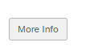

Refers to any technology not previously utilized by businesses (subawardees, partners or beneficiaries) including but not limited to manufacturing, renewable and clean energy, Industry 4.0 and robotics, AI and Machine learning, etc.
Display This Question:
If f. = Yes

Q26 How many businesses engaged in accelerators/testbeds associated with the coalition this past quarter? If none, use 0 (zero).
________________________________________________________________

Display This Question:
If f. = Yes

Q27 Please include the number of businesses the coalition engaged with over the past quarter by size. Engaged refers to any type of information exchange, funding, technical support, etc.
No. of businesses (1)
Self-employed (No employees) (4)
Micro businesses (1-19 employees) (1)
Small businesses (20-499 employees) (2)
Large businesses (500 or more employees) (3)

. Sustain regional governance

Q28 This section will ask about sustaining regional governance about your coalition.
Would you agree or disagree with the following statements regarding the members of your coalition this past quarter?
Please note that if for example MOU was put in place and reported previously, select NA.

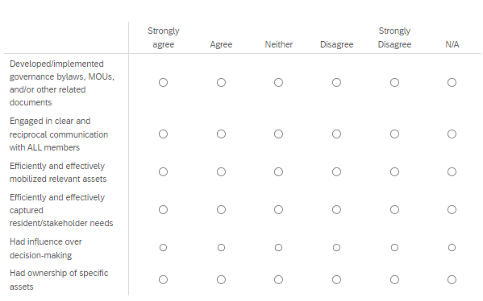

Q30 Over this past quarter, would you say your coalition has shrunk, stayed about the same, or expanded regarding number of partners and stakeholders engaged with?
- Shrunk (1)
- Stayed about the same (2)
- Expanded (3)

Q31 Over this past quarter, would you say the majority of coalition members and stakeholders mostly communicated, coordinated, or collaborated on each of the following BBBRC themes (select all that apply):
 | Communicated (1) | Coordinated (2) | Collaborated (3) | NA (4)
Accelerated innovation in emerging technologies (1)
Help workers access new job opportunities and job training (4)
Increase new business growth and entrepreneurial activity (2)
Build critical enabling infrastructure (3)
Help businesses adopt new technologies and enter new markets (5)
Sustain regional governance (6)

Q32 Over this past quarter, would you agree or disagree on the following statements concerning coalition members and stakeholders:

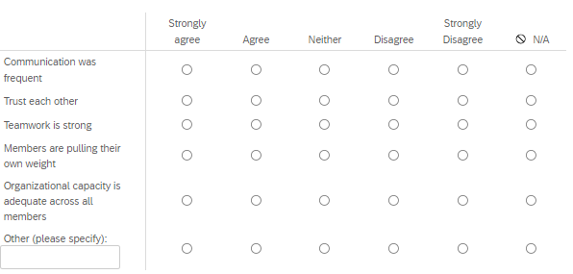

Q33 Would you agree or disagree with the following statements regarding the BBBRC Community of Practice (CoP) you are part of?
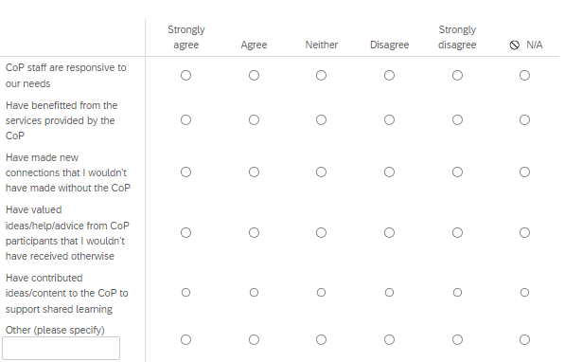

Q34 Do you have any feedback regarding this survey you would like to share with us? Are we missing anything?
________________________________________________________________
________________________________________________________________
________________________________________________________________
________________________________________________________________
________________________________________________________________

End of Block: Sustain regional governance

