NATIONAL CENTER FOR EDUCATION STATISTICS NATIONAL ASSESSMENT OF EDUCATIONAL PROGRESS

National Assessment of Educational Progress (NAEP)2027

Appendix J2
2027 Teacher Questionnaires

OMB# 1850-0928 v.39

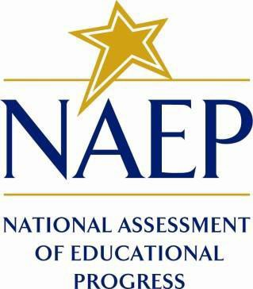

March 2026

Appendix J2 provides the grade 8 science teacher survey questionnaires that were approved and administered in 2024 (OMB# 1850-0928 v.30). The 2027 grade 8 teacher science questionnaires will be submitted in the Amendment (Summer 2026).
Please note, some of the item numbers may be missing or out of order in this appendix. These will be corrected in the platform view.
Table of Contents
Teacher Questionnaires
Draft 2027 Sample Teacher Questionnaire Login Screens 3
Appendix J2-1: 2024 Operational Grade 8 (Core, Reading, Mathematics, Science) 4
Appendix J2-2: 2024 Operational Grade 8 (Science) 16

Draft 2027 Sample Teacher Questionnaire Login Screens
Note: the PRA statements for 2027 will be updated in the Amendment (July 2026).

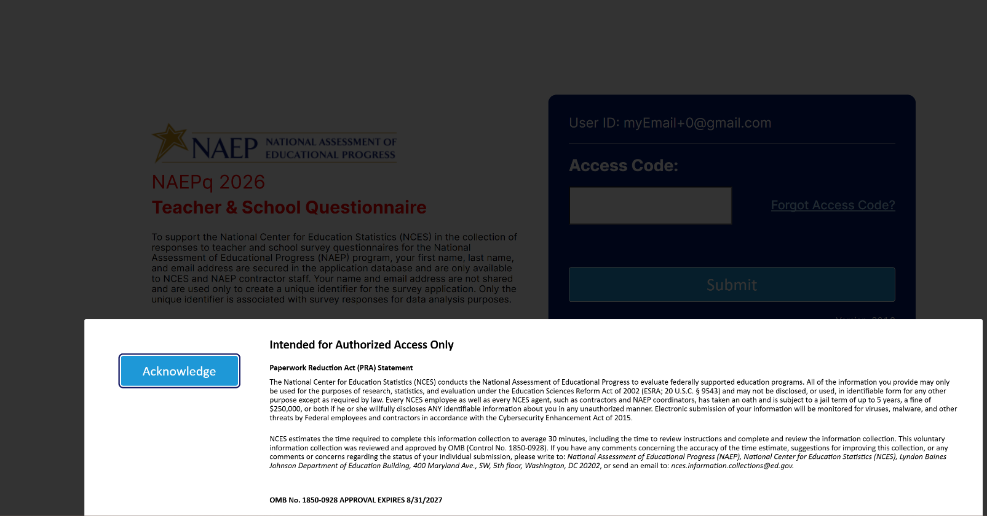

Appendix J2-1: 2024 Operational Grade 8 (Core, Reading, Mathematics, Science)
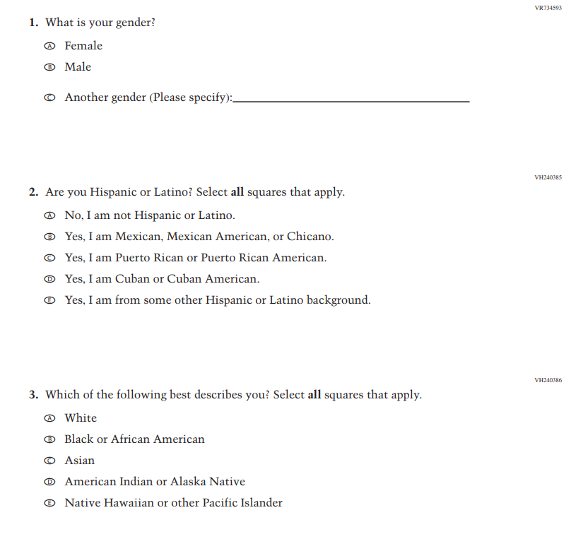
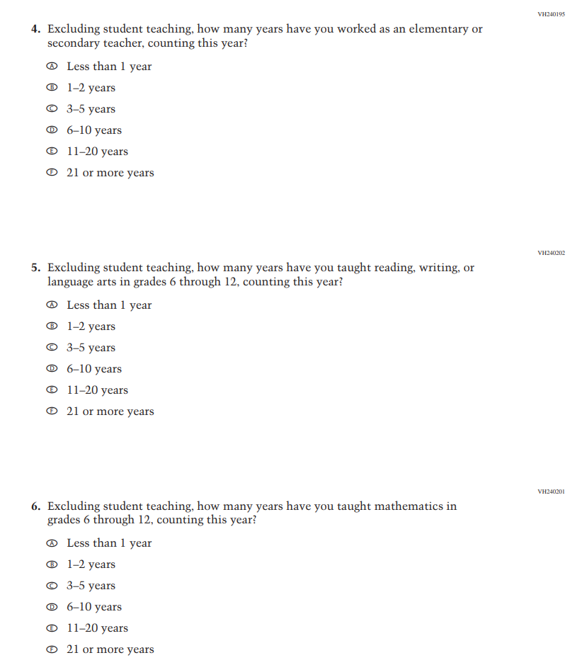
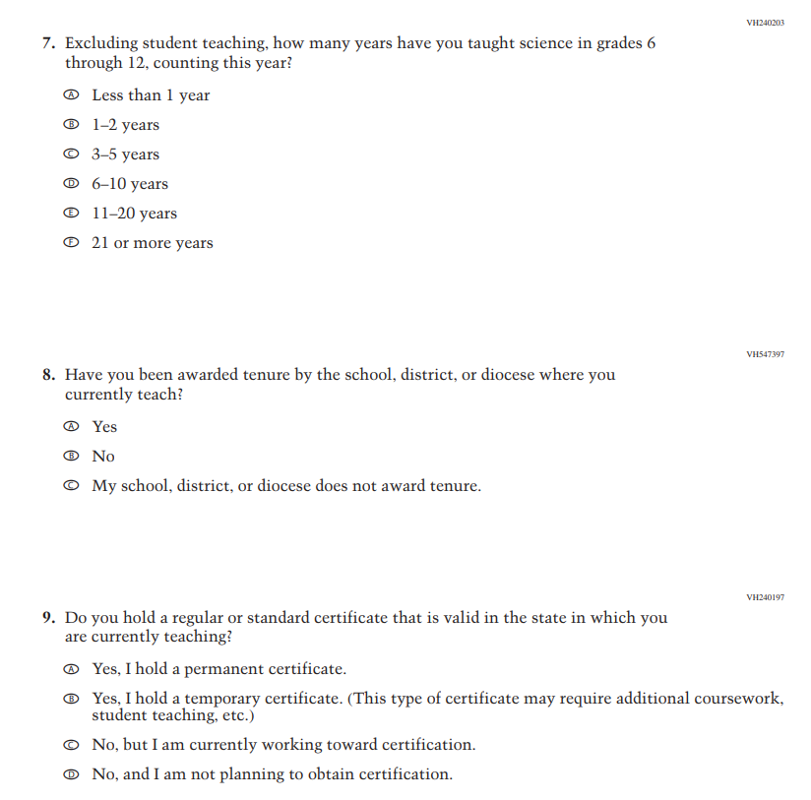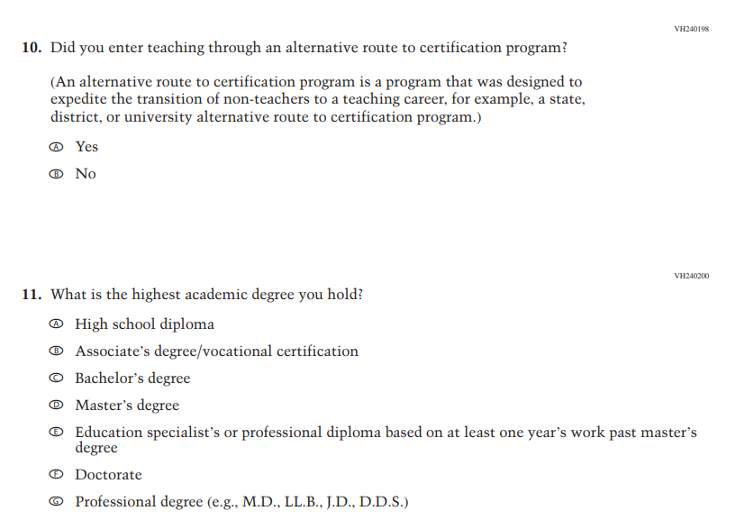
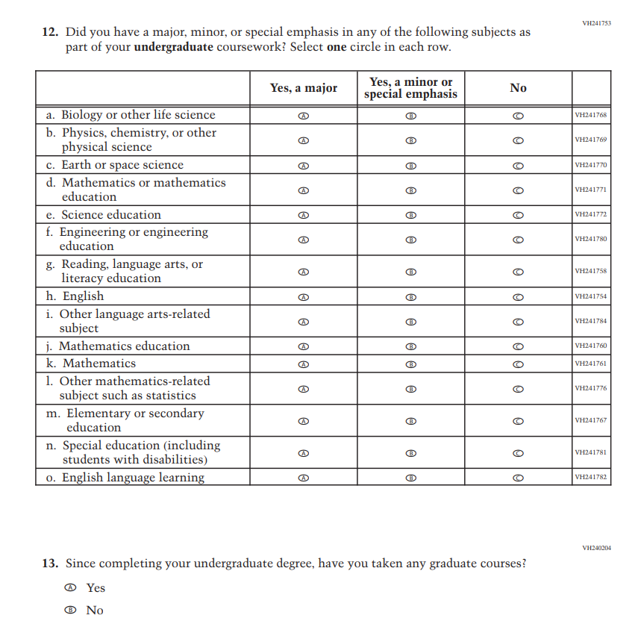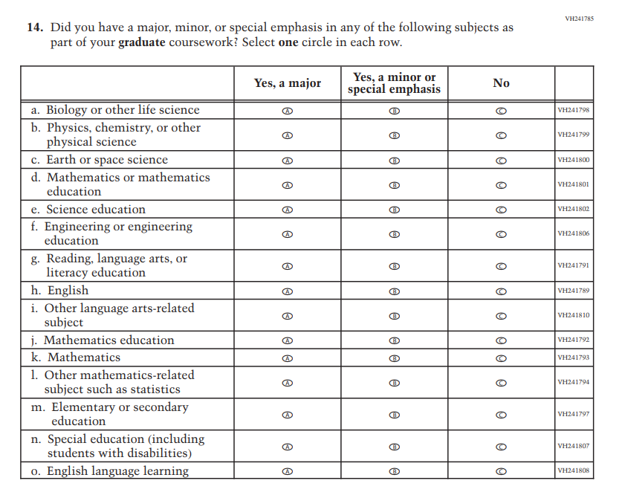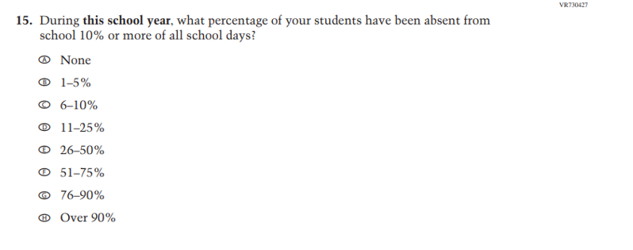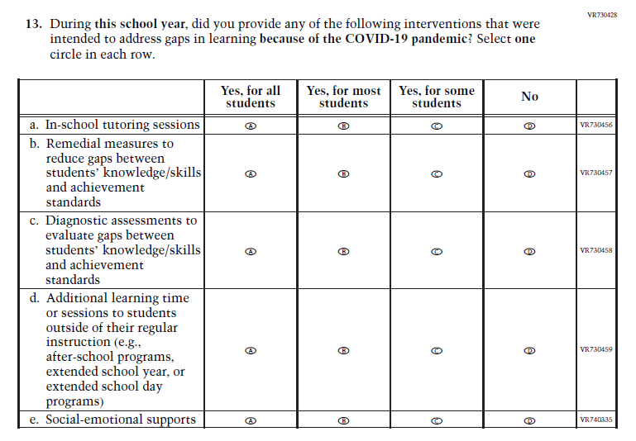
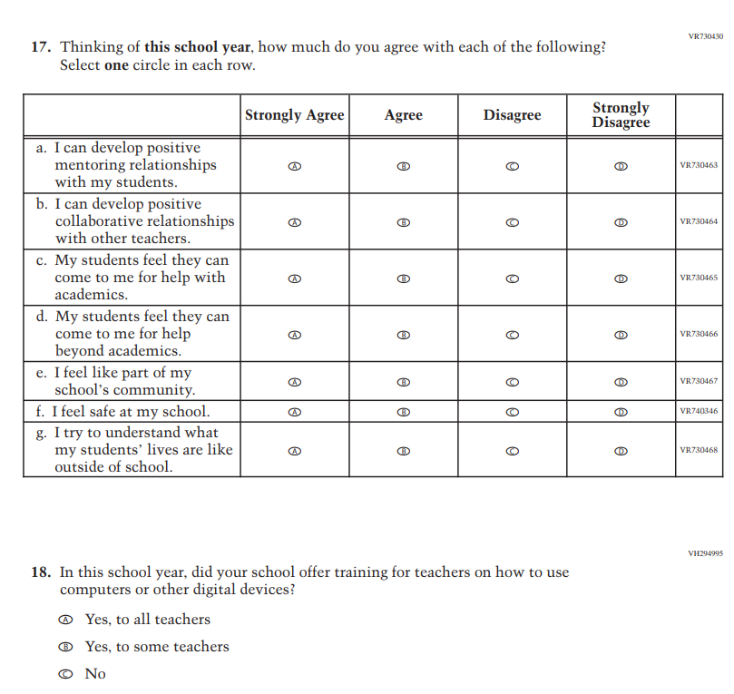
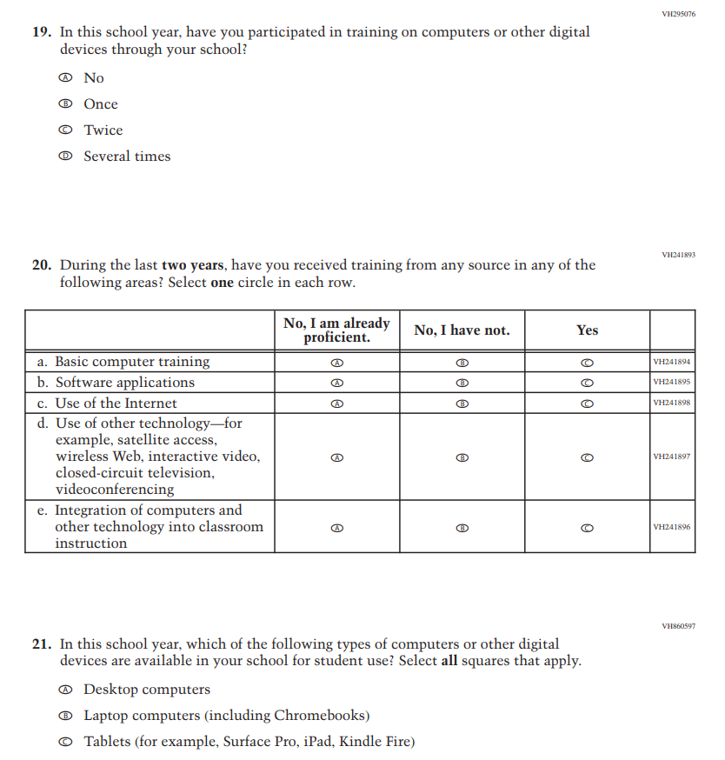
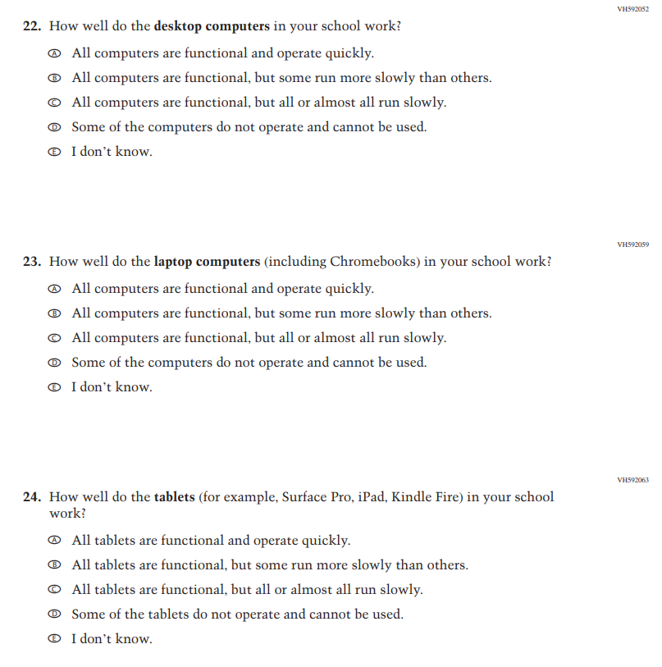
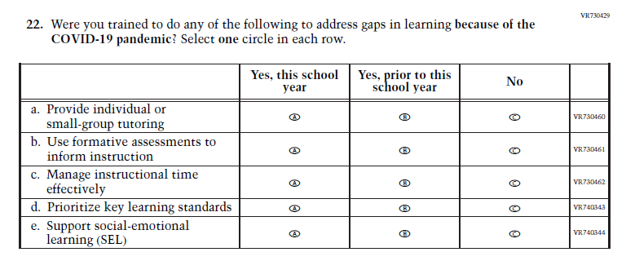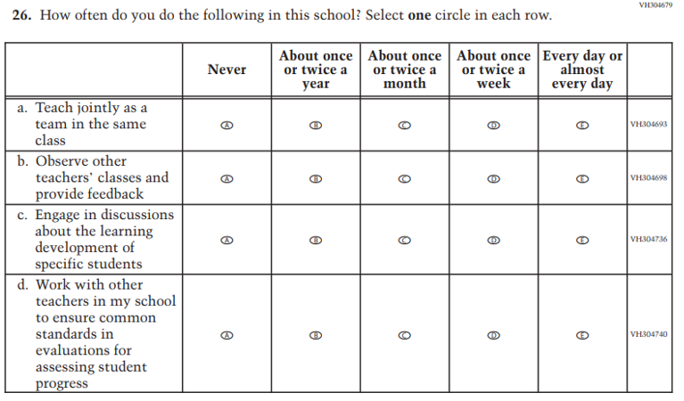
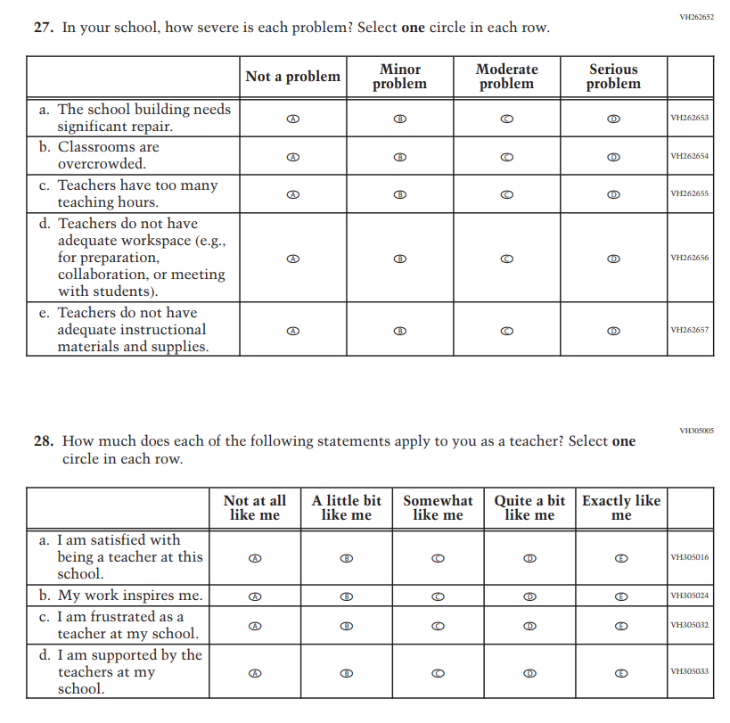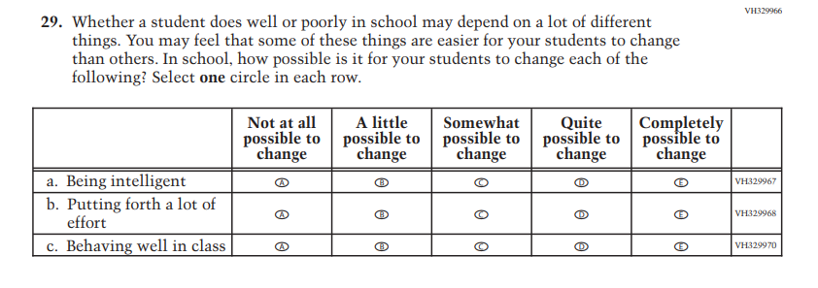

Appendix J2-2: 2024 Operational Grade 8 (Science)
