NATIONAL CENTER FOR EDUCATION STATISTICS NATIONAL ASSESSMENT OF EDUCATIONAL PROGRESS

National Assessment of Educational Progress (NAEP) 2027

Appendix J1
2027 Student Questionnaires

OMB# 1850-0928 v.39

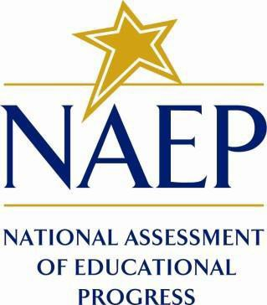

March 2026

Appendix J1 provides the grade 8 and science student survey questionnaires that were approved and administered in 2024 (OMB# 1850-0928 v.30) and debrief items that will be used in 2026 (OMB# 1850-0928 v.38). The 2027 grade 8 science questionnaires will be submitted in the Amendment (Summer 2026).
Please note, some of the item numbers may be missing or out of order in this appendix. These will be corrected in the platform view.

Table of Contents
Student Questionnaires
2027 Draft Student Login Screen 3
Appendix J1-1: 2024 Operational Grade 8 (Science) 4
Appendix J1-2: 2026 Operational Grade 8 (Debrief) 9
Appendix J1-3: 2024 Pilot Grade 8 (Core) 10
Appendix J1-4: 2024 Operational Grade 8 (Core, Science) 11

2027 Draft Student Login Screen
Note: the PRA statements for 2027 will be updated in the Amendment (July 2026).
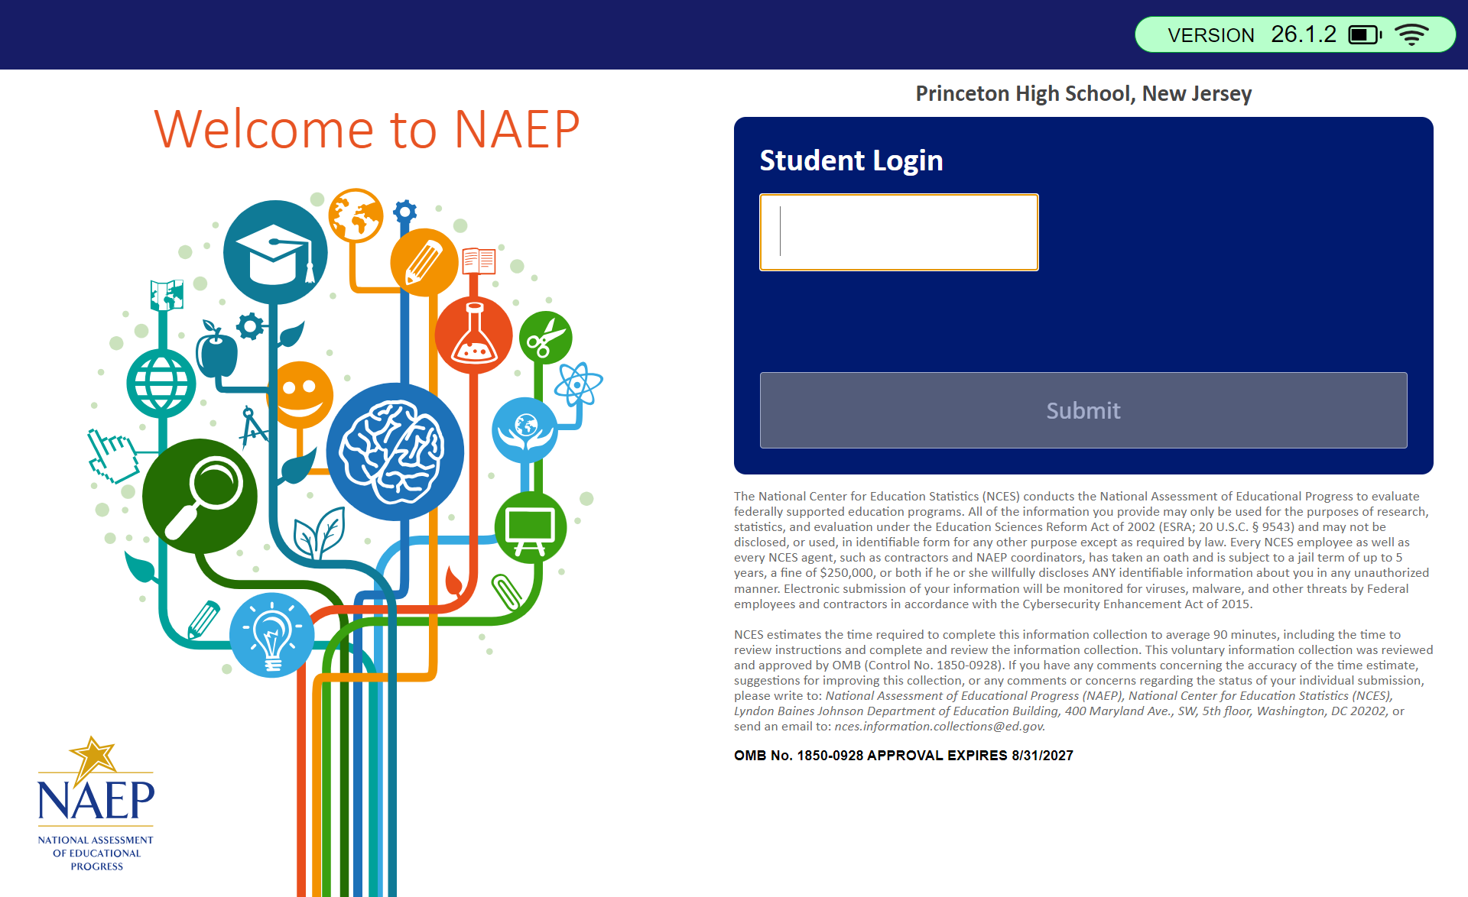

Appendix J1-1: 2024 Operational Grade 8 (Science)
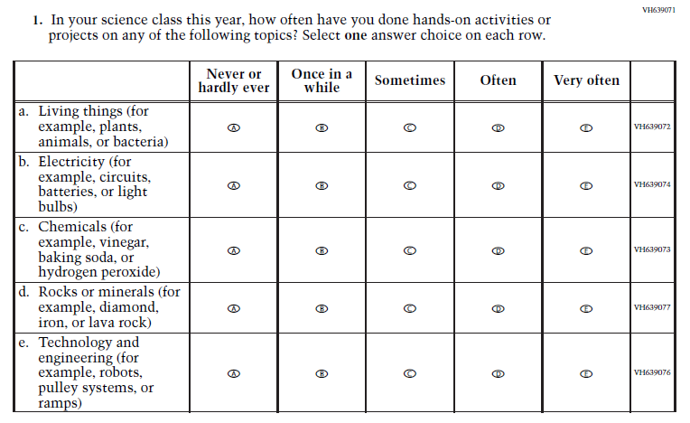
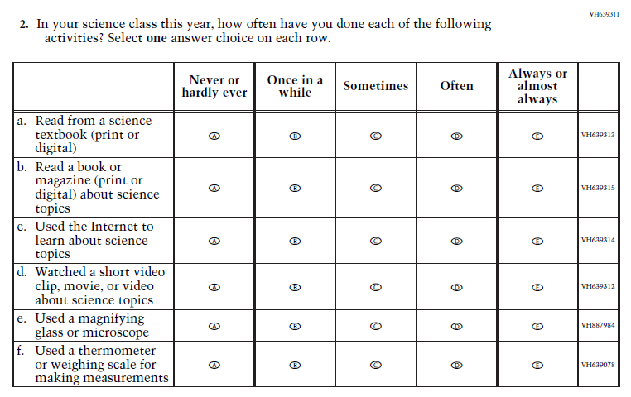

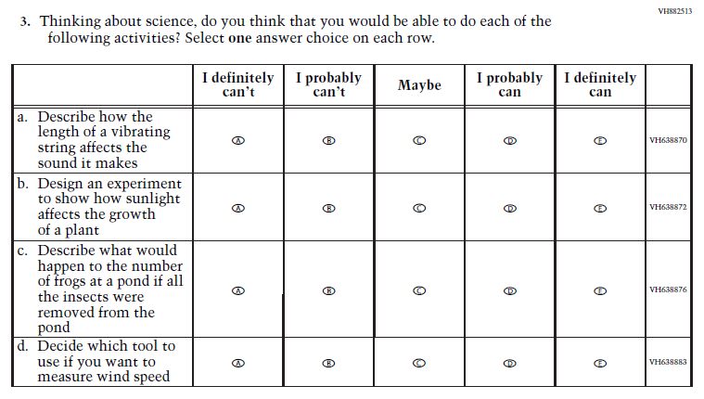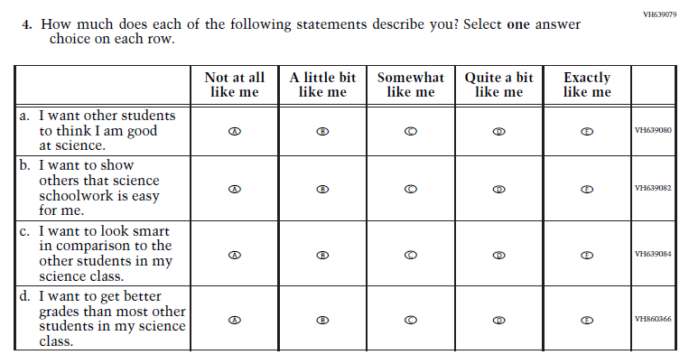

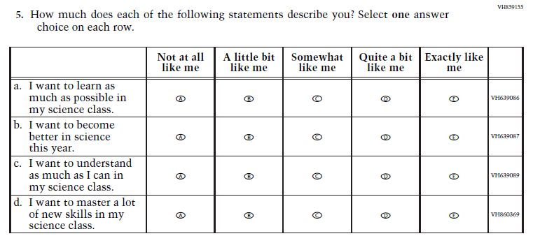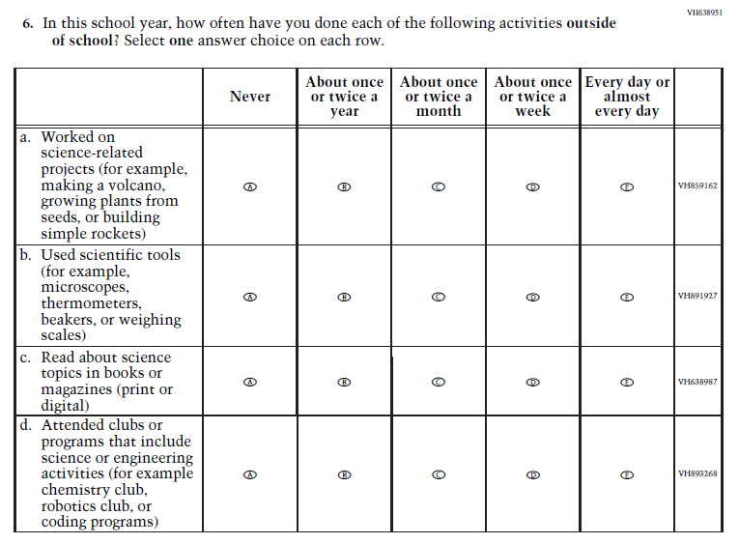

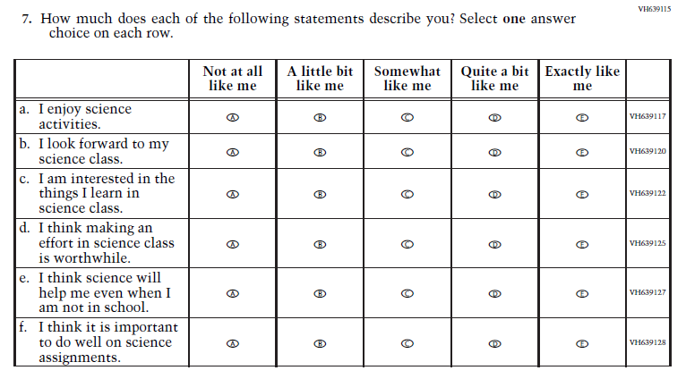
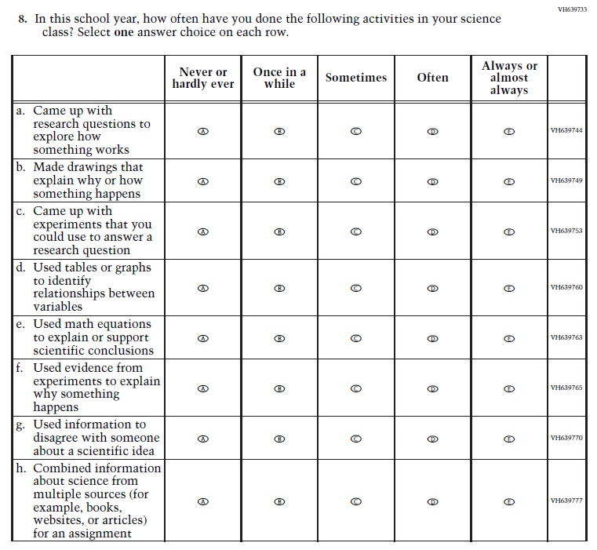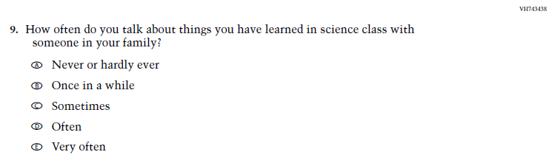

Appendix J1-2: 2026 Operational Grade 8 (Debrief)
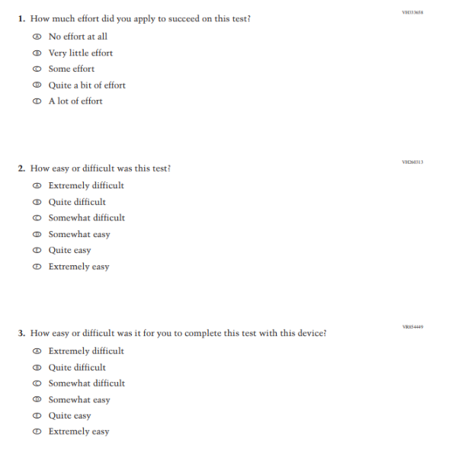

Appendix J1-3: 2024 Pilot Grade 8 (Core)
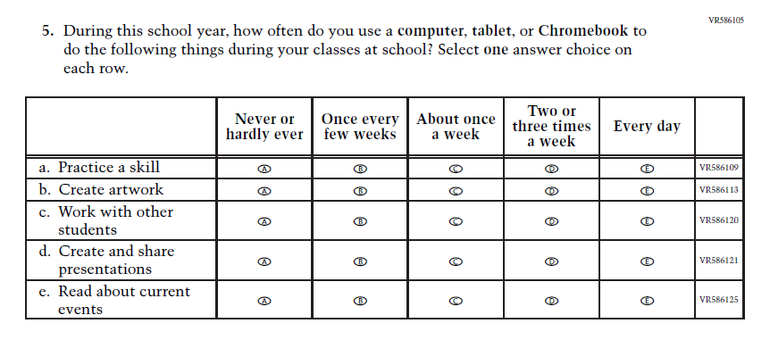
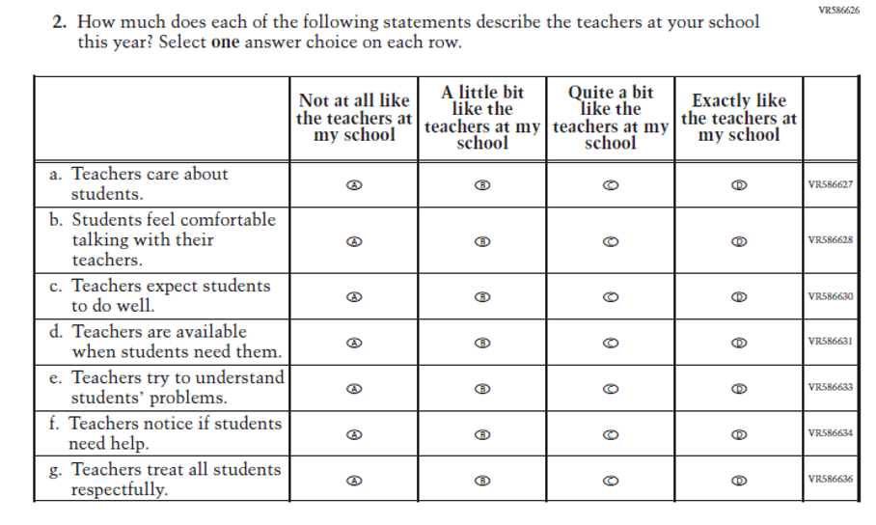
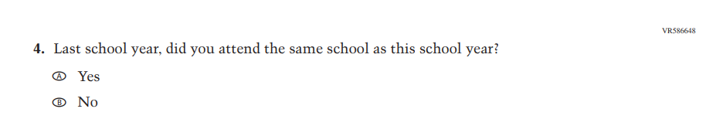

Appendix J1-4: 2024 Operational Grade 8 (Core, Science)
