NATIONAL CENTER FOR EDUCATION STATISTICS
NATIONAL ASSESSMENT OF EDUCATIONAL PROGRESS

National Assessment of Education Progress (NAEP) 2027

Appendix D

NAEP Communications and Recruitment Materials

OMB# 1850-0928 v.39

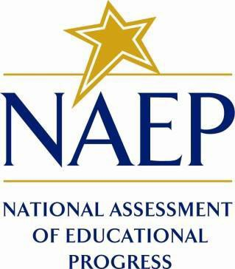

March 2026

A combination of draft and final communication and recruitment materials are included in Appendix D for this 30-day Clearance Package submission. Drafts that have been replaced with final versions are marked by “(NEW)” in the header. Remaining draft communications will be updated in the Amendment package for use in the 2027 NAEP Science Pilot Assessment. The table below shows the administration window and subject.
Activity | Window | Grade | Subjects
2027 NAEP Science Pilot | January-March 2027 | 8 | Science

Important changes in how we collect demographic information are reflected in the 2027 instruments. In March 2024, the Office of Management and Budget (OMB) announced revisions to Statistical Policy Directive No. 15: Standards for Maintaining, Collecting, and Presenting Federal Data on Race and Ethnicity (SPD 15) and published the revised SPD 15 standard in the Federal Register (89 FR 22182). See Part A.7 of this package to see how NCES plans to incorporate these revisions into NAEP 2027.
Additionally, materials in this submission are in compliance with the White House’s Executive Orders “Defending Women from Gender Ideology Extremism and Restoring Biological Truth to the Federal Government,” (January 20, 2025) and “Ending Radical and Wasteful Government DEI Programs and Preferencing,” (January 20, 2025).

Table of Contents
Table of Contents 3
Appendix D-1: NAEP 2027 Notification Letter from Chief State School Officer to District Superintendent (NEW) 5
Appendix D-2: NAEP 2027 Initial School Notification Letter from NAEP State Coordinator to School Principal (NEW) 6
Appendix D-3: NAEP 2027 Facts for Districts (NEW) 8
Appendix D-4: NAEP 2027 Facts for Principals (NEW) 11
Appendix D-5: NAEP 2027 Initial School Technology Survey Notification Letter from NAEP State Coordinator to School Technology Survey Recipient (NEW) 14
Appendix D-6: NAEP 2027 School Technology Summary Auto-Email - AMS to School Technology Survey Respondent (NEW) 16
Appendix D-7: NAEP 2027 eNAEP Download Center (NEW) 17
Appendix D-8: NAEP 2027 eNAEP Download Center Notification, Auto email to School or District Application Installer (NEW) 76
Appendix D-9: NAEP 2027 District Model Assignment Notification (NEW) 78
Appendix D-10: NAEP 2027 Parent-Guardian Notification Letter, Public School (NEW) 79
Appendix D-11: NAEP 2027 Parent-Guardian Notification Letter, Bilingual Spanish Public Schools (NEW) 80
Appendix D-12: NAEP 2027 Parent-Guardian Notification Letter, Private Schools (NEW) 81
Appendix D-13: NAEP 2027 Parent-Guardian Notification Letter, Bilingual Spanish Private Schools (NEW) 82
Appendix D-14: NAEP 2027 Assessment Details Notification Letter to Principal, NAEP Device Model (NEW) 84
Appendix D-15: NAEP 2027 Assessment Details Notification Letter to School Coordinator, NAEP Device Model (NEW) 86
Appendix D-16: NAEP 2027 Assessment Details Letter to Principal, School Device Model (NEW) 89
Appendix D-17: NAEP 2027 Assessment Details Letter to School Coordinator, School Device Model (NEW) 92
Appendix D-18: NAEP 2027 NAEP in your School-NAEP Device, Grade 8 Science (NEW) 95
Appendix D-19: 2027 NAEP in your School-School Device, Grade 8 Science (NEW) 98
Appendix D-20: 2027 NAEP in your Private School-NAEP Device, Grade 8 Science (NEW) 101
Appendix D-21: NAEP 2027 NAEP in your Private School-School Device, Grade 8 Science (NEW) 103
Appendix D-22: NAEP 2027 Save-the-Date (NEW) 105
Appendix D-23: NAEP 2027 Endorsement Letters to Private School Administrator (NEW) 106
Appendix D-24: NAEP 2027 Draft Preassessment Notification, School Device Model 109
Appendix D-25: NAEP 2027 Draft Preassessment Responsibilities Guide, School Device Model 110
Appendix D-26: NAEP 2027 Draft Preassessment Notification, NAEP Device Model 114
Appendix D-27: NAEP 2027 Draft Preassessment Responsibilities Guide, NAEP Device Model 115
Appendix D-28: NAEP 2027 Draft Preassessment Notification-Private School, School Device Model 118
Appendix D-29: NAEP 2027 Draft Preassessment Responsibilities Guide-Private Schools, School Device Model 119
Appendix D-30: NAEP 2027 Draft Preassessment Notification-Private School, NAEP Device Model 123
Appendix D-31: NAEP 2027 Draft Preassessment Responsibilities Guide-Private Schools, NAEP Device Model 124
Appendix D-32: NAEP 2027 Draft School Staff Assistance email templates 127
Appendix D-33: NAEP 2027 Draft Facts for Teachers 137
Appendix D-34: NAEP 2027 Draft Facts for Teachers, Private Schools 143
Appendix D-35: NAEP 2027 Draft Inclusion Guidelines for English Learners 149
Appendix D-36: NAEP 2027 Draft Inclusion Guidelines for Students with Disabilities 153
Appendix D-37: NAEP 2027 Draft Private School Recruitment Video Storyboards 157
Appendix D-38: NAEP 2027 Identify Application Installer Reminder (School Device), From NAEP State Coordinator to District or School Staff (NEW) 160

Appendix D-1: NAEP 2027 Notification Letter from Chief State School Officer to District Superintendent (NEW)

NAEP 2027 Notification Letter From
CSSO TO DISTRICT SUPERINTENDENT
Red text should be customized before mail merge: highlighted text represents mail merge fields

Dear District Superintendent name,

Thank you for all you do to support education in state name. I am writing to notify you that number schools in your district have been selected to participate in the 2027 administration of the National Assessment of Educational Progress (NAEP). NAEP is the largest nationally representative and continuing assessment of what students in the United States know and can do in various subjects. NAEP is administered by the National Center for Education Statistics (NCES), within the U.S. Department of Education. Selected schools represent schools across the nation, and their participation provides an accurate picture of student performance. School District will play an important role by participating, and your full support will help make this a positive experience for your schools and students.

Selected schools will be notified soon, so principals can include the NAEP assessment on their calendars and incorporate it into the planned school program. Schools may work with the NAEP State Coordinator on the assessment date as needed.

NAEP representatives will reach out to schools or districts about using school devices and Internet.

NAEP 2027 Program Overview

The NAEP 2027 program will include a pilot assessment in science at grade 8. Students will be assessed between January 25 and March 19, 2027. The attached list contains the schools in your district selected for NAEP.

NCES will not release results from the pilot assessment but will use the results to inform future NAEP assessments.

Next Steps

Please include the NAEP assessment window (January 25 to March 19, 2027) on your district test calendar.

Information about NAEP can be found in the enclosures/attachments listed below and at http://nces.ed.gov/nationsreportcard. Name, our NAEP State Coordinator, will contact your district and school staff with additional information about next steps.

Thank you for supporting this important assessment and helping us accomplish our goal of 100 percent participation.

Sincerely,

Name of Chief State School Officer

Enclosures/Attachments: List of district schools selected for NAEP
Facts for Districts

CC: State Testing Director
District Assessment Coordinator
NAEP State Coordinator

The National Center for Education Statistics (NCES) conducts the National Assessment of Educational Progress to evaluate federally supported education programs. All of the information you provide may only be used for the purposes of research, statistics, and evaluation under the Education Sciences Reform Act of 2002 (ESRA; 20 U.S.C. § 9543) and may not be disclosed, or used, in identifiable form for any other purpose except as required by law. Every NCES employee as well as every NCES agent, such as contractors and NAEP coordinators, has taken an oath and is subject to a jail term of up to 5 years, a fine of $250,000, or both if he or she willfully discloses ANY identifiable information about you in any unauthorized manner. Electronic submission of your information will be monitored for viruses, malware, and other threats by Federal employees and contractors in accordance with the Cybersecurity Enhancement Act of 2015.

Appendix D-2: NAEP 2027 Initial School Notification Letter from NAEP State Coordinator to School Principal (NEW)

NAEP 2027 Initial School Notification Letter
From NSC to Principal
Red text should be customized before mail merge; highlighted text represents mail merge fields

Dear Principal,

Thank you for all you do to support education in state name. I am writing to inform you that school name
has been selected to represent schools across the nation by participating in the 2027 administration of the National Assessment of Educational Progress (NAEP).

Assessment Overview for Your School

- Subjects: Science pilot assessment
- Students to be assessed: Grade 8
- Assessment window: January 25–March 19, 2027
- Assessment duration: About 120 minutes (including transition time, instructions, and
completion of survey questions)
- Assessment administrators: NAEP representatives

What you need to know

- I will identify and contact a district or school person to complete a School Technology Survey, which will be used to determine whether your school will use school or NAEP devices.
- NAEP representatives will provide significant support to your school before and during the assessment.
- The National Center for Education Statistics will not release results from the pilot but will use the results to inform future NAEP assessments.

Next steps

- In [time of year], I will send you an assessment date. You may work with me on the assessment date as needed.
- I will ask you to identify a school coordinator to serve as the main point of contact, provide a student list, and submit additional information.

Additional information about NAEP can be found in the enclosed/attached copy of Facts for Principals and at http://nces.ed.gov/nationsreportcard. If you have questions, please contact me at NSC/NTC telephone number or via email at NSC/NTC email address.

Our chief state school officer, name, and your district superintendent, name, support NAEP and look forward to your school’s participation. We know that we can count on you to help us reach our goal of 100 percent participation.

Sincerely,

NAEP State Coordinator

Enclosure (or link for electronic mailing): Facts for Principals

CC: District Assessment Coordinator

The National Center for Education Statistics (NCES) conducts the National Assessment of Educational Progress to evaluate federally supported education programs. All of the information you provide may only be used for the purposes of research, statistics, and evaluation under the Education Sciences Reform Act of 2002 (ESRA; 20 U.S.C. § 9543) and may not be disclosed, or used, in identifiable form for any other purpose except as required by law. Every NCES employee as well as every NCES agent, such as contractors and NAEP coordinators, has taken an oath and is subject to a jail term of up to 5 years, a fine of $250,000, or both if he or she willfully discloses ANY identifiable information about you in any unauthorized manner. Electronic submission of your information will be monitored for viruses, malware, and other threats by Federal employees and contractors in accordance with the Cybersecurity Enhancement Act of 2015.

Appendix D-3: NAEP 2027 Facts for Districts (NEW)

NAEP 2027
Facts for Districts
Grade 8 Science Pilot

“NAEP is the only assessment providing half a century of performance data to measure what students know and can do. The state and national trends inform local, state, and national program and policy discussions that improve teaching and learning.”
– David Atherton, EdD, Former Principal, Clear Creek Middle School, Gresham, OR

What is NAEP?
The National Assessment of Educational Progress (NAEP) is an integral measure of academic progress across the nation and over time. It is the largest nationally representative and continuing assessment of what our nation’s students know and can do in various subjects such as civics, mathematics, reading, science, and U.S. history. The program also provides valuable insights into students’ educational experiences and opportunities to learn in and outside of the classroom.

NAEP is a congressionally mandated program administered by the National Center for Education Statistics (NCES), within the U.S. Department of Education’s Institute of Education Sciences.

The National Assessment Governing Board—an independent, bipartisan organization made up of governors, state legislators, state school superintendents, teachers, researchers, and representatives of the general public—sets policy for NAEP.

What NAEP assessments will be administered in 2027?
The 2027 program will include
- a grade 8 science pilot assessment; and
- survey questionnaires for participating students, teachers, and school administrators to provide a better understanding of students’ educational experiences.

NCES will administer the assessment between January 25 and March 19, 2027.

NCES will not release results from the pilot assessment but will use the results to inform future assessments.

Why should my district participate in NAEP?
Your district’s participation is vitally important for several reasons.
- The Governing Board adopted a new framework for the science assessment that will be implemented in 2028. Updating assessment frameworks in regular intervals ensures that NAEP remains relevant to how and what students are learning in the classroom. By participating in the 2027 pilot assessment, your district will help ensure the new assessment questions are valid and a reliable measure of student achievement.
- Schools and students selected to participate in NAEP represent schools and students across the nation. Each school’s participation is critical and contributes to the understanding of students’ educational progress across the United States.

What will students in my district do?
Students participating in the 2027 pilot assessment will complete
- assessment items in science; and, if applicable,
- survey questionnaires that provide valuable information about their educational experiences and opportunities to learn both in and outside of the classroom.

Students are given approximately 2 hours to complete the assessment unless accommodations are provided. The 2-hour assessment window includes time for students to transition to and from the assessment location, receive directions, and complete survey questionnaires. A broad range of accessibility supports are provided for students with disabilities and English learners.

Students will take the assessment using school devices or NAEP devices. NAEP representatives will contact your district in the coming months with more information.

Do teachers need to prepare students for the assessment?
Teachers do not need to prepare their students to take the assessment but should encourage them to do their best.

Who will administer NAEP? What do schools need to provide on the day of the assessment?
NAEP representatives will administer the assessment and provide significant support to schools on assessment day. Schools will need to provide space for students to take the assessment, desks or tables, and an adequate number of electrical outlets in the assessment location.
- In schools where the assessment will be administered using school devices, school and/or district staff who have experience with the devices and technology used by the school will be asked to be available during the testing session(s).
- In schools where the assessment will be administered using NAEP devices, NAEP representatives will bring all necessary materials and equipment to assess the students.

How were schools in my district selected for NAEP?
Schools were selected as part of a carefully designed sampling process that ensures NAEP-selected schools and students are representative of the nation. Learn more at https://nationsreportcard.gov/focus_on_naep/assessment_literacy/#/sampling.

How can school administrators and teachers use NAEP data to help our students?
School administrators and teachers can view NAEP data online at https://nationsreportcard.gov. Through NAEP data, you can examine the relationships between student performance and factors such as demographics, school location, instructional practices, and more.

Questions from previous NAEP assessments can also be used as a helpful educational resource in the classroom. Teachers can use the NAEP Questions Tool (https://nces.ed.gov/nationsreportcard/nqt) to see how their students’ performance compares to peers across the nation. Released NAEP questions come with a scoring guide, sample student responses, and performance data.

How long has NAEP been around?
NAEP was first administered in 1969 to measure student achievement nationally. In 1990, NAEP was administered at the state level for the first time. The NAEP Trial Urban District Assessment (TUDA) program, which measures student achievement in some of the nation’s large urban districts, began in 2002.

Where can I find more information?
Learn more about the NAEP program at https://nces.ed.gov/nationsreportcard, and explore the latest NAEP results at https://nationsreportcard.gov.

You can also find NAEP on: <Facebook logo> <Instagram logo> <LinkedIn logo> <X logo> <YouTube logo>

The National Center for Education Statistics (NCES) conducts the National Assessment of Educational Progress to evaluate federally supported education programs. All of the information you provide may only be used for the purposes of research, statistics, and evaluation under the Education Sciences Reform Act of 2002 (ESRA; 20 U.S.C. § 9543) and may not be disclosed, or used, in identifiable form for any other purpose except as required by law. Every NCES employee as well as every NCES agent, such as contractors and NAEP coordinators, has taken an oath and is subject to a jail term of up to 5 years, a fine of $250,000, or both if he or she willfully discloses ANY identifiable information about you in any unauthorized manner. Electronic submission of your information will be monitored for viruses, malware, and other threats by Federal employees and contractors in accordance with the Cybersecurity Enhancement Act of 2015.

This publication was prepared for the National Assessment of Educational Progress by Manhattan Strategy Group under contract 91990018C0001 to the National Center for Education Statistics, U.S. Department of Education.

Appendix D-4: NAEP 2027 Facts for Principals (NEW)

NAEP 2027
Facts for Principals
Grade 8 Science Pilot

Page One Sidebar
NAEP is an integral part of education in the United States.
- Elected officials, policymakers, and educators all use NAEP results to inform ways to improve education.
- Originating in 1969, NAEP is a congressionally mandated program administered by the National Center for Education Statistics (NCES), within the U.S. Department of Education’s Institute of Education Sciences.
- NAEP serves a different role than state assessments. While states have their own unique assessments with different content standards, the same NAEP assessment is administered across the country, providing a common measure of student achievement.
- Depending on the type of NAEP assessment that is administered, NAEP data are available for the nation, your state, districts that participate in the Trial Urban District Assessment (TUDA), and student groups. NAEP is not designed to report results for individual students, classrooms, or schools.
- Students, teachers, and principals who participate in NAEP are asked to complete survey questionnaires to provide a better understanding of educational experiences and factors that may be related to students’ learning.

Page One Body
“NAEP is the only assessment providing half-a-century of performance data to measure what students know and can do. The state and national trends inform local, state, and national program and policy discussions that improve teaching and learning.”
- David Atherton, EdD, Former Principal, Clear Creek Middle School, Gresham, OR

What is NAEP?
The National Assessment of Educational Progress (NAEP) is the largest nationally representative and continuing assessment of what our nation’s students know and can do in various subjects such as civics, mathematics, reading, science, and U.S. history. NAEP results are released as The Nation’s Report Card.

NAEP is a congressionally mandated program administered by the National Center for Education Statistics (NCES), within the U.S. Department of Education’s Institute of Education Sciences.

The National Assessment Governing Board—an independent, bipartisan organization made up of governors, state legislators, state school superintendents, teachers, researchers, and representatives of the general public—sets policy for NAEP.

What NAEP assessments will be administered in 2027?
The 2027 program will include
- a grade 8 science pilot assessment; and
- survey questionnaires for participating students, teachers, and school administrators to provide a better understanding of students’ educational experiences.

NCES will administer the pilot assessment between January 25 and March 19, 2027.

NCES will not release results from the pilot assessment but will use the results to inform future assessments.

Why should my school and students participate in NAEP?
Your participation is vitally important for several reasons.
- The Governing Board adopted a new framework for the science assessment that will be implemented in 2028. Updating assessment frameworks in regular intervals ensures that NAEP remains relevant to how and what students are learning in the classroom. By participating in the 2027 pilot assessment, your school will help ensure the new assessment questions are valid and a reliable measure of student achievement.
- Schools and students selected to participate in NAEP represent schools and students across the country. Each school’s participation is critical and contributes to the understanding of students’ educational progress across the United States.

For more information about NAEP, visit https://nces.ed.gov/nationsreportcard.

Page Two Body

What is involved for principals and teachers in 2027?
As principals, you make an important contribution to the program by selecting and empowering a NAEP school coordinator, meeting with teachers and participating students, and encouraging your students to participate and do their best. You are essential partners in NAEP. Each school’s participation is critical and contributes to the understanding of students’ educational progress across the United States.

NAEP representatives will provide significant support to your school on assessment day. They will administer the assessment on school devices or NAEP devices and will contact your school in the coming months to provide more information and organize assessment activities.

Schools will need to provide space for students to take the assessment, desks or tables, and an adequate number of electrical outlets in the assessment location.

Teachers do not need to prepare their students to take the assessment but should encourage them to do their best.

The school principal and grade 8 teachers of the sampled students will be asked to complete a questionnaire designed to provide contextual information for the assessment results.

What is involved for students?
The assessment will be administered during regular school hours. The time commitment for students taking the assessment is approximately 2 hours, which includes time for students to transition to and from the assessment location, receive directions and review tutorials, and complete survey questions.

How are schools and students selected for NAEP?
A carefully designed sampling process ensures that NAEP-selected schools and students are representative of all schools and students in across the United States. To ensure that the sample represents all students in the nation’s schools, a broad range of accessibility supports are allowed for students with disabilities and English learners.

How can educators use NAEP resources to help students?
Released NAEP items can be used as a helpful educational resource in the classroom. Teachers and district staff can use the NAEP Questions Tool (https://nces.ed.gov/nationsreportcard/nqt) to create a test and see how your students’ performance compares nationally on specific items. Released NAEP items come with a scoring guide, sample student responses, and performance data.

Where can I find more information?
Learn more about the NAEP program at https://nces.ed.gov/nationsreportcard, and explore the latest NAEP results at https://nationsreportcard.gov.

The National Center for Education Statistics (NCES) conducts the National Assessment of Educational Progress to evaluate federally supported education programs. All of the information you provide may only be used for the purposes of research, statistics, and evaluation under the Education Sciences Reform Act of 2002 (ESRA; 20 U.S.C. § 9543) and may not be disclosed, our used, in identifiable form for any other purpose except as required by law. Every NCES employee as well as every NCES agent, such as contractors and NAEP coordinators, has taken an oath and is subject to a jail term of up to 5 years, a fine of $250,000, or both if he or she willfully discloses ANY identifiable information about you in any unauthorized manner. Electronic submission of your information will be monitored for viruses, malware, and other threats by Federal employees and contractors in accordance with the Cybersecurity Enhancement Act of 2015.

Page Two Footer
Find us on: [insert social media icons]

This publication was prepared for the National Assessment of Educational Progress by Manhattan Strategy Group under contract 91990018C0001 to the National Center for Education Statistics, U.S. Department of Education.

Appendix D-5: NAEP 2027 Initial School Technology Survey Notification Letter from NAEP State Coordinator to School Technology Survey Recipient (NEW)

NAEP 2027 – School Technology Survey Notification Letter
NAEP STATE COORDINATOR TO SCHOOL TECHNOLOGY SURVEY RECIPIENT
Red text should be customized before mail merge; highlighted text represents mail merge fields.

:Do not distribute until notified that the AMS/STS are ready for school and district user access:

Dear [District Technology Director/District Assessment Coordinator/Principal/School Coordinator/ Technology Coordinator]:

Thank you for all you do to support education in state name. I am writing to notify you that one or more schools in your district have been sampled for the 2027 administration of the National Assessment of Educational Progress (NAEP). NAEP will be administered on school devices or Chromebooks provided by NAEP.

To determine each school’s ability to support the administration of NAEP using school devices, we need to understand the technical specifications of the devices used for testing at [School Name]. / the following schools:
- School 1
- School 2
- School 3, etc.

Your role will be to do the following:
- Activate your NAEP Assessment Management System (AMS) account using the link provided in the email [email subject] from [registration email domain].
- Complete the School Technology Survey in the AMS for each school listed above by [Due date], which requires knowledge of
  - the device operating system and available hardware for each sampled school, and
  - district or school device management and security policies.
- Designate an Application Installer in the AMS for each sampled school assigned to administer NAEP on school devices; do this after you complete the School Technology Survey. The individual designated as the Application Installer will be responsible for deploying the NAEP Assessment application to school devices.

*Note, if you would like to designate someone to complete the survey on your behalf, please send their name and email address to [NSC/NTC name] at [NSC/NTC email address].

The NAEP Assessment Application is COPPA and FERPA compliant and does not collect any student education records or personally identifiable information (PII) from students. Visit the [eNAEP Download Center hyperlink] to access the application and review additional technical details about taking NAEP assessments on school or district devices.

You will receive more details about how each school will be assessed and information on the next steps after you complete the School Technology Survey.

What is NAEP?
NAEP is the largest nationally representative and continuing assessment of what our nation’s students know and can do in various subjects. NAEP is administered by the National Center for Education Statistics (NCES), within the U.S. Department of Education.

What will NAEP assess in 2027?
In 2027, NCES will administer a pilot assessment in science at grade 8 on school devices or Chromebooks provided by NAEP.

What if I have questions?
If you have questions about the School Technology Survey, please contact the NAEP help desk at 1-800-283-6237 or naephelp@westat.com. If you have other questions about NAEP, please contact me at NSC/NTC telephone number or NSC/NTC email address.

Again, thank you for your assistance with this very important assessment.

Sincerely,

NAEP State/TUDA Coordinator

Attachments:
School Technology Survey questions PDF (optional)

The National Center for Education Statistics (NCES) conducts the National Assessment of Educational Progress to evaluate federally supported education programs. All of the information you provide may only be used for the purposes of research, statistics, and evaluation under the Education Sciences Reform Act of 2002 (ESRA; 20 U.S.C. § 9543) and may not be disclosed, or used, in identifiable form for any other purpose except as required by law. Every NCES employee as well as every NCES agent, such as contractors and NAEP coordinators, has taken an oath and is subject to a jail term of up to 5 years, a fine of $250,000, or both if he or she willfully discloses ANY identifiable information about you in any unauthorized manner. Electronic submission of your information will be monitored for viruses, malware, and other threats by Federal employees and contractors in accordance with the Cybersecurity Enhancement Act of 2015.

Appendix D-6: NAEP 2027 School Technology Summary Auto-Email - AMS to School Technology Survey Respondent (NEW)

NAEP 2027 – School Technology Survey Summary Auto-Email
AMS to School Technology Survey Respondent

From: AMS email address
To: School Technology Survey Respondent

Subject: NAEP 2027 School Technology Survey

Thank you for completing the School Technology Survey for the 2027 administration of the National Assessment of Educational Progress (NAEP).

NAEP will be administered using school devices (e.g., desktops, laptops, tablets with keyboards) for the following schools. The NAEP Assessment application will need to be deployed or installed on the school devices before [date].
School Name | Sampled Grade | NAEP Application Installer
School 1 | 8 | Missing
School 2 | 8 | Missing
School 3 | 8 | John Doe

Schools assigned to take NAEP on school devices must designate a district- or school-level staff member to oversee the installation of the NAEP Assessment application on the devices. The name of the staff member must be entered into the Assessment Management System (AMS). If you have not already designated a NAEP Application Installer, please do so via the AMS. Enter the staff member’s name in the Manage Team section as the designated NAEP Application Installer. The NAEP Application Installer will receive additional information about how to access and deploy/install the application and confirm device readiness.
NAEP will be administered for the following schools using Chromebooks provided by NAEP. The following schools will receive additional information about next steps in [time of year].
School Name | Sampled Grade
School 1 | 8
School 2 | 8
School 3 | 8

The National Center for Education Statistics (NCES) conducts the National Assessment of Educational Progress to evaluate federally supported education programs. All of the information you provide may only be used for the purposes of research, statistics, and evaluation under the Education Sciences Reform Act of 2002 (ESRA; 20 U.S.C. § 9543) and may not be disclosed, or used, in identifiable form for any other purpose except as required by law. Every NCES employee as well as every NCES agent, such as contractors and NAEP coordinators, has taken an oath and is subject to a jail term of up to 5 years, a fine of $250,000, or both if he or she willfully discloses ANY identifiable information about you in any unauthorized manner. Electronic submission of your information will be monitored for viruses, malware, and other threats by Federal employees and contractors in accordance with the Cybersecurity Enhancement Act of 2015.

Appendix D-7: NAEP 2027 eNAEP Download Center (NEW)

Getting Started > Preparing for Assessment > Preassessment Tools (Landing Page)
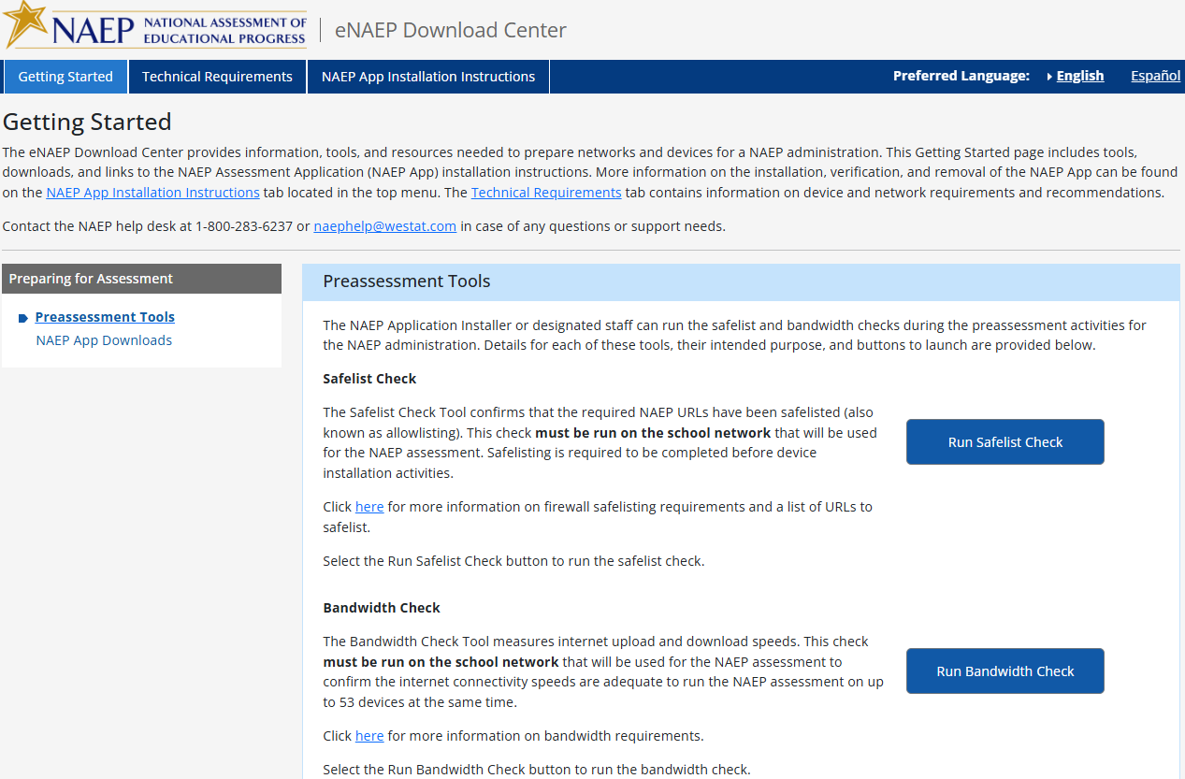

The following are the Safelisting Results messages that will appear depending on the school’s network conditions.
Safelist check passes.
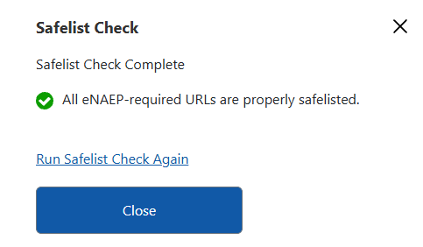
Safelist check fails.
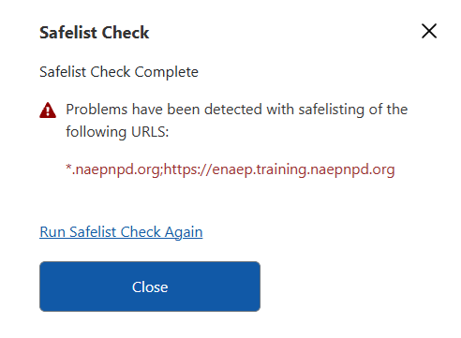
Safelist check passes but not all NAEP content was safelisted (content filters may block the NAEP assessment content).
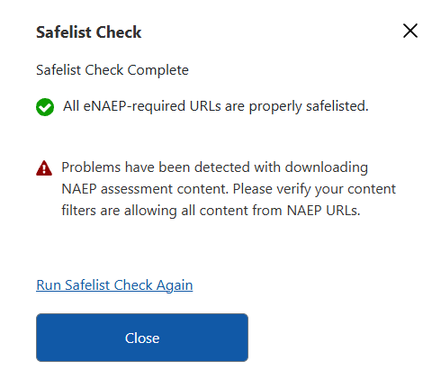

Getting Started > Preparing for Assessment > NAEP App Downloads
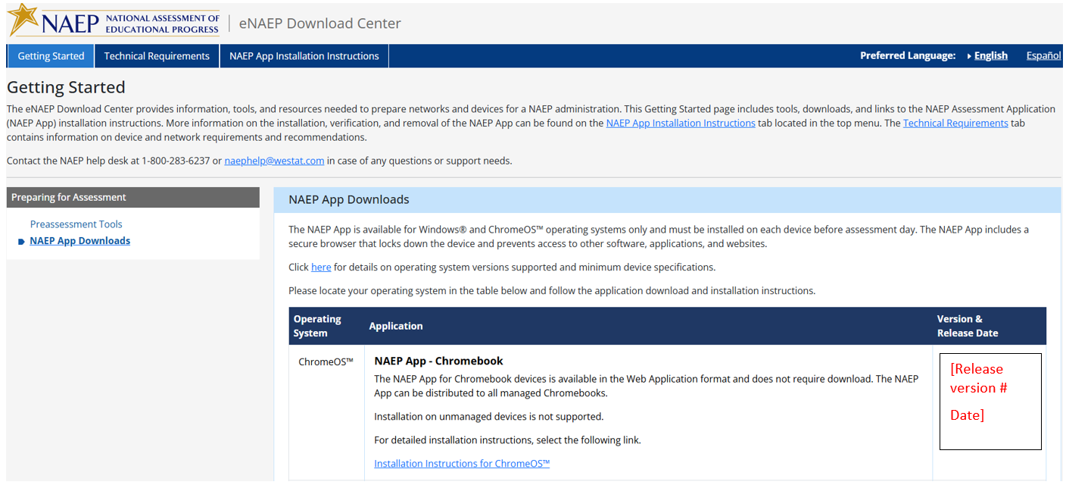

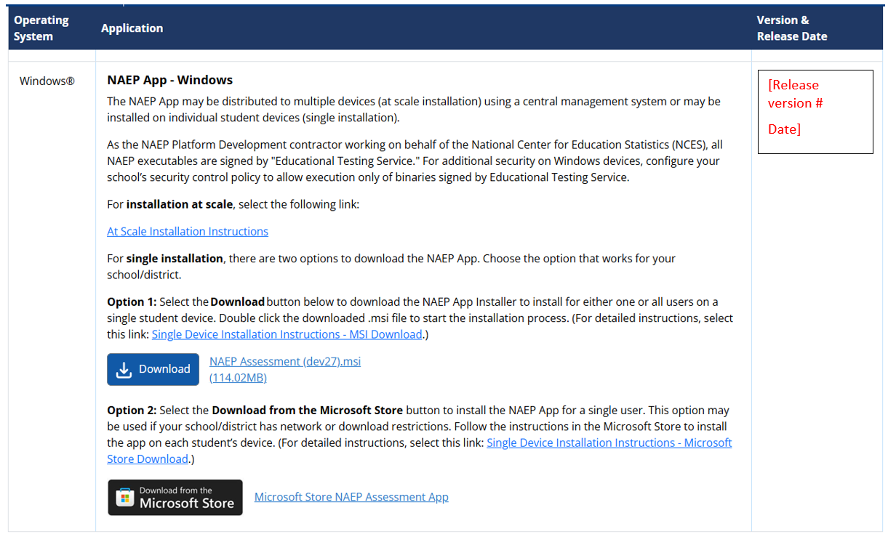
Note: The Version # and Release Date in the last column changes when the NAEP Assessment Application is updated for use during the development process and then when the application is utilized during the NAEP Administration.

Technical Requirements > System Requirements > OS & Hardware Requirements
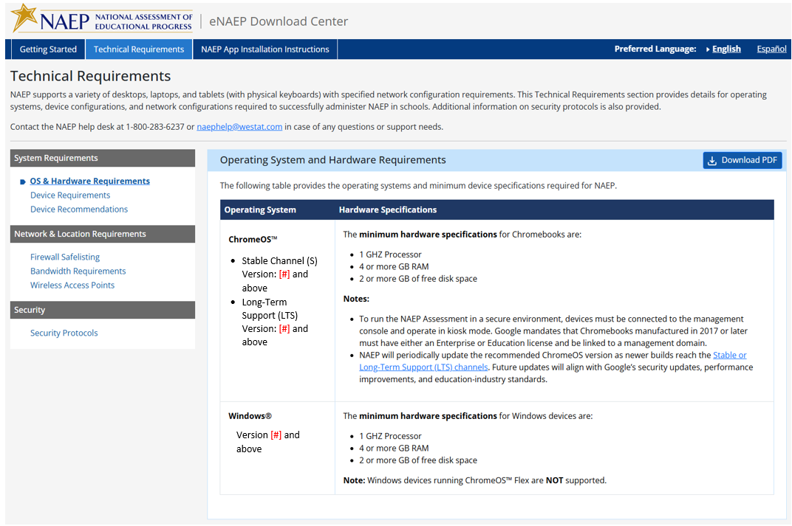
Note: The operating system version # in the first column may change as Google or Microsoft may release new versions. The versions will be tested first and discussed with NCES before version # changes are updated and utilized for an upcoming NAEP Administration.

Technical Requirements > System Requirements > Device Requirements

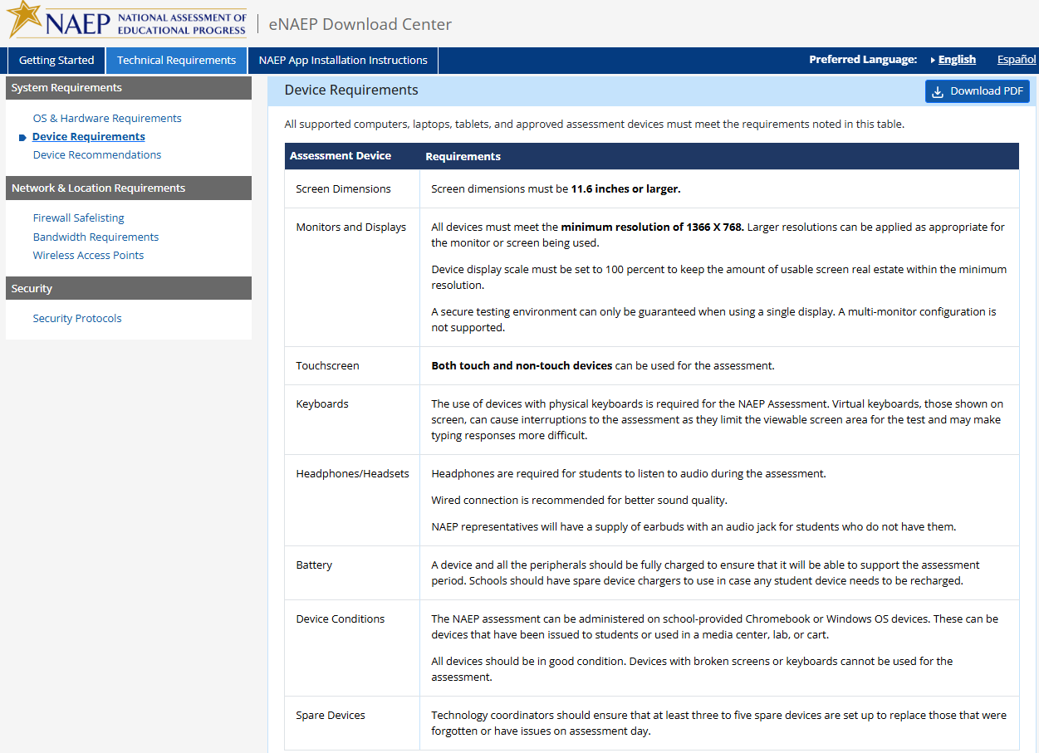

Technical Requirements > System Requirements > Device Recommendations
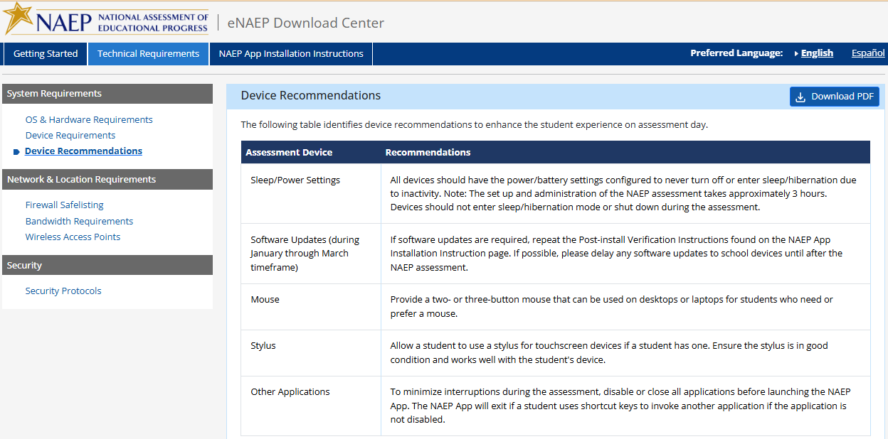

Technical Requirements > Network & Location Requirements > Firewall Safelisting
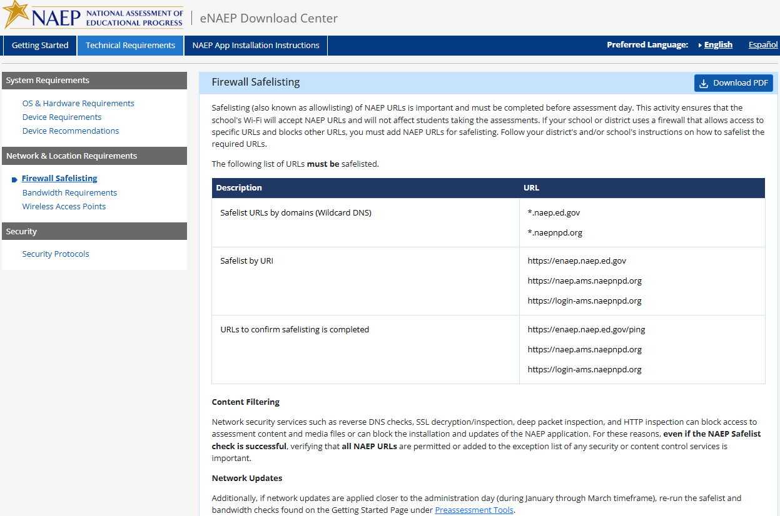
Technical Requirements > Network & Location Requirements > Bandwidth Requirements 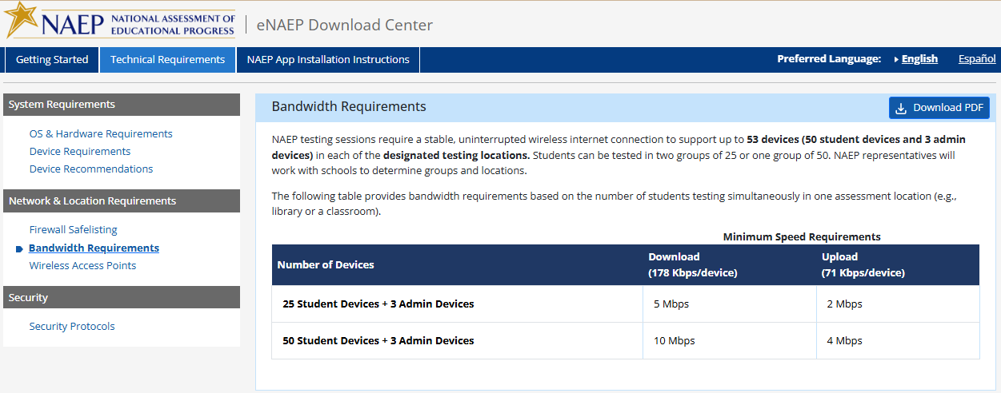

Technical Requirements > Network & Location Requirements > Wireless Access Point
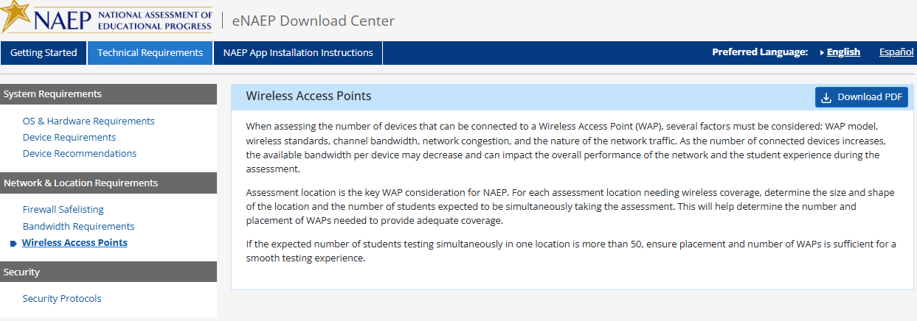

Technical Requirements > Security > Security Protocols
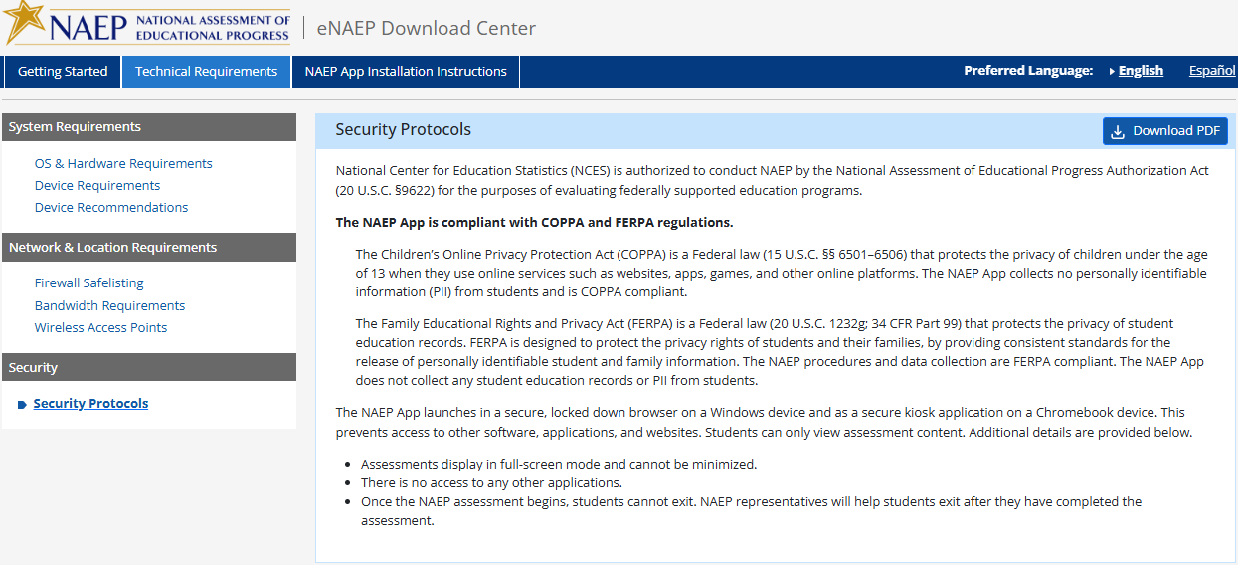

NAEP App Installation Instructions > ChromeOS > Installation Instructions
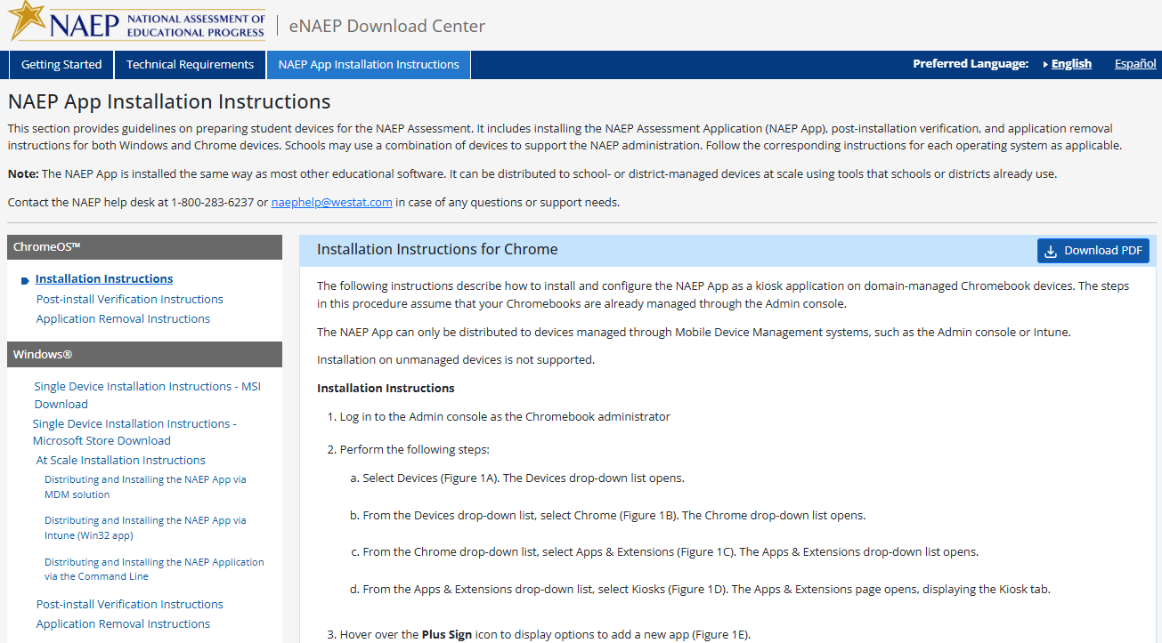
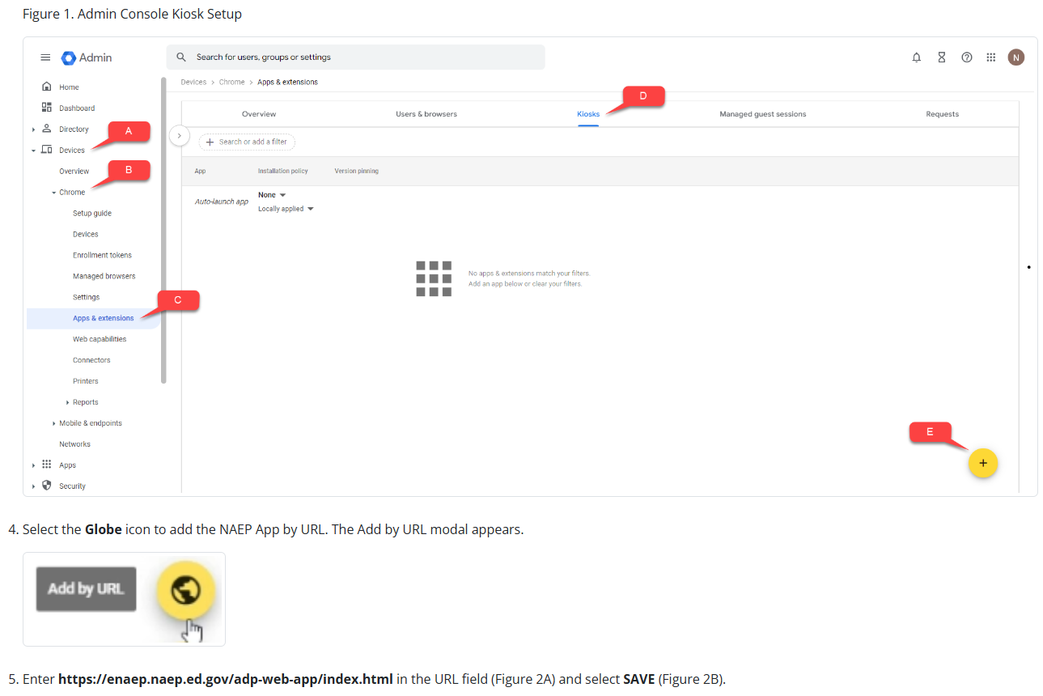

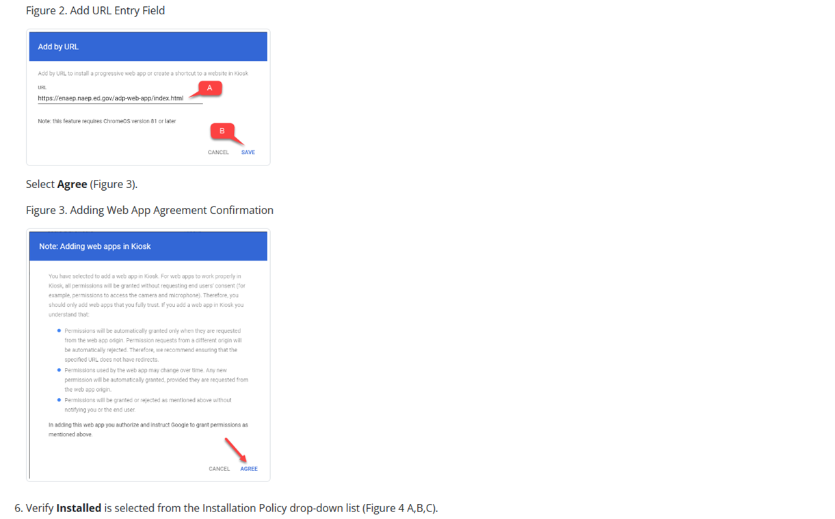
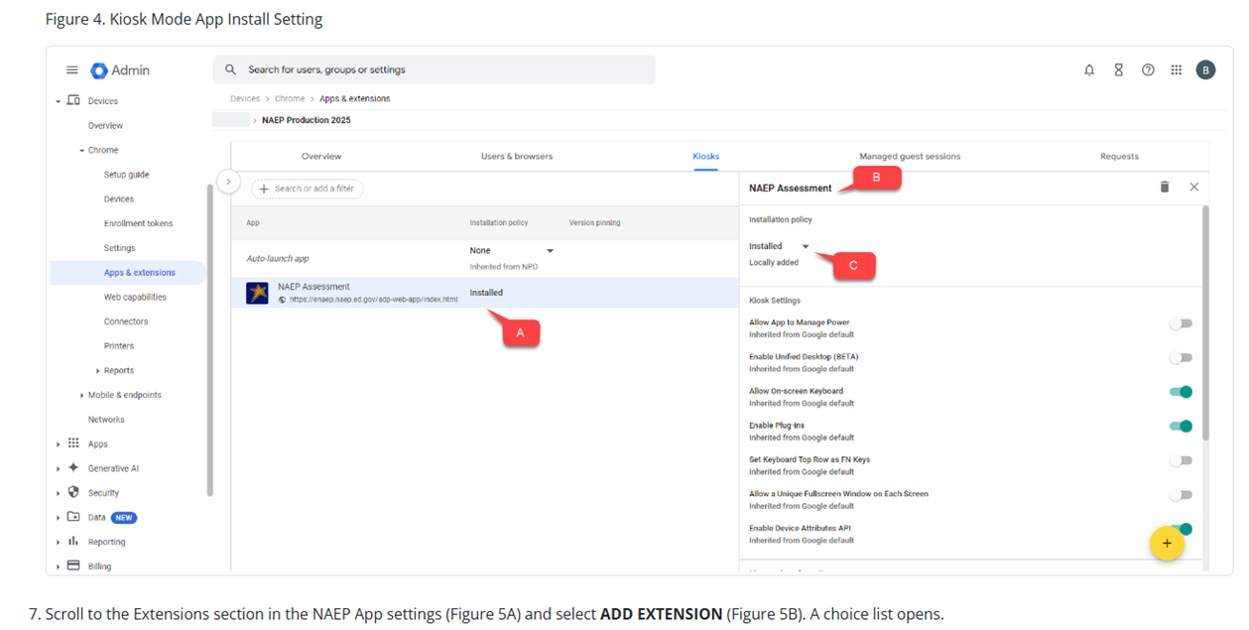
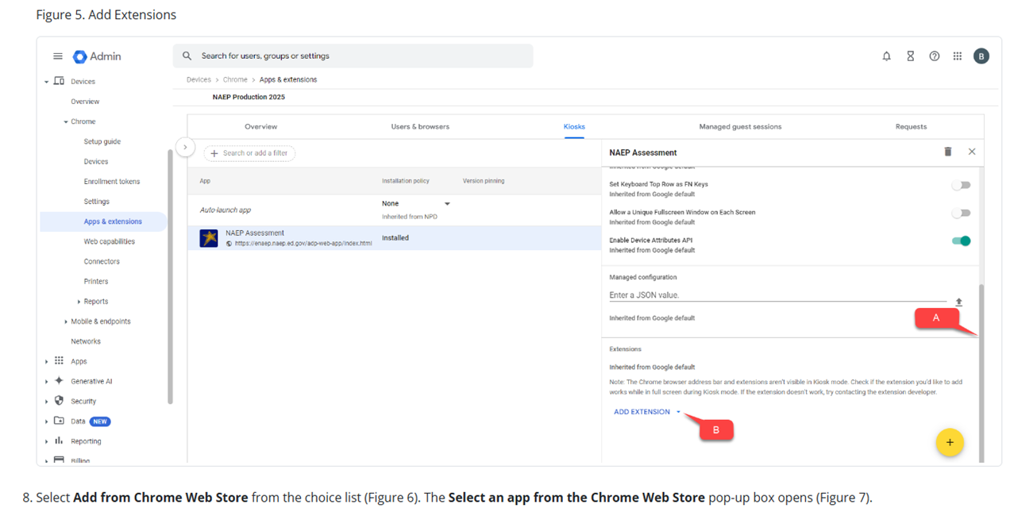
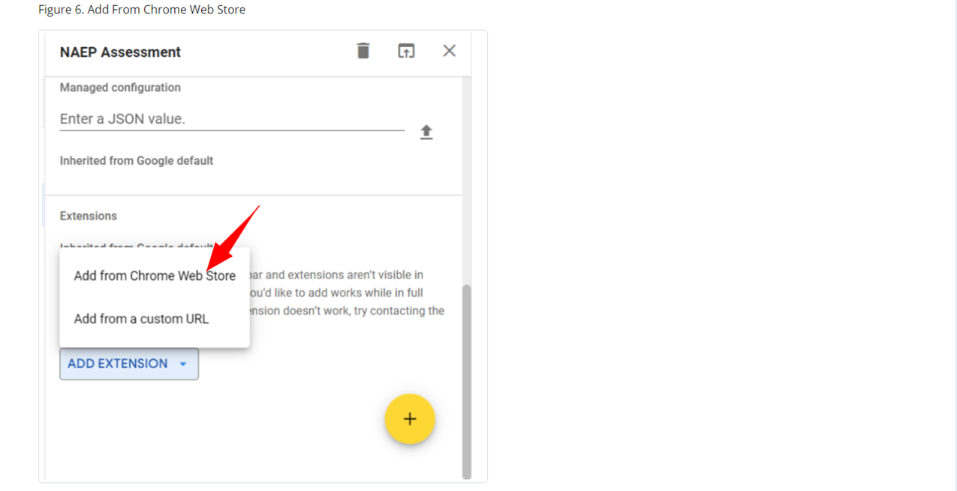
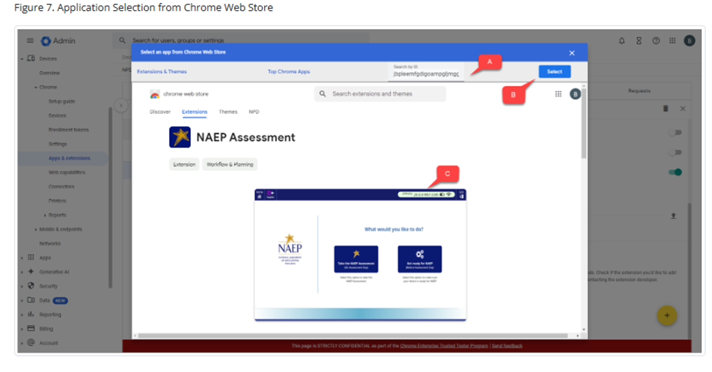
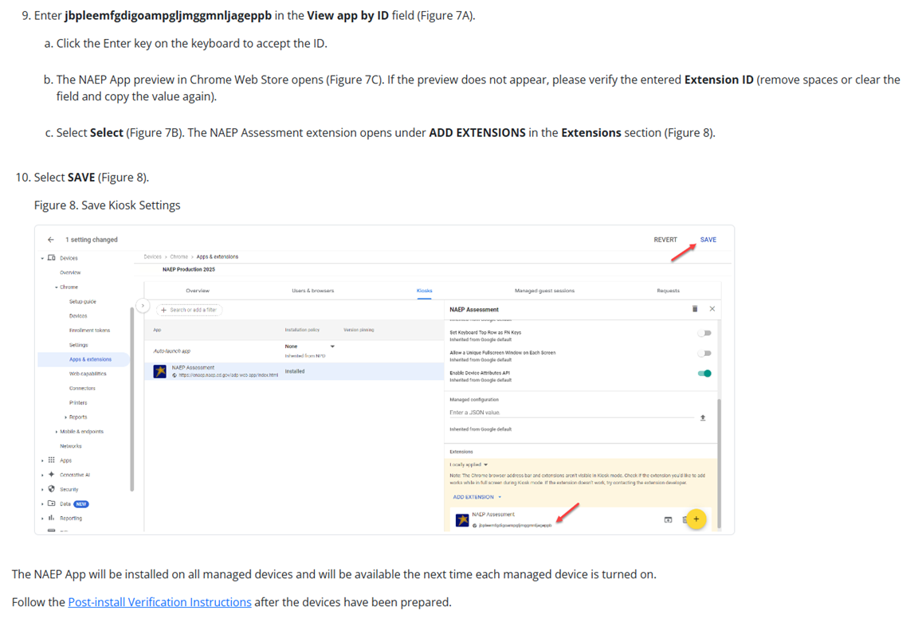

NAEP App Installation Instructions > ChromeOS > Post-install Verification Instructions

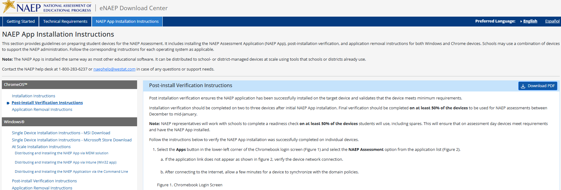
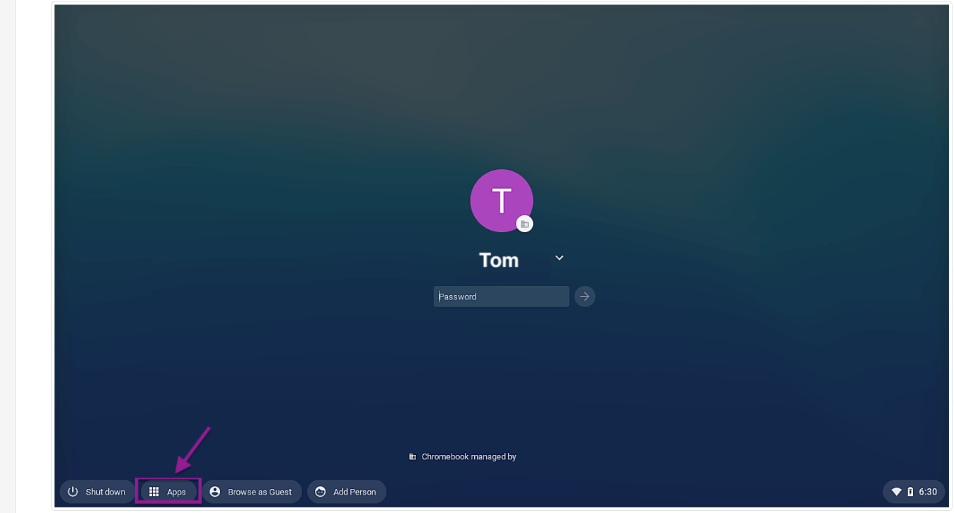
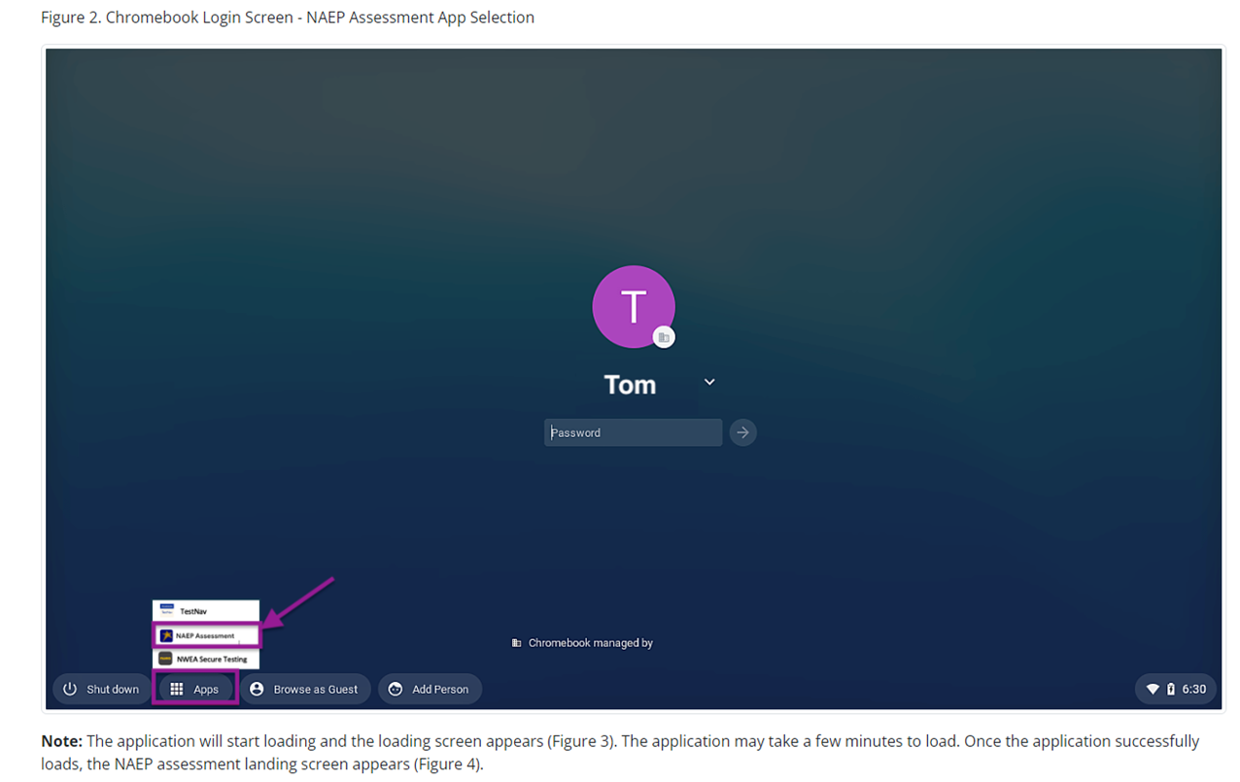
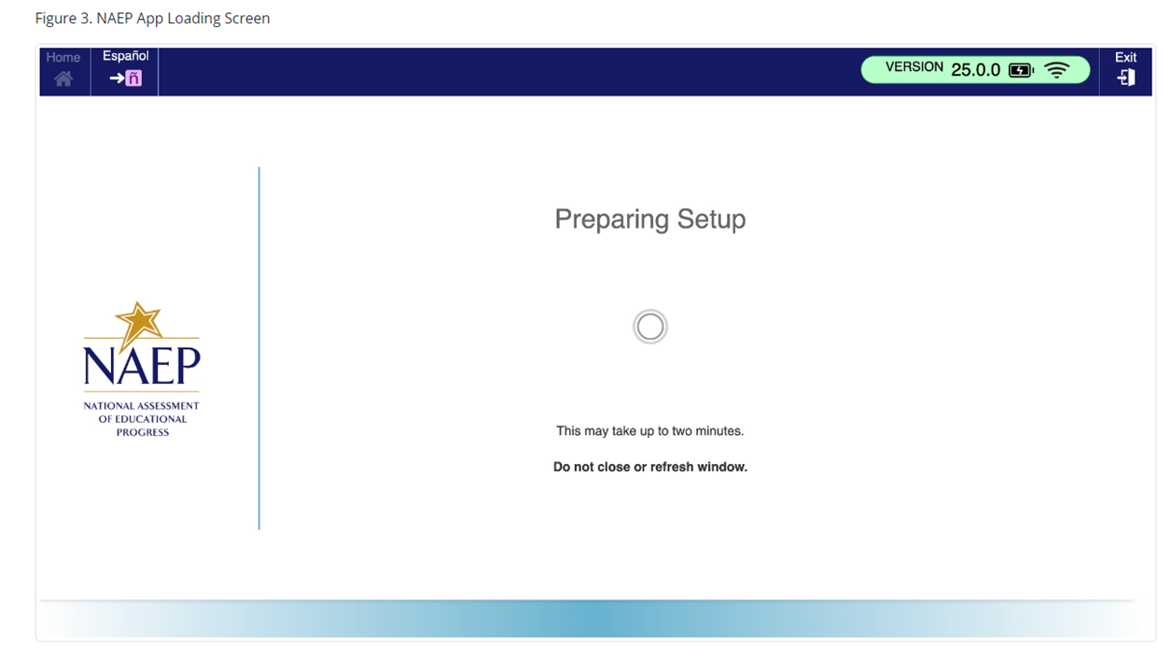
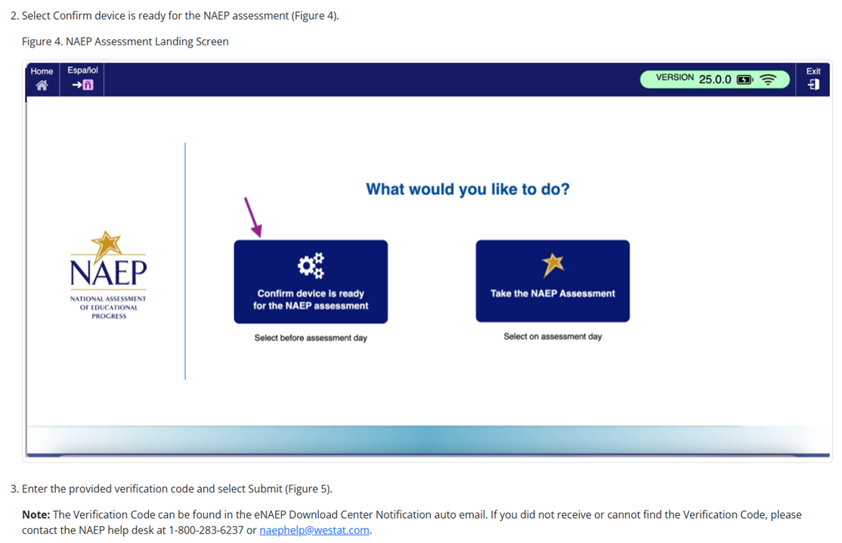

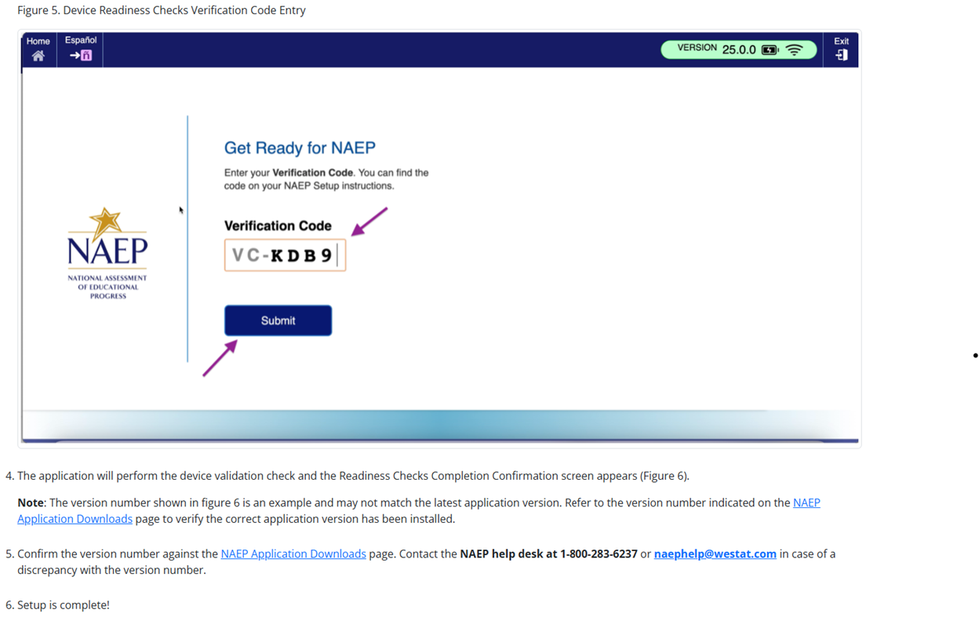

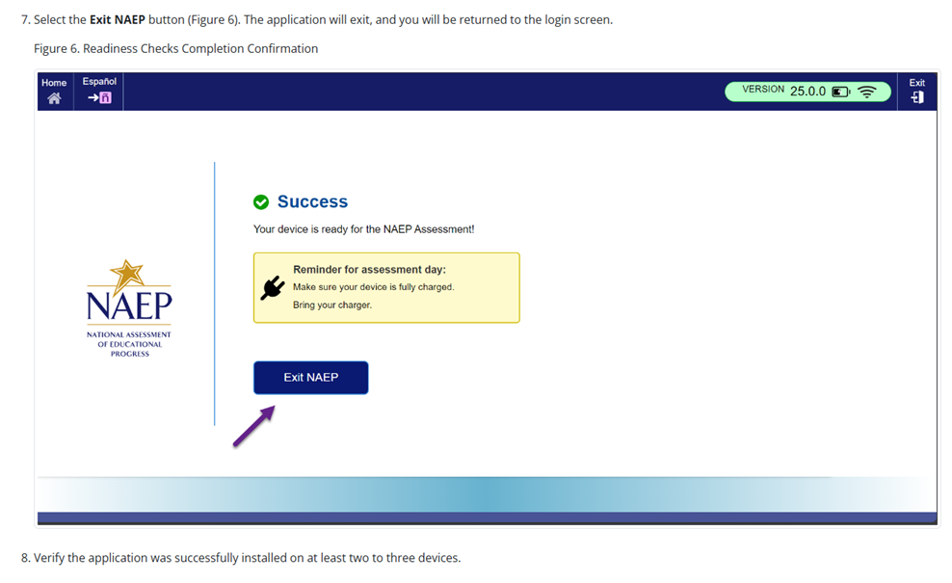

NAEP App Installation Instructions > ChromeOS > Application Removal Instructions
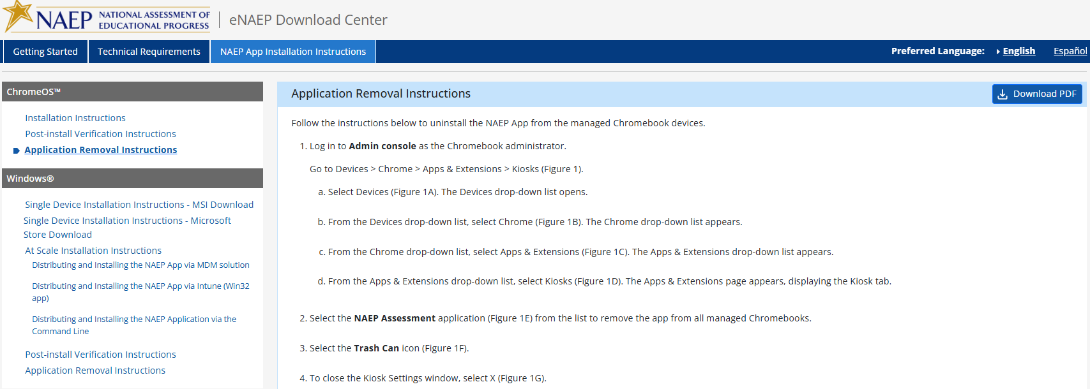
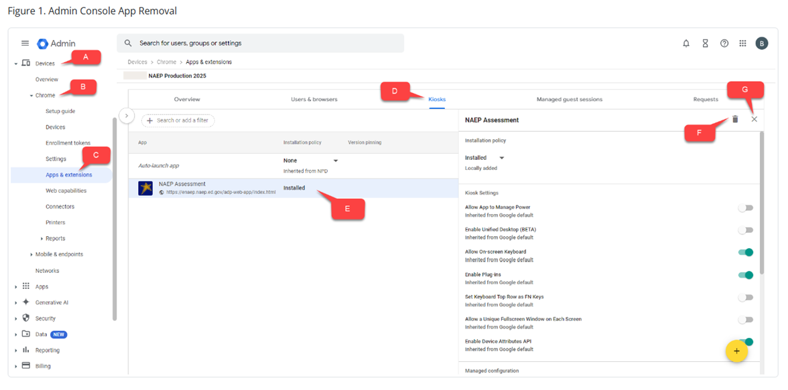

NAEP App Installation Instructions > Windows > Single Device Installation Instructions – MSI Download
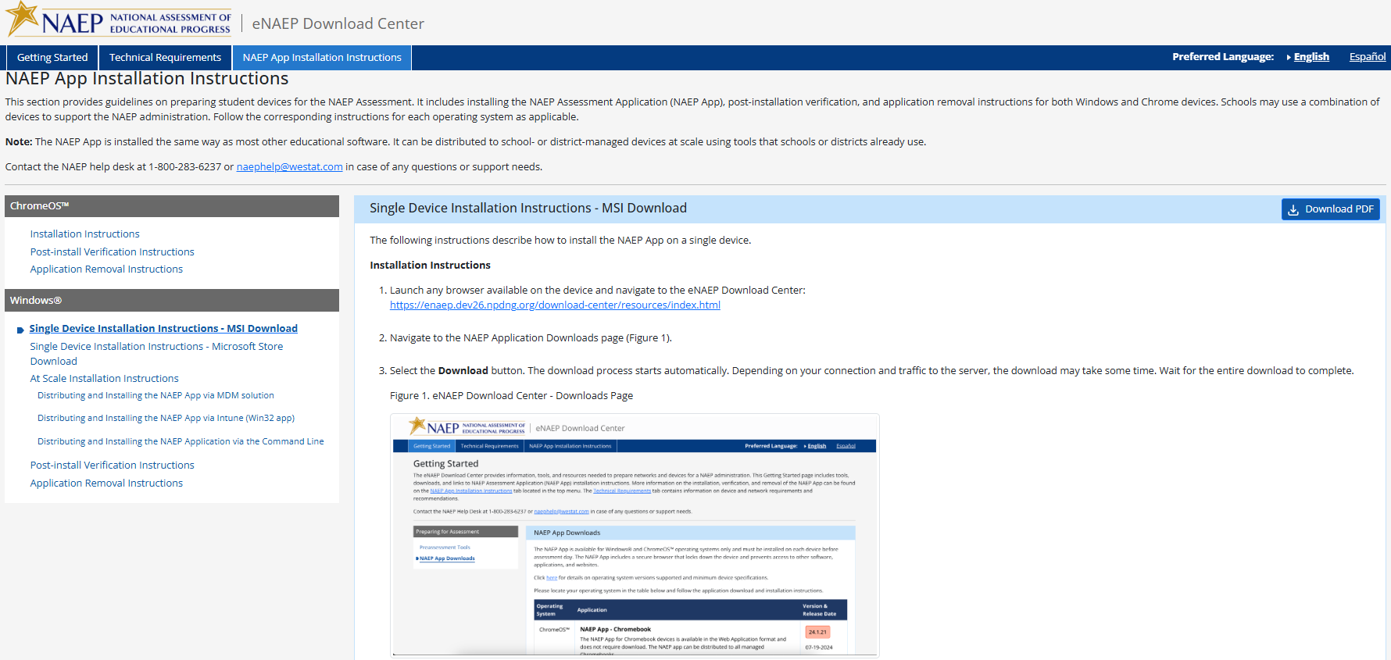
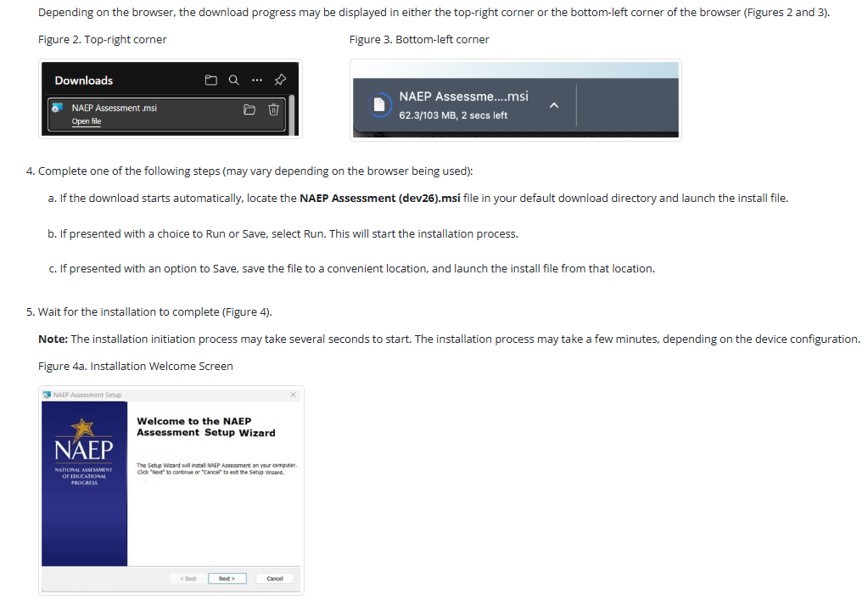
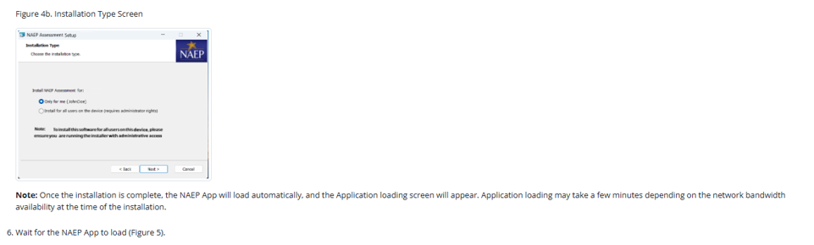
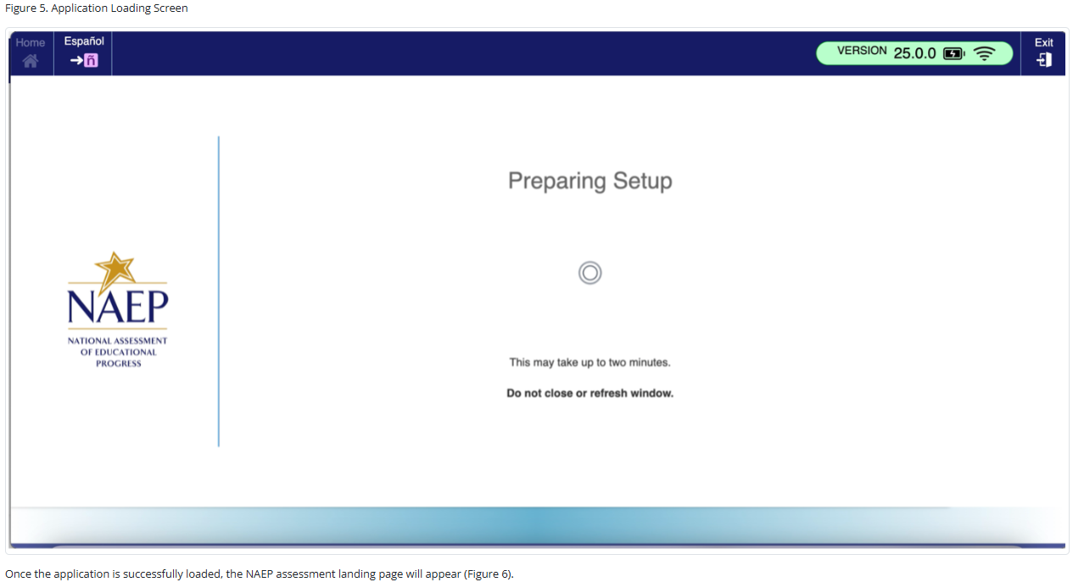
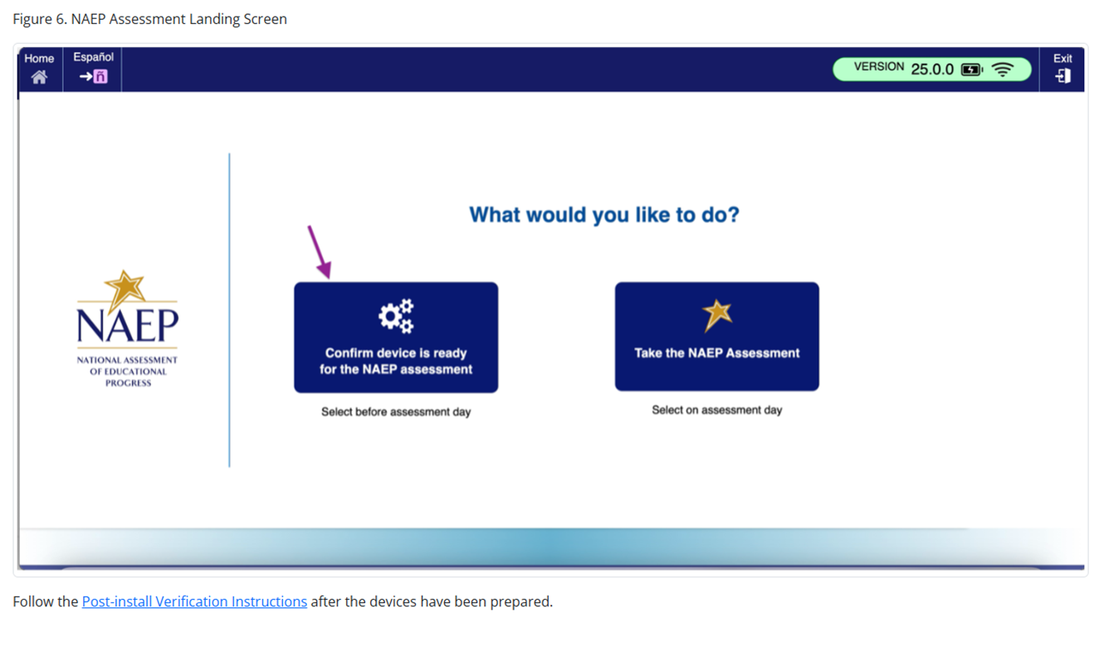

NAEP App Installation Instructions > Windows > Single Device Installation Instructions – Microsoft Store Download
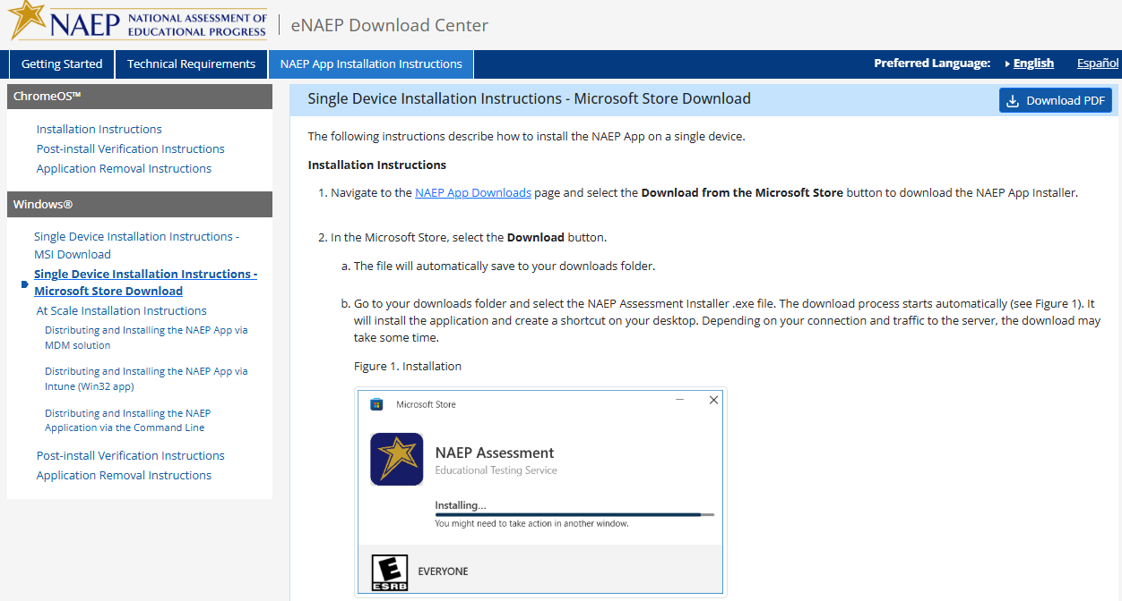

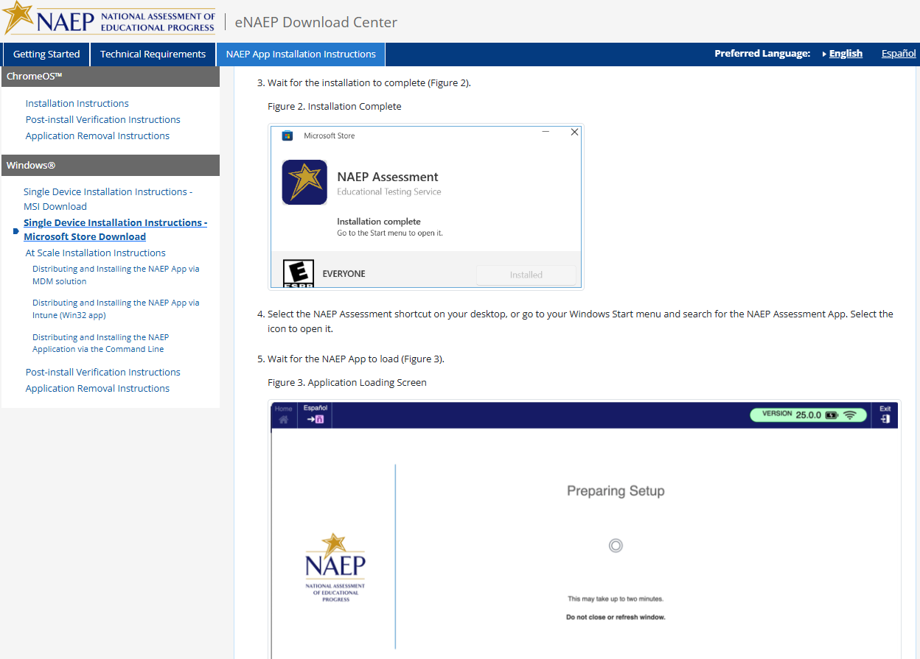
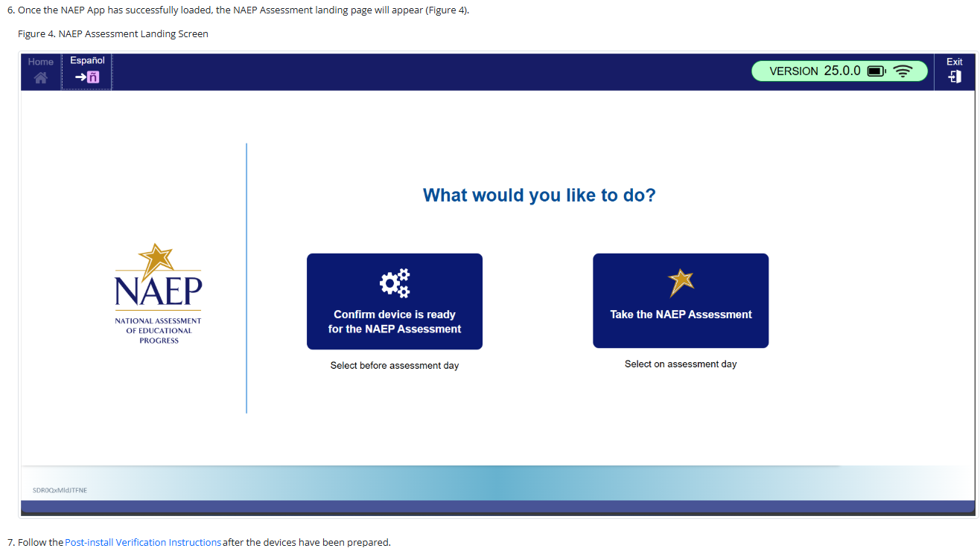

NAEP App Installation Instructions > Windows > At Scale Installation Instructions
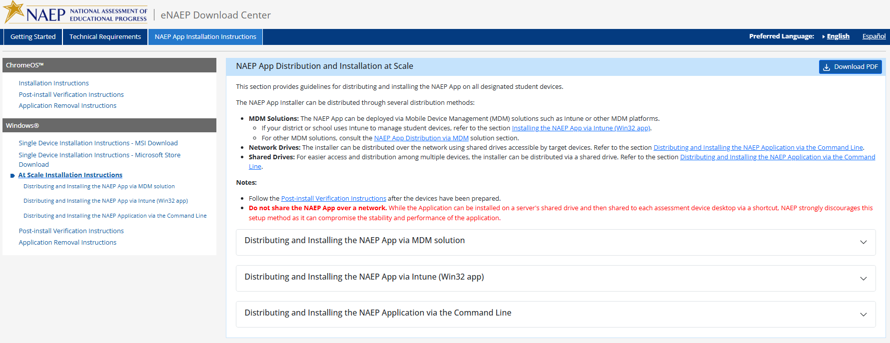

NAEP App Installation Instructions > Windows > At Scale Installation Instructions > Distributing and Installing the NAEP App via MDM Solution

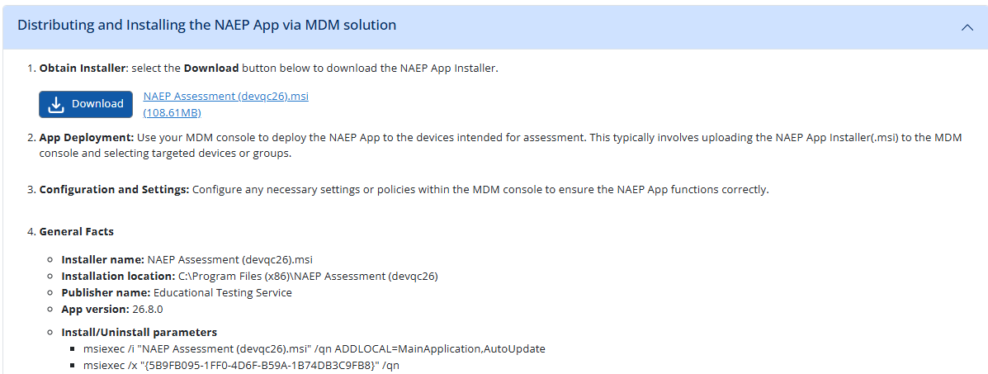

NAEP App Installation Instructions > Windows > At Scale Installation Instructions > Distributing and Installing the NAEP App via Intune (Win32 app)
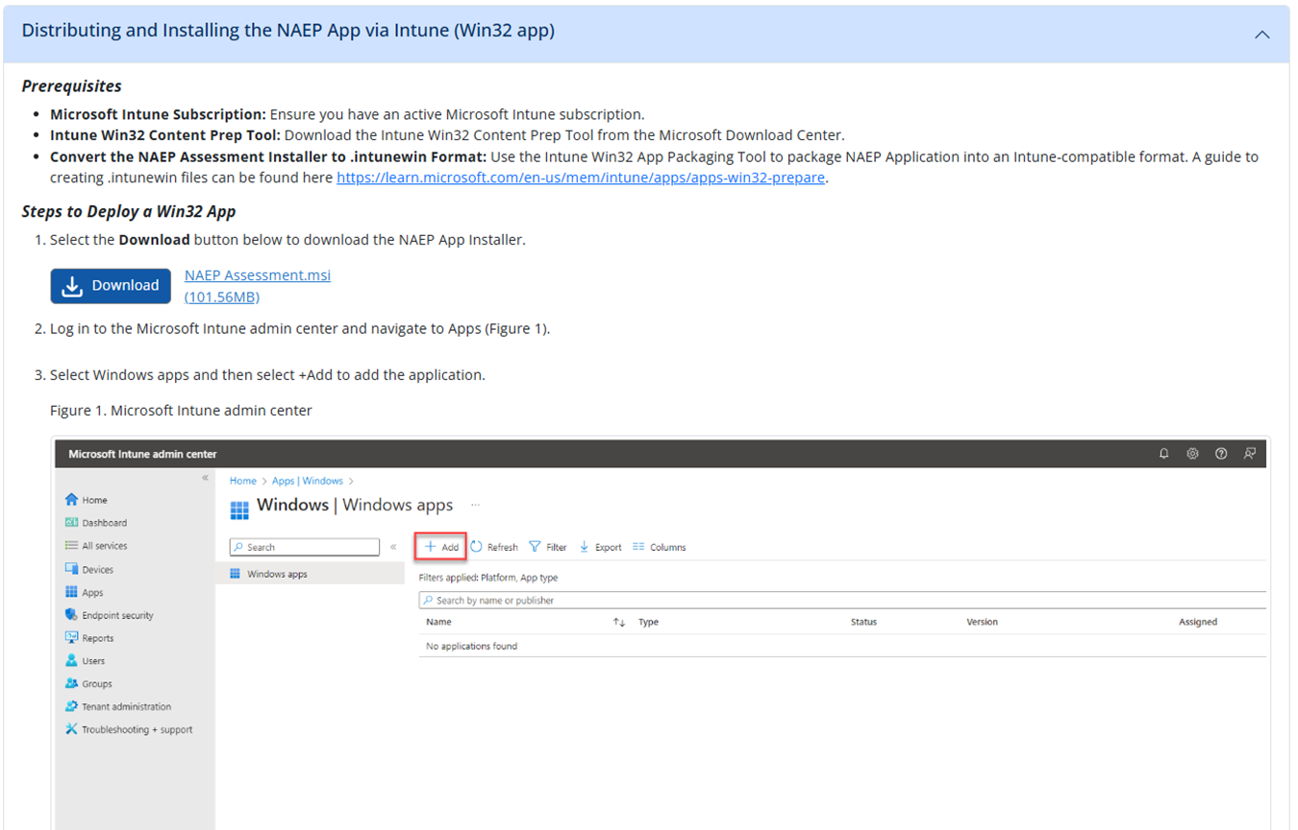
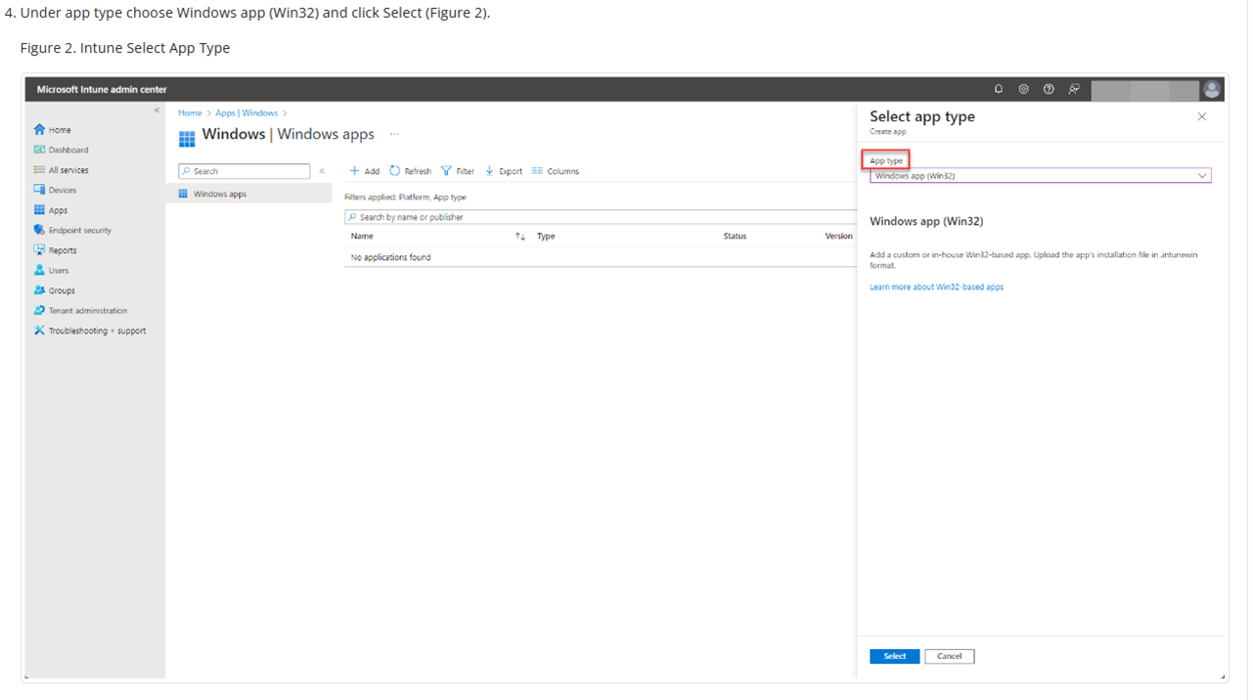
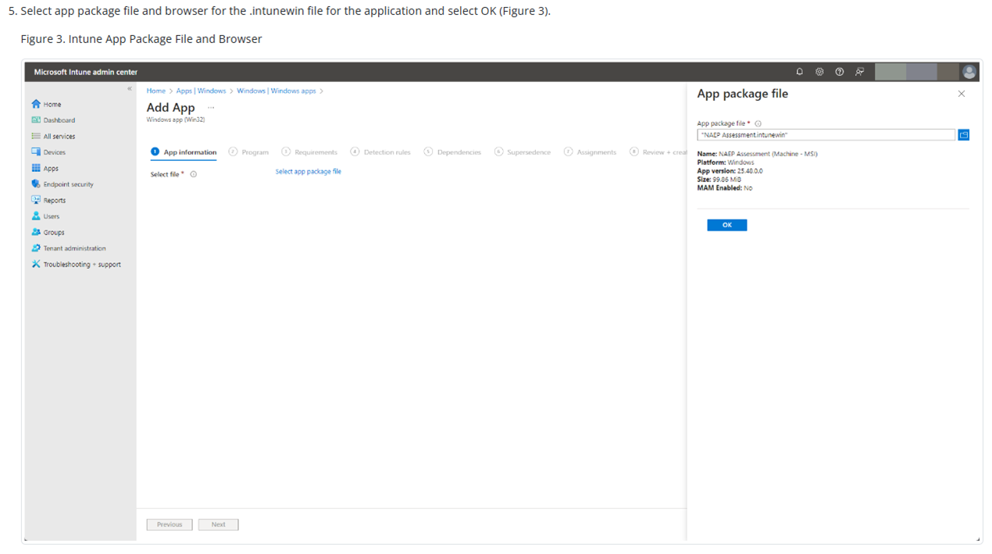
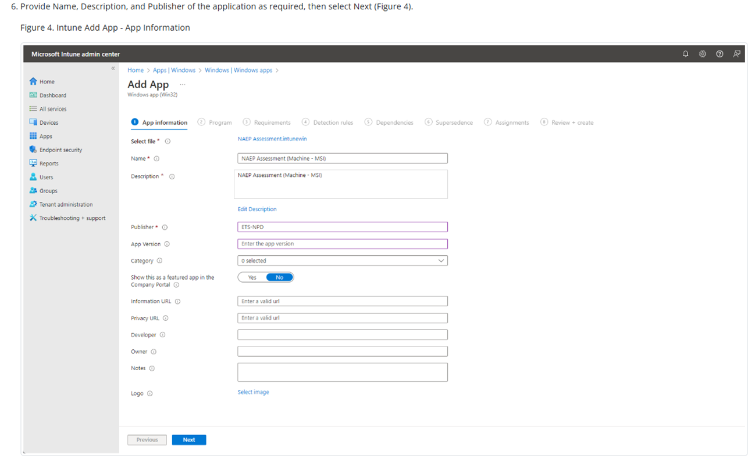
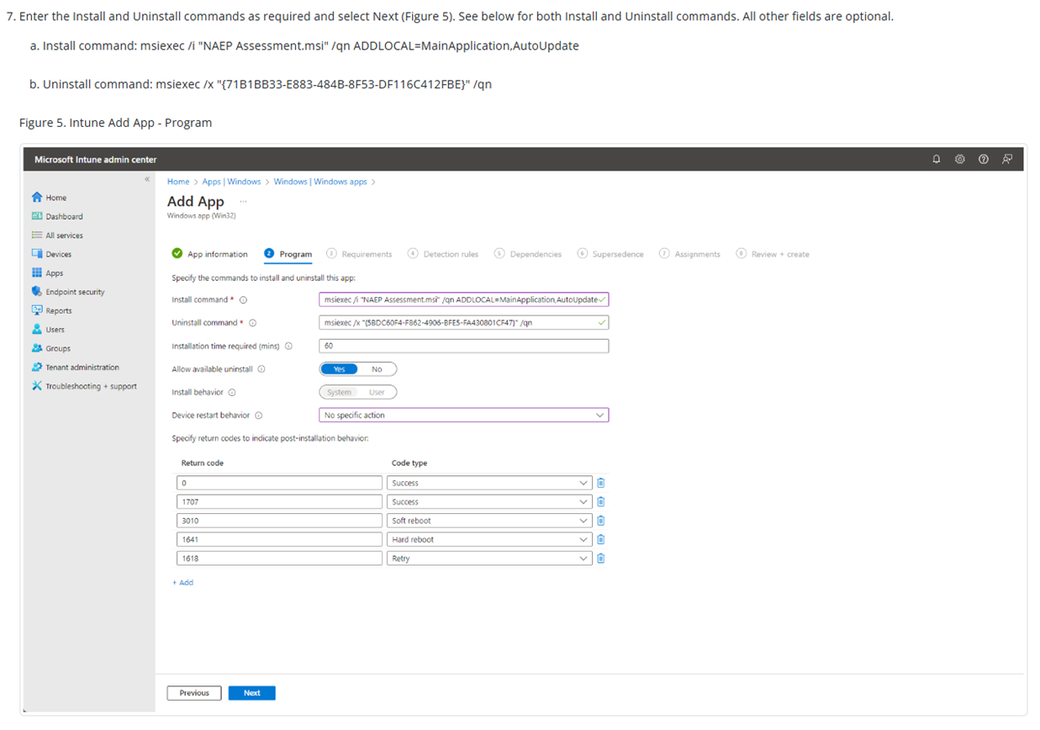
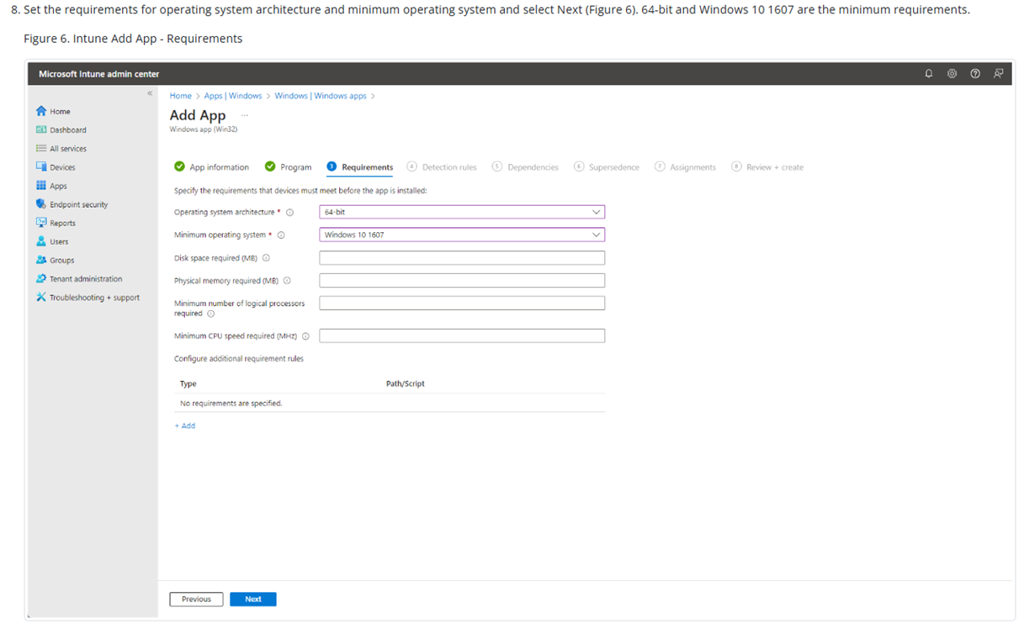
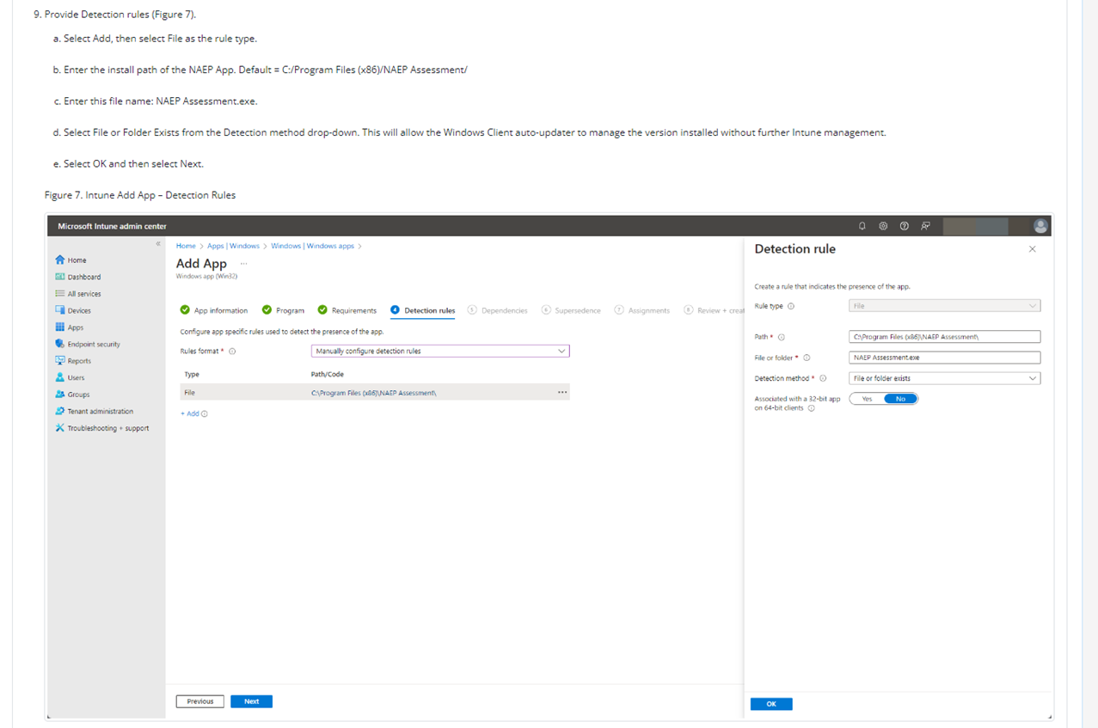
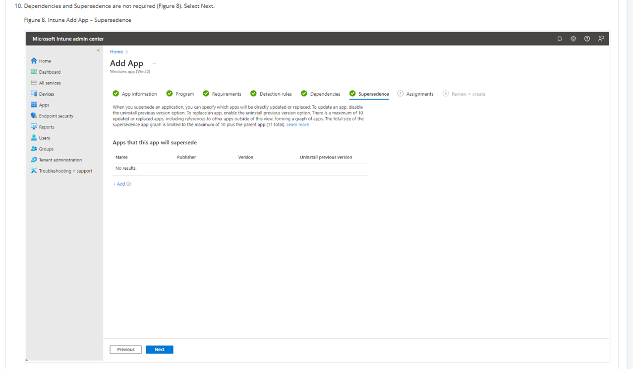
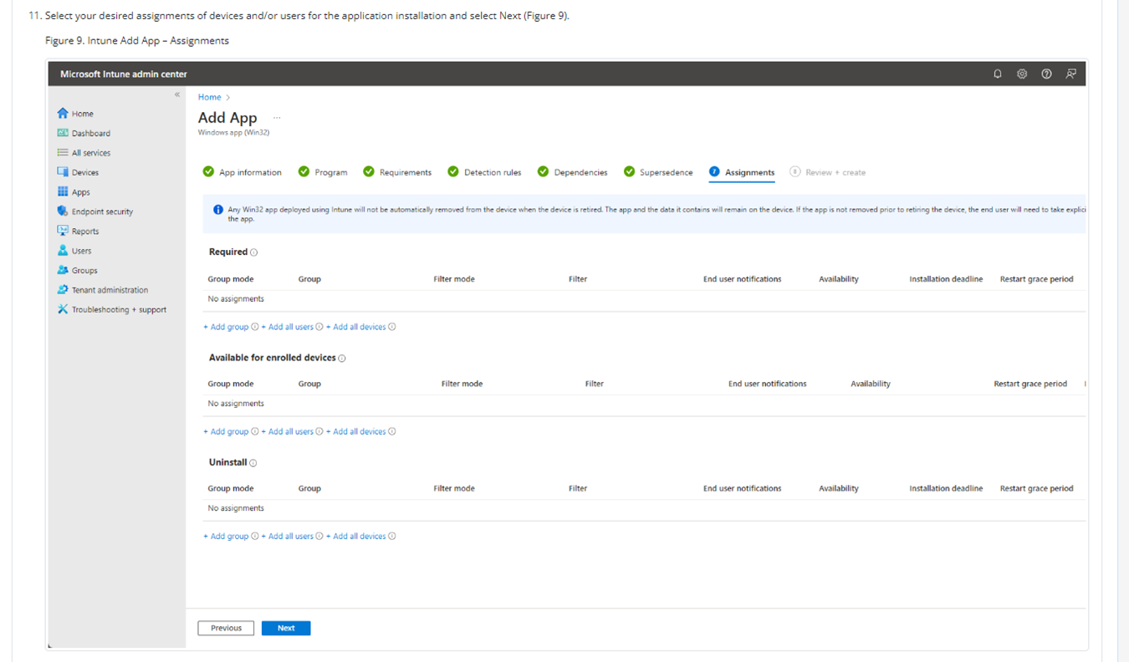
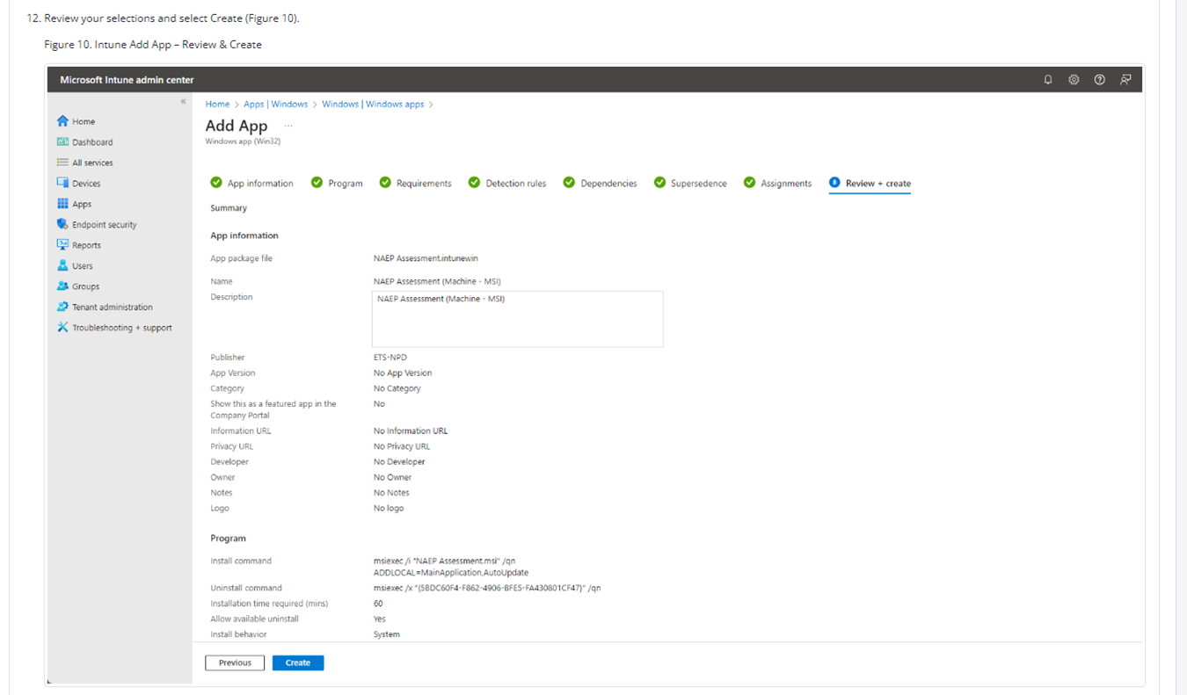
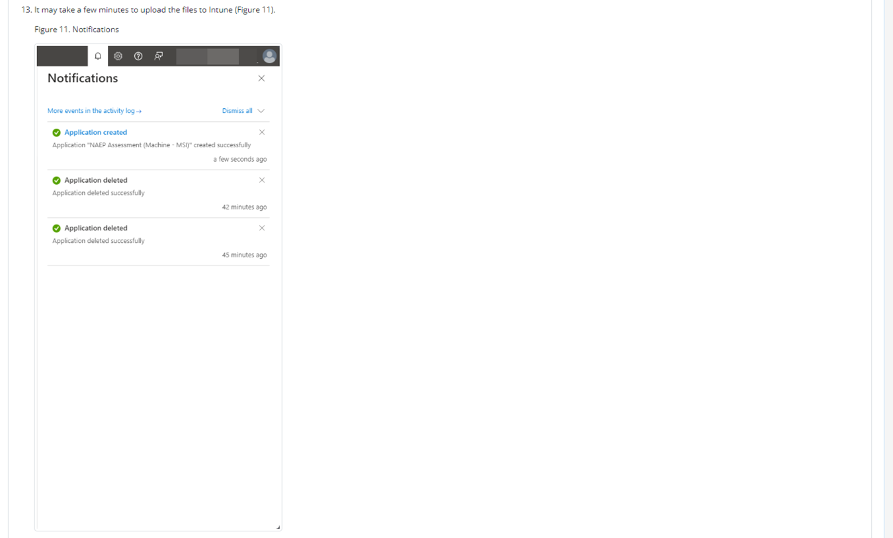
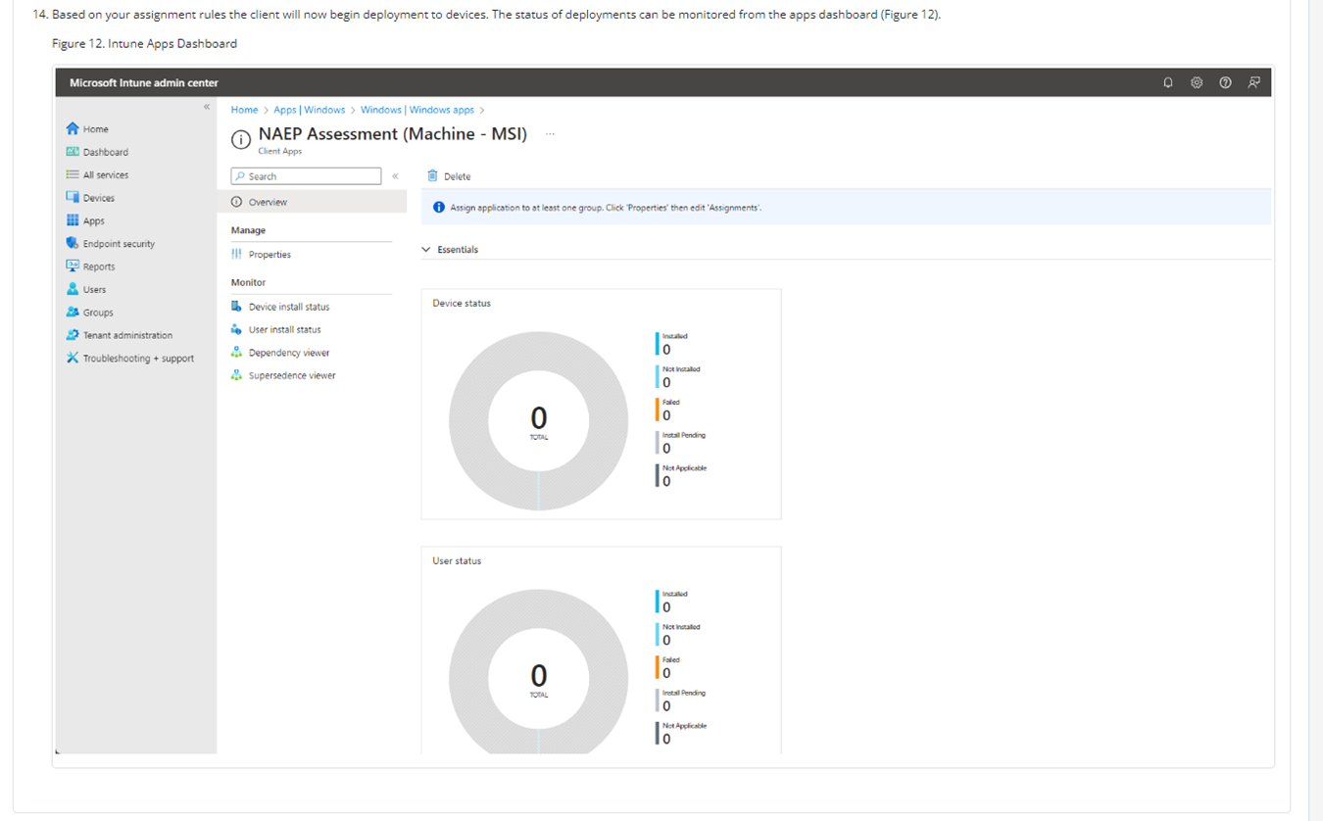

NAEP App Installation Instructions > Windows > At Scale Installation Instructions > Distributing and Installing the NAEP App via the Command Line
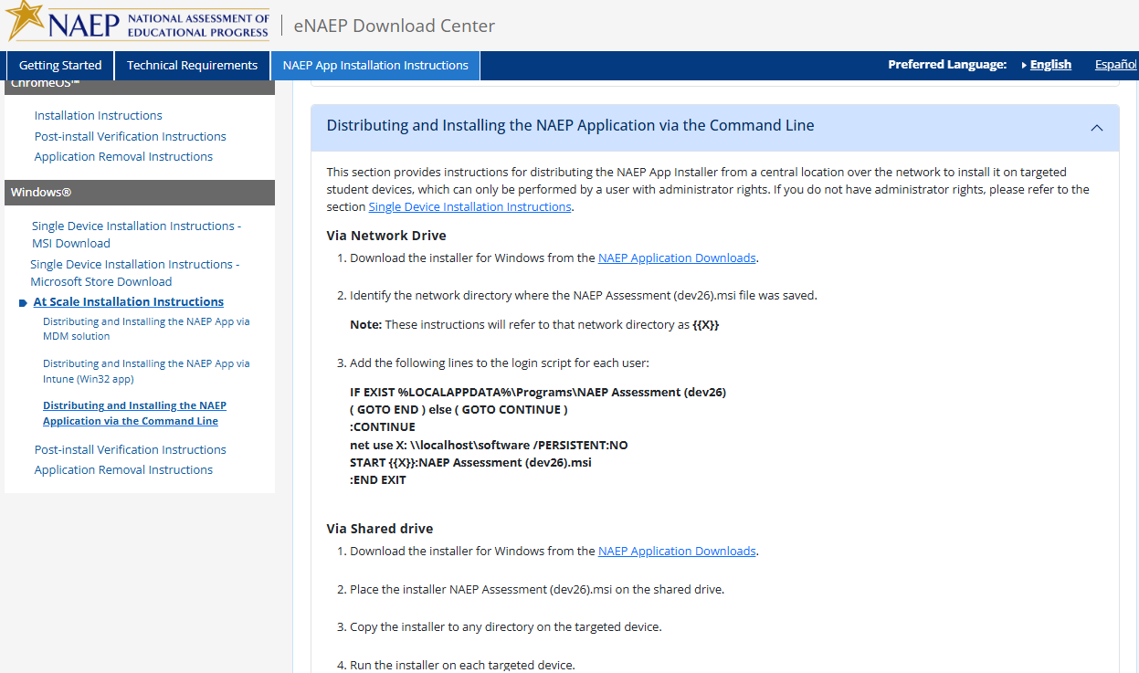

NAEP App Installation Instructions > Windows > Post-Install Verification Instructions
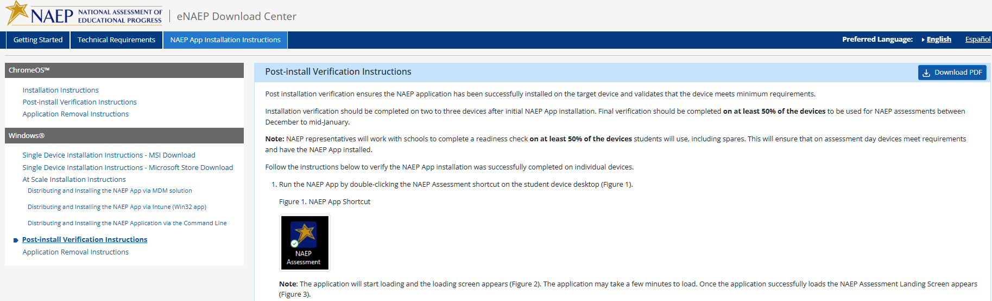
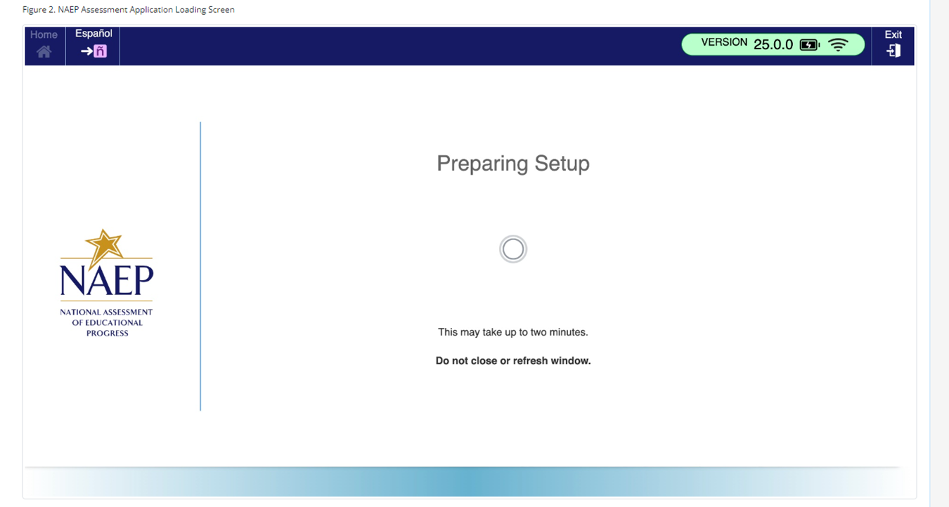
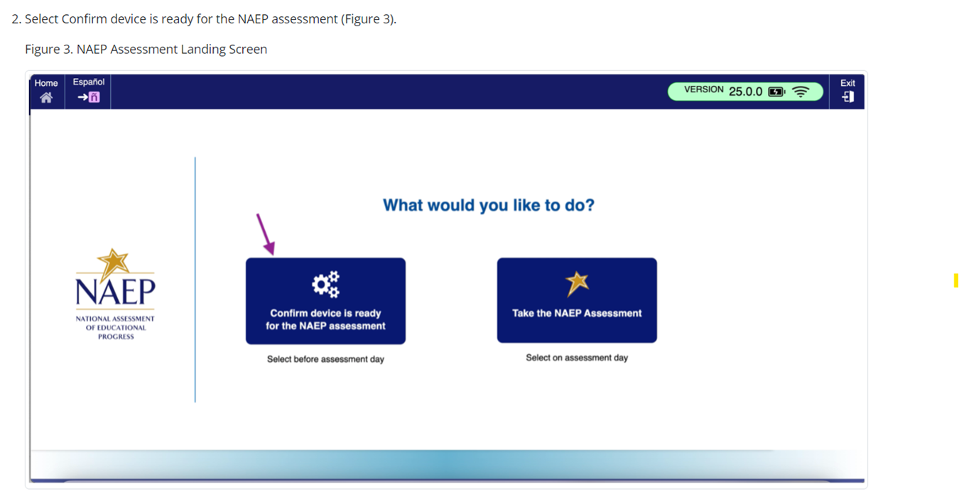
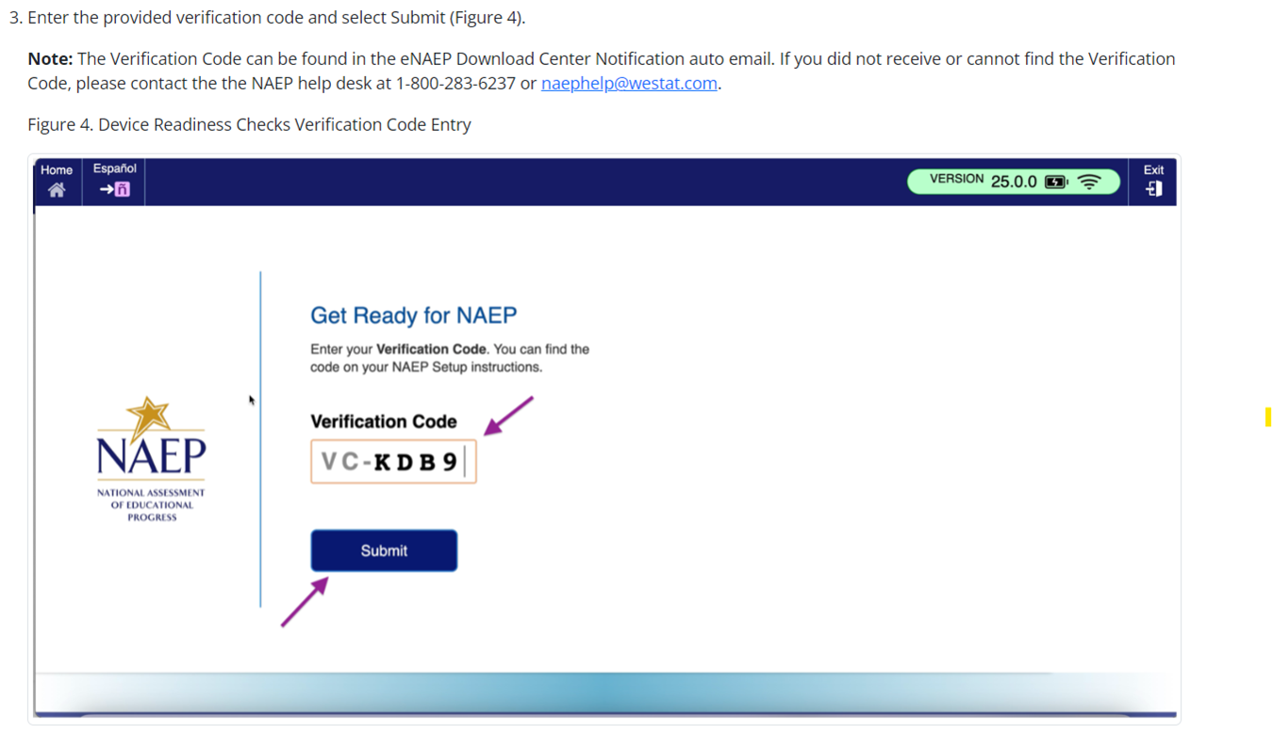
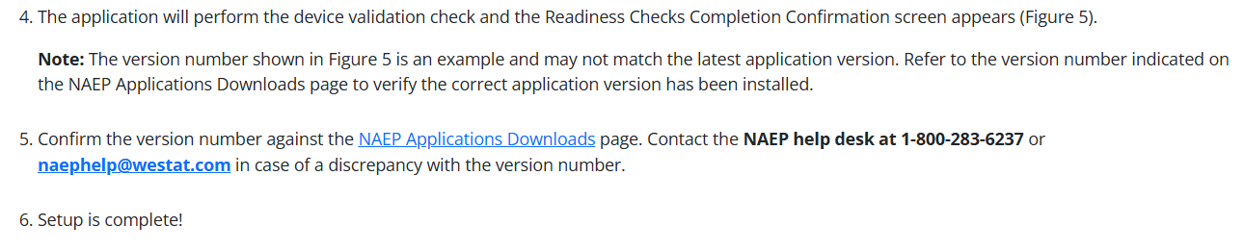
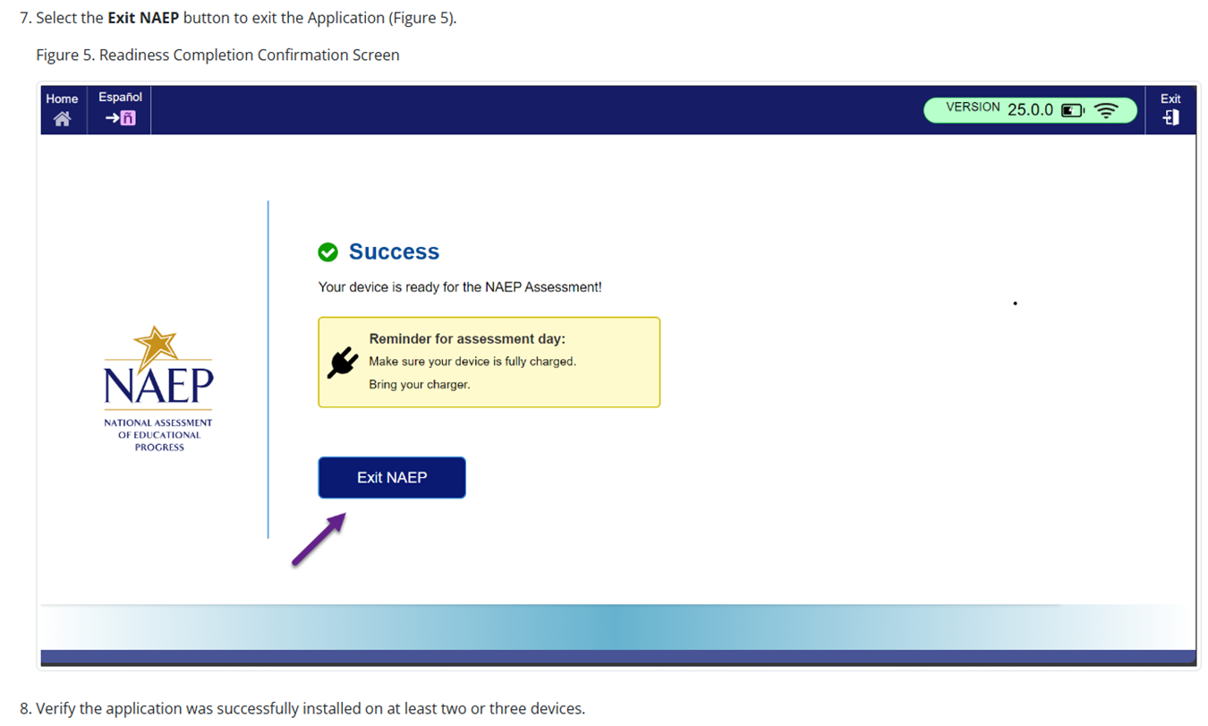

NAEP App Installation Instructions > Windows > Application Removal Instructions
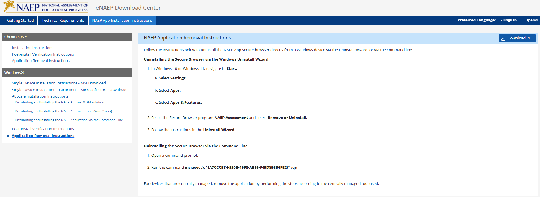

Maintenance Page - English
The maintenance page below was displayed to users who accessed the eNAEP Download Center when it was not yet available. It is inactive when the School Technology Survey is available in the AMS.
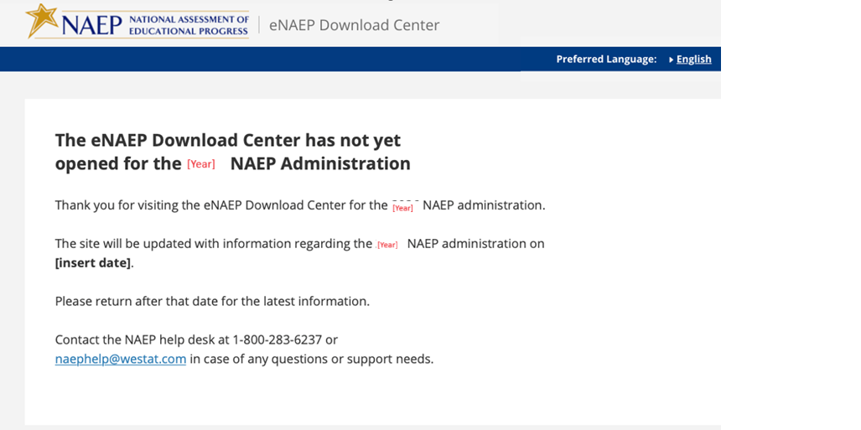

Page Not Found Error Page – English
A user will see the below page if the user attempts to access a link for the eNAEP Download Center that is not valid (e.g., mistype the link).
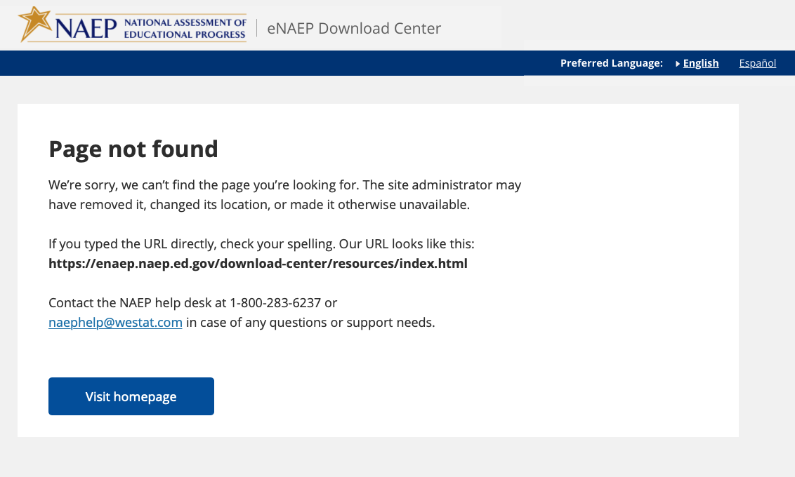

Appendix D-8: NAEP 2027 eNAEP Download Center Notification, Auto email to School or District Application Installer (NEW)

NAEP 2027 – eNAEP Download Center Notification
AUTO EMAIL TO SCHOOL OR DISTRICT APPLICATION INSTALLER
Highlighted text represents merge fields.

Subject: Instructions for School or District NAEP Assessment Application Installer
To: [Application Installer Email]

Dear [Application Installer Firstname] [Application Installer Lastname]:

Your school or district has been selected to participate in the 2027 administration of the National Assessment of Educational Progress (NAEP). You have been identified as the person best suited to prepare the school devices (e.g., desktops, laptops, tablets with keyboards).

You can find important information via the [eNAEP Download Center hyperlink], including the following:
- detailed instructions for installing and uninstalling the NAEP Assessment application on one device or multiple devices operating on Windows or ChromeOS;
- specifications for the types of devices that can be used for the NAEP assessment, and other technical requirements; and
- tools that can be used to confirm the safelisting of NAEP assessment URLs or to conduct bandwidth checks.

Please complete the following activities by [date].

- Prepare for NAEP Assessment Application Installation
Review the Getting Started and Technical Requirements tabs via the eNAEP Download Center for more detailed instructions.
  - Confirm that safelisting is completed using the Safelist Check tool. The check must be run on the school network.
    - Safelist the NAEP URLs provided in Firewall Safelisting section under the Technical Requirements tab if they are not already safelisted.
    - (Optional) Confirm whether the school can support the required bandwidth on the network that will be used for the NAEP assessment using the Bandwidth Check tool.
  - Identify devices that meet the technical requirements to be used to conduct the NAEP assessment.
    - If you plan to install the application only on devices used by students who will take NAEP, please contact your NAEP State or TUDA Coordinator for access to a secure list of sampled students in [month].

- Install the NAEP Assessment Application
The table below lists the school(s) that need the NAEP Assessment application installed on school devices for the sampled grade level. Review the NAEP App Installation Instructions tab via the eNAEP Download Center for detailed instructions. Install the NAEP Assessment application at scale or individually to all school devices to be used on assessment day.

District Name | School Name | Grade

- (Optional) Uninstall the NAEP Assessment Application
Once the NAEP assessment concludes, you may uninstall the NAEP Assessment application as directed by the detailed instructions found on the NAEP App Installation Instructions tab.

Starting in [month], NAEP representatives will work with schools to complete a device readiness check on [XX] percent of the total number of devices students will use to take the assessment, including spares. This will ensure that on assessment day each device meets the technical requirements and has the NAEP Assessment application installed.

What if I have questions?
If you have questions about these tasks, please contact the NAEP help desk at 1-800-283-6237 or naephelp@westat.com. If you have other questions about NAEP, please contact your NAEP State or TUDA Coordinator at [NSC or NTC email].

Thank you again for your assistance with this very important assessment.

Appendix D-9: NAEP 2027 District Model Assignment Notification (NEW)

NAEP 2027 – District Model Assignment Notification
NAEP State Coordinator to District Assessment Coordinator
Red text should be customized before mail merge: highlighted text represents mail merge fields

Dear District Assessment Coordinator,

Thank you for all that you do to support education in state name. I am writing to inform you that administrative model assignments have been made for a school/schools in your district selected to participate in the 2027 administration of the National Assessment of Education Progress (NAEP).

I will reach out to selected schools with details about their administrative model assignment for NAEP and next steps.

Administrative Model Assignments

NAEP will be administered using school devices (e.g., desktops, laptops, tablets with keyboards) for the following school(s).
- School 1 Name, Grade, and Assessed Subjects
- School 2 Name, Grade, and Assessed Subjects
- Etc.

NAEP will be administered using Chromebooks provided by NAEP for the following school(s).
- School 1 Name, Grade, and Assessed Subjects
- School 2 Name, Grade, and Assessed Subjects
- Etc.

Again, thank you for your assistance with this very important assessment of our nation’s students. If you have questions, please contact me at telephone number or via email at email address.

Sincerely,

NAEP State Coordinator

The National Center for Education Statistics (NCES) conducts the National Assessment of Educational Progress to evaluate federally supported education programs. All of the information you provide may only be used for the purposes of research, statistics, and evaluation under the Education Sciences Reform Act of 2002 (ESRA; 20 U.S.C. § 9543) and may not be disclosed, or used, in identifiable form for any other purpose except as required by law. Every NCES employee as well as every NCES agent, such as contractors and NAEP coordinators, has taken an oath and is subject to a jail term of up to 5 years, a fine of $250,000, or both if he or she willfully discloses ANY identifiable information about you in any unauthorized manner. Electronic submission of your information will be monitored for viruses, malware, and other threats by Federal employees and contractors in accordance with the Cybersecurity Enhancement Act of 2015.

Appendix D-10: NAEP 2027 Parent-Guardian Notification Letter, Public School (NEW)

NAEP 2027 PARENT-GUARDIAN NOTIFICATION LETTER
Grade 8 Science Pilot
(School Letterhead)
(Insert Date Here)

Dear Parent or Guardian:

(School name) will participate in the National Assessment of Educational Progress (NAEP) on (date). NAEP is the largest nationally representative and continuing assessment of what students know and can do in various subjects. NAEP is administered by the National Center for Education Statistics, within the U.S. Department of Education. NAEP is different from our state assessments because it is a common measure of achievement across the country.

Your child (will/may) take a science assessment. In addition to subject-area questions, students voluntarily complete NAEP survey questions. These questions provide valuable information about participating students’ educational experiences and opportunities to learn both in and outside of the classroom. More information about NAEP survey questions is available at https://nces.ed.gov/nationsreportcard/parents under the section “Survey Questionnaires & Your Student: What You Need to Know.”

The assessment takes about 120 minutes for most students, which includes transition time, directions, and completion of survey questions.

The information collected is used for statistical purposes only.
- Your child’s grades will not be affected.
- Students may be excused for any reason, are not required to complete the assessment, and may skip any question.
- Although the assessment is voluntary, NAEP depends on student participation. Policymakers, educators, the media, and the educational assessment community use NAEP results to develop ways to improve and report on education. If you do not want your child to participate, please notify me in writing by (date).

There is no need to study in preparation for NAEP, but please encourage your child to do their best. Contact (name) at (telephone number) or at (email address) if you have any questions.

We are excited that our school is participating in NAEP. We know that (school name)’s students will show what our nation’s students know and can do.

Sincerely,
(School Principal’s Name)

The National Center for Education Statistics (NCES) conducts the National Assessment of Educational Progress to evaluate federally supported education programs. All of the information you provide may only be used for the purposes of research, statistics, and evaluation under the Education Sciences Reform Act of 2002 (ESRA; 20 U.S.C. § 9543) and may not be disclosed, or used, in identifiable form for any other purpose except as required by law. Every NCES employee as well as every NCES agent, such as contractors and NAEP coordinators, has taken an oath and is subject to a jail term of up to 5 years, a fine of $250,000, or both if he or she willfully discloses ANY identifiable information about you in any unauthorized manner. Electronic submission of your information will be monitored for viruses, malware, and other threats by Federal employees and contractors in accordance with the Cybersecurity Enhancement Act of 2015.

Appendix D-11: NAEP 2027 Parent-Guardian Notification Letter, Bilingual Spanish Public Schools (NEW)

CARTA DE NOTIFICACIÓN A LOS PADRES O TUTORES SOBRE NAEP DE 2027
Evaluación Piloto de Ciencias para 8.º grado
(Membrete de la escuela)
(Coloque la fecha aquí)
Estimado(a) padre, madre o tutor:

(Nombre de la escuela) participará en la Evaluación Nacional del Progreso Educativo (NAEP, por sus siglas en inglés) el (fecha). NAEP es la evaluación continua y nacionalmente representativa más grande acerca de lo que los estudiantes saben y pueden hacer en diferentes materias. NAEP es administrada por el Centro Nacional de Estadísticas de la Educación (NCES, por sus siglas en inglés), parte del Departamento de Educación de Estados Unidos. NAEP es diferente de nuestras evaluaciones estatales ya que ofrece una medida común de los logros en todo el país.

Su hijo(a) (tomará/posiblemente tome) una evaluación de ciencias. Además de las preguntas sobre la materia, los estudiantes contestan preguntas de contexto de NAEP de manera voluntaria. Las preguntas proporcionan información valiosa acerca de las experiencias y oportunidades de aprendizaje dentro y fuera del salón de clases de los estudiantes participantes. Puede encontrar más información acerca de las preguntas de NAEP en https://nces.ed.gov/nationsreportcard/parents/spanish.aspx en la sección “Cuestionarios de contexto y su estudiante: Lo que debe saber.”

La evaluación toma unos 120 minutos para la mayoría de los estudiantes, incluyendo el tiempo de transición, instrucciones y el contestar las preguntas de contexto.

La información recopilada se utiliza únicamente con fines estadísticos.
- Las calificaciones de su hijo(a) no se verán afectadas.
- Los estudiantes pueden ser excusados por cualquier motivo, no están obligados a completar la evaluación y pueden dejar de responder cualquier pregunta.
- Aunque la evaluación es voluntaria, NAEP depende de la participación de los estudiantes. Los legisladores, los educadores, los medios de comunicación y la comunidad de evaluaciones educativas utilizan los resultados de NAEP para desarrollar maneras para mejorar e informar sobre la educación. Si no desea que su hijo(a) participe, por favor, notifíqueme por escrito antes de (fecha).

No es necesario estudiar en preparación para NAEP, pero anime a su hijo(a) a que haga su mejor esfuerzo. Si tiene alguna pregunta, comuníquese con (nombre) llamando al (número de teléfono) o por correo electrónico escribiendo a (correo electrónico).

Nos entusiasma que nuestra escuela participe en NAEP. Sabemos que los estudiantes de (nombre de la escuela) mostrarán lo que los estudiantes de nuestro país saben y pueden hacer.

Atentamente,
(Nombre del director(a) de la escuela)

El Centro Nacional para Estadísticas de la Educación (NCES, por sus siglas en inglés) administra la Evaluación Nacional del Progreso Educativo para evaluar programas de educación apoyados por el Gobierno federal. Toda la información que proporciones podrá usarse únicamente con fines de investigación, estadísticas y evaluación en virtud de la Ley de Reforma de las Ciencias Educativas de 2002 (ESRA; 20 U.S.C. § 9543) y no podrá darse a conocer o usarse ni para identificarte ni para cualquier otro propósito salvo aquel requerido legalmente. Todos los empleados de NCES al igual que todos los representantes del mismo, como contratistas y coordinadores de NAEP, han hecho un juramento y están sujetos a una pena de prisión de hasta 5 años, una multa de hasta $250,000 o ambas cosas, si dan a conocer intencionalmente CUALQUIER información que te identifique de manera no autorizada. El envío de tu información por vía electrónica será monitoreado por empleados y contratistas federales para detectar virus, programas maliciosos (malware) y otras amenazas conforme a la Ley de Mejoramiento de la Seguridad Cibernética de 2015.

Appendix D-12: NAEP 2027 Parent-Guardian Notification Letter, Private Schools (NEW)

NAEP 2027 PARENT/GUARDIAN NOTIFICATION LETTER PRIVATE SCHOOL
Grade 8 Science Pilot
(School Letterhead)
(Insert Date Here)

Dear Parent or Guardian:

We are pleased to notify you that (school name) has been selected to represent private schools across the nation by participating in the National Assessment of Educational Progress (NAEP) on (date). NAEP is the largest nationally representative and continuing assessment of what students in public and private schools know and can do in various subjects. NAEP is different from state and school assessments because it provides a common measure of student achievement across the country. NAEP is administered by the National Center for Education Statistics, within the U.S. Department of Education.

Your child (will/may) take a science assessment. In addition to subject-area questions, students voluntarily complete NAEP survey questions. The questions provide valuable information about participating students’ educational experiences and opportunities to learn both in and outside of the classroom. More information is available at https://nces.ed.gov/nationsreportcard/parents under the section “Survey Questionnaires & Your Student: What You Need to Know.”

The assessment takes about 120 minutes for most students, including transition time, directions, and completion of the survey questions.

The information collected is used for statistical purposes only.
- Your child’s grades will not be affected.
- Students may be excused for any reason, are not required to complete the assessment, and may skip any question.
- Although the assessment is voluntary, NAEP depends on student participation. Policymakers, educators, the media, and the educational assessment community use NAEP results to develop ways to improve and report on education. If you do not want your child to participate, please notify me in writing by (date).

There is no need to study in preparation for NAEP, but please encourage your child to do their best. Contact (name) at (telephone number) or at (email address) if you have any questions. To learn more about private school participation in NAEP, visit https://nces.ed.gov/nationsreportcard/participating/private_nonpublic.aspx.

We are excited that our school is participating in NAEP. We know that (school name)’s students will show what our nation’s private school students know and can do.

Sincerely,

(School Principal’s Name)

The National Center for Education Statistics (NCES) conducts the National Assessment of Educational Progress to evaluate federally supported education programs. All of the information you provide may only be used for the purposes of research, statistics, and evaluation under the Education Sciences Reform Act of 2002 (ESRA; 20 U.S.C. § 9543) and may not be disclosed, or used, in identifiable form for any other purpose except as required by law. Every NCES employee as well as every NCES agent, such as contractors and NAEP coordinators, has taken an oath and is subject to a jail term of up to 5 years, a fine of $250,000, or both if he or she willfully discloses ANY identifiable information about you in any unauthorized manner. Electronic submission of your information will be monitored for viruses, malware, and other threats by Federal employees and contractors in accordance with the Cybersecurity Enhancement Act of 2015.

Appendix D-13: NAEP 2027 Parent-Guardian Notification Letter, Bilingual Spanish Private Schools (NEW)

CARTA DE NOTIFICACIÓN A LOS PADRES O TUTORES SOBRE NAEP DE 2027
ESCUELAS PRIVADAS
Evaluación Piloto de Ciencias para 8.º grado
(Membrete de la escuela)
(Coloque la fecha aquí)
Estimado(a) padre, madre o tutor:

Nos complace notificarle que (nombre de la escuela) ha sido seleccionada para representar a las escuelas privadas de todo el país en la Evaluación Nacional del Progreso Educativo (NAEP, por sus siglas en inglés) el (fecha). NAEP es la evaluación continua y nacionalmente representativa más grande acerca de lo que los estudiantes en las escuelas públicas y privadas saben y pueden hacer en diferentes materias. NAEP es diferente de nuestras evaluaciones estatales ya que ofrece una medida común de los logros en todo el país. NAEP es administrada por el Centro Nacional de Estadísticas de la Educación (NCES, por sus siglas en inglés), parte del Departamento de Educación de Estados Unidos.

Su hijo(a) (tomará/posiblemente tome) una evaluación de ciencias. Además de las preguntas sobre la materia, los estudiantes contestan preguntas de contexto de NAEP de manera voluntaria. Las preguntas proporcionan información valiosa acerca de las experiencias educativas y oportunidades de aprendizaje dentro y fuera del salón de clases de los estudiantes participantes. Puede encontrar más información en https://nces.ed.gov/nationsreportcard/parents/spanish.aspx en la sección “Cuestionarios de contexto y su estudiante: Lo que debe saber.”

La evaluación toma unos 120 minutos para la mayoría de los estudiantes, incluyendo el tiempo de transición, instrucciones y el contestar las preguntas de contexto.

La información recopilada se utiliza únicamente con fines estadísticos.
- Las calificaciones de su hijo(a) no se verán afectadas.
- Los estudiantes pueden ser excusados por cualquier motivo, no están obligados a completar la evaluación y pueden dejar de responder cualquier pregunta.
- Aunque la evaluación es voluntaria, NAEP depende de la participación de los estudiantes. Los legisladores, los educadores, los medios de comunicación y la comunidad de evaluaciones educativas utilizan los resultados de NAEP para desarrollar maneras para mejorar e informar sobre la educación. Si no desea que su hijo(a) participe, por favor, notifíqueme por escrito antes de (fecha).

No es necesario estudiar en preparación para NAEP, pero anime a su hijo(a) a que haga su mejor esfuerzo. Si tiene alguna pregunta, comuníquese con (nombre) llamando al (número de teléfono) o por correo electrónico escribiendo a (correo electrónico). Para saber más sobre la participación de las escuelas privadas en NAEP, visite https://nces.ed.gov/nationsreportcard/participating/private_nonpublic.aspx (en inglés).

Nos entusiasma que nuestra escuela participe en NAEP. Sabemos que los estudiantes de (nombre de la escuela) mostrarán lo que los estudiantes de las escuelas privadas de nuestro país saben y pueden hacer.

Atentamente,
(Nombre del director(a) de la escuela)

El Centro Nacional para Estadísticas de la Educación (NCES, por sus siglas en inglés) administra la Evaluación Nacional del Progreso Educativo para evaluar programas de educación apoyados por el Gobierno federal. Toda la información que proporciones podrá usarse únicamente con fines de investigación, estadísticas y evaluación en virtud de la Ley de Reforma de las Ciencias Educativas de 2002 (ESRA; 20 U.S.C. § 9543) y no podrá darse a conocer o usarse ni para identificarte ni para cualquier otro propósito salvo aquel requerido legalmente. Todos los empleados de NCES al igual que todos los representantes del mismo, como contratistas y coordinadores de NAEP, han hecho un juramento y están sujetos a una pena de prisión de hasta 5 años, una multa de hasta $250,000 o ambas cosas, si dan a conocer intencionalmente CUALQUIER información que te identifique de manera no autorizada. El envío de tu información por vía electrónica será monitoreado por empleados y contratistas federales para detectar virus, programas maliciosos (malware) y otras amenazas conforme a la Ley de Mejoramiento de la Seguridad Cibernética de 2015.

Appendix D-14: NAEP 2027 Assessment Details Notification Letter to Principal, NAEP Device Model (NEW)

NAEP 2027 Assessment Details Notification Letter (NAEP Device) From
NAEP STATE COORDINATOR TO SCHOOL PRINCIPAL
Red text should be customized before mail merge; highlighted text represents mail merge fields

Dear Principal,

Thank you for all that you do to support education in state name. This [Time of Year], I notified [school name] of its selection to participate in the 2027 administration of the National Assessment of Educational Progress (NAEP). I am following up to provide additional information about preparing for the upcoming assessment, which begins with you designating a school coordinator.

NAEP is the largest nationally representative and continuing assessment of what students in the United States know and can do in various subjects and is administered by the National Center for Education Statistics (NCES), within the U.S. Department of Education.

Assessment Overview for Your School
- Subject: | Science pilot assessment
- Grade: | 8
- Assessment window: | January 25–March 19, 2027
- Assessment sessions: | Up to two sequential sessions of about 25 students each
- Student time: | Approximately 120 minutes (including transition time, directions, and completion of a survey questionnaire)
- Assessment administrators: | NAEP representatives

What you need to know

- Students will respond to science questions, then complete a NAEP survey with questions that provide valuable information about students’ educational experiences and opportunities to learn in and outside the classroom.
- NAEP representatives will provide significant support to your school before and during the assessment. They will administer the assessment and bring all necessary materials and equipment.
  - The presence of a school staff member as an observer during each assessment session is appreciated. It can have a positive impact on students’ motivation.
- Students will complete the assessment using Chromebooks provided by NAEP.

Next steps
- Designate a NAEP school coordinator to serve as the main point of contact, provide a student list, and submit additional information.
- Review the school coordinator’s responsibilities and give the enclosed/attached documents to your designated NAEP school coordinator.
- Your school coordinator should
  - know how to access student information, such as birth date, demographic information, and enrollment status;
  - be comfortable using a computer, because all assessment preparation activities will be completed online; and
  - be familiar with how students participate in statewide assessments.
- Work with school or district technology staff as necessary to safelist the domain naepnpd.org and the NAEP Assessment Management System (AMS) URLs https://ams.naep.ed.gov, https://login.ed.gov/ and https://secure.login.gov/ to ensure you receive important emails and can access the AMS.
- {Use this bullet if following Option 1: Principal activates their AMS account and invites school coordinator} Activate and sign in to your AMS account for NAEP using the link provided in the email [email subject] from [activation email domain].
- {Use this bullet if following Option 1: Principal activates their AMS account and invites school coordinator} In the Manage Team section under the School Coordinator role for your school, enter the designated school coordinator’s name and contact information. Then select Send invitation.
- {Use this bullet if following Option 2: NSC invites the school coordinator, principal not expected to activate an AMS account} Send the designated school coordinator’s name and email address to me using the email address provided below.

In [Time of Year], I will send your assessment date to you and your designated NAEP school coordinator. If necessary, we will work together to identify an alternate date.

Again, I would like to express my appreciation for your assistance with this very important assessment
of our nation’s students. Our Chief State School Officer name supports NAEP and encourages your students’ participation.

Additional information about NAEP can be found in the enclosed documents/attachment and at http://nces.ed.gov/nationsreportcard. If you have questions, please contact me at telephone number or via email at email address.

Sincerely,

NAEP State Coordinator

Enclosure/Attachment (or link for electronic mailing):
NAEP in Your School
Assessment Details notification to your school coordinator
Student List Submission Instructions
Parent/Guardian notification
AMS Account Activation Guide

The National Center for Education Statistics (NCES) conducts the National Assessment of Educational Progress to evaluate federally supported education programs. All of the information you provide may only be used for the purposes of research, statistics, and evaluation under the Education Sciences Reform Act of 2002 (ESRA; 20 U.S.C. § 9543) and may not be disclosed, or used, in identifiable form for any other purpose except as required by law. Every NCES employee as well as every NCES agent, such as contractors and NAEP coordinators, has taken an oath and is subject to a jail term of up to 5 years, a fine of $250,000, or both if he or she willfully discloses ANY identifiable information about you in any unauthorized manner. Electronic submission of your information will be monitored for viruses, malware, and other threats by Federal employees and contractors in accordance with the Cybersecurity Enhancement Act of 2015.

Appendix D-15: NAEP 2027 Assessment Details Notification Letter to School Coordinator, NAEP Device Model (NEW)

NAEP 2027 Assessment Details Notification Letter (NAEP Device) From
NAEP STATE COORDINATOR TO SCHOOL COORDINATOR
Red text should be customized before mail merge; highlighted text represents mail merge fields

Dear School Coordinator,

Welcome to the 2027 administration of the National Assessment of Educational Progress (NAEP). I look forward to working with you to coordinate NAEP in your school. NAEP is the largest nationally representative and continuing assessment of what students in the United States know and can do in various subjects. NAEP is administered by the National Center for Education Statistics (NCES), within the U.S. Department of Education.

Assessment Overview for Your School
- Subject: | Science pilot assessment
- Grade: | 8
- Assessment window: | January 25–March 19, 2027
- Assessment sessions: | Up to two sequential sessions of about 25 students each
- Student time: | Approximately 120 minutes (including transition time, directions, and completion of a survey questionnaire)
- Assessment administrators: | NAEP representatives

As the school coordinator, you have several responsibilities critical to making NAEP a success. The Assessment Management System (AMS) [AMS URL] will be your primary resource for completing assessment planning tasks online for the upcoming assessment. The following timeline indicates when you will need to complete specific assessment planning tasks in the AMS.

- [August–September]:
  - Work with school or district technology staff to safelist the domain naepnpd.org to ensure you receive important emails.
  - Safelist the NAEP AMS URLs https://ams.naep.ed.gov, https://login.ed.gov/ and https://secure.login.gov/ AMS to ensure you can access the AMS.
  - Activate and sign in to your NAEP AMS account using the link provided in the AMS account activation email [email subject] from [activation email domain].
  - Answer the questions in the Provide School Characteristics section by [date].
- [October 5–November 20]: Prepare a list of all grade 8 students and submit the list electronically by [date]. Please see the enclosed instructions.
- [Time of Year]: I will send you an assessment date. If necessary, we will work together to identify an alternate date.
- [Early December]: An assigned NAEP representative responsible for administering the assessment will contact you to introduce themselves and coordinate the scheduling of an Assessment Planning Meeting (APM). The NAEP representative can review how to complete the NAEP planning tasks outlined below upon request.
  - Review the student sample and identify any students who cannot take the assessment. Provide or update any demographic information that is missing or inaccurate.
  - Provide information about students with disabilities (SD) and English learners (EL) so NAEP representatives can plan appropriate testing accommodations. If needed, invite your school’s SD/EL specialists to the AMS to assist with this task. Please note that school staff may need to assist with certain accommodations (e.g., cueing to stay on task).
  - Notify parents/guardians that their children were selected for the assessment. A sample parent/guardian notification letter is enclosed/attached and will be available on the AMS for you to download and print.
  - Schedule the assessment sessions and reserve space at your school. The NAEP team will transport heavy cases of tablets and other materials; please select a location that is on the first floor or accessible by elevator.
  - Identify and provide email addresses for the science teachers of sampled students so they can access and complete the teacher questionnaire. Manage the completion of questionnaires by school staff.
  - Participate in a virtual Assessment Planning Meeting with your NAEP representative. During this virtual meeting, school coordinators will review and confirm assessment details and information entered in the AMS.
- One week before the assessment: Print student appointment cards and notify teachers in advance so they will know when to release students.
- During the assessment: A school staff observer is appreciated during each assessment session. It can positively impact students’ motivation and performance.
- After the assessment: Destroy any hardcopy documents containing student names according to school protocol. Complete a short survey on your experience with NAEP.

What you need to know

- Students will complete the assessment on Chromebooks provided by NAEP.
- NAEP representatives will provide significant support to your school before and during the assessment. They will administer the assessment and bring all necessary materials and equipment.
- Students will respond to science questions, then complete a NAEP survey with questions that provide valuable information about students’ educational experiences and opportunities to learn in and outside the classroom.

Additional information about NAEP can be found at http://nces.ed.gov/nationsreportcard.

Thank you in advance for your cooperation and effort in helping to coordinate this important assessment. If you have any questions, please contact me at telephone number or email address.

Sincerely,

NAEP State Coordinator

Enclosure/Attachment:
NAEP in Your School
Student List Submission Instructions
Parent/Guardian Notification
AMS Account Activation Guide

The National Center for Education Statistics (NCES) conducts the National Assessment of Educational Progress to evaluate federally supported education programs. All of the information you provide may only be used for the purposes of research, statistics, and evaluation under the Education Sciences Reform Act of 2002 (ESRA; 20 U.S.C. § 9543) and may not be disclosed, or used, in identifiable form for any other purpose except as required by law. Every NCES employee as well as every NCES agent, such as contractors and NAEP coordinators, has taken an oath and is subject to a jail term of up to 5 years, a fine of $250,000, or both if he or she willfully discloses ANY identifiable information about you in any unauthorized manner. Electronic submission of your information will be monitored for viruses, malware, and other threats by Federal employees and contractors in accordance with the Cybersecurity Enhancement Act of 2015.

Appendix D-16: NAEP 2027 Assessment Details Letter to Principal, School Device Model (NEW)

NAEP 2027 Assessment Details Notification Letter (School Device) From
NAEP STATE COORDINATOR TO SCHOOL PRINCIPAL
Red text should be customized before mail merge; highlighted text represents mail merge fields

Dear Principal,

Thank you for all that you do to support education in state name. This [Time of Year], I notified [school name] of its selection to participate in the 2027 administration of the National Assessment of Educational Progress (NAEP). I am following up to provide additional information about preparing for the upcoming assessment, which begins with you designating a school coordinator.

NAEP is the largest nationally representative and continuing assessment of what students in the United States know and can do in various subjects and is administered by the National Center for Education Statistics (NCES), within the U.S. Department of Education.

Assessment Overview for Your School
- Subject: | Science pilot assessment
- Grade: | 8
- Assessment window: | January 25–March 19, 2027
- Assessment sessions: | Two groups of up to 25 students each, or one group of up to 50 students in one or two rooms
- Student time: | Approximately 120 minutes (including transition time, instructions, and completion of a survey questionnaire)
- Assessment administrators: | NAEP representatives

What you need to know

- Students will complete the assessment using school devices.
  - A school or district staff member should be available on the day of the assessment in case challenges arise using the school’s devices for NAEP.
- NAEP representatives will administer the assessment and provide significant support to your school before and during the assessment.
  - A staff member’s presence throughout the assessment can have a positive impact on students’ motivation and performance. If assessing all students at the same time in one or two locations, the presence of a school staff member is required at each assessment location to help support classroom management.
- Students will respond to science questions, then complete a NAEP survey with questions that provide valuable information about students’ educational experiences and opportunities to learn in and outside the classroom.

Next steps
- Designate a NAEP school coordinator to serve as the main point of contact, provide a student list, and submit additional information.
- Review the school coordinator’s responsibilities and give the enclosed/attached documents to your designated NAEP school coordinator.
- Your school coordinator should
  - know how to access student information, such as birth date, demographic information, and enrollment status;
  - be comfortable using a computer because all assessment preparation activities will be completed online;
  - be familiar with how students participate in statewide assessments; and
  - have access to the school devices and Internet that will be used on assessment day to help ensure your school is prepared to administer NAEP on school devices.
    - Your school coordinator should review the technology requirements for administering NAEP on school devices.
    - You or the school coordinator may designate a technology coordinator to help complete the technical tasks leading up to the assessment.
- Work with school or district technology staff as necessary to safelist the domain naepnpd.org and the NAEP Assessment Management System (AMS) URLs https://ams.naep.ed.gov, https://login.ed.gov/ and https://secure.login.gov/ to ensure you receive important emails and can access the AMS.
- {Use this bullet if following Option 1: principal activates their AMS account and invites school coordinator} Activate and sign in to your AMS account for NAEP using the link provided in the email [email subject] from [activation email domain].
- {Use this bullet if following Option 1: principal activates their AMS account and invites school coordinator} In the Manage Team section under the School Coordinator role for your school, enter the designated school coordinator’s name and contact information. Then select Send invitation.
- {Use this bullet if following Option 2: NSC invites the school coordinator, principal not expected to activate an AMS account} Send the designated school coordinator’s name and email address to me using the email address provided below.

In [Time of Year], I will send your assessment date to you and your designated NAEP school coordinator. If necessary, we will work together to identify an alternate date.

Again, I would like to express my appreciation for your assistance with this very important assessment
of our nation’s students. Our Chief State School Officer name supports NAEP and encourages your students’ participation.

Additional information about NAEP can be found in the enclosed documents/attachments and at http://nces.ed.gov/nationsreportcard. If you have questions, please contact me at telephone number or via email at email address.

Sincerely,

NAEP State Coordinator

Enclosure/Attachment (or link for electronic mailing):
NAEP in Your School
Assessment Details notification to your school coordinator
Student List Submission Instructions
Parent/Guardian notification
AMS Account Activation Guide

The National Center for Education Statistics (NCES) conducts the National Assessment of Educational Progress to evaluate federally supported education programs. All of the information you provide may only be used for the purposes of research, statistics, and evaluation under the Education Sciences Reform Act of 2002 (ESRA; 20 U.S.C. § 9543) and may not be disclosed, or used, in identifiable form for any other purpose except as required by law. Every NCES employee as well as every NCES agent, such as contractors and NAEP coordinators, has taken an oath and is subject to a jail term of up to 5 years, a fine of $250,000, or both if he or she willfully discloses ANY identifiable information about you in any unauthorized manner. Electronic submission of your information will be monitored for viruses, malware, and other threats by Federal employees and contractors in accordance with the Cybersecurity Enhancement Act of 2015.

Appendix D-17: NAEP 2027 Assessment Details Letter to School Coordinator, School Device Model (NEW)

NAEP 2027 Assessment Details Notification Letter (School Device) From
NAEP STATE COORDINATOR TO SCHOOL COORDINATOR
Red text should be customized before mail merge; highlighted text represents mail merge fields

Dear School Coordinator,

Welcome to the 2027 administration of the National Assessment of Educational Progress (NAEP). I look forward to working with you to coordinate NAEP in your school. NAEP is the largest nationally representative and continuing assessment of what students in the United States know and can do in various subjects. NAEP is administered by the National Center for Education Statistics (NCES), within the U.S. Department of Education.

Assessment Overview for Your School
- Subjects: | Science pilot assessment
- Grade: | 8
- Assessment window: | January 25–March 19, 2027
- Assessment sessions: | Two groups of up to 25 students each, or one group of up to 50 students in one or two rooms
- Student time: | Approximately 120 minutes (including transition time, directions, and completion of a survey questionnaire)
- Assessment administrators: | NAEP representatives

As the school coordinator, you have several responsibilities critical to making NAEP a success. The Assessment Management System (AMS) [AMS URL] will be your primary resource for completing assessment planning tasks online for the upcoming assessment. The following timeline indicates when you will need to complete specific assessment planning tasks in the AMS.

- [August-September]:
  - Work with school or district technology staff to safelist the domain naepnpd.org to ensure you receive important emails.
  - Safelist the NAEP AMS URLs https://ams.naep.ed.gov, https://login.ed.gov/ and https://secure.login.gov/ to ensure you receive important emails and can access the AMS.
  - Activate and sign in to your NAEP AMS account using the link provided in the AMS account activation email [email subject] from [activation email domain].
  - Students will complete the assessment using school devices. Review the responses in the School Technology Survey section/the technical requirements at the eNAEP Download Center to ensure your school’s devices can support the NAEP assessment. If you have any questions about using your school’s devices to administer NAEP, please contact me. My contact information is provided in the last paragraph of this letter.
  - Answer the questions in the Provide School Characteristics section by [date].
- [October 5–November 20]: Prepare a list of all grade 8 students and submit the list electronically by [date]. Please see the enclosed instructions.
- [Time of Year]: I will send you an assessment date. If necessary, we will work together to identify an alternate date.
- [Early December]: An assigned NAEP representative responsible for administering the assessment will contact you to introduce themselves and coordinate the scheduling of an Assessment Planning Meeting (APM). The NAEP representative can review how to complete the NAEP planning tasks outlined below upon request.
  - Review the student sample and identify students who cannot take the assessment. Provide or update any demographic information that is missing or inaccurate.
  - Provide information about students with disabilities (SD) and English learners (EL) so NAEP representatives can plan appropriate testing accommodations. If needed, invite your school’s SD/EL specialists to the AMS to assist with this task. Please note that school staff may need to assist with certain accommodations (e.g., cueing to stay on task).
  - Notify parents/guardians that their children were selected for the assessment. A sample parent/guardian notification letter is enclosed/attached and will be available on the AMS for you to download and print.
  - Schedule the assessment sessions and reserve space at your school.
    - Students may be assessed in two sequential sessions of up to 25 students each or all students at one time in one or two locations. If you select to assess all students at the same time in one or two locations, school staff presence is required at each location to help support classroom management.
  - Provide technical logistics to ensure school devices are ready for the assessment day. If needed, invite a technology coordinator to the AMS to assist with the following tasks:
    - Review responses to the School Technology Survey.
    - Run safelist and bandwidth checks.
    - Confirm that the NAEP Assessment Application is installed by completing a device check on [XX] percent of the school devices that will be used on assessment day.
    - Identify a school or district staff member who can be available on assessment day to resolve any technical issues that may arise with launching the NAEP assessment on school devices.
  - Identify and provide email addresses for the science teachers of sampled students so they can access and complete the teacher questionnaire. Manage the completion of questionnaires by school staff.
  - Participate in the Assessment Planning Meeting with your assigned NAEP representative. During this virtual meeting, school coordinators will review and confirm assessment details and information entered in the AMS.
- One week before the assessment: Print student appointment cards and notify teachers in advance so they will know when to release students.
- During the assessment:
  - A school or district staff member will need to be available on assessment day at the beginning of the testing session to resolve any technical issues that may arise with launching the NAEP assessment on school devices.
  - A school staff member’s presence throughout the assessment can have a positive impact on students’ motivation and performance. If assessing all students at the same time in one or two locations, the presence of a school staff member is required at each location to help support classroom management.
- After the assessment: Destroy any hardcopy documents containing student names according to school protocol. Complete a short email survey on your experience with NAEP.

What you need to know

- Students will complete the assessment on school devices.
- NAEP representatives will provide significant support to your school and administer the assessment.
- Students will respond to science questions, then complete a NAEP survey with questions that provide valuable information about students’ educational experiences and opportunities to learn in and outside the classroom.

Additional information about NAEP can be found at http://nces.ed.gov/nationsreportcard.

Thank you in advance for your cooperation and effort in helping to coordinate this important assessment. If you have any questions, please contact me at telephone number or email address.

Sincerely,

NAEP State Coordinator

Enclosure/Attachment:
NAEP in Your School
Student List Submission Instructions
Parent/Guardian notification
AMS Account Activation Guide

The National Center for Education Statistics (NCES) conducts the National Assessment of Educational Progress to evaluate federally supported education programs. All of the information you provide may only be used for the purposes of research, statistics, and evaluation under the Education Sciences Reform Act of 2002 (ESRA; 20 U.S.C. § 9543) and may not be disclosed, or used, in identifiable form for any other purpose except as required by law. Every NCES employee as well as every NCES agent, such as contractors and NAEP coordinators, has taken an oath and is subject to a jail term of up to 5 years, a fine of $250,000, or both if he or she willfully discloses ANY identifiable information about you in any unauthorized manner. Electronic submission of your information will be monitored for viruses, malware, and other threats by Federal employees and contractors in accordance with the Cybersecurity Enhancement Act of 2015.

Appendix D-18: NAEP 2027 NAEP in your School-NAEP Device, Grade 8 Science (NEW)

NAEP 2027 in Your School – NAEP Device
Grade 8 Science Pilot

Sidebar Page One

What is NAEP?

The National Assessment of Educational Progress (NAEP) is an essential measurement of student achievement in the United States.

- Originating in 1969, NAEP is the largest continuing and nationally representative assessment of what our nation’s students know and can do in various subjects such as civics, mathematics, reading, science, and U.S. history.
- The schools and students participating in NAEP represent schools and students across the country.
- NAEP is considered the gold standard of assessments because of its high technical quality. Elected officials, policymakers, and educators all use NAEP results to inform ways to improve education.
- NAEP is a common measure of academic progress across the nation and over time.

Body Page One

The National Center for Education Statistics (NCES) will administer a NAEP pilot assessment in science to a sample of eighth-grade students between January 25 and March 19, 2027.

NCES will not release results from the pilot assessment but will use the results to inform future NAEP assessments.

What is involved?
NAEP representatives will administer the assessment in your school, using NAEP-provided Chromebooks.

Each student will be assessed in science. It takes approximately 120 minutes for students to complete the assessment, including transition time, directions, and completion of survey questions. NAEP survey questionnaires aim to get a better understanding of students’ educational experiences and opportunities to learn both inside and outside of the classroom.

The school principal and grade 8 teachers of the sampled students will also complete a questionnaire designed to provide contextual information for the assessment results.

To ensure that the sample represents all students in the nation’s schools, a broad range of accessibility supports are allowed for students with disabilities and English learners.
For more information about NAEP, visit www.nces.ed.gov/nationsreportcard.

Body Page Two

Roles and Responsibilities for Coordinating and Administering NAEP

Who will be responsible for coordinating and administering NAEP?
Your NAEP State Coordinator, NAEP representatives, and school staff will work together to coordinate and administer the assessment. Your school will need to assign a staff member to serve as the school coordinator and be the primary contact for the assessment.

The NAEP State Coordinator works at your state department of education and will be responsible for
- working with schools to confirm the assessment date;
- communicating with principals about the importance of NAEP and student participation;
- providing schools with instructions for preparing a list of eighth-grade students (if requested) and information about notifying parents/guardians of participating students;
- providing guidance for including students with disabilities and English learners; and
- responding to questions from the school community throughout the assessment period.

NAEP representatives employed by a U.S. Department of Education contractor to work directly with schools will be responsible for
- working with the school coordinator to finalize assessment logistics;
- participating in a virtual Assessment Planning Meeting with the school coordinator;
- bringing all assessment materials to the school on the scheduled day; and
- administering the assessment.

Each principal will be responsible for
- assigning a school staff member to serve as school coordinator;
- including the NAEP assessment date on the school calendar;
- empowering the designated school coordinator to work with the NAEP representative and NAEP State Coordinator to prepare for the assessment; and
- informing school staff and students about NAEP and why student participation is critically important.

The school coordinator will be responsible for
- activating an account on registering the Assessment Management System (AMS), which will serve as the primary resource and action center throughout the NAEP assessment process;
- confirming the scheduled assessment date with the NAEP State Coordinator;
- providing information about the school;
- if requested, overseeing the submission of an electronic list of all students in the selected grade;
- being familiar with how students participate in statewide assessments;
- using the AMS to collect and enter student information;
- notifying parents/guardians of the assessment;
- communicating with the NAEP representative and participating in a virtual Assessment Planning Meeting to finalize assessment preparations;
- reserving space for the assessment, including room(s), desks or tables, and an adequate number of electrical outlets in the assessment location; and
- collaborating with school staff to ensure a high rate of student participation.

Detailed information about the school coordinator’s responsibilities will be sent at the beginning of the school year.

The National Center for Education Statistics (NCES) conducts the National Assessment of Educational Progress to evaluate federally supported education programs. All of the information you provide may only be used for the purposes of research, statistics, and evaluation under the Education Sciences Reform Act of 2002 (ESRA; 20 U.S.C. § 9543) and may not be disclosed, or used, in identifiable form for any other purpose except as required by law. Every NCES employee as well as every NCES agent, such as contractors and NAEP coordinators, has taken an oath and is subject to a jail term of up to 5 years, a fine of $250,000, or both if he or she willfully discloses ANY identifiable information about you in any unauthorized manner. Electronic submission of your information will be monitored for viruses, malware, and other threats by Federal employees and contractors in accordance with the Cybersecurity Enhancement Act of 2015.

Page Two Footer

Find us on: [insert social media icons]

This publication was prepared for the National Assessment of Educational Progress by Manhattan Strategy Group under contract 91990018C0001 to the National Center for Education Statistics, U.S. Department of Education.

Appendix D-19: 2027 NAEP in your School-School Device, Grade 8 Science (NEW)

NAEP 2027 in Your School – School Device
Grade 8 Science Pilot

Sidebar Page One

What is NAEP?

The National Assessment of Educational Progress (NAEP) is an essential measurement of student achievement in the United States.

- Originating in 1969, NAEP is the largest continuing and nationally representative assessment of what our nation’s students know and can do in various subjects such as civics, mathematics, reading, science, and U.S. history.
- The schools and students participating in NAEP represent schools and students across the country.
- NAEP is considered the gold standard of assessments because of its high technical quality. Elected officials, policymakers, and educators all use NAEP results to inform ways to improve education.
- NAEP is a common measure of academic progress across the nation and over time.

Body Page One

The National Center for Education Statistics (NCES) will administer a NAEP pilot assessment in science to a sample of eighth-grade students between January 25 and March 19, 2027.

NCES will not release results from the pilot assessment but will use the results to inform future NAEP assessments.

What is involved?
NAEP representatives will administer the assessment in your school, using school devices and Internet.

Each student will be assessed in science. It takes approximately 120 minutes for students to complete the assessment, including transition time, directions, and completion of survey questions. NAEP survey questionnaires aim to get a better understanding of students’ educational experiences and opportunities to learn both inside and outside of the classroom.

The school principal and grade 8 teachers of the sampled students will also complete a questionnaire designed to provide contextual information for the assessment results.

To ensure that the sample represents all students in the nation’s schools, a broad range of accessibility supports are allowed for students with disabilities and English learners.

For more information about NAEP, visit www.nces.ed.gov/nationsreportcard.

Body Page Two

Roles and Responsibilities for Coordinating and Administering NAEP

Who will be responsible for coordinating and administering NAEP?
Your NAEP State Coordinator, NAEP representatives, and school staff will work together to coordinate and administer the assessment. Your school will need to assign a staff member to serve as the school coordinator and be the primary contact for the assessment.

The NAEP State Coordinator works at your state department of education and will be responsible for
- working with schools to confirm the assessment date;
- communicating with principals about the importance of NAEP and student participation;
- providing schools with instructions for preparing a list of eighth-grade students (if requested) and information about notifying parents/guardians of participating students;
- providing guidance for including students with disabilities and English learners; and
- responding to questions from the school community throughout the assessment period.

NAEP representatives employed by a U.S. Department of Education contractor to work directly with schools will be responsible for
- verifying information that the school coordinator has provided;
- working with the school coordinator to finalize assessment logistics;
- participating in a virtual Assessment Planning Meeting with the school coordinator; and
- administering the assessment.

Each principal will be responsible for
- assigning a school staff member to serve as school coordinator;
- including the NAEP assessment date on the school calendar;
- empowering the designated school coordinator to work with the NAEP representative and NAEP State Coordinator to prepare for the assessment; and
- informing school staff and students about NAEP and why student participation is critically important.

The school coordinator will be responsible for
- activating an account on the Assessment Management System (AMS), which will serve as the primary resource and action center throughout the NAEP assessment process;
- confirming the scheduled assessment date with the NAEP State Coordinator;
- providing information about the school;
- if requested, overseeing the submission of an electronic list of all students in the selected grade;
- being familiar with how students participate in statewide assessments;
- being familiar with the devices students will use to take the NAEP assessment and complete technical tasks before and during the administration, including confirming that the NAEP Assessment application has been successfully deployed on school devices before assessment day;
- using the AMS to collect and enter student information;
- notifying parents/guardians of the assessment;
- communicating with NAEP representatives and participating in a virtual Assessment Planning Meeting to finalize assessment preparations;
- reserving space for the assessment, including room(s), desks or tables, and an adequate number of electrical outlets in the assessment location;
- ensuring the availability of a school or district staff member on assessment day to address any technical issues; and
- collaborating with school staff to ensure a high rate of student participation.

Detailed information about the school coordinator’s responsibilities will be sent at the beginning of the school year.

The National Center for Education Statistics (NCES) conducts the National Assessment of Educational Progress to evaluate federally supported education programs. All of the information you provide may only be used for the purposes of research, statistics, and evaluation under the Education Sciences Reform Act of 2002 (ESRA; 20 U.S.C. § 9543) and may not be disclosed, or used, in identifiable form for any other purpose except as required by law. Every NCES employee as well as every NCES agent, such as contractors and NAEP coordinators, has taken an oath and is subject to a jail term of up to 5 years, a fine of $250,000, or both if he or she willfully discloses ANY identifiable information about you in any unauthorized manner. Electronic submission of your information will be monitored for viruses, malware, and other threats by Federal employees and contractors in accordance with the Cybersecurity Enhancement Act of 2015.

Page Two Footer

Find us on: [insert social media icons]

This publication was prepared for the National Assessment of Educational Progress by Manhattan Strategy Group under contract 91990018C0001 to the National Center for Education Statistics, U.S. Department of Education.

Appendix D-20: 2027 NAEP in your Private School-NAEP Device, Grade 8 Science (NEW)
NAEP 2027 in Your Private School
Grade 8 Science

Sidebar Page One

What is NAEP?

The National Assessment of Educational Progress (NAEP) is an essential measurement of student achievement in the United States.

- Originating in 1969, NAEP is the largest continuing and nationally representative assessment of what our nation’s students know and can do in various subjects such as civics, mathematics, reading, science, and U.S. history.
- The schools and students participating in NAEP represent schools and students across the country.
- NAEP is considered the gold standard of assessments because of its high technical quality. Elected officials, policymakers, and educators all use NAEP results to inform ways to improve education.
- NAEP is a common measure of academic progress across the nation and over time.

Body Page One

The National Center for Education Statistics (NCES) will administer a NAEP pilot assessment in science to a sample of eighth-grade students between January 25 and March 19, 2027.

NCES will not release results from the pilot assessment but will use the results to inform future NAEP assessments.

What is involved?
Each student will be assessed in science. It takes approximately 120 minutes for students to complete the assessment, including transition time, directions, and completion of survey questions. NAEP survey questionnaires aim to get a better understanding of students’ educational experiences and opportunities to learn both inside and outside of the classroom.

The school principal and grade 8 science teachers will also complete a questionnaire designed to provide contextual information for the assessment results, as well as information about factors that may be related to students’ learning.

To ensure that the sample represents all students in the nation’s schools, a broad range of accessibility supports are allowed for students with disabilities and English learners.

Learn more about the NAEP program at https://nces.ed.gov/nationsreportcard/participating/private_nonpublic.aspx and explore the latest NAEP results at nationsreportcard.gov.

Body Page Two
Roles and Responsibilities for Coordinating and Administering NAEP

Who will be responsible for coordinating and administering NAEP?
Your NAEP representatives and school staff will work together to coordinate and administer the assessment. Your school will need to assign a member of your school’s staff to serve as the school coordinator and be the primary contact for the assessment.

Each principal will be responsible for
- assigning a school staff member to serve as school coordinator;
- including the NAEP assessment date on the school calendar;
- empowering the designated school coordinator to work with the NAEP representatives to prepare for the assessment; and
- informing school staff and students about NAEP and why student participation is critically important.

The school coordinator will be responsible for
- activating an account on the Assessment Management System (AMS), which will serve as the primary resource and action center throughout the NAEP assessment process;
- confirming the suggested assessment date works with the school calendar;
- providing information about the school;
- providing a list of eligible students from which a random sample will be selected for participation in the assessment (student and school names will not be included in any reports);
- being familiar with how students participate in assessments;
- using the AMS to collect and enter student information;
- notifying parents/guardians of the assessment;
- communicating with NAEP representatives and participating in a virtual Assessment Planning Meeting to finalize assessment preparations;
- reserving space for the assessment, including room(s), desks or tables, and an adequate number of electrical outlets in the assessment location;
- ensuring the availability of a school staff member on assessment day to address any technical issues; and
- collaborating with school staff to ensure a high rate of student participation.

Detailed information about the school coordinator’s responsibilities will be sent at the beginning of the school year.

The National Center for Education Statistics (NCES) conducts the National Assessment of Educational Progress to evaluate federally supported education programs. All of the information you provide may only be used for the purposes of research, statistics, and evaluation under the Education Sciences Reform Act of 2002 (ESRA; 20 U.S.C. § 9543) and may not be disclosed, or used, in identifiable form for any other purpose except as required by law. Every NCES employee as well as every NCES agent, such as contractors and NAEP coordinators, has taken an oath and is subject to a jail term of up to 5 years, a fine of $250,000, or both if he or she willfully discloses ANY identifiable information about you in any unauthorized manner. Electronic submission of your information will be monitored for viruses, malware, and other threats by Federal employees and contractors in accordance with the Cybersecurity Enhancement Act of 2015.

Find us on: [insert social media icons]

Appendix D-21: NAEP 2027 NAEP in your Private School-School Device, Grade 8 Science (NEW)

NAEP 2027 in Your Private School
Grade 8 Science

Sidebar Page One

What is NAEP?

The National Assessment of Educational Progress (NAEP) is an essential measurement of student achievement in the United States.

- Originating in 1969, NAEP is the largest continuing and nationally representative assessment of what our nation’s students know and can do in various subjects such as civics, mathematics, reading, science, and U.S. history.
- The schools and students participating in NAEP represent schools and students across the country.
- NAEP is considered the gold standard of assessments because of its high technical quality. Elected officials, policymakers, and educators all use NAEP results to inform ways to improve education.
- NAEP is a common measure of academic progress across the nation and over time.

Body Page One

The National Center for Education Statistics (NCES) will administer a NAEP pilot assessment in science to a sample of eighth-grade students between January 25 and March 19, 2027.

NCES will not release results from the pilot assessment but will use the results to inform future NAEP assessments.

What is involved?
NAEP representatives will administer the assessment in your school, using school devices and Internet.

Each student will be assessed in science. It takes approximately 120 minutes for students to complete the assessment, including transition time, directions, and completion of survey questions. NAEP survey questionnaires aim to get a better understanding of students’ educational experiences and opportunities to learn both inside and outside of the classroom.

The school principal and grade 8 science teachers will also complete a questionnaire designed to provide contextual information for the assessment results, as well as information about factors that may be related to students’ learning.

To ensure that the sample represents all students in the nation’s schools, a broad range of accessibility supports are allowed for students with disabilities and English learners.

Learn more about the NAEP program at https://nces.ed.gov/nationsreportcard/participating/private_nonpublic.aspx and explore the latest NAEP results at nationsreportcard.gov.

Body Page Two

Roles and Responsibilities for Coordinating and Administering NAEP

Who will be responsible for coordinating and administering NAEP?
Your NAEP representatives and school staff will work together to coordinate and administer the assessment. Your school will need to assign a member of your school’s staff to serve as the school coordinator and be the primary contact for the assessment.

Each principal will be responsible for
- assigning a school staff member to serve as school coordinator;
- including the NAEP assessment date on the school calendar;
- empowering the designated school coordinator to work with the NAEP representatives to prepare for the assessment; and
- informing school staff and students about NAEP and why student participation is critically important.

The school coordinator will be responsible for
- activating an account on the Assessment Management System (AMS), which will serve as the primary resource and action center throughout the NAEP assessment process;
- confirming the suggested assessment date works with the school calendar;
- providing information about the school;
- providing a list of eligible students from which a random sample will be selected for participation in the assessment (student and school names will not be included in any reports);
- being familiar with how students participate in assessments;
- being familiar with the devices students will use to take the NAEP assessment to complete technical tasks before and during the administration, including confirming that the NAEP Assessment application has been successfully installed on school devices before assessment day;
- using the AMS to collect and enter student information;
- notifying parents/guardians of the assessment;
- communicating with NAEP representatives and participating in a virtual Assessment Planning Meeting to finalize assessment preparations;
- reserving space for the assessment, including room(s), desks or tables, and an adequate number of electrical outlets in the assessment location;
- ensuring the availability of a school staff member on assessment day to address any technical issues; and
- collaborating with school staff to ensure a high rate of student participation.

Detailed information about the school coordinator’s responsibilities will be sent at the beginning of the school year.

The National Center for Education Statistics (NCES) conducts the National Assessment of Educational Progress to evaluate federally supported education programs. All of the information you provide may only be used for the purposes of research, statistics, and evaluation under the Education Sciences Reform Act of 2002 (ESRA; 20 U.S.C. § 9543) and may not be disclosed, or used, in identifiable form for any other purpose except as required by law. Every NCES employee as well as every NCES agent, such as contractors and NAEP coordinators, has taken an oath and is subject to a jail term of up to 5 years, a fine of $250,000, or both if he or she willfully discloses ANY identifiable information about you in any unauthorized manner. Electronic submission of your information will be monitored for viruses, malware, and other threats by Federal employees and contractors in accordance with the Cybersecurity Enhancement Act of 2015.

Find us on: [insert social media icons]

Appendix D-22: NAEP 2027 Save-the-Date (NEW)

NAEP 2027 Save-the-Date Letter From
NAEP STATE COORDINATOR TO SCHOOL PRINCIPAL – For All Sampled Schools
Red text should be customized before mail merge; highlighted text represents mail merge fields

Save the date!

Dear Principal:

I previously notified you that school name was selected to participate in the 2027 administration of the National Assessment of Educational Progress (NAEP).
When is your NAEP assessment date?

- Your school’s grade 8 students will take the assessment on (assessment date). Please place the NAEP assessment date on your 2026–2027 school calendar.

What you need to know

- About (estimated student sample) students from your school will be selected to participate, but the exact number will be determined by your fall 2026 student enrollment.
- The assessment will take about 120 minutes for most students, including transition time, instructions, and completion of survey questions.
- NAEP representatives will provide significant support to your school for the assessment.

If you have questions about the scheduled assessment date, please contact me at telephone number or email address by date.

Sincerely,

NAEP State Coordinator

CC: District Assessment Coordinator
School Coordinator

The National Center for Education Statistics (NCES) conducts the National Assessment of Educational Progress to evaluate federally supported education programs. All of the information you provide may only be used for the purposes of research, statistics, and evaluation under the Education Sciences Reform Act of 2002 (ESRA; 20 U.S.C. § 9543) and may not be disclosed, or used, in identifiable form for any other purpose except as required by law. Every NCES employee as well as every NCES agent, such as contractors and NAEP coordinators, has taken an oath and is subject to a jail term of up to 5 years, a fine of $250,000, or both if he or she willfully discloses ANY identifiable information about you in any unauthorized manner. Electronic submission of your information will be monitored for viruses, malware, and other threats by Federal employees and contractors in accordance with the Cybersecurity Enhancement Act of 2015.

Appendix D-23: NAEP 2027 Endorsement Letters to Private School Administrator (NEW)

NAEP 2027 Sample Endorsement Letter
From Private School Organization to Non-Religious Private School Administrator
Red text should be customized and letter should be finalized on organization letterhead

Spring 2026

Dear Administrator:

I am writing to encourage your school to participate in the 2027 National Assessment of Educational Progress (NAEP). Your school's participation in NAEP is an opportunity to contribute to the development of future NAEP assessments and ensuring that private schools have a voice in the national education conversation.

First administered in 1969, NAEP is the largest continuing and nationally representative measure of student achievement in private and public schools across the country.

NAEP is different from other assessments.

- NAEP is administered at no cost to schools.
- NAEP representatives provide significant support to schools before and during the assessment day.
- Participating students and schools spend far less time on NAEP than typical large scale assessments require. NAEP is not designed to report results at the school or student level.

For the benefit of the private school community and to provide the most accurate information about student achievement in the United States, I strongly urge you to participate.

More information about private school participation in NAEP can be found at https://nces.ed.gov/nationsreportcard/participating/private_nonpublic.aspx.

If you have questions about NAEP, please contact [private school organization contact person and contact information] OR [NAEP Private School Recruiter, Contact Information].

Sincerely,

[Name]
Private School Organization
Title

NAEP 2027 Sample Endorsement Letter
From Private School Organization to Religious Private School Administrator
Red text should be customized and letter should be finalized on organization letterhead

Spring 2026

Dear Administrator:

I am writing to encourage your school to participate in the 2027 National Assessment of Educational Progress (NAEP). Your school's participation in NAEP is an opportunity to contribute to the development of future NAEP assessments and ensuring that private schools have a voice in the national education conversation.

First administered in 1969, NAEP is the largest continuing and nationally representative measure of student achievement in private and public schools across the country.

NAEP is different from other assessments.

- NAEP is administered at no cost to schools.
- NAEP representatives provide significant support to schools before and during the assessment day.
- Participating students and schools spend far less time on NAEP than typical large scale assessments require. NAEP is not designed to report results at the school or student level.

For the benefit of the private school community and to provide the most accurate information about student achievement in the United States, I strongly urge you to participate. Participation in NAEP can become one of your building blocks for motivating students to contribute to the greater good as they model productive and faith-based lives.

More information about private school participation in NAEP can be found at https://nces.ed.gov/nationsreportcard/participating/private_nonpublic.aspx.

If you have questions about NAEP, please contact [private school organization contact person and contact information] OR [NAEP Private School Recruiter, Contact Information].

Sincerely,

[Name]
Private School Organization
Title

NAEP 2027 Sample Endorsement Letter
From Council for American Private Education (CAPE) to Private School Administrator
Red text should be customized and letter should be finalized on CAPE letterhead

Spring 2026

Dear Administrator:

I am writing to encourage your school to participate in the 2027 National Assessment of Educational Progress (NAEP). CAPE considers NAEP an essential measure of student achievement in the United States.

Private schools represent about 23 percent of schools in the nation and educate about 9 percent of all students. With your support, private schools can achieve excellent participation and contribute to the development of future NAEP assessments.

NAEP is different from other assessments.

- NAEP is administered at no cost to schools.
- NAEP representatives provide significant support to schools before and during the assessment day.
- Participating students and schools spend far less time on NAEP than typical large scale assessments require. NAEP is not designed to report results at the school or student level.

For the benefit of the private school community and to provide the most accurate information about student achievement in the United States, I strongly urge you to participate.

More information about private school participation in NAEP can be found at https://nces.ed.gov/nationsreportcard/participating/private_nonpublic.aspx.

If you have questions about NAEP, please contact [private school organization contact person and contact information] OR [NAEP Private School Recruiter, Contact Information].

Sincerely,

[Name]
Council for American Private Education
Title

Appendix D-24: NAEP 2027 Draft Preassessment Notification, School Device Model

NAEP 2027 Preassessment Notification (School Device)
NAEP STATE COORDINATOR TO
SCHOOL COORDINATOR
Red text should be customized before mail merge; [highlighted text] represents mail merge fields.
Dear [school coordinator name] and [technology coordinator name]:
Thank you for supporting NAEP. I look forward to working with you to coordinate NAEP in your school. The timeline below indicates when you will need to complete specific assessment planning tasks.
- December–January:
    - Complete preassessment activities in the Assessment Management System (AMS)
      - Schedule a virtual Assessment Planning Meeting with your NAEP representative.
      - Review the list of selected students and provide student information.
      - Provide assessment day details, schedule assessment groups and reserve space at your school.
      - Provide details about assessing on school devices and run a network check.
      - Verify that device readiness checks are completed on [XX]% of the school devices that will be used for the assessment.
- January–February:
  - Update the student list by adding any new students who have enrolled since the fall.
  - Attend a virtual Assessment Planning Meeting with NAEP representatives.
- One week before the scheduled assessment:
- Notify parents and guardians of selected students.
- Print and share resources to support assessment activities.
- Remind students to charge their devices and bring their headphones or earbuds on assessment day.
- On assessment day: assessment date
    - A school or district staff member will need to be available at the beginning of the assessment session in case any technical issues arise while launching the NAEP assessment on the school’s devices.
    - School staff presence in the assessment location is encouraged to help support classroom management. If you select the option to assess all students at the same time in one or two locations, school staff presence is required at each location.

I have enclosed a copy of the Preassessment Responsibilities Guide, which provides more information about the tasks you are responsible for completing to prepare for the assessment.

Thank you in advance for your cooperation and effort in helping to coordinate this important assessment.

Sincerely,

NAEP State Coordinator

Enclosures/Attachments:
Preassessment Responsibilities Guide
Facts for Teachers

The National Center for Education Statistics (NCES) conducts the National Assessment of Educational Progress to evaluate federally supported education programs. All of the information you provide may only be used for the purposes of research, statistics, and evaluation under the Education Sciences Reform Act of 2002 (ESRA; 20 U.S.C. § 9543) and may not be disclosed, or used, in identifiable form for any other purpose except as required by law. Every NCES employee as well as every NCES agent, such as contractors and NAEP coordinators, has taken an oath and is subject to a jail term of up to 5 years, a fine of $250,000, or both if he or she willfully discloses ANY identifiable information about you in any unauthorized manner. Electronic submission of your information will be monitored for viruses, malware, and other threats by Federal employees and contractors in accordance with the Cybersecurity Enhancement Act of 2015.

Appendix D-25: NAEP 2027 Draft Preassessment Responsibilities Guide, School Device Model

2027 Preassessment Responsibilities Guide (School Device)
Thank you for supporting the National Assessment of Educational Progress (NAEP). We look forward to working with you to make NAEP a positive experience at your school. The Assessment Management System (AMS) will be your primary resource for completing assessment planning tasks online for the upcoming assessment.
This guide outlines tasks you will complete along with available resources to make assessment day successful.
NAEP Activity Timeline
December–January:
- Complete Preassessment Activities
January–February:
- Add New Students
- Attend Assessment Planning Meeting (APM) with NAEP representative
One week before the assessment:
- Notify Parents and Guardians
- Support Assessment Activities
January [DATE]–March [DATE]:
- NAEP 2027 Assessment Window
After the assessment:
- Wrap Up
You will need to complete the following activities:
- Complete Preassessment Activities
When the student sample is released in December, the following preassessment activities should be completed in the AMS.
  - Schedule Assessment Planning Meeting (APM)
    - An assigned NAEP representative, responsible for administering the assessment, will contact you in December for initial introductions and coordinate the scheduling of a virtual APM. School coordinators will select a date and time (1-hour block) to schedule their APM in the AMS. The NAEP representative can review how to complete the planning tasks outlined below upon request.
  - Provide Student Information
    - Review the student sample and identify any students who cannot take the assessment.
    - Review demographic information and update any information that is missing or inaccurate.
    - Provide information about students with disabilities (SD) and English learners (EL) so NAEP assessment administrators can plan appropriate testing accommodations.
      - You can invite your school’s SD and EL specialists to register for the AMS to assist with this task.
      - Please note that school staff may need to assist with certain accommodations (e.g., cueing to stay on task, scribe). You will need to provide the contact information for the school staff that will assist with these accommodations.
  - Assessment Logistics
    - Record school start and end time
    - Select the desired assessment grouping option
      - Students can either be assessed in two sequential sessions of up to 25 students each or all students at one time in one or two locations.
      - If you select the option to assess all students at the same time in one or two locations, school staff presence is required at each location. If you select the option to assess students at different times, school staff presence in the assessment location is encouraged to help support classroom management.
    - Schedule the assessment groups and reserve space at your school.
    - Review the assigned assessment group for each sampled student and update students’ group assignments as needed.
    - Provide assessment day details, including
      - procedures for arriving and checking in on assessment day;
      - classroom protocols;
      - who to contact in case of emergency; and
      - how you would like students to be dismissed after the assessment.
  - Technical Logistics
    - Confirm the bandwidth, safelisting, and wireless access points.
      - Run a network check to confirm required URLs are safelisted.
      - Check the Wi-Fi at the school to confirm the network meets the technical requirements for assessment day.
      - Confirm that wireless access points can support the required number of device connections
    - Verify device readiness
      - A district or school staff member was identified to manage the installation of the NAEP Assessment application on identified devices for your school. It is important that all student and spare devices have the application installed and meet device requirements.
      - To ensure the devices are ready, a device check is required for [XX]% of the school devices that will be used on assessment day.
      - Complete the Device Readiness Check by launching the NAEP Assessment application on the device and entering the school device verification code. The verification code and instructions for completing this check are available in the Technical Logistics section of the AMS.
        - School staff or students may assist with completing the Device Readiness Check.
    - Record how the school devices and assessment location will be set up for the NAEP assessment.
    - Provide details about the available spare devices, charging, and the earbuds/headphones students will use during the assessment.
    - Identify a school staff member to provide technical support on assessment day.
  - Manage Questionnaires
    - Identify respondents and provide contact information for the school and teacher questionnaires.
    - Match students to the subject-specific teacher in the AMS.
    - Monitor the completion of the questionnaires by school staff.
- Add New Students
- To ensure all students have a chance to be selected for NAEP, you will be asked to update the student list in January (before the Assessment Planning Meeting) by adding any new students who have enrolled since the fall. A random sample will be drawn from this group of newly added students to be included in the assessment.
  - You can invite an additional staff member to register for the AMS as your school’s student information specialist to assist.
- You will need to provide student information, manage questionnaires, and notify the parents and guardians of any newly added students after completing the Add New Students process.
- Attend Assessment Planning Meeting (APM)
- Participate in a 1-hour virtual planning meeting with your NAEP representative to review and confirm the information entered in the AMS.
  - An additional meeting can be scheduled with a technology coordinator to review and confirm technical logistics, if needed.
- Notify Parents and Guardians
- By law, parents and guardians of students selected to participate in NAEP must be notified in writing of their child’s selection prior to the administration of the assessment.
  - In the Notify Parents/Guardians section in the AMS, an electronic copy of the Parent/Guardian Notification Letter is available to download and distribute.
- Certify in the AMS that these notifications have been sent.
- Support Assessment Activities
- Resources can be created and printed from the Support Assessment Activities section in the AMS to remind teachers and students about the assessment.
  - Share the Teacher Notification Letter and List of Participating Students.
  - Distribute the Student Appointment Cards.
  - List of Students for Device Application Installation.
- Remind students to charge their devices and bring their headphones or earbuds on assessment day.
- Assessment Day Responsibilities
- A school or district staff member will need to be available on assessment day at the beginning of the assessment session in case any technical issues arise while launching the NAEP assessment on the school’s devices.
- A staff member’s presence throughout the assessment can have a positive impact on students’ motivation and performance. If assessing all students at the same time in one or two locations, the presence of a school staff member is required at each assessment location to help support classroom management.
- If the attendance of sampled students is less than 90 percent, a makeup session will be necessary, and the NAEP representative will schedule another date to administer the assessment to the absent students.
- If the assessment cannot take place due to technical issues, the NAEP representative will work with your school to reschedule the assessment.
- After the Assessment
- Destroy any hardcopy documents containing student names according to school protocol.
- Complete a short email survey on your experience with NAEP.
- (Optional) Instructions for uninstalling the NAEP Assessment application can be found at the eNAEP Download Center.
  - Please follow your school or district procedures for uninstalling applications on school devices.
If your AMS password has expired, you can request to reset your password by selecting Reset Password. If you have any questions, please contact the NAEP help desk at 1-800-283-6237 or naephelp@westat.com.
Online Resources for Selected Schools
Information for Selected Schools | http://nces.ed.gov/nationsreportcard/participating/schools.aspx
Sample Questions Booklets | http://nces.ed.gov/nationsreportcard/about/booklets.aspx
NAEP Questions Tool | http://nces.ed.gov/nationsreportcard/nqt
Information for Parents and Guardians | http://nces.ed.gov/nationsreportcard/parents
Assessment Frameworks | https://www.nagb.gov/naep-frameworks/frameworks-overview.html
Digitally Based Assessments | https://nces.ed.gov/nationsreportcard/dba
eNAEP Download Center | https://enaep.naep.ed.gov/download-center/resources/index.html

For more information about NAEP, visit https://nces.ed.gov/nationsreportcard/.
Find us on: [Facebook, Instagram, Linked, X, and YouTube logos]

The National Center for Education Statistics (NCES) conducts the National Assessment of Educational Progress to evaluate federally supported education programs. All of the information you provide may only be used for the purposes of research, statistics, and evaluation under the Education Sciences Reform Act of 2002 (ESRA; 20 U.S.C. § 9543) and may not be disclosed, or used, in identifiable form for any other purpose except as required by law. Every NCES employee as well as every NCES agent, such as contractors and NAEP coordinators, has taken an oath and is subject to a jail term of up to 5 years, a fine of $250,000, or both if he or she willfully discloses ANY identifiable information about you in any unauthorized manner. Electronic submission of your information will be monitored for viruses, malware, and other threats by Federal employees and contractors in accordance with the Cybersecurity Enhancement Act of 2015.

Appendix D-26: NAEP 2027 Draft Preassessment Notification, NAEP Device Model

NAEP 2027 Preassessment Notification (NAEP Device)
NAEP STATE COORDINATOR TO SCHOOL COORDINATOR
Red text should be customized before mail merge; [highlighted text] represents mail merge fields.

Dear [school coordinator name]:
Thank you for your support of NAEP. I look forward to working with you to coordinate NAEP in your school. The timeline below indicates when you will need to complete specific assessment planning tasks.
- December–January:
    - Complete preassessment activities in the Assessment Management System (AMS):
      - Schedule a virtual Assessment Planning Meeting (APM) with your NAEP representative.
      - Review the list of selected students and provide student information.
      - Provide assessment day details, schedule assessment groups, and reserve space at your school.
- January–February:
    - Update the student list by adding any new students who have enrolled since the fall.
    - Attend a virtual Assessment Planning Meeting with NAEP representatives.
- One week before the scheduled assessment:
    - Notify parents and guardians of selected students.
    - Print and share resources to support assessment activities.
- On assessment day: [assessment date]
    - School staff presence in the assessment location is encouraged to help support classroom management.
I have enclosed a copy of the Preassessment Responsibilities Guide, which provides more information about the tasks you are responsible for completing to prepare for the assessment.

Thank you in advance for your cooperation and effort in helping to coordinate this important assessment.

Sincerely,

NAEP State Coordinator

Enclosures/Attachments:
Preassessment Responsibilities Guide
Facts for Teachers

The National Center for Education Statistics (NCES) conducts the National Assessment of Educational Progress to evaluate federally supported education programs. All of the information you provide may only be used for the purposes of research, statistics, and evaluation under the Education Sciences Reform Act of 2002 (ESRA; 20 U.S.C. § 9543) and may not be disclosed, or used, in identifiable form for any other purpose except as required by law. Every NCES employee as well as every NCES agent, such as contractors and NAEP coordinators, has taken an oath and is subject to a jail term of up to 5 years, a fine of $250,000, or both if he or she willfully discloses ANY identifiable information about you in any unauthorized manner. Electronic submission of your information will be monitored for viruses, malware, and other threats by Federal employees and contractors in accordance with the Cybersecurity Enhancement Act of 2015.

Appendix D-27: NAEP 2027 Draft Preassessment Responsibilities Guide, NAEP Device Model

NAEP 2027 Preassessment Responsibilities Guide (NAEP Device)
Thank you for supporting the National Assessment of Educational Progress (NAEP). We look forward to working with you to make NAEP a positive experience at your school. The Assessment Management System (AMS) will be your primary resource for completing assessment planning tasks online for the upcoming assessment.
This guide outlines tasks you will complete along with available resources to make assessment day successful.
NAEP Activity Timeline
December–January:
- Complete Preassessment Activities
January–February:
- Add New Students
- Attend Assessment Planning Meeting (APM) with NAEP representative
One week before the scheduled assessment:
- Notify Parents and Guardians
- Support Assessment Activities
January [DATE]–March [DATE]:
- NAEP 2027 Assessment Window
After the assessment:
- Wrap Up
You will need to complete the following activities:
- Complete Preassessment Activities
When the student sample is released in December, the following preassessment activities should be completed in the AMS.
- Schedule Assessment Planning Meeting (APM)
  - An assigned NAEP representative, responsible for administering the assessment, will contact you in December to make initial introductions and coordinate the scheduling of a virtual APM. School coordinators will select a date and time (1-hour block) to schedule their APM in the AMS. Upon request, the NAEP representative can review how to complete the planning tasks outlined below.
- Provide Student Information
  - Review the student sample and identify any students who cannot take the assessment.
  - Review demographic information and update any information that is missing or inaccurate.
  - Provide information about students with disabilities (SD) and English learners (EL) so assessment administrators can plan appropriate testing accommodations.
    - You can invite your school’s SD and EL specialists to the AMS to assist with this task.
    - Please note that school staff may need to assist with certain accommodations (e.g., cueing to stay on task, scribe). You will need to provide the names and contact information for school staff who will assist with these accommodations on assessment day.
- Assessment Logistics
  - Record school start and end times.
  - Schedule the assessment groups and reserve space at your school.
    - School staff presence in the assessment location is encouraged to help support classroom management.
  - Review the assigned assessment group for each sampled student and update students’ group assignments as needed.
  - Provide assessment day details, including
    - procedures for arriving and checking in on assessment day;
    - classroom protocols;
    - who to contact in case of emergency; and
    - how you would like students to be dismissed after the assessment.
- Manage Questionnaires
  - Identify respondents and provide the names and contact information for the school and teacher questionnaires.
  - Match students to the subject-specific teacher in the AMS.
  - Monitor school staff completion of the questionnaires.
- Add New Students
- To ensure all students have a chance to be selected for NAEP, you will be asked to update the student list in January (before the Assessment Planning Meeting) by adding any new students who have enrolled since the fall. A random sample will be drawn from this group of newly added students to be included in the assessment.
  - You can invite an additional staff member to serve as your school’s student information specialist to assist with this task.
- You will need to provide student information, manage questionnaires, and notify the parents and guardians of any newly added students after completing the Add New Students process.
- Attend Assessment Planning Meeting (APM)
- The school coordinator will participate in a 1-hour virtual planning meeting with their NAEP representative to review and confirm student information and assessment details entered in the AMS.
- Notify Parents and Guardians
- By law, parents and guardians of students selected to participate in NAEP must be notified in writing of their child’s selection prior to the administration of the assessment.
  - In the Notify Parents/Guardians section of the AMS, an electronic copy of the Parent/Guardian Notification Letter is available to download and distribute.
- Certify in the AMS that these notifications have been sent.
- Support Assessment Activities
- Resources can be downloaded and printed from the Support Assessment Activities section in the AMS to remind teachers and students about the assessment.
  - Share the Teacher Notification Letter and List of Participating Students.
  - Distribute the Student Appointment Cards.
- Assessment Day Responsibilities
- The school coordinator and the teachers of selected students are encouraged to remain in the room during the assessment to support classroom management. Having a school staff member present during the assessment is appreciated and can positively impact students’ motivation and performance.
- If the attendance of sampled students is less than 90 percent, a makeup session will be necessary, and the NAEP representative will schedule another date to administer the assessment to the absent students.
- After the Assessment
- Destroy any hardcopy documents containing student names according to school protocol.
- Complete a short email survey on your experience with NAEP.

If your AMS password has expired, you can request to reset your password by selecting Reset Password. If you have any questions, please contact the NAEP help desk at 1-800-283-6237 or naephelp@westat.com.
Online Resources for Selected Schools
Information for Selected Schools | http://nces.ed.gov/nationsreportcard/participating/schools.aspx
Introducing NAEP to Teachers video | https://youtu.be/zR1_pUdSlFg
Sample Questions Booklets | http://nces.ed.gov/nationsreportcard/about/booklets.aspx
NAEP Questions Tool | http://nces.ed.gov/nationsreportcard/nqt
Information for Parents and Guardians | http://nces.ed.gov/nationsreportcard/parents
Assessment Frameworks | https://www.nagb.gov/naep-frameworks/frameworks-overview.html
Digitally Based Assessments | https://nces.ed.gov/nationsreportcard/dba

For more information about NAEP, visit https://nces.ed.gov/nationsreportcard/.
Find us on: [Facebook, Instagram, LinkedIn, X, and YouTube logos]

The National Center for Education Statistics (NCES) conducts the National Assessment of Educational Progress to evaluate federally supported education programs. All of the information you provide may only be used for the purposes of research, statistics, and evaluation under the Education Sciences Reform Act of 2002 (ESRA; 20 U.S.C. § 9543) and may not be disclosed, or used, in identifiable form for any other purpose except as required by law. Every NCES employee as well as every NCES agent, such as contractors and NAEP coordinators, has taken an oath and is subject to a jail term of up to 5 years, a fine of $250,000, or both if he or she willfully discloses ANY identifiable information about you in any unauthorized manner. Electronic submission of your information will be monitored for viruses, malware, and other threats by Federal employees and contractors in accordance with the Cybersecurity Enhancement Act of 2015.

Appendix D-28: NAEP 2027 Draft Preassessment Notification-Private School, School Device Model

NAEP 2027 Private School Preassessment Notification (School Device)
GCR TO
SCHOOL COORDINATOR
Red text should be customized before mail merge; [highlighted text] represents mail merge fields.
Dear [school coordinator name] and [technology coordinator name]:
Thank you for supporting NAEP. I look forward to working with you to coordinate NAEP in your school. The timeline below indicates when specific assessment planning tasks will need to be completed.
- December–January:
    - Complete preassessment activities in the AMS.
      - Schedule a virtual Assessment Planning Meeting with your NAEP representative.
      - Review the list of selected students and provide student information.
      - Provide assessment day details, schedule assessment groups, and reserve space at your school.
      - Provide details about assessing on school devices and run a network check.
      - Verify that device readiness checks are completed on [XX]% of the school devices that will be used for the assessment.
- January–February:
  - Attend a virtual Assessment Planning Meeting with NAEP representatives.
- One week before the scheduled assessment:
- Notify parents and guardians of selected students.
- Print and share resources to support assessment activities.
- Remind students to charge their devices and bring their headphones or earbuds on assessment day.
- On Assessment Day: assessment date
    - A school staff member will need to be available at the beginning of the assessment session in case any technical issues arise while launching the NAEP assessment on the school’s devices.
    - School staff presence in the assessment location is encouraged to help support classroom management. If you choose the option to assess all students at the same time in one or two locations, school staff presence is required at each location.

I have provided more information about your responsibilities in the enclosed Preassessment Responsibilities Guide.

Thank you in advance for your cooperation and effort in helping to coordinate this important assessment.

Sincerely,

GCR

Enclosures/Attachments: Preassessment Responsibilities Guide

The National Center for Education Statistics (NCES) conducts the National Assessment of Educational Progress to evaluate federally supported education programs. All of the information you provide may only be used for the purposes of research, statistics, and evaluation under the Education Sciences Reform Act of 2002 (ESRA; 20 U.S.C. § 9543) and may not be disclosed, or used, in identifiable form for any other purpose except as required by law. Every NCES employee as well as every NCES agent, such as contractors and NAEP coordinators, has taken an oath and is subject to a jail term of up to 5 years, a fine of $250,000, or both if he or she willfully discloses ANY identifiable information about you in any unauthorized manner. Electronic submission of your information will be monitored for viruses, malware, and other threats by Federal employees and contractors in accordance with the Cybersecurity Enhancement Act of 2015.

Appendix D-29: NAEP 2027 Draft Preassessment Responsibilities Guide-Private Schools, School Device Model

2027 Field Test Preassessment Responsibilities Guide (School Device)
Thank you for supporting the National Assessment of Educational Progress (NAEP). We look forward to working with you to make NAEP a positive experience at your school. The Assessment Management System (AMS) will be your primary resource for completing assessment planning tasks online for the upcoming assessment.
This guide outlines tasks you will complete along with available resources to make assessment day successful.
NAEP Activity Timeline
December–January:
- Complete Preassessment Activities
January–February:
- Attend Assessment Planning Meeting (APM) with NAEP representative
One week before the assessment:
- Notify Parents and Guardians
- Support Assessment Activities
January [DATE]-March [DATE]:
- NAEP 2027 Assessment Window
After the assessment:
- Wrap Up
You will need to complete the following activities:
- Complete Preassessment Activities
When the student sample is released in December, the following preassessment activities should be completed in the AMS.
  - Schedule Assessment Planning Meeting
    - An assigned NAEP representative, responsible for administering the assessment, will contact you in December for initial introductions and coordinate the scheduling of a virtual APM. School coordinators will select a date and time (1-hour block) to schedule their APM in the AMS. The NAEP representative can review how to complete the planning tasks outlined below upon request.
  - Provide Student Information
    - Review the student sample and identify any students who cannot take the assessment.
    - Review demographic information and update any information that is missing or inaccurate.
    - Provide information about students with disabilities (SD) and English learners (EL) so NAEP assessment administrators can plan appropriate testing accommodations.
      - You can invite your school’s SD and EL specialists to register for the AMS to assist with this task.
      - Please note that school staff may need to assist with certain accommodations (e.g., cueing to stay on task, scribe). You will need to provide the contact information for the school staff that will assist with these accommodations.
  - Assessment Logistics
    - Record school start and end times.
    - Select the desired assessment grouping option:
      - Students can either be assessed in two sequential sessions of up to 25 students each or all at one time in one or two locations.
      - If you select the option to assess all students at the same time in one or two locations, school staff presence is required at each location. If you select the option to assess students at different times, school staff presence in the assessment location is encouraged to help support classroom management.
    - Schedule the assessment groups and reserve space at your school.
    - Review the assigned assessment group for each sampled student and update students’ group assignments as needed.
    - Provide assessment day details, including
      - procedures for arriving and checking in on assessment day;
      - classroom protocols;
      - who to contact in case of emergency; and
      - how you would like students to be dismissed after the assessment.
  - Technical Logistics
    - Confirm the bandwidth, safelisting, and wireless access points:
      - Run a network check to confirm required URLs are safelisted.
      - Check the Wi-Fi at the school to confirm the network meets the technical requirements for assessment day.
      - Confirm that wireless access points can support the required number of device connections.
    - Verify device readiness:
      - A district or school staff member was identified to manage the installation of the NAEP Assessment application on identified devices for your school. It is important that each student device, including at least five spare devices, has the application installed and meets device requirements.
      - To ensure the devices are ready, a device check is required for [XX]% of the school devices that will be used on assessment day.
      - Complete the Device Readiness Check by launching the NAEP Assessment application on the device and entering the school device verification code. The verification code and instructions for completing this check are available in the Technical Logistics section of the AMS.
        - School staff or students may assist with completing the Device Readiness Check.
    - Record how the school devices and assessment location will be set up for the NAEP assessment.
    - Provide details about the available spare devices, charging, and the earbuds/headphones students will use during the assessment.
    - Identify a school staff member to provide technical support on assessment day.
  - Manage Questionnaires
    - Identify respondents and provide contact information for the school and teacher questionnaires.
    - Match students to the subject-specific teacher in the AMS.
    - Monitor the completion of the questionnaires by school staff.
- Attend Assessment Planning Meeting (APM)
- Participate in a 1-hour virtual planning meeting with your NAEP representative to review and confirm the information entered in the AMS.
  - An additional meeting can be scheduled with a technology coordinator to review and confirm technical logistics, if needed.
- Notify Parents and Guardians
- By law, parents and guardians of students selected to participate in NAEP must be notified in writing of their child’s selection prior to the administration of the assessment.
  - In the Notify Parents/Guardians section in the AMS, an electronic copy of the Parent/Guardian Notification Letter is available to download and distribute.
- Verify these notifications have been sent in the AMS.
- Support Assessment Day Activities
- Resources can be created and printed from the Support Assessment Day section in the AMS to remind teachers and students about the assessment.
  - Share the Teacher Notification Letter and List of Participating Students.
  - Distribute the Student Appointment Cards.
  - Share List of Students for Device Application Installation.
- Remind students to charge their devices and bring their headphones or earbuds on assessment day.
- Assessment Day Responsibilities
- A school staff member will need to be available on assessment day at the beginning of the assessment session in case any technical issues arise while launching the NAEP assessment on the school’s devices.
- A staff member’s presence throughout the assessment can have a positive impact on students’ motivation and performance. If assessing all students at the same time in one or two locations, the presence of a school staff member is required at each assessment location to help support classroom management.
- If less than 90 percent of the sampled students are assessed, a makeup session will be necessary, and the NAEP representative will work with you to schedule another date to administer the assessment to the absent students.
- If the assessment cannot take place due to technical issues, the NAEP representative will work with your school to reschedule the assessment.
- After the Assessment
- Destroy any hardcopy documents containing student names according to school protocol.
- Complete a short email survey on your experience with NAEP.
- (Optional) Instructions for uninstalling the NAEP Assessment application can be found at the eNAEP Download Center.
  - Please follow your school or district procedures for uninstalling applications on school devices.
If your AMS password has expired, you can request to reset your password by selecting Reset Password. If you have any questions, please contact the NAEP help desk at 1-800-283-6237 or naephelp@westat.com.
Online Resources Information for selected schools
Information for Selected Schools | https://nces.ed.gov/nationsreportcard/participating/private_nonpublic.aspx
Sample Questions Booklets | http://nces.ed.gov/nationsreportcard/about/booklets.aspx
NAEP Questions Tool | http://nces.ed.gov/nationsreportcard/nqt
Information for Parents and Guardians | http://nces.ed.gov/nationsreportcard/parents
Assessment Frameworks | https://www.nagb.gov/naep-frameworks/frameworks-overview.html
Digitally Based Assessments | https://nces.ed.gov/nationsreportcard/dba

For more information about NAEP, visit https://nces.ed.gov/nationsreportcard/.
Find us on: [Facebook, Instagram, LinkedIn, X, and YouTube logos]

The National Center for Education Statistics (NCES) conducts the National Assessment of Educational Progress to evaluate federally supported education programs. All of the information you provide may only be used for the purposes of research, statistics, and evaluation under the Education Sciences Reform Act of 2002 (ESRA; 20 U.S.C. § 9543) and may not be disclosed, or used, in identifiable form for any other purpose except as required by law. Every NCES employee as well as every NCES agent, such as contractors and NAEP coordinators, has taken an oath and is subject to a jail term of up to 5 years, a fine of $250,000, or both if he or she willfully discloses ANY identifiable information about you in any unauthorized manner. Electronic submission of your information will be monitored for viruses, malware, and other threats by Federal employees and contractors in accordance with the Cybersecurity Enhancement Act of 2015.

Appendix D-30: NAEP 2027 Draft Preassessment Notification-Private School, NAEP Device Model

NAEP 2027 Private School Preassessment Notification (NAEP Device)
GCR to School Coordinator
Red text should be customized before mail merge; [highlighted text] represents mail merge fields.

Dear [school coordinator name]:
Thank you for your support of NAEP. I look forward to working with you to coordinate NAEP in your school. The timeline below indicates when specific assessment planning tasks will need to be completed.
- December–January:
    - Complete preassessment activities in the AMS.
      - Schedule a virtual Assessment Planning Meeting with your NAEP representative.
      - Review the list of selected students and provide student information.
      - Provide assessment day details, schedule assessment groups, and reserve space at your school.
- January–February:
    - Attend a virtual Assessment Planning Meeting with your NAEP representative.
- One week before the scheduled assessment:
    - Notify parents and guardians of selected students.
    - Print and share resources to support assessment activities.
- On Assessment Day: [assessment date]
    - School staff presence in the assessment location is encouraged to help support classroom management.
I have provided more information about your responsibilities in the enclosed Preassessment Responsibilities Guide.

Thank you in advance for your cooperation and effort in helping to coordinate this important assessment.

Sincerely,

GCR

Enclosures/Attachments: Preassessment Responsibilities Guide

The National Center for Education Statistics (NCES) conducts the National Assessment of Educational Progress to evaluate federally supported education programs. All of the information you provide may only be used for the purposes of research, statistics, and evaluation under the Education Sciences Reform Act of 2002 (ESRA; 20 U.S.C. § 9543) and may not be disclosed, or used, in identifiable form for any other purpose except as required by law. Every NCES employee as well as every NCES agent, such as contractors and NAEP coordinators, has taken an oath and is subject to a jail term of up to 5 years, a fine of $250,000, or both if he or she willfully discloses ANY identifiable information about you in any unauthorized manner. Electronic submission of your information will be monitored for viruses, malware, and other threats by Federal employees and contractors in accordance with the Cybersecurity Enhancement Act of 2015.

Appendix D-31: NAEP 2027 Draft Preassessment Responsibilities Guide-Private Schools, NAEP Device Model

NAEP 2027 Private School Preassessment Responsibilities Guide (NAEP Device)
Thank you for your support of the National Assessment of Educational Progress (NAEP). We look forward to working with you to make NAEP a positive experience at your school. The Assessment Management System (AMS) will be your primary resource for completing assessment planning tasks online for the upcoming assessment.
This guide outlines tasks you will complete along with available resources to make assessment day successful.
NAEP Activity Timeline
December–January:
- Complete Preassessment Activities
January–February:
- Attend Assessment Planning Meeting (APM) with NAEP representative
One week before the scheduled assessment:
- Notify Parents and Guardians
- Support Assessment Activities
January [DATE]-March [DATE]:
- NAEP 2027 Assessment Window
After the assessment:
- Wrap Up
You will need to complete the following activities:
- Complete Preassessment Activities
When the student sample is released in December, the following preassessment activities should be completed in the AMS:
- Schedule Assessment Planning Meeting
  - An assigned NAEP representative, responsible for administering the assessment, will contact you in December to introduce themself and coordinate the scheduling of a virtual APM. School coordinators will select a date and time (1-hour block) to schedule their APM in the AMS. The NAEP representative can review how to complete the planning tasks outlined below upon request.
- Provide Student Information
  - Review the student sample and identify any students who cannot take the assessment.
  - Review demographic information and update any information that is missing or inaccurate.
  - Provide information about students with disabilities (SD) and English learners (EL) so NAEP assessment administrators can plan appropriate testing accommodations.
    - You can invite your school’s SD and EL specialists to register for the AMS to assist with this task.
    - Please note that school staff may need to assist with certain accommodations (e.g., cueing to stay on task, scribe). You will need to provide the names and contact information for school staff who will assist with these accommodations on assessment day.
- Assessment Logistics
  - Record school start and end times.
  - Schedule the assessment groups and reserve space at your school.
    - School staff presence in the assessment location is encouraged to help support classroom management.
  - Review the assigned assessment group for each sampled student and update students’ group assignments as needed.
  - Provide assessment day details, including
    - procedures for arriving and checking in on assessment day;
    - classroom protocols;
    - who to contact in case of emergency; and
    - how you would like students to be dismissed after the assessment.
- Manage Questionnaires
  - Identify respondents and provide the names and contact information for the school and teacher questionnaires.
  - Match students to their subject-specific teacher in the AMS.
  - Monitor school staff completion of the questionnaires.
- Attend Assessment Planning Meeting
- The school coordinator will participate in a 1-hour virtual planning meeting with their NAEP representative to review and confirm student information and assessment details entered in the AMS.
- Notify Parents and Guardians
- By law, parents and guardians of students selected to participate in NAEP must be notified in writing of their child’s selection prior to the administration of the assessment.
  - In the Notify Parents/Guardians section of the AMS, an electronic copy of the Parent/Guardian Notification Letter is available to download and distribute.
- Verify in the AMS that these notifications were sent.
- Support Assessment Day Activities.
- Resources can be created and printed from the Support Assessment Day section in the AMS to remind teachers and students about the assessment.
  - Share the Teacher Notification Letter and List of Participating Students.
  - Distribute the Student Appointment Cards.
- Assessment Day Responsibilities
- The school coordinator and the teachers of selected students are encouraged to remain in the room during the assessment to support classroom management. Having a school staff member present during the assessment is appreciated and can positively impact students’ motivation and performance.
- If the attendance of sampled students is less than 90 percent, a makeup session will be necessary, and the NAEP representative will work with you to schedule another date to administer the assessment to the absent students.
- After the Assessment
- Destroy any hardcopy documents containing student names according to school protocol.
- Complete a short email survey on your experience with NAEP.

If your AMS password has expired, you can request to reset your password by selecting Reset Password. If you have any questions, please contact the NAEP help desk at 1-800-283-6237 or naephelp@westat.com.
Online Resources Information for selected schools
Information for Selected Schools | https://nces.ed.gov/nationsreportcard/participating/private_nonpublic.aspx
Sample Questions Booklets | http://nces.ed.gov/nationsreportcard/about/booklets.aspx
NAEP Questions Tool | http://nces.ed.gov/nationsreportcard/nqt
Information for Parents and Guardians | http://nces.ed.gov/nationsreportcard/parents
Assessment Frameworks | https://www.nagb.gov/naep-frameworks/frameworks-overview.html
Digitally Based Assessments | https://nces.ed.gov/nationsreportcard/dba
Information for Selected Schools | https://nces.ed.gov/nationsreportcard/participating/private_nonpublic.aspx

For more information about NAEP, visit https://nces.ed.gov/nationsreportcard/.
Find us on: [Facebook, Instagram, LinkedIn, X, and YouTube logos]

The National Center for Education Statistics (NCES) conducts the National Assessment of Educational Progress to evaluate federally supported education programs. All of the information you provide may only be used for the purposes of research, statistics, and evaluation under the Education Sciences Reform Act of 2002 (ESRA; 20 U.S.C. § 9543) and may not be disclosed, or used, in identifiable form for any other purpose except as required by law. Every NCES employee as well as every NCES agent, such as contractors and NAEP coordinators, has taken an oath and is subject to a jail term of up to 5 years, a fine of $250,000, or both if he or she willfully discloses ANY identifiable information about you in any unauthorized manner. Electronic submission of your information will be monitored for viruses, malware, and other threats by Federal employees and contractors in accordance with the Cybersecurity Enhancement Act of 2015.

Appendix D-32: NAEP 2027 Draft School Staff Assistance email templates

[Technical Support Only]
Subject: NAEP Assessment School Staff Support (Technical Support)
To: School Staff person identified to assist with technology
CC: School Coordinator, Backup Technical Support person
Attachments: “NAEP 2027 School Staff Assistance Guidelines.pdf” and NAEP Non-Disclosure Agreement

Dear [SCHOOL STAFF PERSON FIRST NAME LAST NAME],
Your school has selected you to support the NAEP assessment with school technology because you are familiar with your school’s devices. I look forward to seeing you on [ASSESSMENT DAY OF WEEK], [ASSESSMENT DATE] when I conduct the assessment at your school. Thank you in advance for your help to ensure the NAEP assessment goes smoothly. Attached are the NAEP School Staff Assistance Guidelines detailing your role.

You will be asked to assist the NAEP team with the following:
- Device Setup and Wi-Fi Details:
  - Assist with setting up the school devices (including spare devices) for the assessment.
  - Provide the school’s Wi-Fi network name and credentials.
- Support Students as They Start the Assessment
  - Troubleshoot device and network issues for students as they launch the NAEP Assessment application.
- Technical Support Availability
  - Be available in the room or on-call for device support throughout the assessment.

When I arrive at [ARRIVAL TIME] to set up for the assessment, I will need your assistance with the technology. You are encouraged to remain in the assessment location for the duration of the NAEP assessment. Fifteen minutes after students start the assessment, if you need to leave, please provide the NAEP representative with your contact information in case any technical support is needed after you leave the room.

Please keep in mind that once students are taking the assessment, we ask you to follow these important guidelines to ensure the validity of the assessment:

- Please do not answer any questions that students ask you about their assessment.

- Please refrain from having conversations with anyone during the assessment, including the NAEP representative.

- Please do not look at students’ screens while they are taking the assessment.

Also attached to this email for your review is the NAEP Non-Disclosure Agreement. You will be asked to sign this document digitally on assessment day.
Your school also identified a backup support person, who is copied on this email, to assist in your absence.
Please call or email me if you have any questions.
Thank you,
[NAEP Representative Name]
NAEP Representative
[NAEP Representative Email address]
[Phone]
[Classroom Management Support Only – 1 group of 50]
Subject: NAEP Assessment School Staff Support (Classroom Support)
To: School Staff person identified to assist with classroom support
CC: School Coordinator, Backup Classroom Management Support person
Attachments: “NAEP 2027 School Staff Assistance Guidelines.pdf” and NAEP Non-Disclosure Agreement

Dear [SCHOOL STAFF PERSON FIRST NAME LAST NAME],
Your school has selected you as the classroom management support person for the NAEP assessment. I look forward to seeing you on [ASSESSMENT DAY OF WEEK], [ASSESSMENT DATE] when I arrive to conduct the assessment in your school. Attached is a file detailing your role as a support person.

You are required to remain in the assessment location for the duration of the NAEP assessment to assist with classroom management. Please arrive at the same time as the students. If for some reason you need to leave, another staff member should be available to take your place.
Please keep in mind that once students are taking the assessment, we ask you to follow these important guidelines to ensure the validity of the assessment:

- Please do not answer any questions that students ask you about their assessment.

- Please refrain from having conversations with anyone during the assessment, including the NAEP representative.

- Please do not look at students’ screens while they are taking the assessment.

Also attached to this email for your review is the NAEP Non-Disclosure Agreement. You will be asked to sign this document digitally on assessment day.
Your school also identified a backup support person, who is copied on this email, to assist in your absence.
Please call or email me if you have any questions.
Thank you,
[NAEP Representative Name]
NAEP Representative
[NAEP Representative Email address]
[Phone]

[Classroom Management Support Only – 2 groups of 25 at the same time]
Subject: NAEP Assessment School Staff Support (Classroom Support)
To: School Staff person identified to assist with classroom support
CC: School Coordinator, Backup Classroom Management Support person
Attachments: “NAEP 2027 School Staff Assistance Guidelines.pdf” and NAEP Non-Disclosure Agreement

Dear [SCHOOL STAFF PERSON FIRST NAME LAST NAME],
Your school has selected you as the classroom management support person for the NAEP assessment. I look forward to seeing you on [ASSESSMENT DAY OF WEEK], [ASSESSMENT DATE] when I arrive to conduct the assessment in your school. Attached is a file detailing your role as a support person.

You are required to remain in the assessment location for the duration of the NAEP assessment to assist with classroom management. Please arrive at the same time as the students. If for some reason you need to leave, another staff member should be available to take your place.

Please keep in mind that once students are taking the assessment, we ask you to follow these important guidelines to ensure the validity of the assessment:

- Please do not answer any questions that students ask you about their assessment.

- Please refrain from having conversations with anyone during the assessment, including the NAEP representative.

- Please do not look at students’ screens while they are taking the assessment.

Also attached to this email for your review is the NAEP Non-Disclosure Agreement. You will be asked to sign this document digitally on assessment day.
Your school also identified a backup support person, who is copied on this email, to assist in your absence.
Please call or email me if you have any questions.
Thank you,
[NAEP Representative Name]
NAEP Representative
[NAEP Representative Email address]
[Phone]

[Classroom Management Support Only – 2 groups of 25 at different times]
Subject: NAEP Assessment School Staff Support (Classroom Support)
To: School Staff person identified to assist with classroom support
CC: School Coordinator, Backup Classroom Management Support person
Attachments: “NAEP 2027 School Staff Assistance Guidelines.pdf” and NAEP Non-Disclosure Agreement

Dear [SCHOOL STAFF PERSON FIRST NAME LAST NAME],
Your school has selected you as the classroom management support person for the NAEP assessment. I look forward to seeing you on [ASSESSMENT DAY OF WEEK], [ASSESSMENT DATE] when I arrive to conduct the assessment in your school. Attached is a file detailing your role as a support person.

You are encouraged to remain in the assessment location for the duration of the NAEP assessment to assist with classroom management. Please arrive at the same time students are scheduled to arrive.

Please keep in mind that once students are taking the assessment, we ask you to follow these important guidelines to ensure the validity of the assessment:

- Please do not answer any questions that students ask you about their assessment.

- Please refrain from having conversations with anyone during the assessment, including the NAEP representative.

- Please do not look at students’ screens while they are taking the assessment.

Also attached to this email for your review is the NAEP Non-Disclosure Agreement. You will be asked to sign this document digitally on assessment day.
Your school also identified a backup support person, who is copied on this email, to assist in your absence.
Please call or email me if you have any questions.
Thank you,
[NAEP Representative Name]
NAEP Representative
[NAEP Representative Email address]
[Phone]

[Technical Support and Classroom Management Support – 1 group of 50]
Subject: NAEP Assessment School Staff Support (Classroom and Technical Support)
To: School Staff person identified to assist with technology and classroom support
CC: School Coordinator, Backup School Staff person (for both technology and classroom support)
Attachments: “NAEP 2027 School Staff Assistance Guidelines.pdf” and NAEP Non-Disclosure Agreement

Dear [SCHOOL STAFF PERSON FIRST NAME LAST NAME],
Your school has selected you to support the NAEP assessment with school technology because you are familiar with your school’s devices. You have also been selected to provide classroom management support during the NAEP assessment.

I look forward to seeing you on [ASSESSMENT DAY OF WEEK], [ASSESSMENT DATE] when I arrive to conduct the assessment in your school. Thank you in advance for your help to ensure the NAEP assessment goes smoothly. Attached are the NAEP School Staff assistance guidelines detailing your role.

When I arrive at [ARRIVAL TIME] to set up for the assessment, I will need your assistance with the technology in your school.

You will be asked to assist the NAEP team with the following:
- Device Setup and Wi-Fi Details:
  - Assist with setting up the school devices (including spare devices) for the assessment.
  - Provide the school’s Wi-Fi network name and credentials.
- Support Students as They Start the Assessment
  - Troubleshoot device and network issues for students as they launch the NAEP Assessment application.
- Technical Support Availability
  - Be available in the room or on-call for device support throughout the assessment.

You are required to remain in the assessment location for the duration of the NAEP assessment to assist with school technology and classroom management. If for some reason you need to leave, another staff member should be available to take your place.

Please keep in mind that once students are taking the assessment, we ask you to follow these important guidelines to ensure the validity of the assessment:

- Please do not answer any questions that students ask you about their assessment.

- Please refrain from having conversations with anyone during the assessment, including the NAEP representative.

- Please do not look at students’ screens while they are taking the assessment.

Also attached to this email for your review is the NAEP Non-Disclosure Agreement. You will be asked to sign this document digitally on assessment day.
Your school also identified a backup support person, who is copied on this email, to assist in your absence.
Please call or email me if you have any questions.
Thank you,
[NAEP Representative Name]
NAEP Representative
[NAEP Representative Email address]
[Phone]
[Technical Support and Classroom Management Support - 2 groups of 25 at the same time]
Subject: NAEP Assessment School Staff Support (Classroom and Technical Support)
To: School Staff person identified to assist with technology and classroom support
CC: School Coordinator, Backup School Staff person (for both technology and classroom support)
Attachments: “NAEP 2027 School Staff Assistance Guidelines.pdf” and NAEP Non-Disclosure Agreement

Dear [SCHOOL STAFF PERSON FIRST NAME LAST NAME],
Your school has selected you to support the NAEP assessment with school technology because you are familiar with your school’s devices. You have also been selected to provide classroom management support during the NAEP assessment.

I look forward to seeing you on [ASSESSMENT DAY OF WEEK], [ASSESSMENT DATE] when I arrive to conduct the assessment in your school. Thank you in advance for your help to ensure the NAEP assessment goes smoothly. Attached are the NAEP School Staff assistance guidelines detailing your role.

When I arrive at [ARRIVAL TIME] to set up for the assessment, I will need your assistance with the technology in your school.

You will be asked to assist the NAEP team with the following:
- Device Setup and Wi-Fi Details:
  - Assist with setting up the school devices (including spare devices) for the assessment.
  - Provide the school’s Wi-Fi network name and credentials.
- Support Students as They Start the Assessment
  - Troubleshoot device and network issues for students as they launch the NAEP Assessment application.
- Technical Support Availability
  - Be available in the room or on-call for device support throughout the assessment.

You are required to remain in the assessment location for the duration of the NAEP assessment to assist with school technology and classroom management. If for some reason you need to leave, another staff member should be available to take your place.

Please keep in mind that once students are taking the assessment, we ask you to follow these important guidelines to ensure the validity of the assessment:

- Please do not answer any questions that students ask you about their assessment.

- Please refrain from having conversations with anyone during the assessment, including the NAEP representative.

- Please do not look at students’ screens while they are taking the assessment.

Also attached to this email for your review is the NAEP Non-Disclosure Agreement. You will be asked to sign this document digitally on assessment day.
Your school also identified a backup support person, who is copied on this email, to assist in your absence.
Please call or email me if you have any questions.
Thank you,
[NAEP Representative Name]
NAEP Representative
[NAEP Representative Email address]
[Phone]

[Technical Support and Classroom Management Support - 2 groups of 25 at different times]
Subject: NAEP Assessment School Staff Support (Classroom and Technical Support)
To: School Staff person identified to assist with technology and classroom support
CC: School Coordinator, Backup School Staff person (for both technology and classroom support)
Attachments: “NAEP 2027 School Staff Assistance Guidelines.pdf” and NAEP Non-Disclosure Agreement

Dear [SCHOOL STAFF PERSON FIRST NAME LAST NAME],
Your school has selected you to support the NAEP assessment with school technology because you are familiar with your school’s devices. You have also been selected to provide classroom management support during the NAEP assessment.

I look forward to seeing you on [ASSESSMENT DAY OF WEEK], [ASSESSMENT DATE] when I arrive to conduct the assessment in your school. Thank you in advance for your help to ensure the NAEP assessment goes smoothly. Attached are the NAEP School Staff assistance guidelines detailing your role.

When I arrive at [ARRIVAL TIME] to set up for the assessment, I will need your assistance with the technology in your school.

You will be asked to assist the NAEP team with the following:
- Device Setup and Wi-Fi Details:
  - Assist with setting up the school devices (including spare devices) for the assessment.
  - Provide the school’s Wi-Fi network name and credentials.
- Support Students as They Start the Assessment
  - Troubleshoot device and network issues for students as they launch the NAEP Assessment application.
- Technical Support Availability
  - Be available in the room or on-call for device support throughout the assessment.

You are encouraged to remain in the assessment location for the duration of the NAEP assessment to assist with school technology and classroom management. Once students have been taking the assessment for 15 minutes, if you need to leave, please provide the NAEP representative with your contact information in case any technical support is needed after you leave the room.

Please keep in mind that once students are taking the assessment, we ask you to follow these important guidelines to ensure the validity of the assessment:

- Please do not answer any questions that students ask you about their assessment.

- Please refrain from having conversations with anyone during the assessment, including the NAEP representative.

- Please do not look at students’ screens while they are taking the assessment.

Also attached to this email for your review is the NAEP Non-Disclosure Agreement. You will be asked to sign this document digitally on assessment day.
Your school also identified a backup support person, who is copied on this email, to assist in your absence.
Please call or email me if you have any questions.
Thank you,
[NAEP Representative Name]
NAEP Representative
[NAEP Representative Email address]
[Phone]

Appendix D-33: NAEP 2027 Draft Facts for Teachers

NAEP 2027 Facts for Teachers

What is NAEP?
The National Assessment of Educational Progress (NAEP) is an integral measure of academic progress across the nation and over time. It is the largest nationally representative and continuing assessment of what our nation’s students know and can do in various subjects, such as civics, mathematics, reading, science, and U.S. history. The program also provides valuable insights into students’ educational experiences and opportunities to learn in and outside of the classroom. Elected officials, policymakers, and educators use NAEP results to develop ways to improve education.

NAEP is a congressionally mandated program administered by the National Center for Education Statistics (NCES), within the U.S. Department of Education and the Institute of Education Sciences.

What NAEP assessments will be administered in 2027?
The 2027 program will include
- pilot testing in science at grade 8, to help improve future NAEP assessments; and
- survey questionnaires for participating students, teachers, and principals to provide a better understanding of factors that may be related to students’ learning.

The assessments will be administered between [DATE] to [DATE].

Results from the pilot testing will not be released but will be used to inform future assessments.
“As a teacher, my constant focus is to help students make progress in the classroom. NAEP helps with this mission by creating a common measure of student achievement across the country.”
— Iris Garcia, Teacher, Biscayne Elementary Community School, Miami Beach, Florida

What can teachers and students expect?
Participating students will complete
- assessment items in civics, mathematics, reading, or U.S. history; and, if applicable,
- survey questionnaires that provide valuable information about their educational experiences and opportunities to learn both in and outside of the classroom.

Students are given approximately 2 hours to complete the assessments unless accommodations are provided. This includes transition time, directions, and completion of survey questionnaires. A broad range of accommodations are provided for students with disabilities and English learners.

Teachers do not need to prepare their students to take the assessment, but should encourage students to do their best.

Who will administer NAEP? What do schools need to provide on the day of the assessment?
NAEP representatives will administer the NAEP assessment and provide significant support to schools on assessment day. Schools will need to provide space for students to take the assessment, desks or tables, and an adequate number of electrical outlets in the assessment location.
- In schools where the assessment will be administered using school devices, school and/or district staff who have experience with the devices and technology used by the school may be required to be available during the testing session(s).
- In schools where the assessment will be administered using NAEP devices, NAEP representatives will bring all necessary materials and equipment to assess the students.

How are schools and students selected for NAEP?
Schools were selected as part of a carefully designed sampling process that ensures NAEP-selected schools and students are representative of your district, state, and the nation.

How is NAEP different from our state assessment?
NAEP serves a different role than state assessments. While states have their own unique assessments with different content standards, the same NAEP assessment is administered in every state, providing a common measure of student achievement.

NAEP and Teachers
How are teachers essential partners in NAEP?
Schools and students selected to participate in NAEP represent schools and students across the country. Teachers make an important contribution by encouraging their students to participate and to give their best effort; this helps ensure that NAEP results provide the most accurate measure possible of student achievement across the country. To learn more about NAEP and view FAQs for teachers, visit https://nces.ed.gov/nationsreportcard/educators/.

Why are students, teachers, and principals asked to complete survey questionnaires?
In addition to subject-area questions, students participating in NAEP are asked to complete a survey questionnaire. Results from the questionnaire help put student achievement results into context, allow for meaningful comparison between student groups, and offer important insights for educators, policymakers, and researchers to better understand students’ educational experiences in the United States.

Teachers of students participating in NAEP are also asked to complete a survey questionnaire. The NAEP teacher survey questionnaire gathers information on teacher training and instructional practices. The questionnaire will be delivered via an online format, but teachers can request a paper-and-pencil version. There is no teacher questionnaire for grade 12 assessments.

Principals or school administrators of students participating in NAEP are asked to complete a survey questionnaire that provides information about school policies and characteristics. The questionnaire will also be delivered via an online format, but a paper-and-pencil version is available upon request.

To learn more about NAEP survey questionnaires and view student, teacher, and school questionnaires from previous years, visit https://nces.ed.gov/nationsreportcard/survey_questionnaires.aspx.

How can teachers use NAEP resources and data to help students?
You can use the NAEP Questions Tool (https://nces.ed. gov/nationsreportcard/nqt) to view released NAEP items and create customized assessments for your classroom. You can compare your students’ performance with their peers in your state and across the nation. Teachers, students, and parents can access information and also compare results for various demographic groups. Most released items include a scoring guide, sample student responses, and performance data.

The NAEP Data Explorer (https://www.nationsreportcard.gov/ndecore) is a powerful tool that allows you to examine the relationships between student performance and factors like instructional practices, school resources, and more.

How do the NAEP online dashboards help teachers explore NAEP results and more?
The Achievement Gaps Dashboard lets users explore achievement gaps that reveal significant differences in assessment scores between two groups of students (e.g., male and female students or White and Black students). You can also examine the latest national results in all the NAEP subjects and students’ educational experiences by school type with the new Public, Private, and Charter Schools Dashboard.

View the Achievement Gaps Dashboard at https://www.nationsreportcard.gov/dashboards/achievement_gaps.aspx.

The Public, Private, and Charter Schools Dashboard is available at https://www.nationsreportcard.gov/dashboards/schools_dashboard.aspx.

How long has NAEP been around?
NAEP was first administered in 1969 to measure student achievement nationally. In 1990, NAEP was administered at the state level for the first time. The NAEP Trial Urban District Assessment (TUDA) program, which measures student achievement in some of the nation’s large urban districts, began in 2002. The program has come to be recognized as the gold standard of large-scale assessments due to its high technical quality and rigorous design and methodology.

NAEP Results
The results of NAEP are released as The Nation’s Report Card. Depending on the assessment, NAEP results are available for the nation, states, and select urban districts that participate in TUDA. Results are also available for different student groups based on factors such as race/ethnicity, sex, school location, and more. NAEP is not designed to collect or report results for individual students, classrooms, or schools. Within a school, just some of the student population participates, and student responses are combined with those from other participating students to produce the results.

You can access data from previous assessments at https://nces.ed.gov/nationsreportcard/naepdata and explore the most recent results at https://www.nationsreportcard.gov/.

As part of main NAEP, students in grades 4 and 8 are scheduled to be assessed at the national and state levels in mathematics and reading every 2 years. Under the Elementary and Secondary Education Act, districts and states that receive Title I funds are required to participate in these biennial assessments. Other subjects are assessed periodically. NAEP long-term trend assessments allow the performance of today’s students to be compared with students since the early 1970s and are administered periodically to 9-, 13-, and 17-year-olds.

Recent NAEP Results
Results from the NAEP assessments are released as they become available, following comprehensive scoring and analysis. Results from the 2024 Main NAEP results were released in January 2025. Below are highlights from the results, which are available at https://nces.ed.gov/nationsreportcard/.

2024 NAEP Reading and Math Assessment at Grades 4 and 8
In 2024, the average reading score at both fourth and eighth grade decreased by 2 points compared to 2022. In 2024, the average fourth-grade mathematics score increased by 2 points but was still 3 points lower compared to 2019. The average eighth-grade mathematics score did not significantly change from 2022 to 2024 but the 2024 score was still 8 points lower compared to 2019.
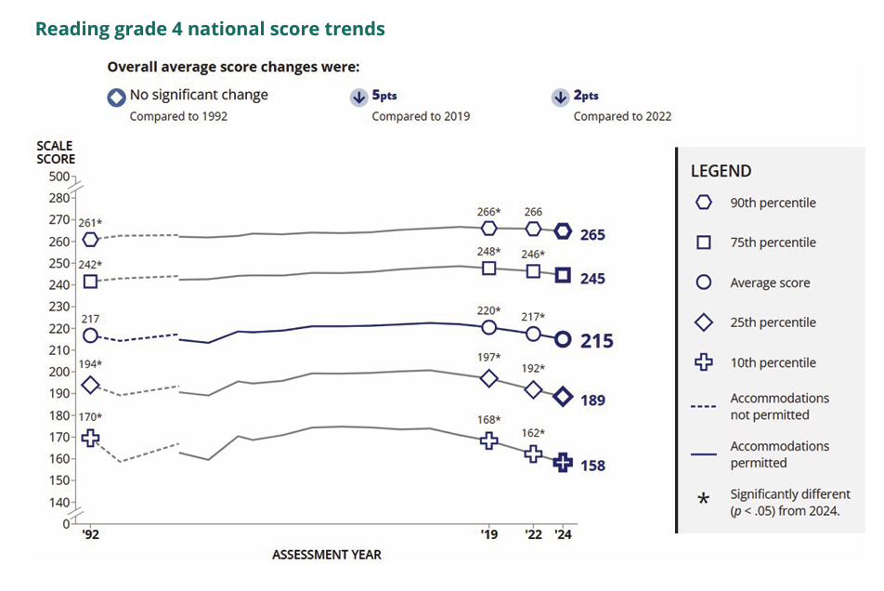
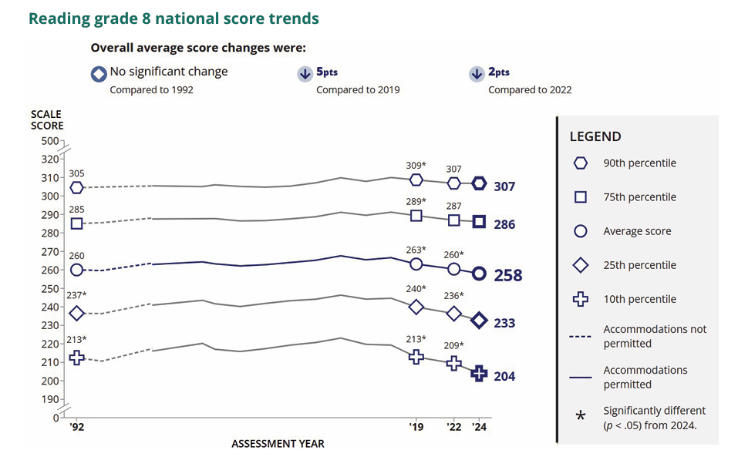
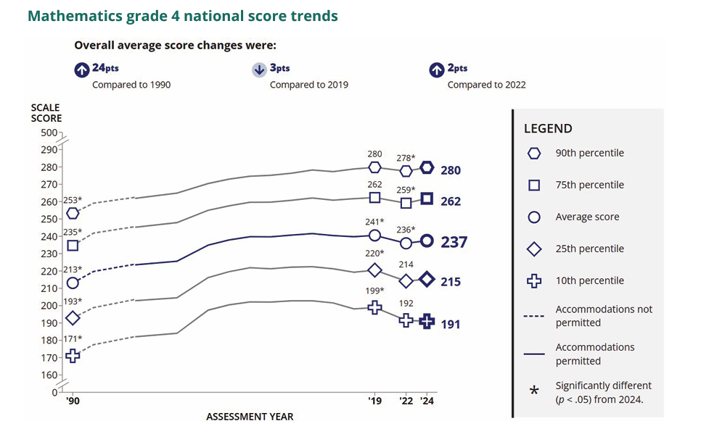
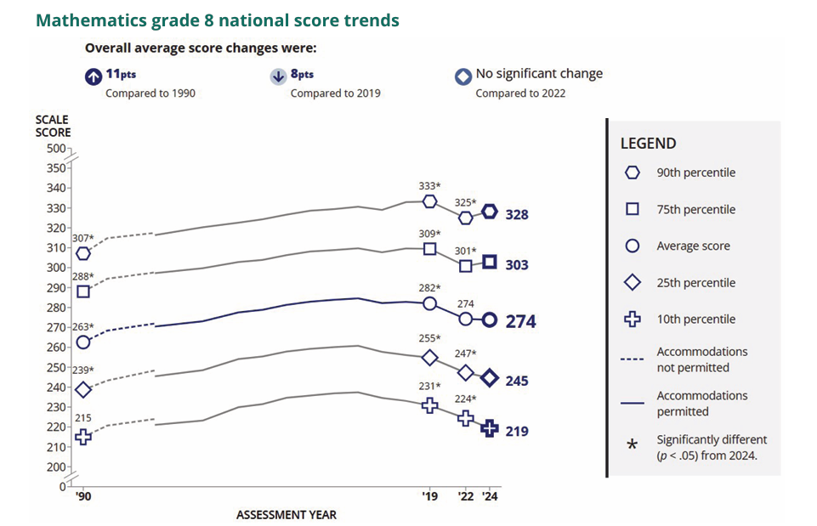

More About NAEP
To learn about upcoming NAEP assessments, download NAEP reports, and access sample questions, visit https://nces.ed.gov/nationsreportcard. Explore the latest NAEP results at https://nationsreportcard.gov.

Learn what NAEP means for schools that are selected to participate and get the latest NAEP news in Measure Up: NAEP News for the School Community, available online at https://nces.ed.gov/nationsreportcard/about/schools.aspx.

To hear teachers share their thoughts about why NAEP results are important, view the video Introducing NAEP to Teachers at https://nces.ed.gov/nationsreportcard/participating/schools.aspx.

To find your NAEP State Coordinator’s contact information, visit https://nces.ed.gov/nationsreportcard/states and select your state or jurisdiction from the drop-down menu.

For additional assistance, call the NAEP help desk at 800-283-6237.

“The NAEP team that arrived at our school made the assessment process painless. Everyone on the team previously worked as an educator and interacted well with all of our students.”
—Kimberly Wilborn, Guidance Counselor, Sandburg Middle School, Fairfax County Public Schools, Alexandria, Virginia

The National Center for Education Statistics (NCES) conducts the National Assessment of Educational Progress to evaluate federally supported education programs. All of the information you provide may only be used for the purposes of research, statistics, and evaluation under the Education Sciences Reform Act of 2002 (ESRA; 20 U.S.C. § 9543) and may not be disclosed, or used, in identifiable form for any other purpose except as required by law. Every NCES employee as well as every NCES agent, such as contractors and NAEP coordinators, has taken an oath and is subject to a jail term of up to 5 years, a fine of $250,000, or both if he or she willfully discloses ANY identifiable information about you in any unauthorized manner. Electronic submission of your information will be monitored for viruses, malware, and other threats by Federal employees and contractors in accordance with the Cybersecurity Enhancement Act of 2015.

This publication was prepared for the National Assessment of Educational Progress by Manhattan Strategy Group under contract 91990018C0001 to the National Center for Education Statistics, U.S. Department of Education.

Appendix D-34: NAEP 2027 Draft Facts for Teachers, Private Schools

NAEP 2027 Facts for Teachers in Private Schools
Page 1

The National Assessment of Educational Progress (NAEP) is the largest continuing and nationally representative assessment of what students in public and private schools know and can do in various subjects. First administered in 1969, NAEP collects and reports information on student trends and performance and compares the achievement of students in public schools with the achievement of students in private schools. Private schools represent about 23 percent of the schools in the nation, educate approximately 9 percent of the nation’s students, and are a critical component of the NAEP program. Private school data are essential to providing a complete and accurate picture of education in the United States and informing future policy decisions. The results of NAEP are released to the public as The Nation’s Report Card.
All About NAEP
As private school teachers, you are essential partners in NAEP. You make an important contribution by sharing your class time and encouraging your students to participate and do their best. When students take part in NAEP and give their best effort, we get the most accurate measure possible of student achievement across the country.
Teachers can use NAEP questions as a resource in the classroom. Teachers can use the NAEP Questions Tool at http://nces.ed.gov/nationsreportcard/nqt to create online self-scoring tests for students and see how the performance of students in private schools compares nationally with that of students in public schools on specific items. Released items generally come with a scoring guide, sample student responses, and performance data. Students can try NAEP questions by visiting https://www.nationsreportcard.gov/sample_questions.aspx.
Teachers can watch the NAEP teacher video. The video provides an overview of the assessment as well as tips on how to support students selected to participate. Watch the video at https://www.youtube.com/watch?v=zR1_pUdSlFg.
Teachers can also view the private school video. Teachers and heads of school describe their experiences with the NAEP assessment and the value of NAEP to private schools in an online video, Private Schools and NAEP: A National Conversation. Watch the video at https://www.youtube.com/watch?v=oLs7_L7pGgs.
Sidebar (Right)
I’m thankful for the opportunity for our school to participate in NAEP because I believe it leads to useful outcomes for individual schools, private schools specifically, and education generally in our country. I would strongly encourage all private schools to participate, if selected. — Dr. James A. Thomas President of Columbia Academy, Columbia, TN

Page 2

Highlights of the NAEP 2027 Program
From [DATE] to [DATE], NAEP field staff will administer assessments in public and private schools across the country. The assessments will be administered at grade 8 in science.
NAEP representatives will provide significant support to schools and will administer the assessment. Students will spend up to 120 minutes completing the assessment. This includes transition time, directions, and completion of a student questionnaire.
It’s important to know that...
No advance preparation is needed. No advance preparation for teachers or for students is necessary. Trained NAEP representatives, employed by a contractor to the National Center for Education Statistics, administer NAEP.
Inclusion is essential. To ensure that student achievement is accurately reported, students with disabilities (SD) and English learners (EL) are encouraged to participate in NAEP assessments. Many accommodations are allowed during the assessment, such as extended time, breaks during the test, and a separate setting. SD and EL teachers who work with the students selected for the assessment are asked to provide information to determine how these students will be assessed on NAEP.
NAEP data are used for statistical purposes only.† No one involved in administering NAEP keeps personal information on teachers or students after the assessments are completed. There are no results for individual students, classrooms, or schools.
Sidebar (Right)
How NAEP reports results
Since 1969, NAEP has produced many reports chronicling trends over time in student performance. Results for private schools are generally reported as overall private school results and for two groups of private schools, Catholic and other private schools.
NAEP also disseminates contextual information from data collected on student survey questionnaires. This information can be used to inform parents, the public, and education policymakers about our students’ educational experiences inside and outside the classroom. You can access data from previous assessments at https://www.nationsreportcard.gov/ndecore/xplore/nde and explore the most recent results at https://www.nationsreportcard.gov. For a quick, but detailed, look at results for private schools, explore the Public, Private, and Charter Schools Dashboard at https://www.nationsreportcard.gov/dashboards/schools_dashboard.aspx.
Highlights of NAEP 2024 Mathematics and Reading
The NAEP 2024 mathematics and reading results include both achievement and survey questionnaire data for students in grades 4 and 8 across the country. The national results combine data from students assessed in public and private schools. Some highlights of these results are included on the following pages.

Page 3
In 2024, the average fourth-grade mathematics score was higher compared to 2022, but was lower than in 2019. The score was higher in 2024 than in 1990. The average eighth-grade mathematics score was not different from 2022, but was lower than in 2019. The score was higher in 2024 than in 1990. Average scores are reported on NAEP mathematics scales at grades 4 and 8 that range from 0 to 500.
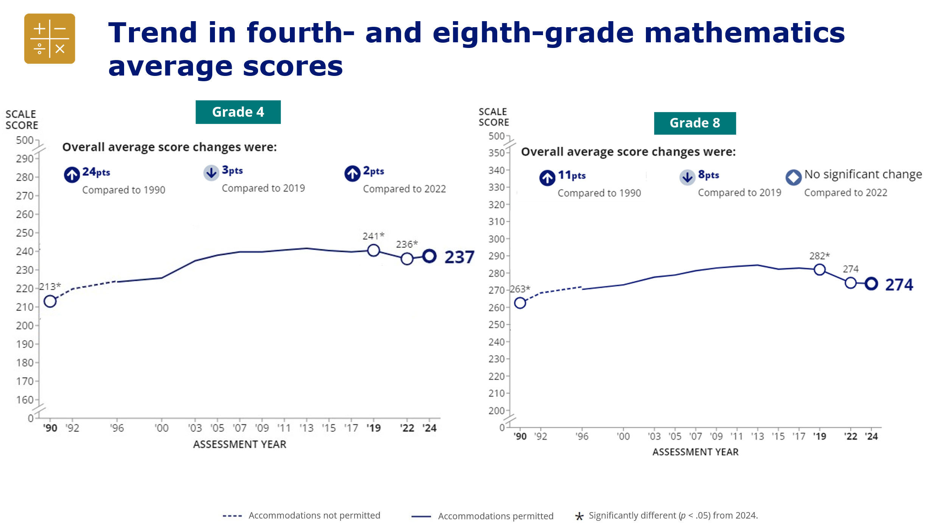
In 2024, the average fourth-grade reading score was lower compared to 2022 and 2019, but not different from 1992. The average eighth-grade mathematics score was lower compared to 2022 and 2019, but not different from 1992. Average scores are reported on NAEP reading scales at grades 4 and 8 that range from 0 to 500.
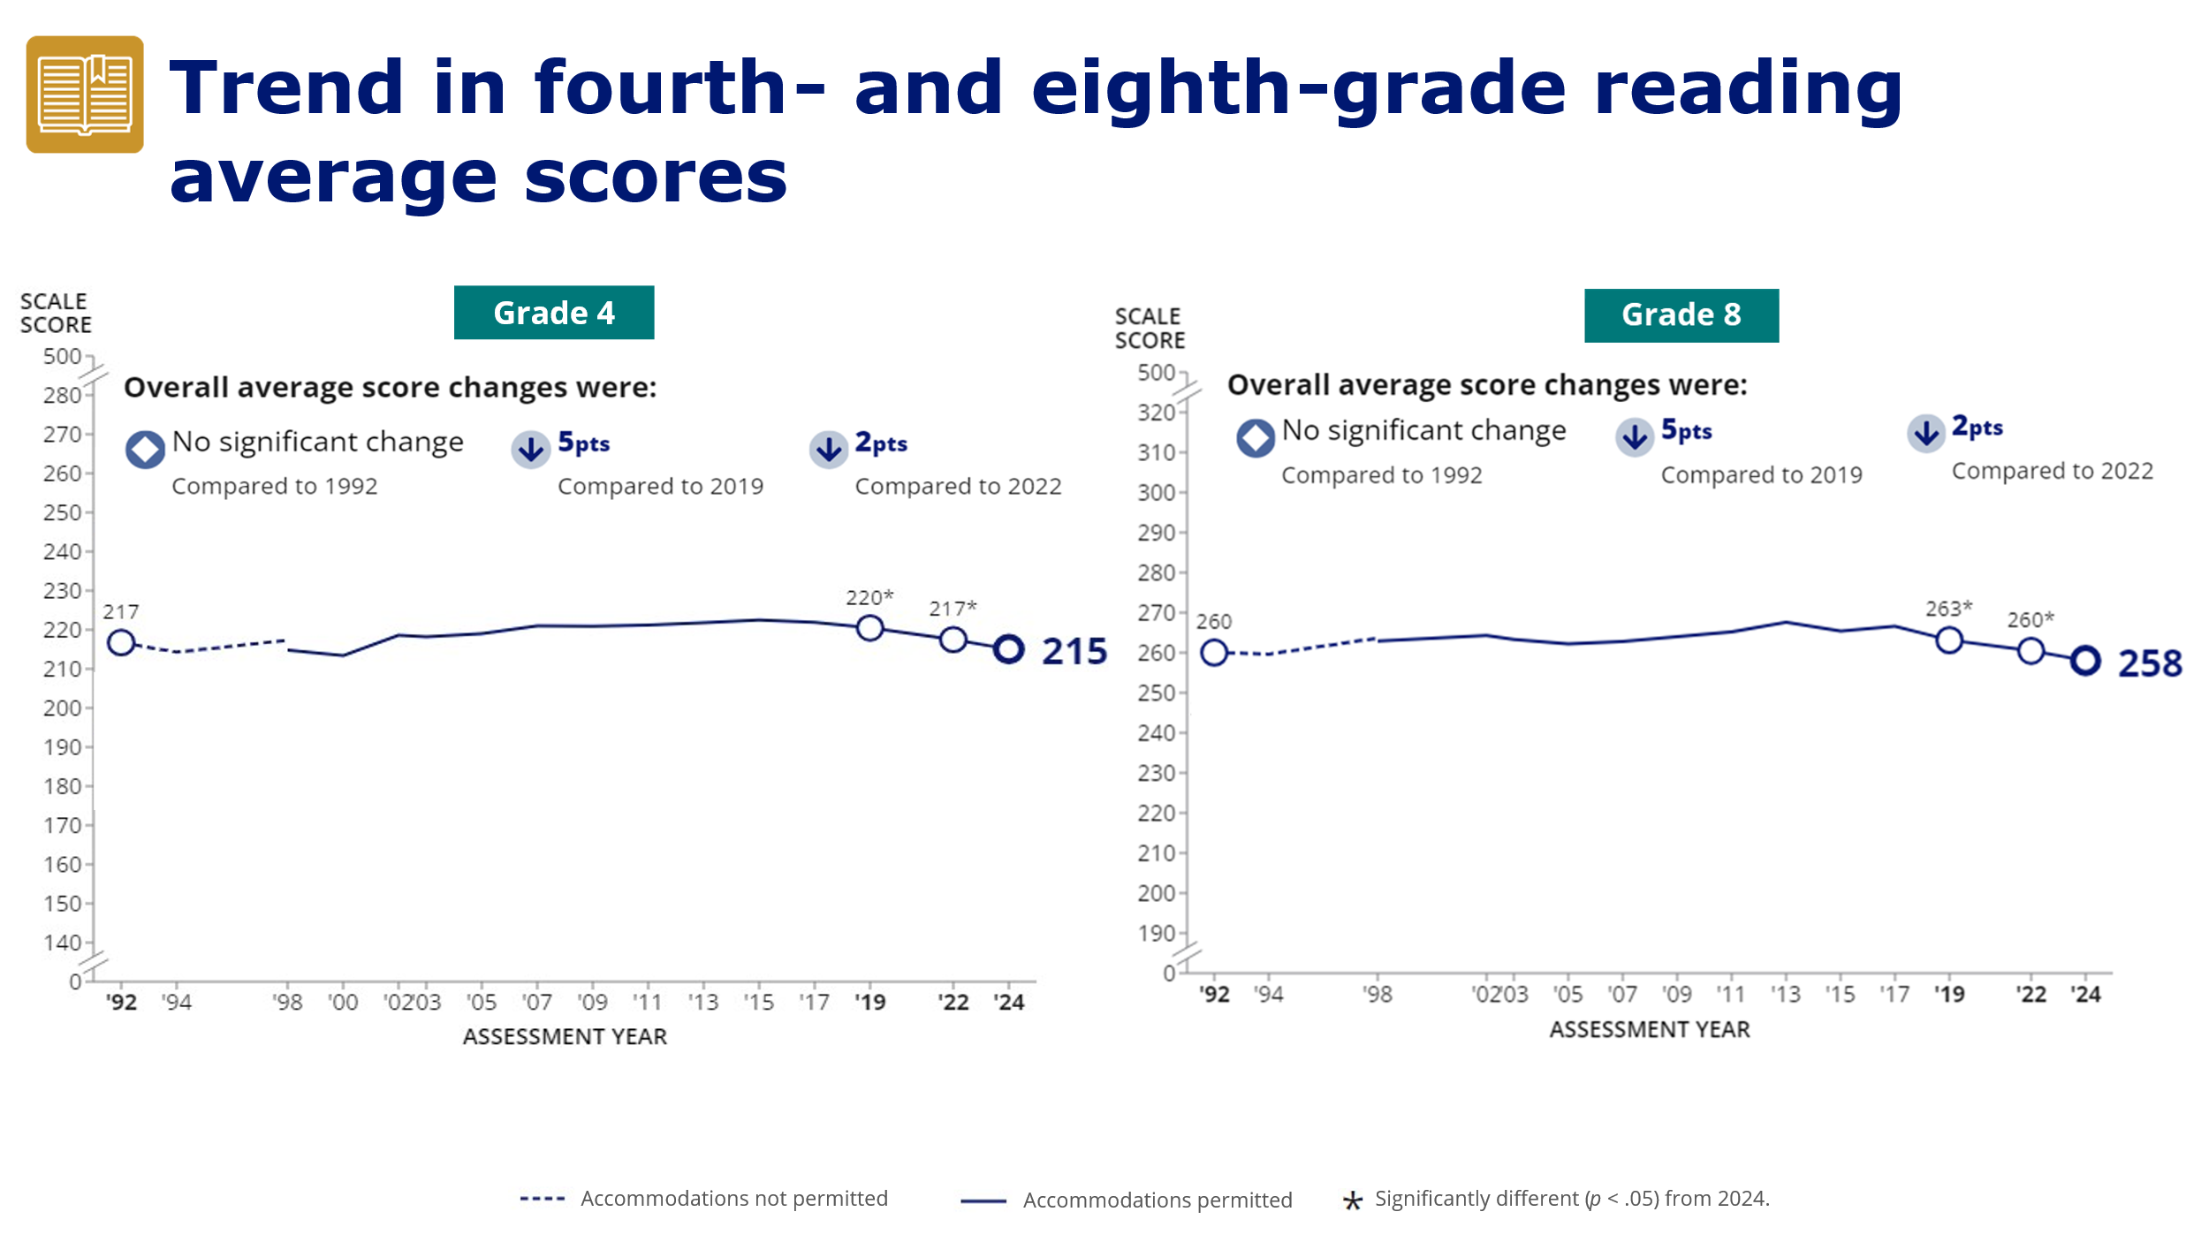

Page 4
When eighth-graders took the reading assessment January—March in 2019, 2022, and 2024, they were asked to indicate the number of days they had been absent from school in the previous month. The response options were none, 1 or 2 days, 3 or 4 days, 5 to 10 days, and more than 10 days.
For the top two response options, 5 to 10 days and more than 10 days, the percentage of eighth-graders who reported missing 5 or more days from school in the previous month (11 percent) was lower in 2024 than in 2022 (16 percent). However, in comparison to 2019, the percentages of eighth-grade students missing 5 to 10 days and more than 10 days were higher in 2024.
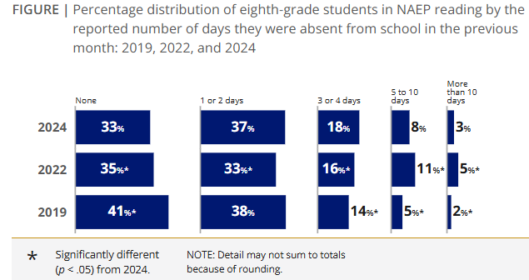

Accessing NAEP Data for Catholic and Private Schools
NAEP Catholic and private school data are available online at
https://www.nationsreportcard.gov
https://www.nationsreportcard.gov/ndecore
https://www.nationsreportcard.gov/dashboards/schools_dashboard.aspx.
NAEP and Catholic School Participation
More information about NAEP and private school participation, including a short video highlighting the value of participation, is available at https://nces.ed.gov/nationsreportcard/participating/private_nonpublic.aspx.
† The National Center for Education Statistics (NCES) conducts the National Assessment of Educational Progress to evaluate federally supported education programs. All of the information you provide may only be used for the purposes of research, statistics, and evaluation under the Education Sciences Reform Act of 2002 (ESRA; 20 U.S.C. § 9543) and may not be disclosed, or used, in identifiable form for any other purpose except as required by law. Every NCES employee as well as every NCES agent, such as contractors and NAEP coordinators, has taken an oath and is subject to a jail term of up to 5 years, a fine of $250,000, or both if he or she willfully discloses ANY identifiable information about you in any unauthorized manner. Electronic submission of your information will be monitored for viruses, malware, and other threats by Federal employees and contractors in accordance with the Cybersecurity Enhancement Act of 2015.

<Facebook, Instagram, LinkedIn, X, and YouTube Logos>

Appendix D-35: NAEP 2027 Draft Inclusion Guidelines for English Learners

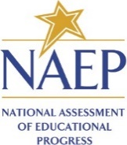

State
NAEP 2027 Inclusion Policy for English learners (EL)
Grade 8 Science

The State Department of Education expects that most English learners will be included on the National Assessment of Educational Progress (NAEP). Only English learners who have been enrolled in U.S. schools for less than one (1) full academic year before the NAEP assessment and cannot access NAEP may be excluded from any NAEP assessment. All other English learners should participate in NAEP with or without NAEP-allowed accommodations. If you have questions about the NAEP accommodations, please contact name, NAEP State Coordinator at email.
Several accommodations provided on the state assessments are not necessary for the NAEP assessments because they are available for all students through universal design elements. The chart below is divided into three sections: (1) universal design elements that are available to all students, (2) accommodations provided by the test delivery system, and (3) accommodations provided outside the test delivery system. NAEP accommodations are only allowed for English learners.
Please keep in mind that NAEP does not produce results for individual students or schools, unlike the state assessments. In other words, the NAEP assessments do not impose consequences for the student or the school and are instead intended purely to provide a picture of educational performance and progress.
Please note all assessments are not the same and are developed to measure specific constructs. Therefore, NAEP may not allow or support all accessibility features and accommodations of the state assessments. The following are the expectations for inclusion on NAEP:
- Students who receive multiple-day testing on the state assessments should take the NAEP assessments in 1 day with breaks as needed. NAEP is much shorter than most state assessments, so multiple-day testing is not supported.
- Graphic organizers are not allowed on the NAEP assessment.

Table 1: NAEP Universal Design Elements available to all students
Grade 8 Science-- Digitally Based Assessment on Device
Universal Design Element | Description
Zooming | Enlarges some content onscreen up to two times (2X) the default text/image size on the screen while preserving clarity, contrast, and color.  - Does not include the tutorial, toolbar, item tabs, scrollbars, calculator, and equation editor.
Individual Testing Experience | Read Aloud and other UDE and accommodations are provided through the device and will not distract other students in the room.  - Students have earbuds to reduce distractions.  - Students interact directly with device.  - Tested with other selected students.  - Refer to the accommodation Preferential Seating to minimize distractions for testing with other students.
Directions Read Aloud/Text-to-Speech (English) | All directions in the assessment are text-to-speech enabled, including general directions, directions within the assessment, Tutorial, Help, and Student Questionnaire screens.
Directions Explained/Clarified | Students can raise their hand at any time and ask the test administrator to clarify or explain directions.
Read Aloud/Text-to- Speech (English) – Occasional or Most or All | Students select some or all text to be read aloud by the system using text-to- speech.
Use a Computer/Tablet to Respond | All students respond on devices.
Color Theming | Option 1: black text on white background (default)  Option 2: white text on black background  Option 3: black text on beige background  - This tool is not available for the tutorial and some items.
Text Notepad | Allows text to be entered from the physical keyboard to record notes into a resizable window for each question.
Text Highlighter | Allows the highlighting of text on the screen for most content.
Pencil Tool | Allows freehand drawing and highlighting on the screen for most content.
Elimination Capability | Students can gray out answer choices for multiple-choice items.  - This tool is not available for constructed-response items.
Volume Adjustment | Students can raise or lower voice-over volume using the device’s volume buttons.
Closed Captioning | All voice-over narration is closed-captioned.
Scratch Paper | Administrators inform students that scratch paper (and pencil) is available upon request.

Table 2: NAEP accommodations provided by test delivery system.
Grade 8 Science-- Digitally Based Assessment on Device
Accommodation | Description
Extended Time | Students are given up to three times (3X) the allotted time to complete the assessment.  - If state test is untimed, students may or may not require extended time on NAEP.  - Most students are able to complete the NAEP cognitive sections in the time allowed.

Table 3: NAEP accommodations provided outside the test delivery system.
Grade 8 Science– Digitally Based Assessment on Device
Accommodation | Description
Breaks During Test | Students are allowed to take breaks as requested or at predetermined intervals during the assessment. Students can take the assessment in more than one sitting during a single day.
Separate Location/Small Group | Student is tested in a separate location to meet testing needs as appropriate.  - Refer to the UDE Individual Testing Experience and accommodation Preferential Seating to determine if separate location/small group is needed.  - May be in the same room but in a specific location or a different room.  - Can be individual or with a small group of students.
Familiar Person Present in Testing Room | The aide who regularly works with the student must be present in the testing room during time of assessment.  - Only trained NAEP staff may conduct the assessment session.
Uses Template | Provided by the school.  - Cutout, masking, color overlays, line reader, or place marker.
Special Equipment | Provided by the school.  - FM system, amplification equipment, auditory amplification device.  - Noise buffers, study carrel, blinder, special lighting, adaptive furniture.  - Stress ball or sensory fidget item.
Preferential Seating | Provided by the school.  - Seating to reduce distractions within the general testing session.  - Front of the class, close to the test administrator, etc.
Cueing to Stay on Task | Provided by a school staff member.  - Monitor for understanding, monitor placement of responses.  - Redirect to stay on task, reminders to stay on task, prompts to stay on task.  - Provide verbal encouragement, reinforcement, refocus.  - Track test items.
Bilingual Dictionary (in any language) | A handheld electronic or hardcopy bilingual dictionary provided by the school in any language that contains English translations of words but does not contain definitions.  - Also known as a word-for-word dictionary, word-to-word translation dictionary, or a bilingual word list.
Other (specify) | Any accommodation not listed above. Please check with your NAEP State Coordinator to see if other accommodations are allowed on NAEP.

Appendix D-36: NAEP 2027 Draft Inclusion Guidelines for Students with Disabilities

State
NAEP 2027 Inclusion Policy for Students with Disabilities (SD)
Grade 8 Science

The State Department of Education expects that most students with disabilities will be included on the National Assessment of Educational Progress (NAEP). Only students who meet (or met) participation criteria for [State Alternate Assessment Name] may be excluded from any NAEP assessment. All other students with disabilities should participate in NAEP with or without NAEP-allowed accommodations. If you have questions about the NAEP accommodations, please contact name, NAEP State Coordinator at email.
Several accommodations provided on the state assessments are not necessary for the NAEP digitally based assessments because they are available for all students through universal design elements. The chart below is divided into three sections: (1) universal design elements that are available to all students, (2) accommodations provided by the test delivery system, and (3) accommodations provided outside the test delivery system. NAEP accommodations are only allowed for a student on an Individualized Education Program (IEP) or Section 504 Plan.
Please keep in mind that NAEP does not produce results for individual students or schools, unlike the state assessments. In other words, the NAEP assessments do not impose consequences for the student or the school and are instead intended purely to provide a picture of educational performance and progress.
Please note all assessments are not the same and are developed to measure specific constructs. Therefore, NAEP may not allow or provide all accessibility features and accommodations the state assessments allow. The following are the expectations for inclusion on NAEP:
- Students who receive multiple-day testing on the state assessments should take the NAEP assessments in 1 day with breaks as needed. NAEP is much shorter than most state assessments, so multiple-day testing is not supported.
- Graphic organizers are not allowed on the NAEP assessment.

Table 1: NAEP Universal Design Elements available to all students.
Grade 8 Science -- Digitally Based Assessment on Device
Universal Design Element | Description
Zooming | Enlarges some content onscreen up to two times (2X) the default text/image size on the screen while preserving clarity, contrast, and color.  - Does not include the tutorial, toolbar, item tabs, scrollbars, calculator, and equation editor.  - Select the Magnification accommodation if students need all assessment content magnified.
Individual Testing Experience | Read Aloud and other UDE and accommodations are provided through the device and will not distract other students in the room.  - Students have earbuds to reduce distractions.  - Students interact directly with device.  - Tested with other selected students.  - Refer to the accommodation Preferential Seating to minimize distractions for testing with other students.
Directions Read Aloud/Text-to-Speech (English) | All directions in the assessment are text-to-speech enabled, including general directions, directions within the assessment, Tutorial, Help, and Student Questionnaire screens.
Directions Explained/Clarified | Students can raise their hand at any time and ask the test administrator to clarify or explain directions.
Read Aloud/Text-to- Speech (English) – Occasional or Most or All | Students select some or all text to be read aloud by the system using text-to- speech.
Use a Computer/Tablet to Respond | All students respond on devices.
Color Theming | Option 1: black text on white background (default)  Option 2: white text on black background  Option 3: black text on beige background  - This tool is not available for the tutorial and some items.  - Select the accommodation High Contrast for Visually Impaired Students if students need all content in high contrast.
Text Notepad | Allows text to be entered from the physical keyboard to record notes into a resizable window for each question.
Text Highlighter | Allows the highlighting of text on the screen for most content.
Pencil Tool | Allows freehand drawing on the screen for most content.
Elimination Capability | Students can gray out answer choices for multiple-choice items. This tool is not available for constructed-response items.
Volume Adjustment | Students can raise or lower voice-over volume using the device’s volume buttons.
Closed Captioning | All voice-over narration is closed-captioned.
Scratch Paper | Administrators inform students that scratch paper (and pencil) is available upon request.

Table 2: NAEP accommodations provided by test delivery system.
Grade 8 Science -- Digitally Based Assessment on Device
Accommodation | Description
Extended Time | Students are given up to three times (3X) the allotted time to complete the assessment.  - If state test is untimed, students may or may not require extended time on NAEP.  - Most students are able to complete the NAEP cognitive sections in the time allowed.
Calculator Version of the Test | Provides a test form that permits the use of a calculator. The calculator is an onscreen calculator provided via the test delivery system.
Hearing Impaired Version of the Test | All auditory content is closed-captioned.

Table 3: NAEP accommodations provided outside the test delivery system.
Grade 8 Science -- Digitally Based Assessment on Device
Accommodation | Description
Breaks During Test | Students are allowed to take breaks as requested or at predetermined intervals during the assessment. Students can take the assessment in more than one sitting during a single day.
Separate Location/Small Group | Student is tested in a separate location to meet testing needs as appropriate.  - Refer to the UDE Individual Testing Experience and accommodation Preferential Seating to determine if separate location/small group is needed.  - May be in the same room but in a specific location or a different room.  - Can be individual or with a small group of students.
Familiar Person Present in Testing Room | The aide who regularly works with the student must be present in the testing room during time of assessment.  - Only trained NAEP staff may conduct the assessment session.
Uses Template | Provided by the school.  Cutout, masking, color overlays, line reader, or place marker.
Special Equipment | Provided by the school.  FM system, amplification equipment, auditory amplification device.  Noise buffers, study carrel, blinder, special lighting, adaptive furniture.  Stress ball or sensory fidget item.
Preferential Seating | Provided by the school.  Seating to reduce distractions within the general testing session.  Front of the class, close to the test administrator, etc.
Cueing to Stay on Task | Provided by a school staff member.  Monitor for understanding, monitor placement of responses.  Redirect to stay on task, reminders to stay on task, prompts to stay on task.  Provide verbal encouragement, reinforcement, refocus.  Track test items.
Other (specify) | Any accommodation not listed above. Please check with your NAEP Coordinator to see if other accommodations are allowed on NAEP.

Appendix D-37: NAEP 2027 Draft Private School Recruitment Video Storyboards

Video Title: NAEP is Supported by Many Private School Organizations
Screen # | Narrated Text | Description of Screen
1 | The National Assessment of Educational Progress, also known as NAEP, or The Nation’s Report Card, is supported by many private school organizations. | NAEP logo appears on screen.
2 | Several organizations have provided letters of support for the NAEP 2027 assessment, including the Council for American Private Education (CAPE), the National Catholic Educational Association (NCEA), the National Association of Independent Schools (NAIS), and the Association of Christian Schools International (ACSI) among many others. | Screen shots of endorsement letters from CAPE, NCEA, NAIS, and ACSI appear on screen.  [Note, we have not yet received these letters and will customize the narrated text to match the letters we receive]
3 | Here is the full list of private school organizations that have provided letters of support for NAEP 2027. | [Placeholder for full list of organizations that provide letters in 2027]
4 | By participating in NAEP 2027, your school will contribute to the picture of education across the nation and to future policy decisions. For more information about the importance of participation in NAEP, contact your private school organization leaders or your NAEP representative. | A map of the United States with education icons popping out of various locations in the map
5 | NAEP, giving private schools a voice in the national education conversation. | NAEP, giving private schools a voice in the national education conversation.

Video Title: NAEP Benefits for Students, Teachers, and Schools
Screen # | Narrated Text | Description of Screen
1 | Your school has been selected to represent private schools across our nation by participating in the National Assessment of Educational Progress, also known as NAEP or The Nation’s Report Card. | NAEP logo appears on screen.
2 | Students, teachers, and schools all benefit by participating in NAEP. | Icons representing students, teachers, and schools
3 | By participating, students can receive a certificate of community service for their time spent on the NAEP assessment. | Screen shot of community service certificate
4 | Students experience an engaging assessment with rich content in a low-stakes environment as there are no results for individual students or schools. | Images of students participating in the NAEP assessment
5 | Students who participate in NAEP contribute to improving the quality of education for all students in the United States. | A map of the United States with education icons popping out of various locations in the map
6 | Teachers do not need to prepare their students to take the NAEP assessment, but make an important contribution by encouraging their students to participate and to give their best effort; this helps ensure that NAEP results provide the most accurate measure possible of student achievement across the country. | Image of teachers supporting students in the classroom
7 | Teachers can also use NAEP’s free data tools such as the NAEP Questions Tool to review sample NAEP questions, see how students performed on these sample questions, and generate tests online using NAEP questions. | Screen shot of the NAEP Questions Tool website
8 | Schools will receive a certificate of appreciation for participating in NAEP. | Screen shot of the school certificate
9 | We look forward to working with you to make NAEP a success in your private school. Please reach out to your NAEP representative to discuss any participation questions. NAEP, giving private schools a voice in the national education conversation. | Image of NAEP representatives.  NAEP, giving private schools a voice in the national education conversation.
Video Title: Participation in NAEP is Easy
Screen # | Narrated Text | Description of Screen
1 | Your school has been selected to represent private schools across our nation by participating in the National Assessment of Educational Progress, also known as NAEP or The Nation’s Report Card. | NAEP logo appears on screen.
2 | In order to have a complete picture of the academic achievement and progress of the nation's private school students, selected private schools must participate in NAEP. Your school’s participation is an opportunity to help make it possible for private school data to be reported and compared with public school data. | Icons representing public and private schools  Your school’s participation is important!
3 | Participating in NAEP is easy and there is no cost to your school to participate. Your school has been assigned a NAEP representative who will support your school’s designated NAEP school coordinator to ensure smooth assessment day activities. NAEP representatives will work with the school coordinator to confirm that the assessment date works with the school calendar, to secure a space for the assessment to take place, and to confirm other assessment day logistics. | Participating in NAEP is easy!  Image of the NAEP representatives on the phone with a school coordinator
4 | NAEP representatives will provide significant support to schools and administer the assessment to students. When the assessment is complete, NAEP representatives will return the testing location to its original condition. | Images of NAEP representatives bringing the equipment to the school and administering the assessment
5 | We look forward to working with you to make NAEP a success in your private school. Please reach out to your NAEP representative to discuss any participation questions. NAEP, giving private schools a voice in the national education conversation. | Image of NAEP representatives.  NAEP, giving private schools a voice in the national education conversation.

Appendix D-38: NAEP 2027 Identify Application Installer Reminder (School Device), From NAEP State Coordinator to District or School Staff (NEW)

NAEP 2027 Identify Application Installer Reminder (School Device)
From NAEP State Coordinator to district or school staff
Red text should be customized before mail merge; highlighted text represents mail merge fields

Dear DAC, DTD, principal, school coordinator, technology coordinator,

Thank you for all that you do to support education in State Name.
Earlier this year, the School Technology Survey for the National Assessment of Educational Progress (NAEP) determined that School Name/the following schools will use school devices to participate in the 2027 administration.
- School 1
- School 2
I am requesting your help with designating a NAEP Application Installer, who will be responsible for coordinating the installation of the NAEP Assessment application to school devices. The NAEP Application Installer must have administrative permissions for the school devices to install the NAEP Assessment application. For more information about the NAEP Assessment Application, visit the [eNAEP Download Center hyperlink].

Next Steps:
- Option 1: Use this bullet if the district or school staff will enter the installer’s name in AMS.
Please sign in to the Assessment Management System and enter the NAEP Application Installer’s name and contact information. This can be done from the School Technology Survey Manager or from the Manage Teams section on the school summary page.
- Option 2: Use this bullet if the NSC will enter the installer’s name in the AMS
Please send the designated NAEP Application Installer’s name and email address to me using the email address provided below.
Questions?
- Additional information about NAEP can be found at http://nces.ed.gov/nationsreportcard.
- If you have questions, please contact me at telephone number or via email at email address.

Sincerely,

NAEP State Coordinator

The National Center for Education Statistics (NCES) conducts the National Assessment of Educational Progress to evaluate federally supported education programs. All of the information you provide may only be used for the purposes of research, statistics, and evaluation under the Education Sciences Reform Act of 2002 (ESRA; 20 U.S.C. § 9543) and may not be disclosed, or used, in identifiable form for any other purpose except as required by law. Every NCES employee as well as every NCES agent, such as contractors and NAEP coordinators, has taken an oath and is subject to a jail term of up to 5 years, a fine of $250,000, or both if he or she willfully discloses ANY identifiable information about you in any unauthorized manner. Electronic submission of your information will be monitored for viruses, malware, and other threats by Federal employees and contractors in accordance with the Cybersecurity Enhancement Act of 2015.

