NATIONAL CENTER FOR EDUCATION STATISTICS NATIONAL ASSESSMENT OF EDUCATIONAL PROGRESS

National Assessment of Educational Progress (NAEP) 2027

Appendix J3
2027 School Questionnaires

OMB# 1850-0928 v.39

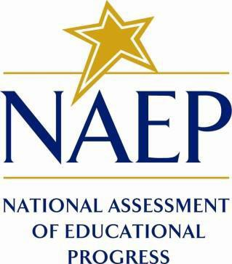

March 2026

Appendix J3 provides the grade 8 science school administrator survey questionnaires that were approved and administered in 2024 (OMB# 1850-0928 v.30). The 2027 grade 8 school administrator science questionnaires will be submitted in the Amendment (Summer 2026).
Please note, some of the item numbers may be missing or out of order in this appendix. These will be corrected in the platform view.

Table of Contents
School Questionnaires
Draft 2027 School Administrator Questionnaire Login Screen 3
Appendix J3-1: 2024 Operational Grade 8 (Core) 4
Appendix J3-2: 2024 Operational Grade 8 (Science) 16
Appendix J3-3: 2024 Operational Grade 4, 8, and 12 Charter School 20
Appendix J3-4: 2024 Pilot Grade 8 (Core) 23

Draft 2027 School Administrator Questionnaire Login Screen
Note: the PRA statements for 2027 will be updated in the Amendment (July 2026).

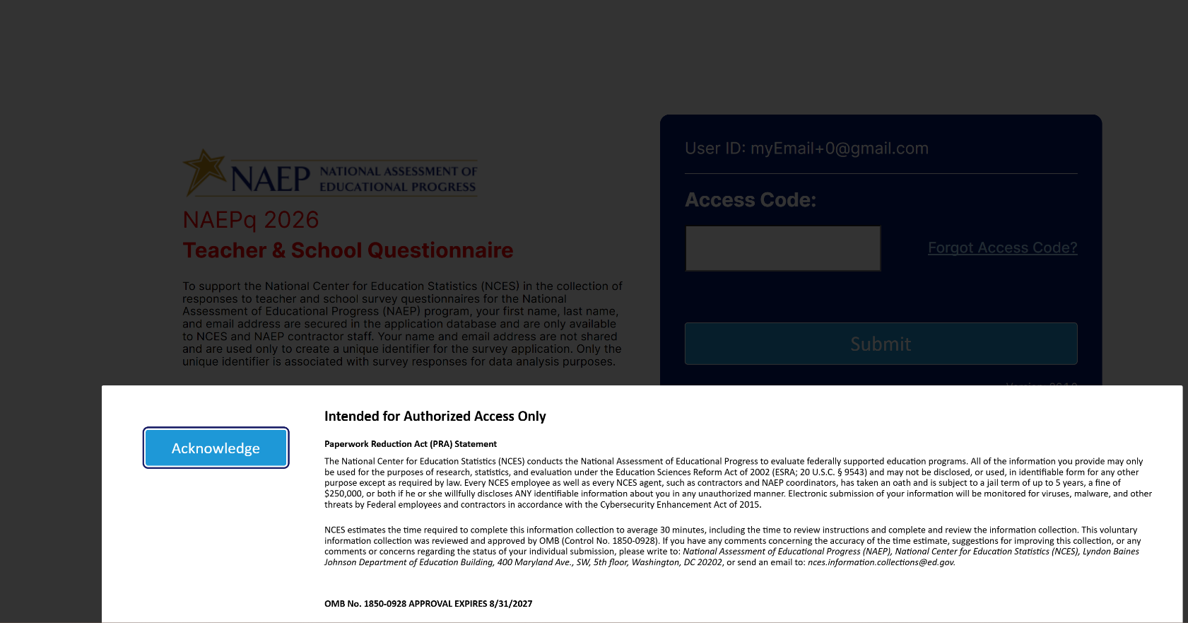

Appendix J3-1: 2024 Operational Grade 8 (Core)
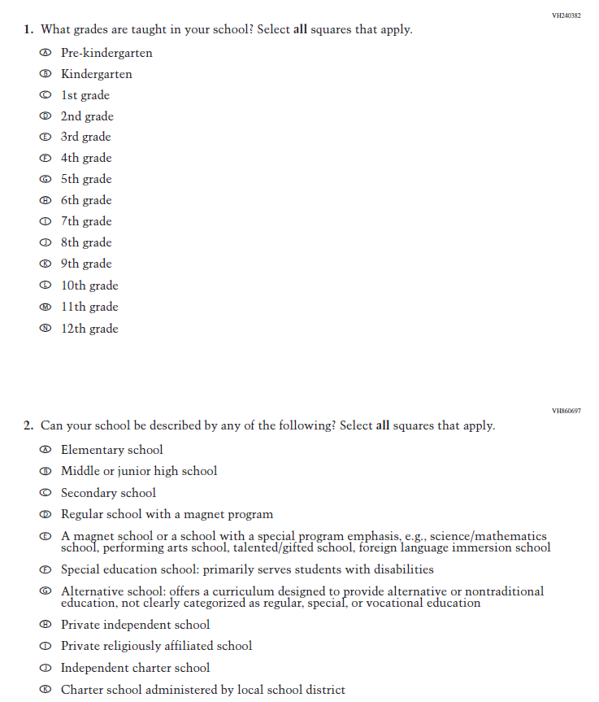
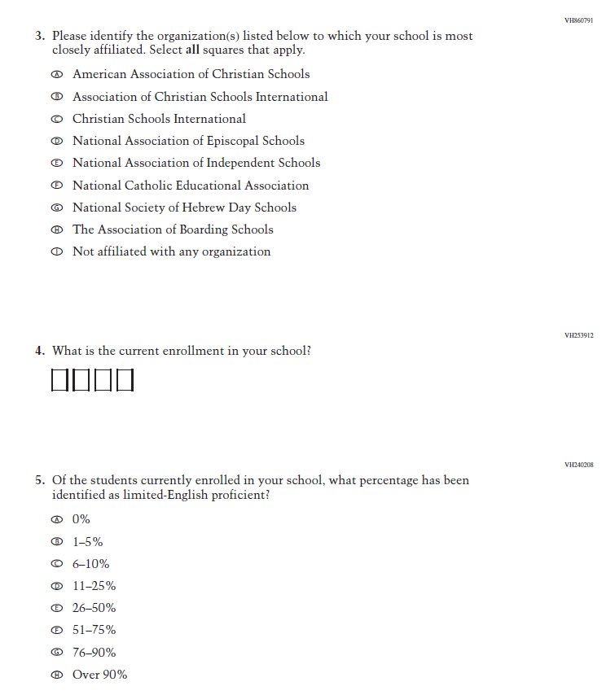
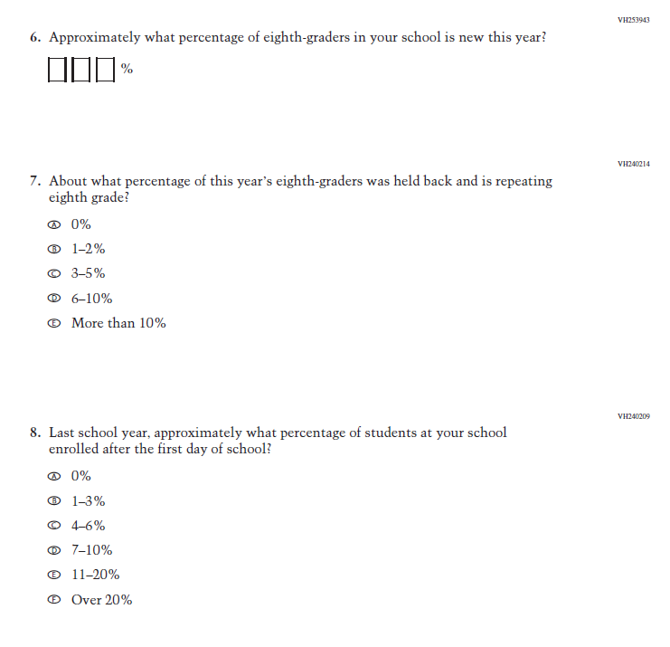
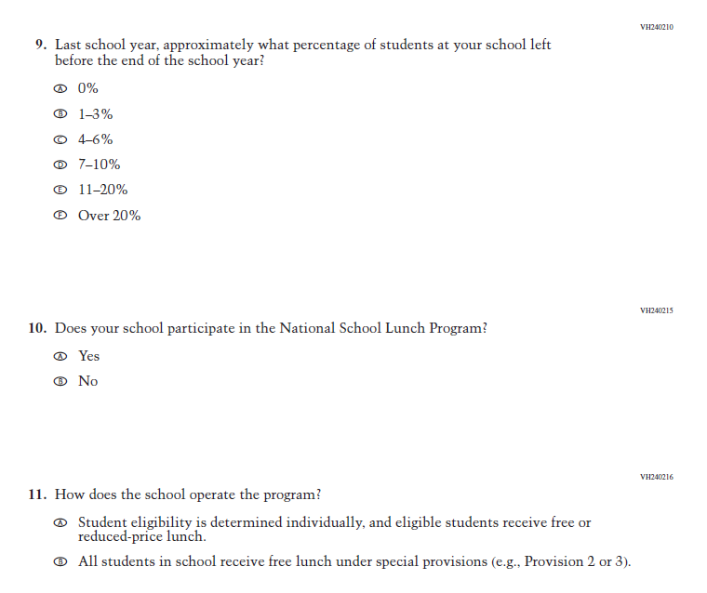
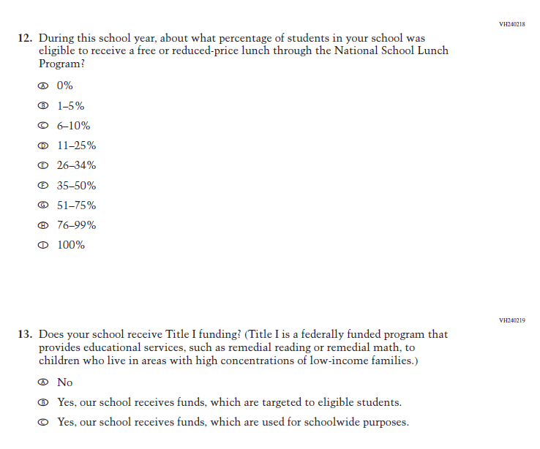
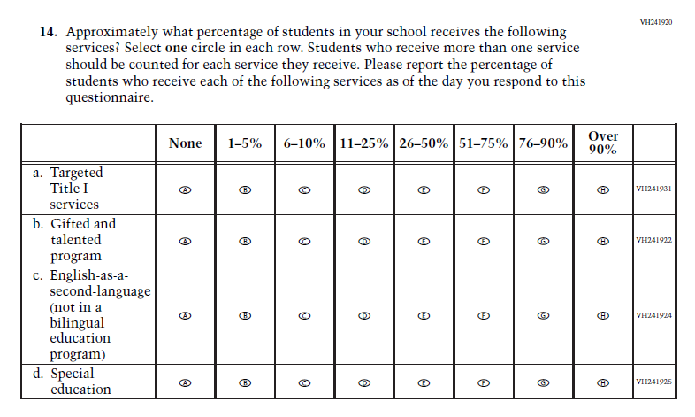
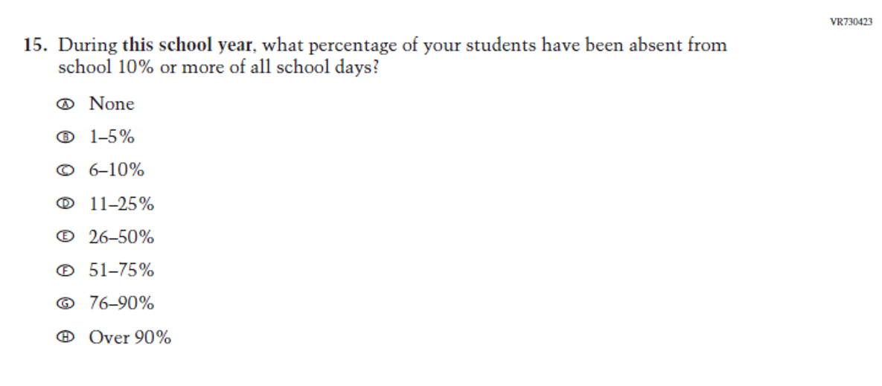
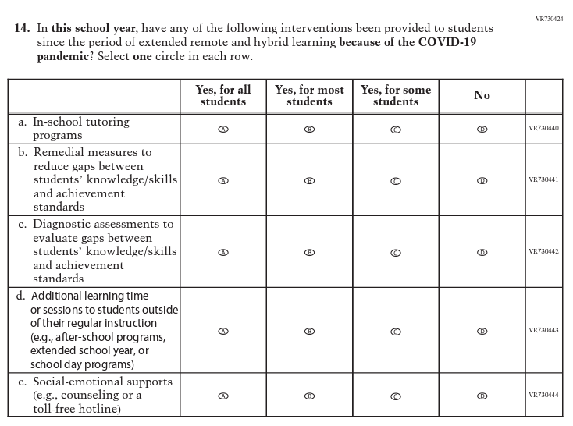
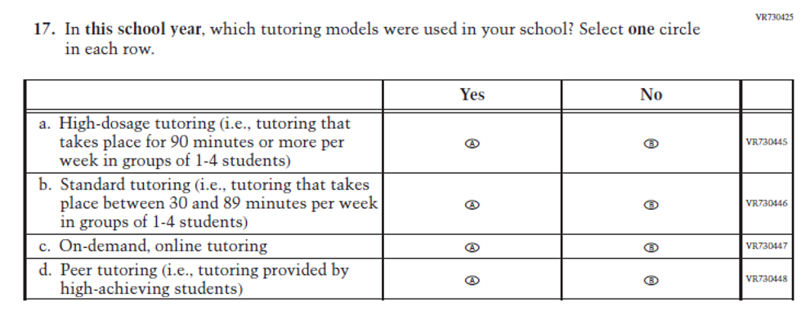
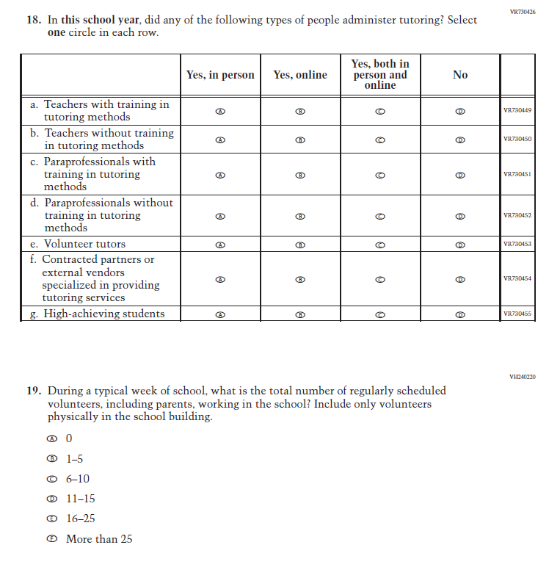
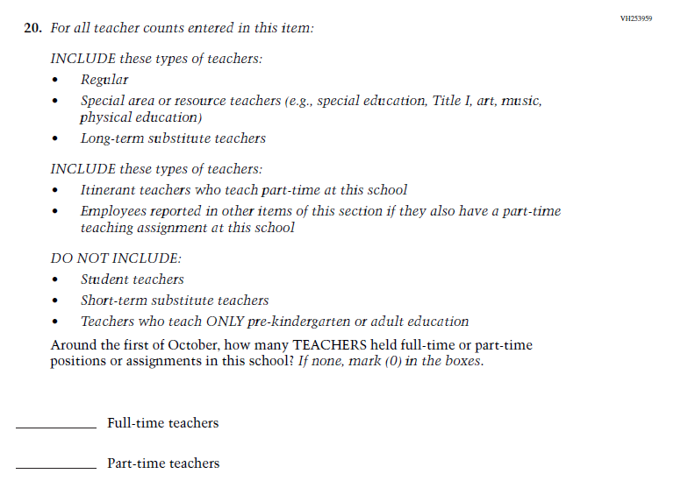
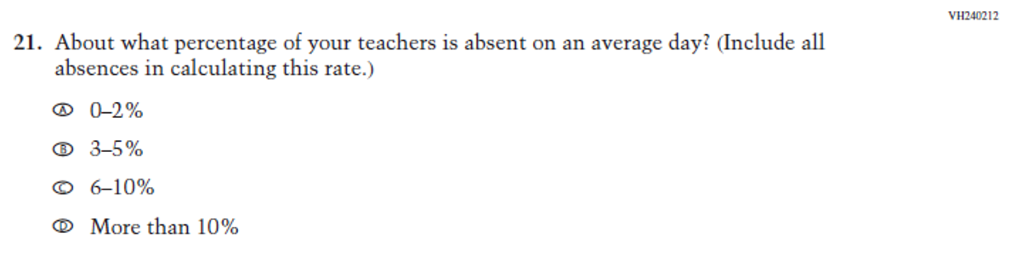
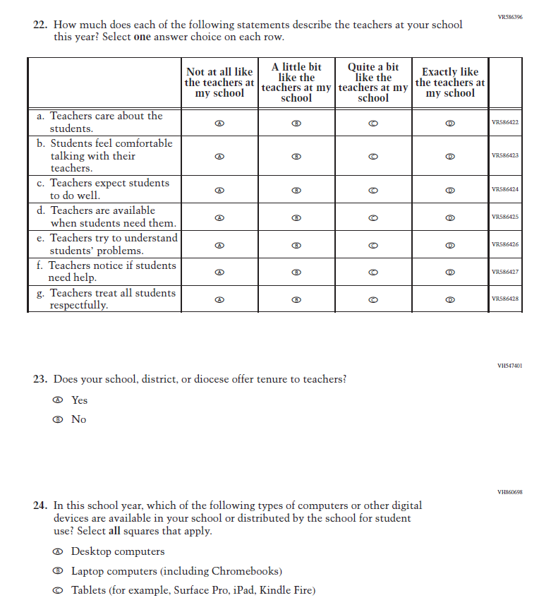
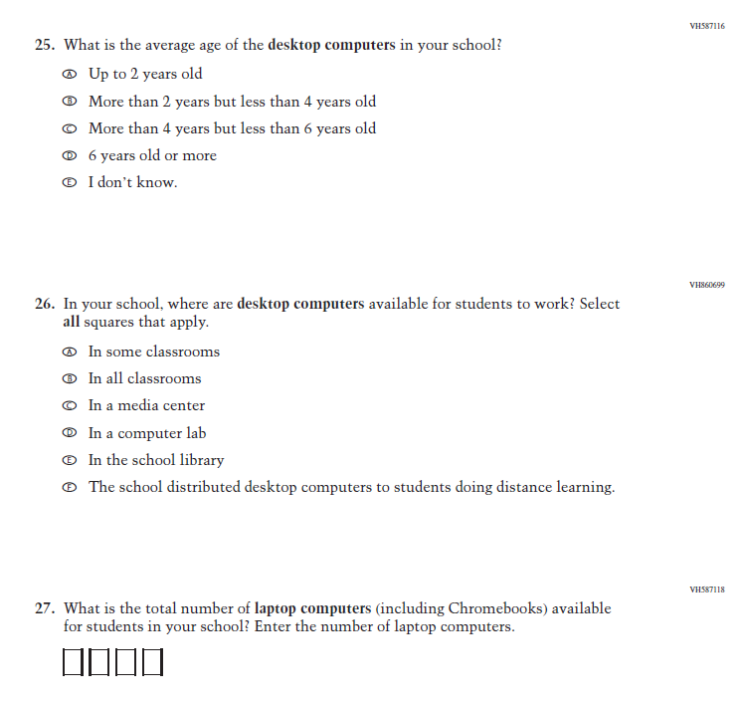
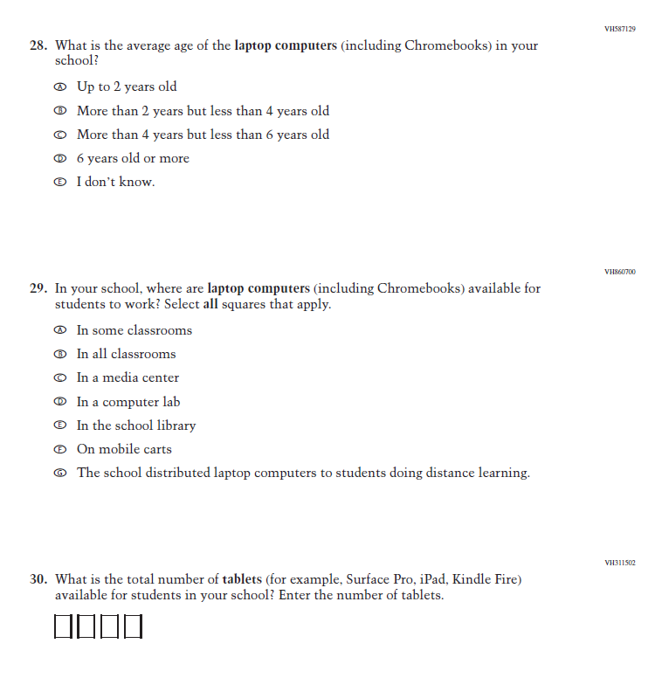
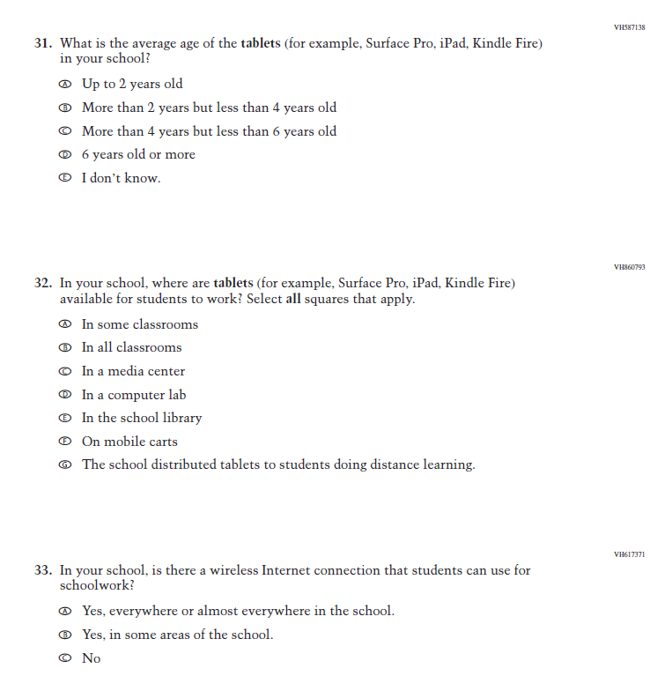
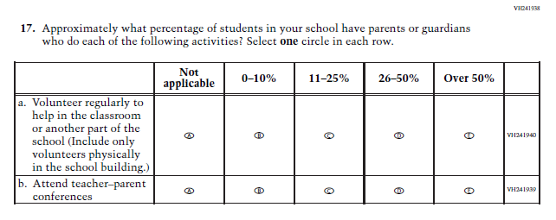

Appendix J3-2: 2024 Operational Grade 8 (Science)
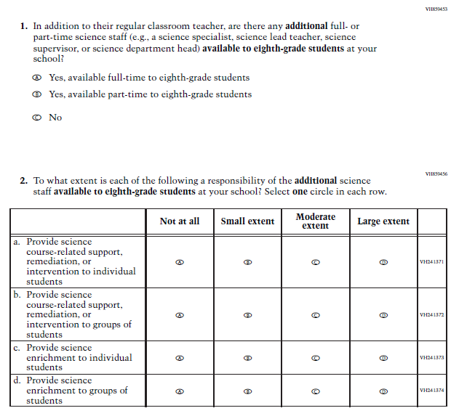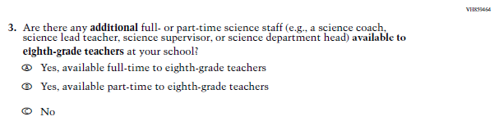

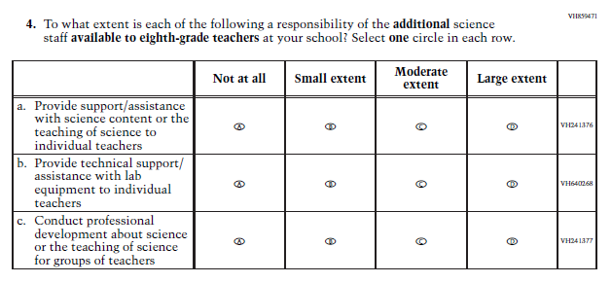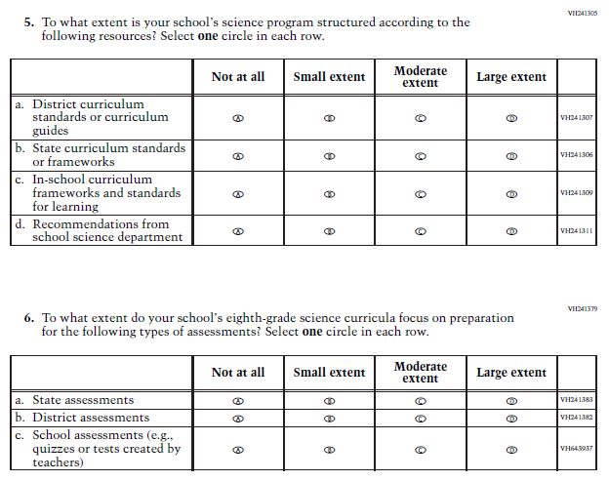

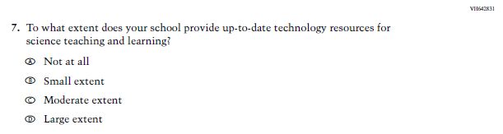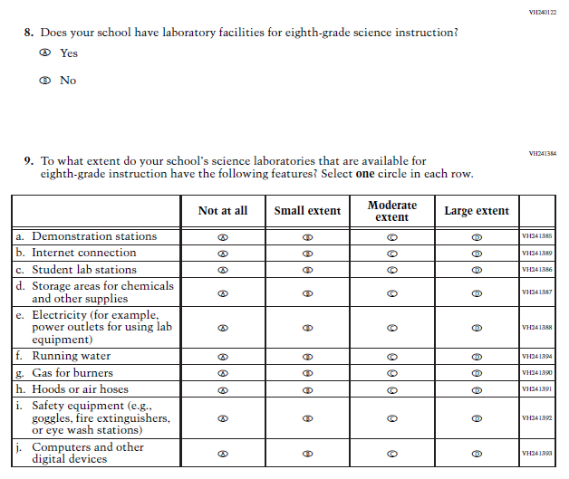

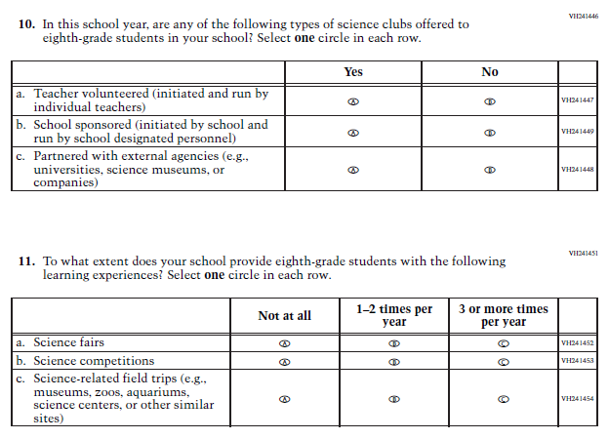

Appendix J3-3: 2024 Operational Grade 4, 8, and 12 Charter School
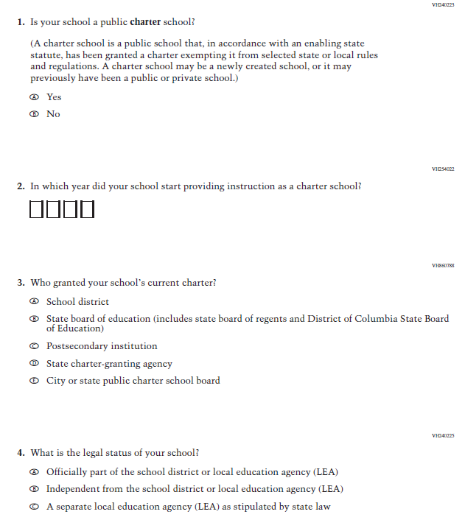

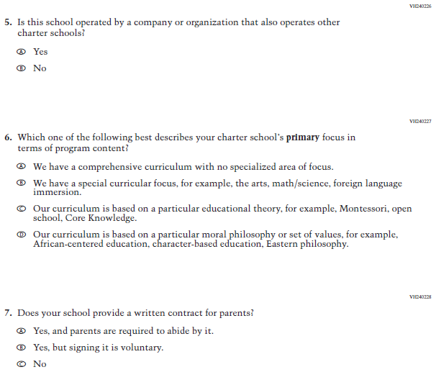

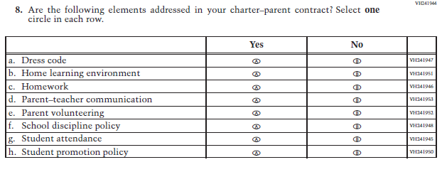

Appendix J3-4: 2024 Pilot Grade 8 (Core)
