FORM OMB 83-C CONTINUED: DHS/ICE/HSI Form 73-061 HSI Tip Line
The proposed addition of a check box and agency field to ICE’s public tip form, allowing law enforcement (particularly in sanctuary jurisdictions) to report tips, including on the release of criminal aliens from state custody, constitutes excepted work under the ADA. This modification directly supports ICE’s mission to protect against imminent threats to human life and the protection of property. Sanctuary jurisdictions that do not honor ICE detainers often release individuals with criminal histories, including violent offenses, posing significant risks to public safety. By enabling state law enforcement to securely and anonymously report these releases, the check box ensures ICE can act swiftly to apprehend dangerous individuals, mitigating threats to both human life and property. This enhancement is critical to ICE’s ability to respond effectively to these imminent risks during a lapse in appropriations.
Additionally, this work is consistent with ADA requirements because it supports law enforcement operations funded under the BBB. ICE has appropriated funding through the BBB to carry out specific enforcement activities, and the tips collected via this form would directly support those funded operations. The check box is a non-substantive change to an existing tool that enhances ICE’s ability to gather actionable intelligence, ensuring that resources provided under the BBB are used effectively to advance ICE’s law enforcement objectives. As such, this activity does not rely on unfunded resources and is fully aligned with appropriated funding streams.
In conclusion, the check box is both an operational necessity and a lawful use of ICE’s resources during a funding lapse. It enhances ICE’s ability to protect public safety by addressing imminent threats and supports law enforcement activities funded under the BBB. For these reasons, the proposed modification qualifies as excepted work under the ADA and is essential to ICE’s mission to safeguard human life and property.
____________________________________________________________________________________
First New Field: "Are you a Law Enforcement Officer?" with radio button option for YES and NO. When YES radio button is selected, the following four new fields will also appear.
Second New Field: "Your Agency (Optional):" with text input box.
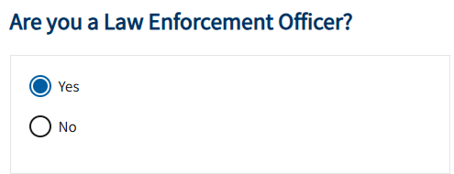
Example:

