Initial Email for Survey:
Subject: Taxpayer Assistance Center (TAC) Services Survey
Thank you for your recent visit. We hope your experience was positive. Please take a moment to complete our brief survey; your feedback helps us improve our services and better support your future needs.
Click here to take the survey.
Thank you for your valuable input.
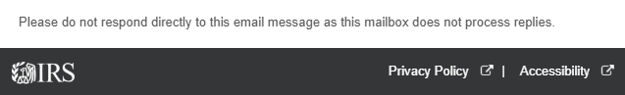
------------------------------------------------------------------------------------------------------------------
Reminder Email for Survey:
Subject: Reminder: Taxpayer Assistance Center (TAC) Services Survey
This is a follow-up regarding our brief survey about your recent visit. Your input helps us improve our services and better support your future needs.
Please click here to take the survey.
Thank you for your valuable input.
Initial SMS Text for Survey (130 characters)
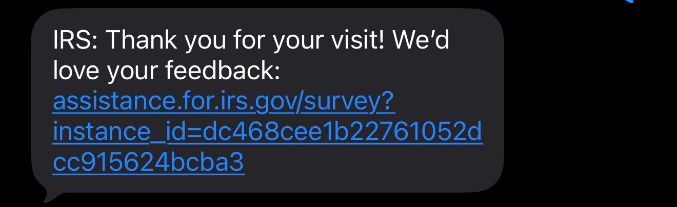
*No reminder text will be sent by text.

