Wave 1: Initial Invitation
Dear [Taxpayer Name],
The IRS is committed to improving its performance and services to American taxpayers. Please participate in an important initiative to bring about this positive change.
We would like to get your feedback about your recent Excise Tax examination or registration review. Your honest opinions about your interactions with IRS services and employees will help us improve the taxpayer experience. For example, feedback from taxpayers like you has been used to improve and expand the digital services offered by the IRS.
You can take the survey on most devices with a web browser, like a desktop computer, laptop, tablet, or smartphone. The survey should take less than 5 minutes to complete.
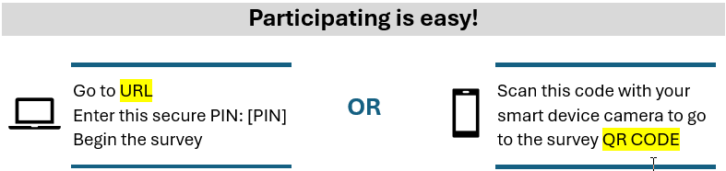

If you have questions about this survey, please e-mail SBSE.CXSurvey@irs.gov or call 1-800-XXX-XXXX (placeholder until we secure a phone number).
The IRS is committed to improving service to every taxpayer. Please take a few moments to share your thoughts on how we can best improve the services and support we provide. Your participation is voluntary, and your responses will be combined with other responses to protect your privacy.
Thank you in advance for your participation.

Sincerely,
Name
Title and organization

Wave 2: First Reminder
We recently invited you to participate in a survey of IRS taxpayers. If you have completed the survey, thank you.
We are administering a survey to taxpayers who have recently gone through a recent Excise Tax examination or registration review. We want your feedback about the audit/review process and the service you received.
If you have not completed the survey, please follow the instructions below to participate (choose only one option). This survey should take less than 5 minutes.

If you have questions about this survey, please e-mail SBSE.CXSurvey@irs.gov or call 1-800-XXX-XXXX (placeholder until we secure a phone number).
Survey results help the IRS improve services for taxpayers. Your feedback is critical to making these positive changes. Your participation is voluntary, and your responses will be combined with other responses to protect your privacy.
Thank you for taking part in this important survey.

Sincerely,
Name
Title and organization

Wave 3: Second Reminder (Postcard)
QR Code placed at top left
Do We Have Your Input Yet?
Recently, you received a letter asking for your opinions about the service you recently received from the IRS during your Excise Tax examination or registration review. If you have already completed the survey, thank you. If not, please take a few minutes to complete it. We want your opinions and suggestions.
To complete the survey, type URL into your web browser and enter this secure PIN: [PIN] or scan the QR code shown at the top of this postcard.
The survey is brief and should take less than 5 minutes to complete. Your participation is voluntary, and your responses will be combined with other responses to protect your privacy.
If you have questions about this survey, please e-mail SBSE.CXSurvey@irs.gov or call 1-800-XXX-XXXX (placeholder until we secure a phone number).

Sincerely,
Name
Title and organization

Wave 4: Third/Final Reminder
We recently invited you to participate in a survey requesting your feedback about your experiences during a recent IRS interaction. This survey will be closing soon – add your voice before it is too late.
We are sending surveys to taxpayers who have gone through a recent Excise Tax examination or registration review. Your responses will help us understand your experiences and opinions and will be used to improve communication and services for taxpayers.
This survey should take less than 5 minutes to complete. Participation is voluntary, and your responses will be combined with other responses to protect your privacy.
Or by Mail:
1. Fill out the enclosed survey
2. Return it in the postage-paid envelope
If you have questions about this survey, please e-mail SBSE.CXSurvey@irs.gov or call 1-800-XXX-XXXX (placeholder until we secure a phone number).
Thank you for taking part in this important survey.

Sincerely,
Name
Title and organization

