PARENTAL PERMISSION FORM

Our school is taking part in the National Youth Tobacco Survey (NYTS). This surveillance project is sponsored by the Food and Drug Administration (FDA). Students in grades 6 through 12 will be asked to complete a survey about their tobacco and nicotine related beliefs, attitudes and behaviors, intent to use, and exposure to influences that promote or discourage tobacco and nicotine use.
Students will be asked to use an internet-connected device to fill out a survey that takes about 12-15 minutes on average to complete.
Doing this survey will pose no physical risk to your child. The survey has been designed to protect your child’s privacy. Students will not enter their names in the survey. Also, no school or student will ever be mentioned by name in a report of the results. Your child will get no immediate benefit from taking part in the survey; however, the results of this survey will help your child and other children in the future. We would like all selected students to take part in the survey, but the survey is voluntary. No action will be taken against the school, you, or your child, if your child does not take part. Students can skip any questions that they do not wish to answer. In addition, students may stop participating in the survey at any point without penalty. If you would like to see the survey, a copy is available in the school office. Your child will be asked specifically about electronic cigarettes, cigarettes, cigars (including cigars, little cigars, and cigarillos), smokeless tobacco (chewing tobacco, snuff, or dip; snus; dissolvable tobacco products), hookahs, pipe tobacco, bidis, roll your own cigarettes, heated tobacco products, and nicotine pouches.
Please read the section below and check one box. Then, sign the form and return it to the school within 3 days. Please see the other side of this form for more facts about the survey. If your child's teacher or principal cannot answer your questions about the survey, please call Jean Lennon, Project Director, toll-free at 1-866-354-0987. Thank you.

Child’s name: _________________________________________________ Grade:_______________
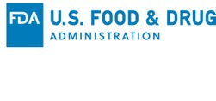
I have read this form and know what the survey is about.
Please check one box:
YES, my child may take part in this survey.
NO, my child may not take part in this survey.
Parent or guardian’s signature: ____________________________________ Date:_______________

Please see the other side of this form for more facts about the survey.

SURVEY FACT SHEET
Why is the NYTS  being done? | The purpose of the NYTS is to gather nationally representative data for students in grades 6 through 12 for the following tobacco and nicotine related topics: (1) prevalence of use [electronic cigarettes, cigarettes, cigars (including cigars, little cigars, and cigarillos), smokeless tobacco (chewing tobacco, snuff, or dip; snus; dissolvable tobacco products), hookahs, pipe tobacco, bidis, roll your own cigarettes, heated tobacco products, and nicotine pouches], (2) knowledge and attitudes, (3) media and advertising, (4) minors’ access and enforcement, (5) school curriculum, (6) secondhand smoke exposure, and (7) cessation.
Are sensitive questions  asked? | Students will be asked specifically about electronic cigarettes, cigarettes, cigars (including cigars, little cigars, and cigarillos), smokeless tobacco (chewing tobacco, snuff, or dip; snus; dissolvable tobacco products), hookahs, pipe tobacco, bidis, roll your own cigarettes, heated tobacco products, oral nicotine products and nicotine pouches. Some students may consider some questions sensitive, especially those asking about content with which they are not familiar, such as pipes, snus, or dissolvable tobacco. In addition, questions regarding a student’s sexual orientation, experience with discrimination, and neighborhood environment are asked to obtain data to determine if these factors are associated with observed disparities in tobacco use among our youth, thus allowing public health and health professionals to reduce tobacco related disparities. Students can skip any questions they do not wish to answer.
Will student names be  used or linked to the  surveys? | No. The survey has been designed to protect your child’s privacy.  The survey is submitted electronically, and no one at the school will be able to see your student’s responses. Students do not enter their name in the survey.
Do students take the  survey more than once  to see how their behaviors change? | No. Each year a new sample of states, schools, and students is  selected. Students who take part one year cannot be tracked because  their names are not on the survey.
How was my child  selected to be in the  survey? | About 28,000 students from approximately 540 schools across the  country were selected to take part. One or two classes (about 25 to  50 students) in each grade 6 through 12 were picked randomly to  take part in each school.
How long does it take  to fill out the survey?  Does the survey include  a physical test? | Since the survey was converted to an electronic version with  skip patterns, it takes 12-15 minutes on average to complete.  The survey does not include a physical test or exam.
Can I see the questions  my child will be asked? | Yes, a copy of the survey is at your child’s school.











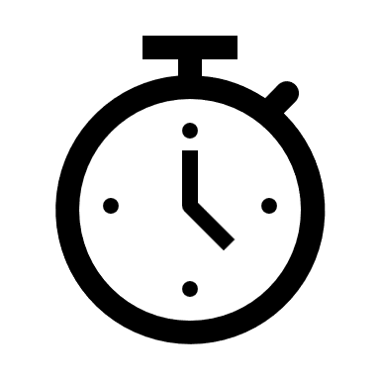



Public reporting burden for this collection of information is estimated to average 30 minutes per survey, including time for reviewing instructions, searching existing data sources, gathering and maintaining the data needed, and completing and reviewing the collection of information. An agency may not conduct or sponsor, and a person is not required to respond to, a collection of information unless it displays a currently valid OMB control number. Send comments regarding this burden estimate or any other aspect of this collection of information, including suggestions for reducing this burden to: Office of Operations, Food and Drug Administration, Three White Flint North, 10A-12M, 11601 Landsdown St., North Bethesda, MD 20852, PRAStaff@fda.hhs.gov, ATTN: PRA (0910-0932).

