School Coordinator Instructions for Providing Class Lists for Sampling

The NYTS study procedures require collecting lists of classrooms. In each school, students will be selected as entire classrooms. First, the School Coordinator (SC) and NYTS Liaison will identify a subject area that all students take from which to select classrooms. Then, the NYTS Liaison will ask the SC to provide an ordered list of ALL the 6th through 12th grade classes for that subject at the school, using the steps below.
- List ALL the [SUBJECT] classes for grades 6-12, using the NYTS Class List Template provided.
- Include grade, class name, period, teacher, teacher email, and number of students in the class.
- Email the list to your NYTS Liaison.

Classes will be selected by the study sampling team and emailed to the School Coordinator.

Example of Class List Template
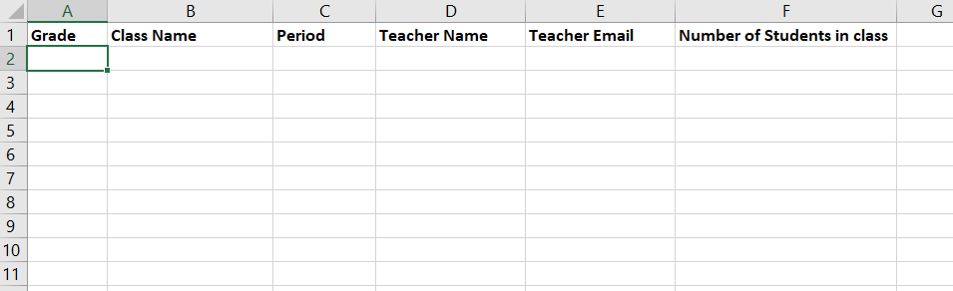

Classroom Sampling FAQ
Can I choose which classes will participate or ask for volunteer classes? No. The NYTS team must select the classrooms. This process is needed to make sure that the students who complete the survey represent all students across the country.
Can I submit the class list in a format other than Excel? The class list can be provided in whatever format is easiest.
What if we use mixed-grade classrooms? All students in grades 6 through 12 are eligible. For classes that include multiple grades, students in the eligible grades can participate while others complete an alternative activity.
For any additional questions, please contact your NYTS Liaison or the NYTS team at NYTS@rti.org or toll-free (866) 354-0987.

