NATIONAL CENTER FOR EDUCATION STATISTICS NATIONAL ASSESSMENT OF EDUCATIONAL PROGRESS

National Assessment of Educational Progress (NAEP) 2026

Appendix J-S
2024 Spanish Questionnaires Samples

OMB# 1850-0928 v.38



September 2025

Important changes in how we collect demographic information are reflected in the 2026 instruments that are ready for publication and review. In March 2024, the Office of Management and Budget (OMB) announced revisions to Statistical Policy Directive No. 15: Standards for Maintaining, Collecting, and Presenting Federal Data on Race and Ethnicity (SPD 15) and published the revised SPD15 standard in the Federal Register (89 FR 22182). See Part A.7 of this package to see how NCES plans to incorporate these revisions into NAEP 2026.
Additionally, materials in this Amendment are in compliance with the White House’s Executive Orders “Defending Women from Gender Ideology Extremism and Restoring Biological Truth to the Federal Government,” (January 20, 2025) and “Ending Radical and Wasteful Government DEI Programs and Preferencing,” (January 20, 2025).
Appendix J-S provides Operational and Pilot Spanish student, teacher, and school survey questionnaires that will be administered in 2026. Summary tables reflect any changes to the items from the 2024 administration. Please note, some of the numbers of the items may be missing or out of order in these printed versions. This will be corrected in the platform view.

Table of Contents
Student Login Screen 5
Appendix J-1-s: Spanish Translations of Student Questionnaires 6
Appendix J-1a-s-BL: Summary of Changes Operational Grade 4 CORE 7
Appendix J-1a-s-BL: Operational Grade 4 CORE 11
Appendix J-1b-s-PR: Summary of Changes Operational Grade 4 CORE 14
Appendix J-1b-s-PR: Operational Grade 4 CORE 17
Appendix J-1c-s-BL: Summary of Changes Operational Grade 8 CORE 20
Appendix J-1c-s-BL: Operational Grade 8 CORE 26
Appendix J-1d-s-PR: Summary of Changes Operational Grade 8 CORE 32
Appendix J-1d-s-PR: Operational Grade 8 CORE 38
Appendix J-1e-s-BL: Summary of Changes Operational Grade 4 Mathematics 44
Appendix J-1e-s-BL: Operational Grade 4 Mathematics 46
Appendix J-1f-s-PR: Summary of Changes Operational Grade 4 Mathematics 49
Appendix J-1f-s-PR: Operational Grade 4 Mathematics 51
Appendix J-1g-s-BL: Summary of Changes Operational Grade 8 Mathematics 54
Appendix J-1g-s-BL: Operational Grade 8 Mathematics 60
Appendix J-1h-s-PR: Summary of Changes Operational Grade 8 Mathematics 66
Appendix J-1h-s-PR: Operational Grade 8 Mathematics 72
Appendix J-1i-s-BL: Summary of Changes Operational Grade 4 Reading 78
Appendix J-1i-s-BL: Operational Grade 4 Reading 81
Appendix J-1j-s-BL: Summary of Changes Operational Grade 8 Reading 85
Appendix J-1j-s-BL: Operational Grade 8 Reading 89
Appendix J-1k-s-BL: Operational Grade 8 Civics 95
Appendix J-1l-s-BL: Operational Grade 8 U.S. History 100
Appendix J-1m-s-BL: Summary of Changes Operational Grade 4 Debrief 105
Appendix J-1m-s-BL: Operational Grade 4 Debrief 106
Appendix J-1n-s-PR: Summary of Changes Operational Grade 4 Debrief 107
Appendix J-1n-s-PR: Operational Grade 4 Debrief 108
Appendix J-1o-s-BL: Summary of Changes Operational Grade 8 Debrief 109
Appendix J-1o-s-BL: Operational Grade 8 Debrief 110
Appendix J-1p-s-PR: Summary of Changes Operational Grade 8 Debrief 111
Appendix J-1p-s-PR: Operational Grade 8 Debrief 112
Appendix J-1q-s-PR: Pilot Grade 4 Core 113
Appendix J-1r-s-PR: Pilot Grade 8 Core 116
Appendix J-1s-s-PR: Pilot Grade 4 Mathematics 122
Appendix J-1t-s-PR: Pilot Grade 8 Mathematics 125
Appendix J-1u-s-PR: Pilot Grade 4 Debrief 131
Appendix J-1v-s-PR: Pilot Grade 8 Debrief 132
Appendix J-2-s: Spanish Translations of Teacher Questionnaires 133
Sample Teacher Login Screen 134
Appendix J-2a-s-PR: Summary of Changes Operational Grade 4 CORE 135
Appendix J-2a-s-PR: Operational Grade 4 CORE 149
Appendix J-2b-s-PR: Summary of Changes Operational Grade 8 CORE 159
Appendix J-2b-s-PR: Operational Grade 8 CORE 170
Appendix J-2c-s-PR: Summary of Changes Operational Grade 4 Mathematics 184
Appendix J-2c-s-PR: Operational Grade 4 Mathematics 191
Appendix J-2d-s-PR: Summary of Changes Operational Grade 8 Mathematics 200
Appendix J-2d-s-PR: Operational Grade 8 Mathematics 210
Appendix J-3-s: Spanish Translations of School Questionnaires 220
Sample School Administrator Login Screen 221
Appendix J-3a-s-PR: Summary of Changes Operational Grade 4 CORE 222
Appendix J-3a-s-PR: Operational Grade 4 CORE 230
Appendix J-3b-s-PR: Summary of Changes Operational Grade 8 CORE 239
Appendix J-3b-s-PR: Operational Grade 8 CORE 249
Appendix J-3c-s-PR: Summary of Changes Operational Grade 4 Mathematics 256
Appendix J-3c-s-PR: Operational Grade 4 Mathematics 260
Appendix J-3d-s-PR: Summary of Changes Operational Grade 8 Mathematics 264
Appendix J-3d-s-PR: Operational Grade 8 Mathematics 268

Student Login Screen

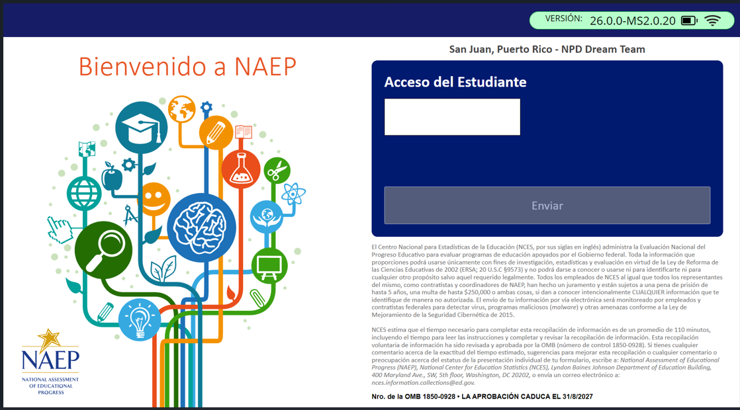

Appendix J-1-s: Spanish Translations of Student Questionnaires

Appendix J-1a-s-BL: Summary of Changes Operational Grade 4 CORE
2026 Operational Grade 4 Core Student – Bilingual
Previous item | 2026 item | D/A/R | Rationale
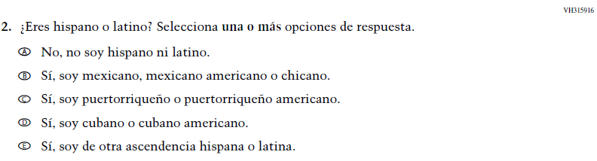  (2024 Operational Grade 4 Student Core - Bilingual) | N/A | D | This Item was dropped and replaced with an updated Item (VR862573) that adheres to OMB updated Statistical Policy Directive No. 15.
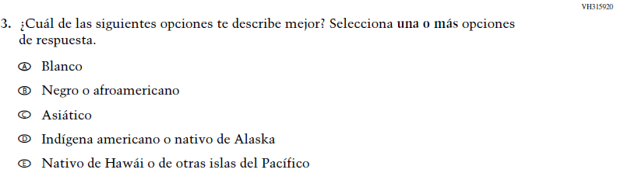  (2024 Operational Grade 4 Student Core - Bilingual) | 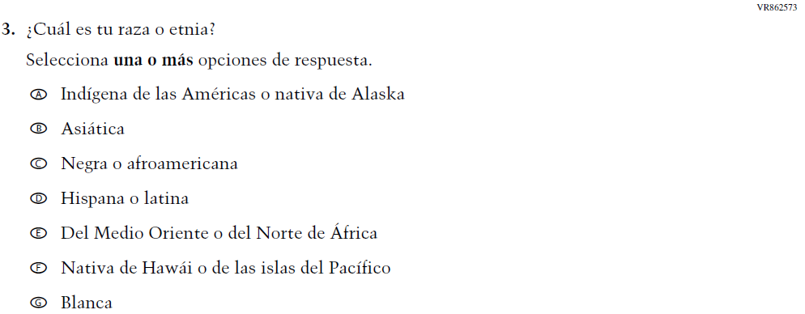  Issue: Student Background | R | VH315916  and this Item were replaced with this updated Item that adheres to OMB updated Statistical Policy Directive No. 15.
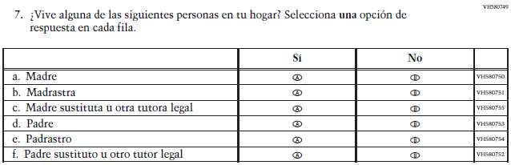  (2024 Operational Grade 4 Student Core - Bilingual) | 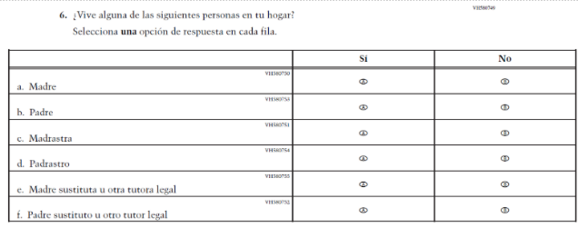  Issue: Socioeconomic Status | R | The SubItems in this Item were re-sequenced for clarity.
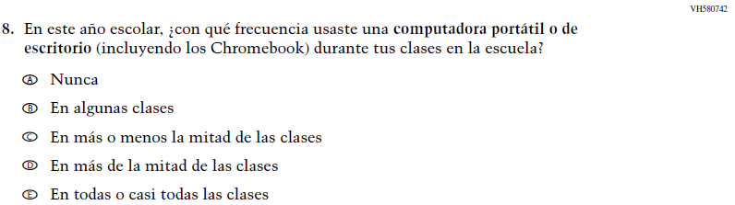  (2024 Operational Grade 4 Student Core - Bilingual) | N/A | D | This Item was dropped to make space for new Student Items in the 2026 NAEP Assessment.
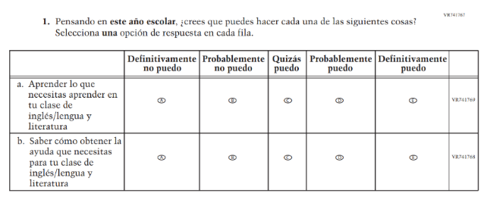  (2024 Operational Grade 4 Student Core – Bilingual Reading) | N/A | D | Learning Recovery Items were dropped from the 2026 NAEP Assessment.
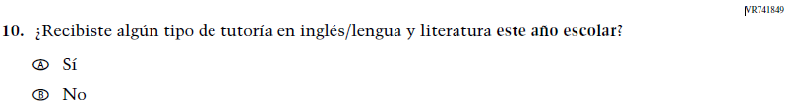  (2024 Operational Grade 4 Student Core – Bilingual Reading) | N/A | D | Learning Recovery Items were dropped from the 2026 NAEP Assessment.
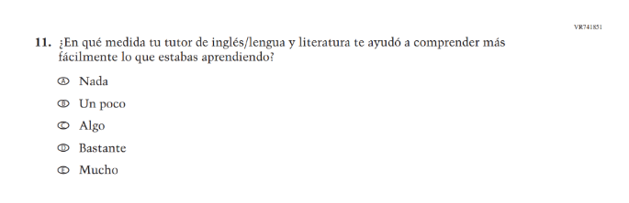  (2024 Operational Grade 4 Student Core – Bilingual Reading) | N/A | D | Learning Recovery Items were dropped from the 2026 NAEP Assessment.
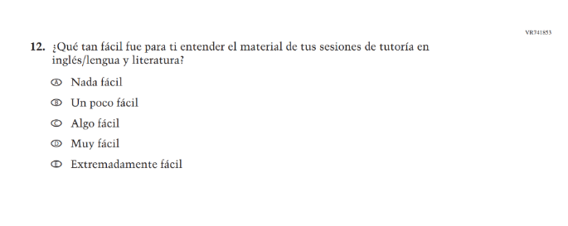(2024 Operational Grade 4 Student Core – Bilingual Reading) | N/A | D | Learning Recovery Items were dropped from the 2026 NAEP Assessment.
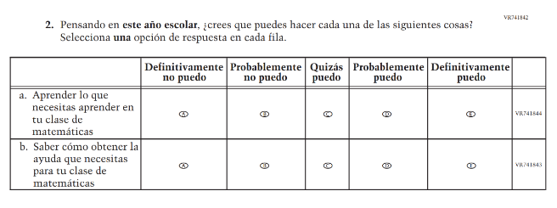(2024 Operational Grade 4 Student Core – Bilingual Math) | N/A | D | Learning Recovery Items were dropped from the 2026 NAEP Assessment.
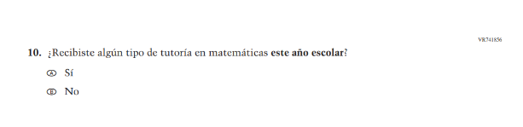(2024 Operational Grade 4 Student Core – Bilingual Math) | N/A | D | Learning Recovery Items were dropped from the 2026 NAEP Assessment.
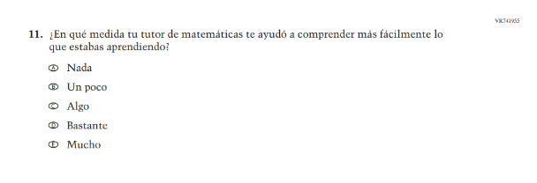(2024 Operational Grade 4 Student Core – Bilingual Math) | N/A | D | Learning Recovery Items were dropped from the 2026 NAEP Assessment.
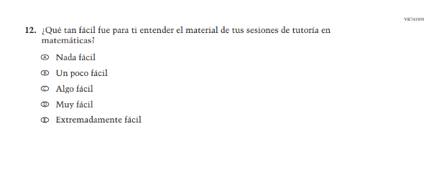(2024 Operational Grade 4 Student Core – Bilingual Math) | N/A | D | Learning Recovery Items were dropped from the 2026 NAEP Assessment.
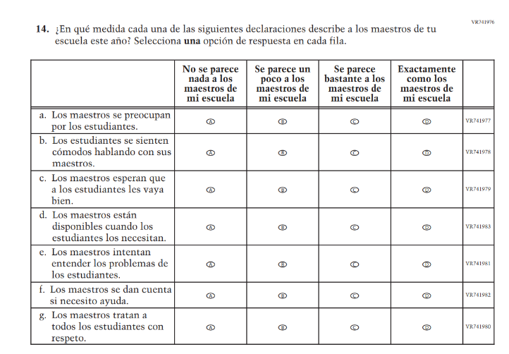(2024 Operational Grade 4 Student Core - Bilingual) | 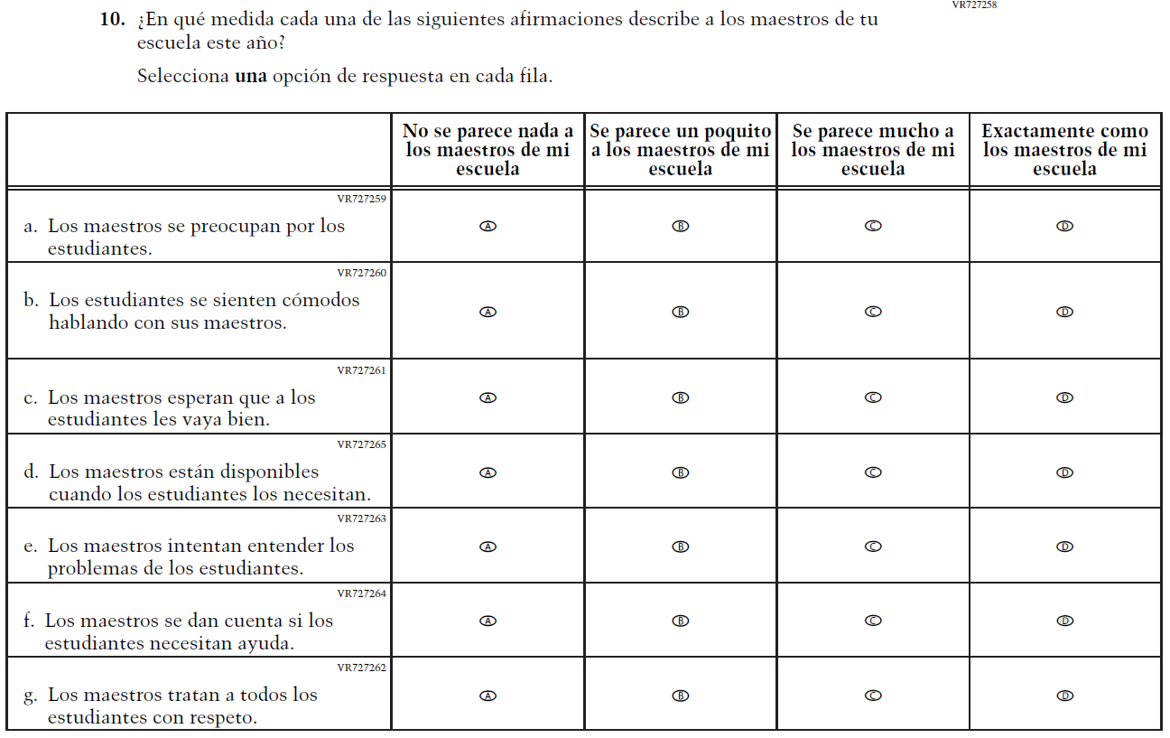  Issue: Learning Environment | R | SubItems a. and f. were revised for clarity and consistency.

2026 Operational Grade 4 Core Student – Bilingual
Previous item | 2026 item | D/A/R+ | Rationale
N/A  (2024 Operational Grade 4 Student Core - Bilingual) | 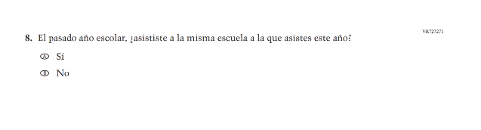  Issue: School Climate | A | This Item was added to gather information on student mobility.

Appendix J-1a-s-BL: Operational Grade 4 CORE
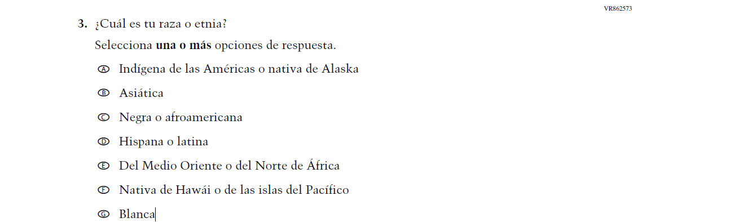

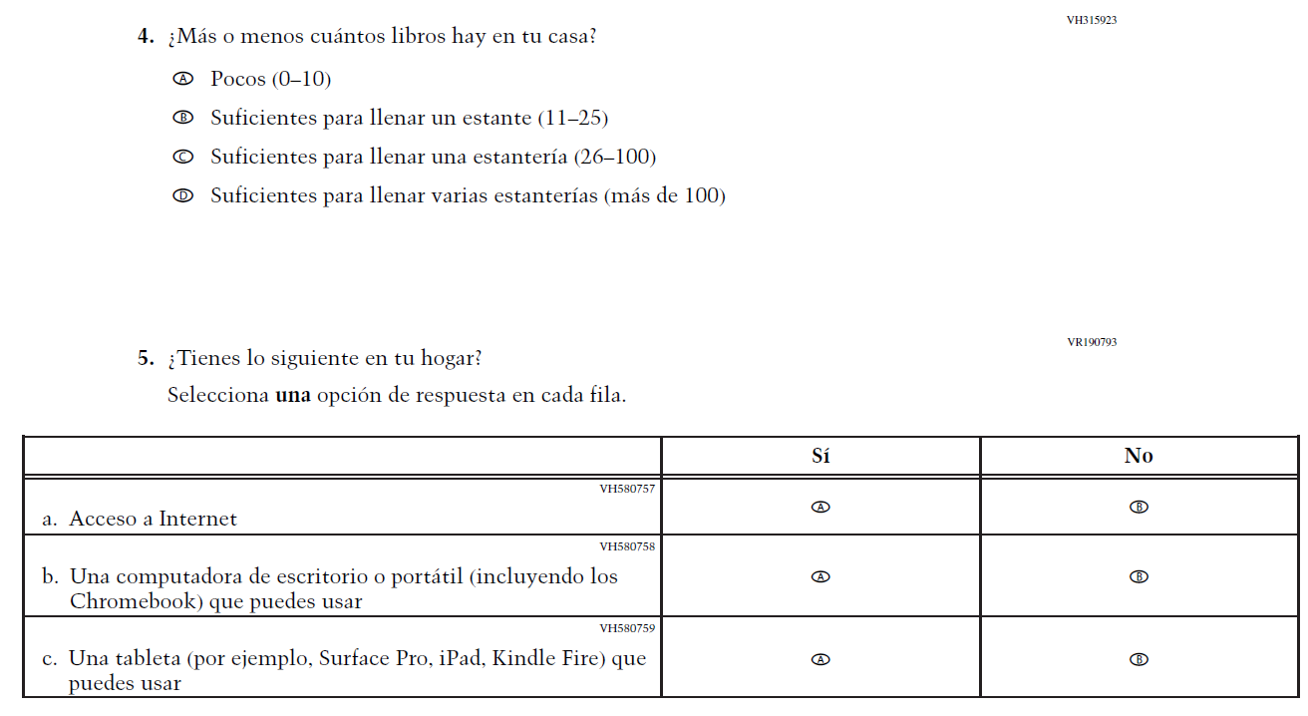
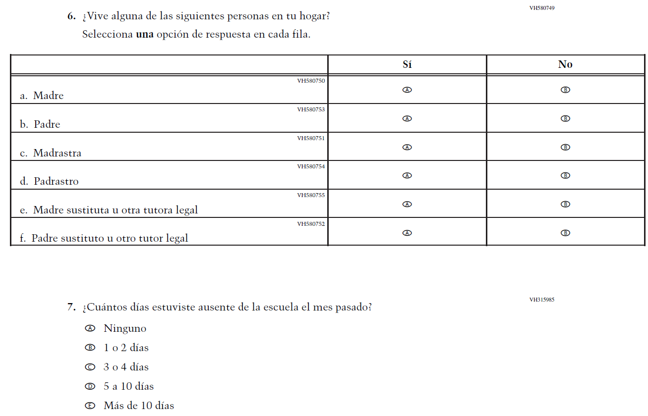
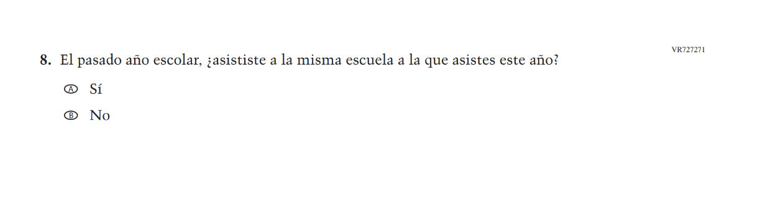
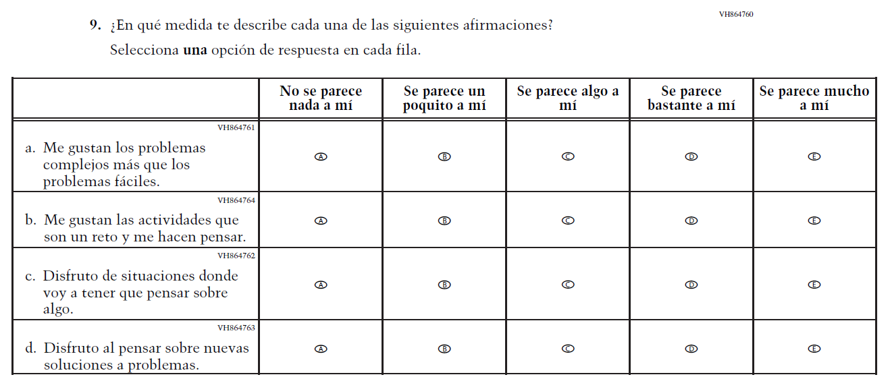

Appendix J-1b-s-PR: Summary of Changes Operational Grade 4 CORE
2026 Operational Grade 4 Core Student – Puerto Rico
Previous item | 2026 item | D/A/R+ | Rationale
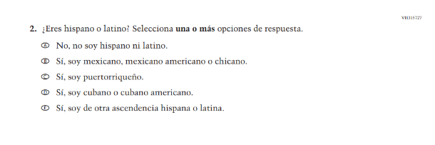  (2024 Operational Grade 4 Student Core – Puerto Rico) | N/A | D | This Item was dropped and replaced with an updated Item (VR862574) that adheres to OMB updated Statistical Policy Directive No. 15.
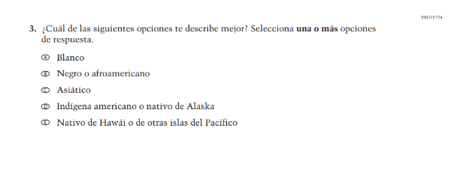  (2024 Operational Grade 4 Student Core – Puerto Rico) | 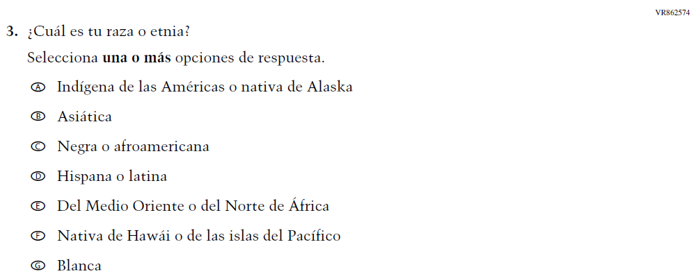  Issue: Student Background | R | VH315727  and this Item were replaced with this updated Item that adheres to OMB updated Statistical Policy Directive No. 15.
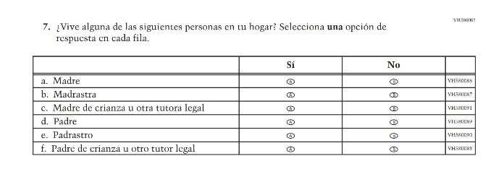  (2024 Operational Grade 4 Student Core – Puerto Rico) | 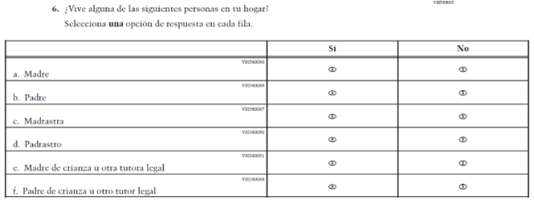Issue: Socioeconomic Status | R | The SubItems in this Item were re-sequenced for clarity.
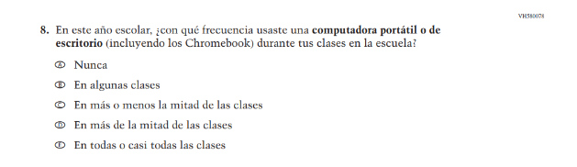  (2024 Operational Grade 4 Student Core – Puerto Rico) | N/A | D | This Item was dropped to make space for new Student Items in the 2026 NAEP Assessment.
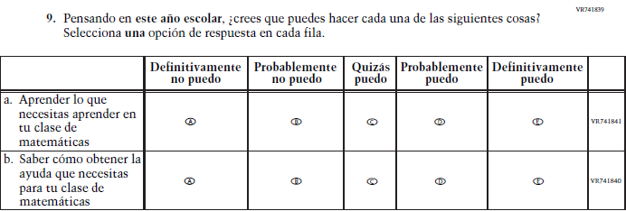  (2024 Operational Grade 4 Student Core - Puerto Rico) | N/A | D | Learning Recovery Items were dropped from the 2026 NAEP Assessment.
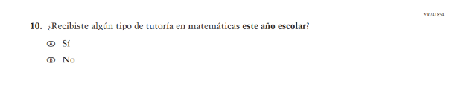(2024 Operational Grade 4 Student Core - Puerto Rico) | N/A | D | Learning Recovery Items were dropped from the 2026 NAEP Assessment.
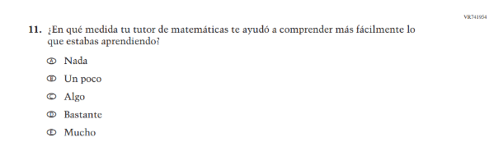  (2024 Operational Grade 4 Student Core - Puerto Rico) | N/A | D | Learning Recovery Items were dropped from the 2026 NAEP Assessment.
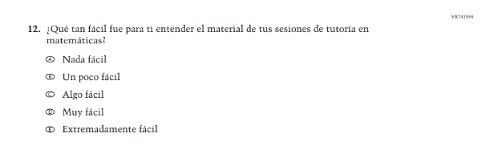(2024 Operational Grade 4 Student Core - Puerto Rico) | N/A | D | Learning Recovery Items were dropped from the 2026 NAEP Assessment.
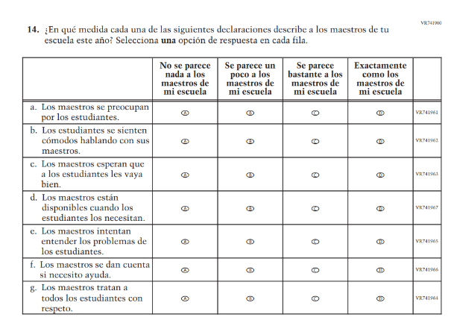(2024 Operational Grade 4 Student Core - Puerto Rico) | 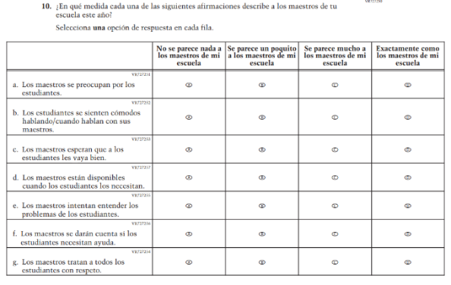  Issue: Learning Environment | R | SubItems a. and f. were revised for clarity and consistency.

2026 Operational Grade 4 Core Student – Puerto Rico
Previous item | 2026 item | D/A/R+ | Rationale
N/A  (2024 Operational Grade 4 Student Core – Puerto Rico) | 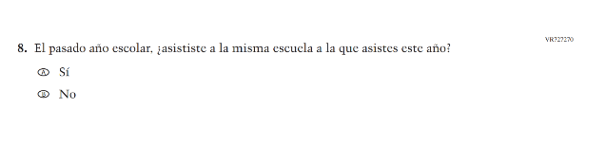  Issue: School Climate | A | This Item was added to gather information on student mobility.

Appendix J-1b-s-PR: Operational Grade 4 CORE
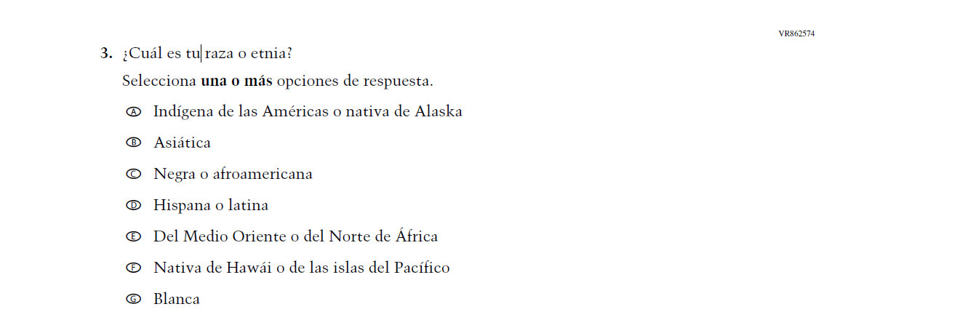

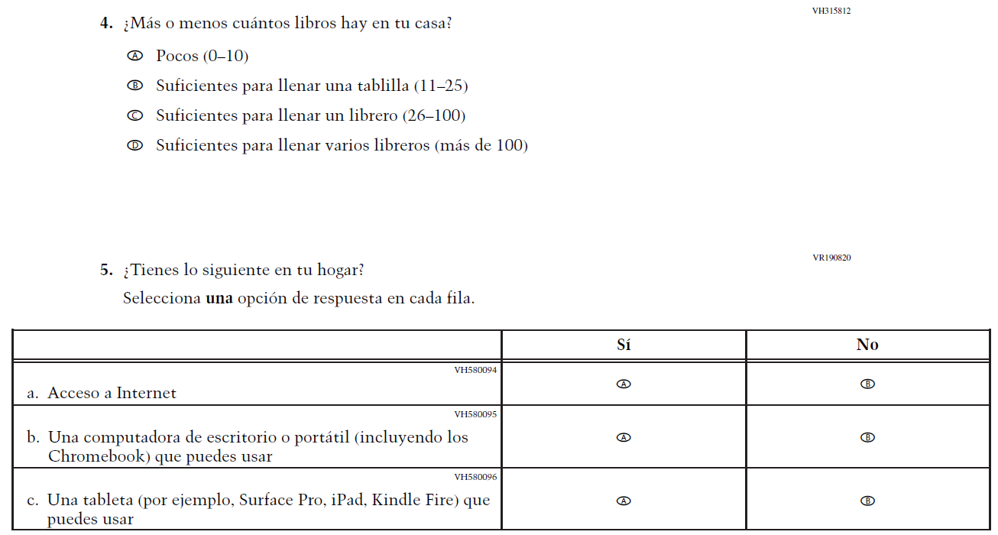
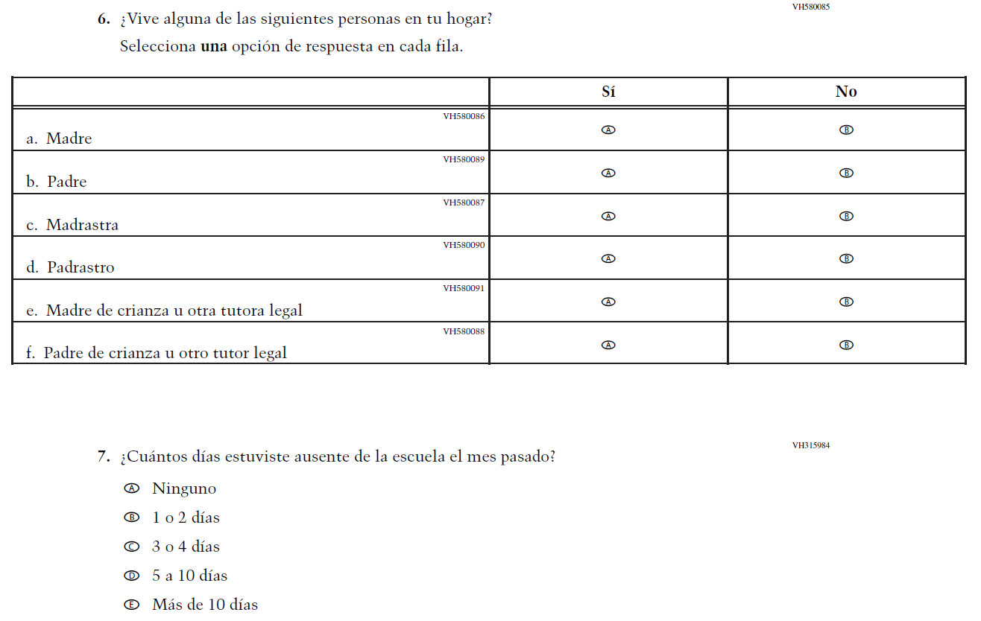
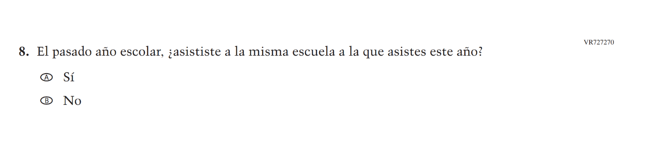
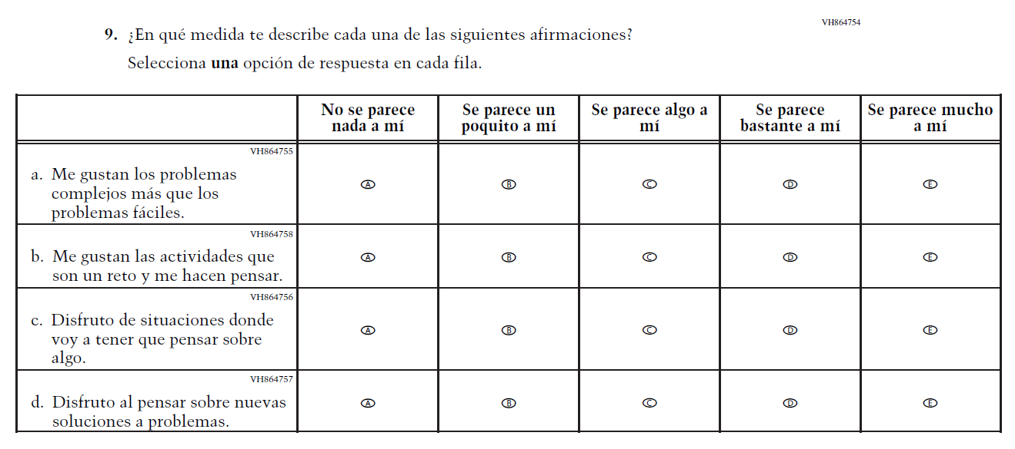
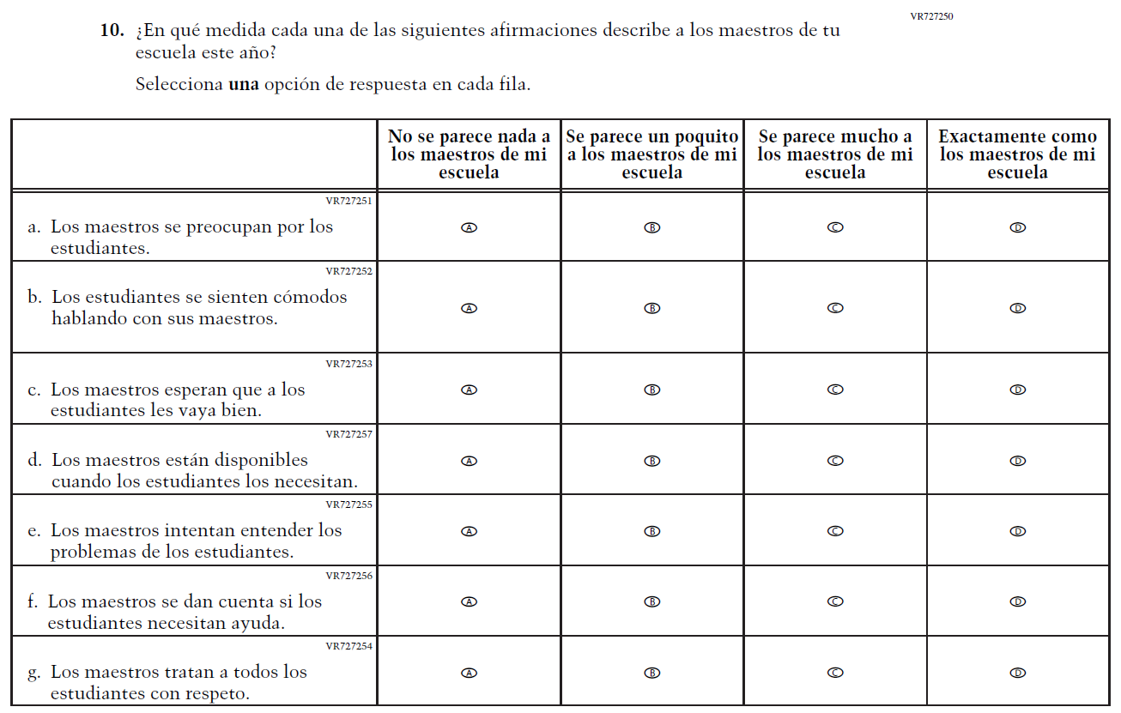

Appendix J-1c-s-BL: Summary of Changes Operational Grade 8 CORE
2026 Operational Grade 8 Core Student – Bilingual
Previous item | 2026 item | D/A/R+ | Rationale
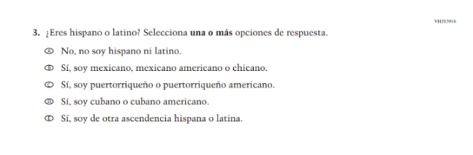  (2024 Operational Grade 8 Student Core – Bilingual) | N/A | D | This Item was dropped and replaced with an updated Item (VR862573) that adheres to OMB updated Statistical Policy Directive No. 15.
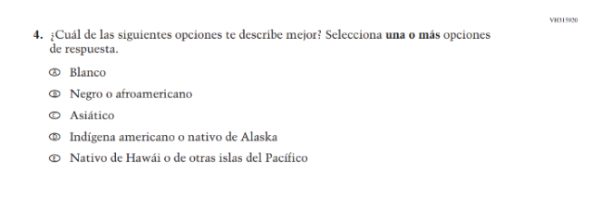  (2024 Operational Grade 8 Student Core – Bilingual) | 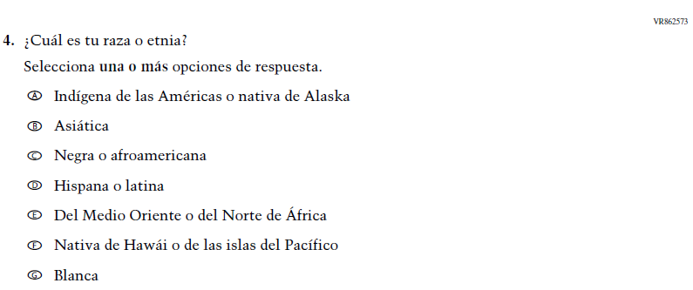  Issue: Student Background | R | VH315916  and this Item were replaced with this updated Item that adheres to OMB updated Statistical Policy Directive No. 15.
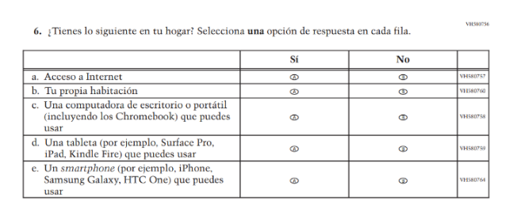  (2024 Operational Grade 8 Student Core – Bilingual) | 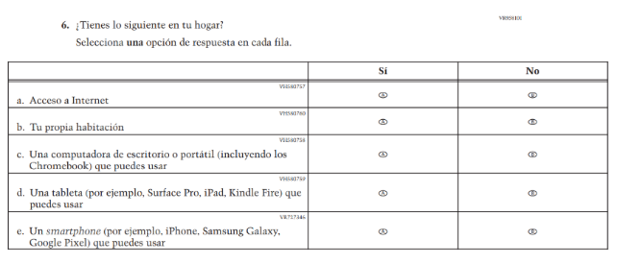  Issue: Socioeconomic Status | R | SubItem e. was revised to provide a more current example.
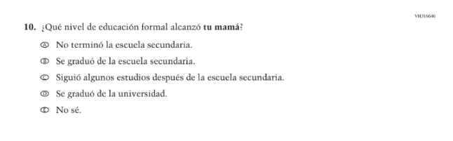(2024 Operational Grade 8 Student Core – Bilingual) | 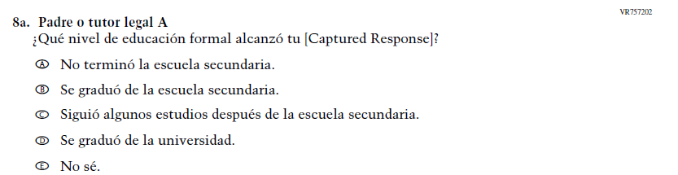  Issue: Socioeconomic Status | R | Dated Parent/  Guardian Education Item was replaced with an updated format.
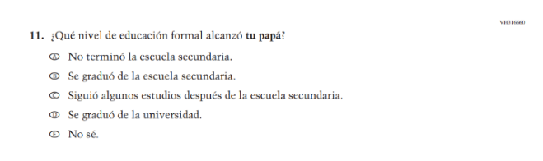(2024 Operational Grade 8 Student Core – Bilingual) | 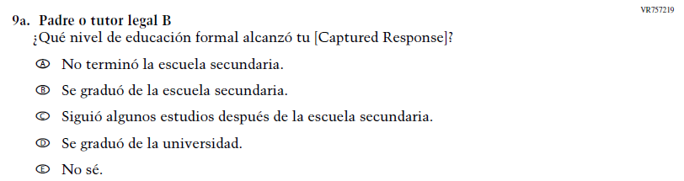  Issue: Socioeconomic Status | R | Dated Parent/  Guardian Education Item was replaced with an updated format.
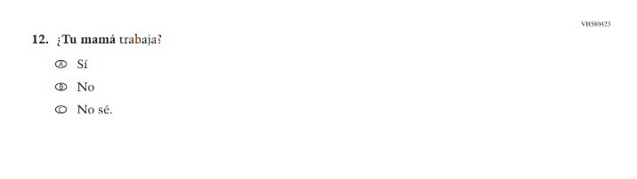(2024 Operational Grade 8 Student Core – Bilingual) | 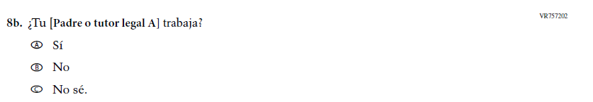  Issue: Socioeconomic Status | R | Dated Parent/  Guardian Education Item was replaced with an updated format.
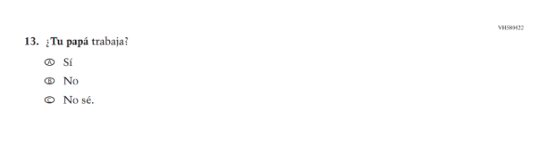(2024 Operational Grade 8 Student Core – Bilingual) | 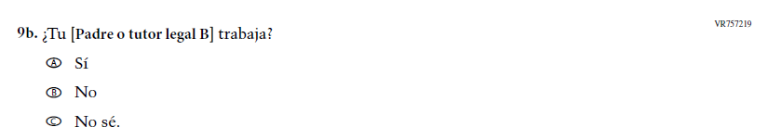  Issue: Socioeconomic Status | R | Dated Parent/  Guardian Education Item was replaced with an updated format.
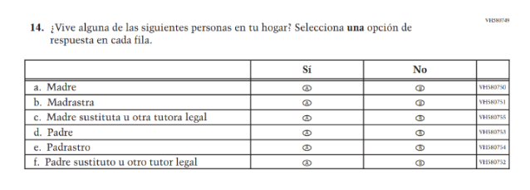(2024 Operational Grade 8 Student Core – Bilingual) | 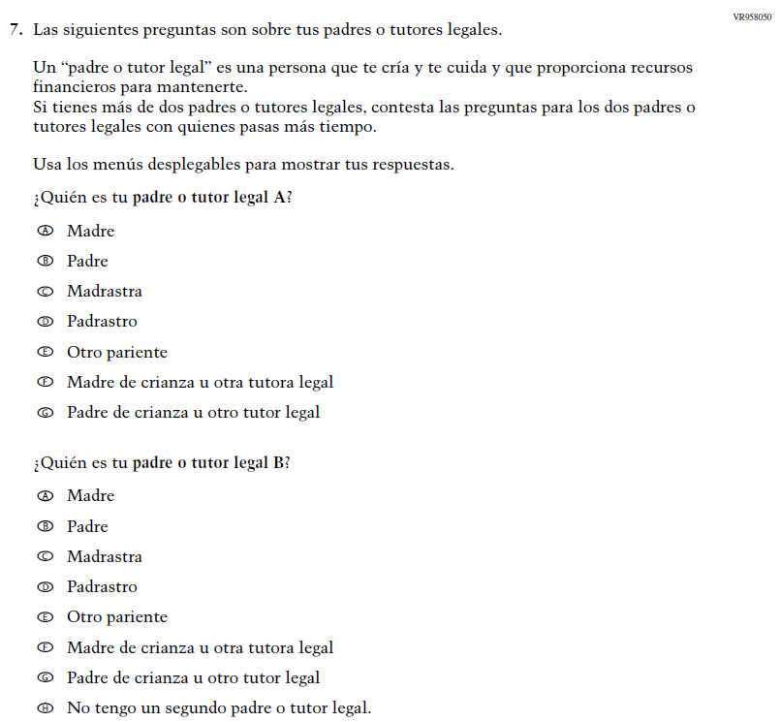  Issue: Socioeconomic Status | R | VH580749 was dropped and replaced with Item VR958050 as an updated format for collecting information on parent/ guardian education and employment.
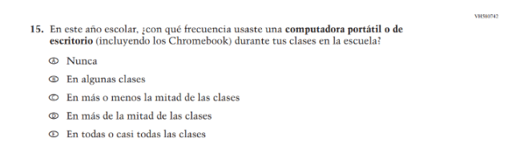(2024 Operational Grade 8 Student Core – Bilingual) | N/A | D | This Item was dropped to make space for new Student Items in the 2026 NAEP Assessment.
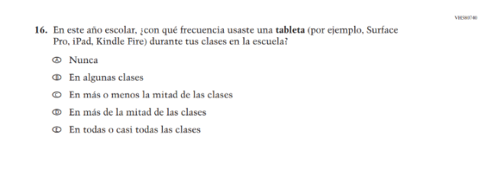(2024 Operational Grade 8 Student Core – Bilingual) | N/A | D | This Item was dropped to make space for new Student Items in the 2026 NAEP Assessment.
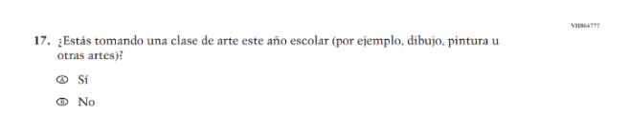(2024 Operational Grade 8 Student Core – Bilingual) | N/A | D | This Item was dropped to make space for new Student Items in the 2026 NAEP Assessment.
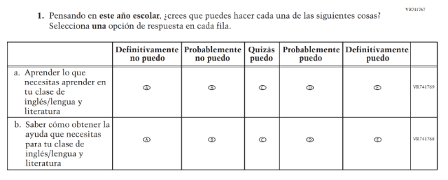(2024 Operational Grade 8 Student Core – Bilingual Reading) | N/A | D | Learning Recovery Items were dropped from the 2026 NAEP Assessment.
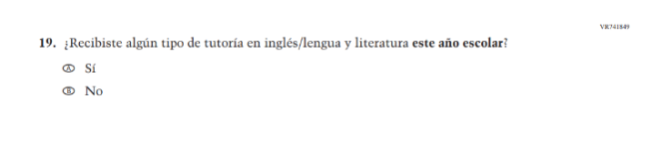(2024 Operational Grade 8 Student Core – Bilingual Reading) | N/A | D | Learning Recovery Items were dropped from the 2026 NAEP Assessment.
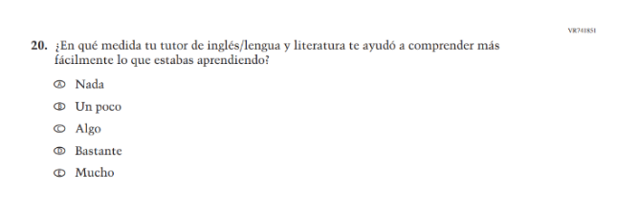(2024 Operational Grade 8 Student Core – Bilingual Reading) | N/A | D | Learning Recovery Items were dropped from the 2026 NAEP Assessment.
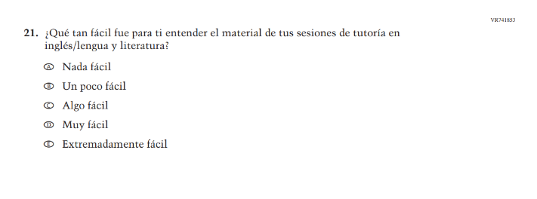(2024 Operational Grade 8 Student Core – Bilingual Reading) | N/A | D | Learning Recovery Items were dropped from the 2026 NAEP Assessment.
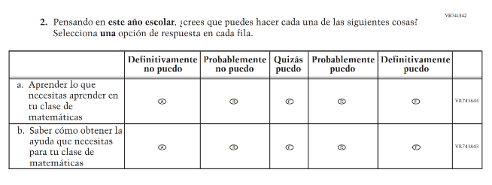(2024 Operational Grade 8 Student Core – Bilingual Math) | N/A | D | Learning Recovery Items were dropped from the 2026 NAEP Assessment.
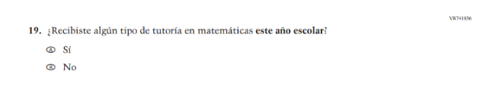(2024 Operational Grade 8 Student Core – Bilingual Math) | N/A | D | Learning Recovery Items were dropped from the 2026 NAEP Assessment.
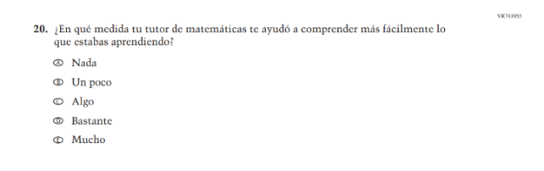(2024 Operational Grade 8 Student Core – Bilingual Math) | N/A | D | Learning Recovery Items were dropped from the 2026 NAEP Assessment.
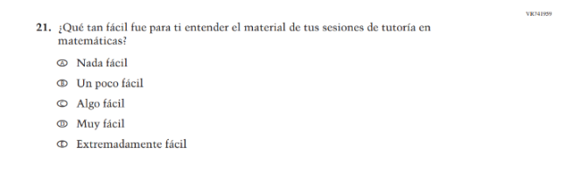(2024 Operational Grade 8 Student Core – Bilingual Math) | N/A | D | Learning Recovery Items were dropped from the 2026 NAEP Assessment.
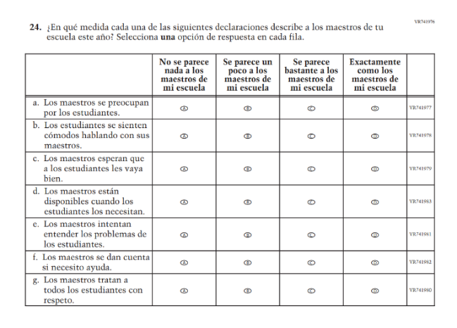(2024 Operational Grade 8 Student Core – Bilingual) | 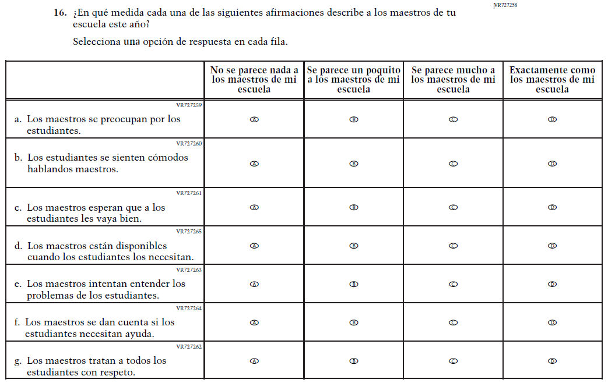  Issue: Learning Environment | R | Subitems a. and f. were revised for clarity and consistency.

2026 Operational Grade 8 Core Student – Bilingual
Previous item | 2026 item | D/A/R+ | Rationale
N/A  (2024 Operational Grade 8 Student Core - Bilingual) | 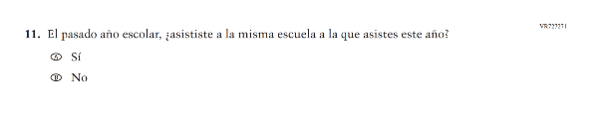  Issue: School Climate | A | This Item was added to gather information on student mobility.

Appendix J-1c-s-BL: Operational Grade 8 CORE
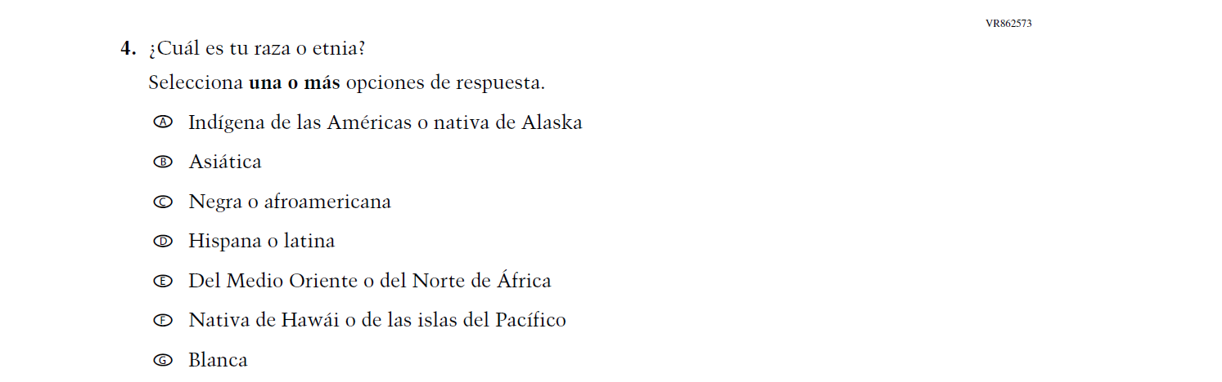

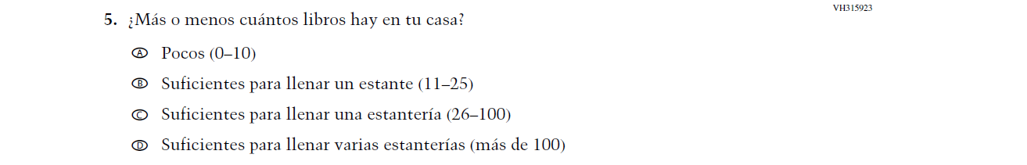

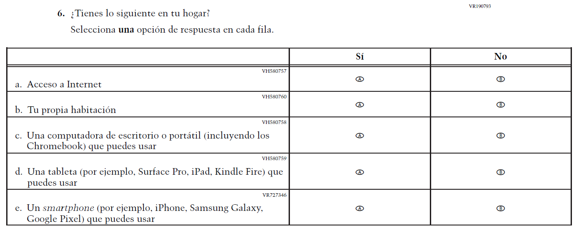
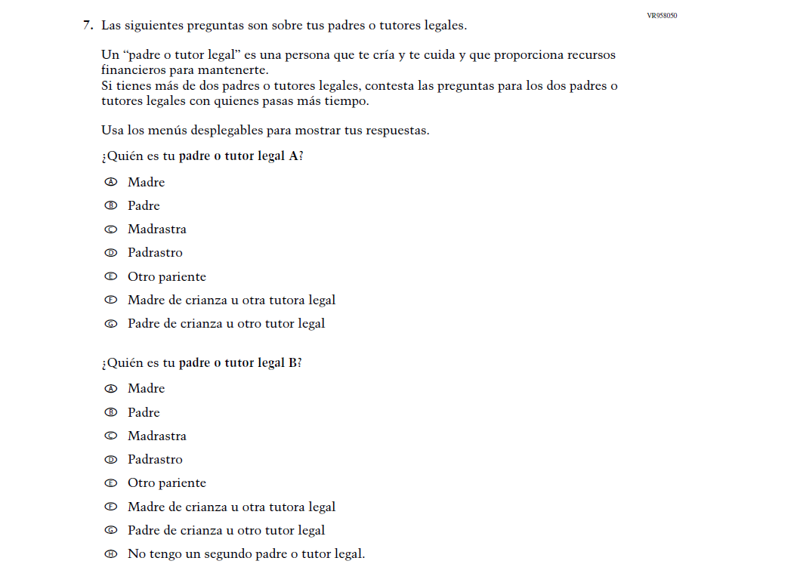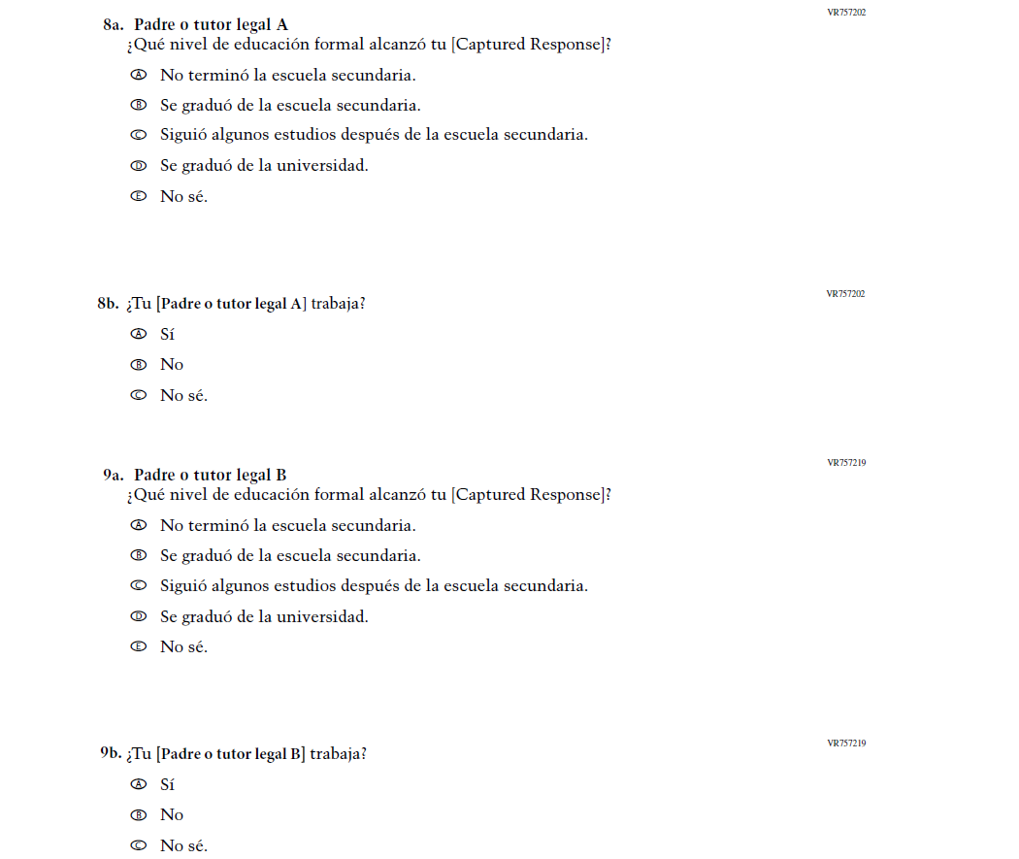

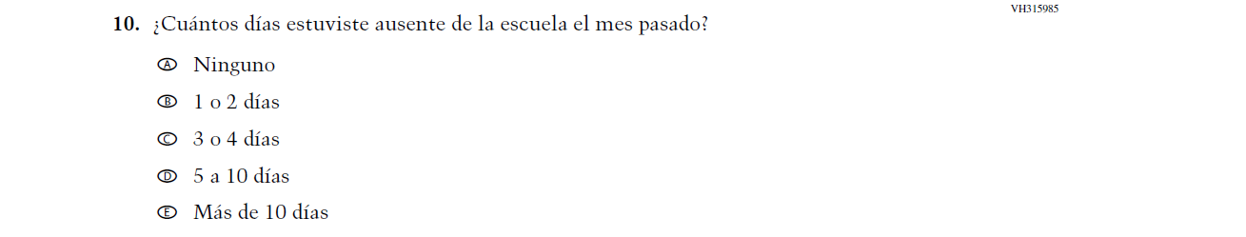
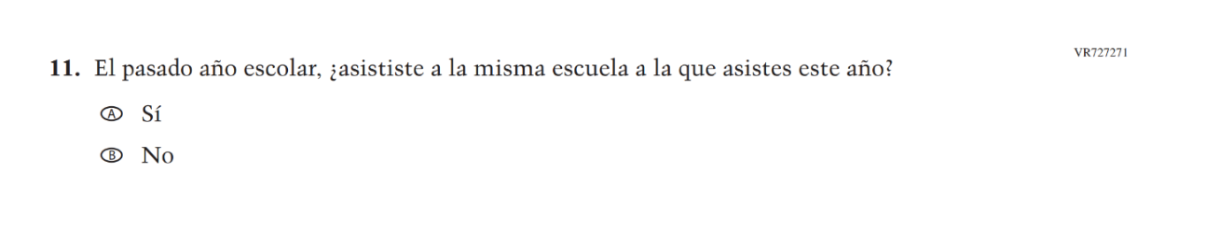
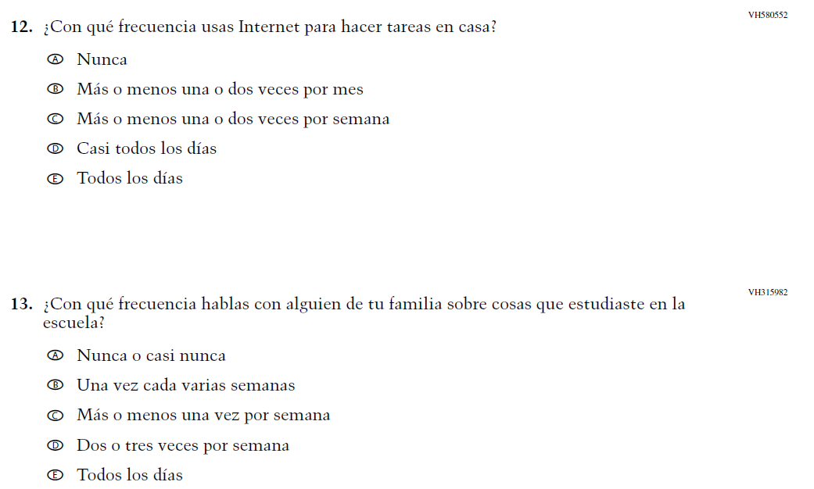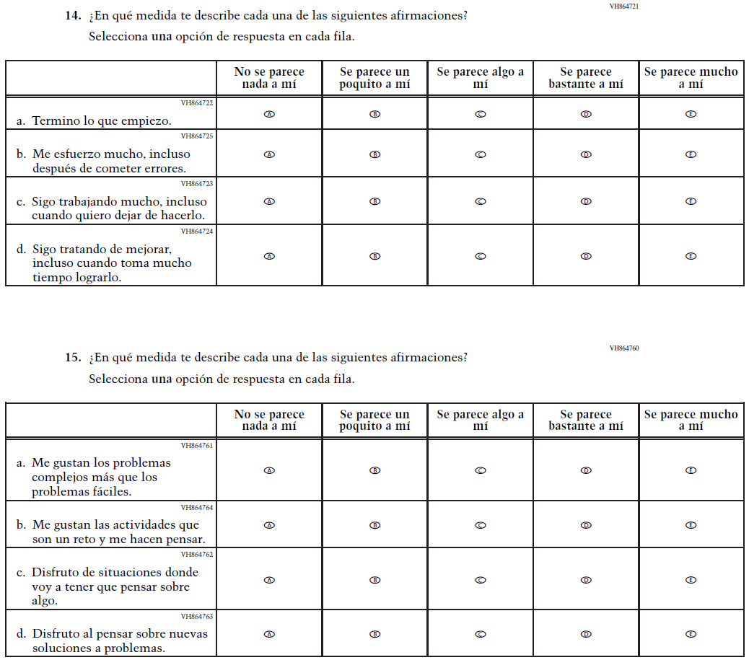

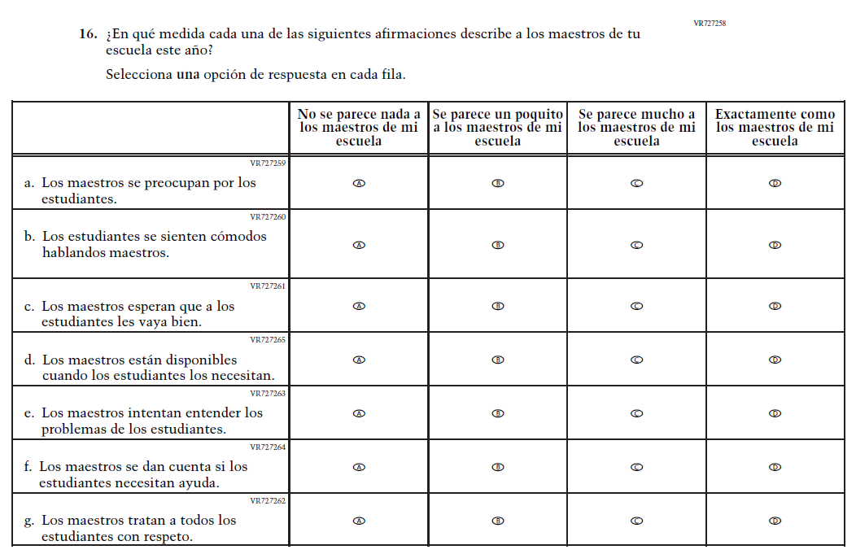

Appendix J-1d-s-PR: Summary of Changes Operational Grade 8 CORE
2026 Operational Grade 8 Core Student – Puerto Rico
Previous item | 2026 item | D/A/R+ | Rationale
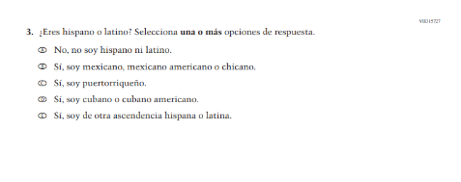  (2024 Operational Grade 8 Student Core – Puerto Rico) | N/A | D | This Item was dropped and replaced with an updated Item (VR862574) that adheres to OMB updated Statistical Policy Directive No. 15.
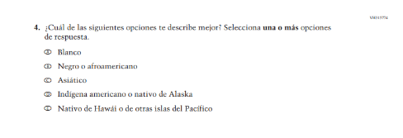  (2024 Operational Grade 8 Student Core – Puerto Rico) | 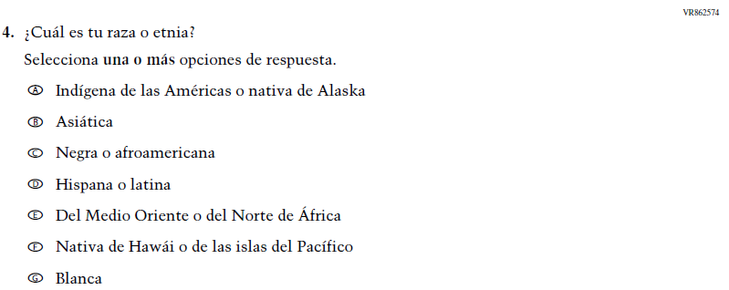  Issue: Student Background | R | VH315727  and this Item were replaced with this updated Item that adheres to OMB updated Statistical Policy Directive No. 15.
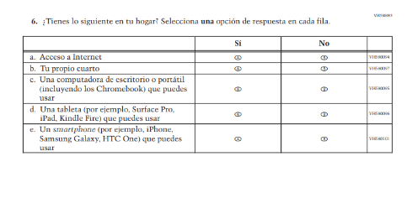  (2024 Operational Grade 8 Student Core – Puerto Rico) | 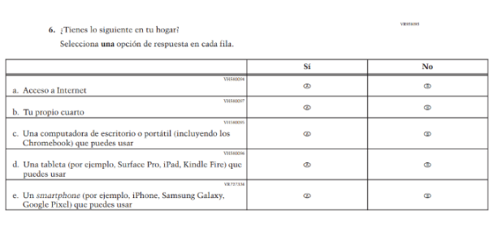  Issue: Socioeconomic Status | R | SubItem e. was revised to provide a more current example.
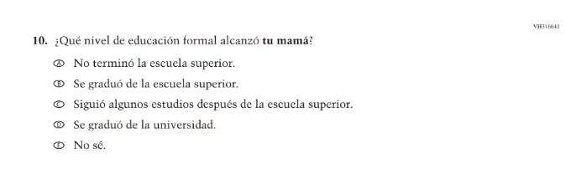(2024 Operational Grade 8 Student Core - Puerto Rico) | 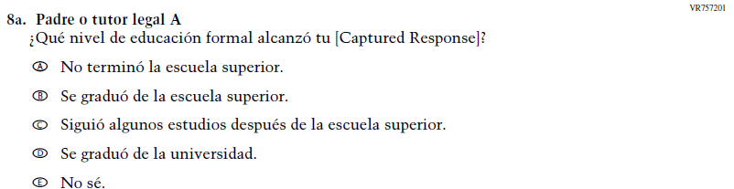  Issue: Socioeconomic Status | R | Dated Parent/  Guardian Education Item was replaced with an updated format.
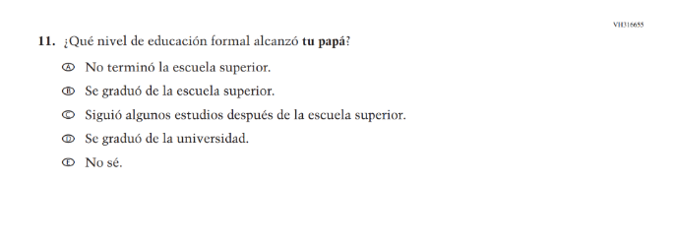(2024 Operational Grade 8 Student Core - Puerto Rico) | 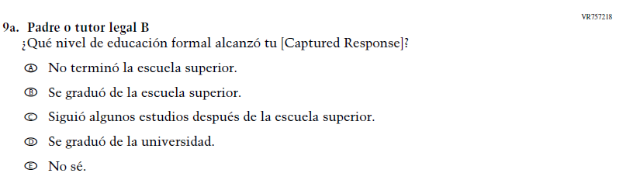  Issue: Socioeconomic Status | R | Dated Parent/  Guardian Education Item was replaced with an updated format.
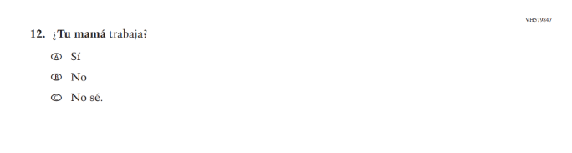  (2024 Operational Grade 8 Student Core - Puerto Rico) | 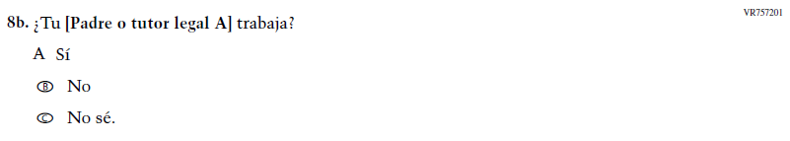  Issue: Socioeconomic Status | R | Dated Parent/  Guardian Education Item was replaced with an updated format.
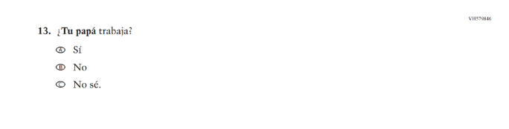(2024 Operational Grade 8 Student Core - Puerto Rico) | 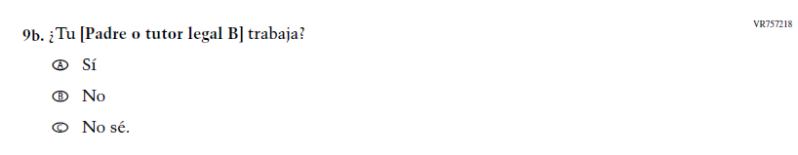  Issue: Socioeconomic Status | R | Dated Parent/  Guardian Education Item was replaced with an updated format.
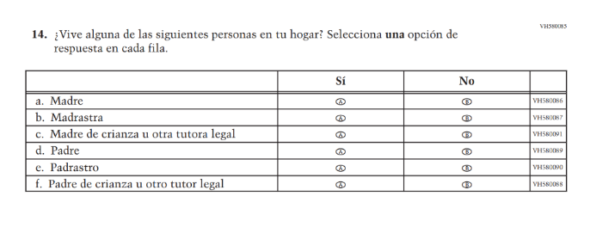(2024 Operational Grade 8 Student Core - Puerto Rico) | 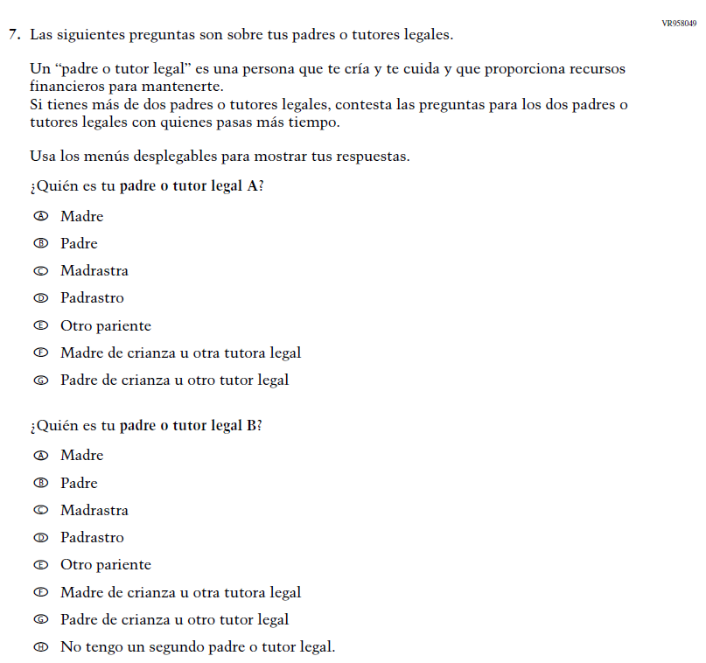  Issue: Socioeconomic Status | R | VH580749 was dropped and replaced with Item VR958050 as an updated format for collecting information on parent/ guardian education and employment.
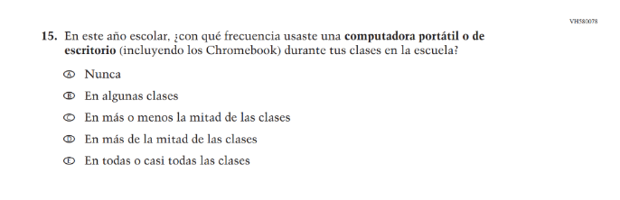(2024 Operational Grade 8 Student Core - Puerto Rico) | N/A | D | This Item was dropped to make space for new Student Items in the 2026 NAEP Assessment.
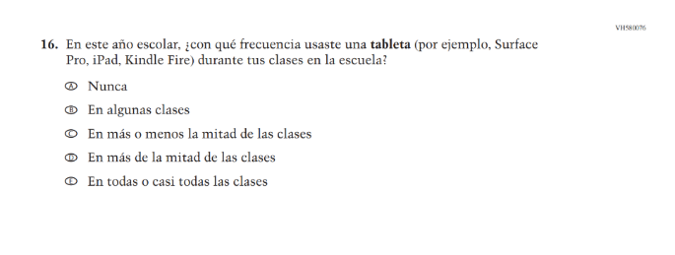(2024 Operational Grade 8 Student Core - Puerto Rico) | N/A | D | This Item was dropped to make space for new Student Items in the 2026 NAEP Assessment.
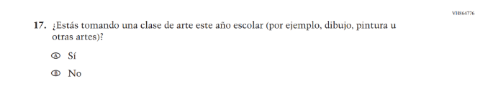(2024 Operational Grade 8 Student Core - Puerto Rico) | N/A | D | This Item was dropped to make space for new Student Items in the 2026 NAEP Assessment.
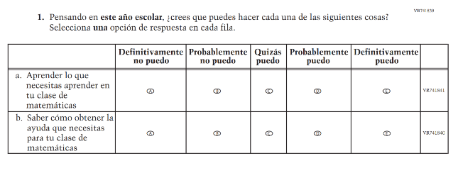(2024 Operational Grade 8 Student Core - Puerto Rico) | N/A | D | Learning Recovery Items were dropped from the 2026 NAEP Assessment.
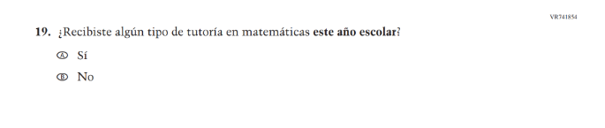(2024 Operational Grade 8 Student Core - Puerto Rico) | N/A | D | Learning Recovery Items were dropped from the 2026 NAEP Assessment.
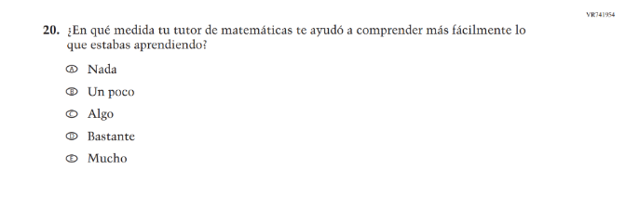(2024 Operational Grade 8 Student Core - Puerto Rico) | N/A | D | Learning Recovery Items were dropped from the 2026 NAEP Assessment.
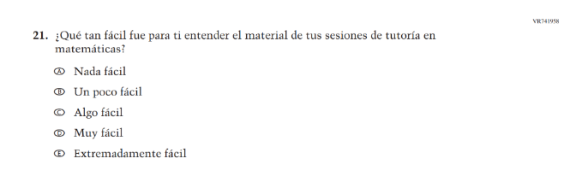(2024 Operational Grade 8 Student Core - Puerto Rico) | N/A | D | Learning Recovery Items were dropped from the 2026 NAEP Assessment.
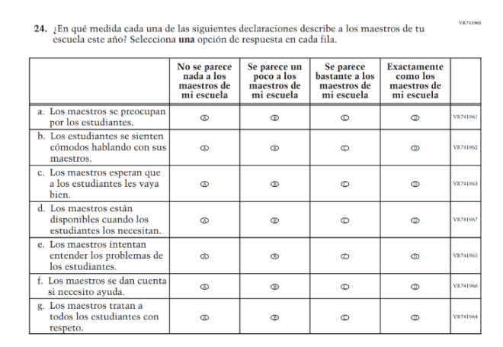(2024 Operational Grade 8 Student Core - Puerto Rico) | 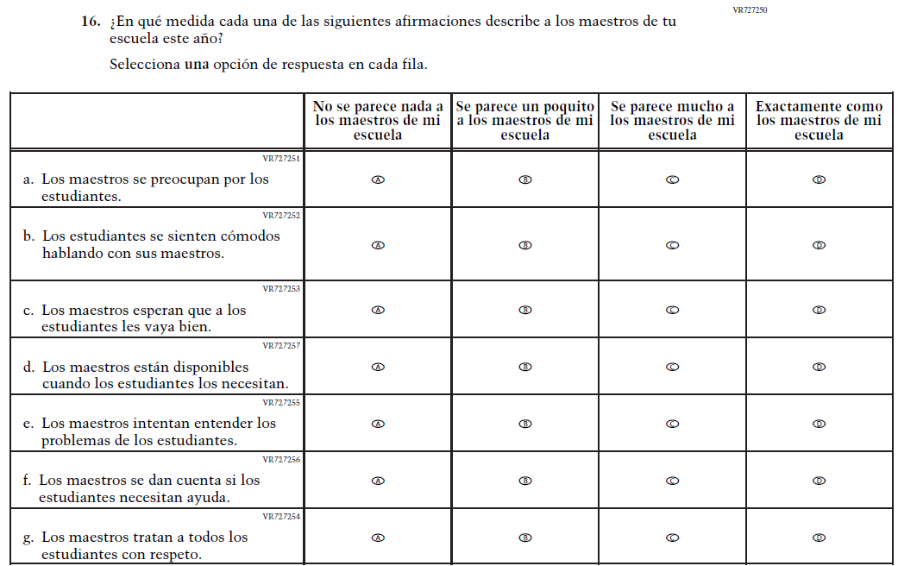  Issue: Learning Environment | R | Subitems a. and f. were revised for clarity and consistency.
2026 Operational Grade 8 Core Student – Puerto Rico
Previous item | 2026 item | D/A/R+ | Rationale
N/A  (2024 Operational Grade 8 Student Core – Puerto Rico) | 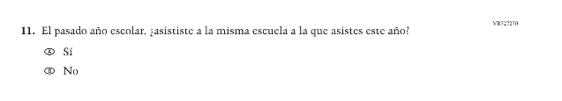  Issue: School Climate | A | This Item was added to gather information on student mobility.

Appendix J-1d-s-PR: Operational Grade 8 CORE
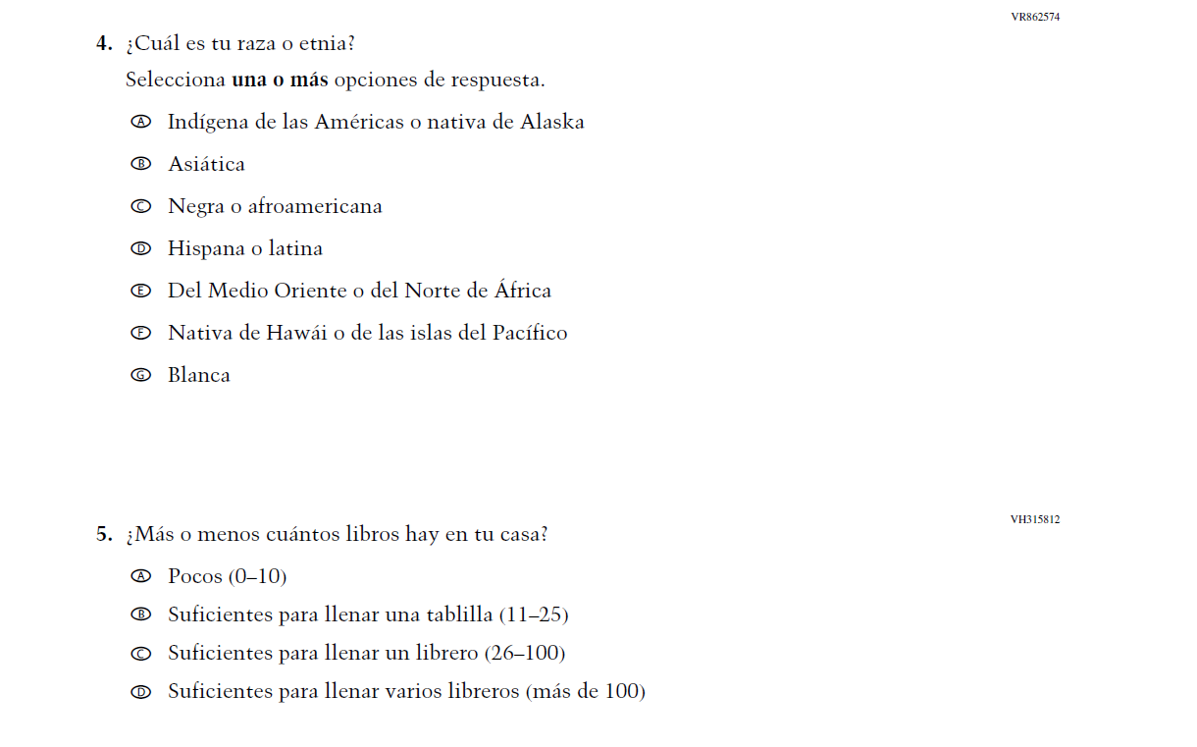
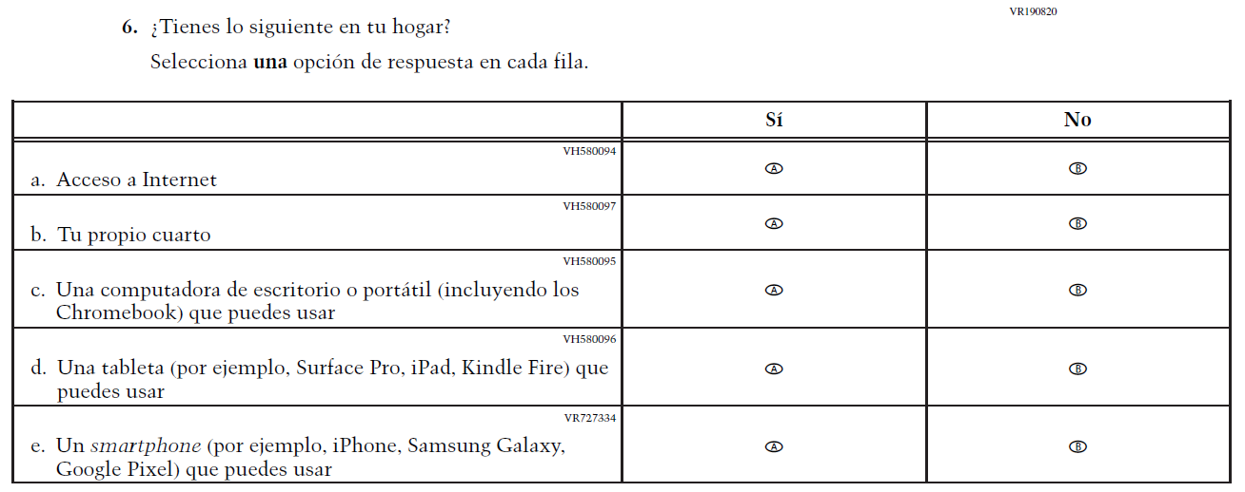
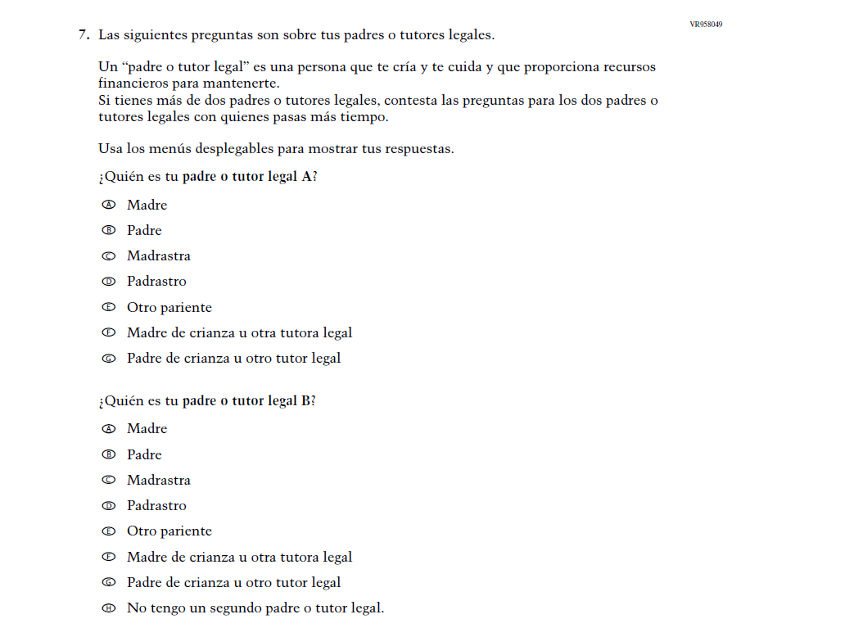
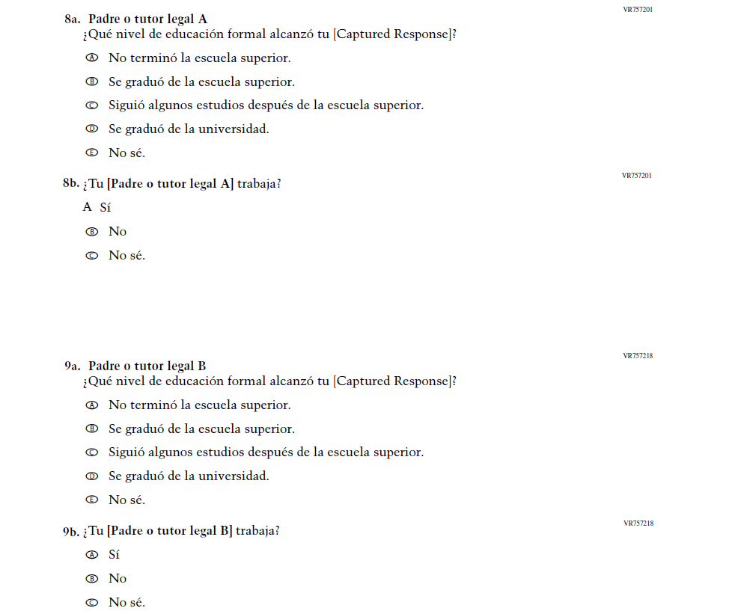

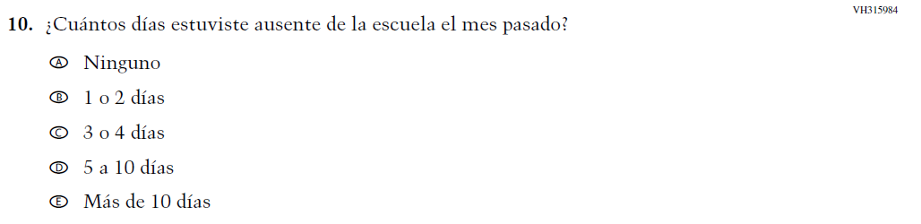
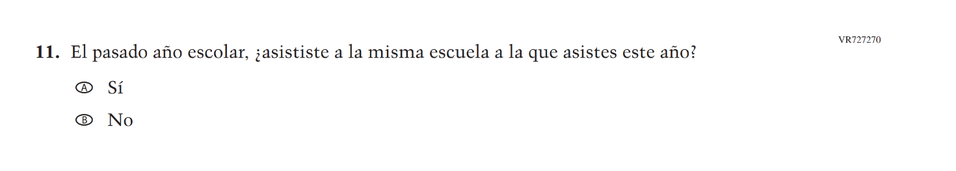
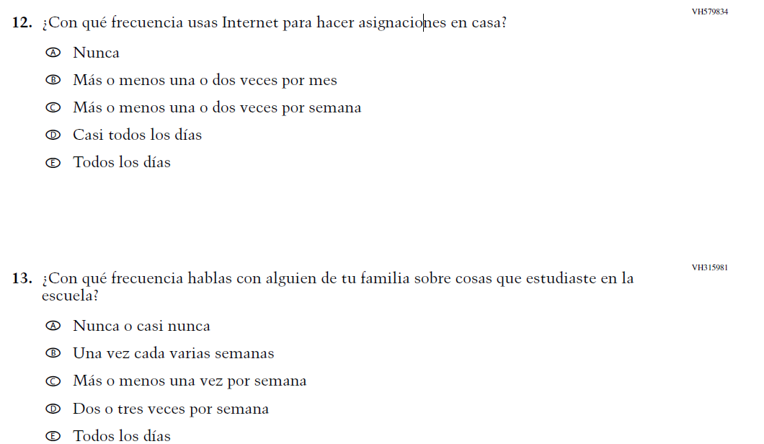
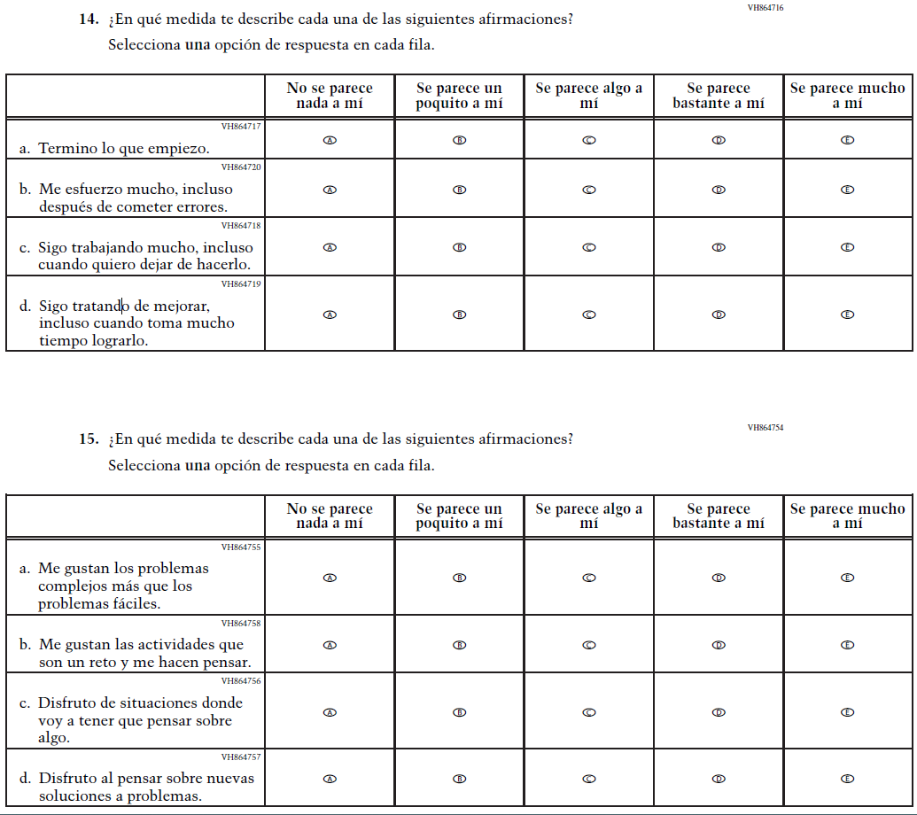
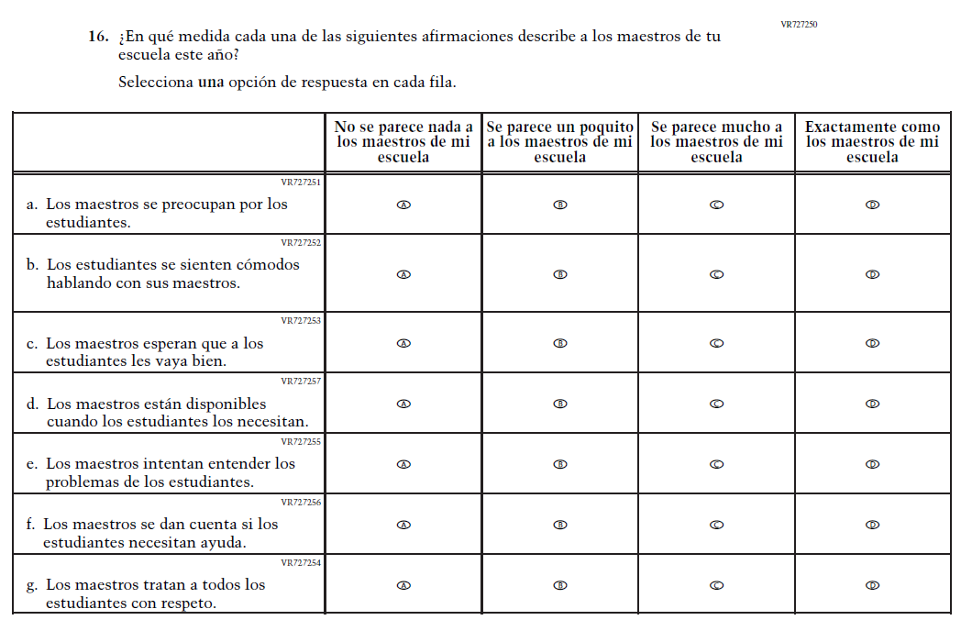

Appendix J-1e-s-BL: Summary of Changes Operational Grade 4 Mathematics
2026 Operational Grade 4 Math Student – Bilingual
Previous item | 2026 item | D/A/R+ | Rationale
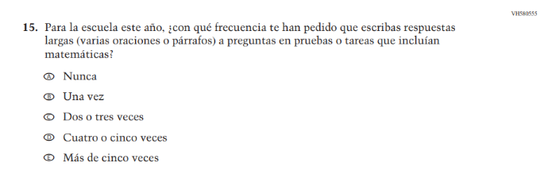  (2024 Operational Grade 4 Student Math - Bilingual) | N/A | D | This item was dropped in favor of a new item.
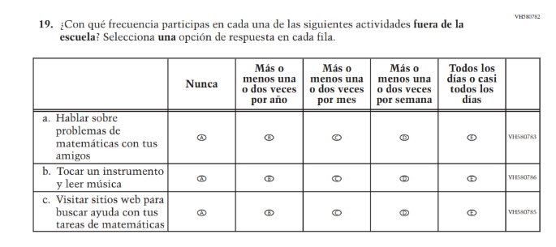  (2024 Operational Grade 4 Student Math - Bilingual) | N/A | D | This item was dropped to reduce questionnaire length.
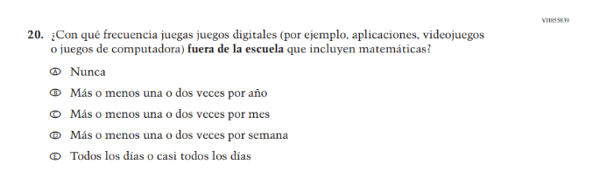  (2024 Operational Grade 4 Student Math - Bilingual) | N/A | D | This item was dropped to reduce questionnaire length.

2026 Operational Grade 4 Math Student – Bilingual
Previous item | 2026 item | D/A/R+ | Rationale
N/A  (2024 Operational Grade 4 Student Math - Bilingual) | 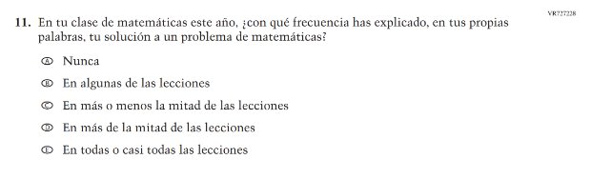  Issue: Mathematical Content and Practices | A | This item was developed to measure content aligned with the new Mathematics framework.
N/A  (2024 Operational Grade 4 Student Math - Bilingual) | 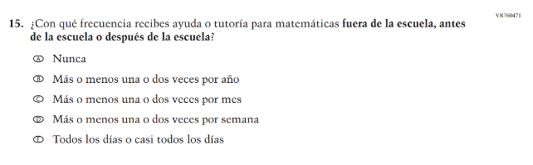  Issue: Mathematical Content and Practices | A | This new item captures the important aspect of help or tutoring received by students.
N/A  (2024 Operational Grade 4 Student Math - Bilingual) | 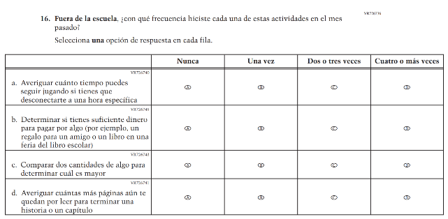  Issue: Mathematical Content and Practices | A | This item was developed to measure content aligned with the new Mathematics framework.

Appendix J-1e-s-BL: Operational Grade 4 Mathematics
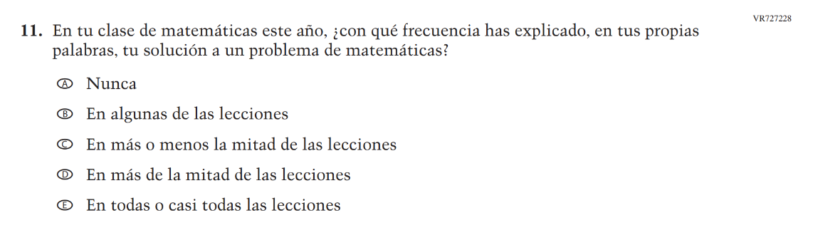
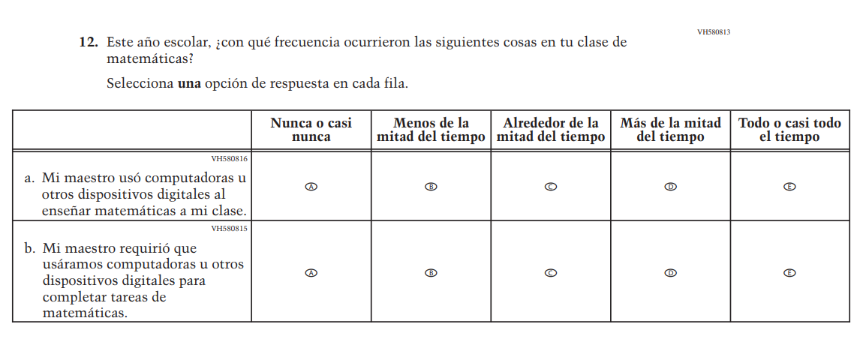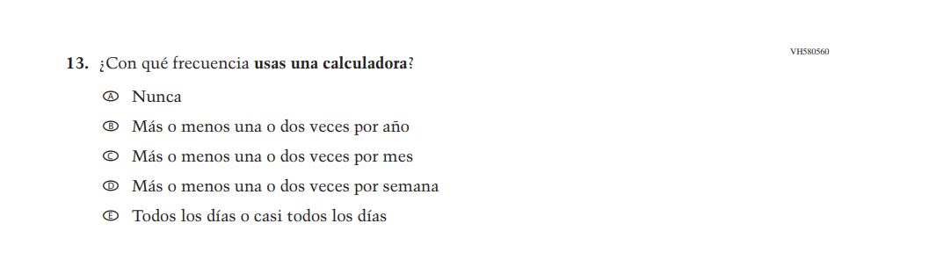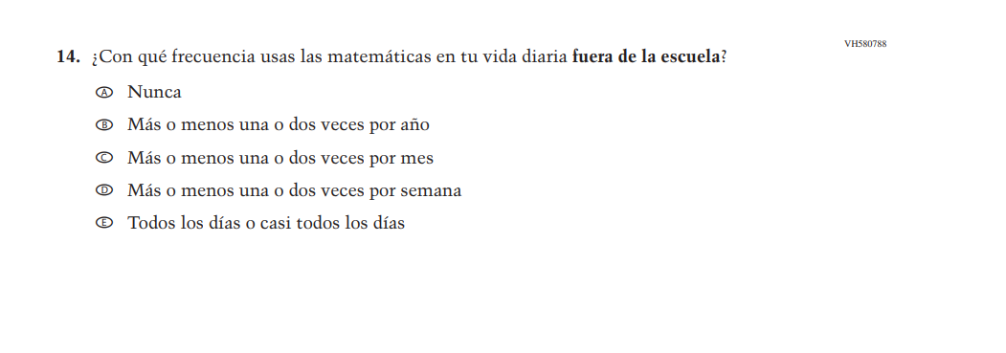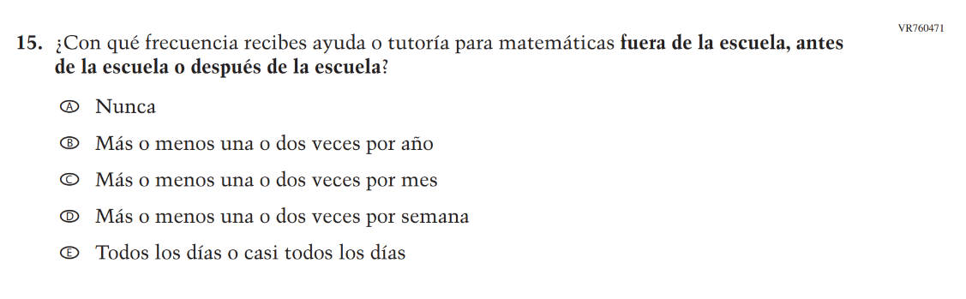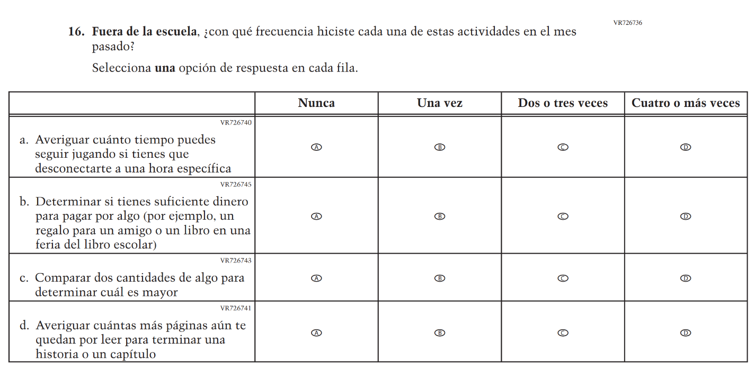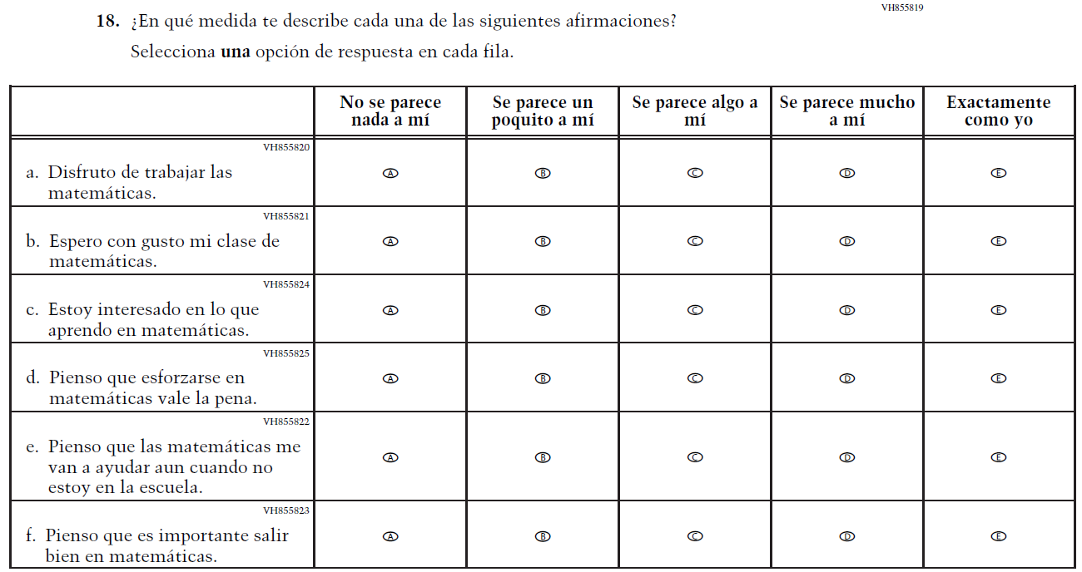

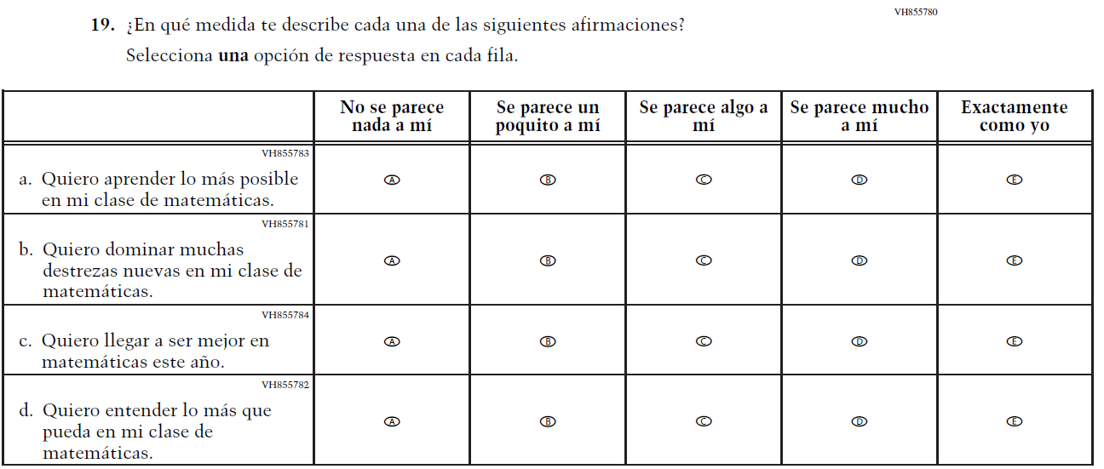

Appendix J-1f-s-PR: Summary of Changes Operational Grade 4 Mathematics
2026 Operational Grade 4 Math Student – Puerto Rico
Previous item | 2026 item | D/A/R+ | Rationale
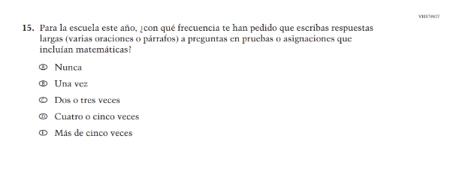  (2024 Operational Grade 4 Student Math – Puerto Rico) | N/A | D | This item was dropped in favor of a new item.
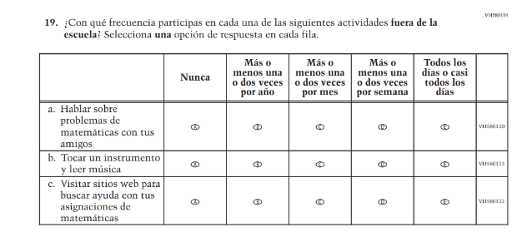  (2024 Operational Grade 4 Student Math – Puerto Rico) | N/A | D | This item was dropped to reduce questionnaire length.
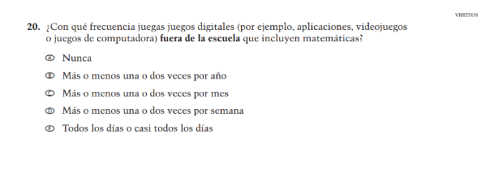  (2024 Operational Grade 4 Student Math – Puerto Rico) | N/A | D | This item was dropped to reduce questionnaire length.

2026 Operational Grade 4 Math Student – Puerto Rico
Previous item | 2026 item | D/A/R+ | Rationale
N/A  (2024 Operational Grade 4 Student Math – Puerto Rico) | 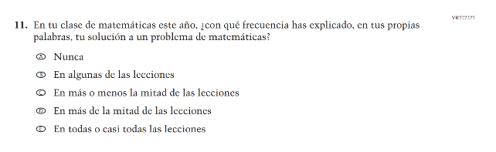  Issue: Mathematical Content and Practices | A | This item was developed to measure content aligned with the new Mathematics framework.
N/A  (2024 Operational Grade 4 Student Math - Puerto Rico) | 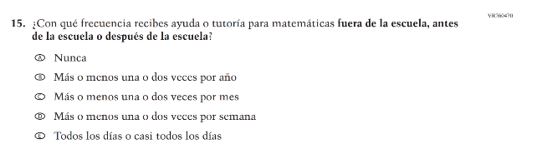  Issue: Mathematical Content and Practices | A | This new item captures the important aspect of help or tutoring received by students.
N/A  (2024 Operational Grade 4 Student Math - Puerto Rico) | 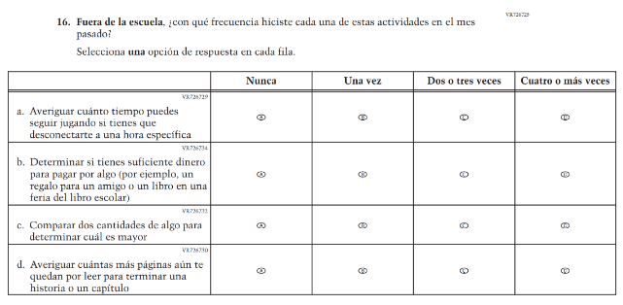  Issue: Mathematical Content and Practices | A | This item was developed to measure content aligned with the new Mathematics framework.

Appendix J-1f-s-PR: Operational Grade 4 Mathematics
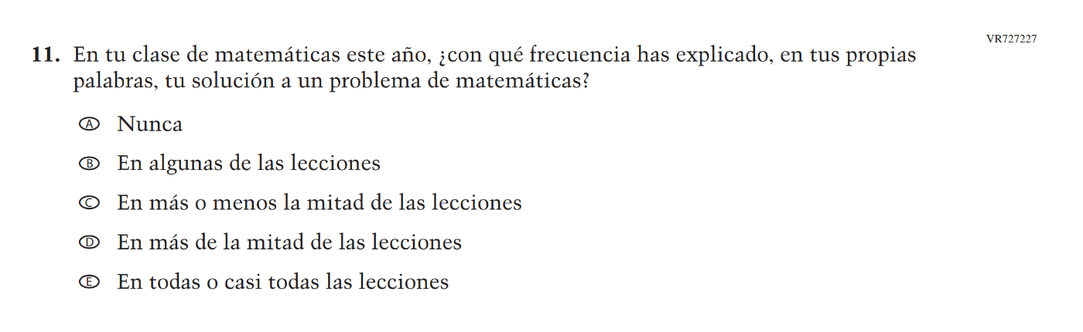
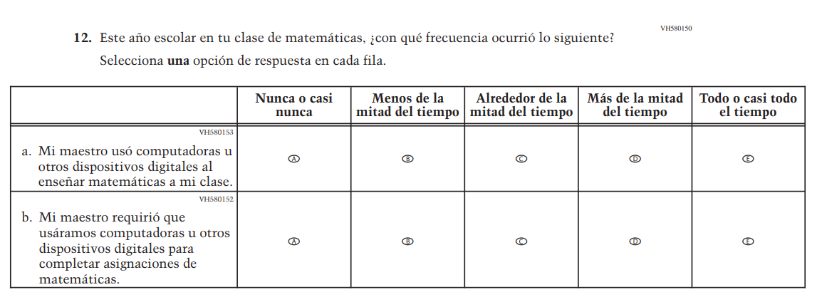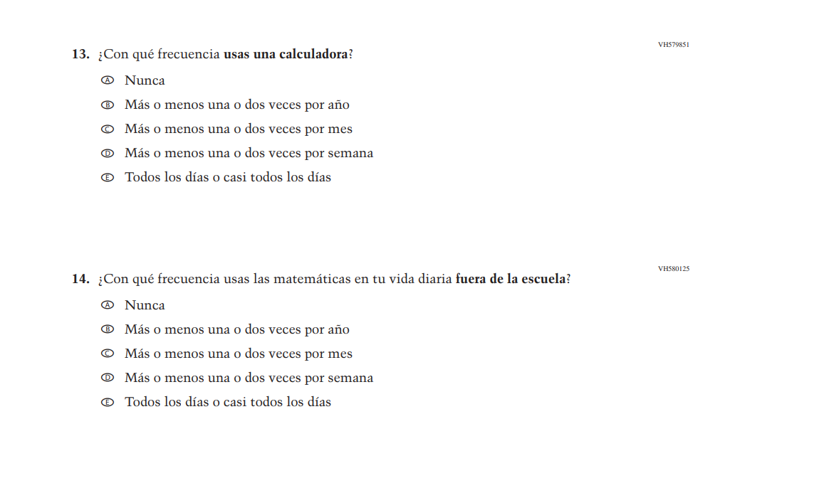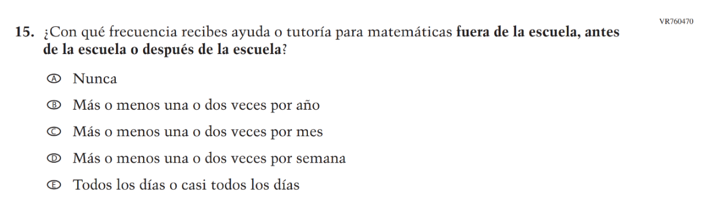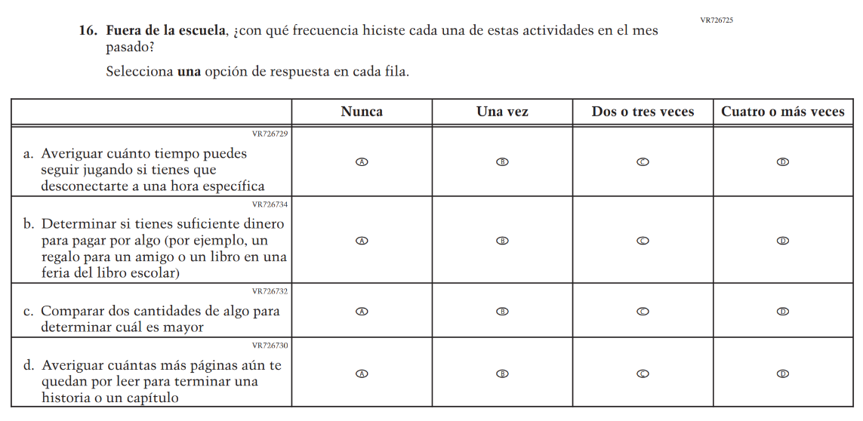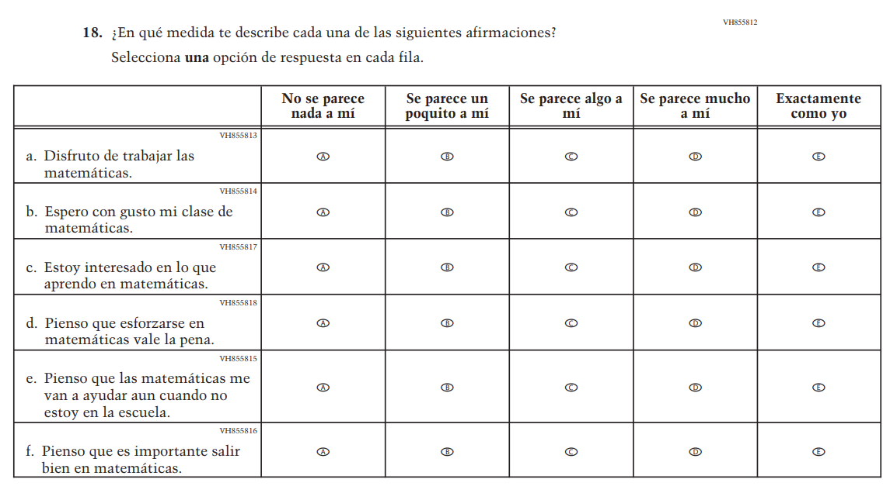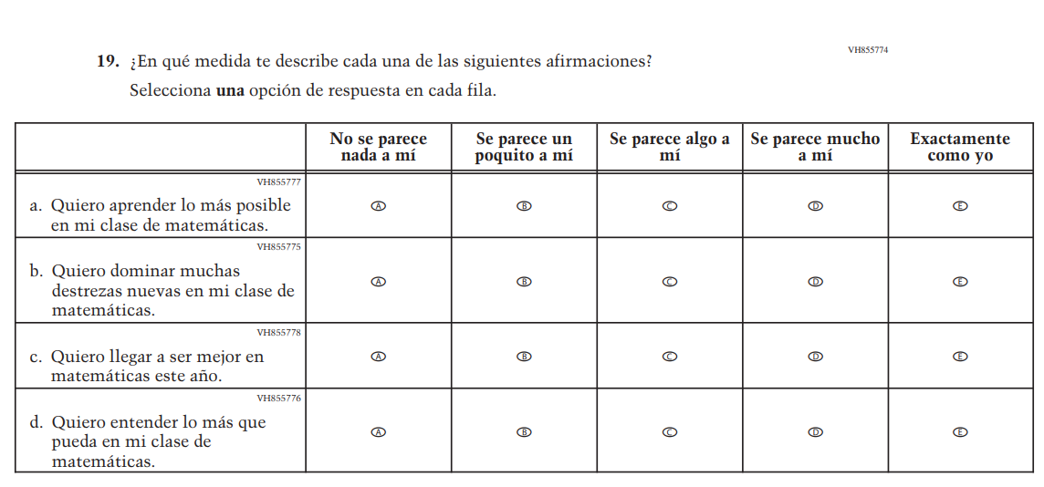

Appendix J-1g-s-BL: Summary of Changes Operational Grade 8 Mathematics
2026 Operational Grade 8 Math Student – Bilingual
Previous item | 2026 item | D/A/R+ | Rationale
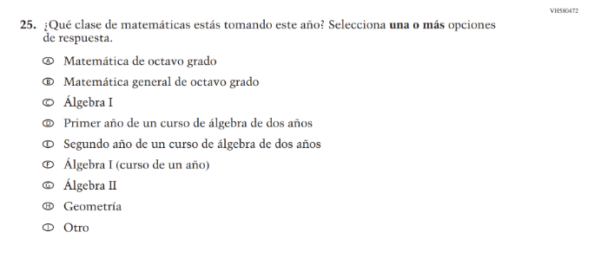  (2024 Operational Grade 8 Student Math - Bilingual) | N/A | D | This item was dropped in favor of a new/revised item.
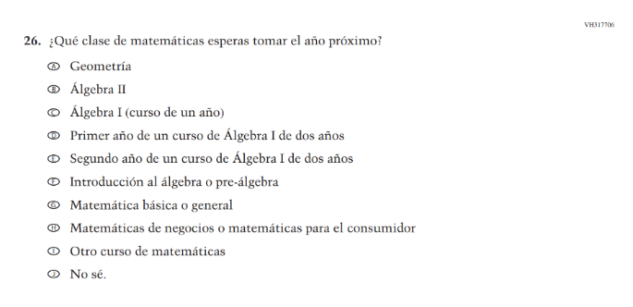  (2024 Operational Grade 8 Student Math - Bilingual) | N/A | D | This item was dropped in favor of a new/revised item.
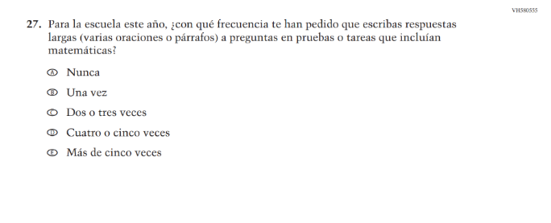  (2024 Operational Grade 8 Student Math - Bilingual) | N/A | D | This item was dropped in favor of a new/revised item.
N/A  (2024 Operational Grade 8 Student Math - Bilingual) | 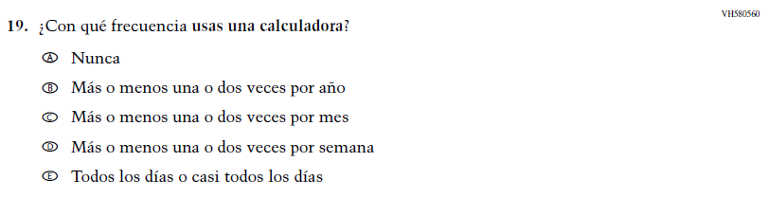  Issue: Instructional Organization and Strategies | A | This item was added for consistency with the questionnaire at grade 4.
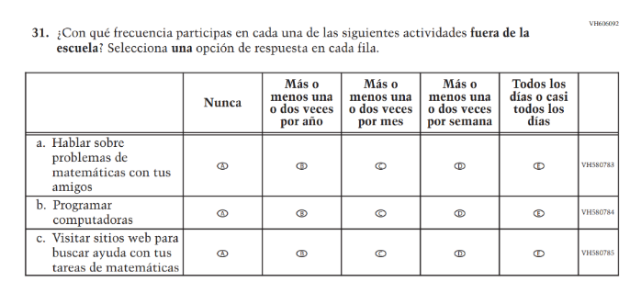  (2024 Operational Grade 8 Student Math - Bilingual) | N/A | D | This item was dropped to reduce questionnaire length.
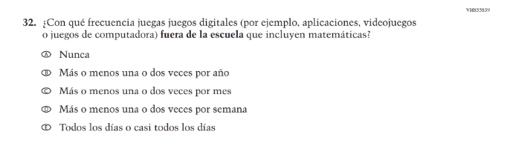(2024 Operational Grade 8 Student Math - Bilingual) | N/A | D | This item was dropped to reduce questionnaire length.
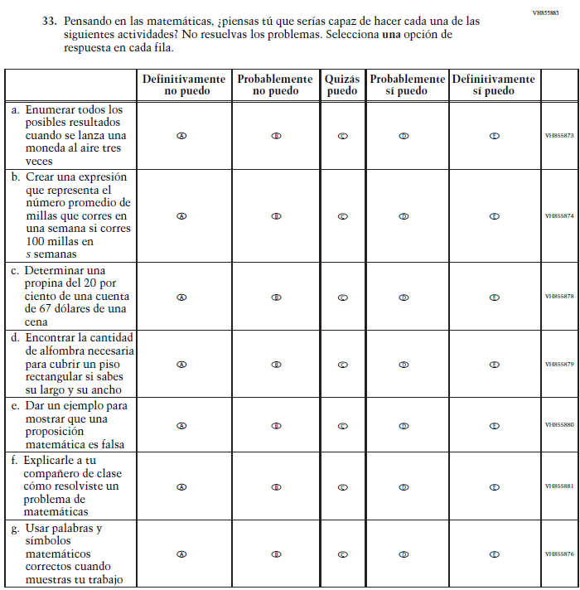  (2024 Operational Grade 8 Student Math - Bilingual) | N/A | D | This item was dropped in favor of a new/revised item.

2026 Operational Grade 8 Math Student – Bilingual
Previous item | 2026 item | D/A/R+ | Rationale
N/A  (2024 Operational Grade 8 Student Math - Bilingual) | 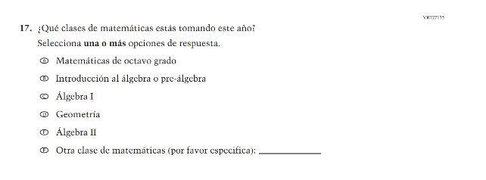  Issue: Mathematical Content and Practices | A | The new item includes streamlined response options.
N/A  (2024 Operational Grade 8 Student Math - Bilingual) | 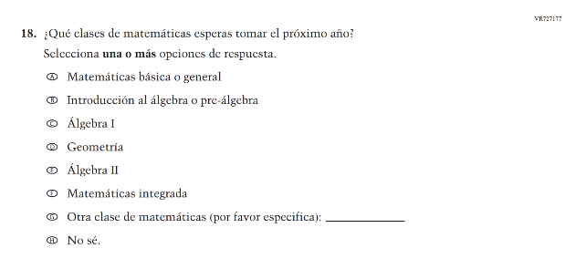  Issue: Mathematical Content and Practices | A | The new item includes streamlined response options.
N/A  (2024 Operational Grade 8 Student Math - Bilingual) | 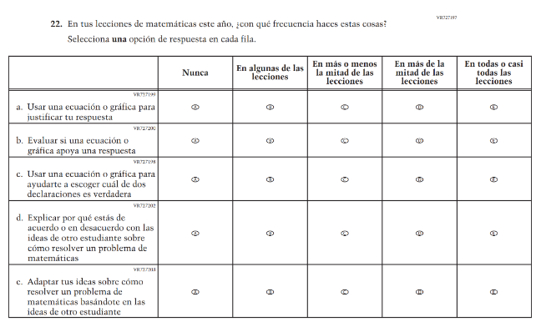  Issue: Mathematical Content and Practices | A | This item was developed to measure content aligned with the new Mathematics framework.
N/A  (2024 Operational Grade 8 Student Math - Bilingual) | 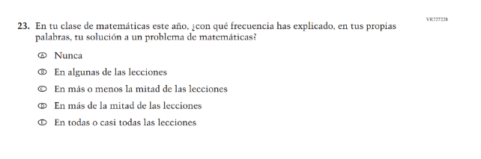  Issue: Student Mathematical Identity | A | This item was developed to measure content aligned with the new Mathematics framework.
N/A  (2024 Operational Grade 8 Student Math - Bilingual) | 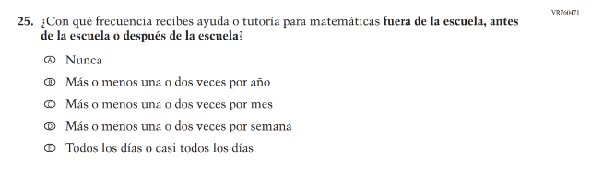  Issue: N/A | A | This new item captures the important aspect of help or tutoring received by students.
N/A  (2024 Operational Grade 8 Student Math - Bilingual) | 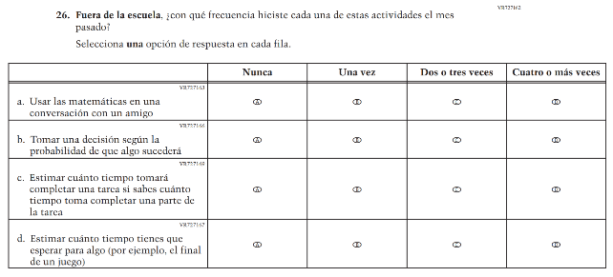  Issue: Mathematical Content and Practices | A | This item was developed to measure content aligned with the new Mathematics framework.
N/A  (2024 Operational Grade 8 Student Math - Bilingual) | 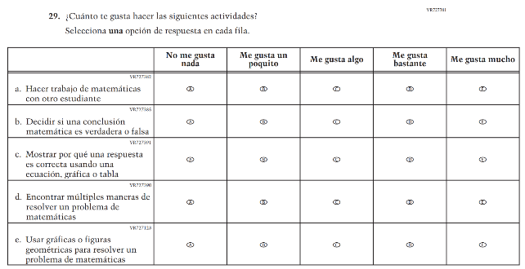  Issue: Mathematical Content and Practices | A | This item was developed to measure content aligned with the new Mathematics framework.
N/A  (2024 Operational Grade 8 Student Math - Bilingual) | 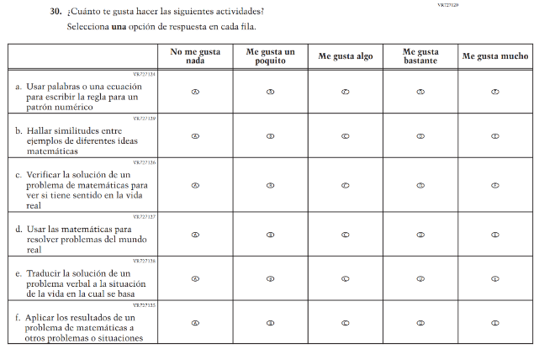  Issue: Mathematical Content and Practices | A | This item was developed to measure content aligned with the new Mathematics framework.
N/A  (2024 Operational Grade 8 Student Math - Bilingual) | 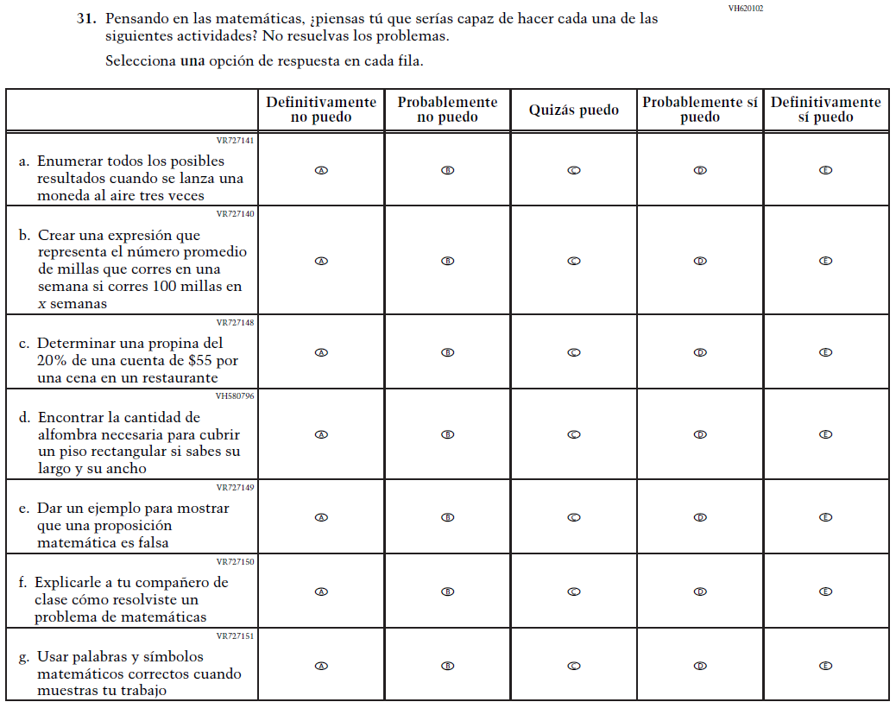  Issue: Student Mathematical Identity | A | The new item includes streamlined subitems b and c for greater clarity.

Appendix J-1g-s-BL: Operational Grade 8 Mathematics
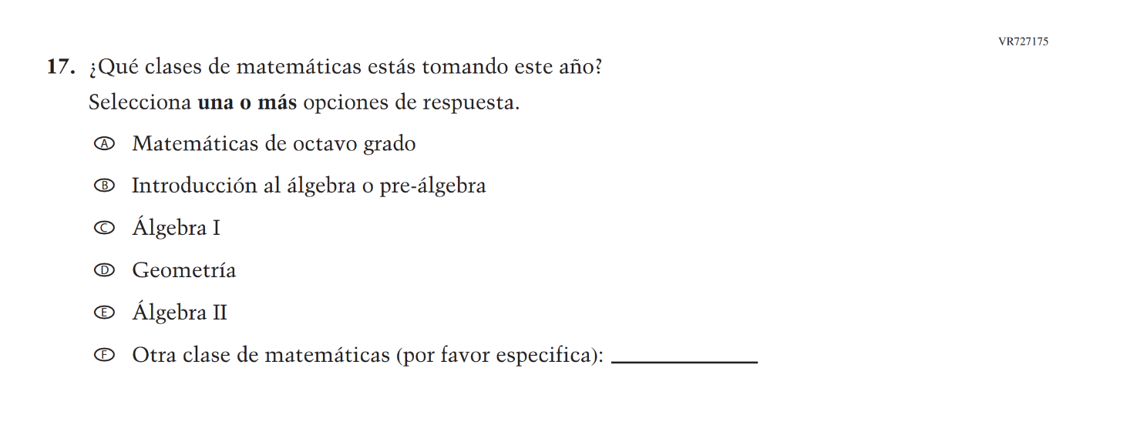
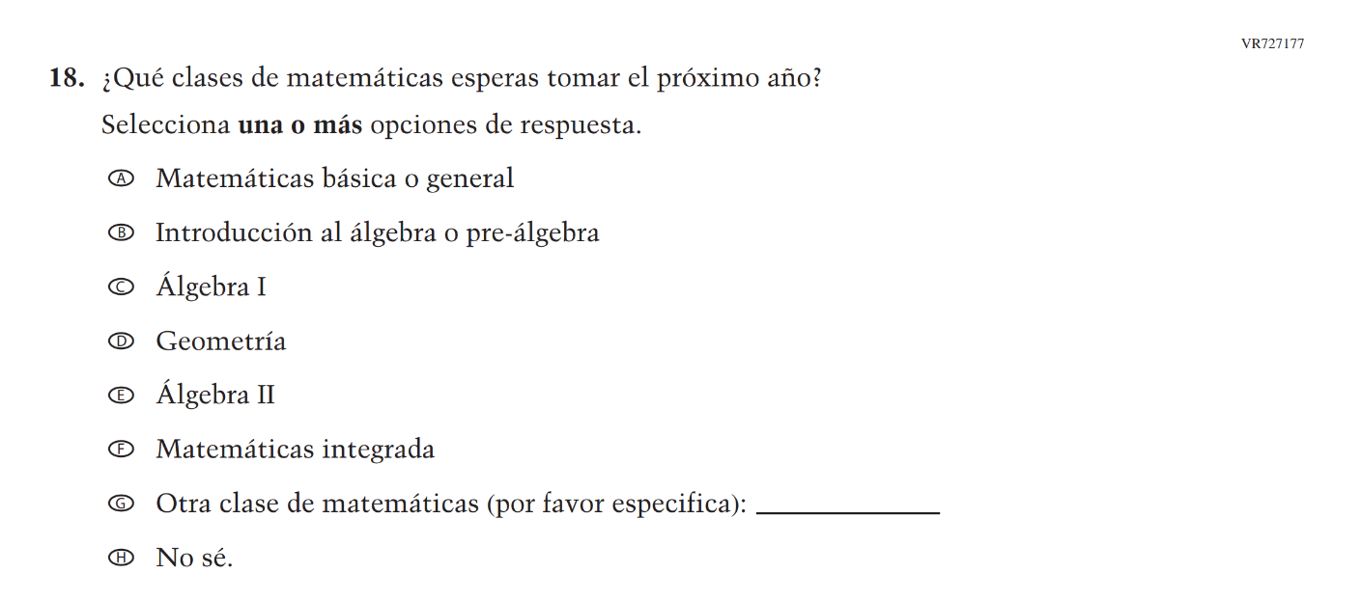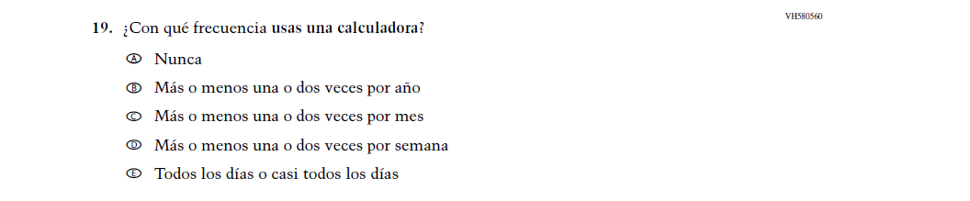

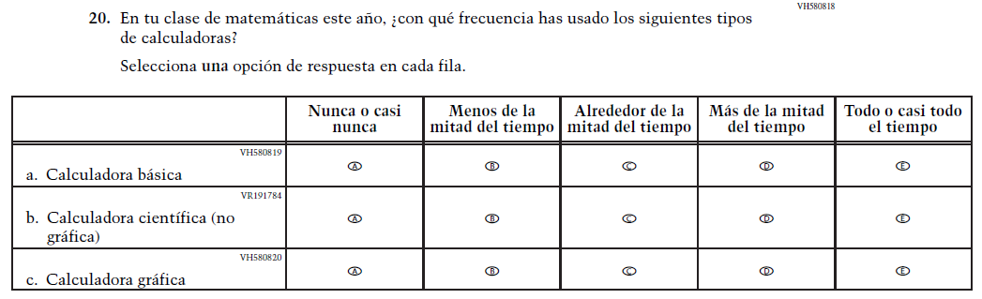

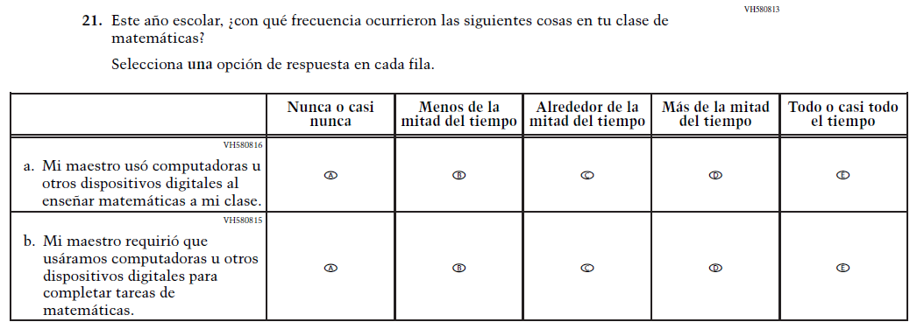
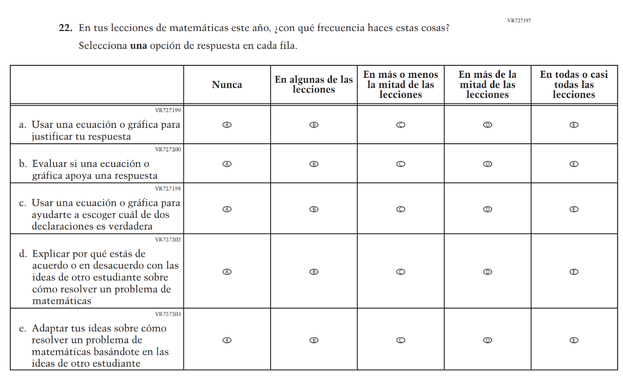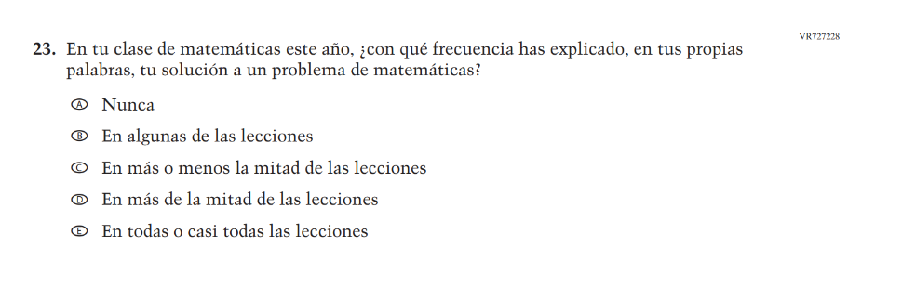
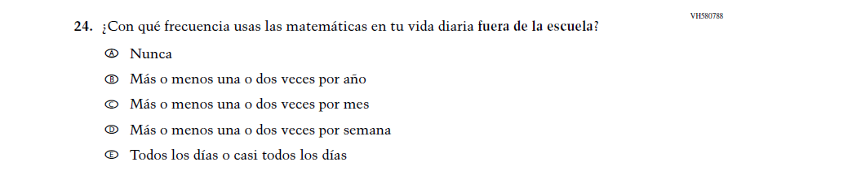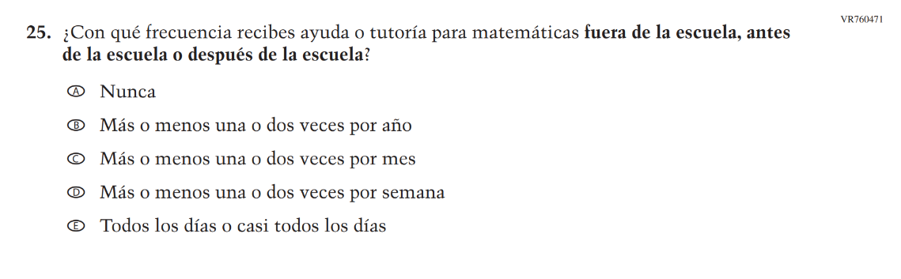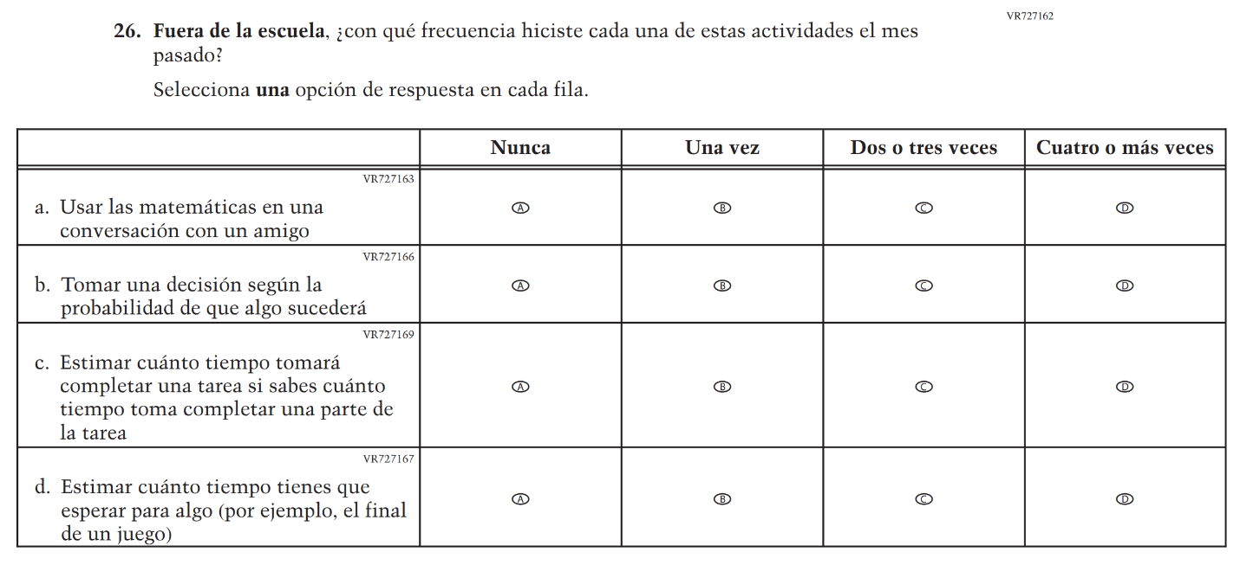
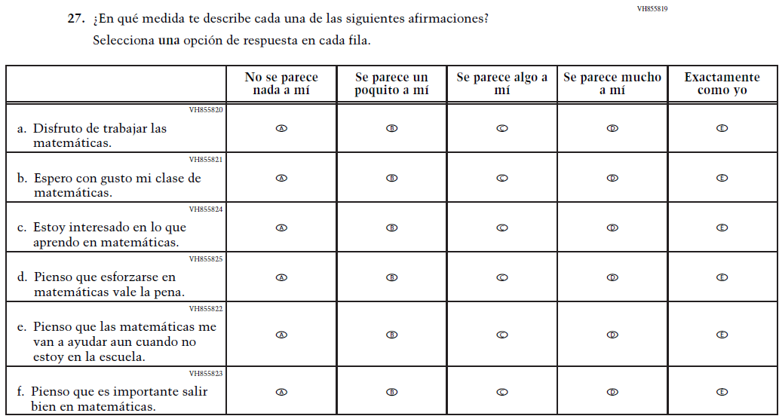
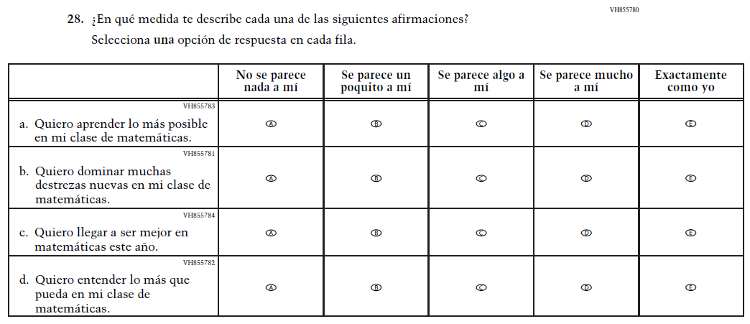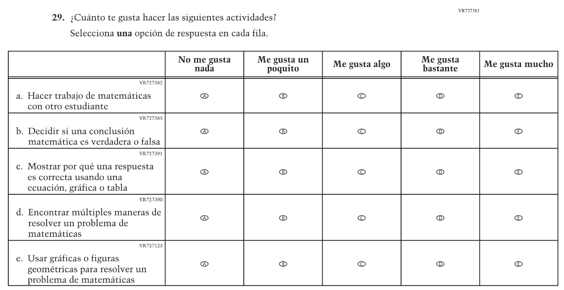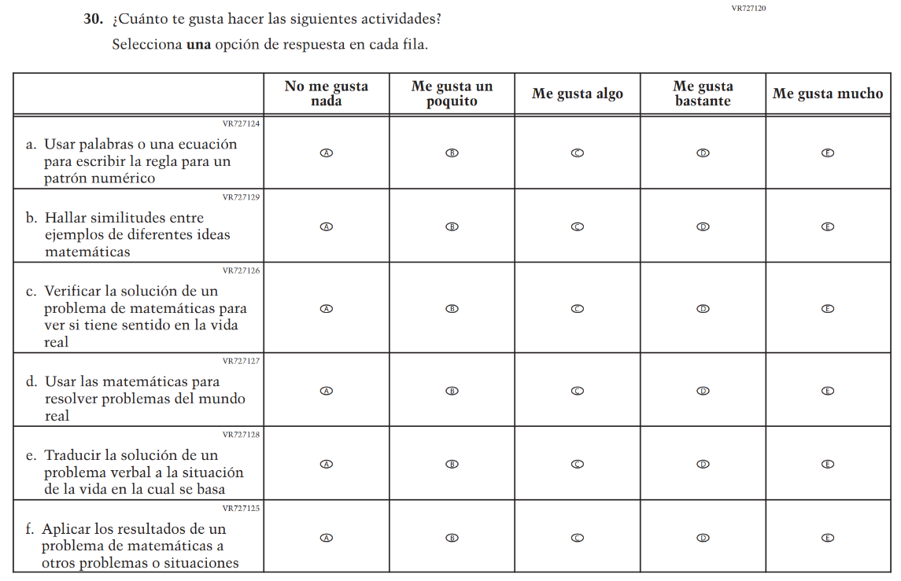

Appendix J-1h-s-PR: Summary of Changes Operational Grade 8 Mathematics
2026 Operational Grade 8 Math Student – Puerto Rico
Previous item | 2026 item | D/A/R+ | Rationale
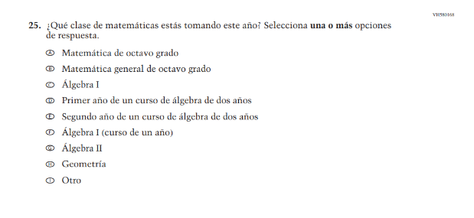  (2024 Operational Grade 8 Student Math – Puerto Rico) | N/A | D | This item was dropped in favor of a new item.
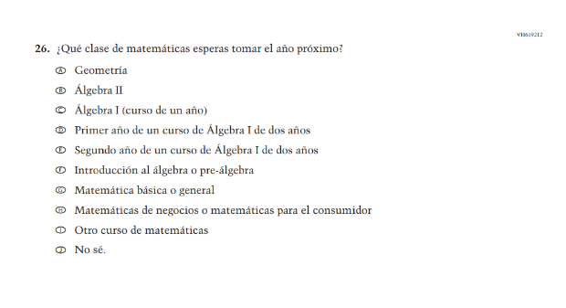  (2024 Operational Grade 8 Student Math – Puerto Rico) | N/A | D | This item was dropped in favor of a new item.
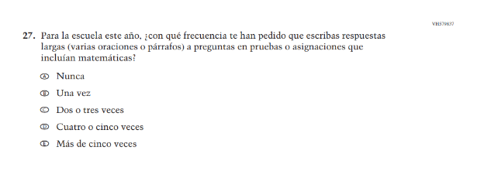  (2024 Operational Grade 8 Student Math - Puerto Rico) | N/A | D | This item was dropped in favor of a new item.
N/A  (2024 Operational Grade 8 Student Math – Puerto Rico) | 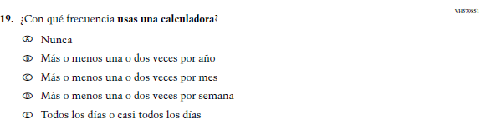  Issue: Instructional Organization and Strategies | A | This item was added for consistency with the questionnaire at grade 4.
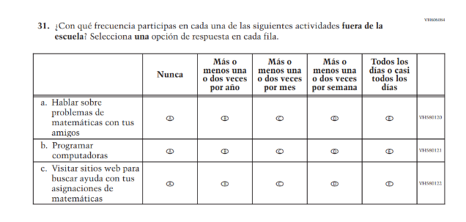  (2024 Operational Grade 8 Student Math – Puerto Rico) | N/A | D | This item was dropped to reduce questionnaire length.
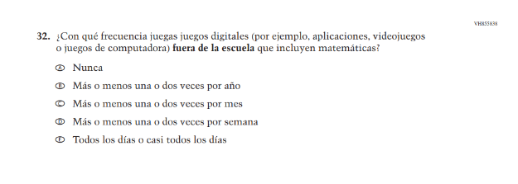  (2024 Operational Grade 8 Student Math – Puerto Rico) | N/A | D | This item was dropped to reduce questionnaire length.
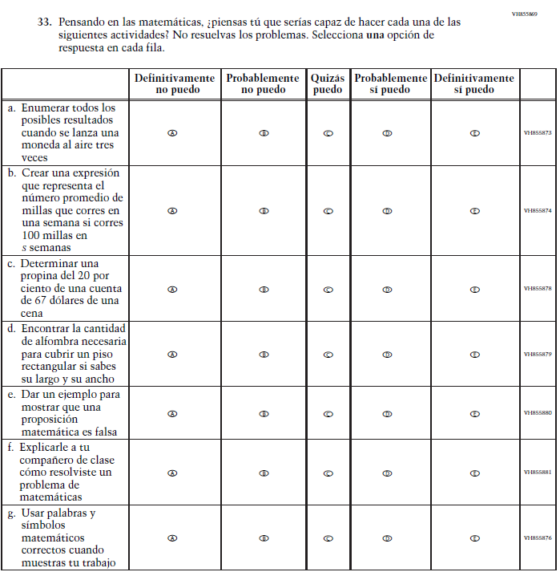  (2024 Operational Grade 8 Student Math – Puerto Rico) | N/A | D | This item was dropped to reduce questionnaire length.

2026 Operational Grade 8 Math Student – Puerto Rico
Previous item | 2026 item | D/A/R+ | Rationale
N/A  (2024 Operational Grade 8 Student Math – Puerto Rico) | 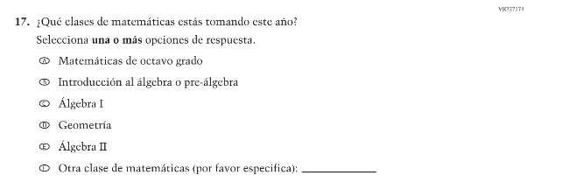  Issue: Mathematical Content and Practices | A | The new item includes streamlined response options.
N/A  (2024 Operational Grade 8 Student Math - Puerto Rico) | 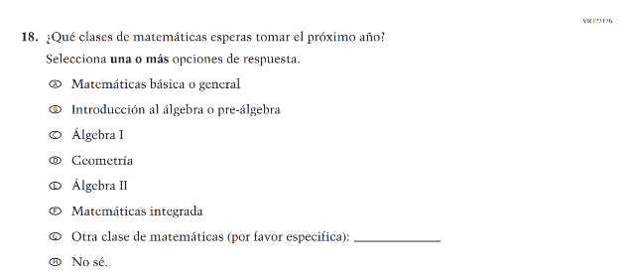  Issue: Mathematical Content and Practices | A | The new item includes streamlined response options.
N/A  (2024 Operational Grade 8 Student Math - Puerto Rico) | 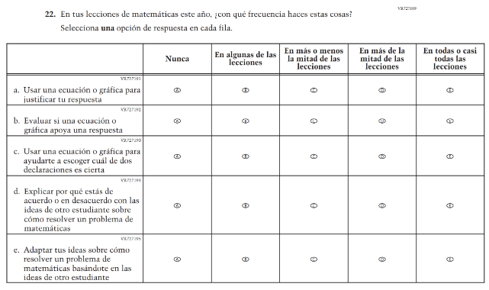  Issue: Mathematical Content and Practices | A | This item was developed to measure content aligned with the new Mathematics framework.
N/A  (2024 Operational Grade 8 Student Math - Puerto Rico) | 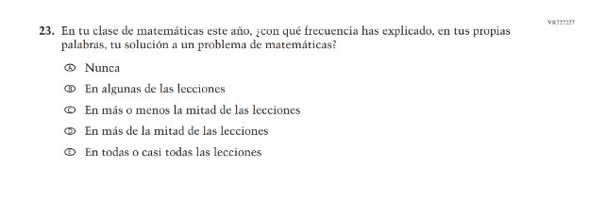  Issue: Student Mathematical Identity | A | This item was developed to measure content aligned with the new Mathematics framework.
N/A  (2024 Operational Grade 8 Student Math - Puerto Rico) | 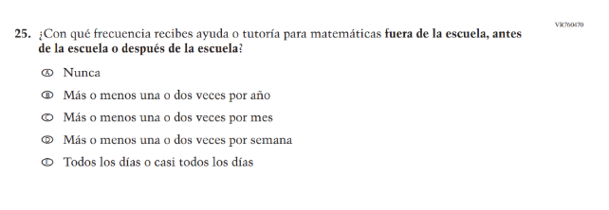  Issue: N/A | A | This new item captures the important aspect of help or tutoring received by students.
N/A  (2024 Operational Grade 8 Student Math - Puerto Rico) | 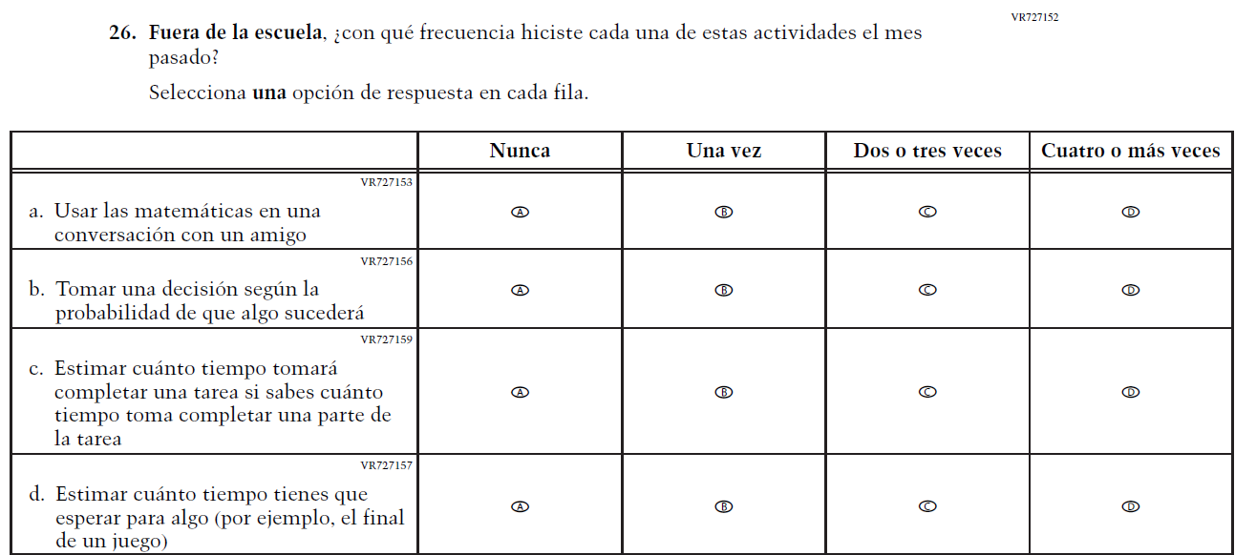  Issue: Mathematical Content and Practices | A | This item was developed to measure content aligned with the new Mathematics framework.
N/A  (2024 Operational Grade 8 Student Math - Puerto Rico) | 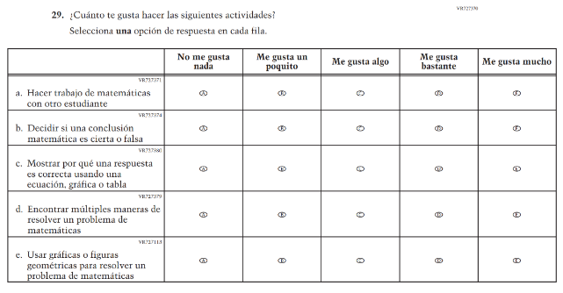  Issue: Mathematical Content and Practices | A | This item was developed to measure content aligned with the new Mathematics framework.
N/A  (2024 Operational Grade 8 Student Math - Puerto Rico) | 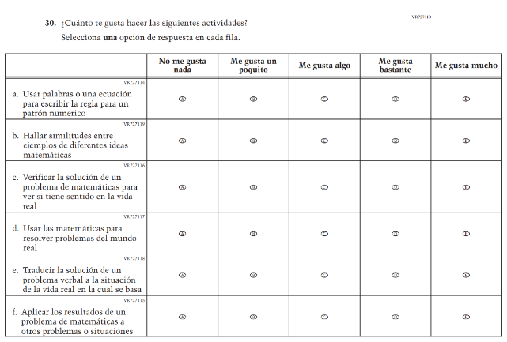  Issue: Mathematical Content and Practices | A | This item was developed to measure content aligned with the new Mathematics framework.
N/A  (2024 Operational Grade 8 Student Math - Puerto Rico) | 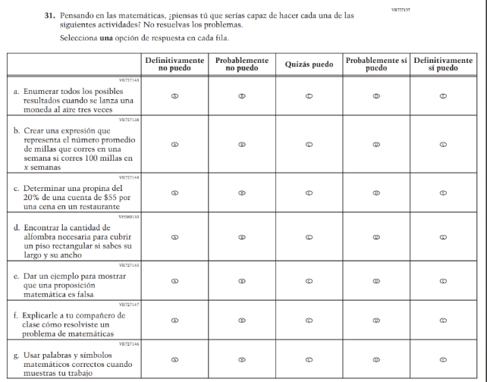  Issue: Student Mathematical Identity | A | The new item includes streamlined subitems b and c for greater clarity.

Appendix J-1h-s-PR: Operational Grade 8 Mathematics
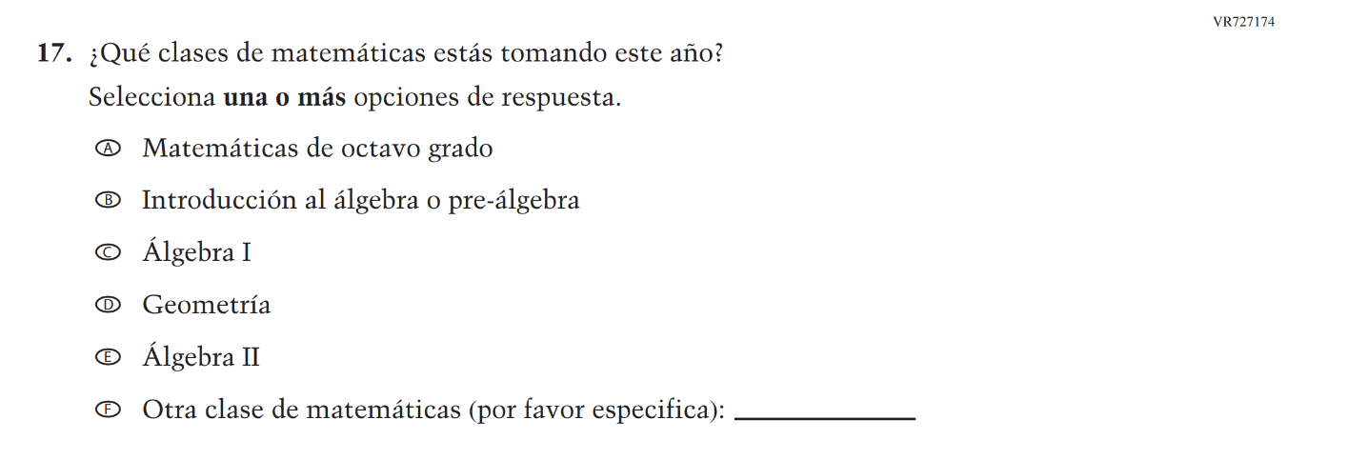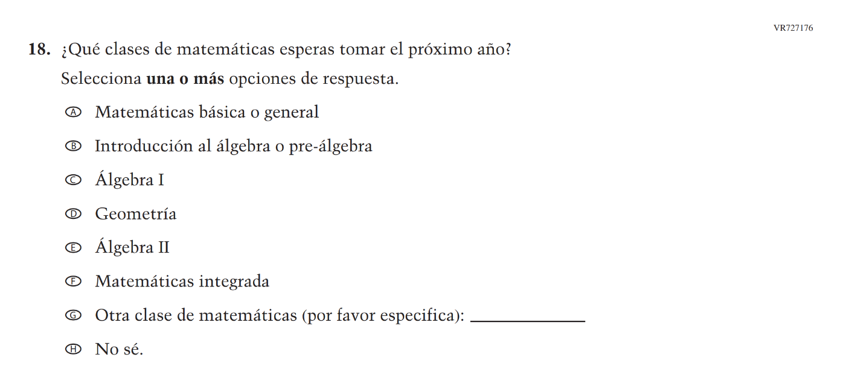
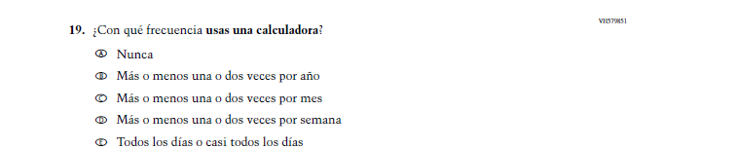

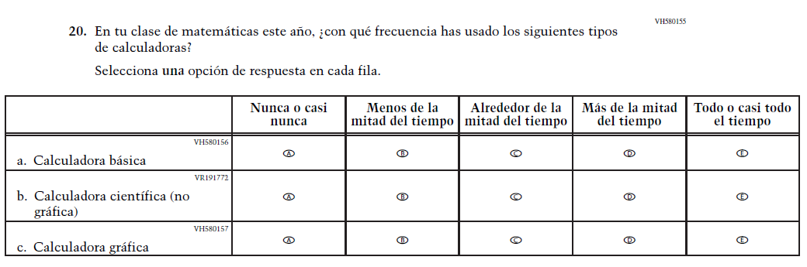

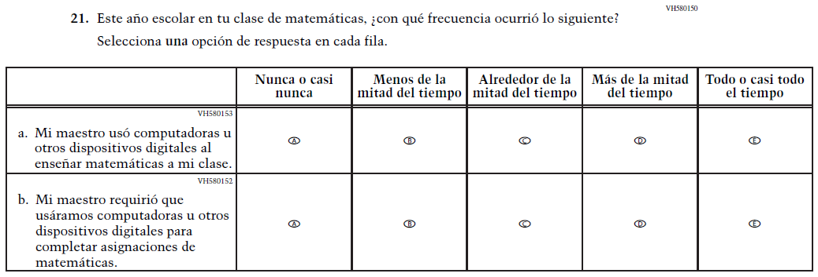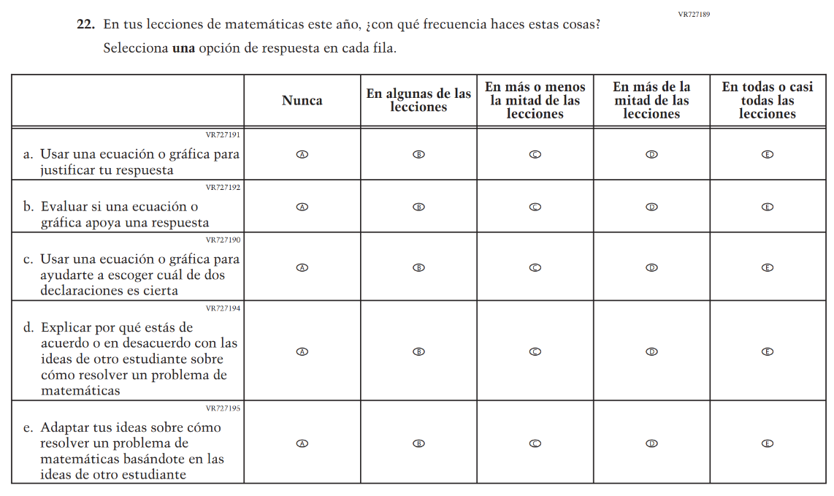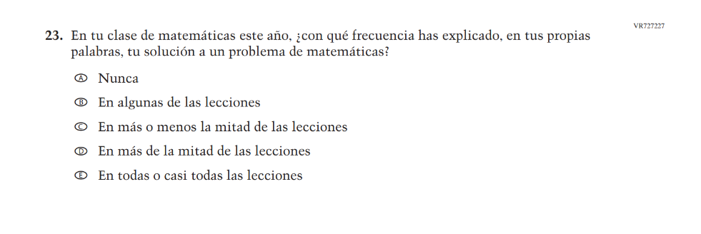

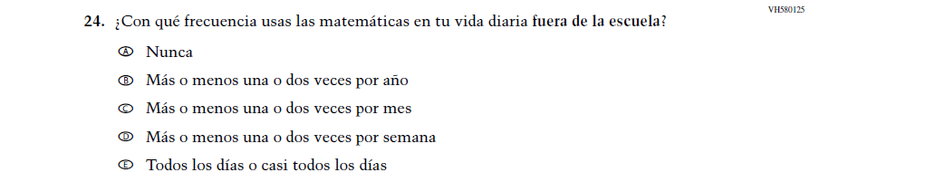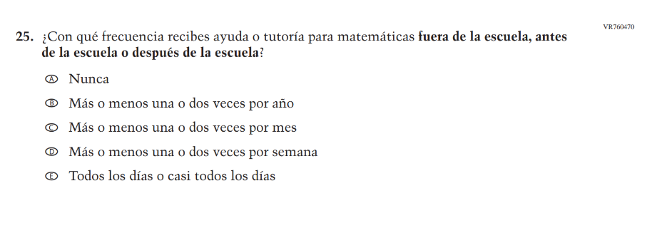
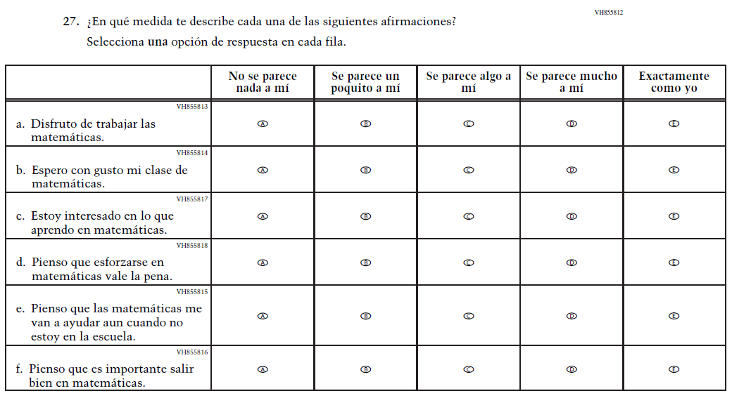

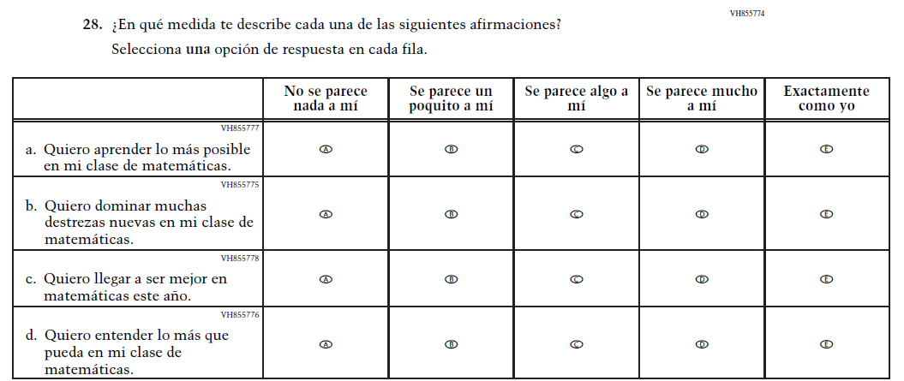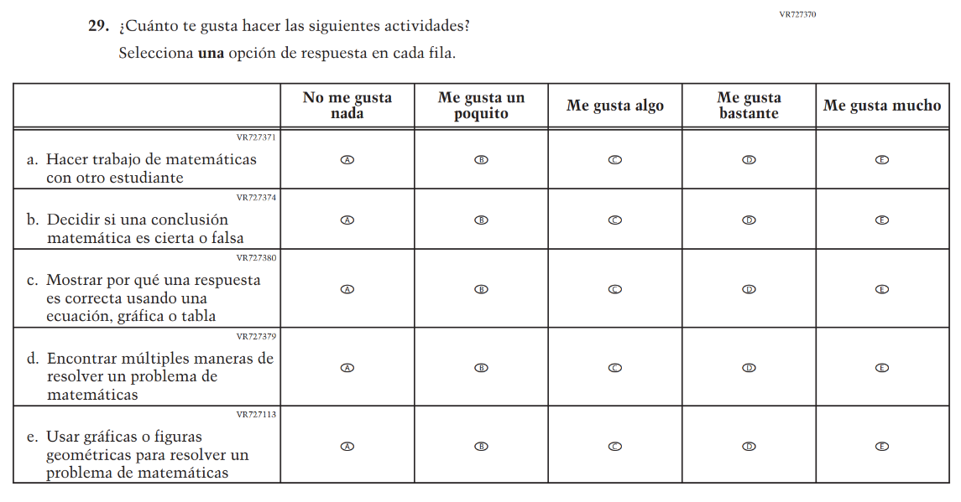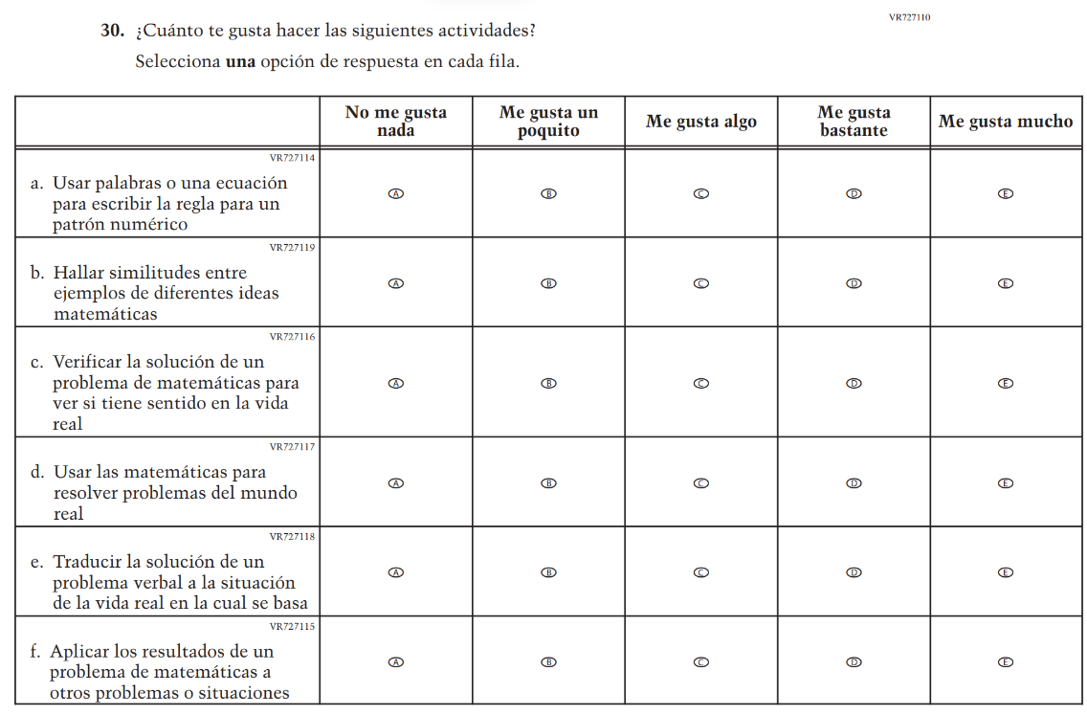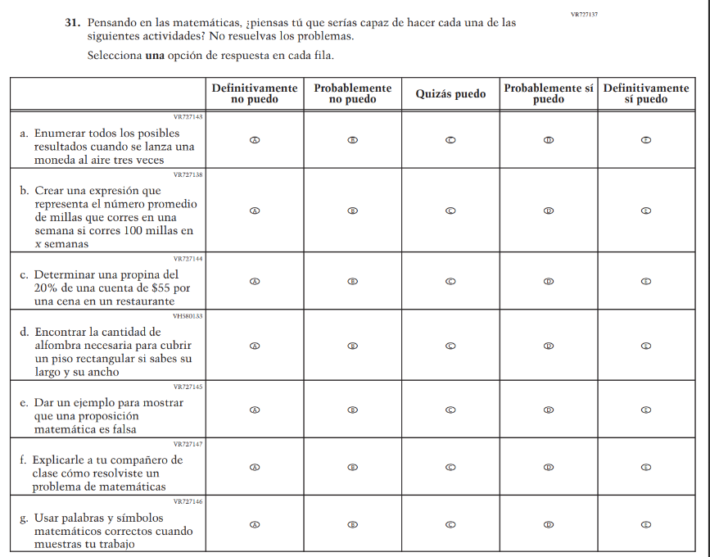

Appendix J-1i-s-BL: Summary of Changes Operational Grade 4 Reading
2026 Operational Grade 4 Reading Student – Bilingual
Previous item | 2026 item | D/A/R+ | Rationale
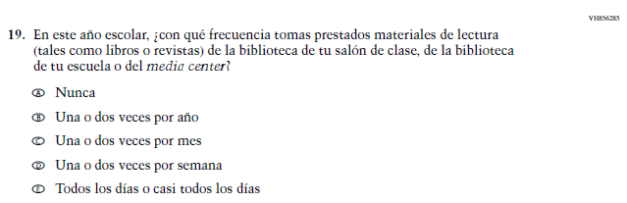  (2024 Operational Grade 4 Student Reading - Bilingual) | 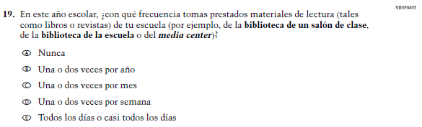  Issue: Engagement and Motivation | R | This item was revised for clarity.
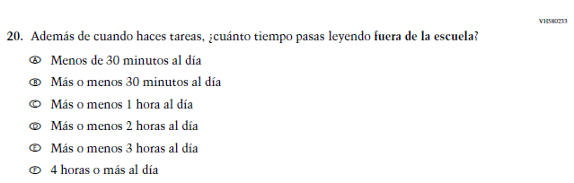 (2024 Operational Grade 4 Student Reading - Bilingual) | N/A | D | This item was dropped in favor of a new/revised item.
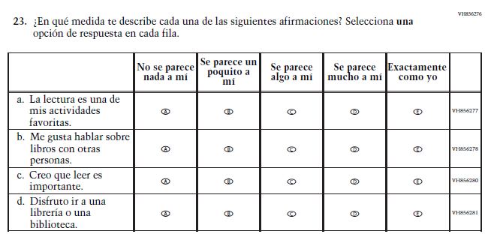 (2024 Operational Grade 4 Student Reading - Bilingual) | 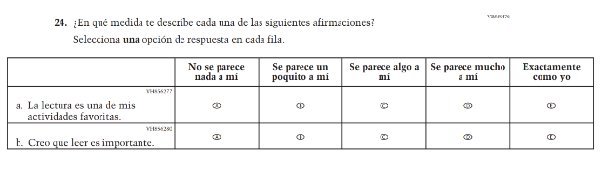  Issue: Reading Motivation | R | This Item was revised to reduce questionnaire length.
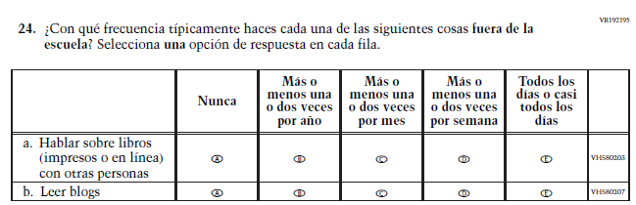 (2024 Operational Grade 4 Student Reading - Bilingual) | N/A | D | This Item was dropped to reduce questionnaire length.

2026 Operational Grade 4 Reading Student – Bilingual
Previous item | 2026 item | D/A/R+ | Rationale
N/A  (2024 Operational Grade 4 Student Reading - Bilingual) | 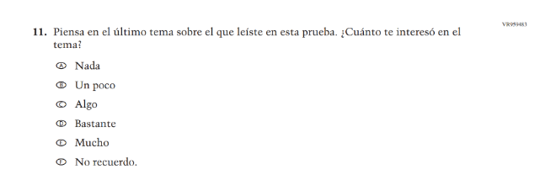  Issue: Engagement and Motivation | A | This item was developed to measure content aligned with the new Reading framework.
N/A  (2024 Operational Grade 4 Student Reading - Bilingual) | 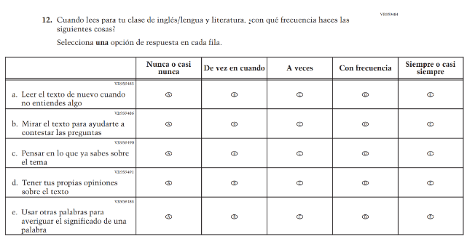  Issue: Cognition and Metacognition | A | This item was developed to measure content aligned with the new Reading framework.
N/A  (2024 Operational Grade 4 Student Reading - Bilingual) | 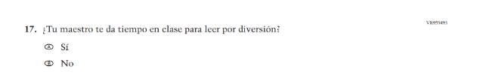  Issue: Teacher, Instructional, and Classroom Supports | A | This item was developed to measure content aligned with the new Reading framework.
N/A  (2024 Operational Grade 4 Student Reading - Bilingual) | 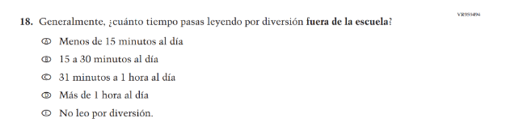  Issue: Engagement and Motivation | A | This item was developed to measure content aligned with the new Reading framework and places the emphasis on “reading for fun.”
N/A  (2024 Operational Grade 4 Student Reading - Bilingual) | 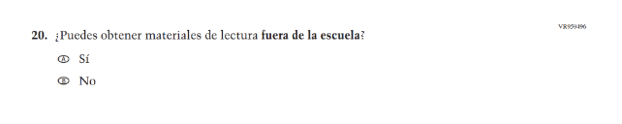  Issue: School and Community Resources | A | This item was developed to measure content aligned with the new Reading framework.
N/A  (2024 Operational Grade 4 Student Reading - Bilingual) | 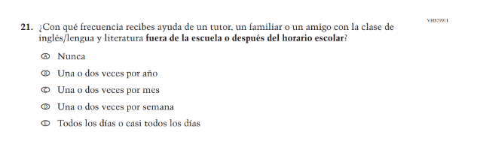  Issue: School and Community Resources | A | This trend item was added to measure content aligned with the new Reading framework.

Appendix J-1i-s-BL: Operational Grade 4 Reading
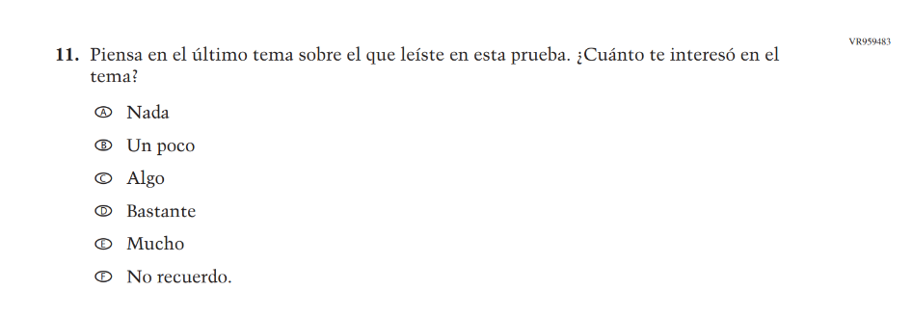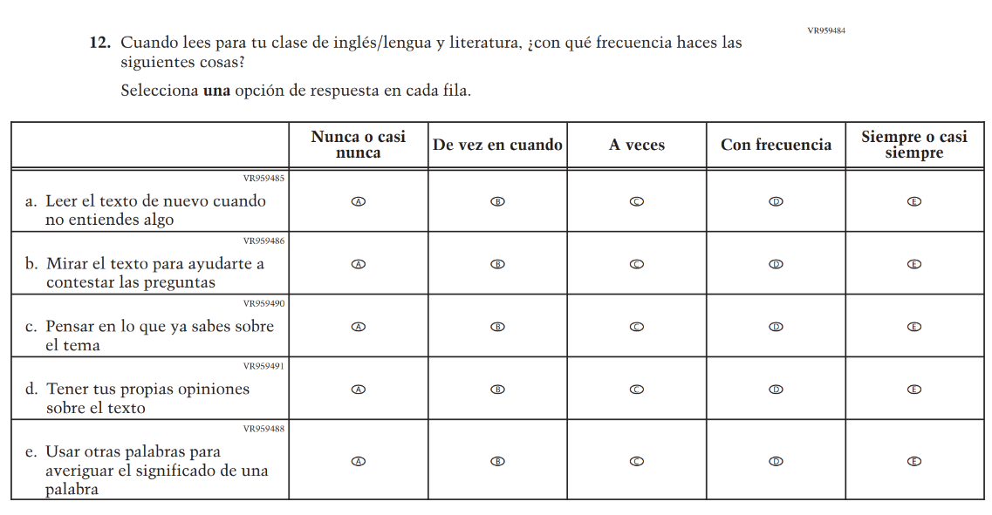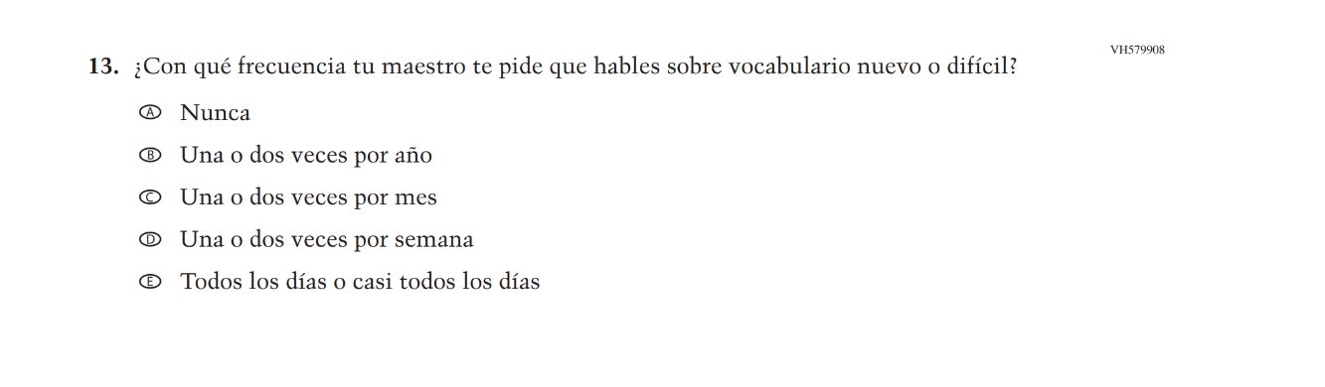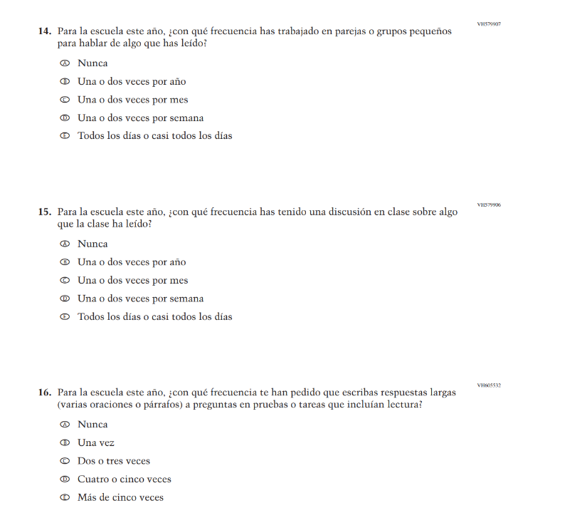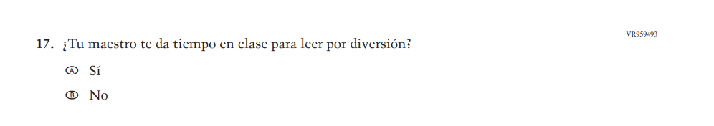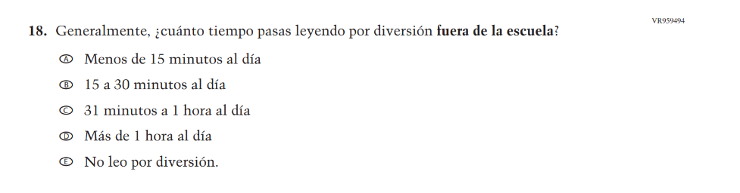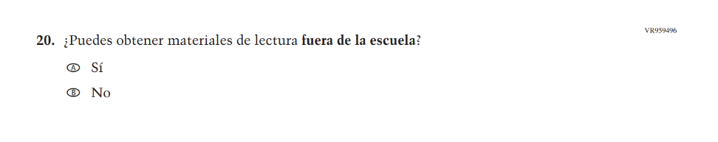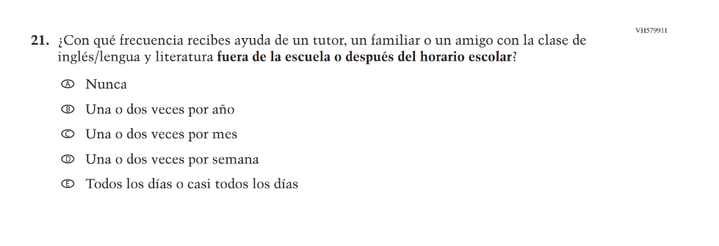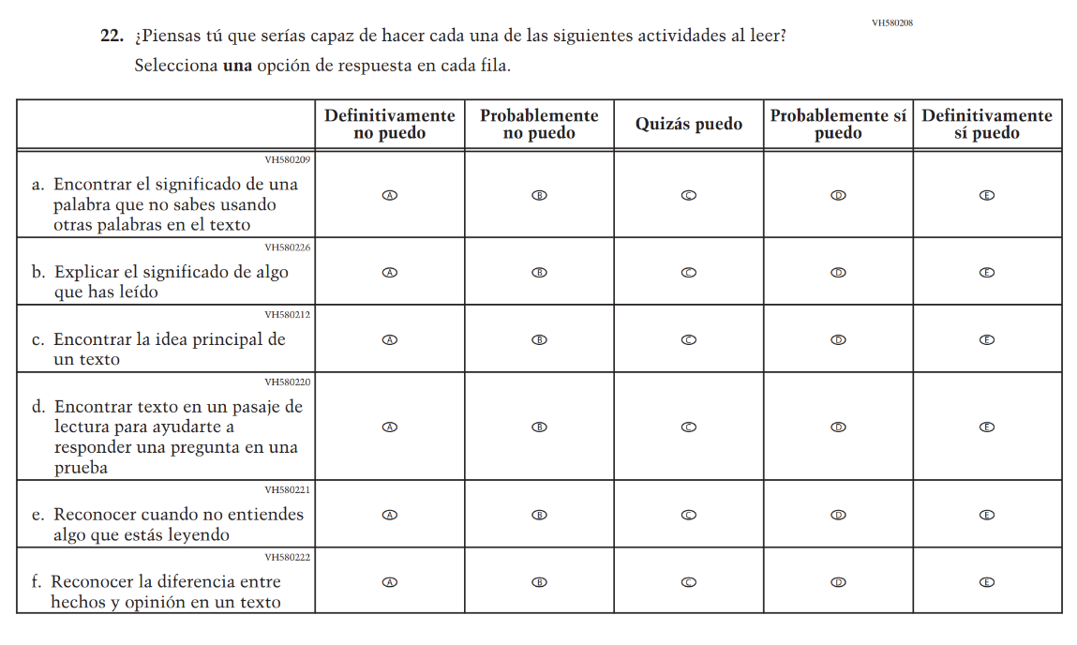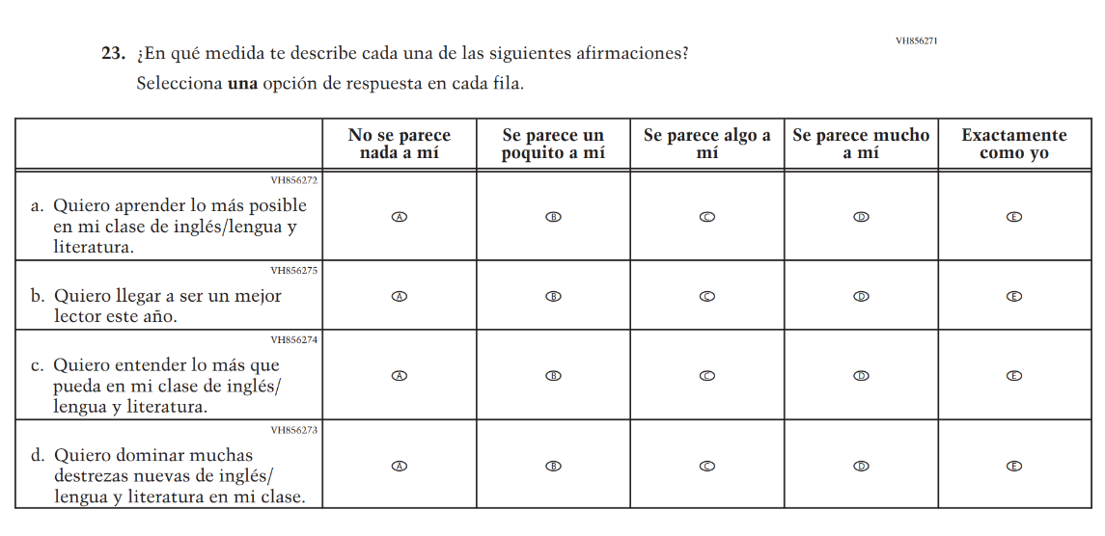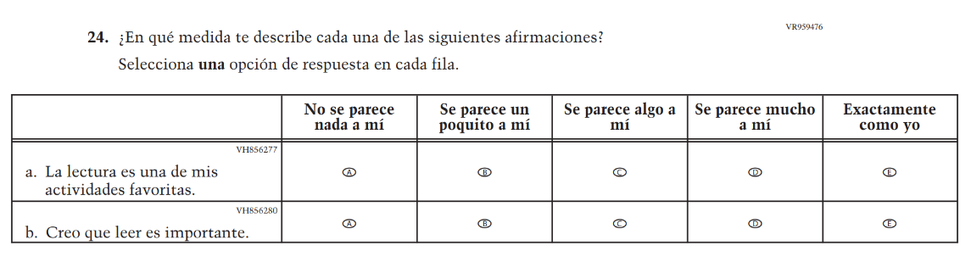

Appendix J-1j-s-BL: Summary of Changes Operational Grade 8 Reading
2026 Operational Grade 8 Reading Student – Bilingual
Previous item | 2026 item | D/A/R+ | Rationale
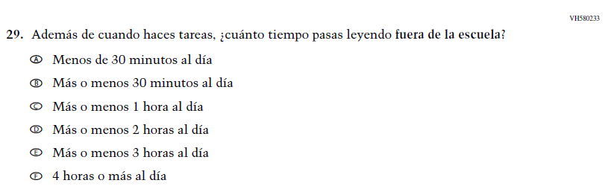 (2024 Operational Grade 8 Student Reading - Bilingual) | N/A | D | This item was dropped in favor of a new/revised item.
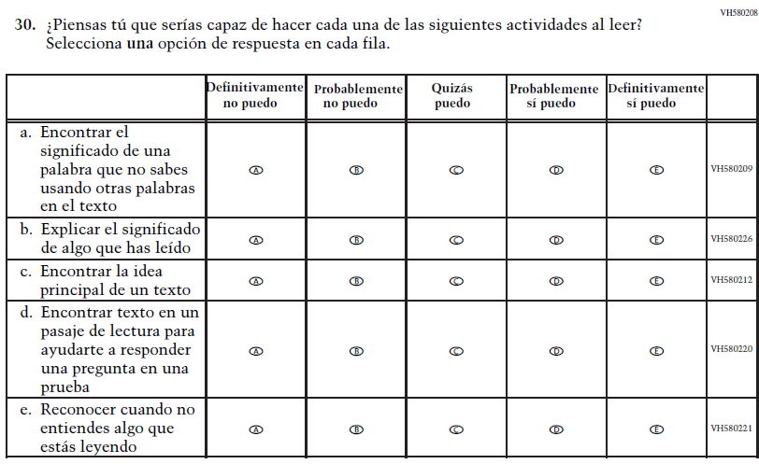  (2024 Operational Grade 8 Student Reading - Bilingual) | 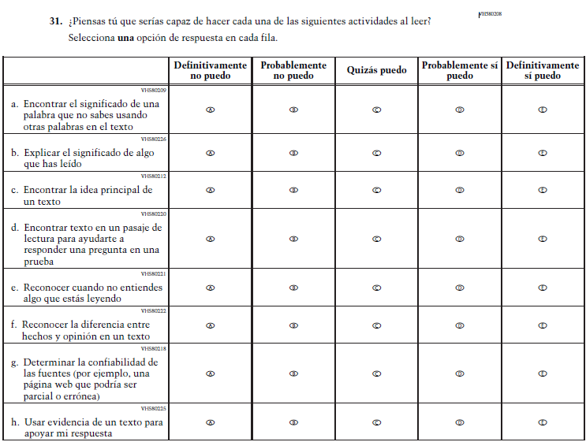  Issue: Engagement and Motivation | R | Two matrix items were combined into VH580208 for 2026.
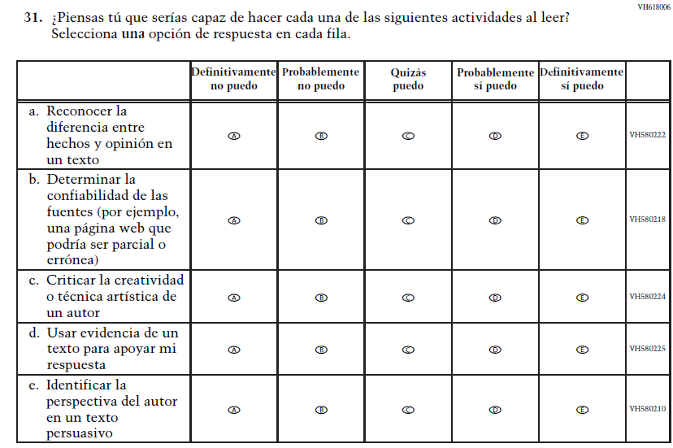  (2024 Operational Grade 8 Student Reading - Bilingual) | N/A | D | This Item was dropped and some subitems were included in new matrix item VH580208 for 2026.
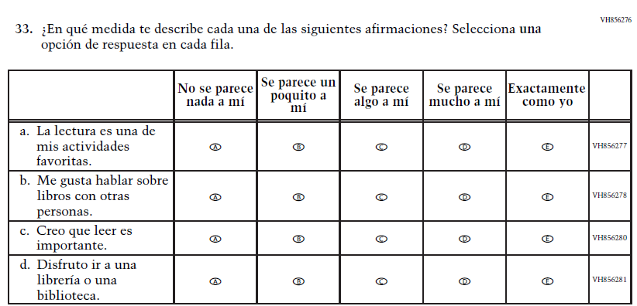  (2024 Operational Grade 8 Student Reading - Bilingual) | 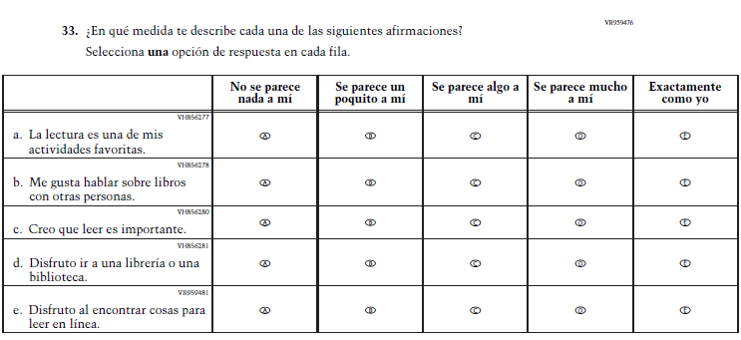  Issue: Engagement and Motivation | R | This item was revised to add subitem VH856281.

2026 Operational Grade 8 Reading Student – Bilingual
Previous item | 2026 item | D/A/R+ | Rationale
N/A  (2024 Operational Grade 8 Student Reading - Bilingual) | 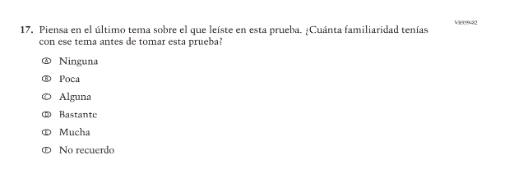  Issue: Cognition and Metacognition | A | This item was developed to measure content aligned with the new Reading framework.
N/A  (2024 Operational Grade 8 Student Reading - Bilingual) | 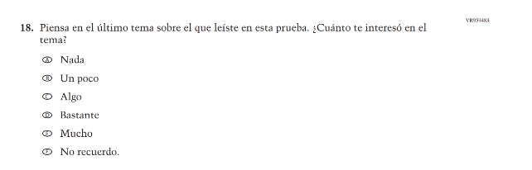  Issue: Engagement and Motivation | A | This item was developed to measure content aligned with the new Reading framework.
N/A  (2024 Operational Grade 8 Student Reading - Bilingual) | 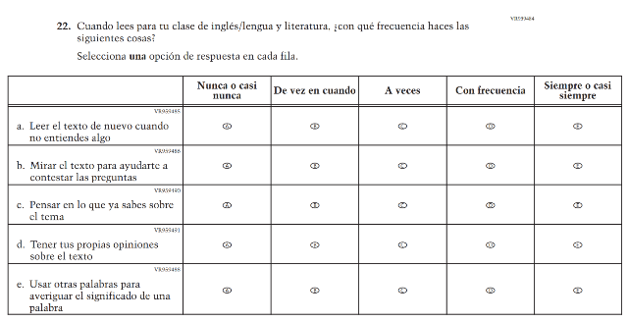  Issue: Cognition and Metacognition | A | This item was developed to measure content aligned with the new Reading framework.
N/A  (2024 Operational Grade 8 Student Reading - Bilingual) | 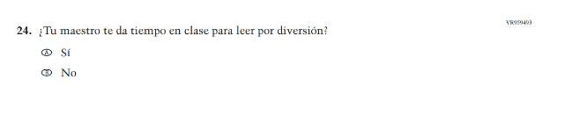  Issue: Engagement and Motivation | A | This item was developed to measure content aligned with the new Reading framework.
N/A  (2024 Operational Grade 8 Student Reading - Bilingual) | 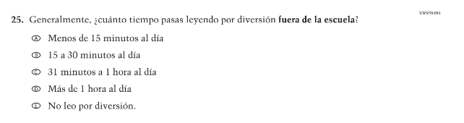  Issue: Engagement and Motivation | A | This item was developed to measure content aligned with the new Reading framework.
N/A  (2024 Operational Grade 8 Student Reading - Bilingual) | 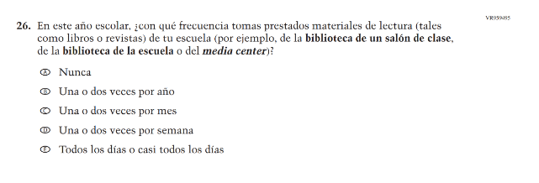  Issue: Engagement and Motivation | A | This item was developed to measure content aligned with the new Reading framework.
N/A  (2024 Operational Grade 8 Student Reading - Bilingual) | 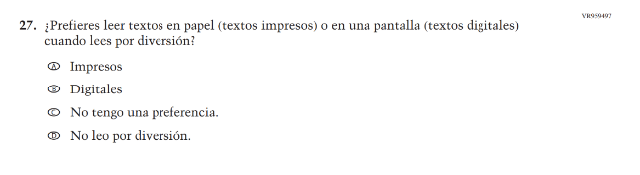  Issue: Engagement and Motivation | A | This item was developed to measure content aligned with the new Reading framework.
N/A  (2024 Operational Grade 8 Student Reading - Bilingual) | 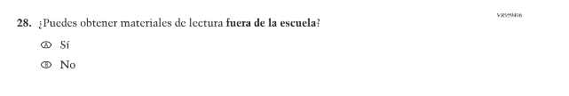  Issue: School and Community Resources | A | This item was developed to measure content aligned with the new Reading framework.
N/A  (2024 Operational Grade 8 Student Reading - Bilingual) | 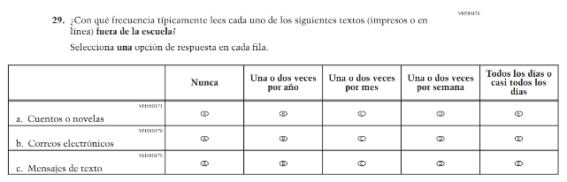  Issue: School and Community Resources | A | This item was developed to measure content aligned with the new Reading framework.
N/A  (2024 Operational Grade 8 Student Reading - Bilingual) | 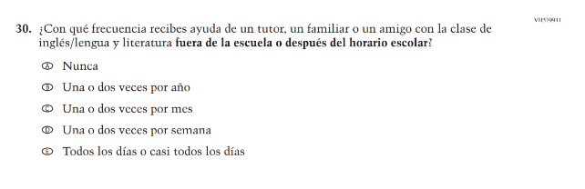  Issue: School and Community Resources | A | This item was developed to measure content aligned with the new Reading framework.

Appendix J-1j-s-BL: Operational Grade 8 Reading
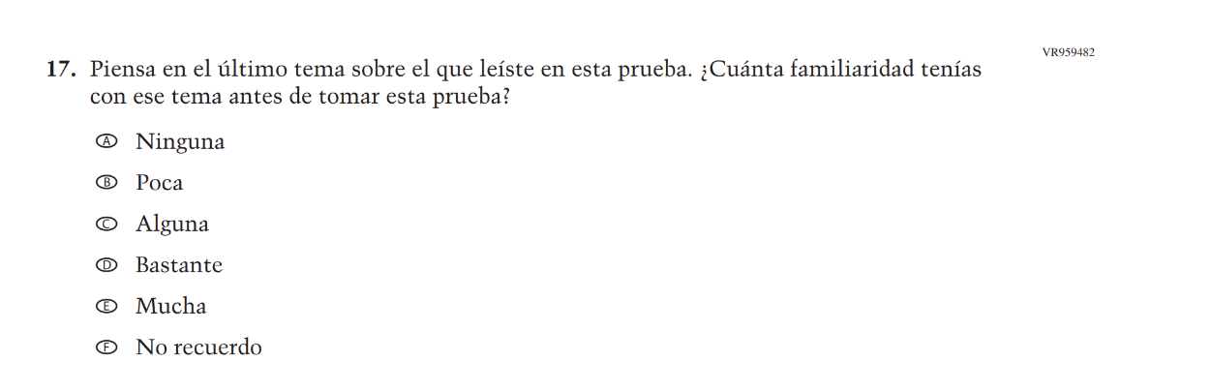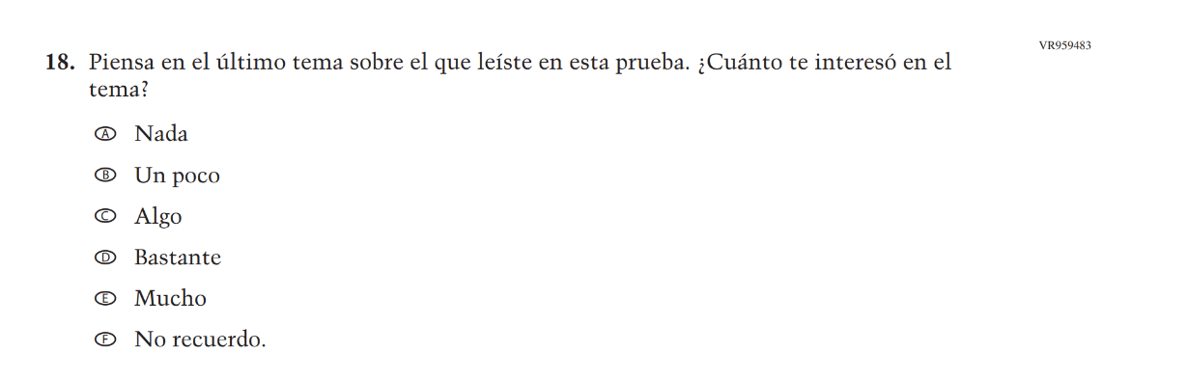
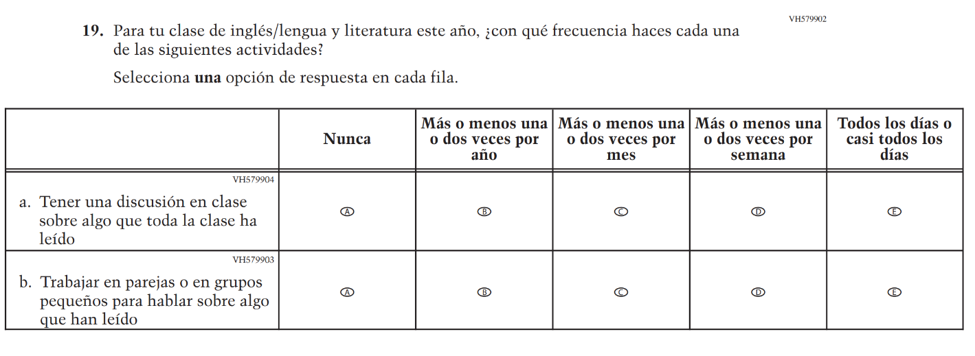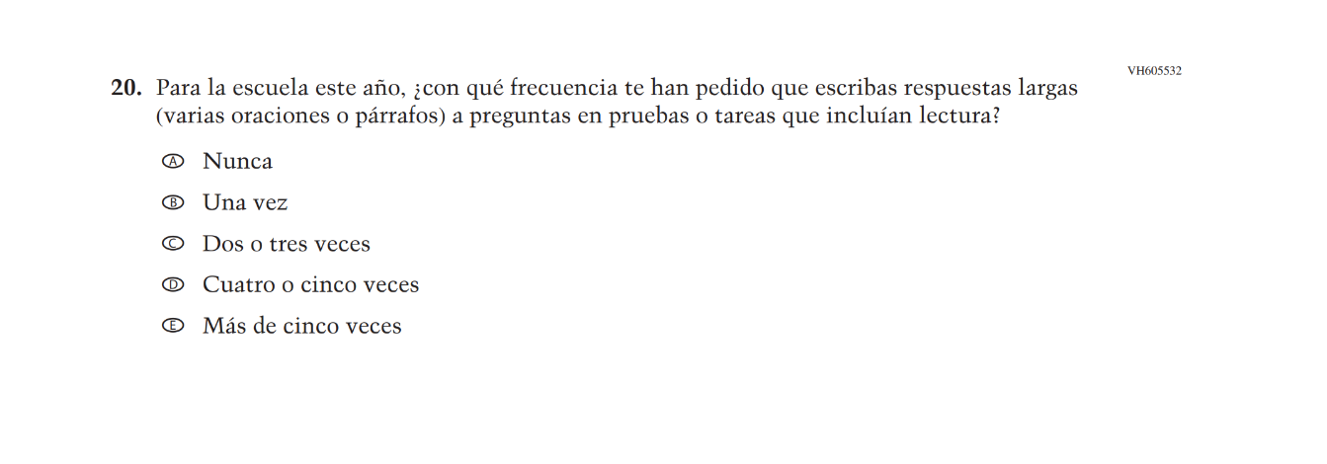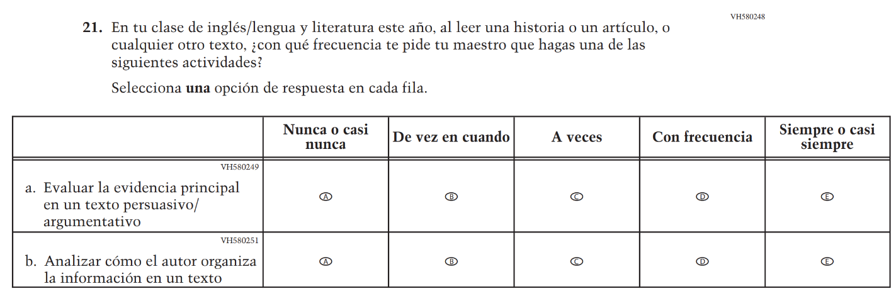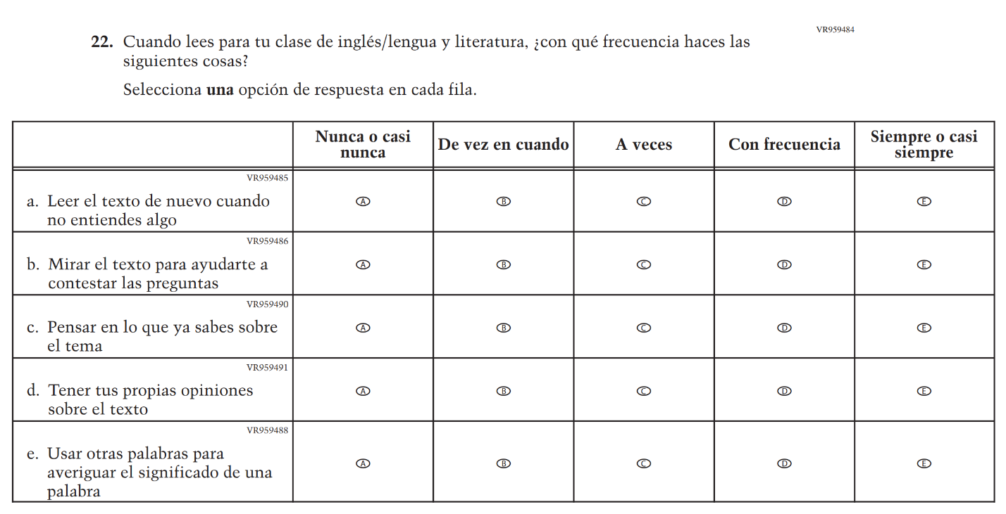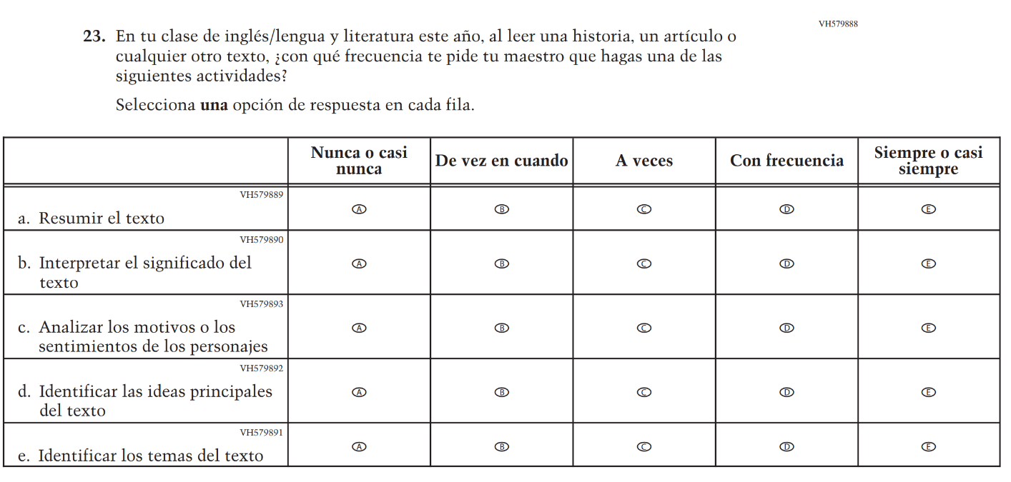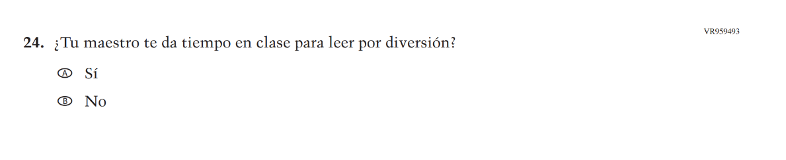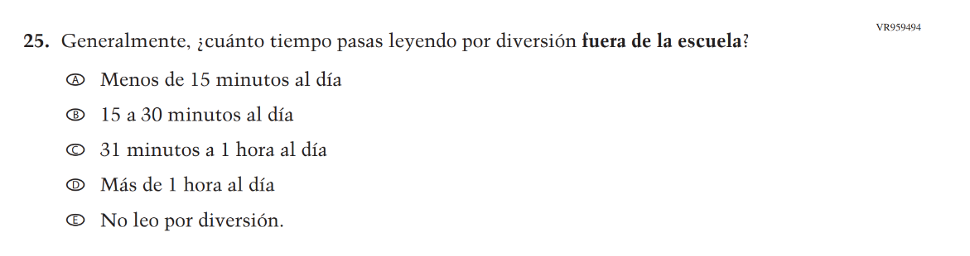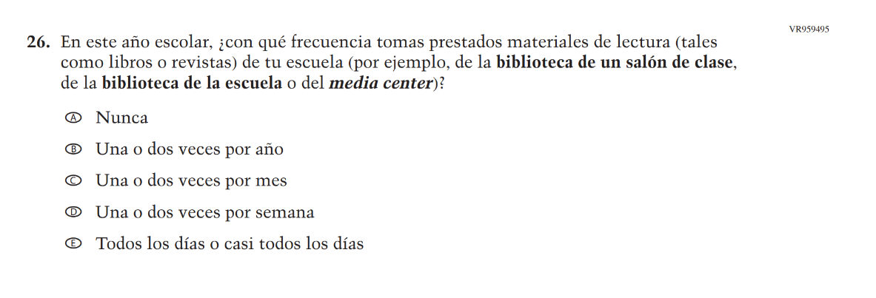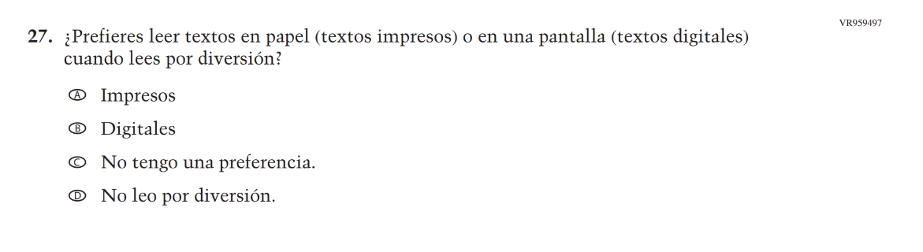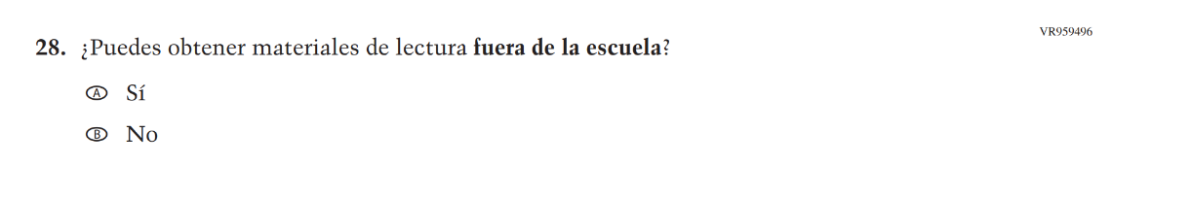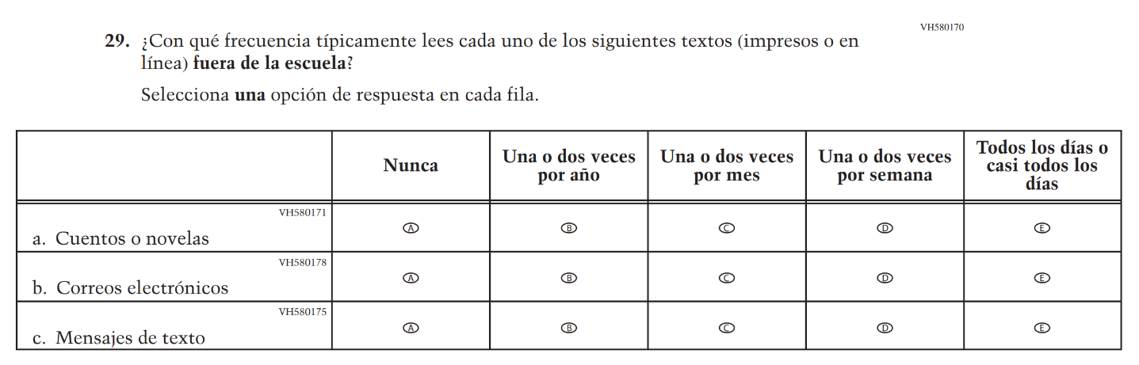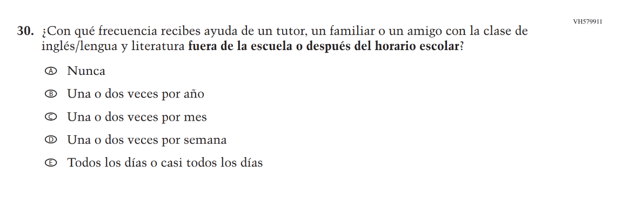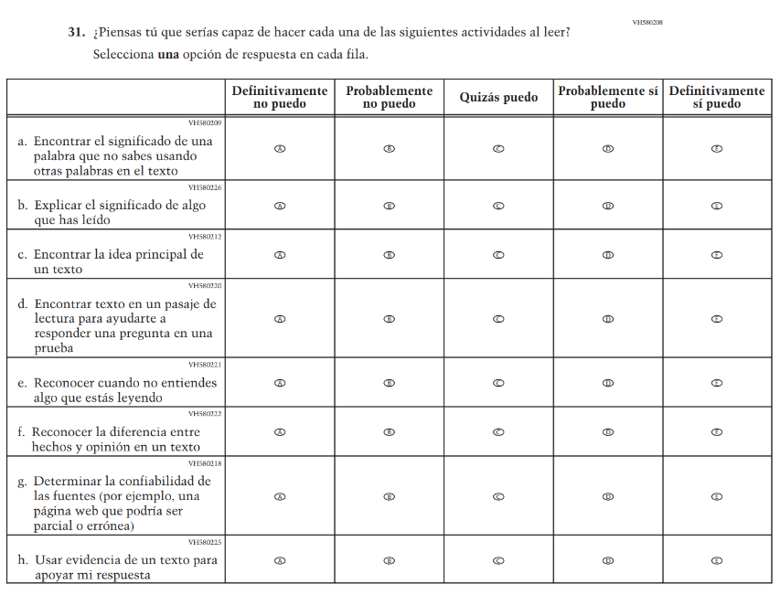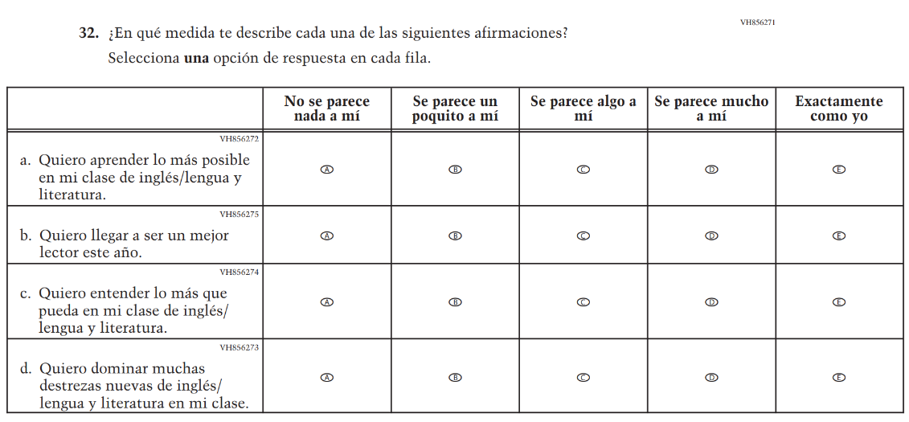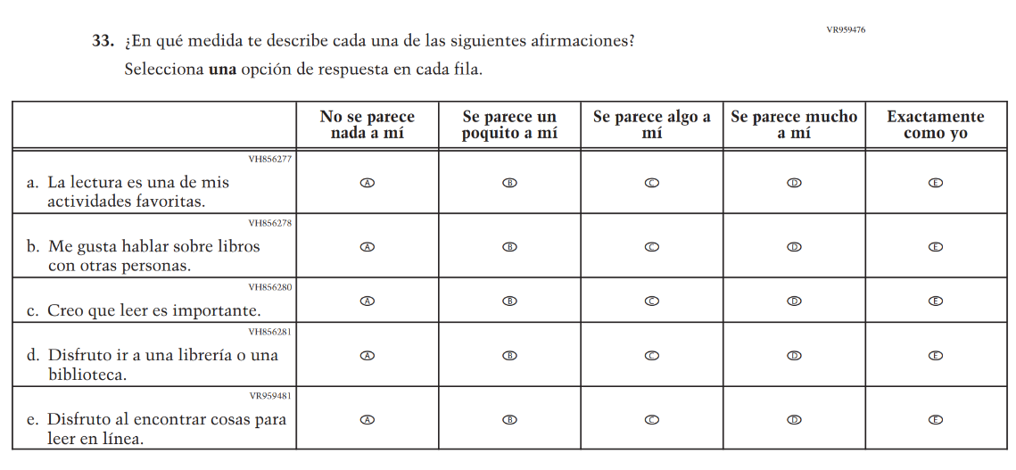

Appendix J-1k-s-BL: Operational Grade 8 Civics
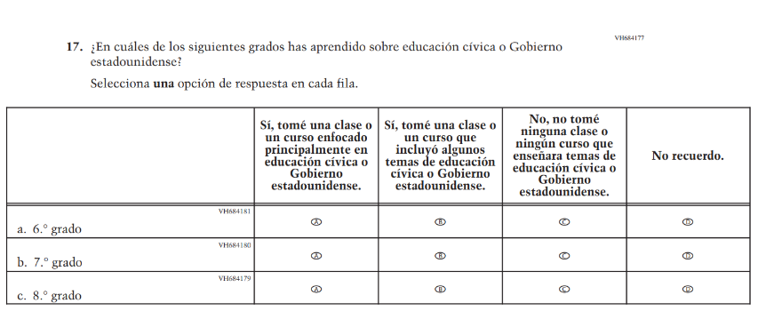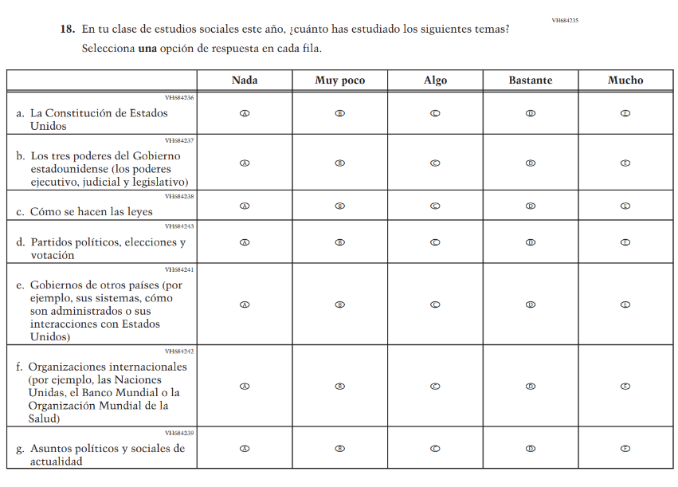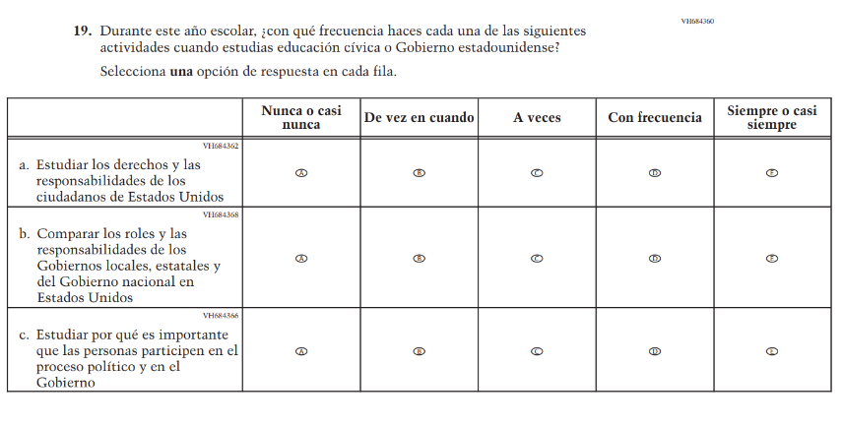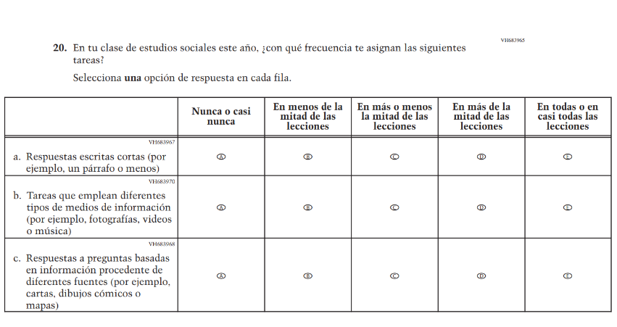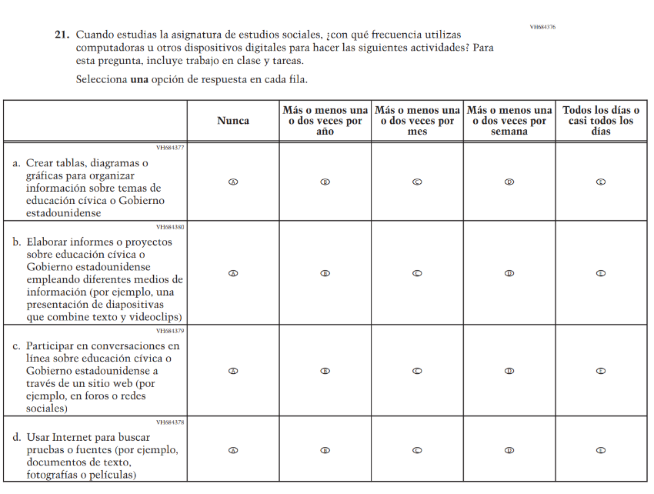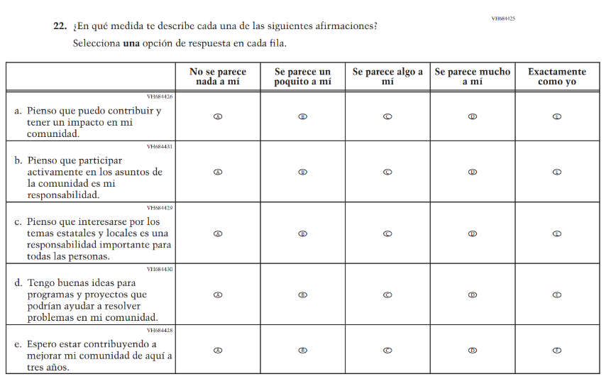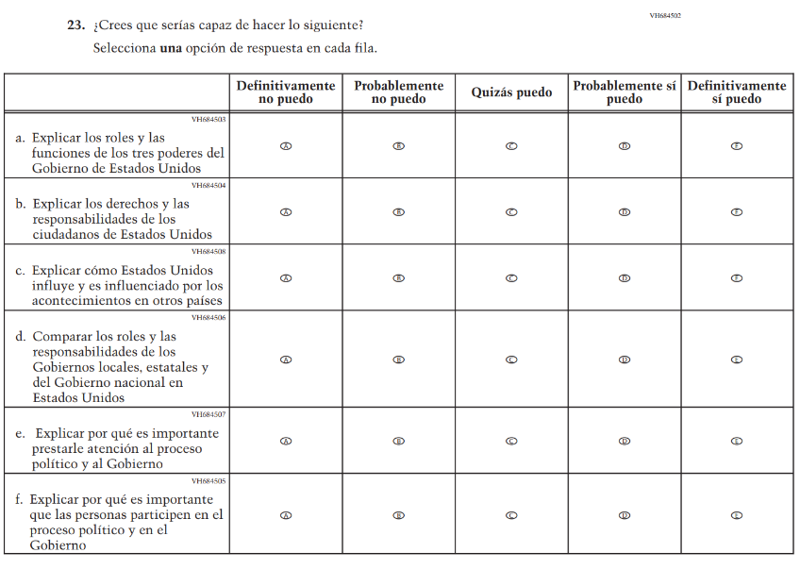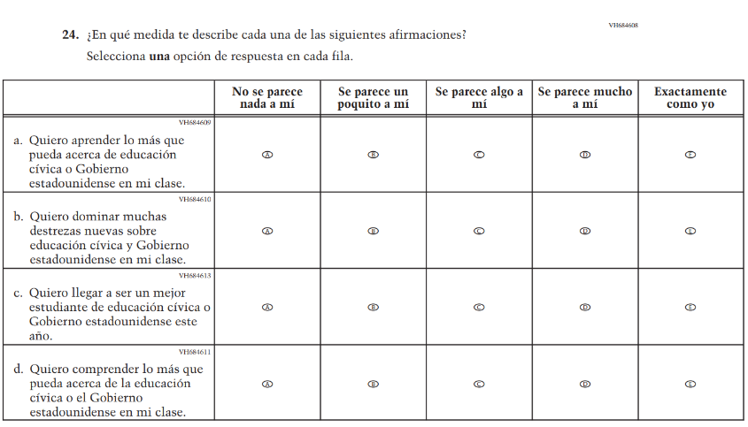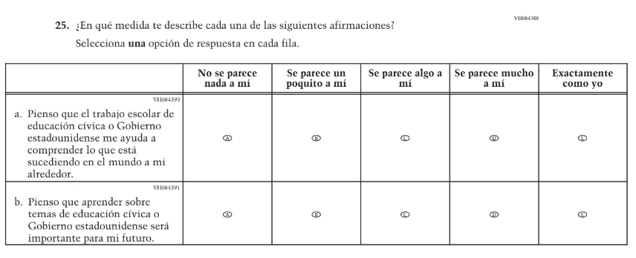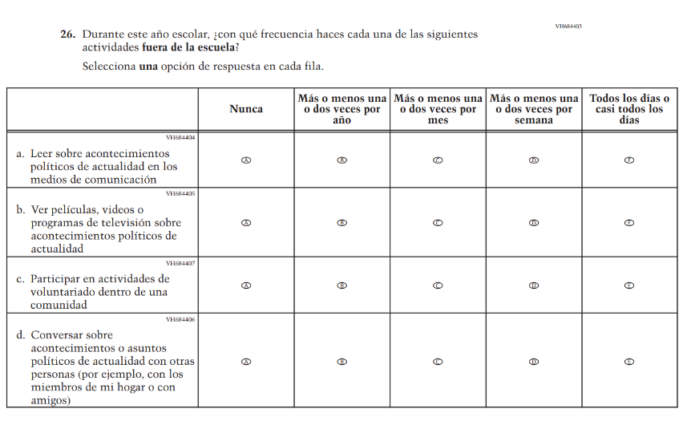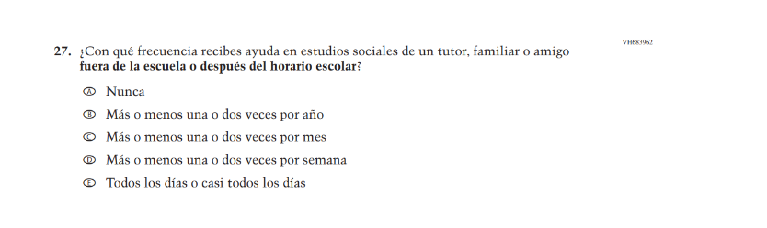

Appendix J-1l-s-BL: Operational Grade 8 U.S. History
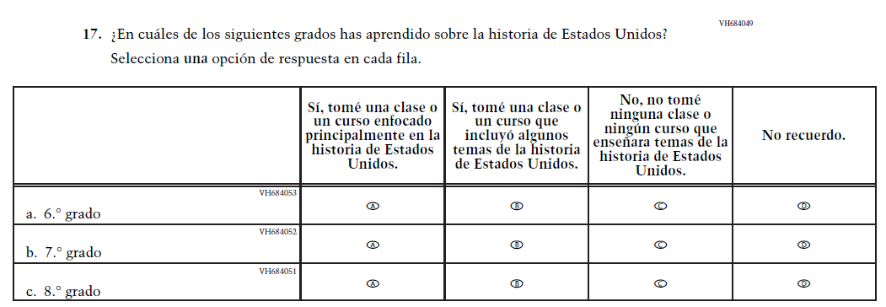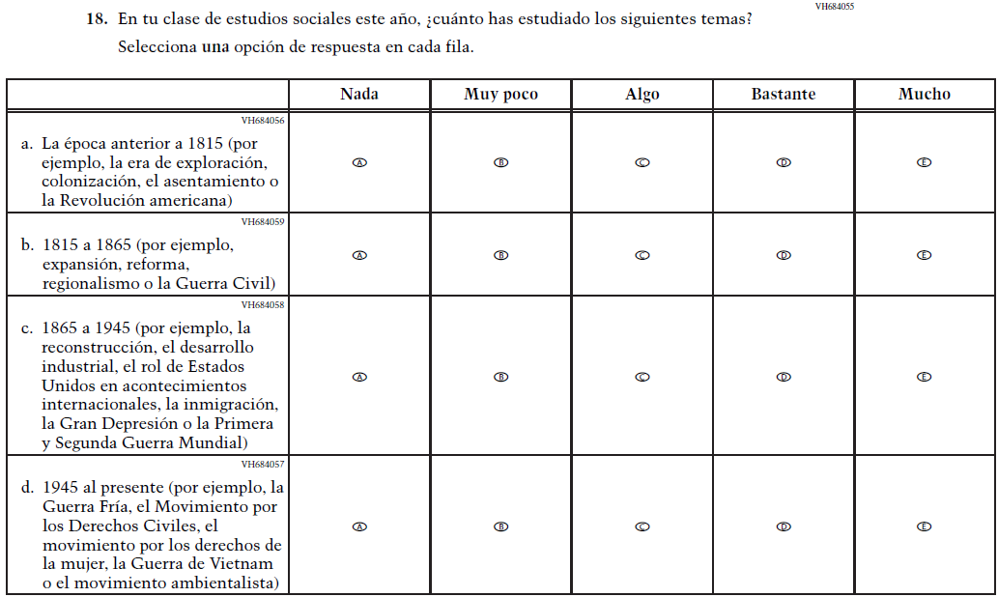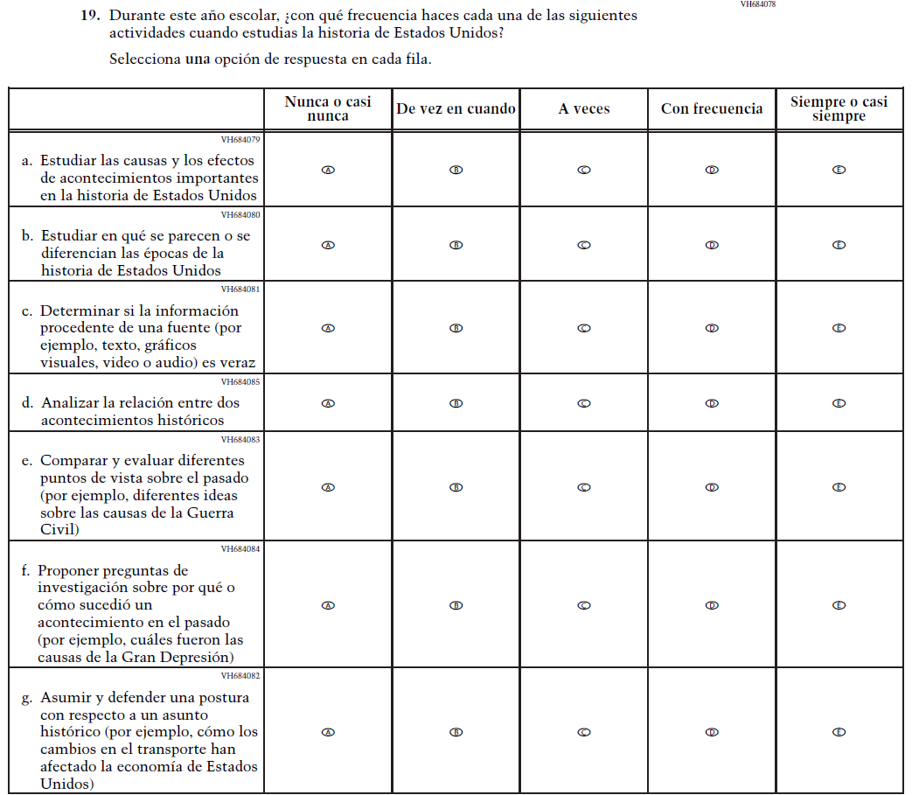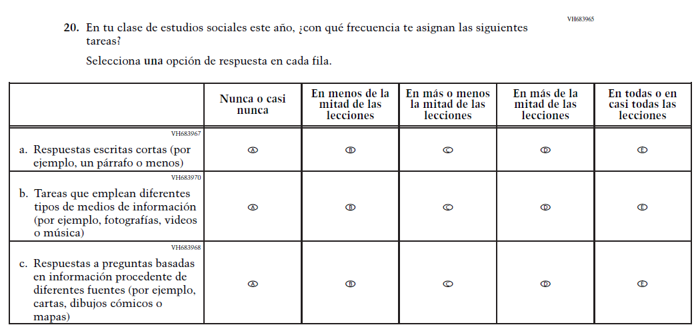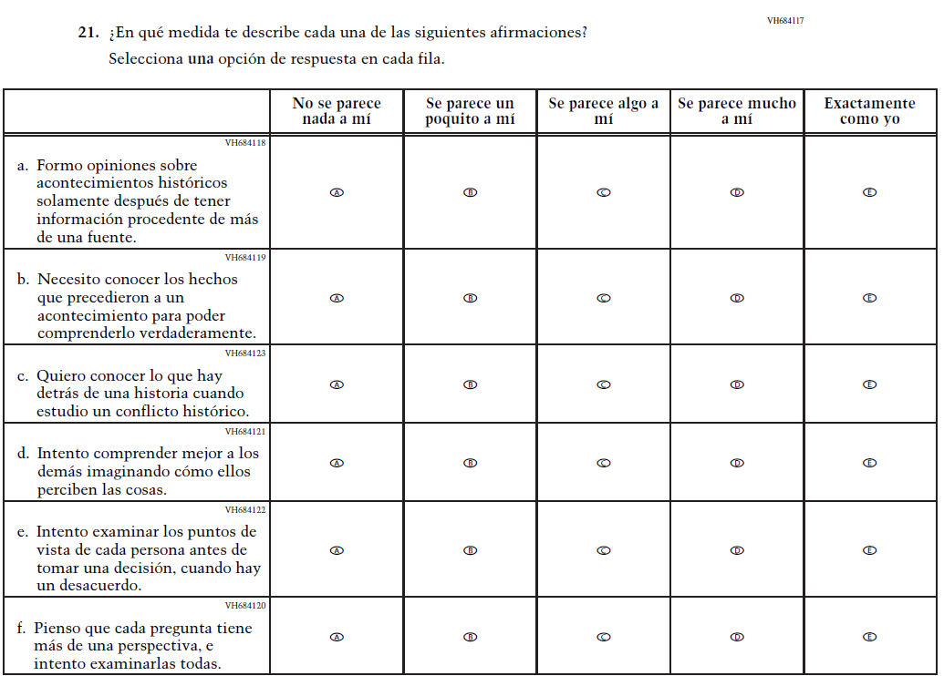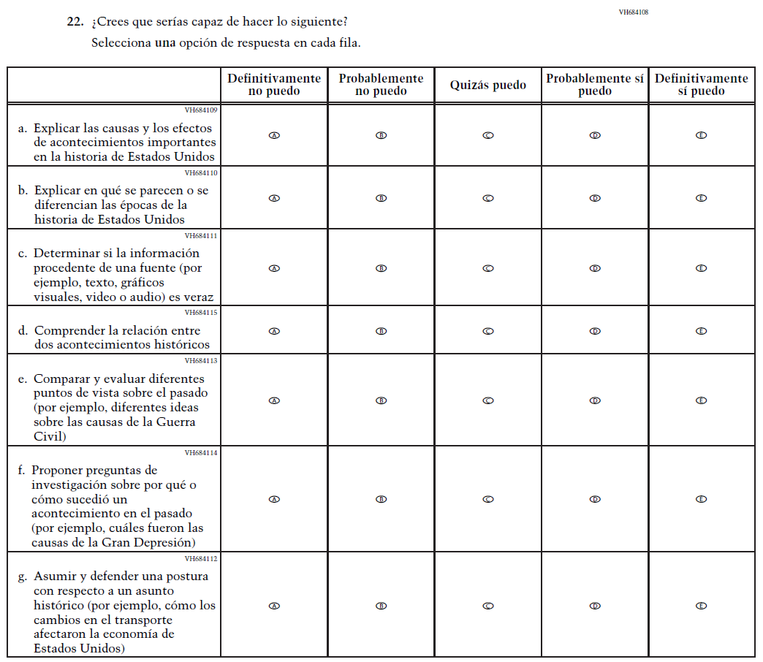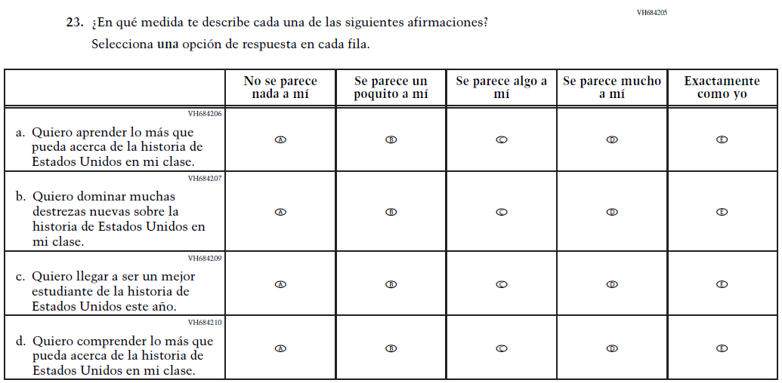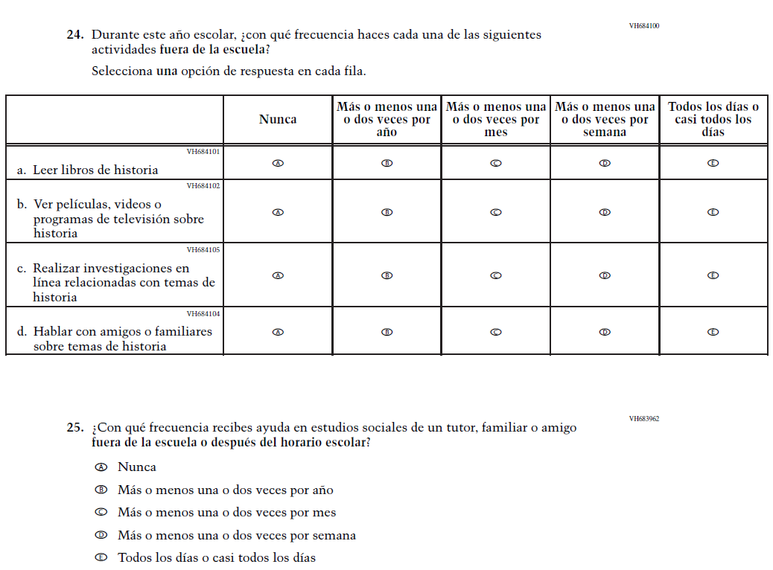

Appendix J-1m-s-BL: Summary of Changes Operational Grade 4 Debrief
2026 Operational Grade 4 Core Student – Bilingual
Previous item | 2026 item | D/A/R+ | Rationale
N/A  (2024 Operational Grade 4 Student Debrief - Bilingual) | 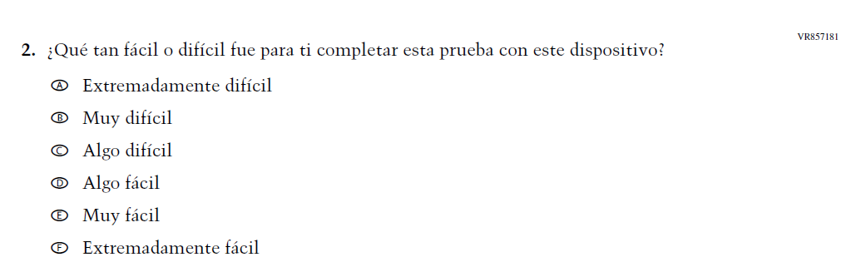  Issue: Debrief | A | This Item was added to understand students’ experiences with using their devices to take the assessment.

Appendix J-1m-s-BL: Operational Grade 4 Debrief

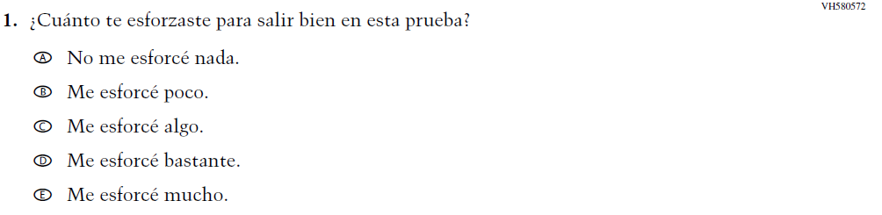

Appendix J-1n-s-PR: Summary of Changes Operational Grade 4 Debrief
2026 Operational Grade 4 Core Student – Puerto Rico
Previous item | 2026 item | D/A/R+ | Rationale
N/A  (2024 Operational Grade 4 Student Debrief – Puerto Rico) | 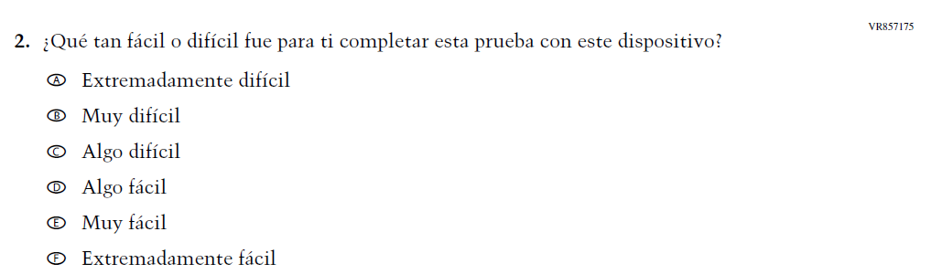  Issue: Debrief | A | This Item was added to understand students’ experiences with using their devices to take the assessment.

Appendix J-1n-s-PR: Operational Grade 4 Debrief

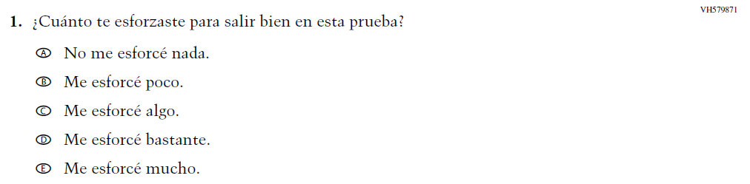

Appendix J-1o-s-BL: Summary of Changes Operational Grade 8 Debrief
2026 Operational Grade 8 Debrief Student – Bilingual
Previous item | 2026 item | D/A/R+ | Rationale
N/A  (2024 Operational Grade 8 Student Debrief - Bilingual) | 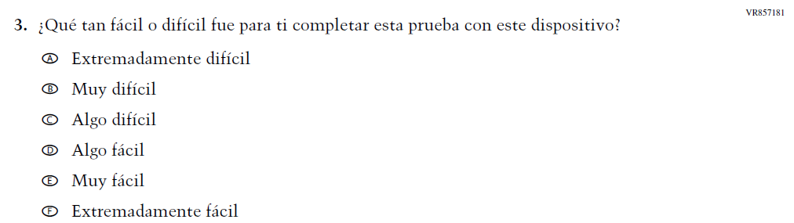  Issue: Debrief | A | This Item was added to understand students’ experiences with using their devices to take the assessment.

Appendix J-1o-s-BL: Operational Grade 8 Debrief

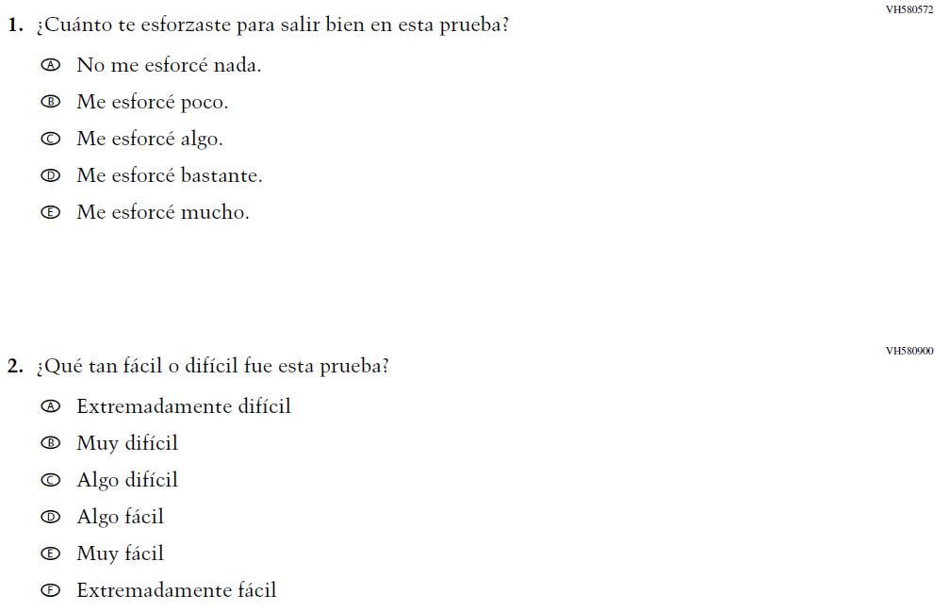

Appendix J-1p-s-PR: Summary of Changes Operational Grade 8 Debrief
2026 Operational Grade 8 Core Student – Puerto Rico
Previous item | 2026 item | D/A/R+ | Rationale
N/A  (2024 Operational Grade 8 Student Debrief – Puerto Rico) | 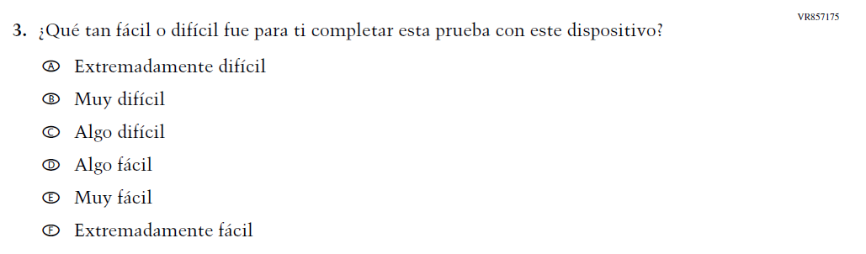  Issue: Debrief | A | This Item was added to understand students’ experiences with using their devices to take the assessment.

Appendix J-1p-s-PR: Operational Grade 8 Debrief
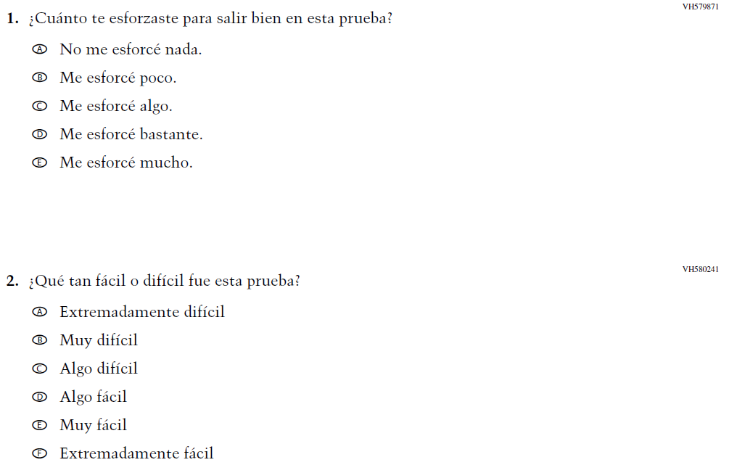

Appendix J-1q-s-PR: Pilot Grade 4 Core

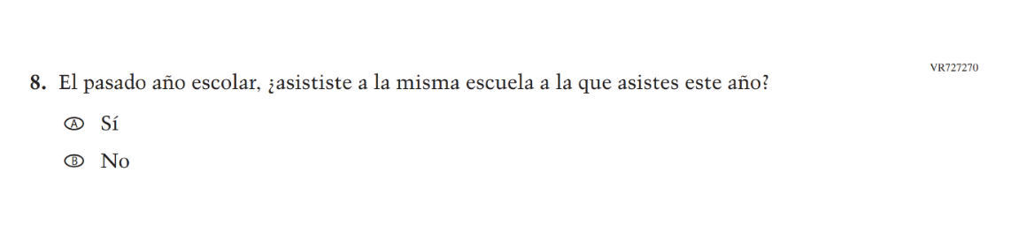

Appendix J-1r-s-PR: Pilot Grade 8 Core

Appendix J-1s-s-PR: Pilot Grade 4 Mathematics
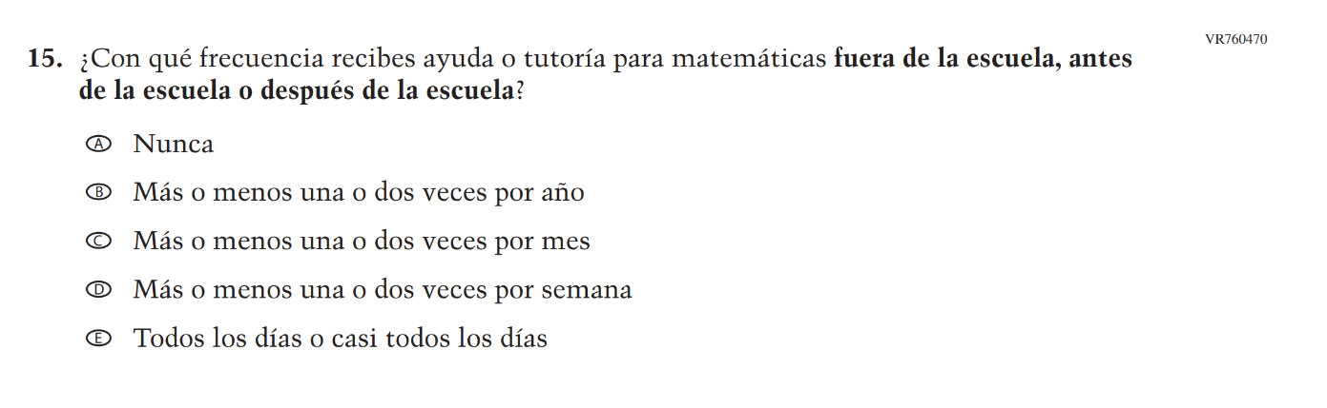

Appendix J-1t-s-PR: Pilot Grade 8 Mathematics 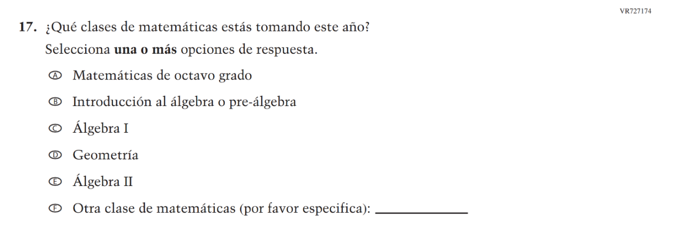

Appendix J-1u-s-PR: Pilot Grade 4 Debrief

Appendix J-1v-s-PR: Pilot Grade 8 Debrief

Appendix J-2-s: Spanish Translations of Teacher Questionnaires

Sample Teacher Login Screen
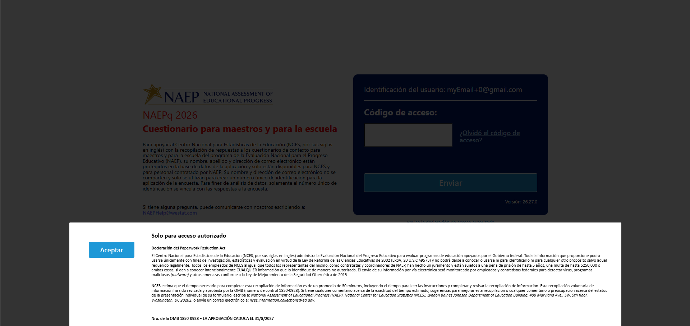

Appendix J-2a-s-PR: Summary of Changes Operational Grade 4 CORE
2026 Operational Grade 4 Core Teacher – Puerto Rico
Previous item | 2026 item | D/A/R+ | Rationale
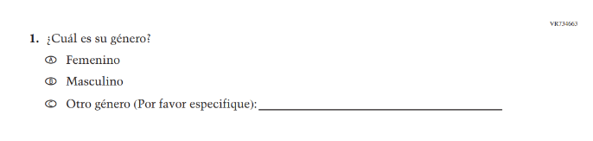  (2024 Operational Grade 4 Teacher Core – Puerto Rico) | N/A | D | This Item was dropped to adhere to the January 2025 Executive Order on gender ideology and identity.
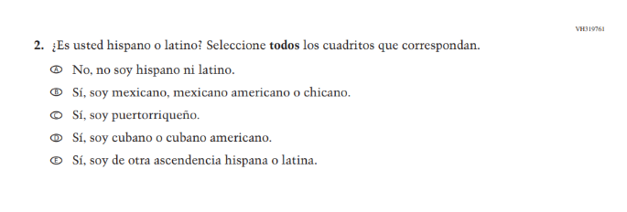  (2024 Operational Grade 4 Teacher Core – Puerto Rico) | N/A | D | This Item was dropped and folded into the following suite of updated Race/ Ethnicity Items.
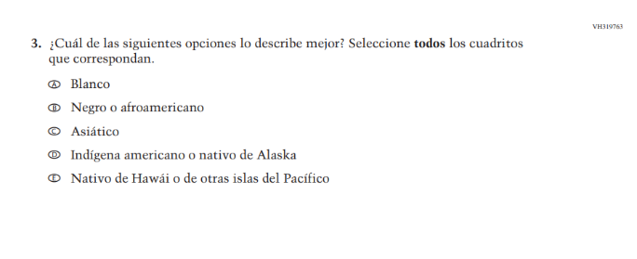  (2024 Operational Grade 4 Teacher Core – Puerto Rico) | 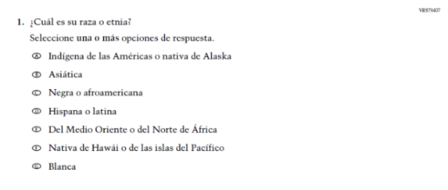  Issue: Race/Ethnicity | R | For 2026, we have aligned Inline Directions in Teacher and School Items with the Directions currently used in Student Items. The Race/ Ethnicity Items have been updated to adhere to OMB updated Statistical Policy Directive No. 15.
 | 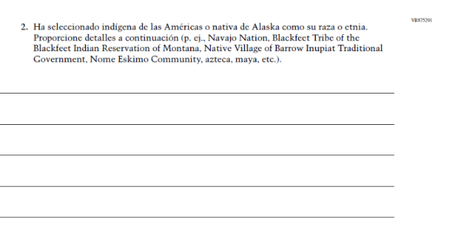Issue: Race/Ethnicity | A | The Race/ Ethnicity Items have been updated.
 | 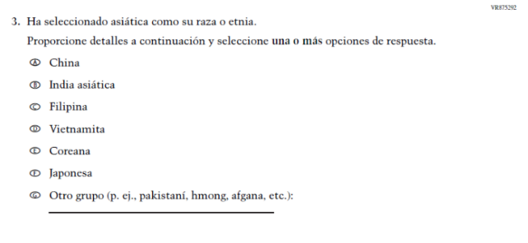Issue: Race/Ethnicity | A | The Race/ Ethnicity Items have been updated.
 | 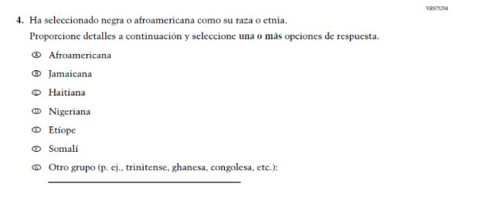Issue: Race/Ethnicity | A | The Race/ Ethnicity Items have been updated.
 | 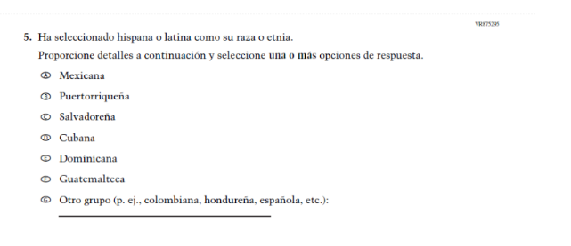Issue: Race/Ethnicity | A | The Race/ Ethnicity Items have been updated.
 | 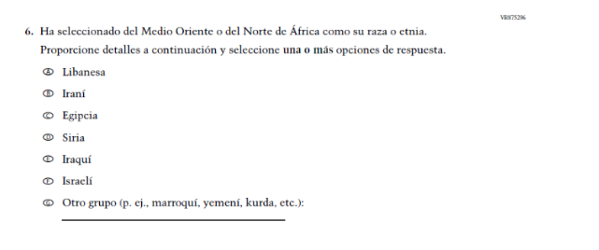Issue: Race/Ethnicity | A | The Race/ Ethnicity Items have been updated.
 | 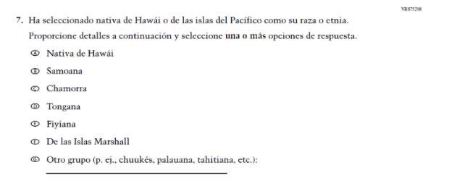Issue: Race/Ethnicity | A | The Race/ Ethnicity Items have been updated.
 | 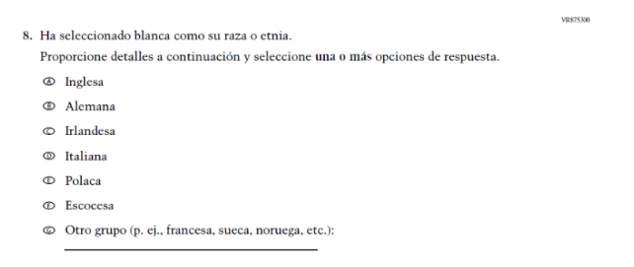Issue: Race/Ethnicity | A | The Race/ Ethnicity Items have been updated.
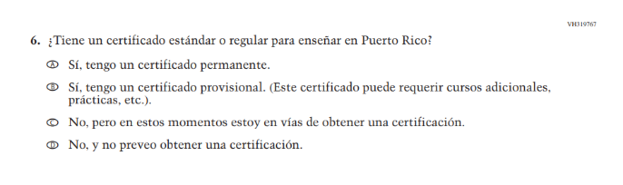(2024 Operational Grade 4 Teacher Core – Puerto Rico) | N/A | D | This item was dropped in favor of a new/revised item.
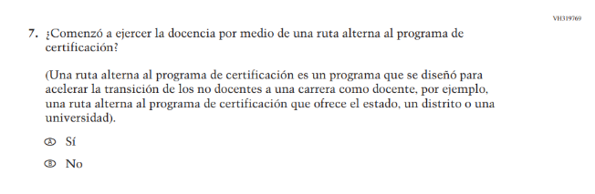(2024 Operational Grade 4 Teacher Core – Puerto Rico) | 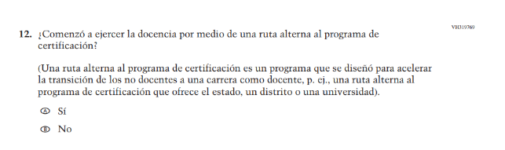  Issue: Teacher Preparation | R | We revised “por ejemplo” to “p. ej.” to be consistent with the phrasing used elsewhere in Teacher and School Items.
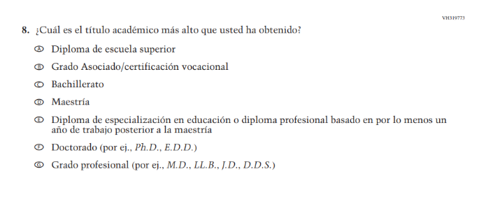  (2024 Operational Grade 4 Teacher Core – Puerto Rico) | 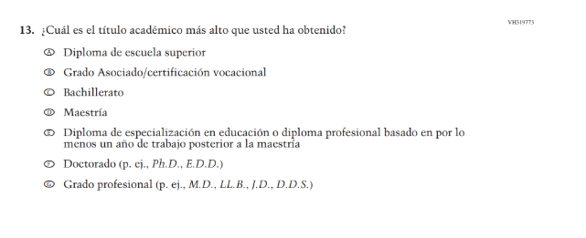  Issue: Teacher Preparation | R | We revised “por ej.” to “p. ej.” to be consistent with the phrasing used elsewhere in Teacher and School Items.
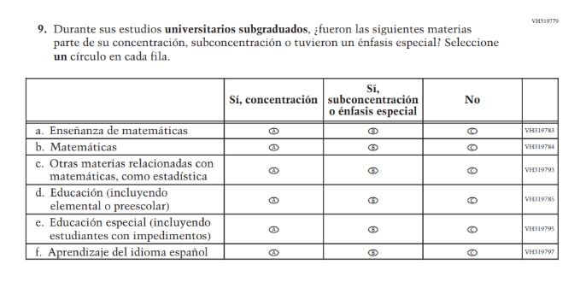(2024 Operational Grade 4 Teacher Core – Puerto Rico) | 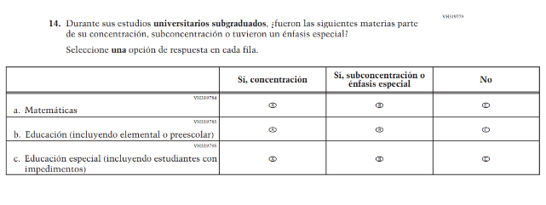  Issue: Teacher Preparation | R | For 2026, we have aligned Inline Directions in Teacher and School Items with the Directions currently used in Student Items. SubItems a, c, and f were dropped due to high percentages of “No” responses (over 80%).
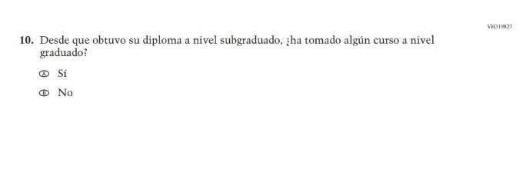(2024 Operational Grade 4 Teacher Core – Puerto Rico) | N/A | D | This Item was dropped to reduce burden and streamline content.
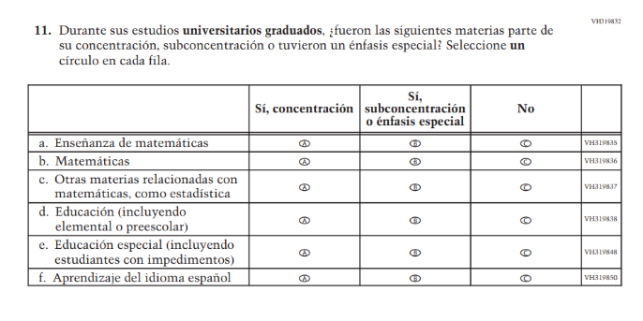(2024 Operational Grade 4 Teacher Core – Puerto Rico) | 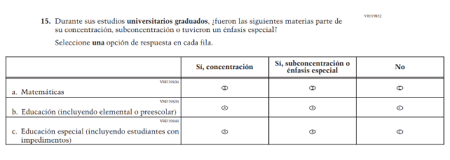  Issue: Teacher Preparation | R | For 2026, we have aligned Inline Directions in Teacher and School Items with the Directions currently used in Student Items. SubItems a, c, and f were dropped due to high percentages of “No” responses (over 80%).
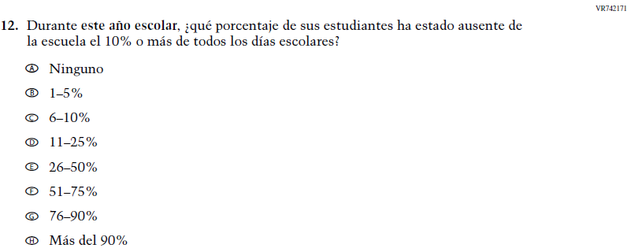  (2024 Operational Grade 4 Teacher Core – Puerto Rico) | N/A | D | Learning Recovery Items were dropped from the 2026 NAEP Assessment.
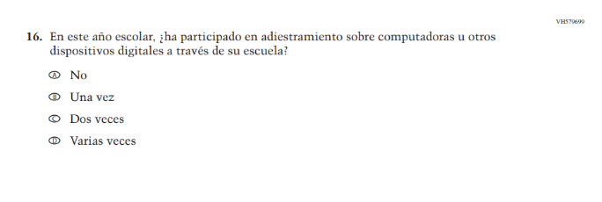(2024 Operational Grade 4 Teacher Core – Puerto Rico) | N/A | D | This Item was dropped to prioritize newer, updated Teacher items on Technology Use.
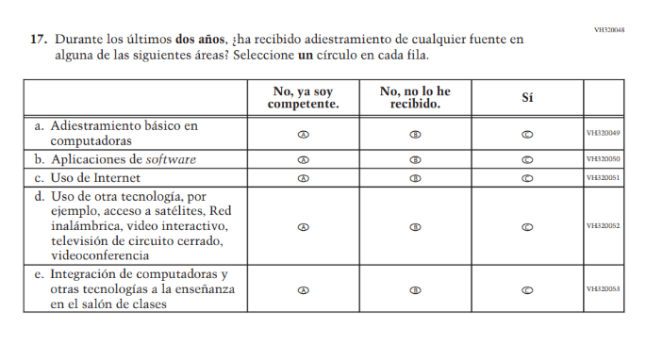(2024 Operational Grade 4 Teacher Core – Puerto Rico) | N/A | D | This item was dropped in favor of a new/revised item.
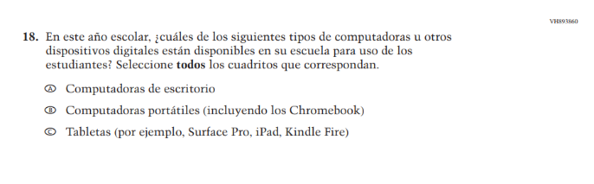(2024 Operational Grade 4 Teacher Core – Puerto Rico) | N/A | D | This and the related Items were dropped in favor of a more current and concise format for questions on Technology Use.
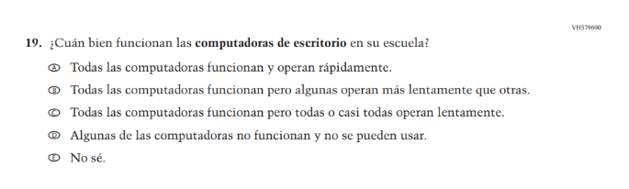(2024 Operational Grade 4 Teacher Core – Puerto Rico) | N/A | D | This and the related Items were dropped in favor of a more current and concise format for questions on Technology Use.
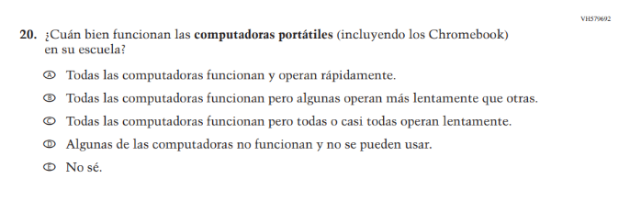(2024 Operational Grade 4 Teacher Core – Puerto Rico) | N/A | D | This and the related Items were dropped in favor of a more current and concise format for questions on Technology Use.
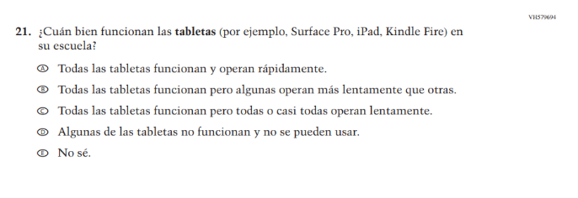(2024 Operational Grade 4 Teacher Core – Puerto Rico) | N/A | D | This and the related Items were dropped in favor of a more current and concise format for questions on Technology Use.
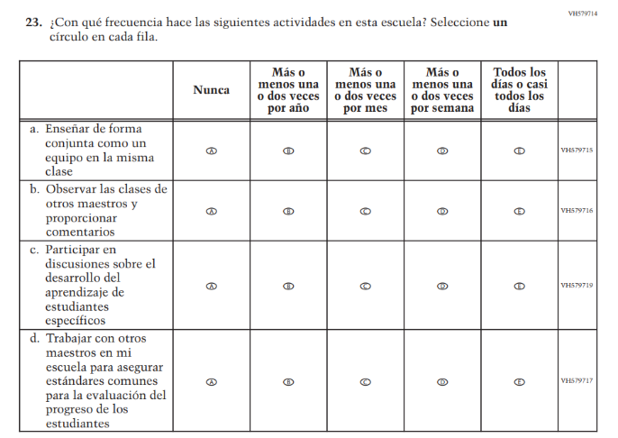(2024 Operational Grade 4 Teacher Core – Puerto Rico) | N/A | D | This Item was dropped to make space for new Teacher Items in the 2026 NAEP Assessment.
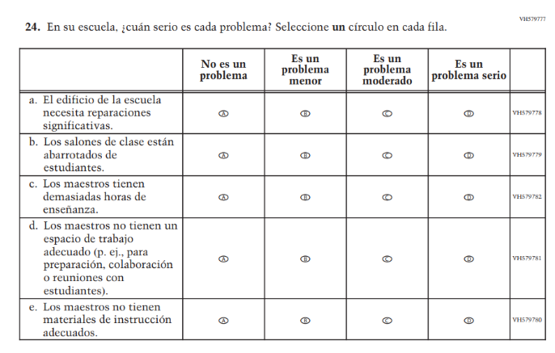(2024 Operational Grade 4 Teacher Core – Puerto Rico) | 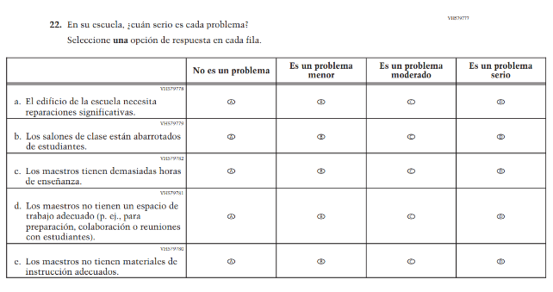  Issue: School Climate | R | For 2026, we have aligned Inline Directions in Teacher and School Items with the Directions currently used in Student Items.
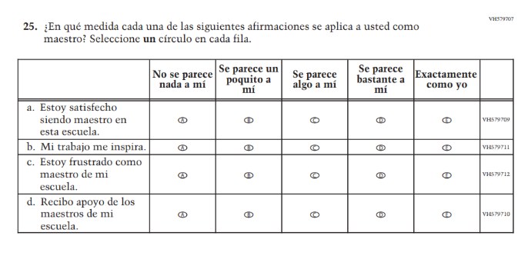(2024 Operational Grade 4 Teacher Core – Puerto Rico) | 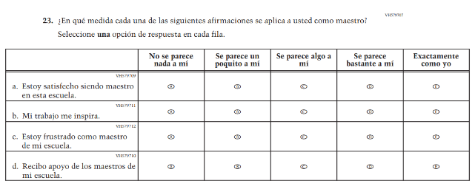  Issue: School Climate | R | For 2026, we have aligned Inline Directions in Teacher and School Items with the Directions currently used in Student Items.
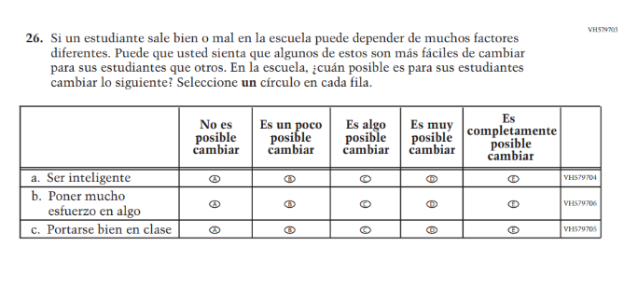(2024 Operational Grade 4 Teacher Core – Puerto Rico) | 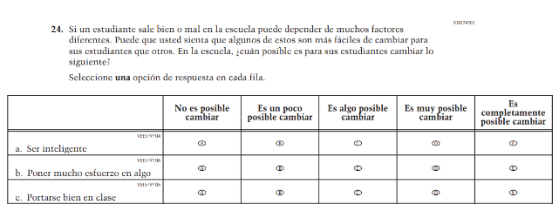  Issue: Desire for Learning | R | For 2026, we have aligned Inline Directions in Teacher and School Items with the Directions currently used in Student Items.

2026 Operational Grade 4 Core Teacher – Puerto Rico
Previous item | 2026 item | D/A/R+ | Rationale
N/A  (2024 Operational Grade 4 Teacher Core – Puerto Rico) | 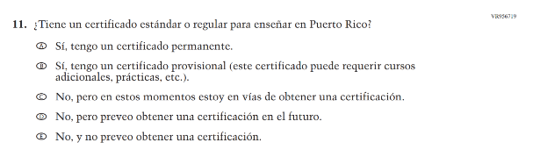  Issue: Teacher Preparation | A | This item was developed to replace a dropped item (VH319767).
N/A  (2024 Operational Grade 4 Teacher Core – Puerto Rico) | 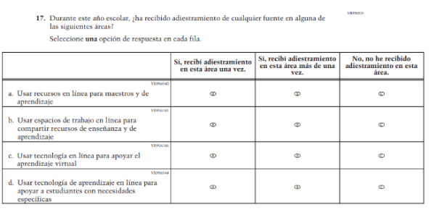  Issue: Technology Use | A | This item was developed to replace a dropped item (VH320048) and to focus on training in Technology Use.
N/A  (2024 Operational Grade 4 Teacher Core – Puerto Rico) | 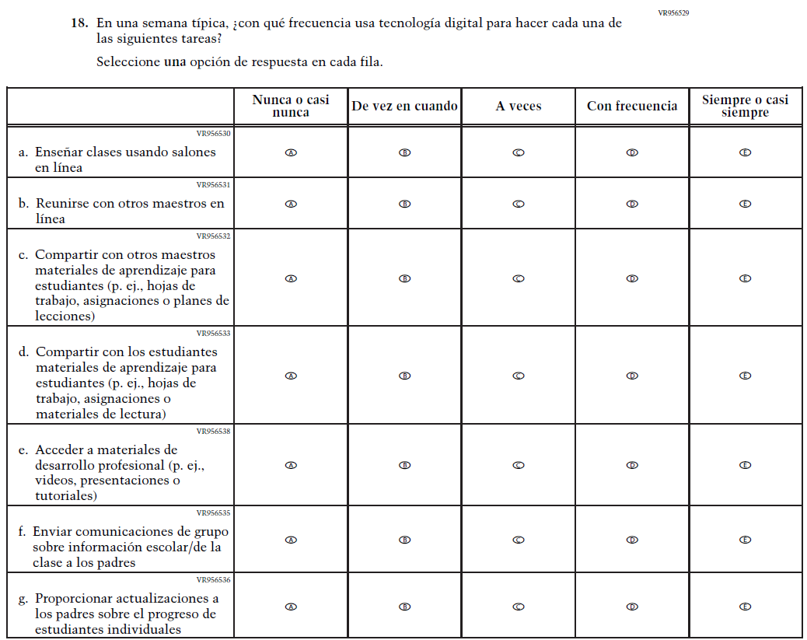  Issue: Technology Use | A | This Item was added to measure technology use among teachers.
N/A  (2024 Operational Grade 4 Teacher Core – Puerto Rico) | 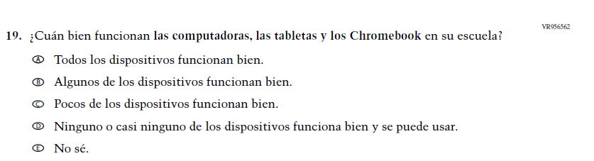  Issue: Technology Use | A | This Item was added to measure technology use among teachers.
N/A  (2024 Operational Grade 4 Teacher Core – Puerto Rico) | 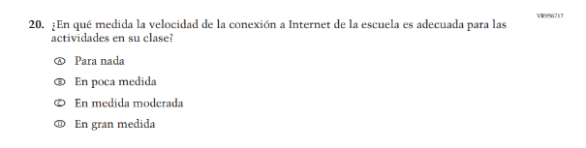  Issue: Technology Use | A | This Item was added to measure technology use among teachers.
N/A  (2024 Operational Grade 4 Teacher Core – Puerto Rico) | 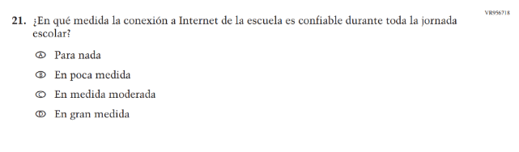  Issue: Technology Use | A | This Item was added to measure technology use among teachers.
N/A  (2024 Operational Grade 4 Teacher Core – Puerto Rico) | 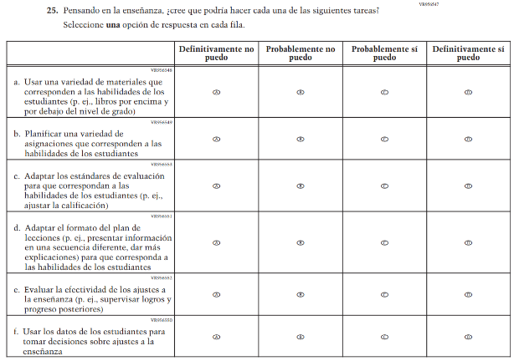  Issue: Teacher Factors | A | This Item was developed to measure teaching self-efficacy.
N/A  (2024 Operational Grade 4 Teacher Core – Puerto Rico) | 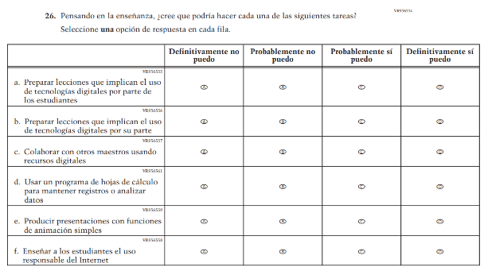  Issue: Teacher Factors | A | This Item was developed to measure teacher technology self-efficacy.

Appendix J-2a-s-PR: Operational Grade 4 CORE
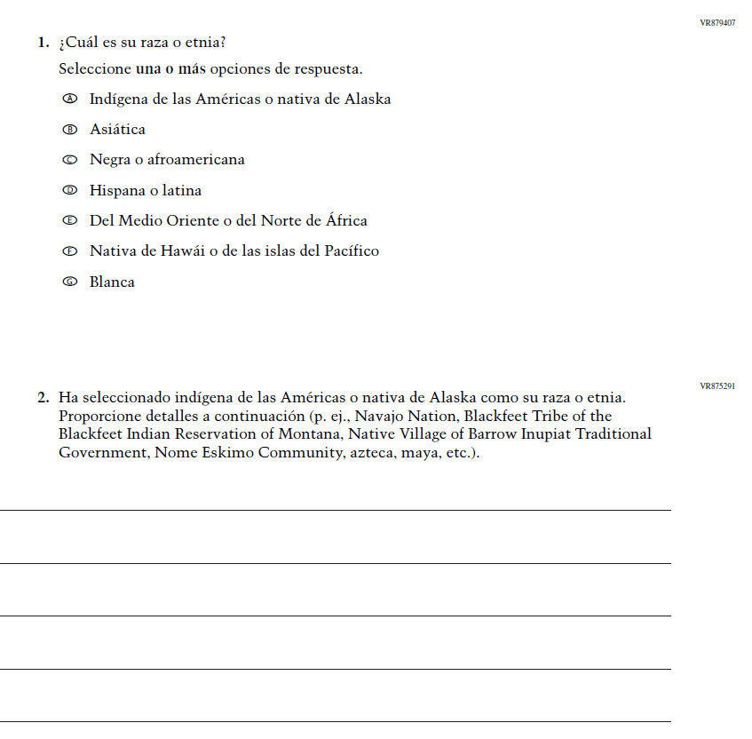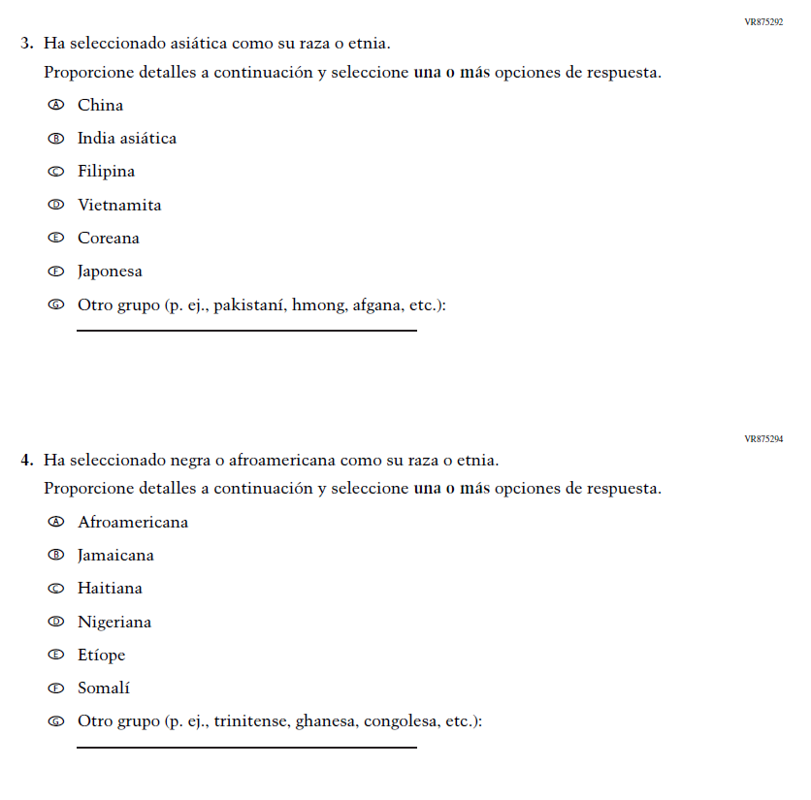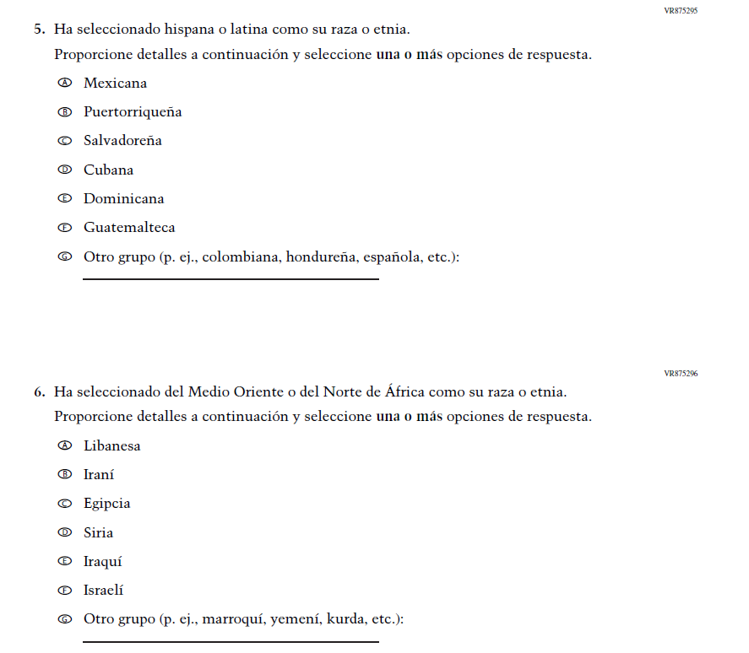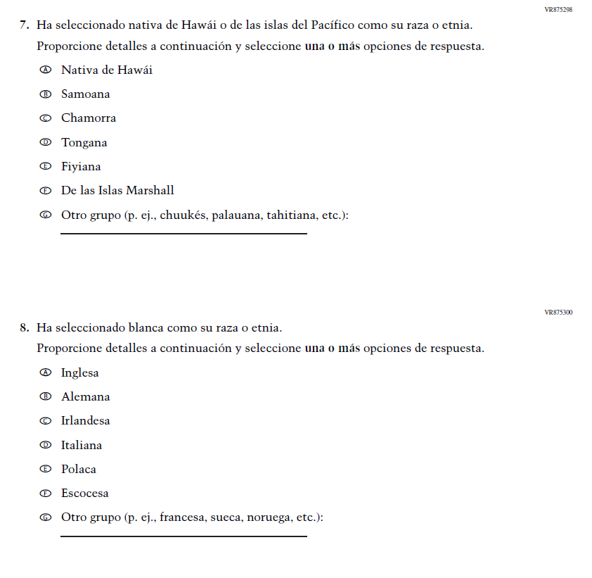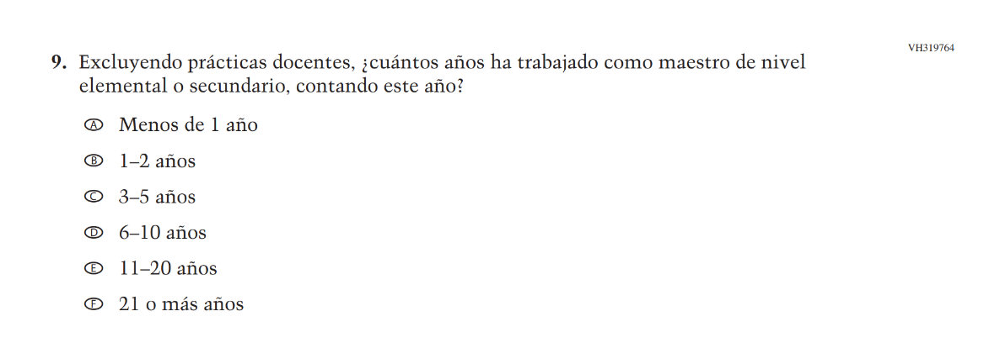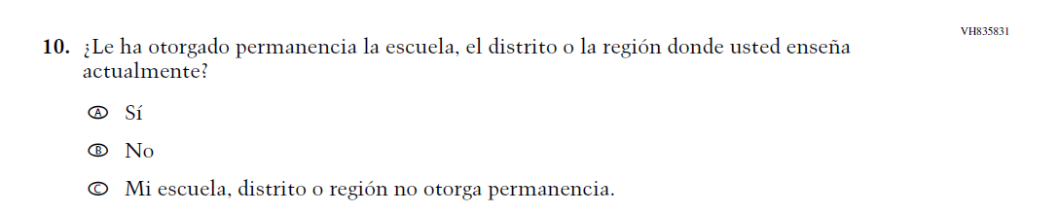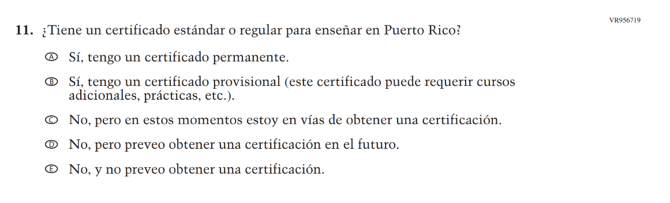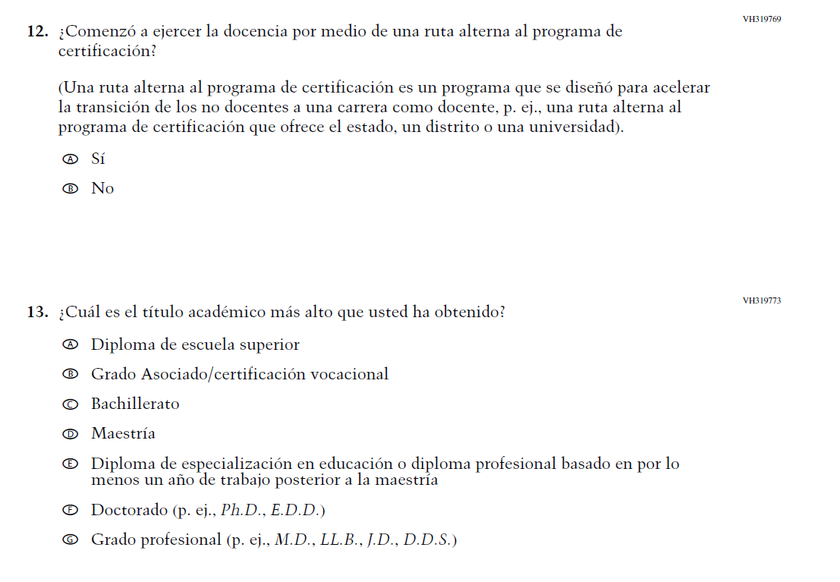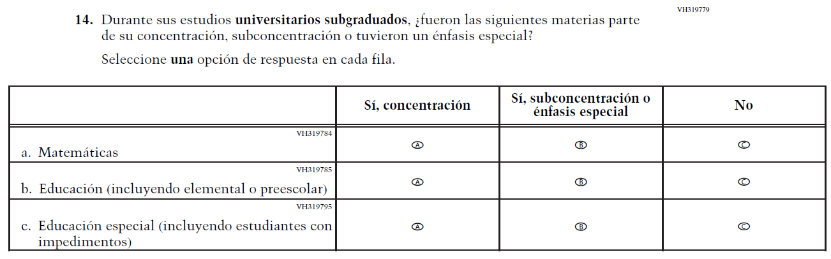
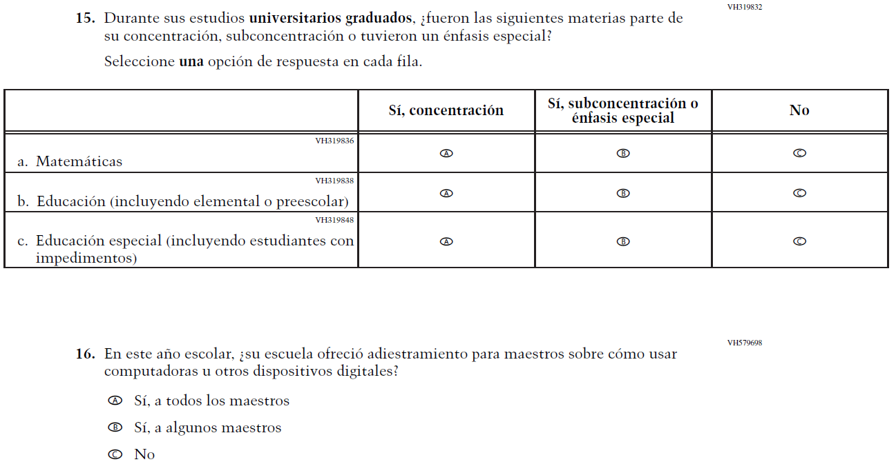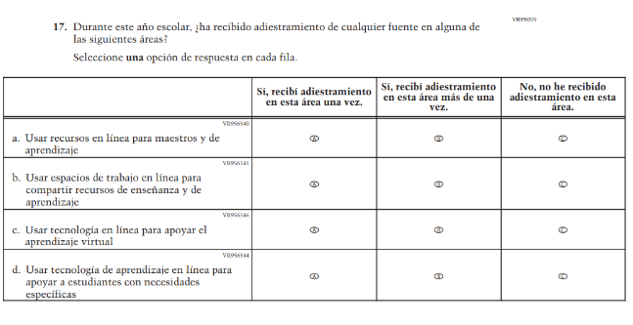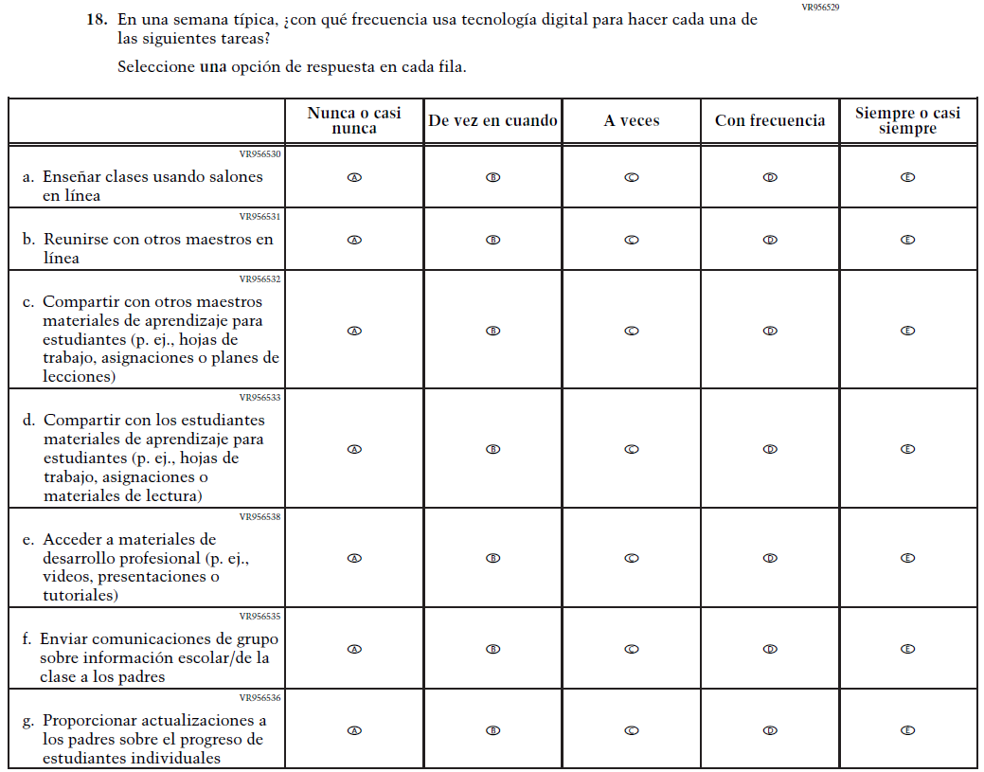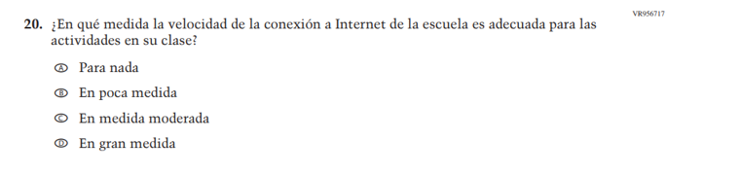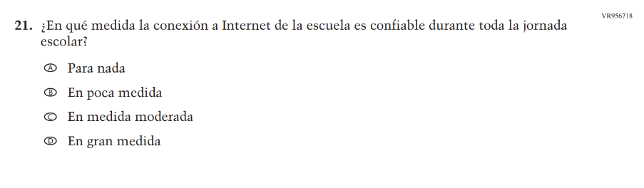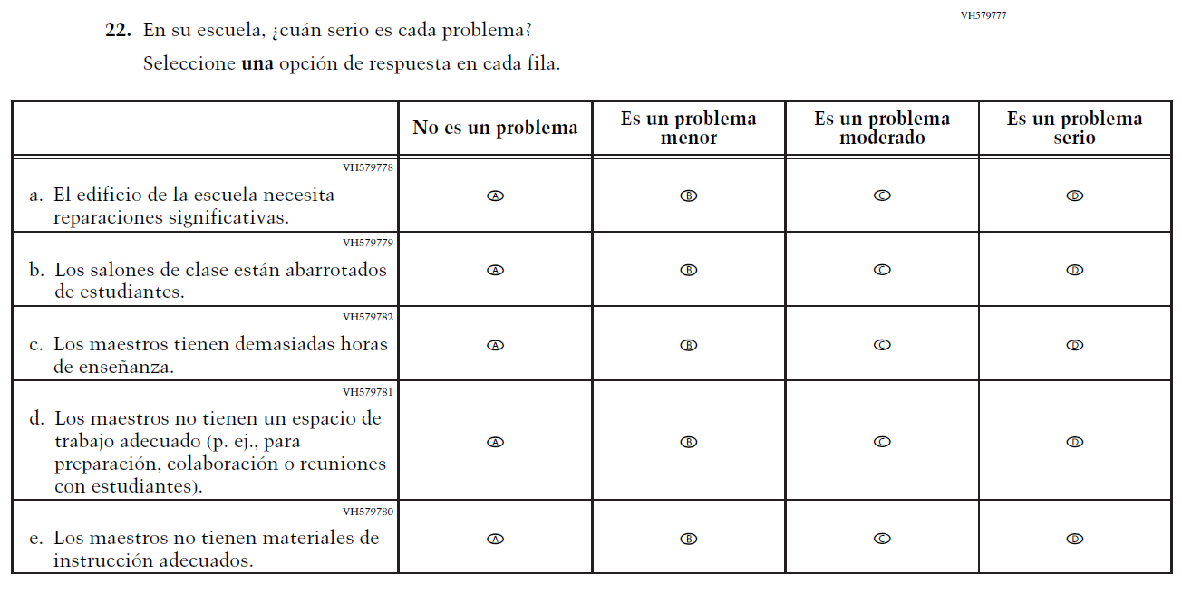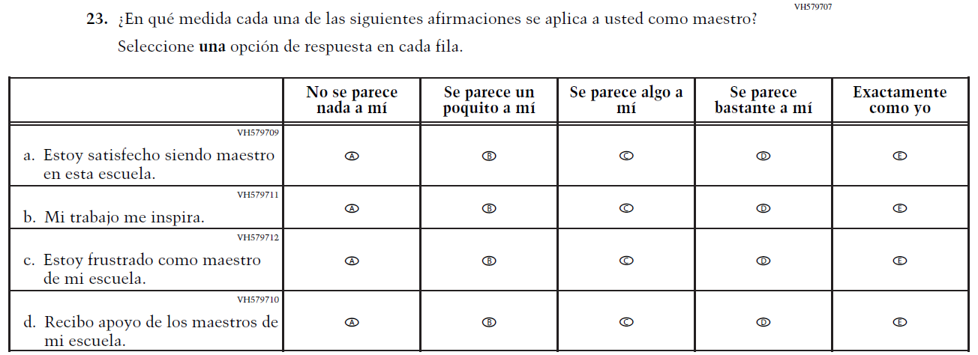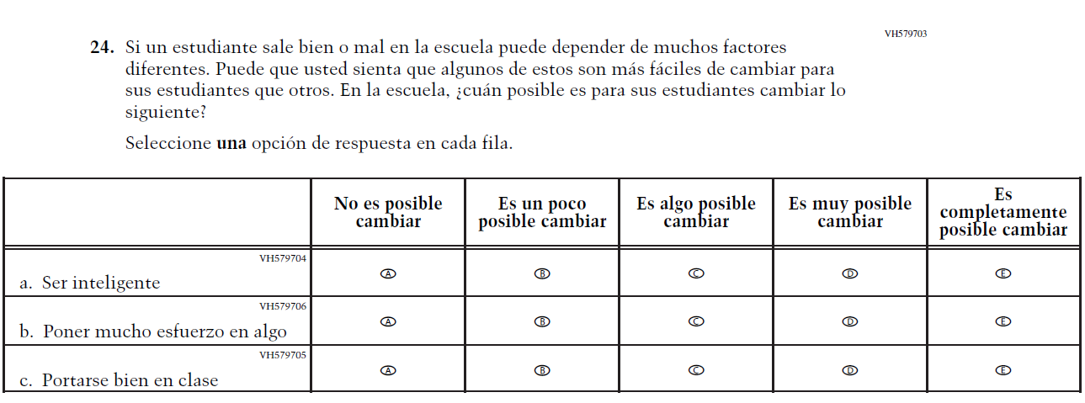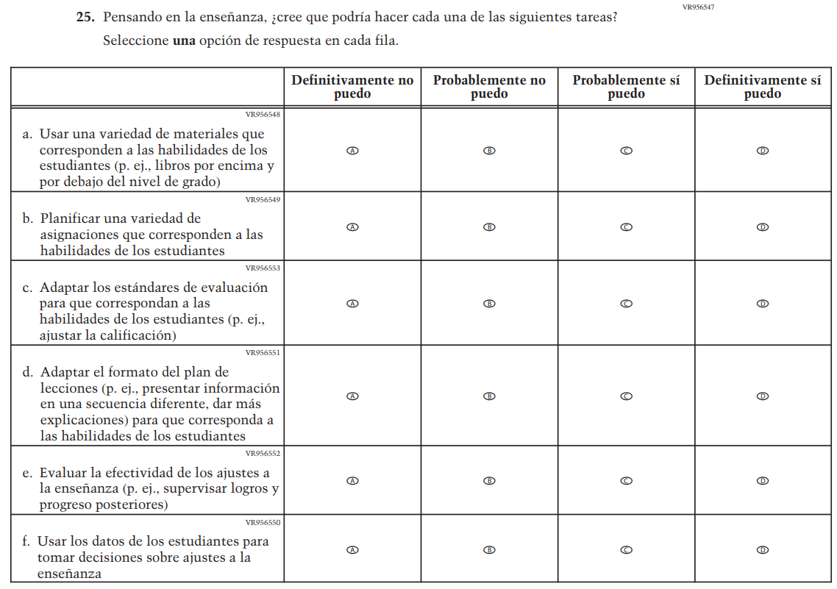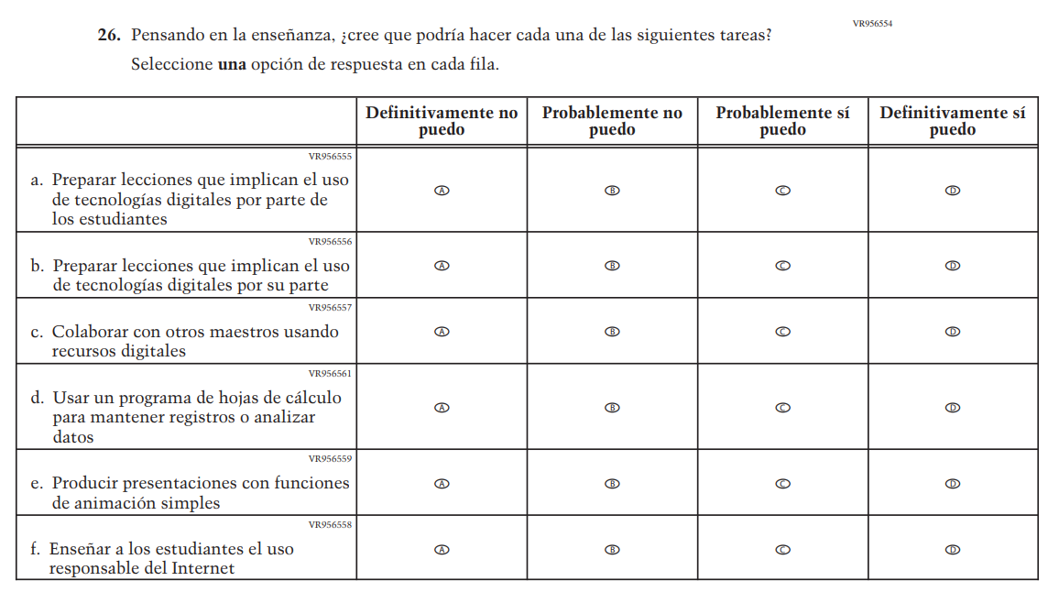

Appendix J-2b-s-PR: Summary of Changes Operational Grade 8 CORE
2026 Operational Grade 8 Core Teacher – Puerto Rico
Previous item | 2026 item | D/A/R+ | Rationale
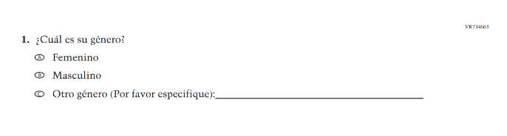  (2024 Operational Grade 8 Teacher Core – Puerto Rico) | N/A | D | This Item was dropped to adhere to the January 2025 Executive Order on gender ideology and identity.
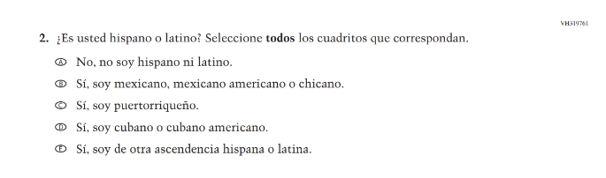  (2024 Operational Grade 8 Teacher Core – Puerto Rico) | N/A | D | This Item was dropped and folded into the following suite of updated Race/ Ethnicity Items.
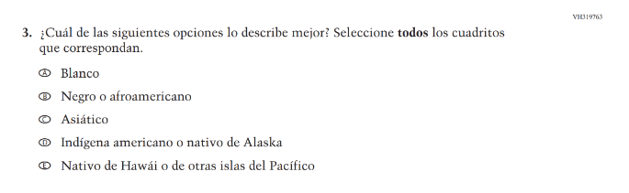  (2024 Operational Grade 8 Teacher Core – Puerto Rico) | 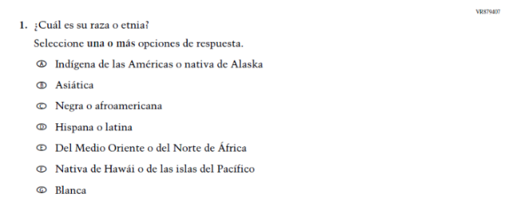  Issue: Race/Ethnicity | R | For 2026, we have aligned Inline Directions in Teacher and School Items with the Directions currently used in Student Items. The Race/ Ethnicity Items have been updated.
N/A  (2024 Operational Grade 8 Teacher Core – Puerto Rico) | 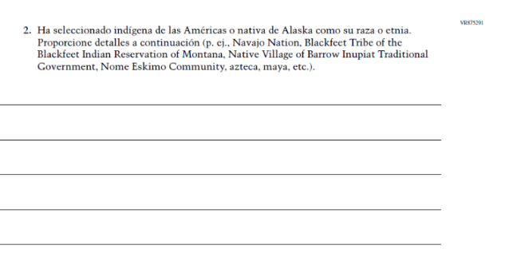Issue: Race/Ethnicity | A | The Race/ Ethnicity Items have been updated.
N/A  (2024 Operational Grade 8 Teacher Core – Puerto Rico) | 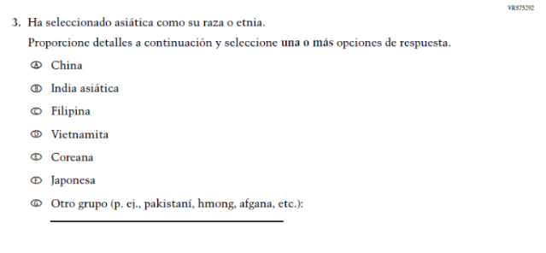Issue: Race/Ethnicity | A | The Race/ Ethnicity Items have been updated.
N/A  (2024 Operational Grade 8 Teacher Core – Puerto Rico) | 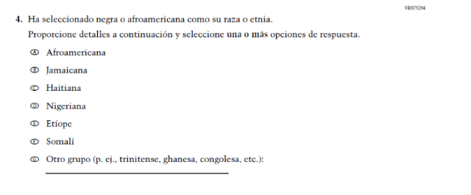Issue: Race/Ethnicity | A | The Race/ Ethnicity Items have been updated.
N/A  (2024 Operational Grade 8 Teacher Core – Puerto Rico) | 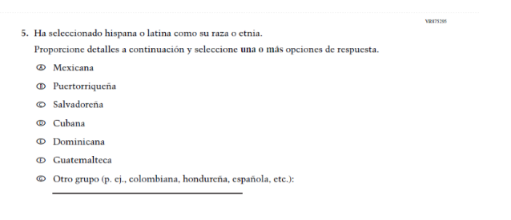Issue: Race/Ethnicity | A | The Race/ Ethnicity Items have been updated.
N/A  (2024 Operational Grade 8 Teacher Core – Puerto Rico) | 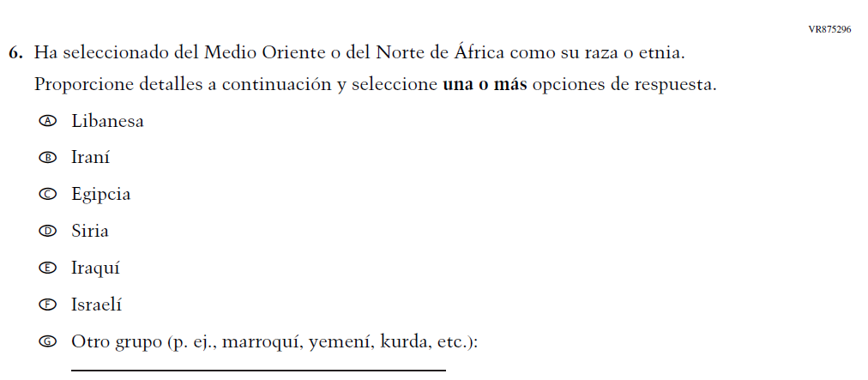Issue: Race/Ethnicity | A | The Race/ Ethnicity Items have been updated.
N/A  (2024 Operational Grade 8 Teacher Core – Puerto Rico) | 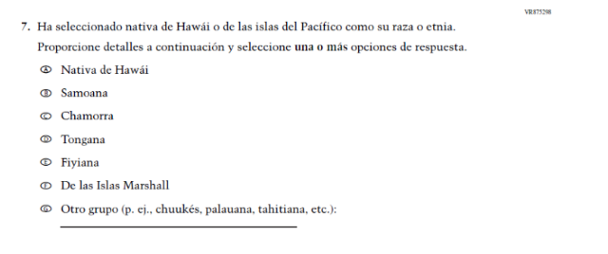Issue: Race/Ethnicity | A | The Race/ Ethnicity Items have been updated.
N/A  (2024 Operational Grade 8 Teacher Core – Puerto Rico) | 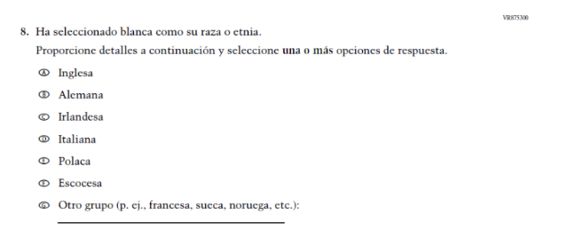Issue: Race/Ethnicity | A | The Race/ Ethnicity Items have been updated.
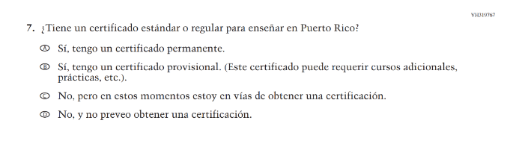(2024 Operational Grade 8 Teacher Core – Puerto Rico) | N/A | D | This item was dropped in favor of a new/revised item.
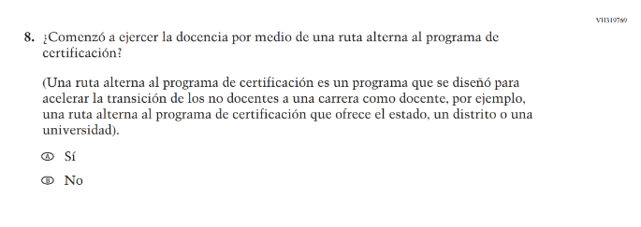(2024 Operational Grade 8 Teacher Core – Puerto Rico) | 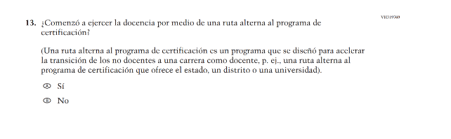  Issue: Teacher Preparation | R | We revised “por ejemplo” to “p.ej.” to be consistent with the phrasing used elsewhere in Teacher and School Items.
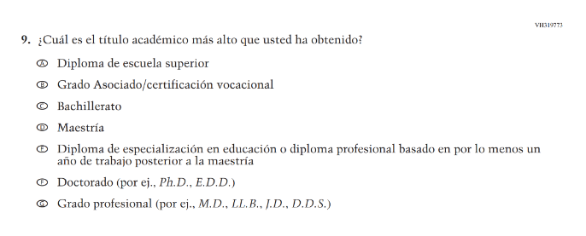  (2024 Operational Grade 8 Teacher Core – Puerto Rico) | 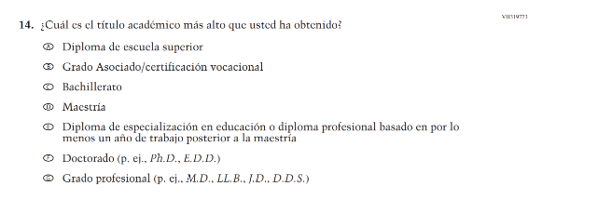  Issue: Teacher Preparation | R | We revised “por ej.” to “p.ej.” to be consistent with the phrasing used elsewhere in Teacher and School Items.
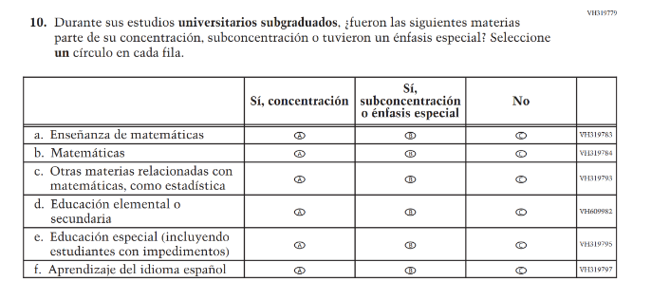(2024 Operational Grade 8 Teacher Core – Puerto Rico) | 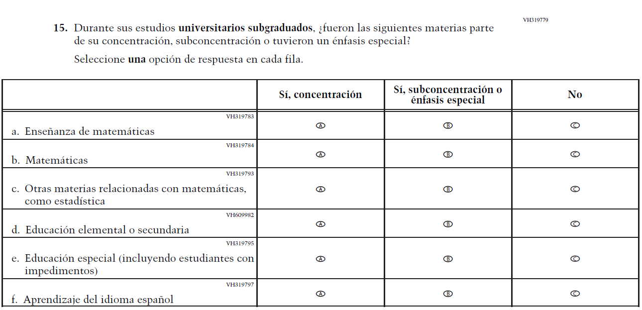  Issue: Teacher Preparation | R | For 2026, we have aligned Inline Directions in Teacher and School Items with the Directions currently used in Student Items.
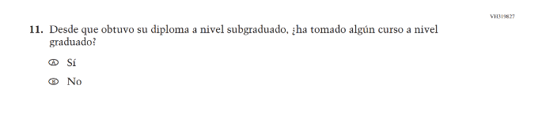(2024 Operational Grade 8 Teacher Core – Puerto Rico) | N/A | D | This Item was dropped to reduce burden and streamline content.
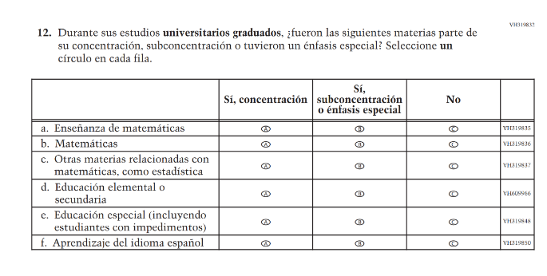(2024 Operational Grade 8 Teacher Core – Puerto Rico) | 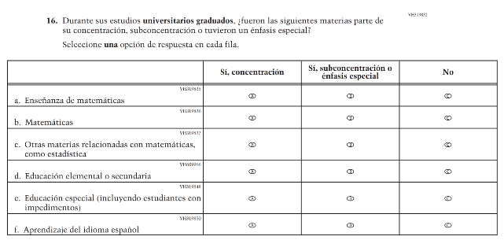  Issue: Teacher Preparation | R | For 2026, we have aligned Inline Directions in Teacher and School Items with the Directions currently used in Student Items.
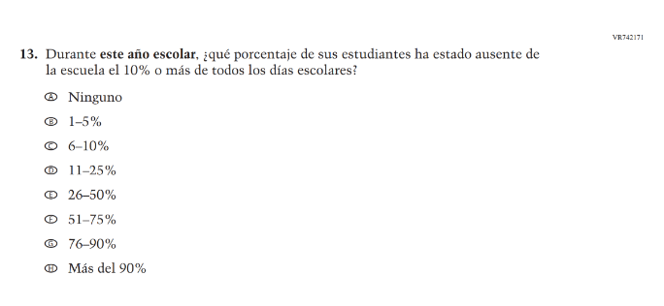(2024 Operational Grade 8 Teacher Core – Puerto Rico) | N/A | D | Learning Recovery Items were dropped from the 2026 NAEP Assessment.
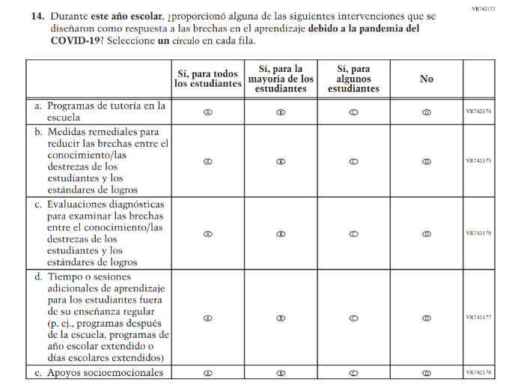(2024 Operational Grade 8 Teacher Core – Puerto Rico) | N/A | D | Learning Recovery Items were dropped from the 2026 NAEP Assessment.
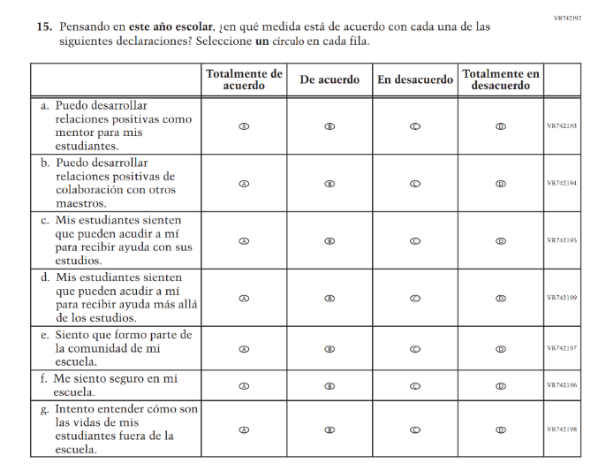(2024 Operational Grade 8 Teacher Core – Puerto Rico) | N/A | D | Learning Recovery Items were dropped from the 2026 NAEP Assessment.
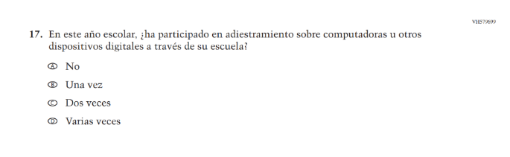(2024 Operational Grade 8 Teacher Core – Puerto Rico) | N/A | D | This Item was dropped to prioritize newer, updated Teacher items on Technology Use.
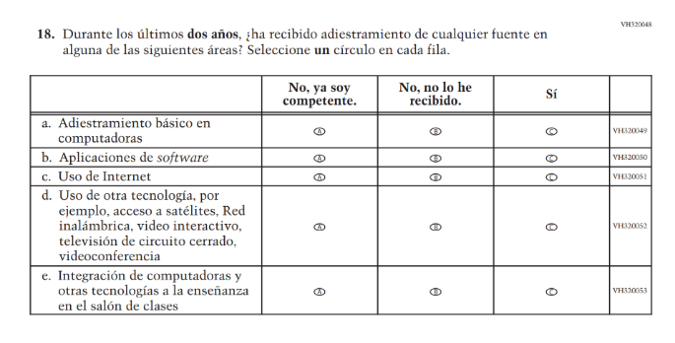(2024 Operational Grade 8 Teacher Core – Puerto Rico) | N/A | D | This item was dropped in favor of a new/revised item.
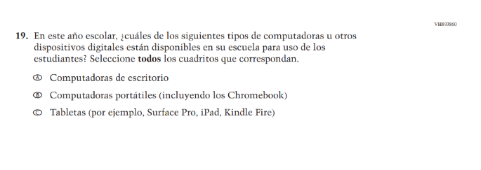(2024 Operational Grade 8 Teacher Core – Puerto Rico) | N/A | D | This and the related Items were dropped in favor of a more current and concise format for questions on Technology Use.
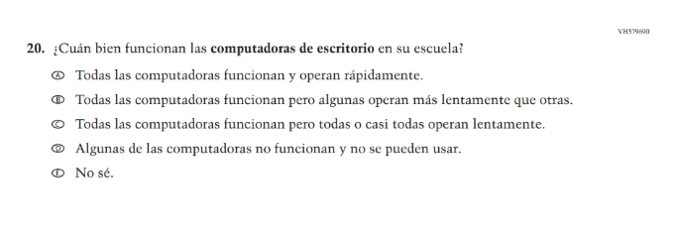(2024 Operational Grade 8 Teacher Core – Puerto Rico) | N/A | D | This and the related Items were dropped in favor of a more current and concise format for questions on Technology Use.
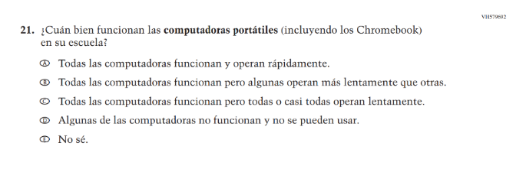(2024 Operational Grade 8 Teacher Core – Puerto Rico) | N/A | D | This and the related Items were dropped in favor of a more current and concise format for questions on Technology Use.
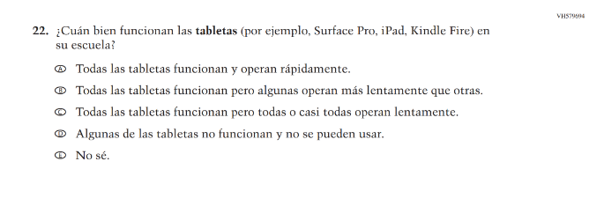(2024 Operational Grade 8 Teacher Core – Puerto Rico) | N/A | D | This and the related Items were dropped in favor of a more current and concise format for questions on Technology Use.
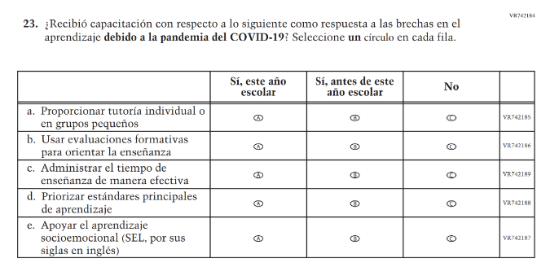(2024 Operational Grade 8 Teacher Core – Puerto Rico) | N/A  Issue: | D | Learning Recovery Items were dropped from the 2026 NAEP Assessment.
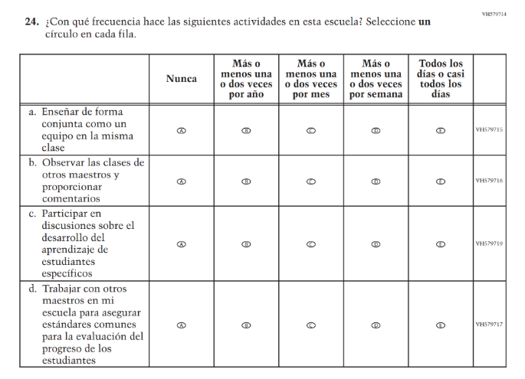(2024 Operational Grade 8 Teacher Core – Puerto Rico) | N/A | D | This Item was dropped to make space for new Teacher Items in the 2026 NAEP Assessment.
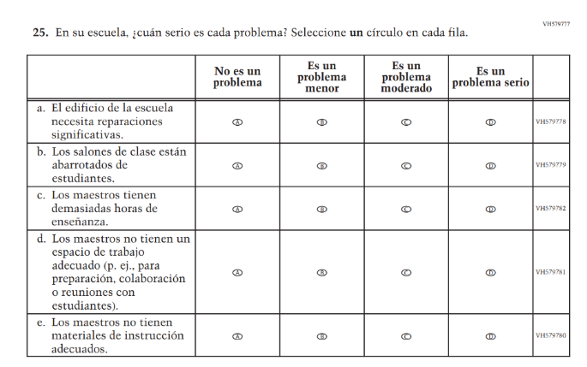(2024 Operational Grade 8 Teacher Core – Puerto Rico) | 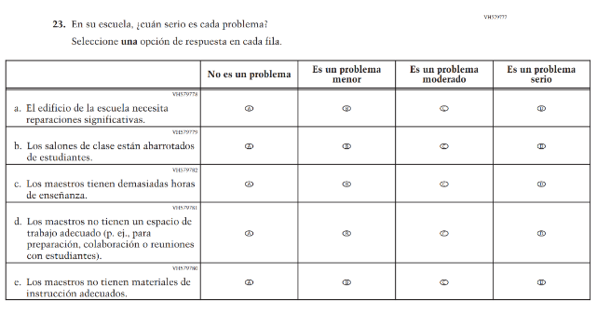Issue: School Climate | R | For 2026, we have aligned Inline Directions in Teacher and School Items with the Directions currently used in Student Items.
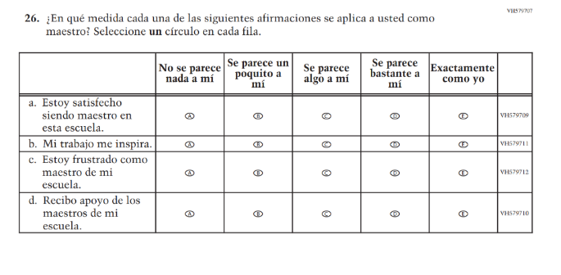(2024 Operational Grade 8 Teacher Core – Puerto Rico) | 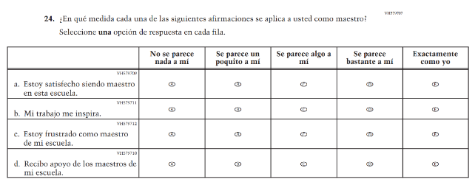Issue: School Climate | R | For 2026, we have aligned Inline Directions in Teacher and School Items with the Directions currently used in Student Items.
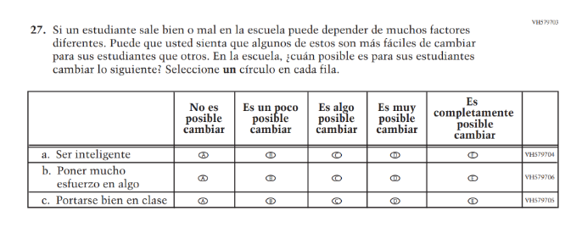(2024 Operational Grade 8 Teacher Core – Puerto Rico) | 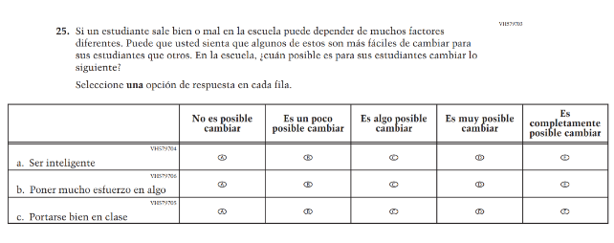Issue: Desire for Learning | R | For 2026, we have aligned Inline Directions in Teacher and School Items with the Directions currently used in Student Items.

2026 Operational Grade 8 Core Teacher – Puerto Rico
Previous item | 2026 item | D/A/R+ | Rationale
N/A  (2024 Operational Grade 8 Teacher Core – Puerto Rico) | 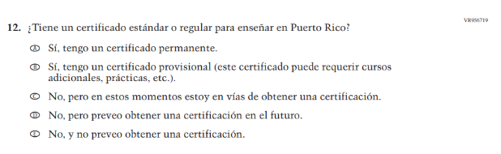  Issue: Teacher Preparation | A | This item was developed to replace a dropped item (VH319767).
N/A  (2024 Operational Grade 8 Teacher Core – Puerto Rico) | 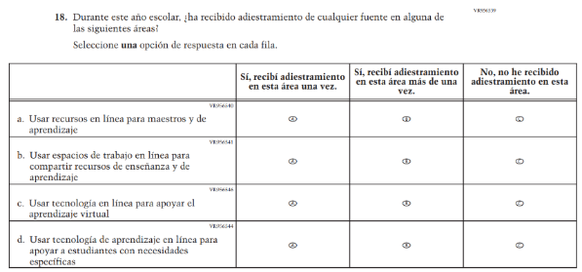  Issue: Technology Use | A | This item was developed to replace a dropped item (VH320048) and to focus on training in Technology Use.
N/A  (2024 Operational Grade 8 Teacher Core – Puerto Rico) | 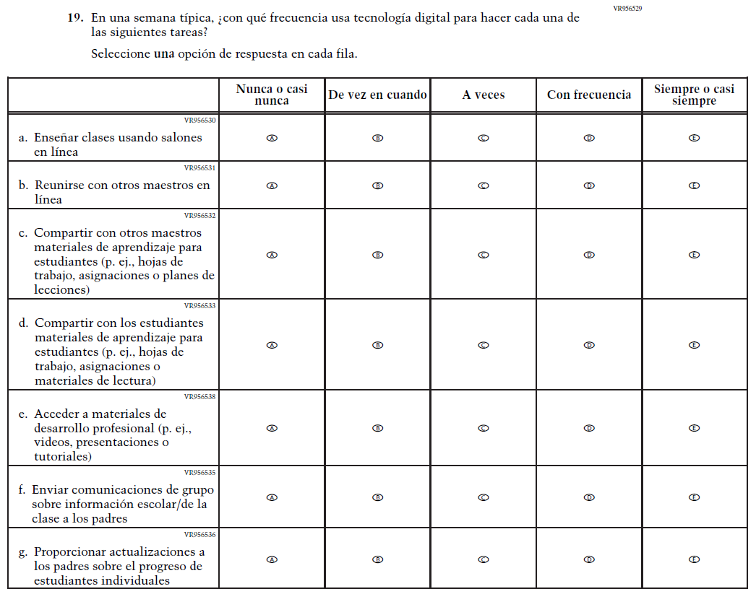  Issue: Technology Use | A | This Item was added to measure technology use among teachers.
N/A  (2024 Operational Grade 8 Teacher Core – Puerto Rico) | 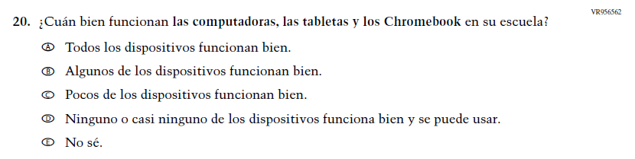  Issue: Technology Use | A | This Item was developed to measure technology use and quality of digital technology in schools.
N/A  (2024 Operational Grade 8 Teacher Core – Puerto Rico) | 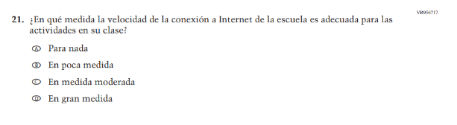  Issue: Technology Use | A | This Item was developed to measure technology use and quality of digital technology in schools.
N/A  (2024 Operational Grade 8 Teacher Core – Puerto Rico) | 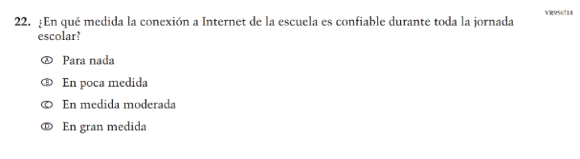  Issue: Technology Use | A | This Item was added to measure technology use among teachers.
N/A  (2024 Operational Grade 8 Teacher Core – Puerto Rico) | 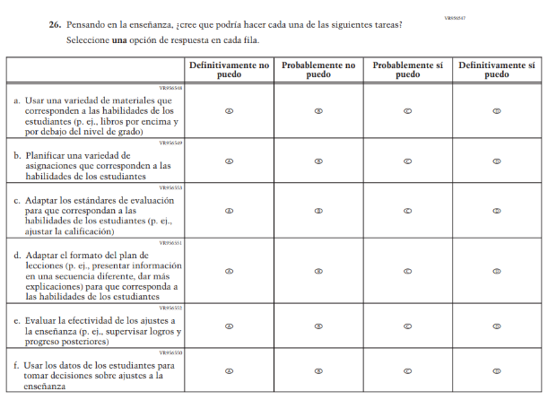  Issue: Teacher Factors | A | This Item was developed to measure teaching self-efficacy.
N/A  (2024 Operational Grade 8 Teacher Core – Puerto Rico) | 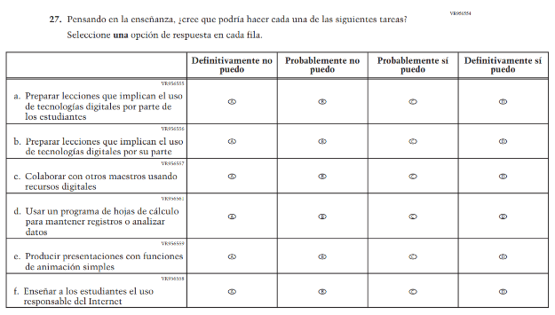  Issue: Teacher Factors | A | This Item was developed to measure teacher technology self-efficacy.

Appendix J-2b-s-PR: Operational Grade 8 CORE
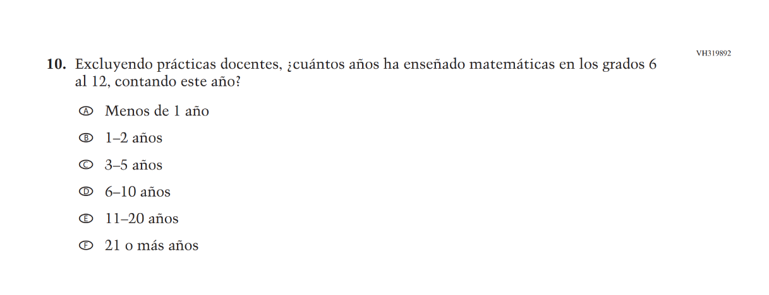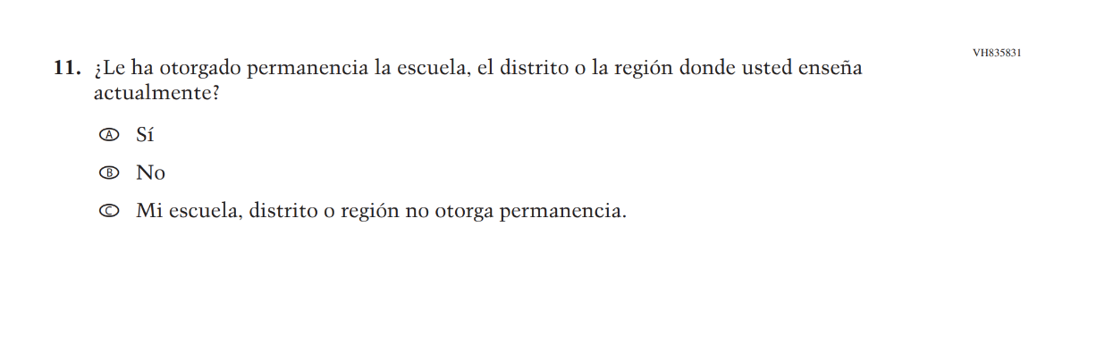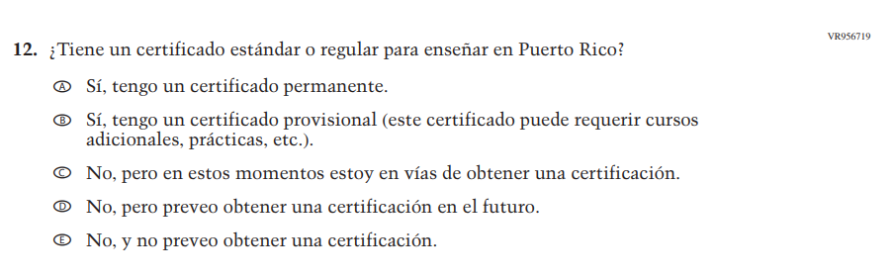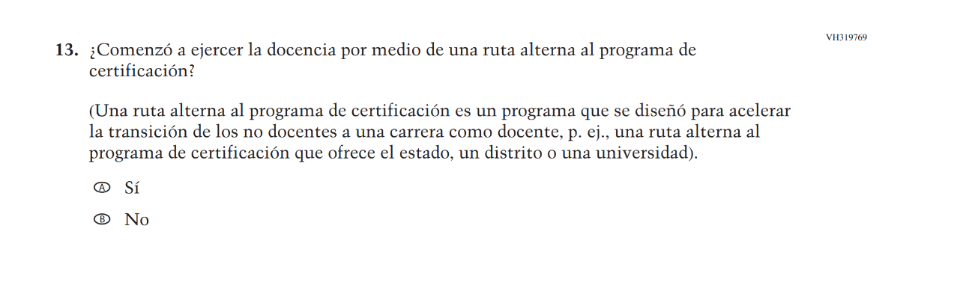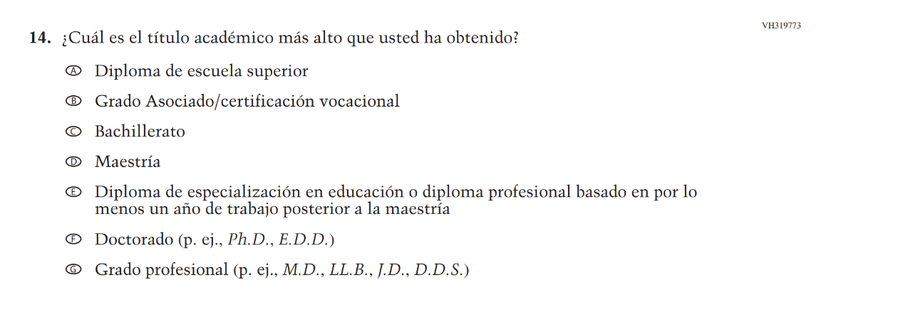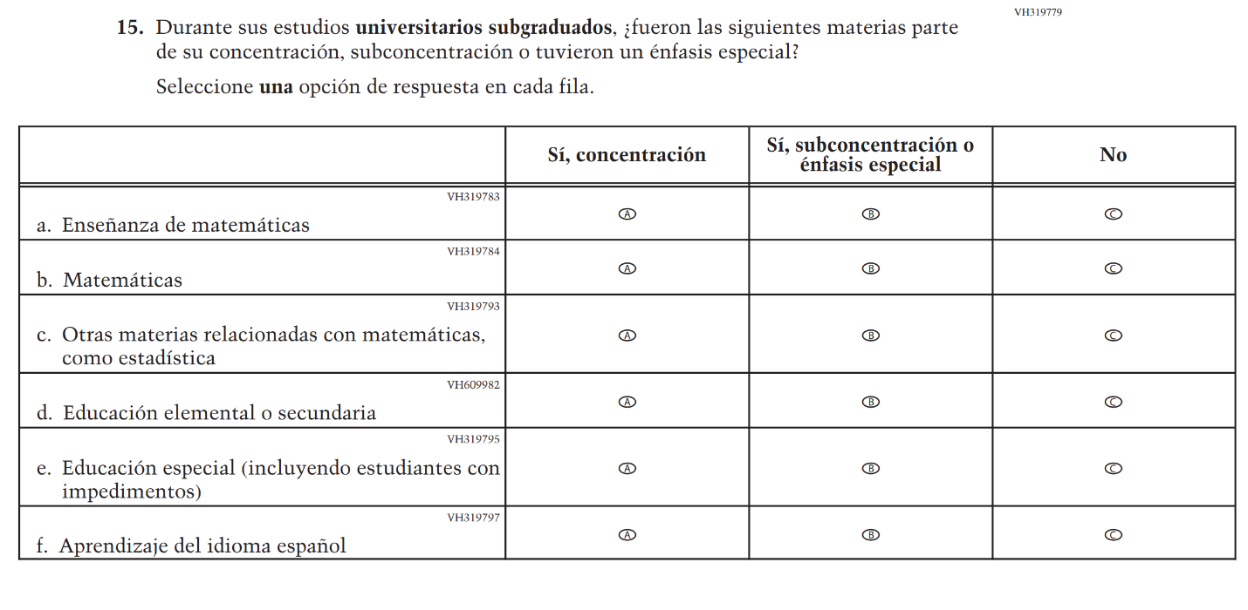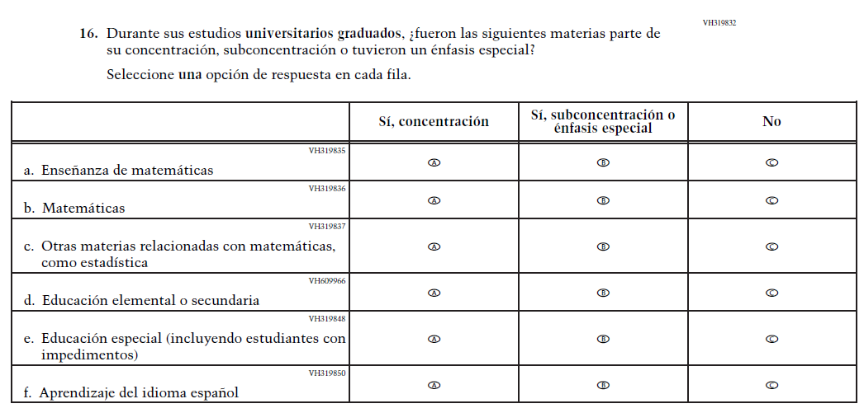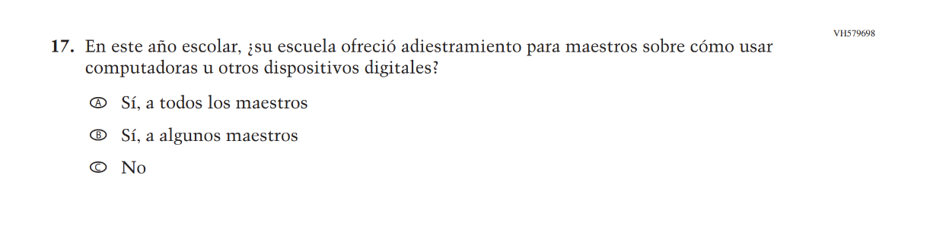
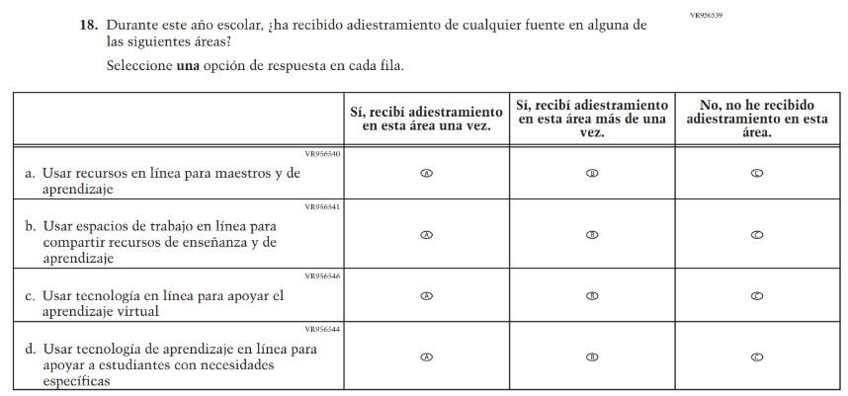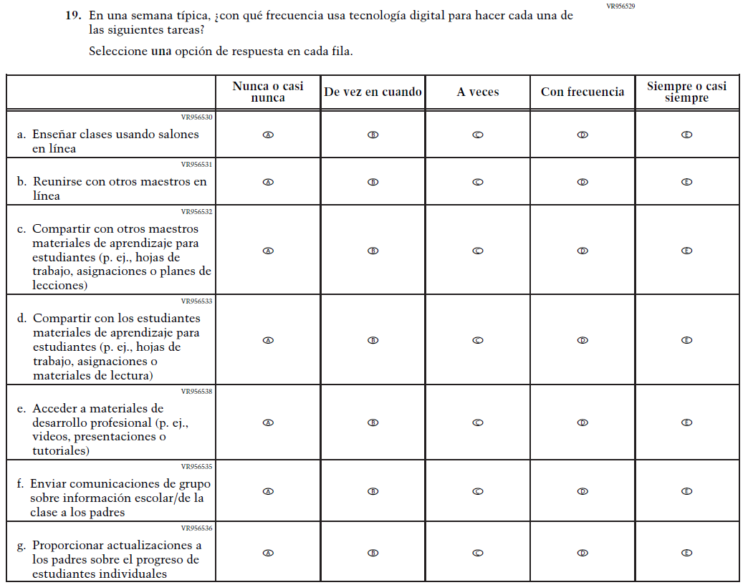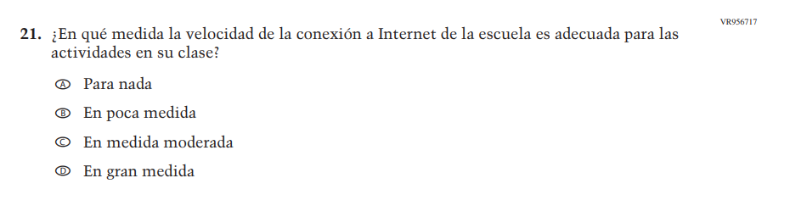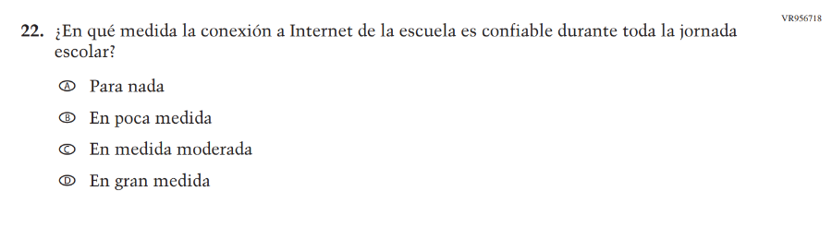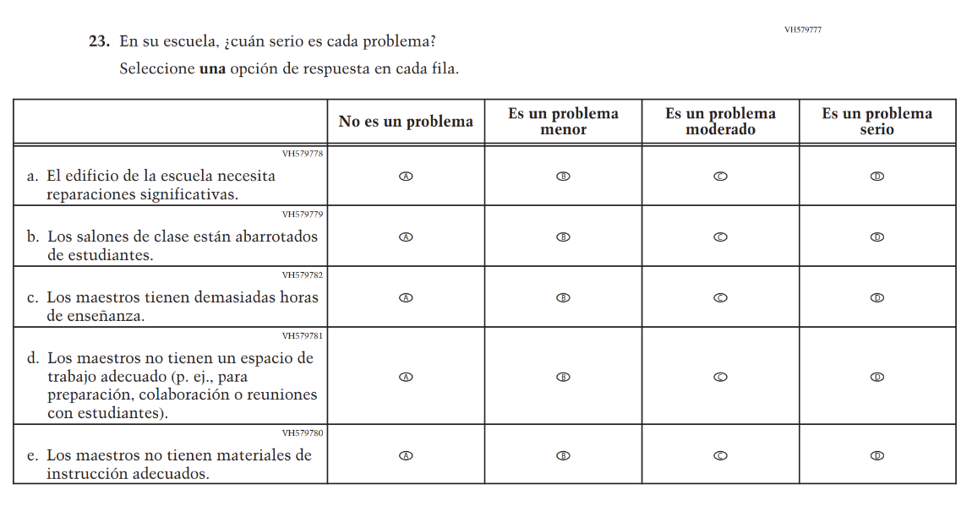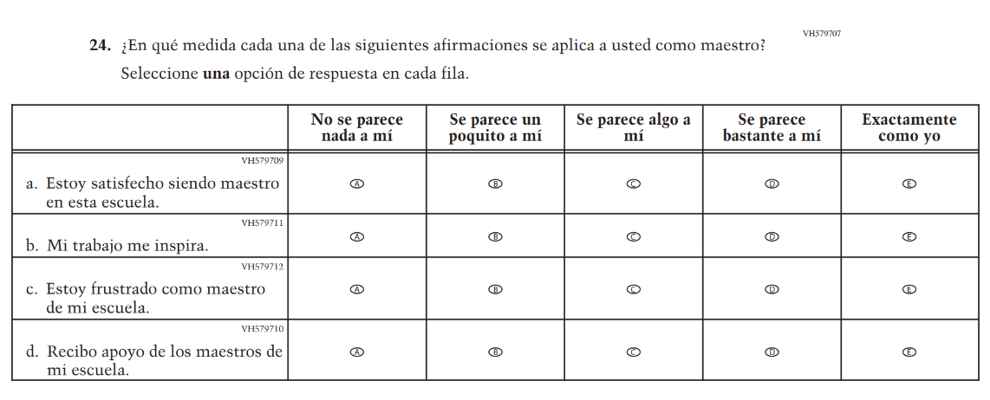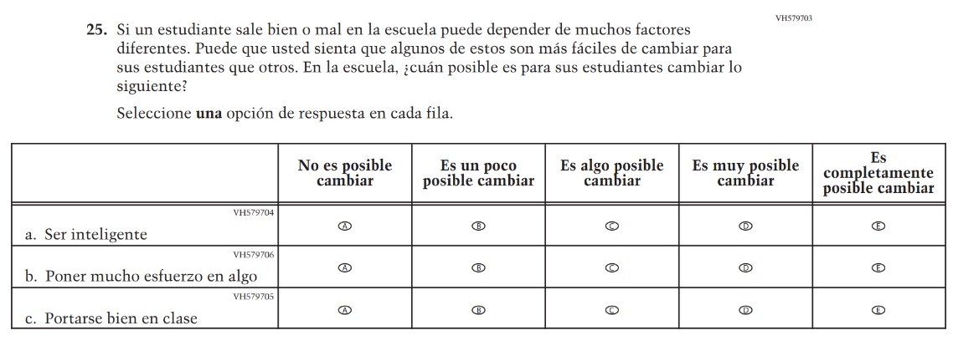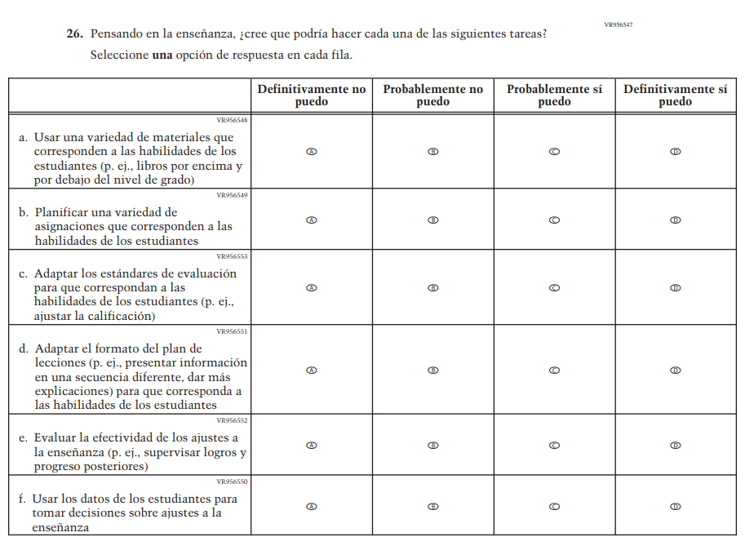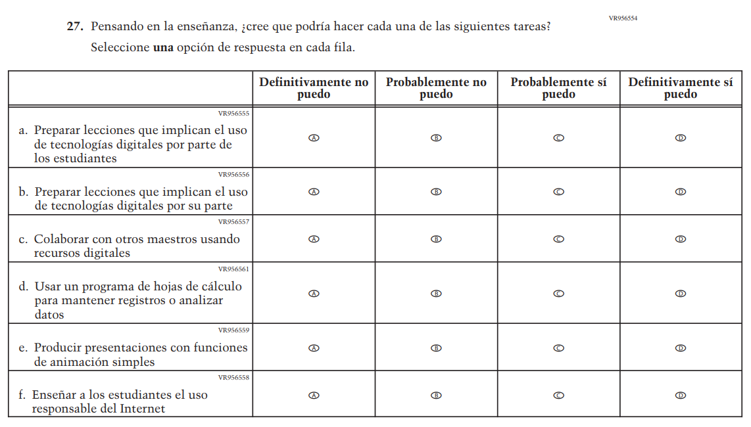

Appendix J-2c-s-PR: Summary of Changes Operational Grade 4 Mathematics
2026 Operational Grade 4 Math Teacher – Puerto Rico
Previous item | 2026 item | D/A/R+ | Rationale
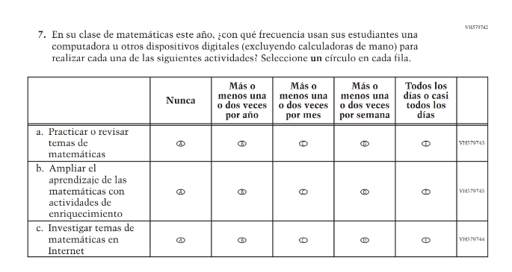  (2024 Operational Grade 4 Teacher Math – Puerto Rico) | 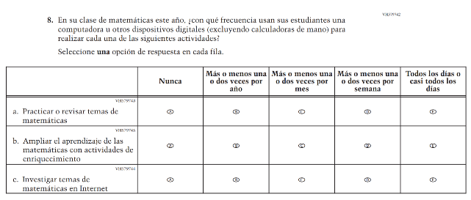  Issue: Instructional Organization and Strategies | R | For 2026, we have aligned Inline Directions in Teacher and School Items with the Directions currently used in Student Items.
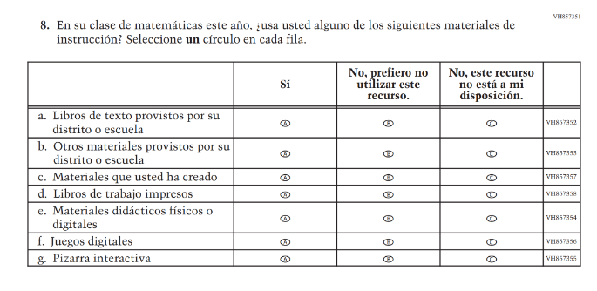  (2024 Operational Grade 4 Teacher Math – Puerto Rico) | N/A | D | This item was dropped in favor of a new/revised item.
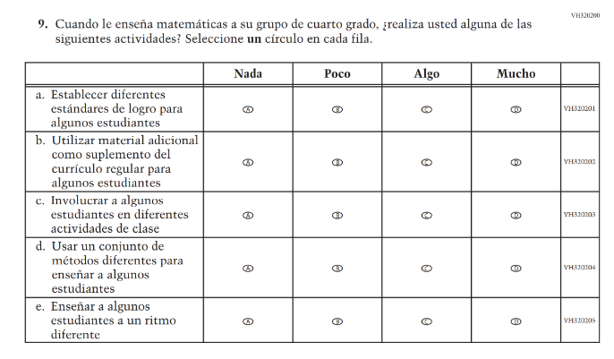  (2024 Operational Grade 4 Teacher Math – Puerto Rico) | N/A | D | This item was dropped in favor of a new/revised item.
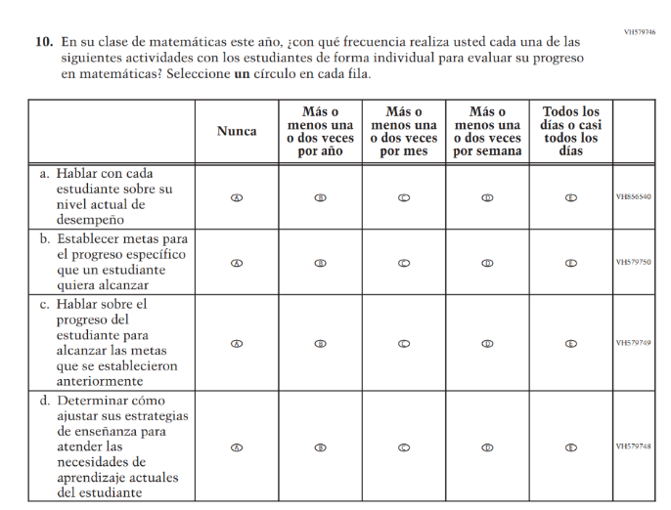(2024 Operational Grade 4 Teacher Math – Puerto Rico) | 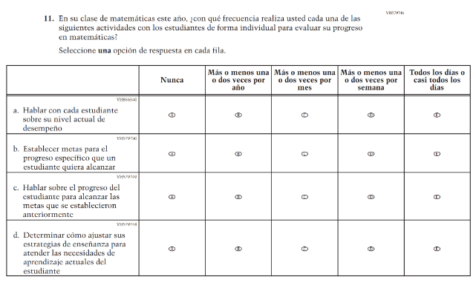  Issue: Instructional Organization and Strategies | R | For 2026, we have aligned Inline Directions in Teacher and School Items with the Directions currently used in Student Items.
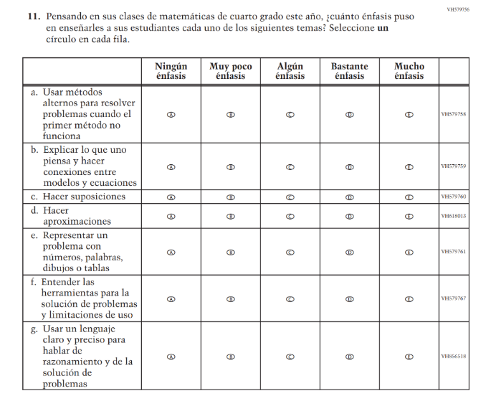(2024 Operational Grade 4 Teacher Math – Puerto Rico) | N/A | D | This item was dropped in favor of a new/revised item.
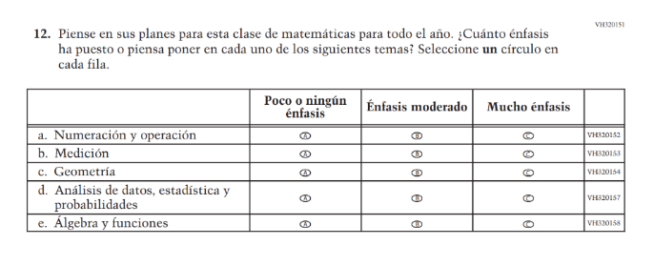  (2024 Operational Grade 4 Teacher Math – Puerto Rico) | N/A | D | This Item was dropped to reduce questionnaire length.
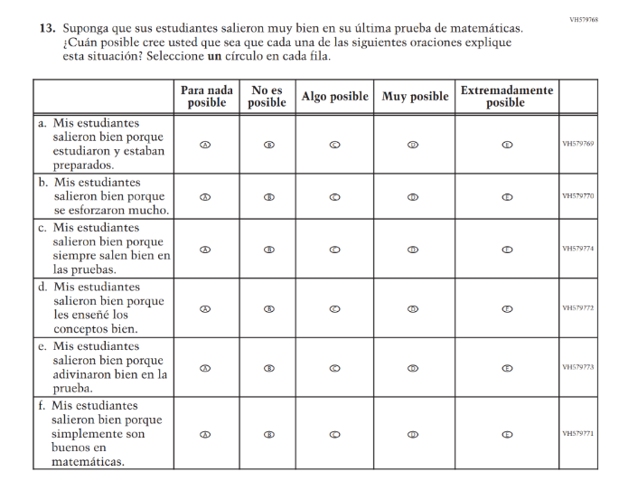(2024 Operational Grade 4 Teacher Math – Puerto Rico) | N/A | D | This Item was dropped to reduce questionnaire length.
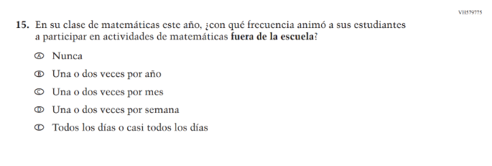(2024 Operational Grade 4 Teacher Math – Puerto Rico) | N/A | D | This item was dropped to reduce questionnaire length.
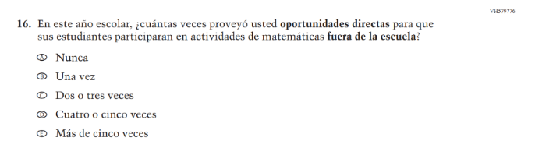(2024 Operational Grade 4 Teacher Math – Puerto Rico) | N/A | D | This item was dropped to reduce questionnaire length.

2026 Operational Grade 4 Math Teacher – Puerto Rico
Previous item | 2026 item | D/A/R+ | Rationale
N/A  (2024 Operational Grade 4 Teacher Math – Puerto Rico) | 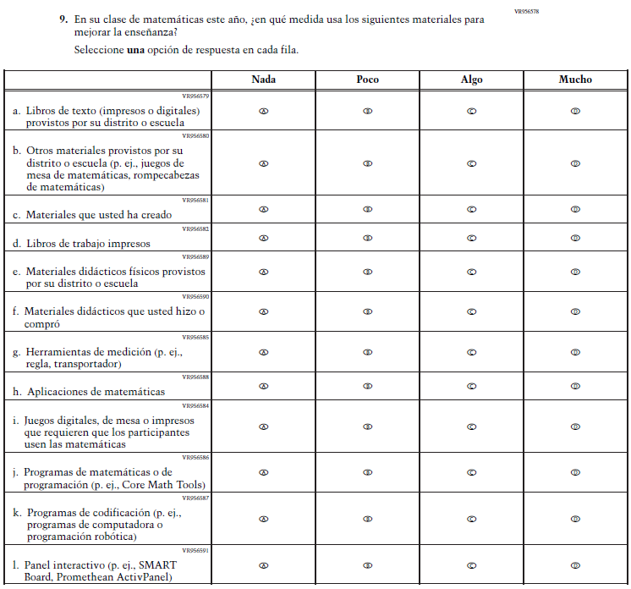  Issue: Instructional Resources | A | This item was developed to measure content aligned with the new Mathematics framework.
N/A  (2024 Operational Grade 4 Teacher Math – Puerto Rico) | 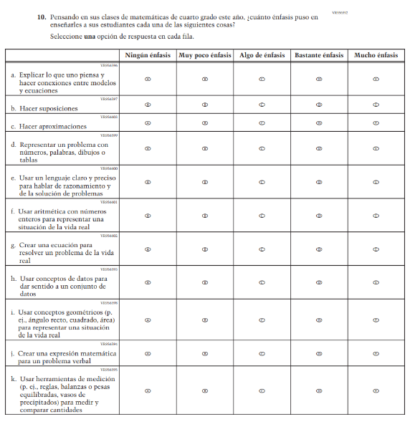  Issue: N/A | A | This item was developed to measure content aligned with the new Mathematics framework.
N/A  (2024 Operational Grade 4 Teacher Math – Puerto Rico) | 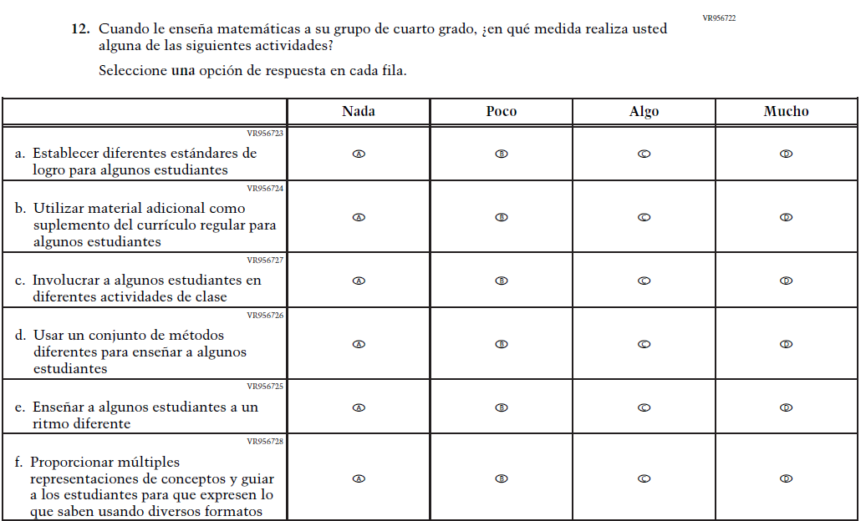  Issue: Instructional Organization and Strategies | A | This item was developed to measure content aligned with the new Mathematics framework.
N/A  (2024 Operational Grade 4 Teacher Math – Puerto Rico) | 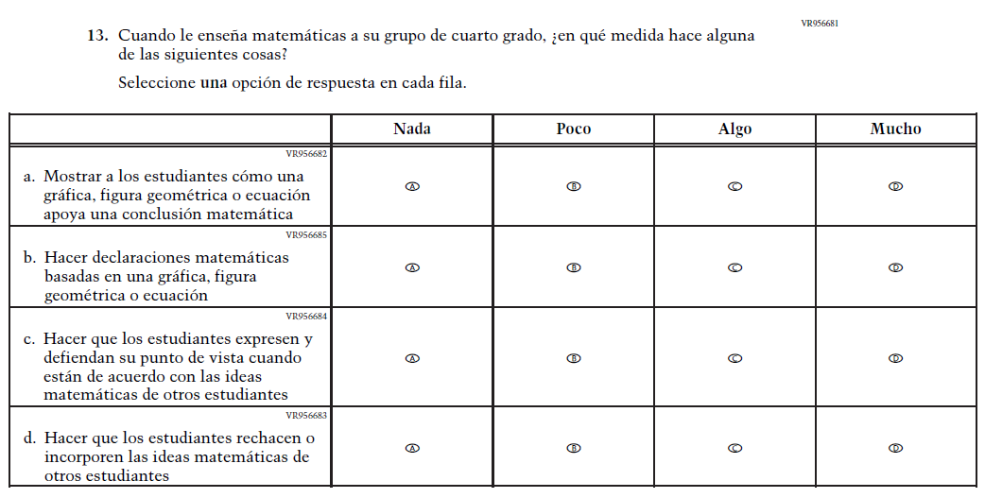  Issue: Instructional Organization and Strategies | A | This item was developed to measure content aligned with the new Mathematics framework.
N/A  (2024 Operational Grade 4 Teacher Math – Puerto Rico) | 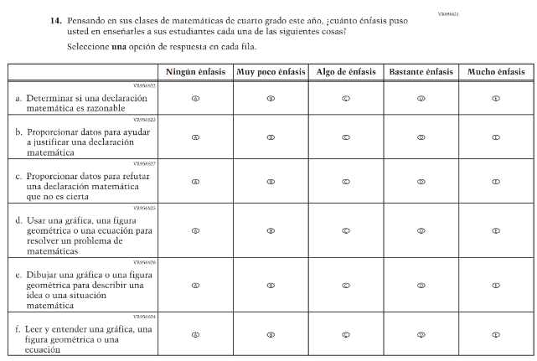  Issue: Mathematical Content and Practices | A | This item was developed to measure content aligned with the new Mathematics framework.
N/A  (2024 Operational Grade 4 Teacher Math – Puerto Rico) | 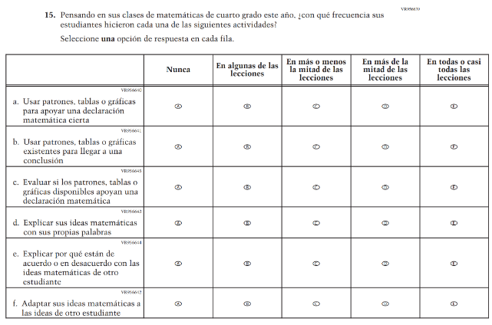  Issue: Mathematical Content and Practices | A | This item was developed to measure content aligned with the new Mathematics framework.
N/A  (2024 Operational Grade 4 Teacher Math – Puerto Rico) | 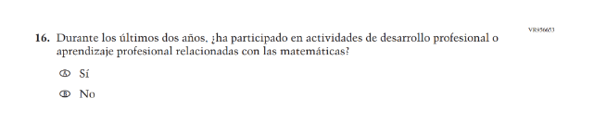  Issue: Teacher Factors | A | This item was developed to measure content aligned with the new Mathematics framework.
N/A  (2024 Operational Grade 4 Teacher Math – Puerto Rico) | 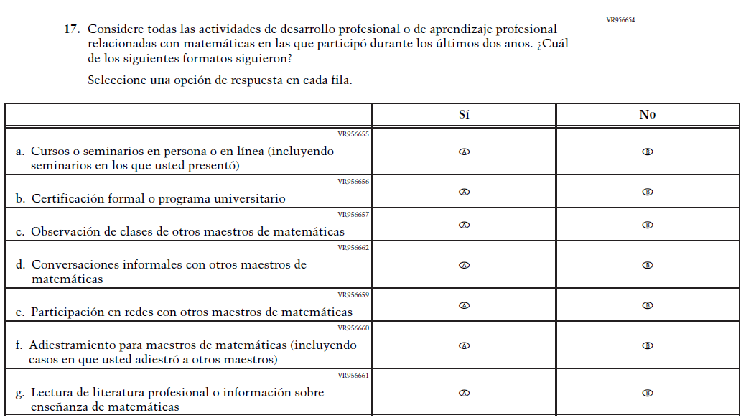  Issue: Teacher Factors | A | This item was developed to measure content aligned with the new Mathematics framework.
N/A  (2024 Operational Grade 4 Teacher Math – Puerto Rico) | 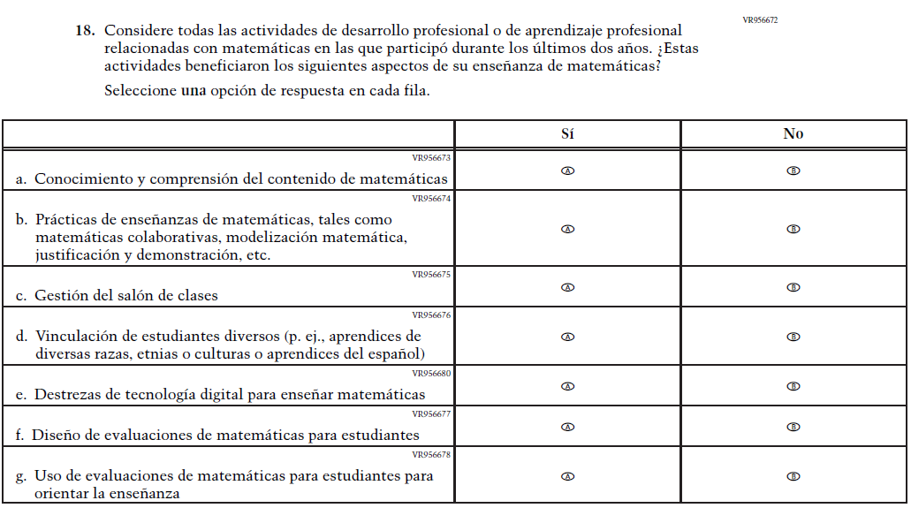  Issue: Teacher Factors | A | This item was developed to measure content aligned with the new Mathematics framework.

Appendix J-2c-s-PR: Operational Grade 4 Mathematics
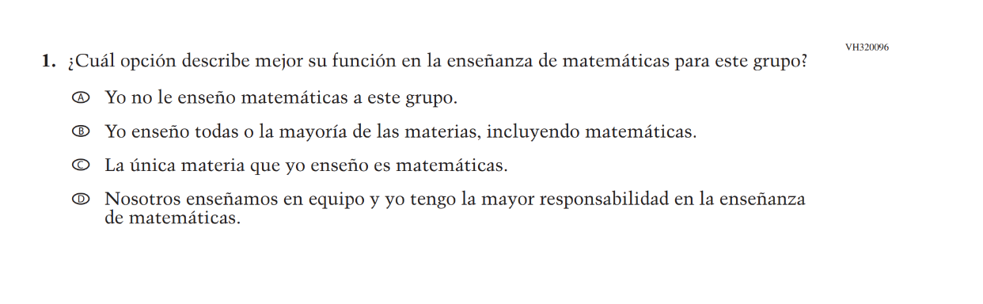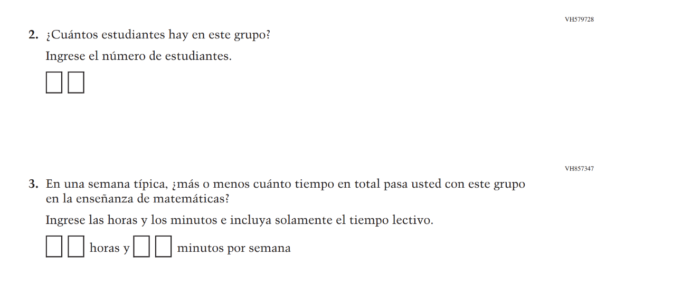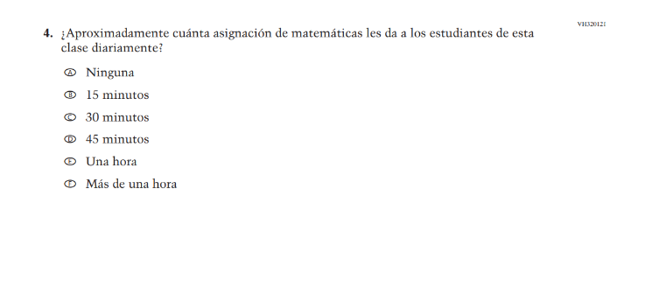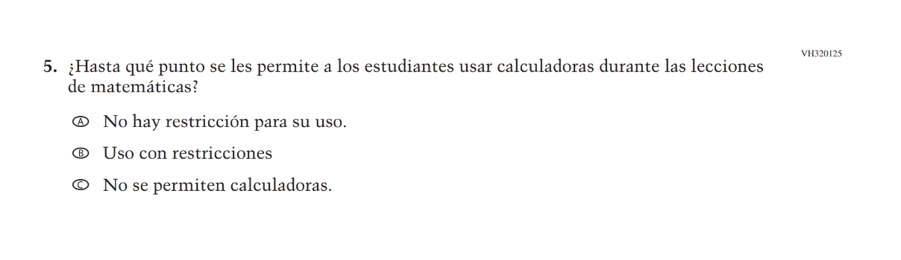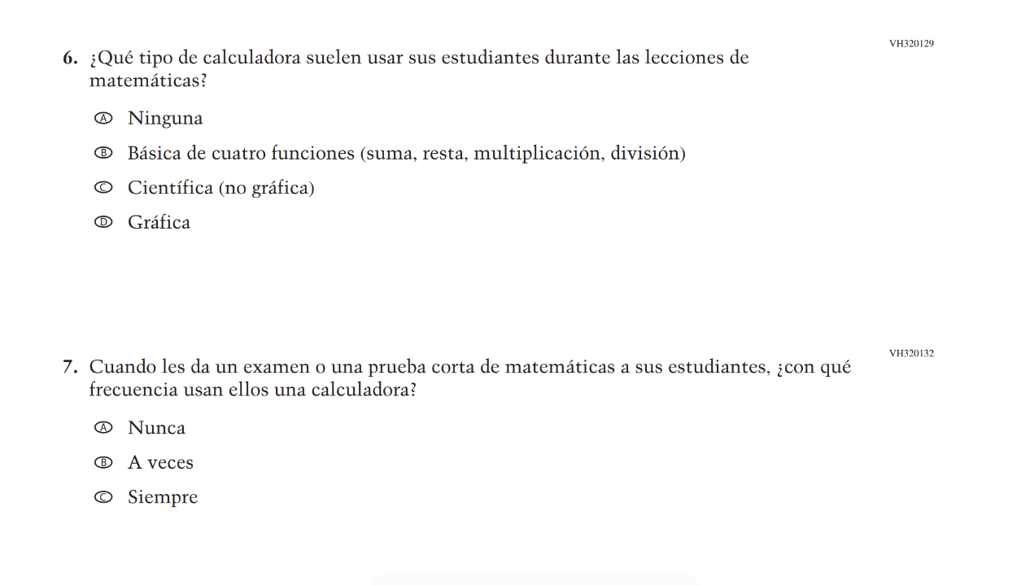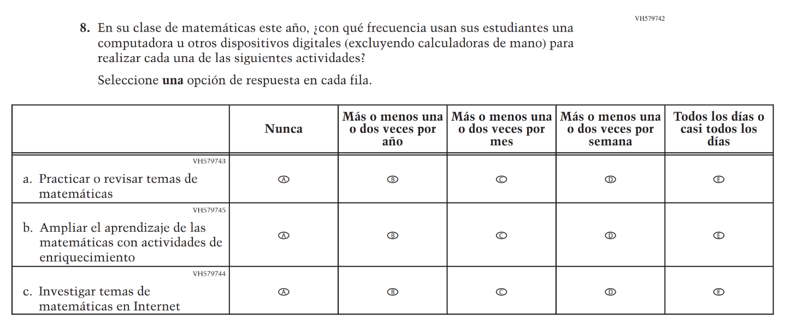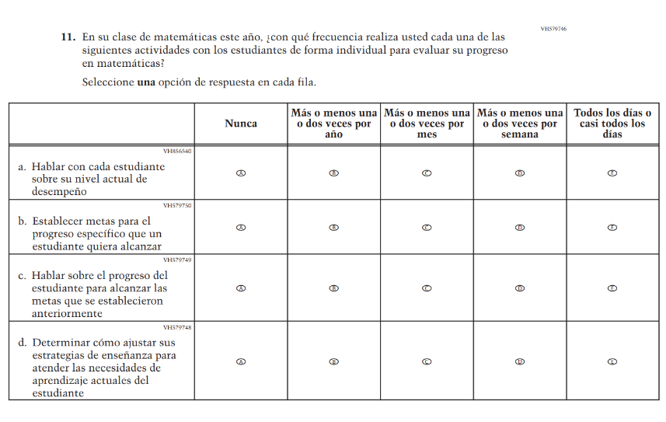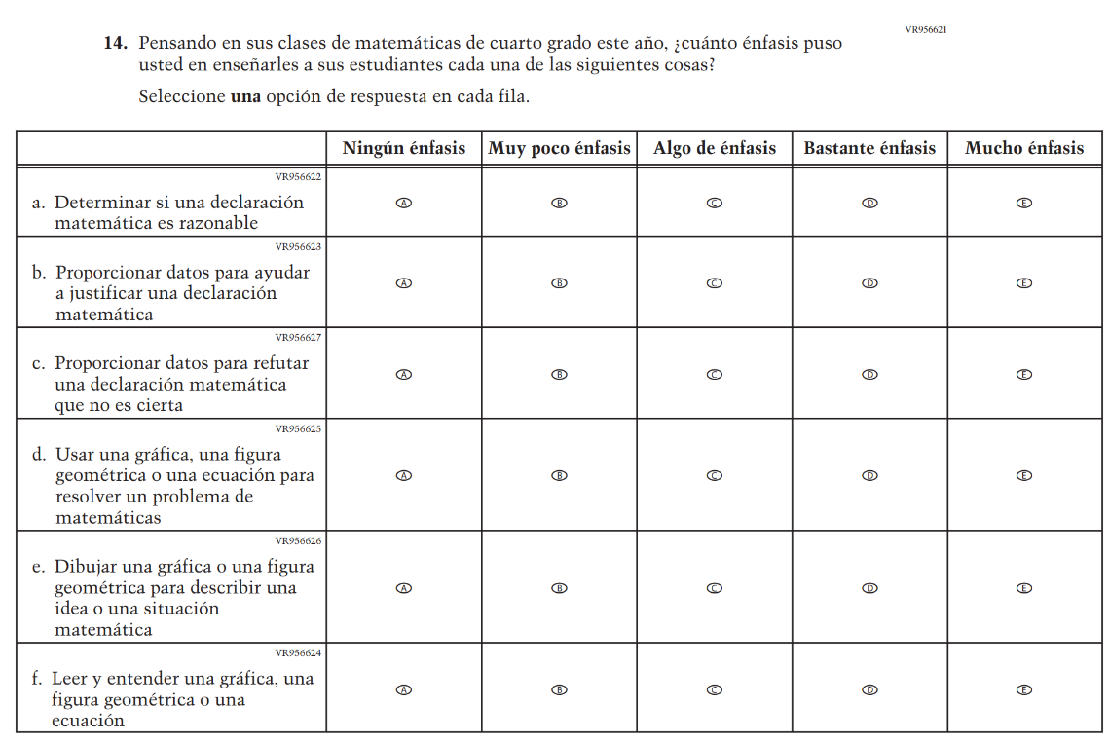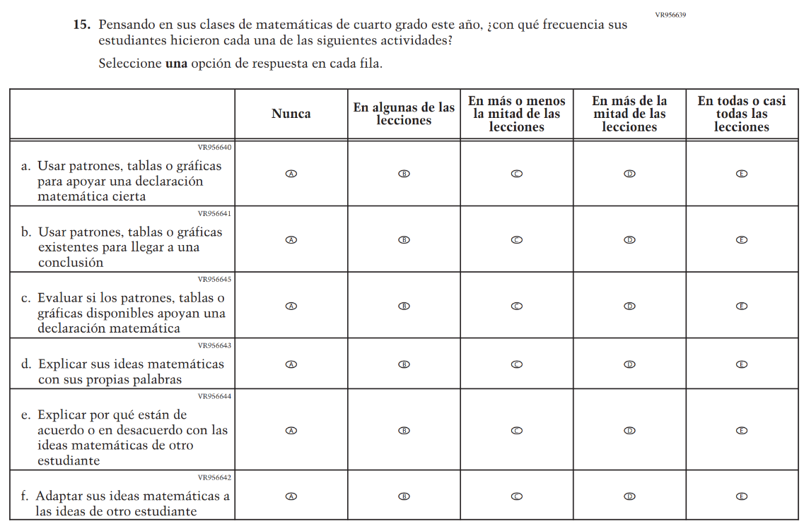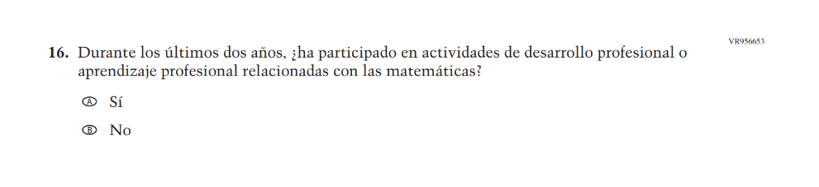

Appendix J-2d-s-PR: Summary of Changes Operational Grade 8 Mathematics
2026 Operational Grade 8 Math Teacher – Puerto Rico
Previous item | 2026 item | D/A/R+ | Rationale
(2024 Operational Grade 8 Teacher Math – Puerto Rico) | Issue: Instructional Organization and Strategies | R | For 2026, we have aligned Inline Directions in Teacher and School Items with the Directions currently used in Student Items.
(2024 Operational Grade 8 Teacher Math – Puerto Rico) | N/A | D | This item was dropped in favor of a new/revised item.
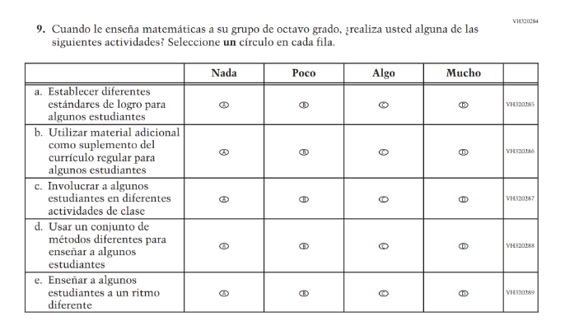  (2024 Operational Grade 8 Teacher Math – Puerto Rico) | N/A | D | This item was dropped in favor of a new/revised item.
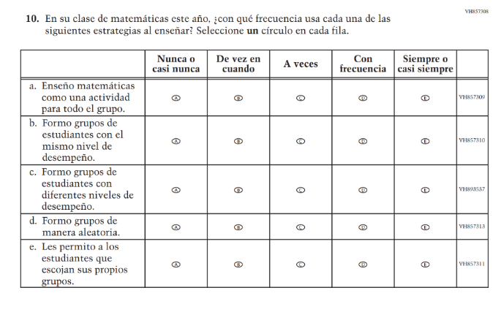(2024 Operational Grade 8 Teacher Math – Puerto Rico) | 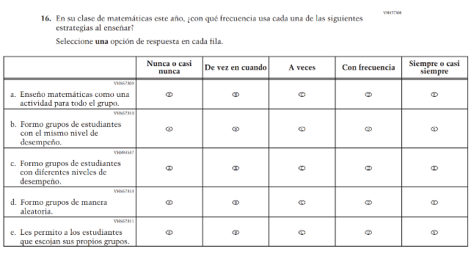  Issue: Instructional Organization and Strategies | R | For 2026, we have aligned Inline Directions in Teacher and School Items with the Directions currently used in Student Items.
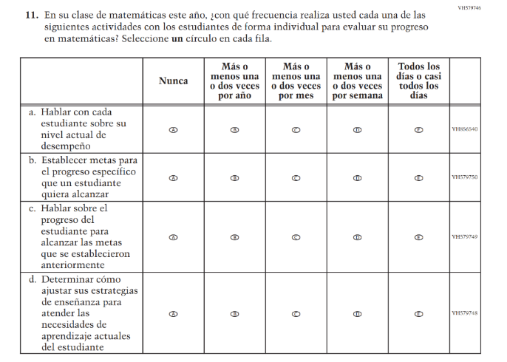(2024 Operational Grade 8 Teacher Math – Puerto Rico) | 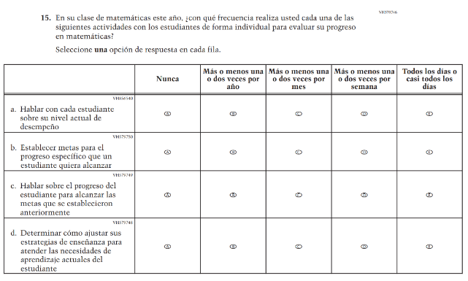Issue: Instructional Organization and Strategies | R | For 2026, we have aligned Inline Directions in Teacher and School Items with the Directions currently used in Student Items.
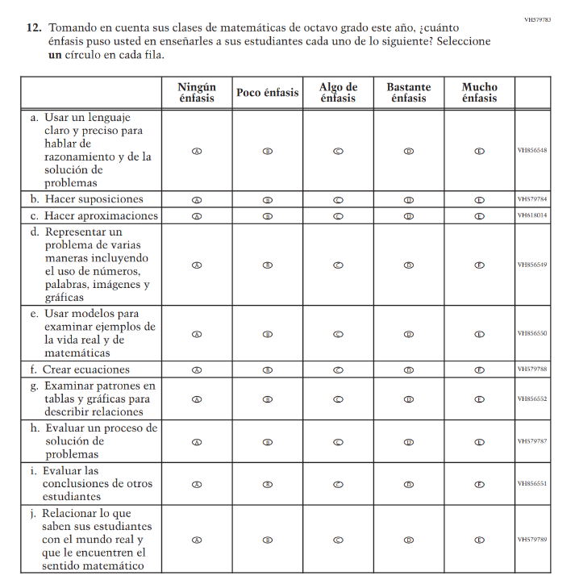(2024 Operational Grade 8 Teacher Math – Puerto Rico) | N/A | D | This item was dropped in favor of a new/revised item.
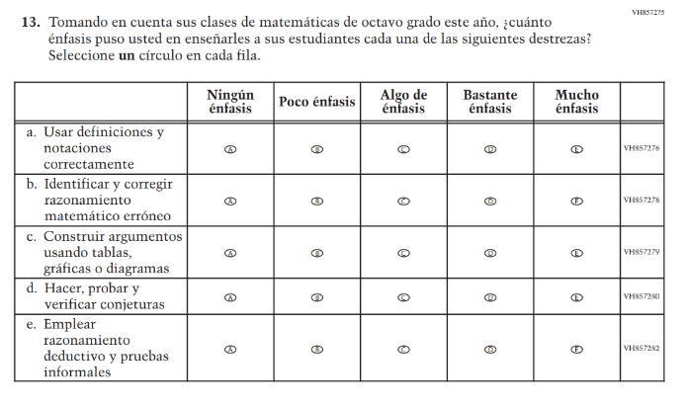(2024 Operational Grade 8 Teacher Math – Puerto Rico) | 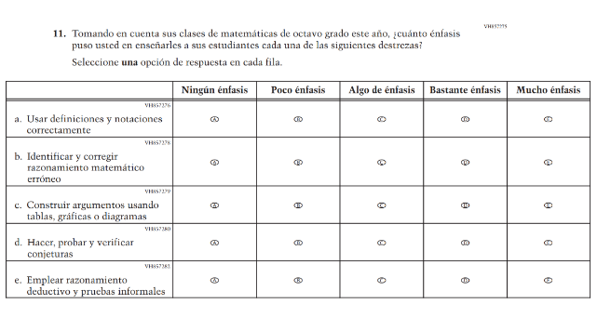Issue: Mathematical Content and Practices | R | For 2026, we have aligned Inline Directions in Teacher and School Items with the Directions currently used in Student Items.
(2024 Operational Grade 8 Teacher Math – Puerto Rico) | N/A | D | This Item was dropped to reduce questionnaire length.
(2024 Operational Grade 8 Teacher Math – Puerto Rico) | N/A | D | This Item was dropped to reduce questionnaire length.
(2024 Operational Grade 8 Teacher Math – Puerto Rico) | N/A | D | This Item was dropped to reduce questionnaire length.
(2024 Operational Grade 8 Teacher Math – Puerto Rico) | N/A | D | This Item was dropped to reduce questionnaire length.

2026 Operational Grade 8 Math Teacher – Puerto Rico
Previous item | 2026 item | D/A/R+ | Rationale
N/A  (2024 Operational Grade 8 Teacher Math – Puerto Rico) | 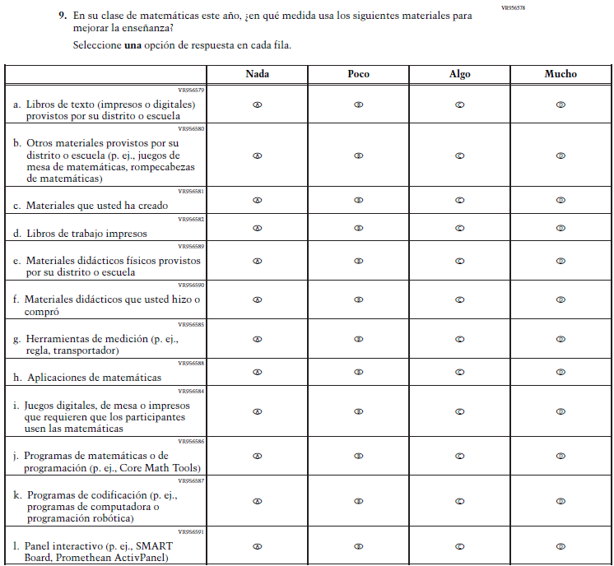  Issue: Instructional Resources | A | This item was developed to measure content aligned with the new Mathematics framework.
N/A  (2024 Operational Grade 8 Teacher Math – Puerto Rico) | 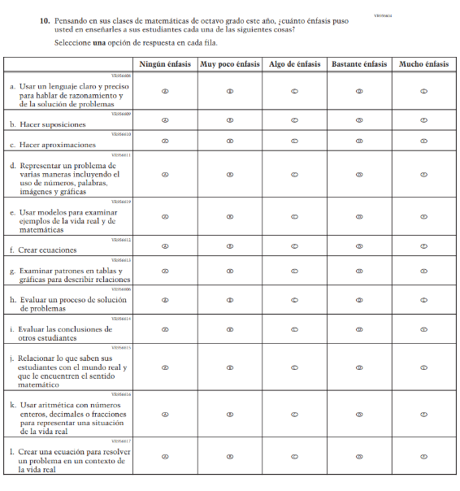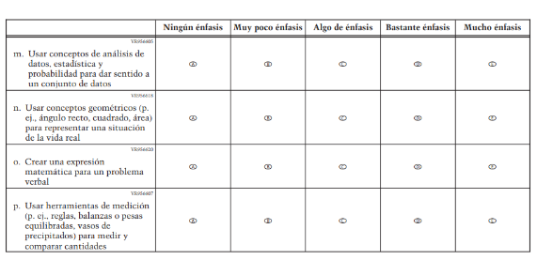  Issue: Mathematical Content and Practices | A | This item was developed to measure content aligned with the new Mathematics framework.
N/A  (2024 Operational Grade 8 Teacher Math – Puerto Rico) | 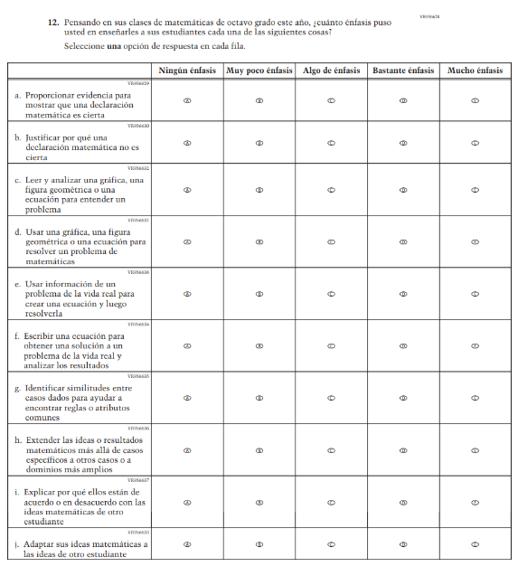  Issue: Mathematical Content and Practices | A | This item was developed to measure content aligned with the new Mathematics framework.
N/A  (2024 Operational Grade 8 Teacher Math – Puerto Rico) | 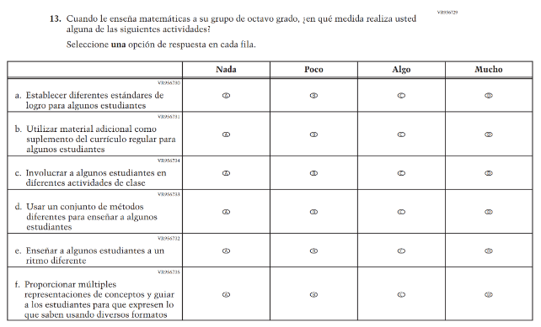  Issue: Instructional Organization and Strategies | A | This item was developed to measure content aligned with the new Mathematics framework.
N/A  (2024 Operational Grade 8 Teacher Math – Puerto Rico) | 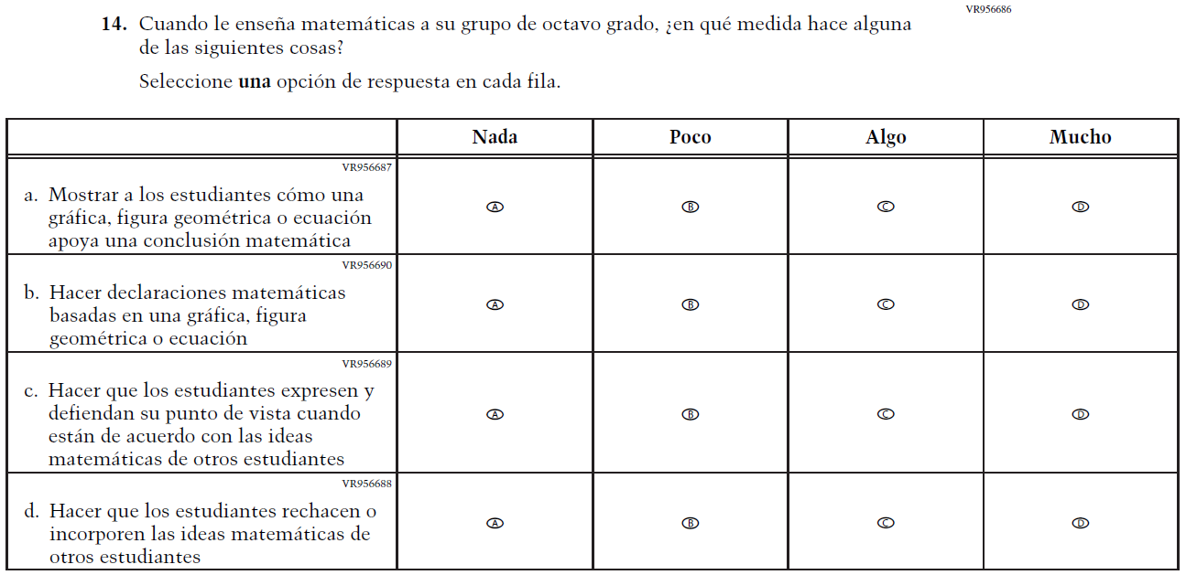  Issue: Instructional Organization and Strategies | A | This item was developed to measure content aligned with the new Mathematics framework.
N/A  (2024 Operational Grade 8 Teacher Math – Puerto Rico) | 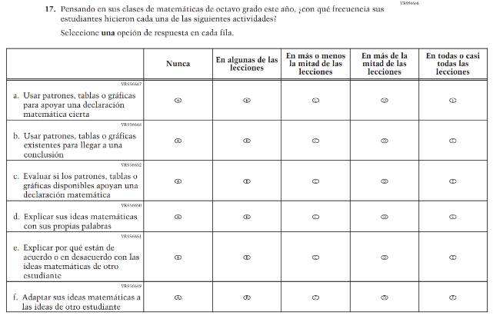  Issue: Mathematical Content and Practices | A | This item was developed to measure content aligned with the new Mathematics framework.
N/A  (2024 Operational Grade 8 Teacher Math – Puerto Rico) | 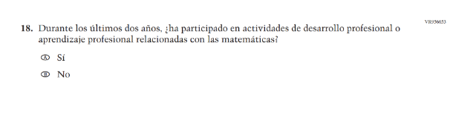  Issue: Teacher Factors | A | This item was developed to measure content aligned with the new Mathematics framework.
N/A  (2024 Operational Grade 8 Teacher Math – Puerto Rico) | 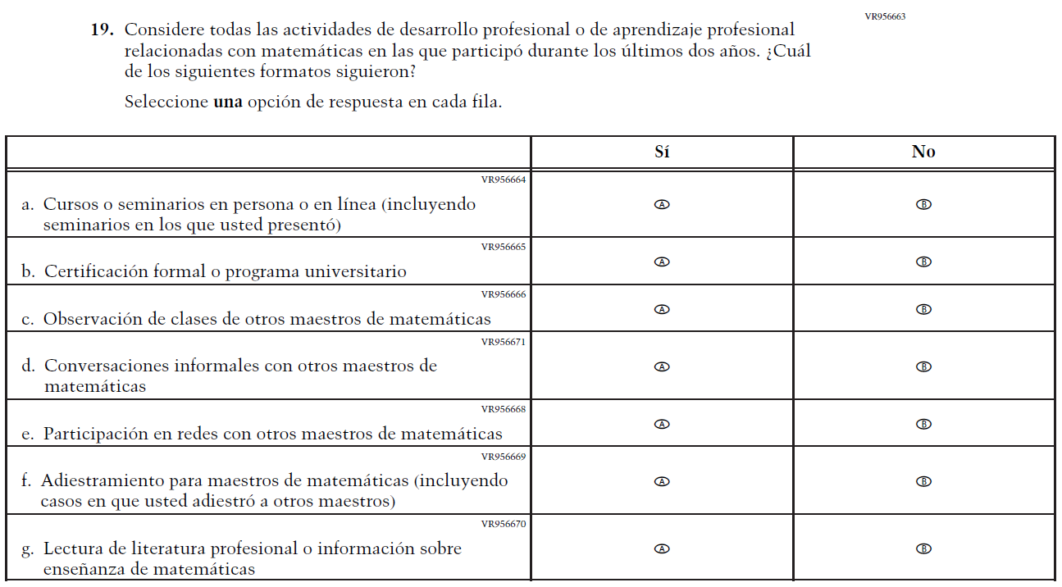  Issue: Teacher Factors | A | This item was developed to measure content aligned with the new Mathematics framework.
N/A  (2024 Operational Grade 8 Teacher Math – Puerto Rico) | 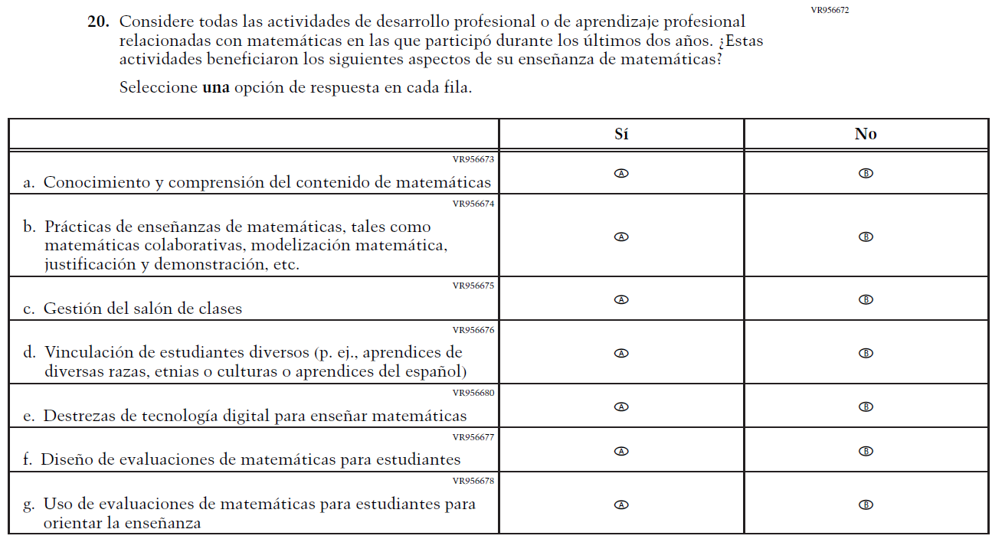  Issue: Teacher Factors | A | This item was developed to measure content aligned with the new Mathematics framework.

Appendix J-2d-s-PR: Operational Grade 8 Mathematics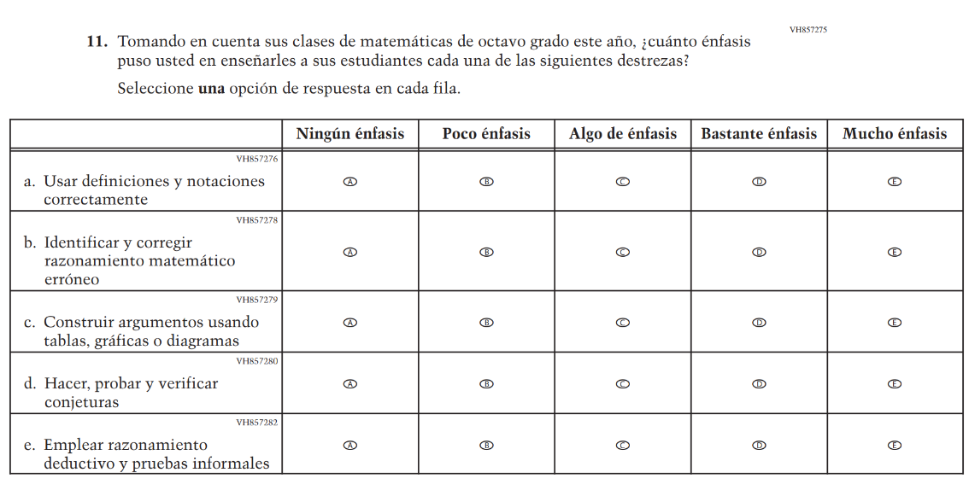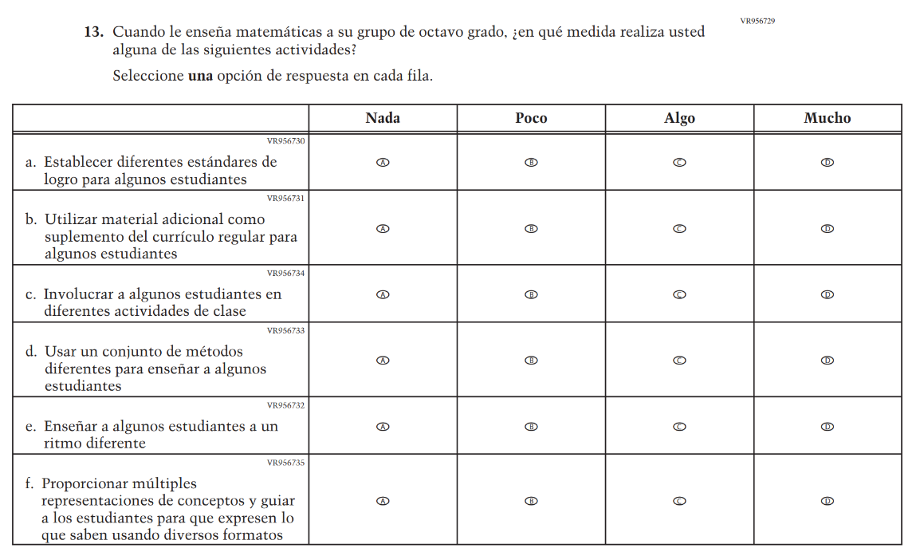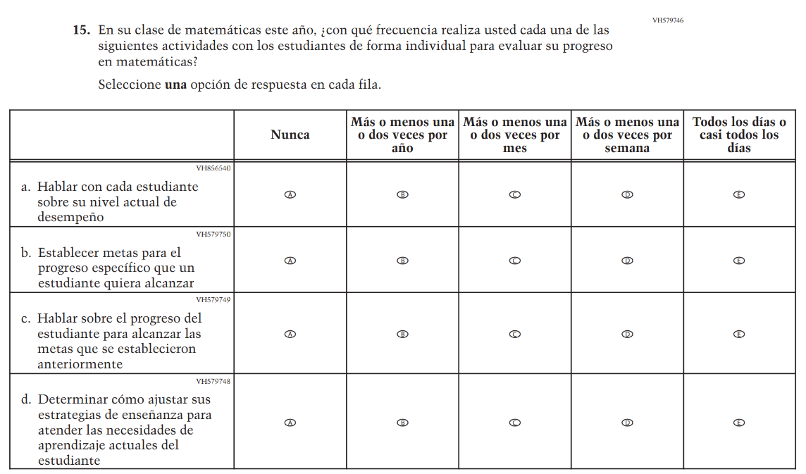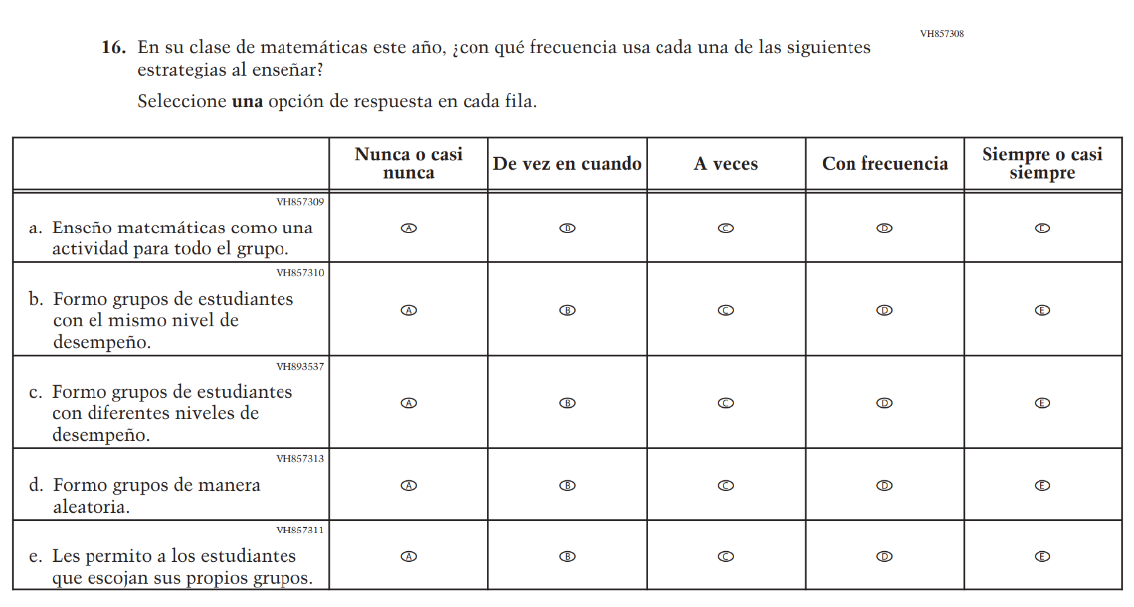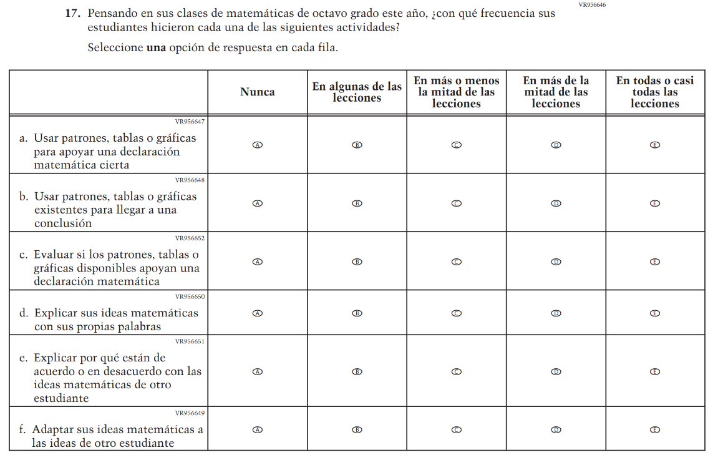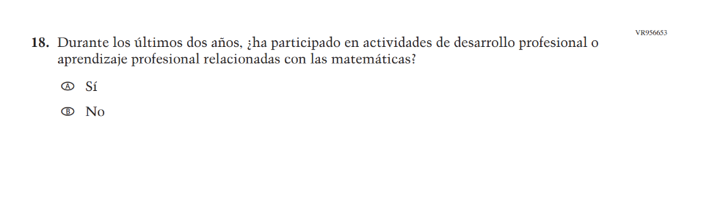

Appendix J-3-s: Spanish Translations of School Questionnaires

Sample School Administrator Login Screen

Appendix J-3a-s-PR: Summary of Changes Operational Grade 4 CORE
2026 Operational Grade 4 Core School – Puerto Rico
Previous item | 2026 item | D/A/R+ | Rationale
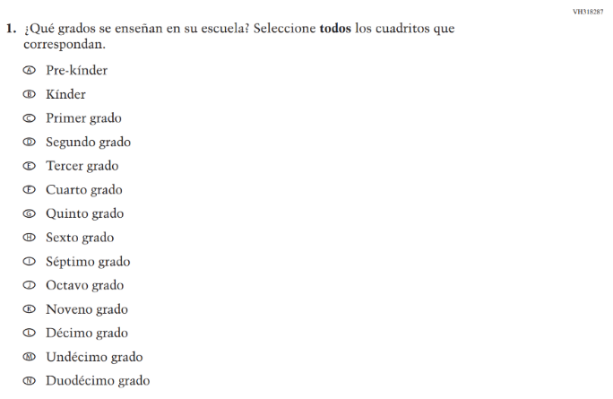  (2024 Operational Grade 4 School Core – Puerto Rico) | 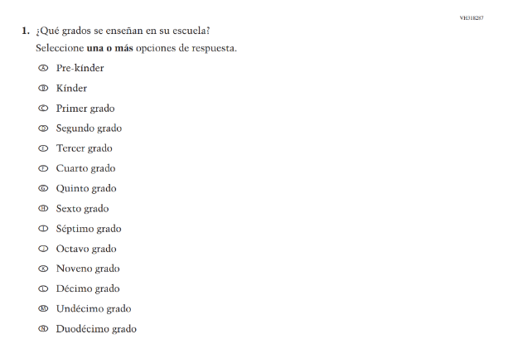  Issue: School Climate | R | For 2026, we have aligned Inline Directions in Teacher and School Items with the Directions currently used in Student Items.
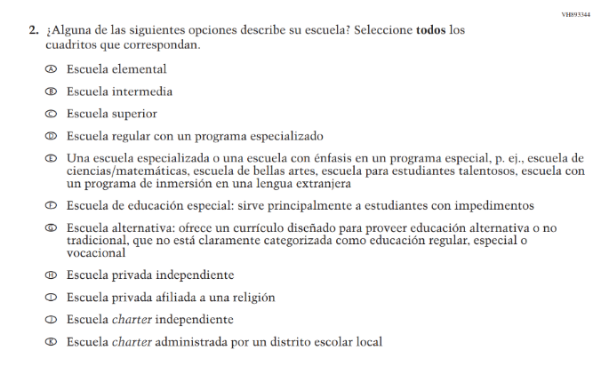  (2024 Operational Grade 4 School Core – Puerto Rico) | 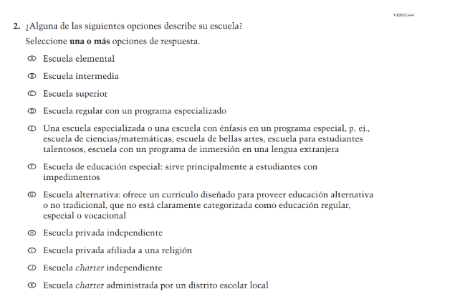  Issue: School Climate | R | For 2026, we have aligned Inline Directions in Teacher and School Items with the Directions currently used in Student Items.
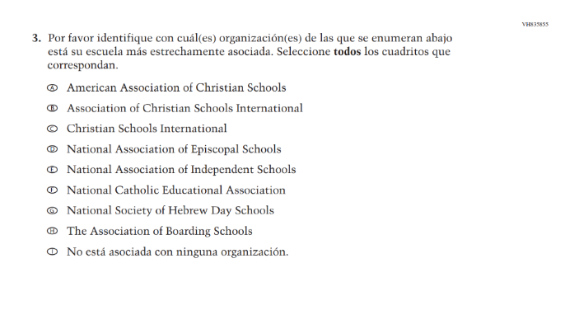  (2024 Operational Grade 4 School Core – Puerto Rico) | N/A | D | This Item was dropped due to low response frequencies and low relevance to the larger NAEP sample.
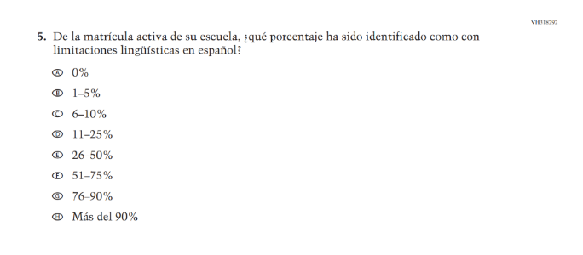(2024 Operational Grade 4 School Core – Puerto Rico) | 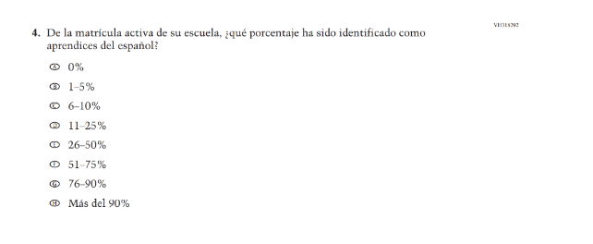  Issue: School Climate | R | This Item was revised to update "con limitaciones lingüísticas en español" to "aprendices del español."
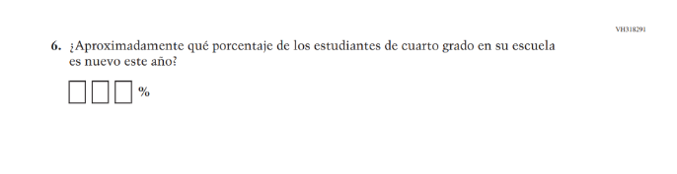  (2024 Operational Grade 4 School Core – Puerto Rico) | 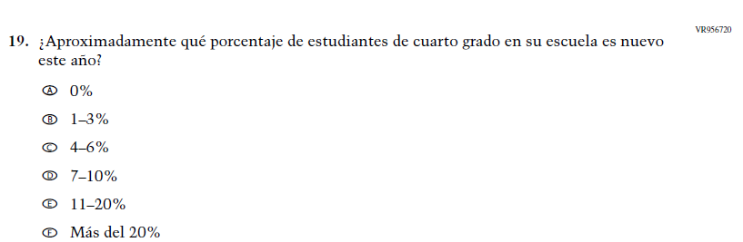  Issue: School Climate | R | This Item was revised to use response options for improved data collection and reporting of student mobility.
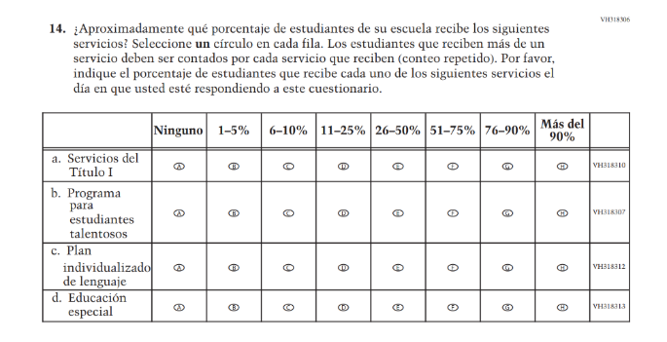  (2024 Operational Grade 4 School Core – Puerto Rico) | 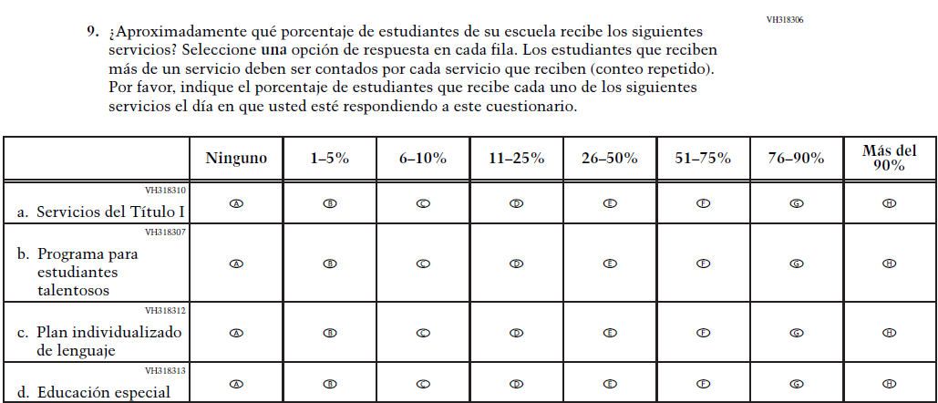  Issue: | R | For 2026, we have aligned Inline Directions in Teacher and School Items with the Directions currently used in Student Items.
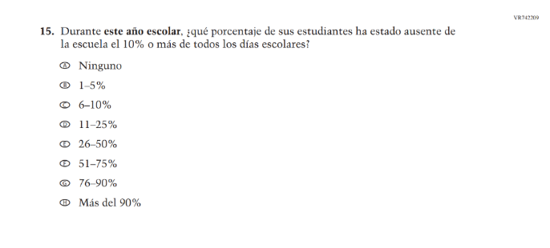(2024 Operational Grade 4 School Core – Puerto Rico) | N/A | D | Learning Recovery Items were dropped from the 2026 NAEP Assessment.
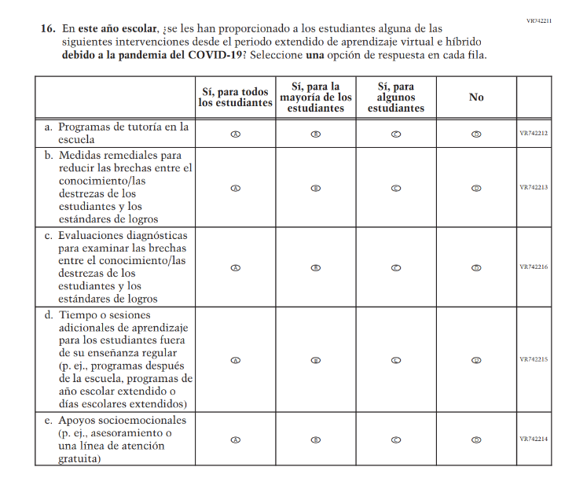(2024 Operational Grade 4 School Core – Puerto Rico) | N/A | D | Learning Recovery Items were dropped from the 2026 NAEP Assessment.
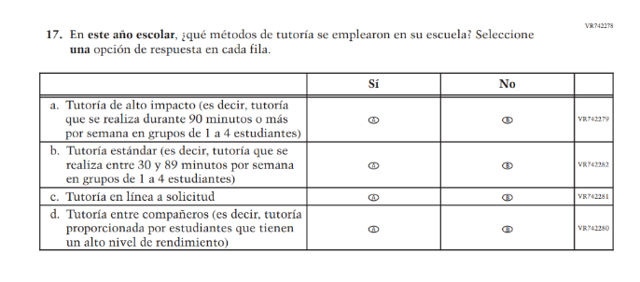(2024 Operational Grade 4 School Core – Puerto Rico) | N/A | D | Learning Recovery Items were dropped from the 2026 NAEP Assessment.
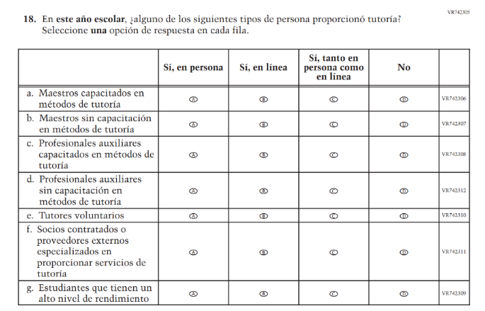(2024 Operational Grade 4 School Core – Puerto Rico) | N/A | D | Learning Recovery Items were dropped from the 2026 NAEP Assessment.
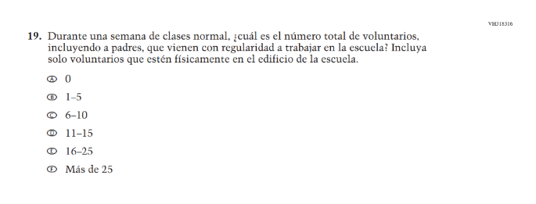(2024 Operational Grade 4 School Core – Puerto Rico) | N/A | D | This Item was dropped due to lack of insight provided by the question and to prioritize new content.
N/A  (2024 Operational Grade 4 School Core – Puerto Rico) | 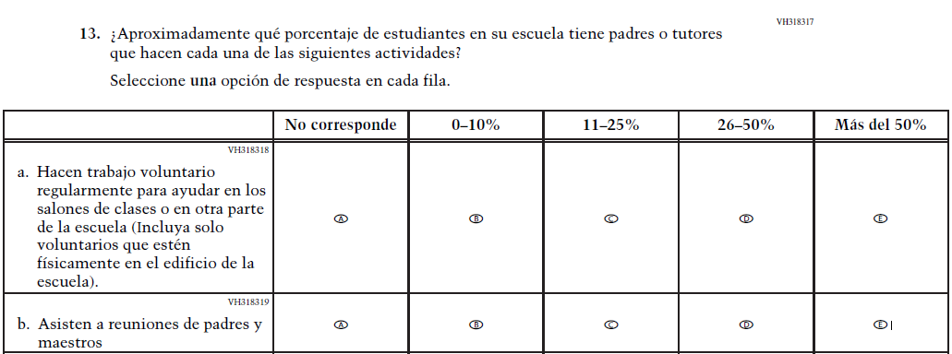  Issue: School Climate | A | This Item was previously administered in the 2022 NAEP Assessment and added in 2026 to measure parental involvement in the school.
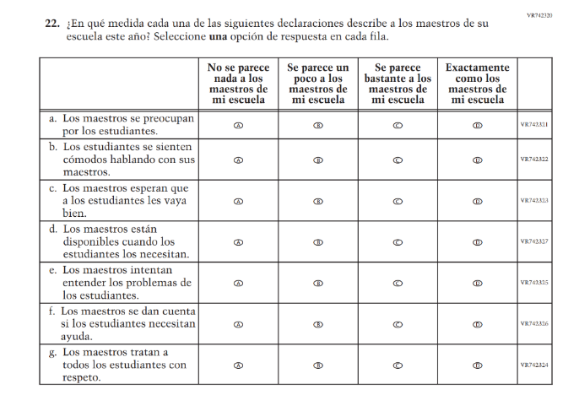(2024 Operational Grade 4 School Core – Puerto Rico) | 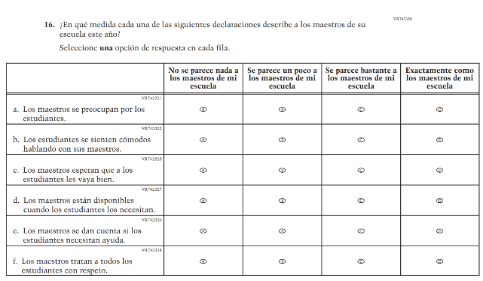  Issue: Learning Environment | R | For 2026, we have aligned Inline Directions in Teacher and School Items with the Directions currently used in Student Items. Also, SubItem e. from 2024 was dropped for 2026.
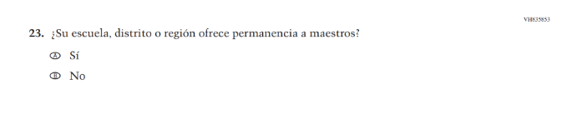(2024 Operational Grade 4 School Core – Puerto Rico) | N/A | D | This Item was dropped due to lack of insight provided by the question and to prioritize new content.
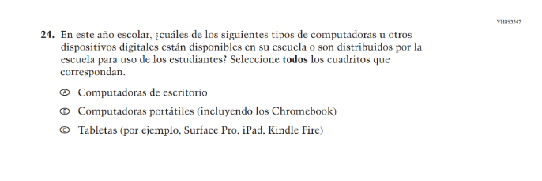(2024 Operational Grade 4 School Core – Puerto Rico) | N/A | D | This and the related Items were dropped in favor of a more current and concise format for questions on Technology Use.
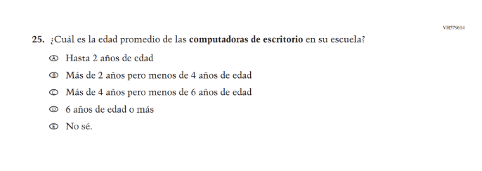(2024 Operational Grade 4 School Core – Puerto Rico) | N/A | D | This and the related Items were dropped in favor of a more current and concise format for questions on Technology Use.
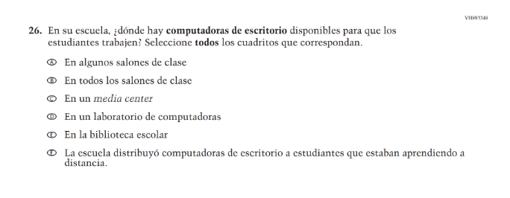(2024 Operational Grade 4 School Core – Puerto Rico) | N/A | D | This and the related Items were dropped in favor of a more current and concise format for questions on Technology Use.
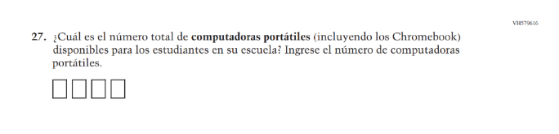(2024 Operational Grade 4 School Core – Puerto Rico) | N/A | D | This and the related Items were dropped in favor of a more current and concise format for questions on Technology Use.
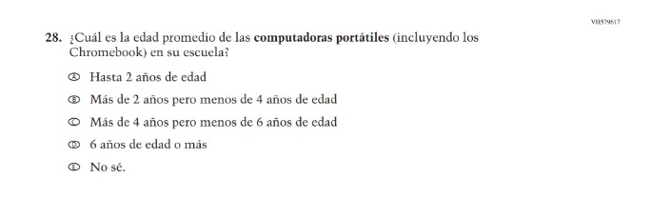(2024 Operational Grade 4 School Core – Puerto Rico) | N/A | D | This and the related Items were dropped in favor of a more current and concise format for questions on Technology Use.
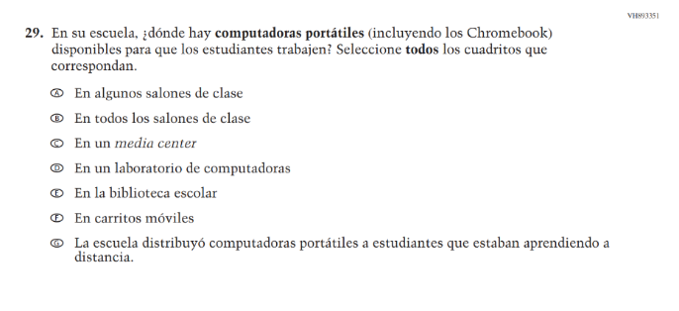(2024 Operational Grade 4 School Core – Puerto Rico) | N/A | D | This and the related Items were dropped in favor of a more current and concise format for questions on Technology Use.
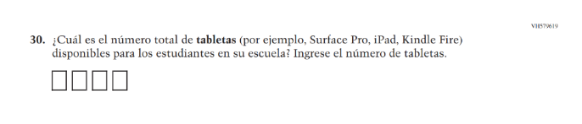(2024 Operational Grade 4 School Core – Puerto Rico) | N/A | D | This and the related Items were dropped in favor of a more current and concise format for questions on Technology Use.
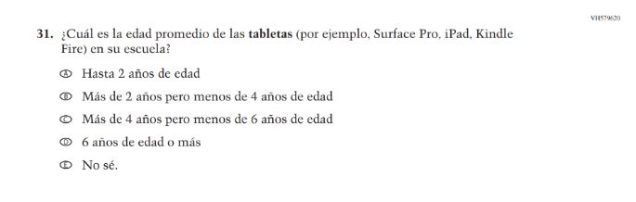(2024 Operational Grade 4 School Core – Puerto Rico) | N/A | D | This and the related Items were dropped in favor of a more current and concise format for questions on Technology Use.
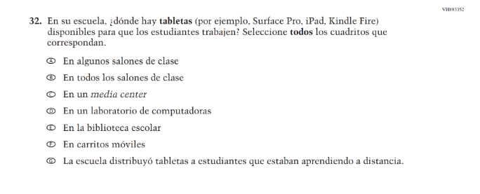(2024 Operational Grade 4 School Core – Puerto Rico) | N/A | D | This and the related Items were dropped in favor of a more current and concise format for questions on Technology Use.

2026 Operational Grade 4 Core School – Puerto Rico
Previous item | 2026 item | D/A/R+ | Rationale
N/A  (2024 Operational Grade 4 School Core – Puerto Rico) | 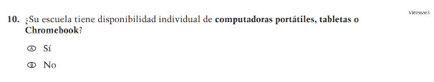  Issue: Technology Use | A | This Item was developed to measure technology use and student access to digital technology for learning.
N/A  (2024 Operational Grade 4 School Core – Puerto Rico) | 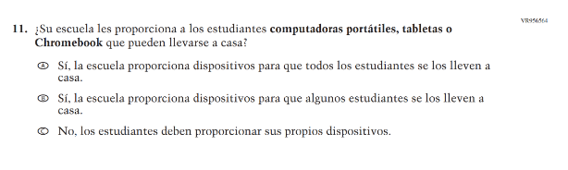  Issue: Technology Use | A | This Item was developed to measure technology use and student access to digital technology for learning.
N/A  (2024 Operational Grade 4 School Core – Puerto Rico) | 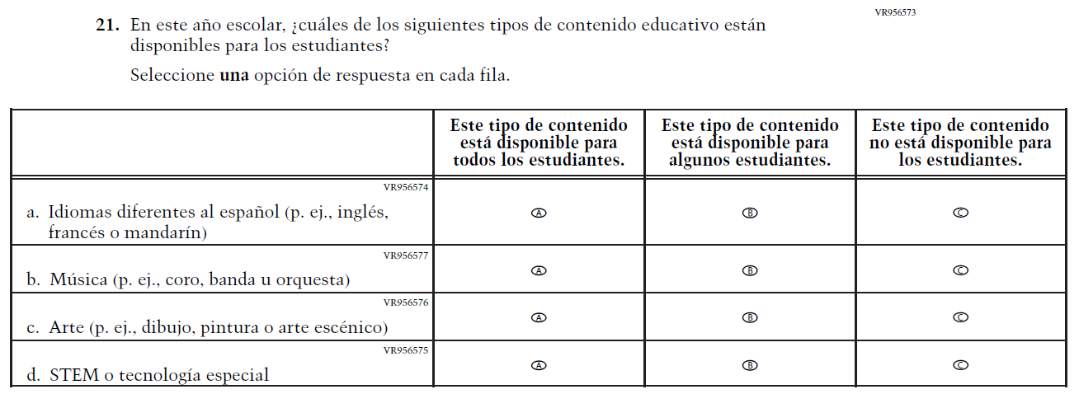  Issue: School Climate | A | This Item was developed to measure students’ learning environments and access to educational content focused on languages, music, art, and STEM.

Appendix J-3a-s-PR: Operational Grade 4 CORE

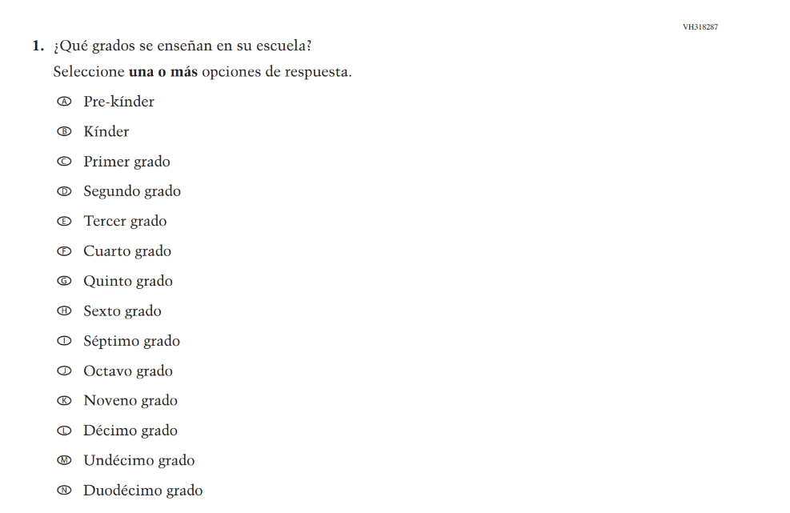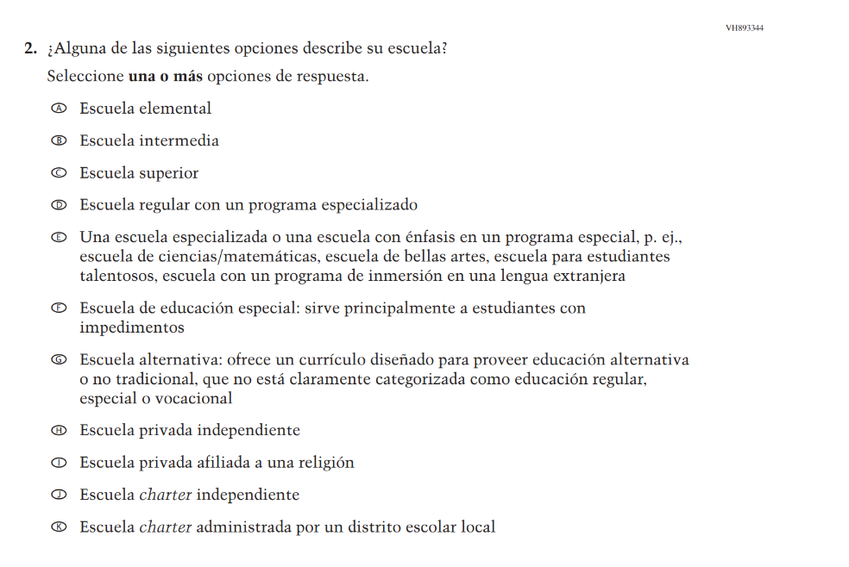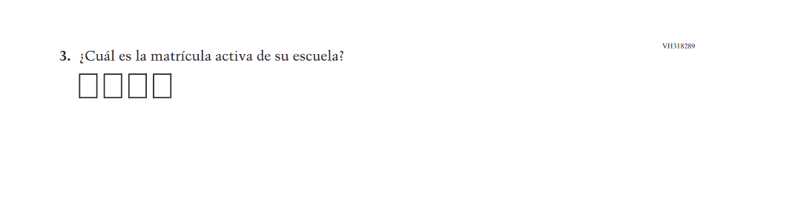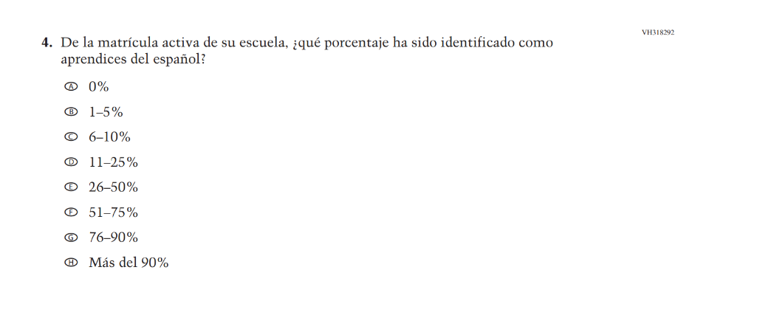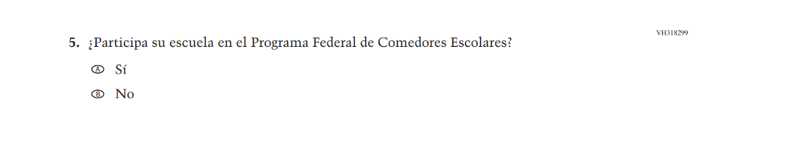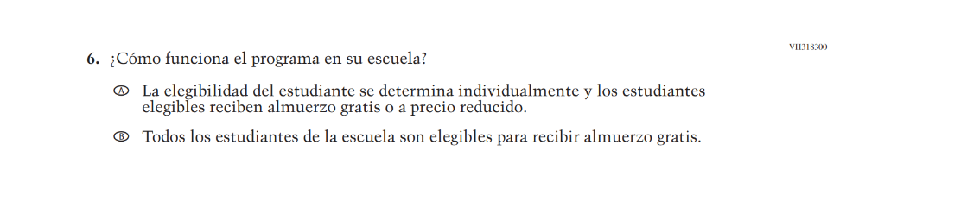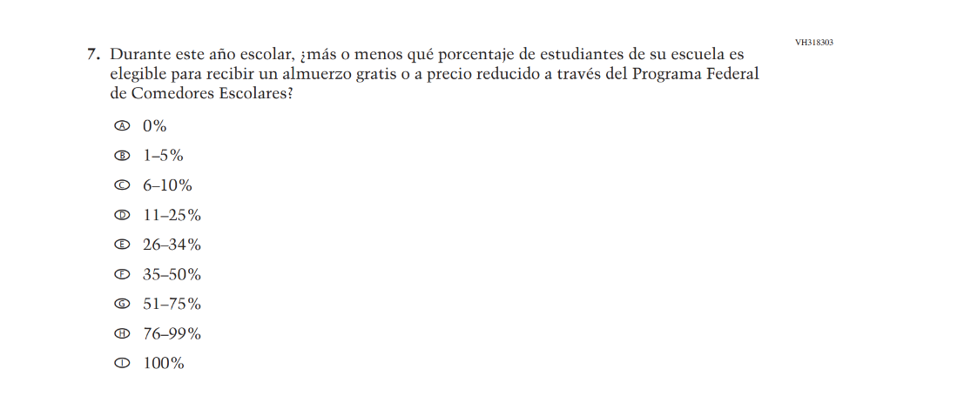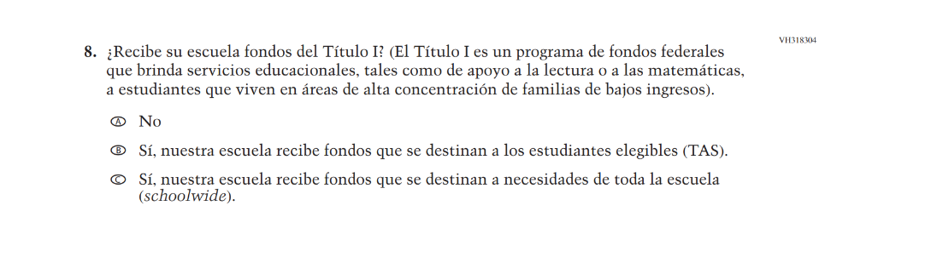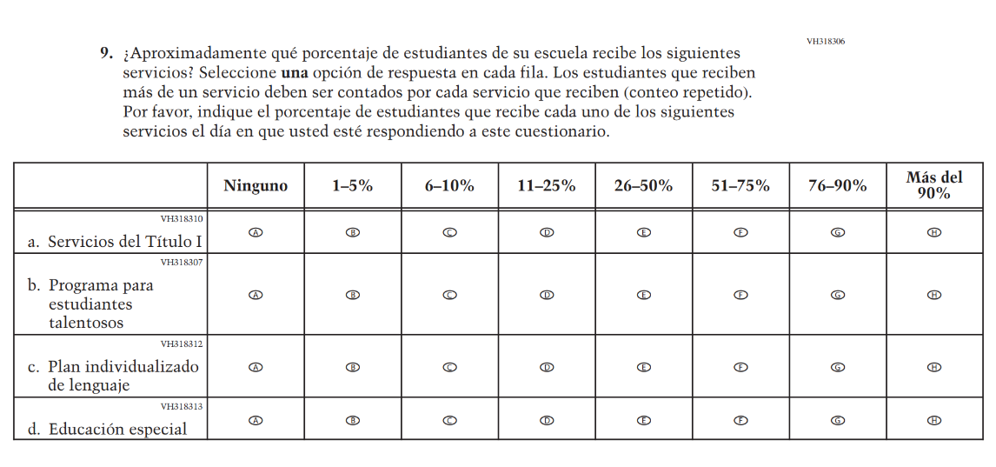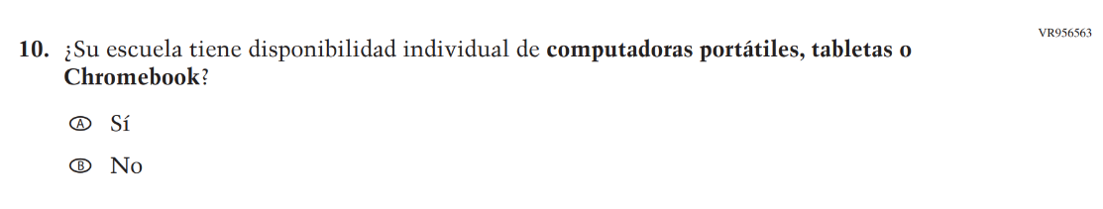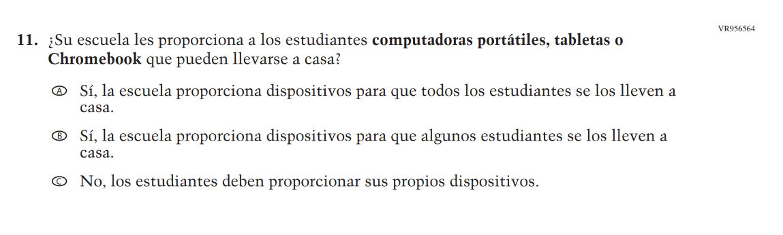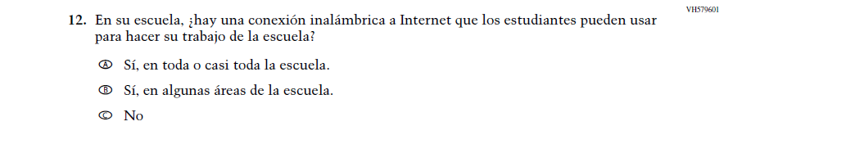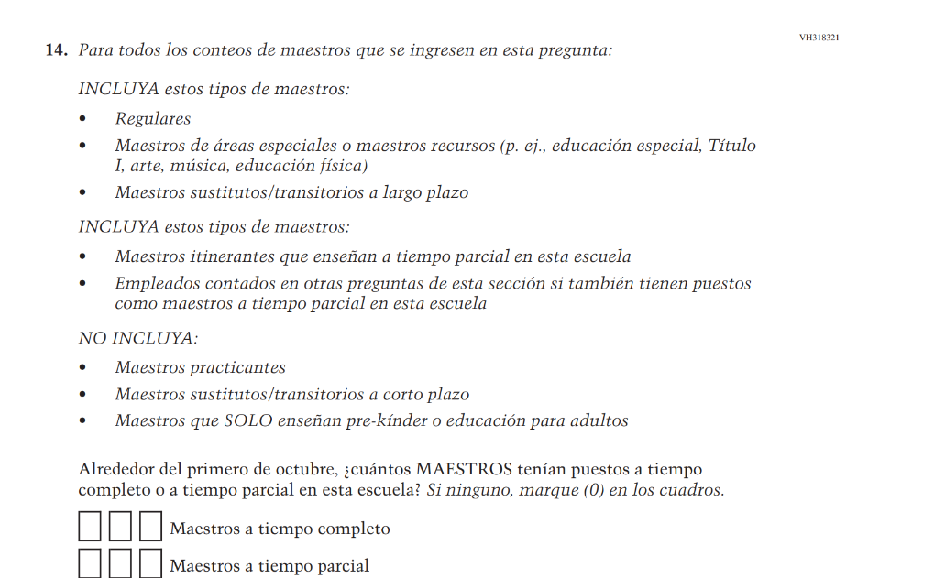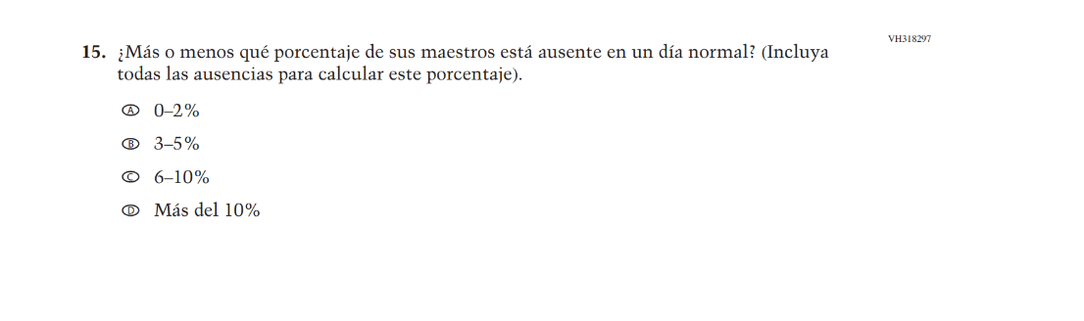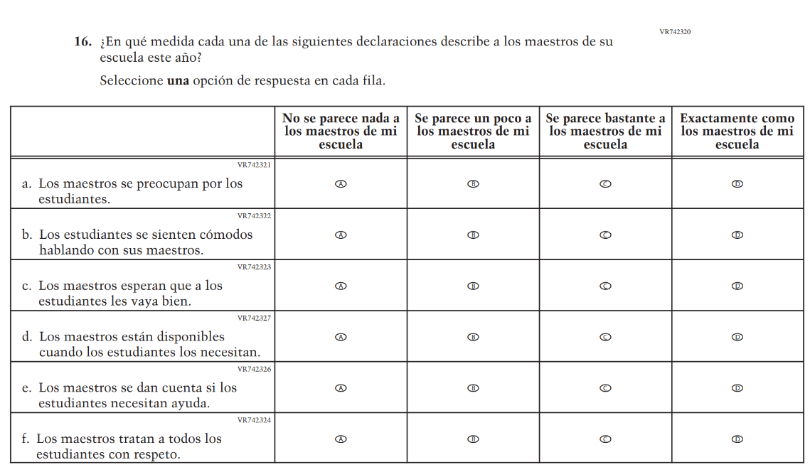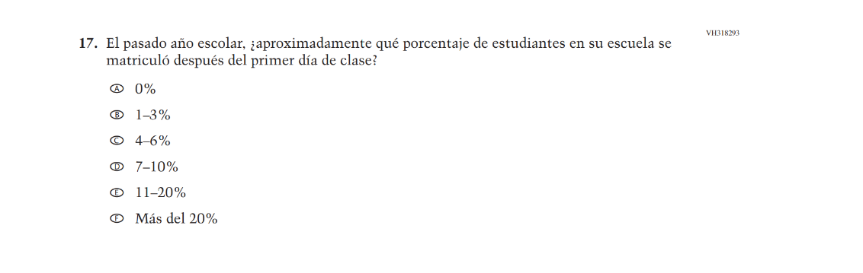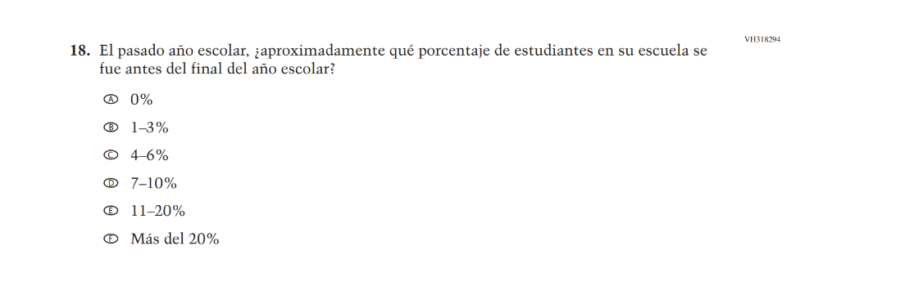
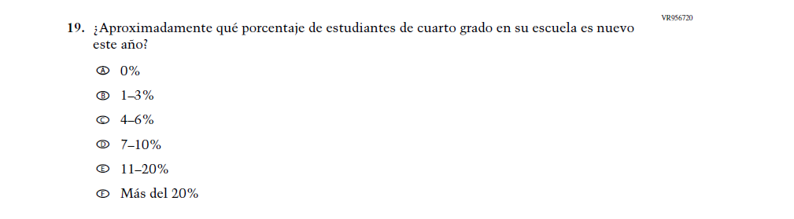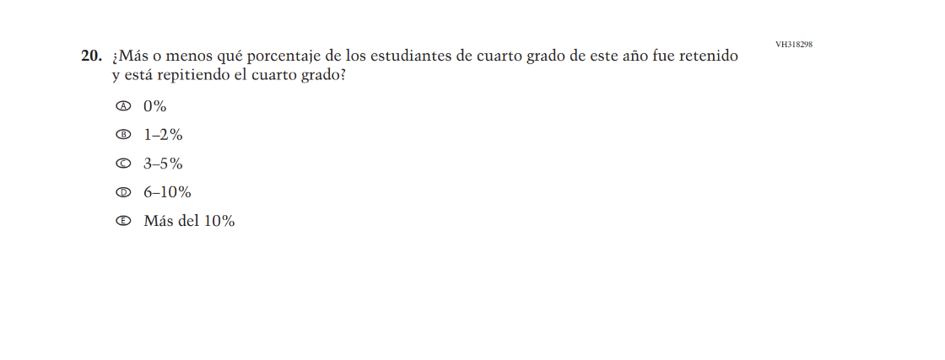

Appendix J-3b-s-PR: Summary of Changes Operational Grade 8 CORE
2026 Operational Grade 8 Core School – Puerto Rico
Previous item | 2026 item | D/A/R+ | Rationale
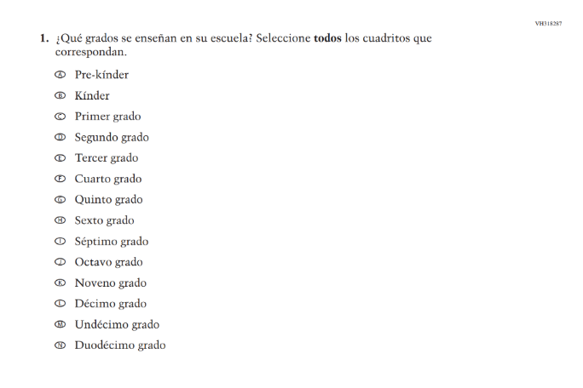  (2024 Operational Grade 8 School Core – Puerto Rico) | 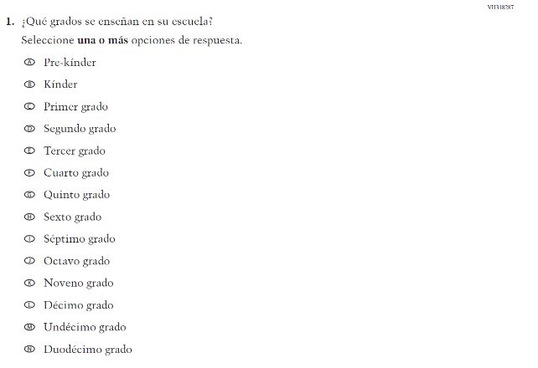  Issue: School Climate | R | For 2026, we have aligned Inline Directions in Teacher and School Items with the Directions currently used in Student Items.
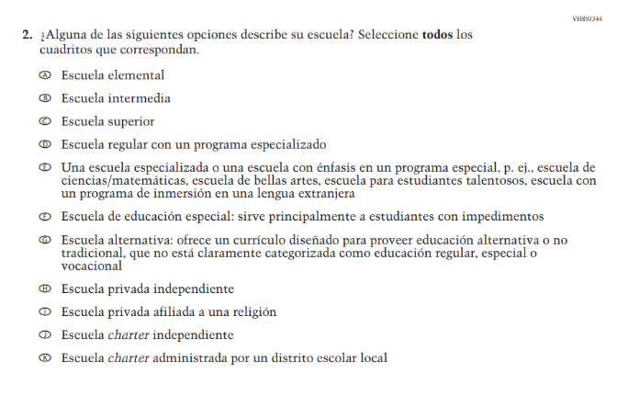  (2024 Operational Grade 8 School Core – Puerto Rico) | 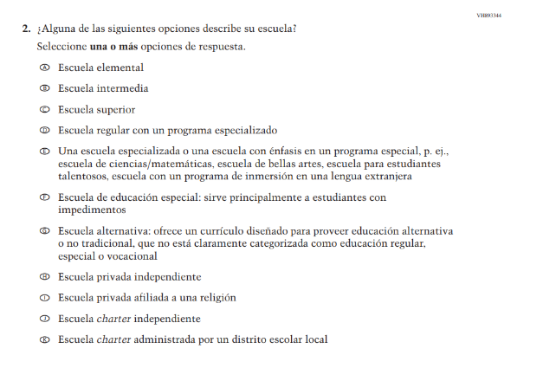  Issue: School Climate | R | For 2026, we have aligned Inline Directions in Teacher and School Items with the Directions currently used in Student Items.
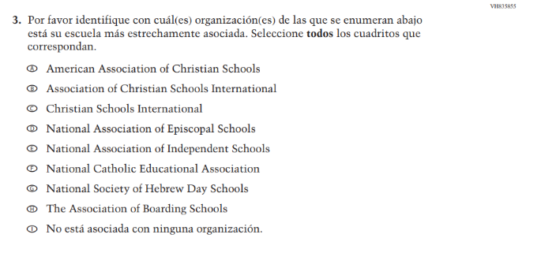  (2024 Operational Grade 8 School Core – Puerto Rico) | N/A | D | This Item was dropped due to low response frequencies and low relevance to the larger NAEP sample.
(2024 Operational Grade 4 School Core – Puerto Rico) | Issue: School Climate | R | This Item was revised to update "con limitaciones lingüísticas en español" to "aprendices del español."
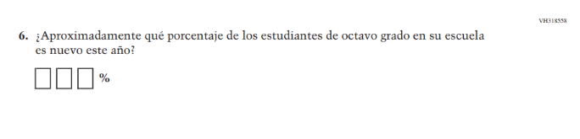(2024 Operational Grade 8 School Core – Puerto Rico) | 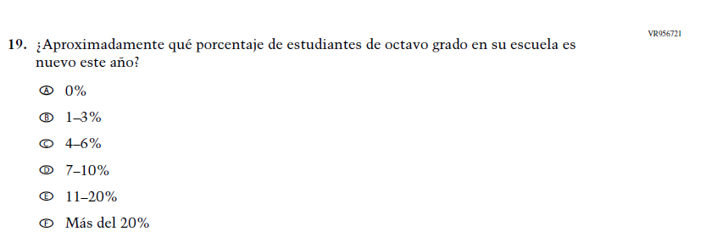  Issue: School Climate | R | This Item was revised to use response options for improved data collection and reporting of student mobility.
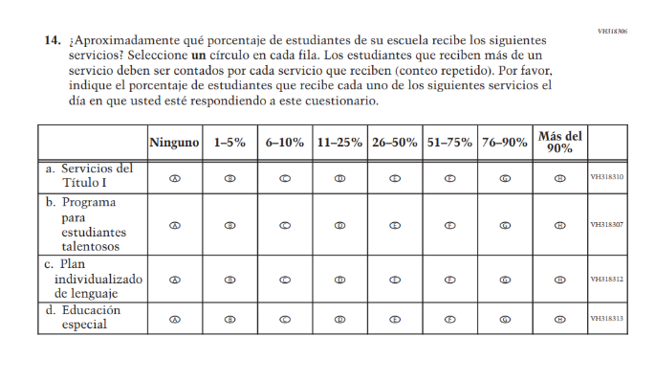(2024 Operational Grade 8 School Core – Puerto Rico) | 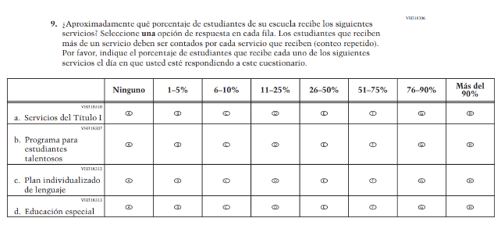  Issue: School Climate | R | For 2026, we have aligned Inline Directions in Teacher and School Items with the Directions currently used in Student Items.
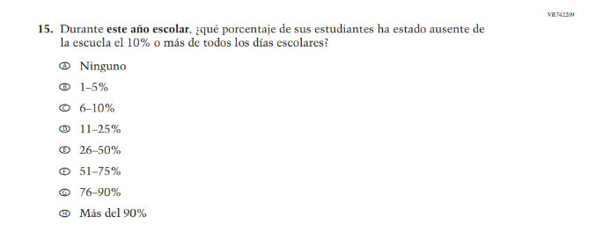  (2024 Operational Grade 8 School Core – Puerto Rico) | N/A | D | Learning Recovery Items were dropped from the 2026 NAEP Assessment.
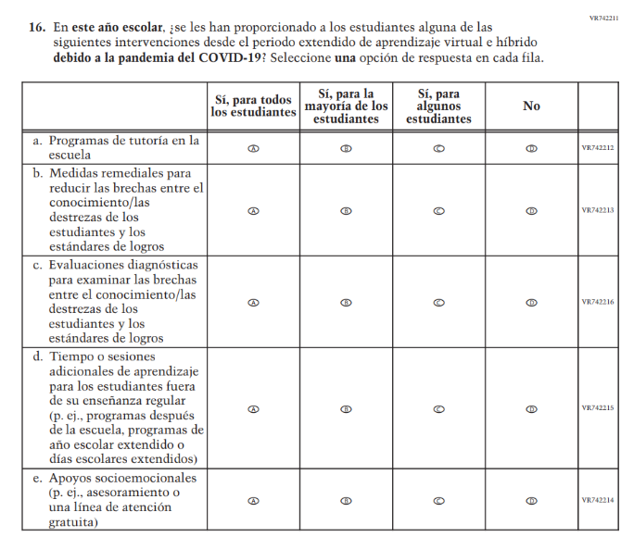(2024 Operational Grade 8 School Core – Puerto Rico) | N/A | D | Learning Recovery Items were dropped from the 2026 NAEP Assessment.
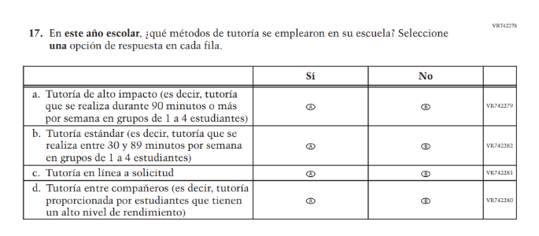(2024 Operational Grade 8 School Core – Puerto Rico) | N/A | D | Learning Recovery Items were dropped from the 2026 NAEP Assessment.
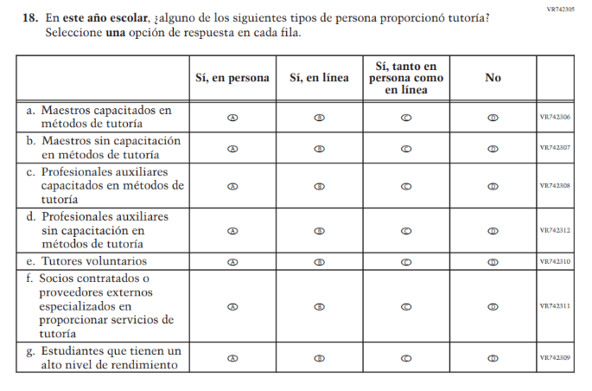(2024 Operational Grade 8 School Core – Puerto Rico) | N/A | D | Learning Recovery Items were dropped from the 2026 NAEP Assessment.
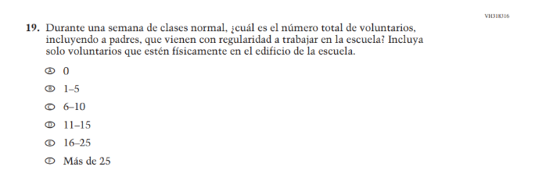(2024 Operational Grade 8 School Core – Puerto Rico) | N/A | D | This Item was dropped due to lack of insight provided by the question and to prioritize new content.
N/A  (2024 Operational Grade 4 School Core – Puerto Rico) | Issue: School Climate | A | This Item was previously administered in the 2022 NAEP Assessment and added in 2026 to measure parental involvement in the school.
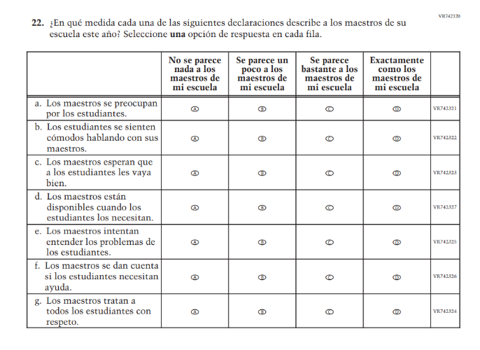(2024 Operational Grade 8 School Core – Puerto Rico) | 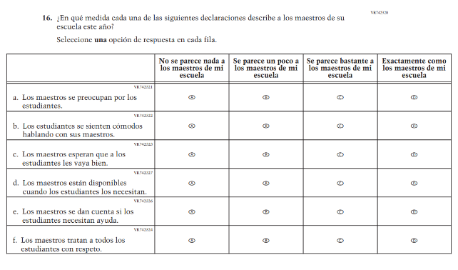  Issue: Learning Environment | R | For 2026, we have aligned Inline Directions in Teacher and School Items with the Directions currently used in Student Items. Also, SubItem e. from 2024 was dropped for 2026.
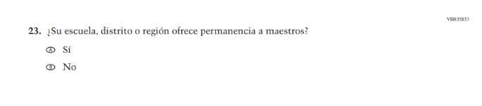(2024 Operational Grade 8 School Core – Puerto Rico) | N/A | D | This Item was dropped due to lack of insight provided by the question and to prioritize new content.
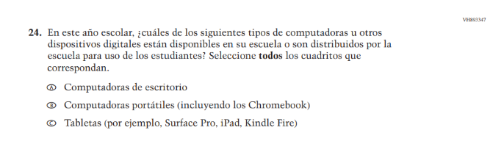(2024 Operational Grade 8 School Core – Puerto Rico) | N/A | D | This and the related Items were dropped in favor of a more current and concise format for questions on Technology Use.
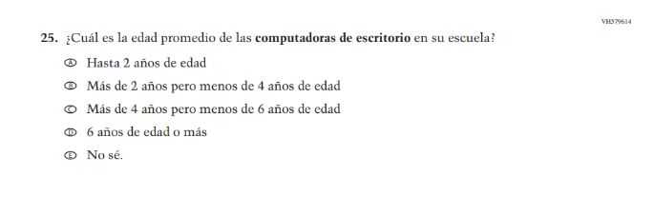(2024 Operational Grade 8 School Core – Puerto Rico) | N/A | D | This and the related Items were dropped in favor of a more current and concise format for questions on Technology Use.
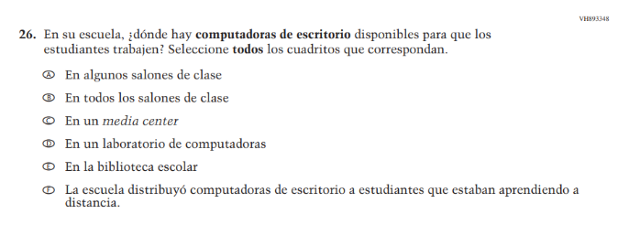(2024 Operational Grade 8 School Core – Puerto Rico) | N/A | D | This and the related Items were dropped in favor of a more current and concise format for questions on Technology Use.
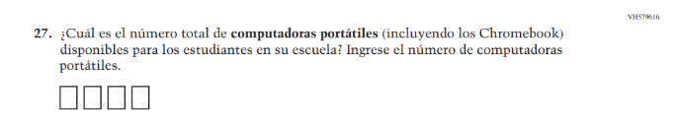(2024 Operational Grade 8 School Core – Puerto Rico) | N/A | D | This and the related Items were dropped in favor of a more current and concise format for questions on Technology Use.
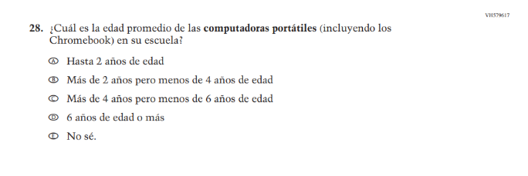(2024 Operational Grade 8 School Core – Puerto Rico) | N/A | D | This and the related Items were dropped in favor of a more current and concise format for questions on Technology Use.
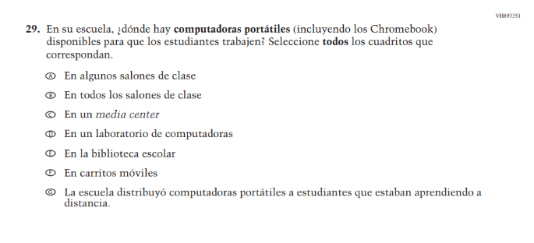(2024 Operational Grade 8 School Core – Puerto Rico) | N/A | D | This and the related Items were dropped in favor of a more current and concise format for questions on Technology Use.
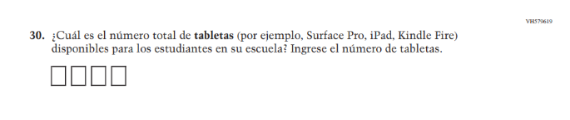(2024 Operational Grade 8 School Core – Puerto Rico) | N/A | D | This and the related Items were dropped in favor of a more current and concise format for questions on Technology Use.
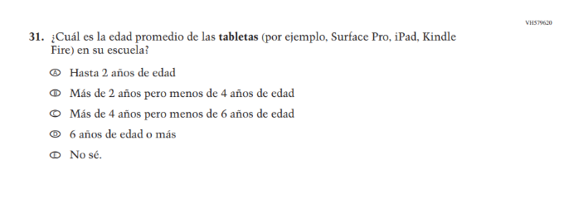(2024 Operational Grade 8 School Core – Puerto Rico) | N/A | D | This and the related Items were dropped in favor of a more current and concise format for questions on Technology Use.
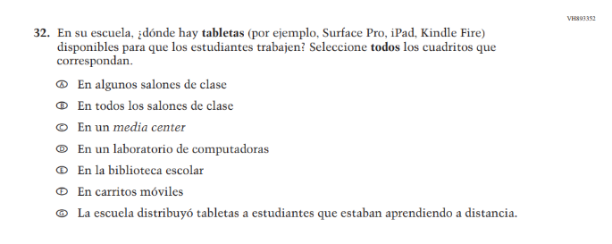(2024 Operational Grade 8 School Core – Puerto Rico) | N/A | D | This and the related Items were dropped in favor of a more current and concise format for questions on Technology Use.

2026 Operational Grade 8 Core School – Puerto Rico
Previous item | 2026 item | D/A/R+ | Rationale
N/A  (2024 Operational Grade 8 School Core – Puerto Rico) | 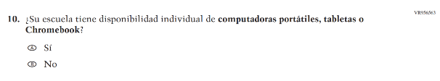  Issue: Technology Use | A | This Item was developed to measure technology use and student access to digital technology for learning.
N/A  (2024 Operational Grade 8 School Core – Puerto Rico) | 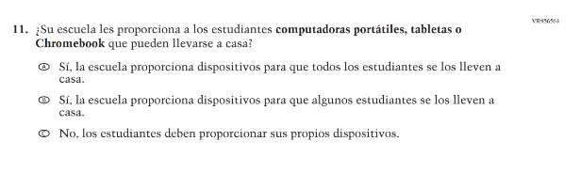  Issue: Technology Use | A | This Item was developed to measure technology use and student access to digital technology for learning.
N/A  (2024 Operational Grade 8 School Core – Puerto Rico) | 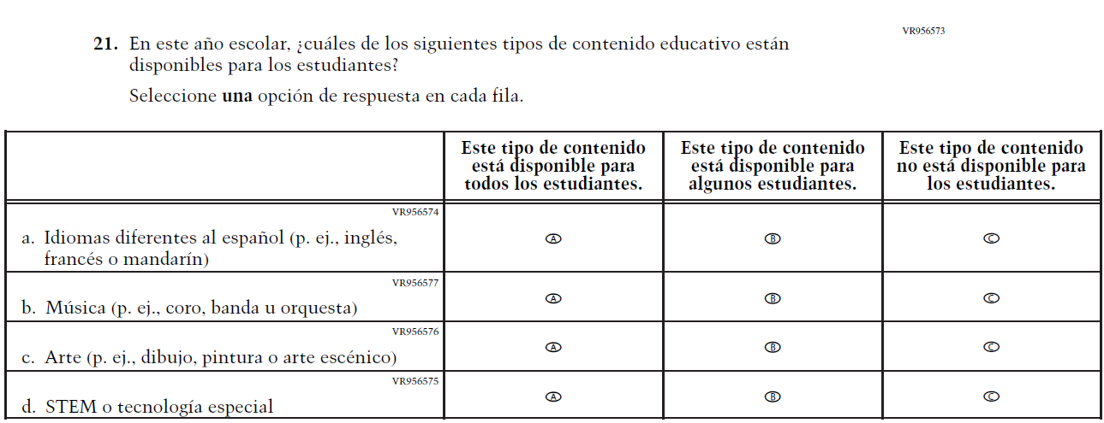  Issue: School Climate | A | This Item was developed to measure students’ learning environments and access to educational content focused on languages, music, art, and STEM.

Appendix J-3b-s-PR: Operational Grade 8 CORE
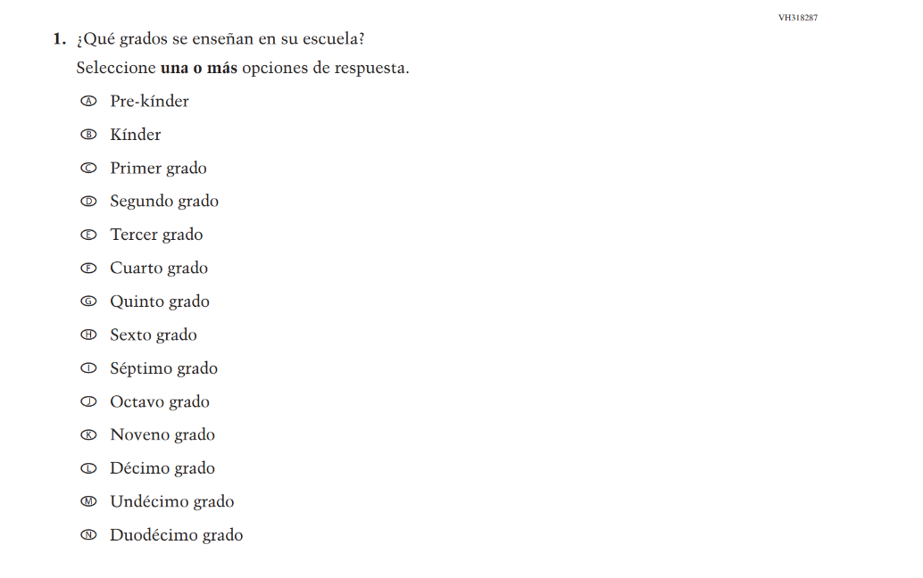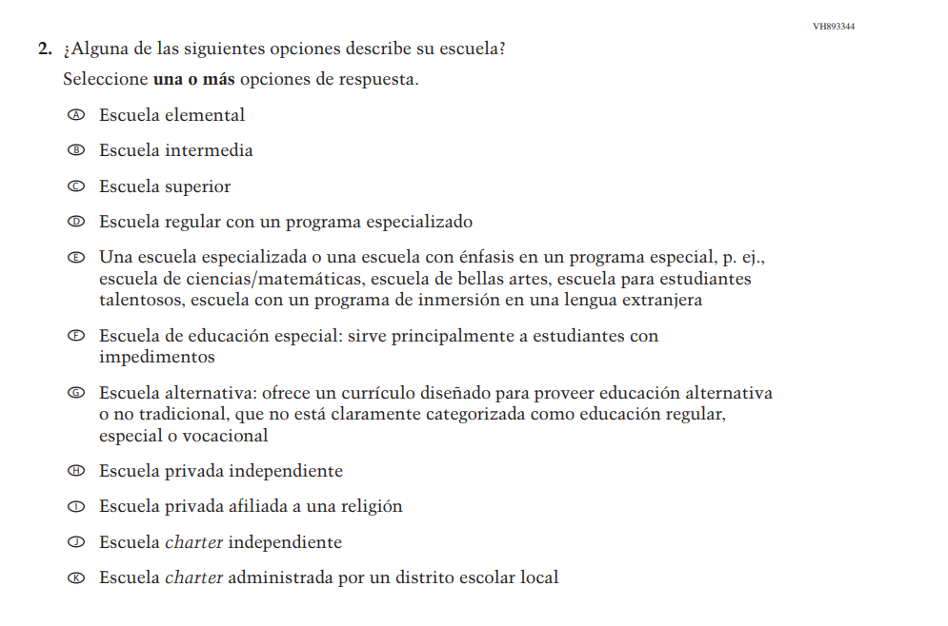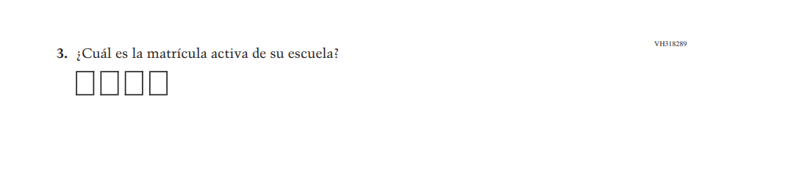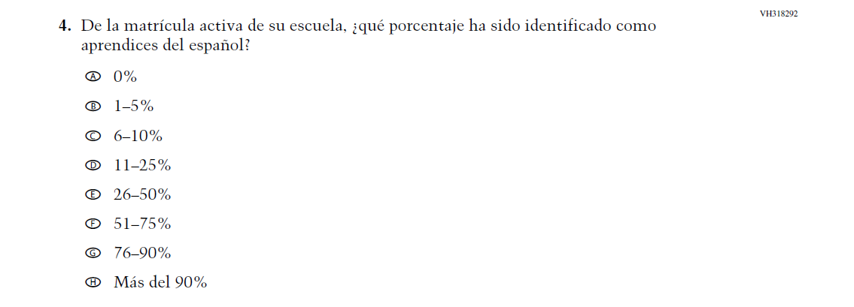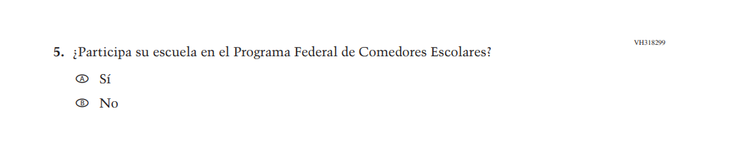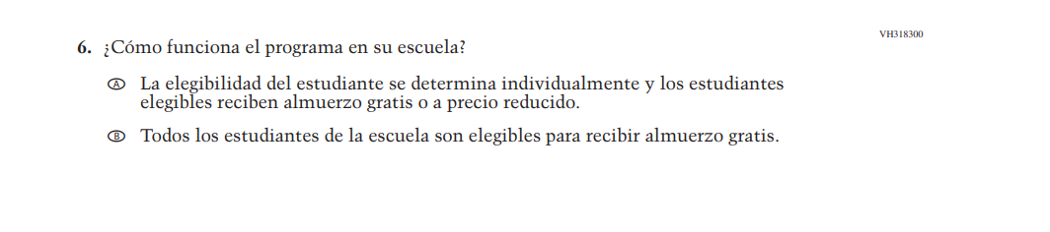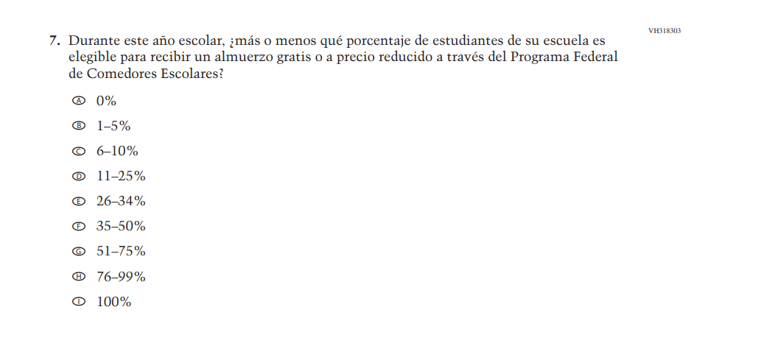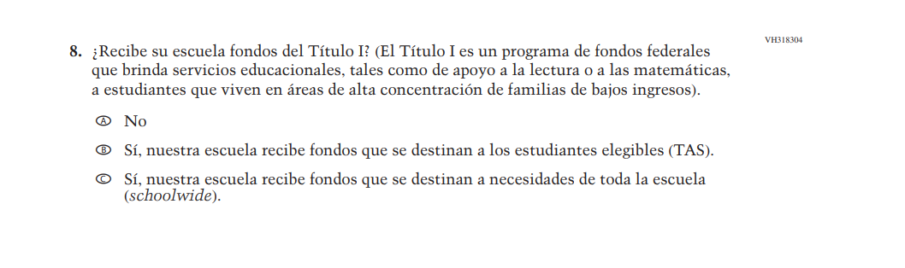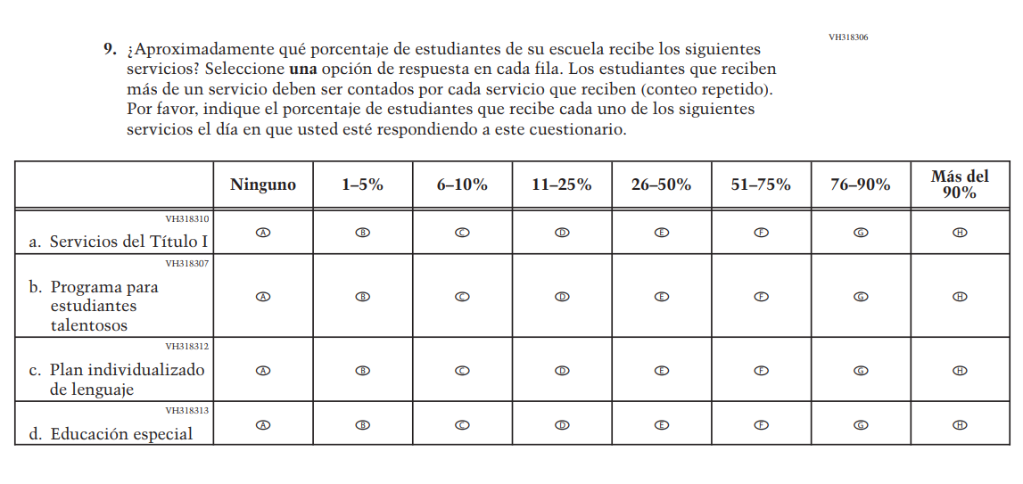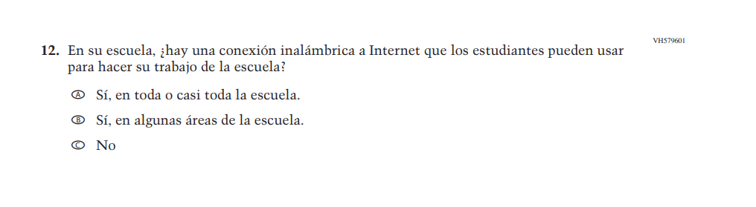
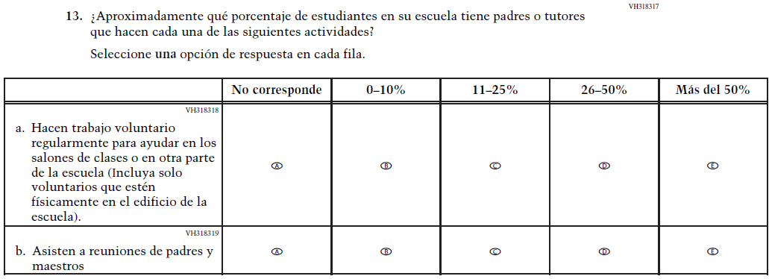
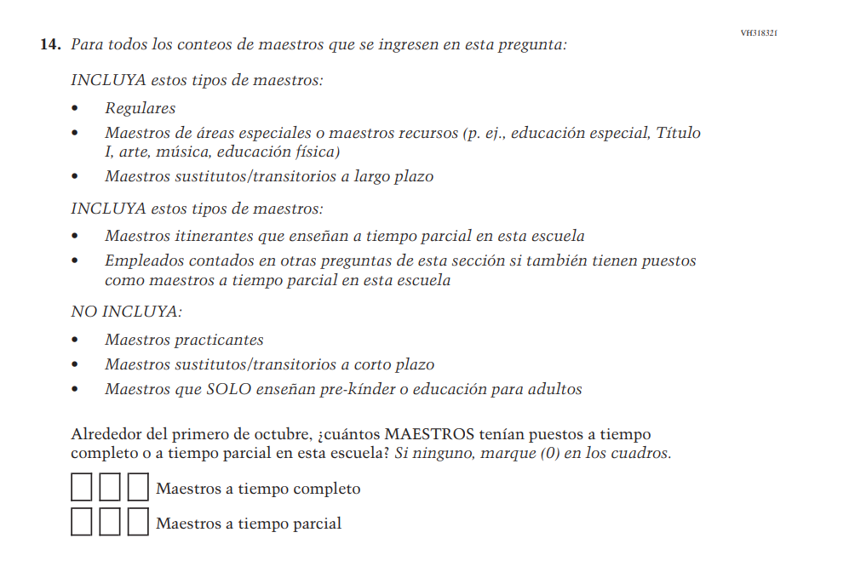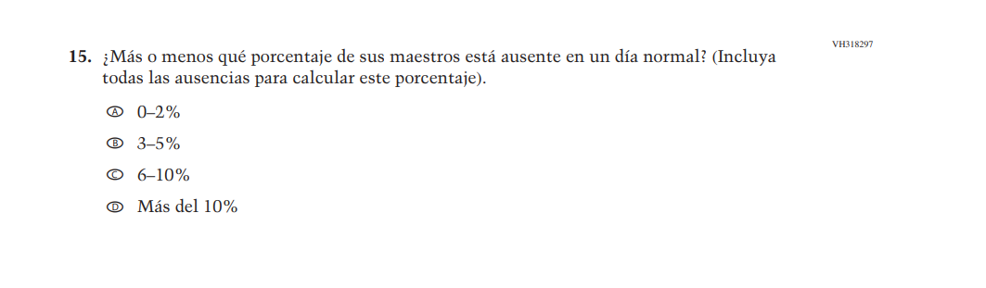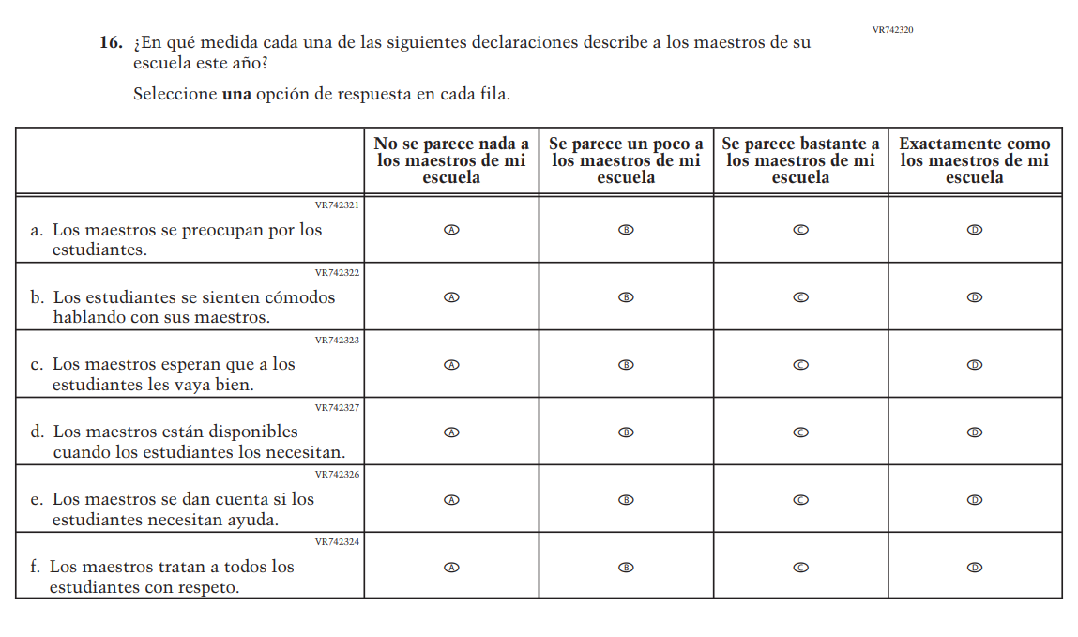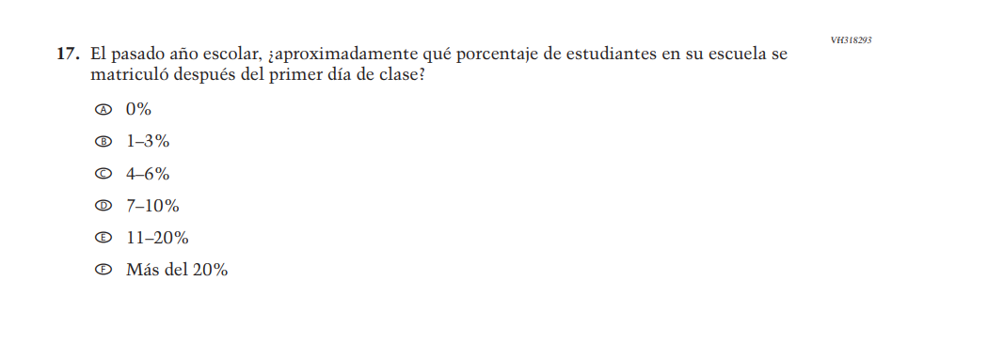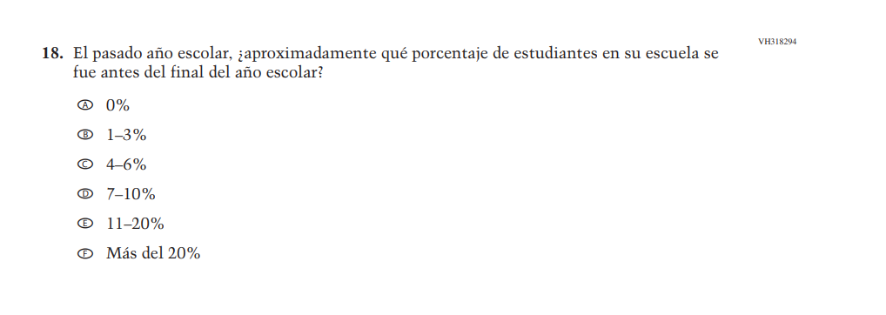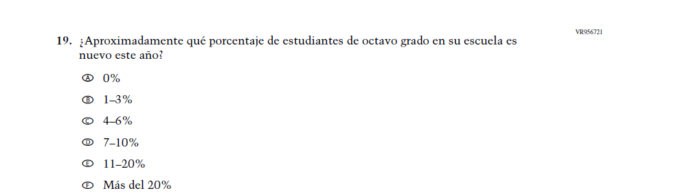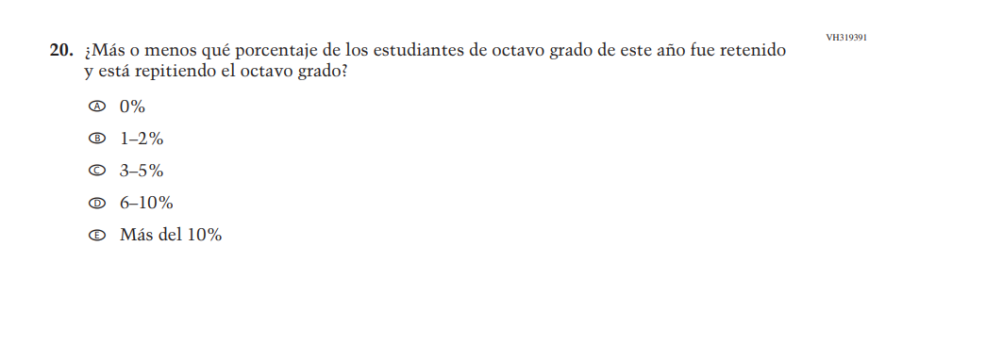

Appendix J-3c-s-PR: Summary of Changes Operational Grade 4 Mathematics
2026 Operational Grade 4 Math School – Puerto Rico
Previous item | 2026 item | D/A/R+ | Rationale
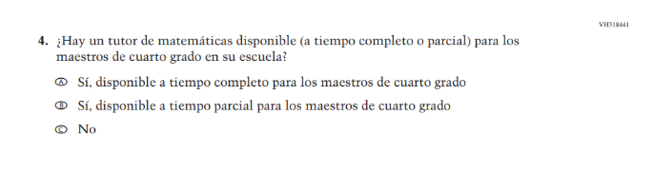  (2024 Operational Grade 4 School Math – Puerto Rico) | N/A | D | This item was dropped in favor of a new/revised item.
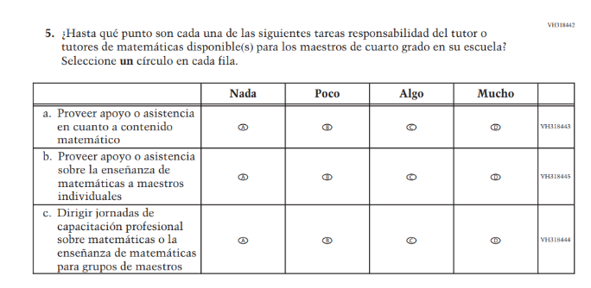  (2024 Operational Grade 4 School Math – Puerto Rico) | N/A | D | This item was dropped in favor of a new/revised item.
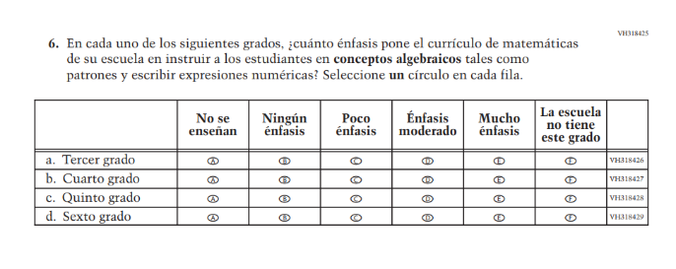  (2024 Operational Grade 4 School Math – Puerto Rico) | N/A | D | This item was dropped in favor of a new/revised item.
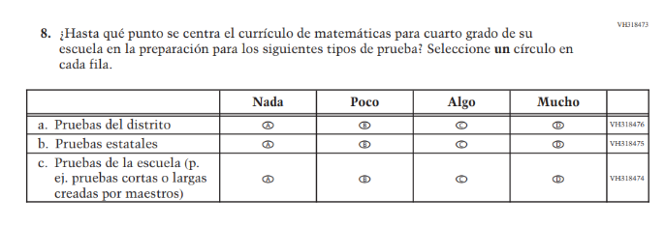 (2024 Operational Grade 4 School Math – Puerto Rico) | 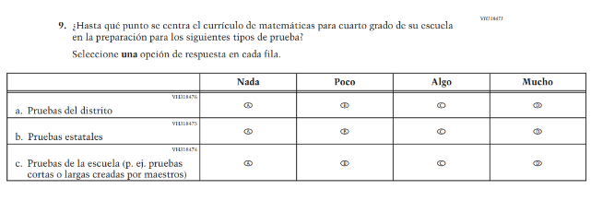  Issue: N/A | R | For 2026, we have aligned Inline Directions in Teacher and School Items with the Directions currently used in Student Items.
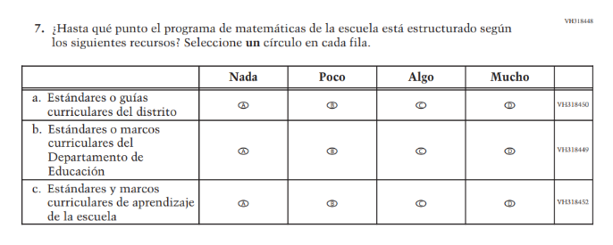(2024 Operational Grade 4 School Math – Puerto Rico) | 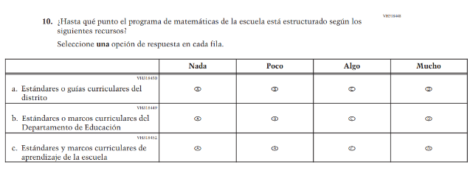  Issue: N/A | R | For 2026, we have aligned Inline Directions in Teacher and School Items with the Directions currently used in Student Items.
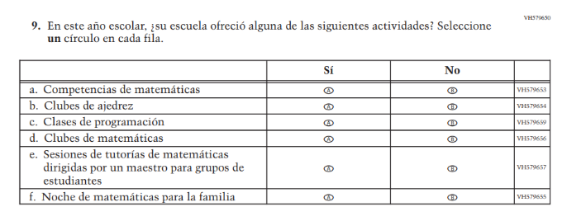  (2024 Operational Grade 4 School Math – Puerto Rico) | N/A | D | This item was dropped in favor of a new/revised item.

2026 Operational Grade 4 Math School – Puerto Rico
Previous item | 2026 item | D/A/R+ | Rationale
N/A  (2024 Operational Grade 4 School Math – Puerto Rico) | 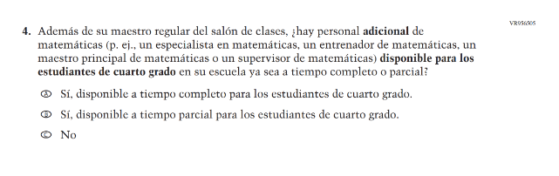  Issue: Mathematical Content and Practices | A | This item was developed to measure content aligned with the new Mathematics framework.
N/A  (2024 Operational Grade 4 School Math – Puerto Rico) | 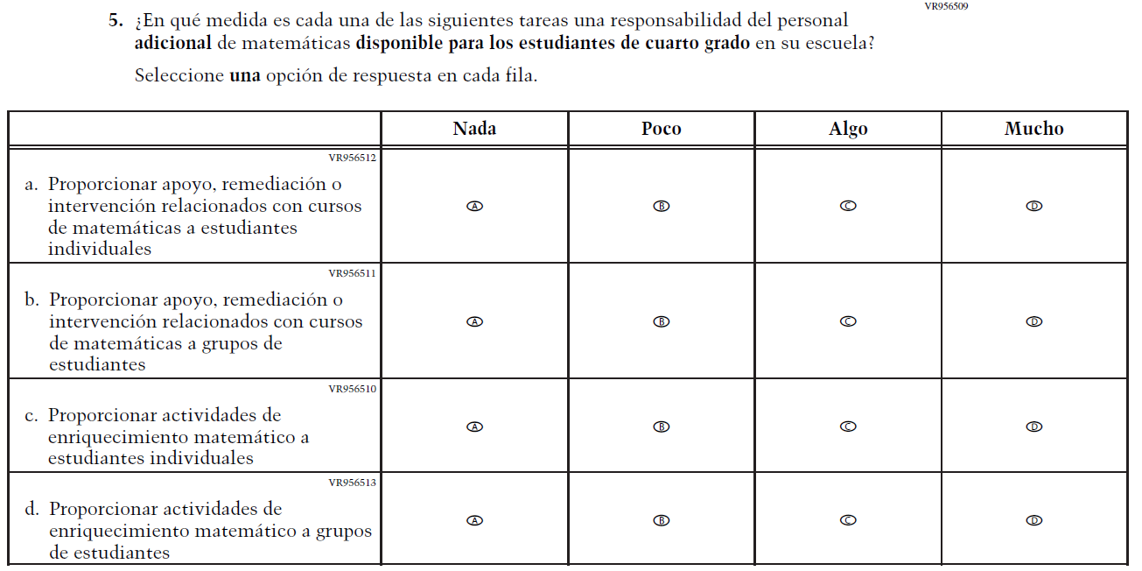  Issue: Instructional Organization and Strategies | A | This item was developed to measure content aligned with the new Mathematics framework.
N/A  (2024 Operational Grade 4 School Math – Puerto Rico) | 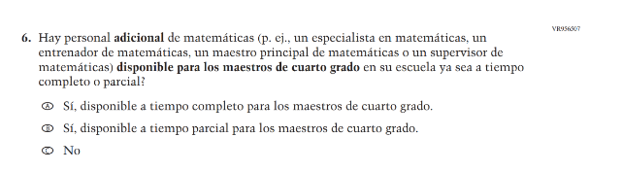  Issue: Teacher Factors | A | This item was developed as a clearer version of a dropped item (VH318441).
N/A  (2024 Operational Grade 4 School Math – Puerto Rico) | 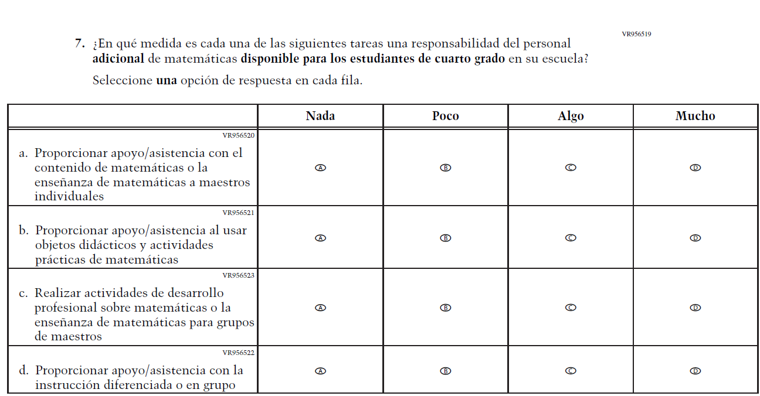  Issue: Instructional Organization and Strategies | A | This item was developed to measure content aligned with the new Mathematics framework.
N/A  (2024 Operational Grade 4 School Math – Puerto Rico) | 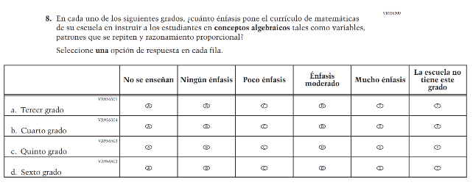  Issue: Mathematical Content and Practices | A | This item was developed as a clearer version of a dropped item (VH318425).
N/A  (2024 Operational Grade 4 School Math – Puerto Rico) | 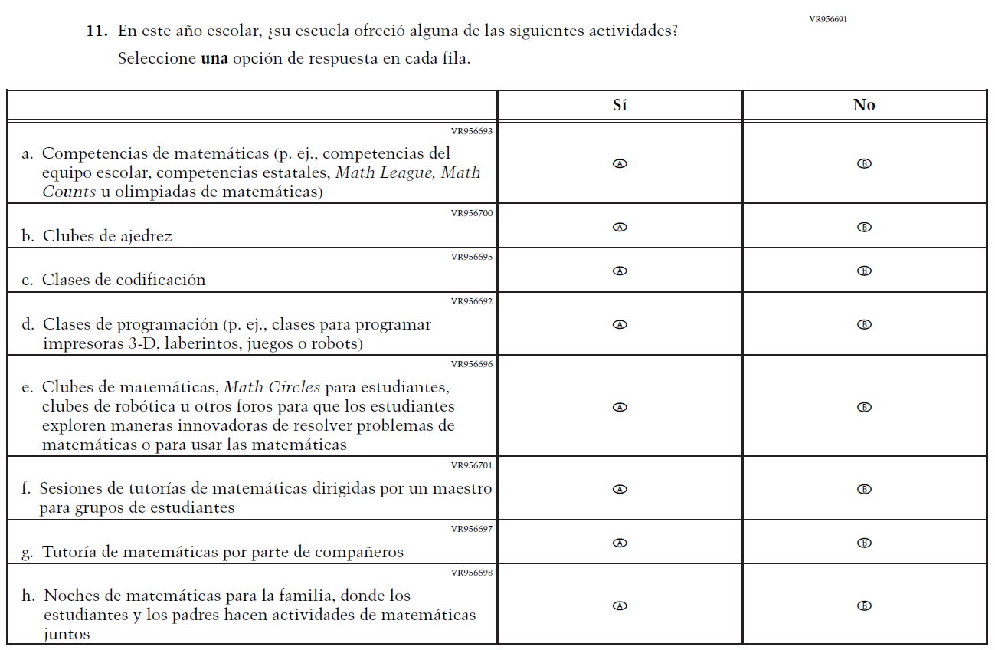  Issue: N/A | A | This item was developed as a clearer version of a dropped item (VH579650).

Appendix J-3c-s-PR: Operational Grade 4 Mathematics

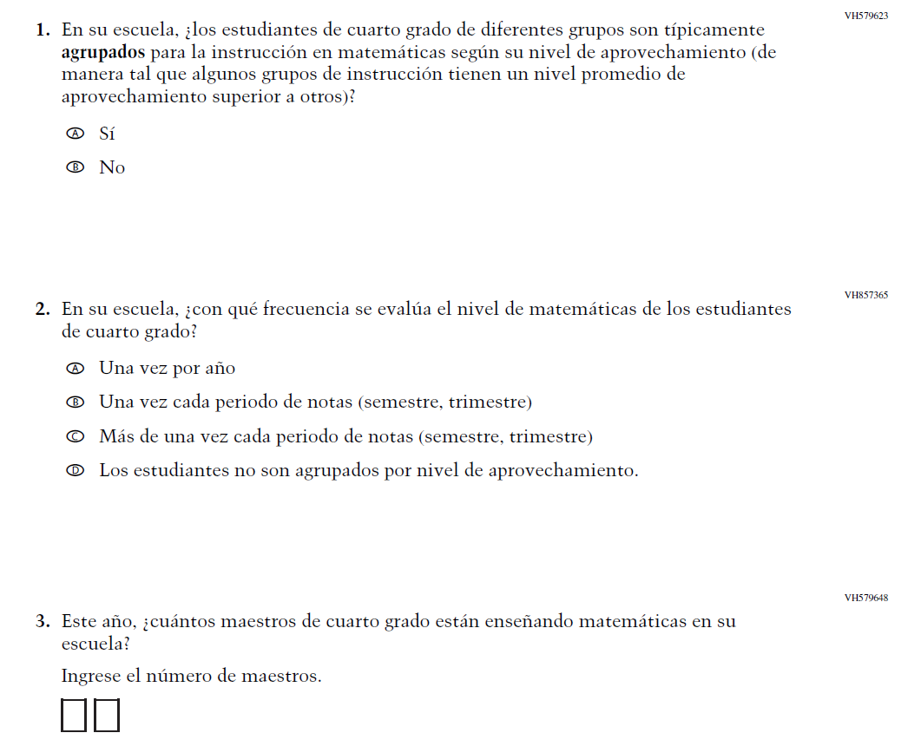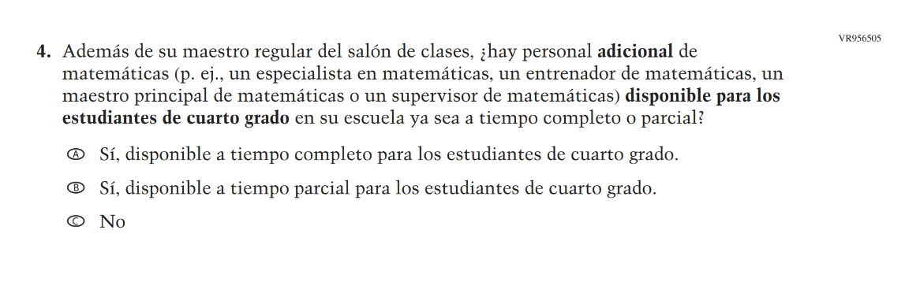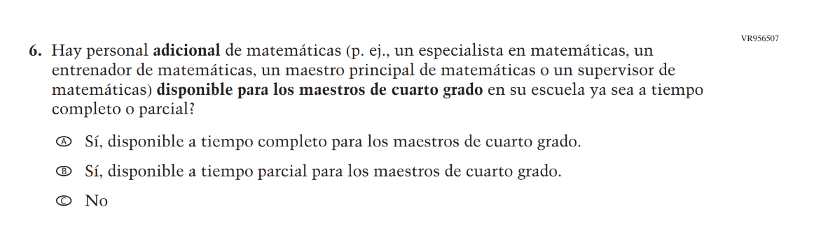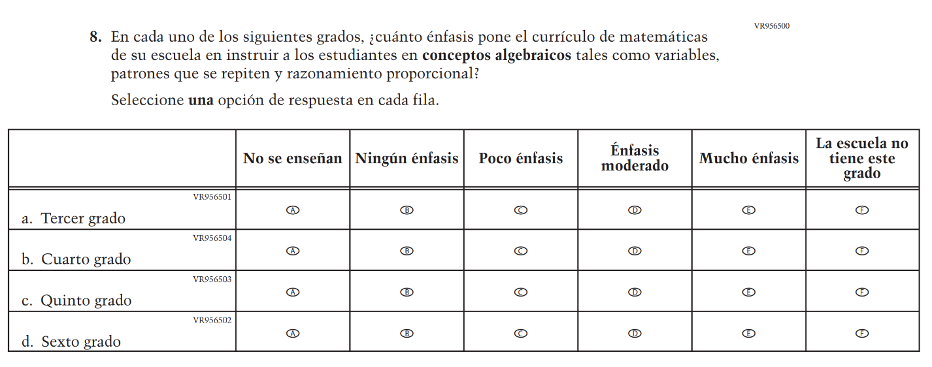

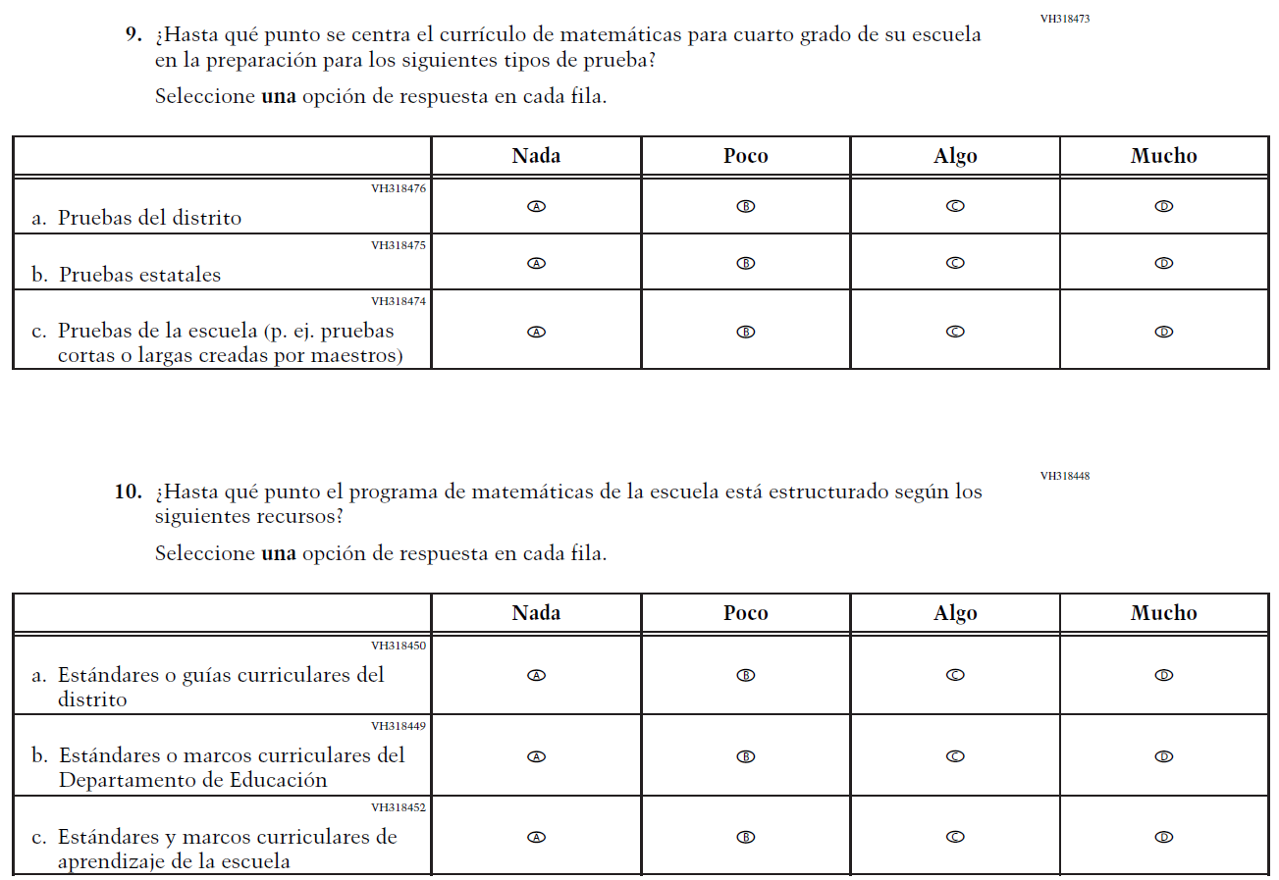

Appendix J-3d-s-PR: Summary of Changes Operational Grade 8 Mathematics
2026 Operational Grade 8 Math School – Puerto Rico
Previous item | 2026 item | D/A/R+ | Rationale
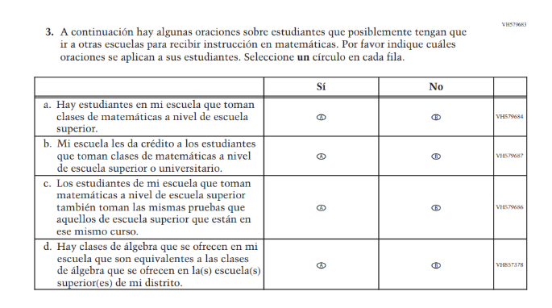  (2024 Operational Grade 8 School Math – Puerto Rico) | 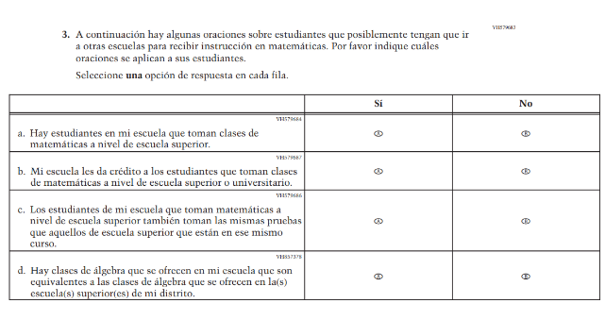  Issue: N/A | R | For 2026, we have aligned Inline Directions in Teacher and School Items with the Directions currently used in Student Items.
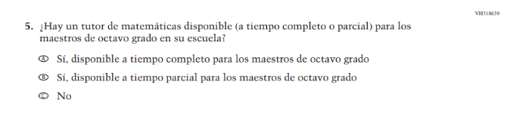  (2024 Operational Grade 8 School Math – Puerto Rico) | N/A | D | This item was dropped in favor of a new/revised item.
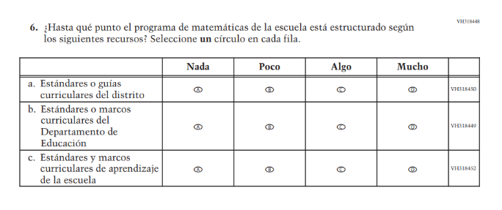  (2024 Operational Grade 8 School Math – Puerto Rico) | 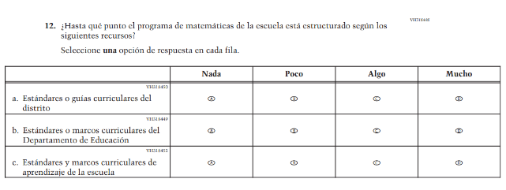  Issue: N/A | R | For 2026, we have aligned Inline Directions in Teacher and School Items with the Directions currently used in Student Items.
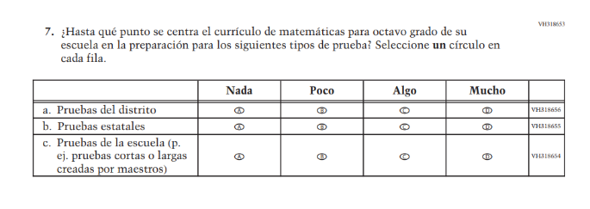(2024 Operational Grade 8 School Math – Puerto Rico) | 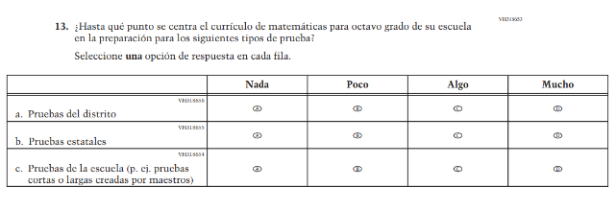  Issue: N/A | R | For 2026, we have aligned Inline Directions in Teacher and School Items with the Directions currently used in Student Items.
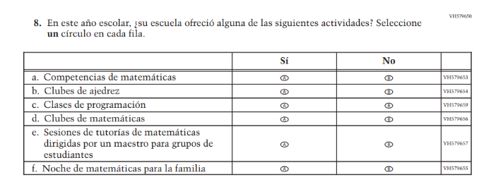(2024 Operational Grade 8 School Math – Puerto Rico) | N/A | D | This item was dropped in favor of a new/revised item.

2026 Operational Grade 8 Math School – Puerto Rico
Previous item | 2026 item | D/A/R+ | Rationale
N/A  (2024 Operational Grade 8 School Math – Puerto Rico) | 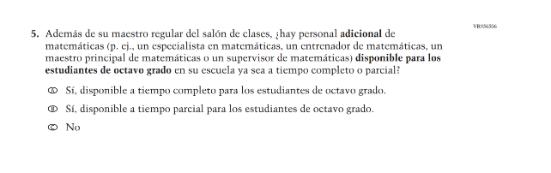  Issue: Mathematical Content and Practices | A | This item was developed to measure content aligned with the new Mathematics framework.
N/A  (2024 Operational Grade 8 School Math – Puerto Rico) | 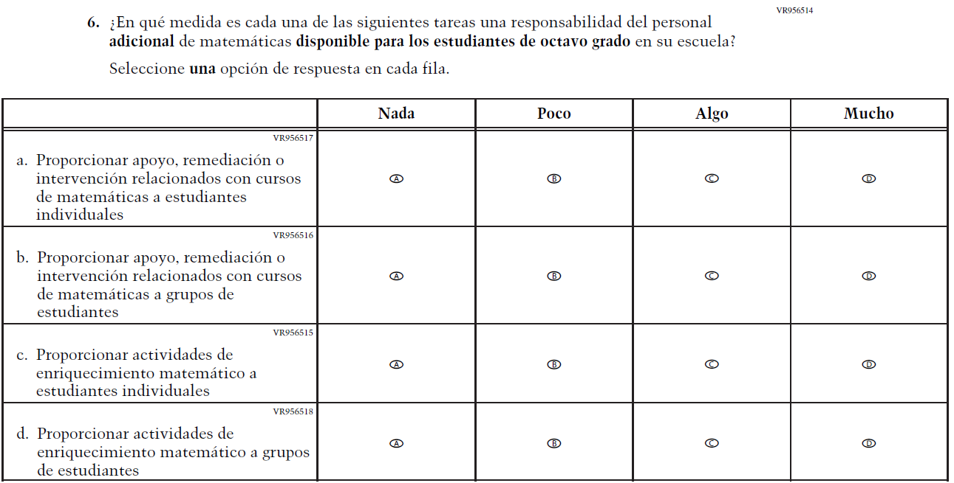  Issue: Instructional Organization and Strategies | A | This item was developed to measure content aligned with the new Mathematics framework.
N/A  (2024 Operational Grade 8 School Math – Puerto Rico) | 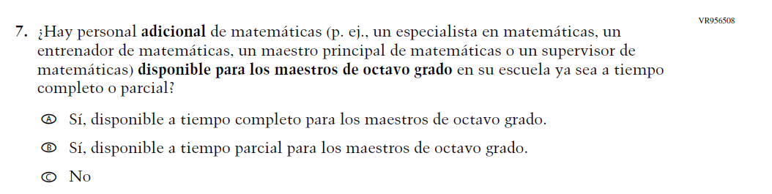  Issue: Teacher Factors | A | This item was developed as a clearer version of a dropped item (VH318639).
N/A  (2024 Operational Grade 8 School Math – Puerto Rico) | 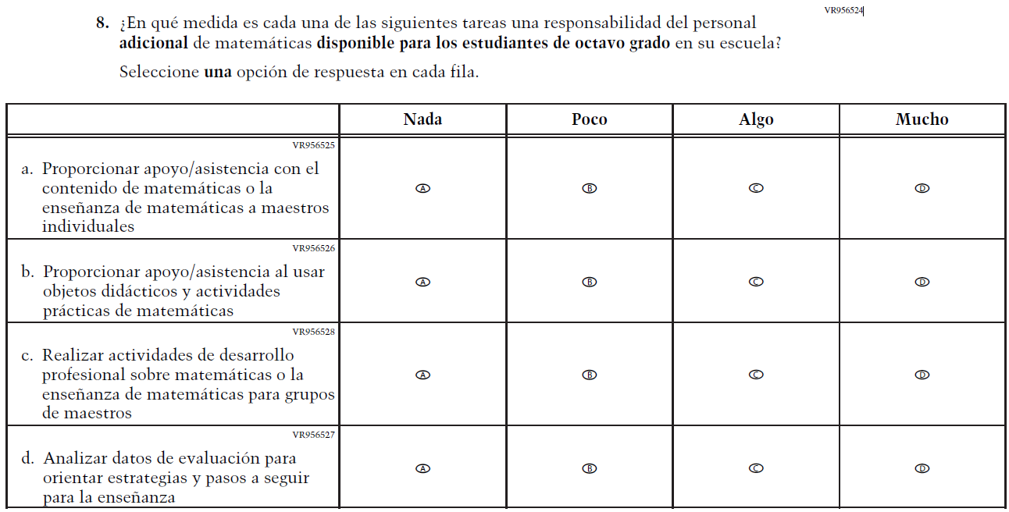  Issue: Teacher Factors | A | This item was developed to measure content aligned with the new Mathematics framework.
N/A  (2024 Operational Grade 8 School Math – Puerto Rico) | 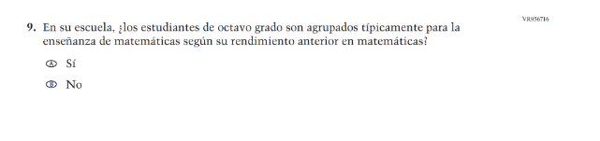  Issue: Instructional Organization and Strategies | A | This item was developed to measure content aligned with the new Mathematics framework.
N/A  (2024 Operational Grade 8 School Math – Puerto Rico) | 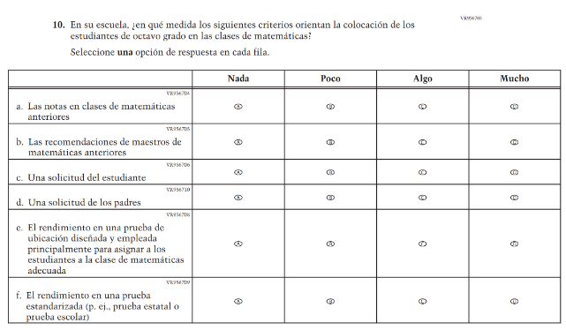  Issue: Instructional Organization and Strategies | A | This item was developed to measure content aligned with the new Mathematics framework.
N/A  (2024 Operational Grade 8 School Math – Puerto Rico) | 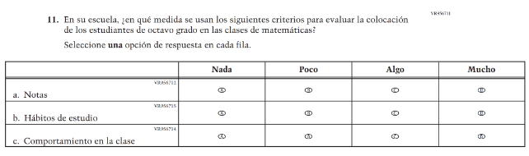  Issue: Instructional Organization and Strategies | A | This item was developed to measure content aligned with the new Mathematics framework.
N/A  (2024 Operational Grade 8 School Math – Puerto Rico) | 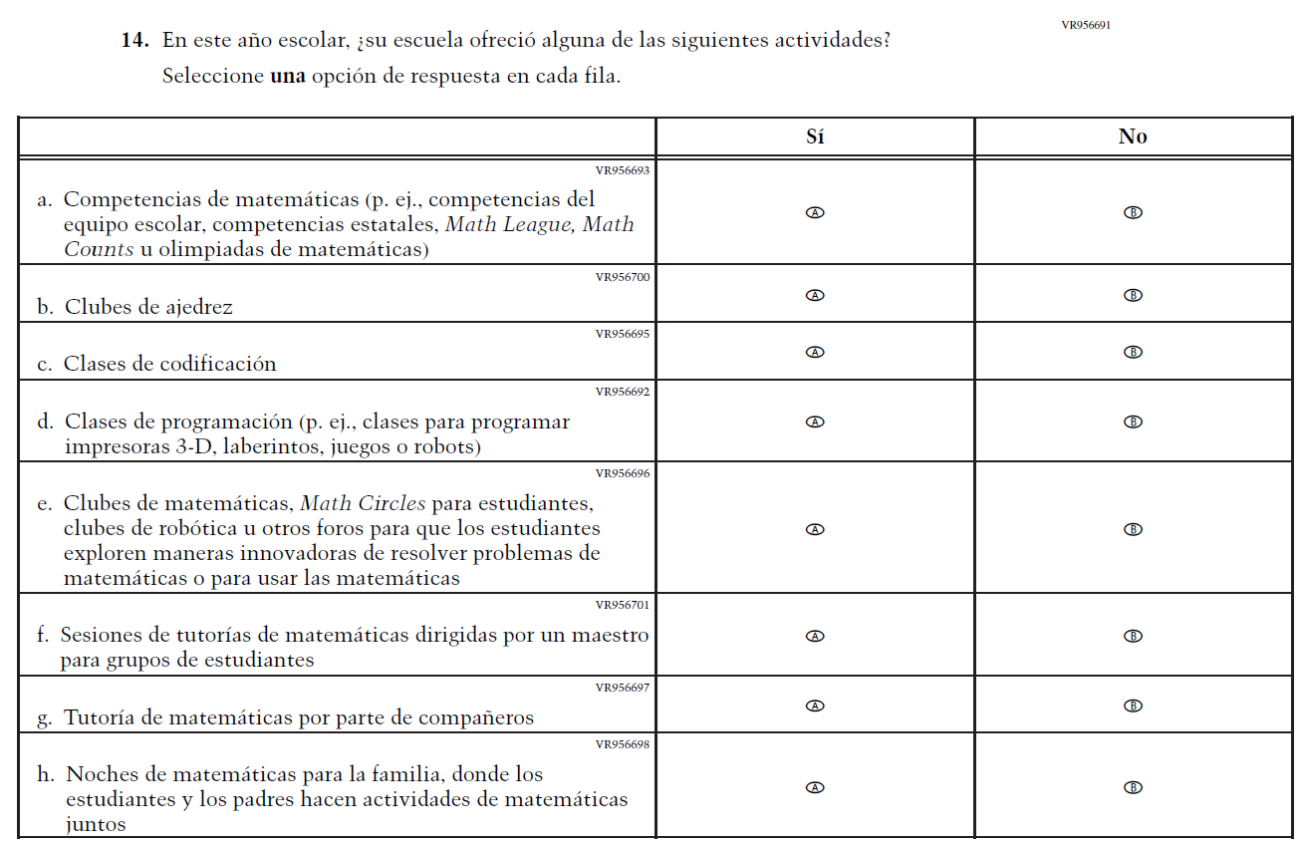  Issue: N/A | A | This item was developed as a clearer version of a dropped item (VH579650).

Appendix J-3d-s-PR: Operational Grade 8 Mathematics
