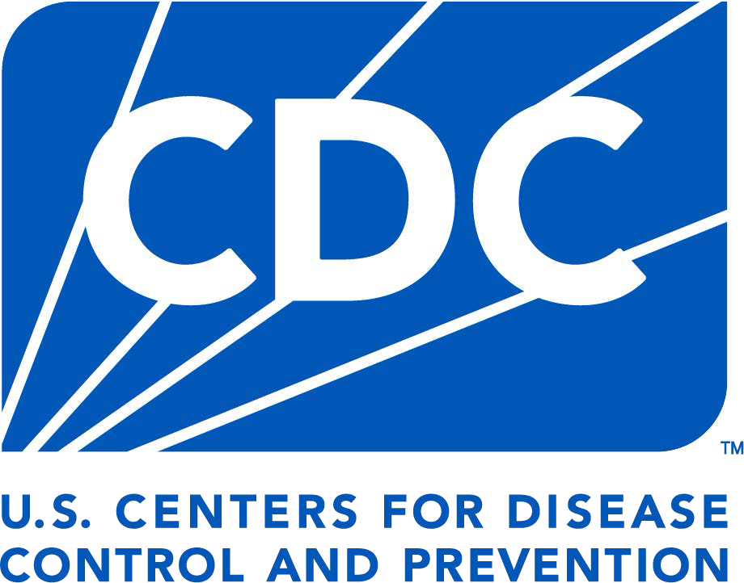

Facility Incident Reporting Form
FOR POLIOVIRUS THEFT or LOSS

Facilities retaining poliovirus infectious materials must report any poliovirus containment breach to the U.S. CDC Emergency Operation Center (EOC) at (770) 488-7100. After notifying the EOC, submit this form to the U.S. National Authority for Containment of Poliovirus (NAC) at poliocontainment@cdc.gov within 12 hours of the incident. Form sections A and B must be
FORM APPROVED OMB NO. 0920-1424 EXP DATE: 12/31/2026

reported within 12 hours of the incident, and any information not available at the time of submission should be provided as a resubmission within
72 hours of the incident. The U.S. NAC may share information about the incident with relavant CDC leadership and a national poliovirus containment oversight body to ensure appropriate measures are implemented.

FORM INSTRUCTIONS: Fill out each section as thoroughly as possible. Provide a signature after all sections are complete. If you are unable to sign digitally; print the document, sign manually, and scan to PDF format. If the form is opened using a web browser and features are unavailable, reopen with Adobe Acrobat. Send the completed form to the U.S. NAC at poliocontainment@cdc.gov. Contact NAC for assistance at poliocontainment@cdc.gov or 404-718-5160.

A. FACILITY INFORMATION (REPORT WITHIN 12 HOURS)

Facility Name:

Department:
Address: City:  State:  Zip:

FACILITY CONTACT INFORMATION
Form submitted by: Title Name Email Phone # Format: (xxx) xxx-xxxx

B. INCIDENT INFORMATION (REPORT WITHIN 12 HOURS)
- Date of incident discovery¹: 2. Time of incident discovery:

(Date format: MM/DD/YYYY)

- Date of CDC/NAC notification:
(Date format: MM/DD/YYYY)
(Include time zone, Ex: 9:15 am EST)

- Has the incident been reported to the facility biosafety officer?............................................... Yes No N/A
- Has the incident been reported to the facility Security Representative?.................................. Yes No N/A
- Has the incident been reported to the appropriate law enforcement agency?......................... Yes No N/A

- Incident type (e.g., theft or loss):
For theft, complete section C1. For loss, complete section C2.

- At what biosafety level did the incident occur? If other, please describe:

1 The date of incident discovery is the date that the incident was discovered by facility staff.

Public reporting burden: CDC estimates the average public reporting burden for this collection of information as 45 minutes per response, including the time for reviewing instructions, searching existing data/information sources, gathering and maintaining the data/information needed, and completing and reviewing the collection information unless it displays a currently valid OMB control number. Send comments regarding this burden estimate or any other aspect of this collection of information, including suggestions for reducing this burden to CDC/ATSDR Information Review Office; 1600 Clifton Road NE, MS D-74, Atlanta, Georgia 30333; ATTN: PRA (0920-1424).

B. INCIDENT INFORMATION, CONTINUED (REPORT WITHIN 12 HOURS)
- Briefly describe the details of incident. e.g.,location (bldg, room, etc.) and equipment (freezer, centrifuge, etc.):

- Enter the material type, virus type, sample type, and if known, the amount of virus sample involved in the incident. If there is
a mixture of material types, enter a separate record for each material type in separate rows. If known, enter the viral concentration (ml or g) and/or poliovirus strain associated with the incident.

Material Type | Virus Type | Sample Type | Amt. (ml or g) | Conc.  (µg/ml or titer) | Poliovirus Strain
Submit Sections A and B within 12 hours of incident
Submit Form
C. ADDITIONAL INCIDENT DETAILS (REPORT WITHIN 72 HOURS)
C1. THEFT OF MATERIAL

- Type of theft: (choose all that apply)
Forced Entry
Insider/Insider Assist
Unauthorized Access
Undetermined

- Was the stolen poliovirus material recovered? Yes No

If yes, date of recovery:

(Date format: MM/DD/YYYY)

- Was there a potential exposure to humans? Yes No Unsure
(If yes, also complete the Facility Incident Reporting Form for Release/Exposure-link)

- Has local law enforcement been notified? Yes

- Local law enforcement agency:

No Not yet

- Local law enforcement point of contact (title and name):

- Local law enforcement point of contact information (phone/email):

C2. LOSS OF MATERIAL

1 Type of loss: (choose all that apply)
Sample loss in transit Other:
Sample loss/discarded at Inventory/record keeping error facility
Unknown

- Was there a potential exposure to humans?
Yes
No Unsure

(If yes, also complete the Facility Incident Reporting Form for Exposure/Release-link)

- Was the lost poliovirus material recovered?
3a If yes, date of recovery:
Yes No Unsure

(Date format: MM/DD/YYYY)

C. ADDITIONAL INCIDENT DETAILS, CONTINUED (REPORT WITHIN 72 HOURS)

- Provide the date of the last inventory/audit performed:
Note: Provide an approximate date if exact date is unknown.

(Date format: MM/DD/YYYY)

Provide a full narrative of the incident, including steps taken immediately after the incident.

D. DECLARATION
By signing this document, I acknowledge that the data provided are correct and accurately reflect the reported incident. I understand that the information provided on this form may be provided to relevant CDC leadership and may result in the declaration of a public health event of international concern (PHEIC) in alignment with International Health Regulations.2

E-signature after Sections A, B, and C are complete:
Accountable Individual: Name:

( e.g., Laboratory Head,
Principal Investigator) Title:
Date:
Submit Form Submit Sections C and D within 72 hours of incident

DEFINITIONS (General definitions on CDC U.S. NAC website)

Accountable individual:A person responsible for poliovirus materials (e.g., Principal Investigator, Laboratory Director).
Accident/incident: Event that occurs with IM or PIM poliovirus which may impact poliovirus containment. Events may result in the following:
- Injury
- Exposure or illness
- Breach of containment
- Other events resulting in property damage or disruption of facility operations
- Accidents/incidents hereinto referred to as incidents.

Certificate of Registration (CR): A CR indicates that the U.S. NAC acknowledges the facility has met the primary containment conditions for designation as a U.S. poliovirus-essential facility.
Date of incident discovery: Date incident was discovered by facility staff.
Facility: Any site (e.g., laboratory, repository, or vaccine production unit) owned or operated by any level of government, academic institution, corporation, company, partnership, society, association, firm, sole proprietorship or other legal entity.
Infectiousmaterial(IM): Clinical materials from confirmed wild poliovirus (including VDPV) infections or OPV/Sabin; environmental sewage or water samples that have tested positive for the presence of wild polioviruses or OPV/ Sabin strains.
Nucleic acids: Refers to RNA, cDNA and total nucleic acid, extracted from poliovirus infectious materials (e.g., a virus isolate) or potentially infectious materials (e.g., stool, respiratory specimen, sewage). Extraction methods not validated to inactive poliovirus should be reported as inactivation failures for these materials.
Poliovirus containment perimeter: Poliovirus-essential facility area(s) listed on the PEF CR application.
Potentially Infectious Materials (PIM): All materials potentially contaminated with any type or strain of WPV or OPV/Sabin poliovirus, or where the presence of polioviruses cannot be ruled out. PIM can include but is not limited to:
  - Fecal or respiratory secretion samples and their derivatives (e.g., stool suspensions, extracted nucleic acids, etc.) collected for any purpose in a geographic area where WPV/cVDPV is present or OPV is being used at the time of collection
  - Fecal or respiratory secretion samples and their derivatives (e.g., stool suspensions, extracted nucleic acids, etc.) collected for any
purpose in a geographic area where WPV/cVDPV is present or OPV is being used at the time of collection
- Products of such materials (above) from PV-permissive cells or
experimentally infected polio-susceptible animals
- Uncharacterized enterovirus-like cell culture isolates derived from human specimens from countries known or suspected to have circulating WPV/VDPV or use of OPV at the time of collection
- Respiratory and enteric virus stocks derived from PV PIM and handled under conditions conducive to maintaining the viability or enabling the replication of incidental PV
- Environmental samples (e.g., concentrated sewage, wastewater) collected from areas known or suspected to have circulating WPV/ VDPV or use of OPV at the time of collection.
Poliovirus containment breach: Loss of poliovirus containment at any level which may result in potential infection to persons or potential spread in the environment. Any facility accident involving IM or PIM poliovirus that may potentially expose humans to any poliovirus through ingestion, inhalation, or skin contact by release, exposure, theft, or loss.
Poliovirus Designated Facility (PVDF): A facility designed by the US NAC as serving a critical national or international function that involves the handling and/or storage of needed poliovirus infectious or potentially infectious material.
Poliovirus exposure: Any facility accident that potentially exposes humans to any poliovirus.
Poliovirus release: Loss of primary containment of IM or PIM poliovirus which may result in potential infection to persons or potential spread in the environment.
Risk assessment: A qualitative or semi-qualitative process undertaken by individuals with expertise in appropriate disciplines and backgrounds in response to an identified hazard.
Sabin/OPV: Attenuated poliovirus strains (approved for use in oral polio vaccines by national regulatory authorities, principally Sabin strains).
VDPV: Vaccine-derived poliovirus; Classified with wild polioviruses and usually demonstrate 1–15% sequence differences from the parental OPV strain; they may have circulated in the community (cVDPV) or have replicated for prolonged periods in immunodeficient subjects (iVDPV) or be ambiguous and of unknown origin (aVDPV).

2 Centers for Disease Control and Prevention. (2024, May 15). International Health Regulations. Global Health. https://www.cdc.gov/global-health/topics-programs/ihr.html

