Amputation System of Care Survey


VA provides free, confidential support 24/7 for Veterans and their family and friends. If you
OMB Number: 2900-0876
Expiration: 2/28/2026
Estimated Burden: 5 minutes
are in crisis, contact the Veterans Crisis Line by dialing 988 (Press 1), or dialing 1 (800)
273-8255 (Press 1), or texting 838255, or visiting https://www.veteranscrisisline.net. If you are
homeless or at risk of homelessness, contact the National Call Center for Homeless
Veterans (NCCHV) by dialing 1 (877) 424-3838 or visiting https://www.va.gov/HOMELESS/.

Help us serve you better.

Your opinion matters. We want to hear about your experience regarding your most recent VA Amputation Specialty Clinic appointment. By indicating how much you agree or disagree with the statements below, you directly help us improve VA services!

This voluntary survey should take approximately 5 minutes to complete.

In which state do you receive medical care? Required
[Drop Down with Each State]

Which Medical Center do you visit? Required
[Drop Down with Each Medical Center in State selected]

Prior to my VA amputation specialty clinic visit, I felt prepared for my appointment.
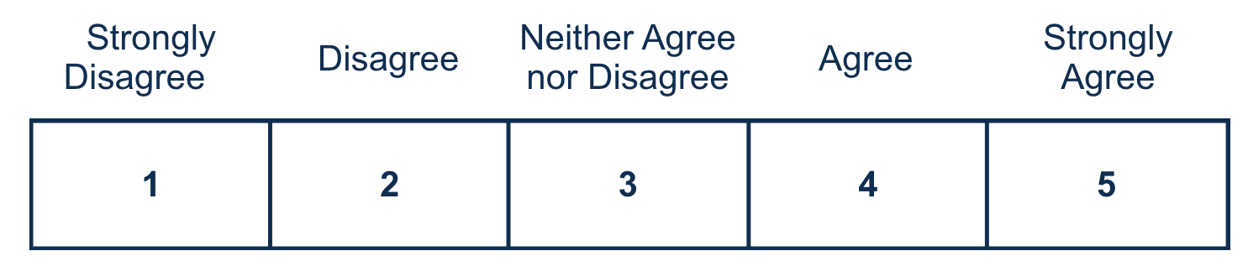

During my clinic experience, I felt the VA amputation specialty care team was knowledgeable and had expertise in amputation care.

After my clinic visit, I knew what to expect when prescribed a prosthesis.
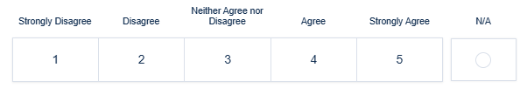
The time it took to get my most recently prescribed prosthesis was reasonable.
My VA amputation care team and my non-VA prosthetist work well together to take care of me.
The VA amputation specialty care team met my needs.

I know how to get in touch with my VA amputation specialty care team.
I would recommend VA amputation specialty care clinic to other Veterans. Required

Use the text box below to enter details of the additional feedback (optional). Please do not include any personally identifiable information, (i.e. Social Security Number, Veteran ID, or medical information). We are interested in details about your experience with the VA amputation specialty care clinic.

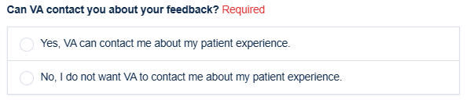
<Logic only appears if Veteran gives permission to contact> Name

<Logic only appears if Veteran gives permission to contact> Phone Number
<Logic only appears if Veteran gives permission to contact> Email



Privacy Notice: By filling out this survey, you are authorizing VA database access to retrieve Veteran contact information to follow up with you accordingly for purposes of service recovery, potential crisis, or to learn more about feedback you have shared regarding your experience with VA. Your contact information and response may be referred to the Veterans Crisis Line if an automated review indicates your response may be concerning. The Veterans Crisis Line may contact you for follow up as a result of that referral. VA may utilize individual Veteran survey data from this survey or other sources to ensure the final scores truly and accurately represent the experiences of Veterans. This collection of information is authorized by 38 U.S.C. Section 301. The Systems of Records Notice can be found here: https://www.federalregister.gov/d/2021-01526.
Respondent Burden: An agency may not conduct or sponsor, and a person is not required to respond to a collection of information unless it displays a currently valid OMB control number. The OMB control number for this project is 2900-0876, and it expires 02/28/2026. Public reporting burden for this collection of information is estimated to average 5 minutes per respondent, per year, including the time for reviewing instructions, searching existing data sources, gathering and maintaining the data needed, and completing and reviewing the collection of information. Send comments regarding this burden estimate and any other aspect of this collection of information, including suggestions for reducing the burden, to VA Reports Clearance Officer at vapra@va.gov. Please refer to OMB Control No. 2900-0876 in any correspondence. Do not send your completed VA Form to this email address.

VA provides free, confidential support 24/7 for Veterans and their family and friends. If you
OMB Number: 2900-0876
Expiration: 2/28/2026
Estimated Burden: 5 minutes
are in crisis, contact the Veterans Crisis Line by dialing 988 (Press 1), or dialing 1 (800)
273-8255 (Press 1), or texting 838255, or visiting https://www.veteranscrisisline.net. If you are
homeless or at risk of homelessness, contact the National Call Center for Homeless
Veterans (NCCHV) by dialing 1 (877) 424-3838 or visiting https://www.va.gov/HOMELESS/.

Thank you for choosing VA.

The U.S. Department of Veterans Affairs uses these surveys to collect your feedback in order to continuously improve your experience with VA services.
Please visit VA.gov to explore benefits, resources, and information at VA.

