VSO Feedback Survey
V7 DRAFT 01/02/2026
Working Draft, Pre-Decisional, Deliberative document – Internal VA Use Only


VA provides free, confidential support 24/7 for Veterans and their family and friends. If you
OMB Number: 2900-0876
Expiration: 1/31/2029
Estimated Burden: 5 minutes
are in crisis, contact the Veterans Crisis Line by dialing 988 (Press 1), or dialing 1 (800)
273-8255 (Press 1), or texting 838255, or visiting https://www.veteranscrisisline.net. If you are
homeless or at risk of homelessness, contact the National Call Center for Homeless
Veterans (NCCHV) by dialing 1 (877) 424-3838 or visiting https://www.va.gov/HOMELESS/.

Help us serve you better.
Your opinion matters. In January 2024, VA created the opportunity for Veterans Service Organizations (VSO) to participate in the VA Benefits and Services Course (BAS). Please complete this survey to let us know about your experience. The more information you share with us, the better we can serve you and transitioning Service members/Veterans.

This voluntary survey should take approximately 5 minutes to complete.

[1] I am satisfied with how the Benefits and Services (BAS) course enabled me as a VSO representative to connect with more transitioning Service members/Veterans. Required
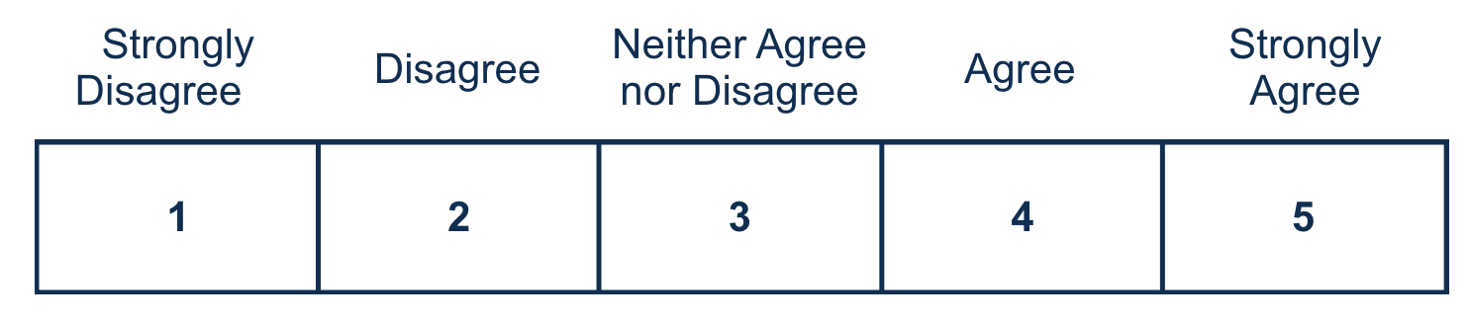

[2] The information or guidance I received helped me to register for the VA Benefits and Services (BAS) course.

[3] It was easy to navigate the registration portal.
[4] The scheduling information for the course was easy to understand.
[5] VA provided useful information about the roles and responsibilities of the VSO to participate in the VA Benefits and Services (BAS) course.
[6] The Benefits Advisor clearly communicated how to effectively participate in the VA Benefits and Services (BAS) course.

[7] I received adequate information about how to work effectively with the Benefits Advisor to support transitioning Service members/Veterans.

[8] The Department of War Transition Assistance Program staff was helpful.

[9] Participating in the VA Benefits and Services (BAS) course has positively impacted my work with transitioning Service Members/Veterans.
[10] I trust VA to support Veterans Service Organizations with assisting transitioning Service members/Veterans with the benefits and services they have earned. Required
[11] What can VA do to improve VSO participation in the Benefits and Services course?

[12] Is there anything else you would like to share about the VSO integration process?



Respondent Burden: An agency may not conduct or sponsor, and a person is not required to respond to a collection of information unless it displays a currently valid OMB control number. The OMB control number for this project is 2900-0876, and it expires 01/31/2029. Public reporting burden for this collection of information is estimated to average 5 minutes per respondent, per year, including the time for reviewing instructions, searching existing data sources, gathering and maintaining the data needed, and completing and reviewing the collection of information. Send comments regarding this burden estimate and any other aspect of this collection of information, including suggestions for reducing the burden, to VA Reports Clearance Officer at vapra@va.gov. Please refer to OMB Control No. 2900-0876 in any correspondence. Do not send your completed VA Form to this email address.

VSO Feedback Survey
V7 DRAFT 01/02/2026
Working Draft, Pre-Decisional, Deliberative document – Internal VA Use Only

VA provides free, confidential support 24/7 for Veterans and their family and friends. If you
OMB Number: 2900-0876
Expiration: 1/31/2029
Estimated Burden: 5 minutes
are in crisis, contact the Veterans Crisis Line by dialing 988 (Press 1), or dialing 1 (800)
273-8255 (Press 1), or texting 838255, or visiting https://www.veteranscrisisline.net. If you are
homeless or at risk of homelessness, contact the National Call Center for Homeless
Veterans (NCCHV) by dialing 1 (877) 424-3838 or visiting https://www.va.gov/HOMELESS/.

Thank you for choosing VA.

The U.S. Department of Veterans Affairs uses these surveys to collect your feedback in order to continuously improve your experience with VA services.
Please visit VA.gov to explore benefits, resources, and information at VA.

