Outpatient Healthcare Visit – Adding Whole Health Questions


VA provides free, confidential support 24/7 for Veterans and their family and friends. If you
OMB Number: 2900-0876
Expiration: 1/31/2029
Estimated Burden: 3 minutes
are in crisis, contact the Veterans Crisis Line by dialing 988 (Press 1), or dialing 1 (800)
273-8255 (Press 1), or texting 838255, or visiting https://www.veteranscrisisline.net. If you are
homeless or at risk of homelessness, contact the National Call Center for Homeless
Veterans (NCCHV) by dialing 1 (877) 424-3838 or visiting https://www.va.gov/HOMELESS/.

Help us serve you better.
We want to hear about your recent [Facility name] healthcare visit on [date]. By indicating how much you agree or disagree with the statements below, you directly help us improve VA services.

This voluntary survey should take approximately 3 minutes to complete.

After I entered [Facility name], I found it easy getting to my appointment.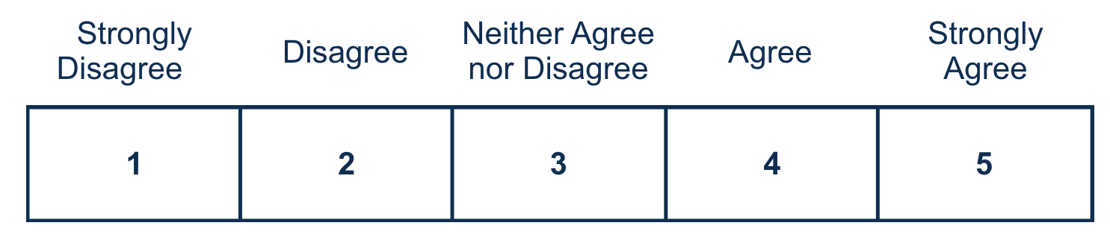

After I checked in for my appointment, I knew what to expect.
My provider listened carefully to me. Required
My provider explained things in a way that I could understand.
After my visit, I knew what I needed to do next.
I am satisfied with the service I received from [Facility name]. Required
During my most recent VA health care experience, I felt respected and comfortable.
<Logic only appears for Whole Health Appointments> The [Whole Health offering] helped me set goals for improving my health and well-being.

<Logic only appears for Whole Health Appointments> The [Whole Health offering] helped me achieve my goals for improving my health and well-being.
My healthcare team included what matters most to me in my plans for what to do next to manage my health and well-being. Required
<Logic only appears for Whole Health Appointments> The [Whole Health offering] helped me function better in the roles that matter most to me in my life.
I trust [Facility name] for my health care needs. Required

Would you like to provide additional feedback with a concern, compliment, or recommendation about your experience(s) with [Facility name]? Please select from one of the following options. Required
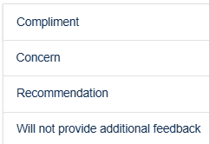
Use the text box below to enter details of the additional feedback (optional). Please do not include any personally identifiable information, Social Security Number, Veteran ID, or medical information, but do provide details about your experience.

Can VA contact you about your feedback? Required
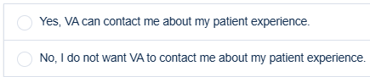

Respondent Burden: An agency may not conduct or sponsor, and a person is not required to respond to a collection of information unless it displays a currently valid OMB control number. The OMB control number for this project is 2900-0876, and it expires 01/31/2029. Public reporting burden for this collection of information is estimated to average 3 minutes per respondent, per year, including the time for reviewing instructions, searching existing data sources, gathering and maintaining the data needed, and completing and reviewing the collection of information. Send comments regarding this burden estimate and any other aspect of this collection of information, including suggestions for reducing the burden, to VA Reports Clearance Officer at vapra@va.gov. Please refer to OMB Control No. 2900-0876 in any correspondence. Do not send your completed VA Form to this email address.

