August 11, 2025

Non-substantive Change Justification Statement for
OMB Control Number 1513–0026, Claim for Drawback of Tax on Tobacco Products, Cigarette Papers, and Cigarette Tubes

The Internal Revenue Code of 1986 (IRC) at 26 U.S.C. 5706 provides for the drawback (refund) of Federal excise tax paid on tobacco products and cigarette papers and tubes when such articles are shipped from the United States for export in accordance with the bond and regulatory requirements prescribed by the Secretary of the Treasury. Among other things, pursuant to section 1111(d) of the Homeland Security Act of 2002, as codified at 6 U.S.C. 531(d), the Alcohol and Tobacco Tax and Trade Bureau (TTB) administers chapter 52 of the IRC, which contains the IRC’s provisions related to tobacco products, processed tobacco, and cigarette papers and tubes.
Under its IRC authority, TTB has issued regulations governing tobacco-related export drawback claims, which are codified in 27 CFR part 44, subpart K (§§ 44.221 through 44.232). Under § 44.221, claimants may file for drawback of the excise tax paid on tobacco products and cigarette papers and tubes when such articles are subsequently shipped to a foreign country, Puerto Rico, the U.S. Virgin Islands, or a possession of the United States, provided that the claimant complies with the provisions of subpart K.
Specific to this collection request, which is approved under OMB control number 1513–0026, the TTB regulations at 27 CFR 44.222 require respondents to file tobacco-related export drawback claims using form TTB F 5620.7, Claim for Drawback of Tax on Tobacco Products, Cigarette Papers and Cigarette Tubes. The form identifies the claimant, the articles on which drawback is claimed, and the amount of tax claimed for drawback.
On March 25, 2025, the President issued an Executive Order, “Modernizing Payments To and From America’s Bank Account,” which was published in the Federal Register as E.O. 14247 on March 28, 2025, at 90 FR 14001. As a cost-saving and theft-prevention measure, the Executive Order requires, in general, that the Secretary of the Treasury cease issuing paper checks for all Federal disbursements, benefit payments, vendor payments, and tax refunds, and to make such payments via direct deposit or other electronic methods, effective September 30, 2025.
In response to E.O. 14247, TTB is revising form TTB F 5620.7 to add Item 9, which will allow the respondent to select payment of the claimed excise tax drawback either by direct deposit to a checking or savings account or as a credit to be taken on their tobacco excise tax return. In addition, if the claimant selects the direct deposit option, TTB has added Items 10 and 11 to the form to collect, respectively, the respondent’s direct deposit routing number and bank account number. The addition of those three new Items also results in the renumbering of previous Items 9, 10, 11, and the subsequent Item numbers as necessary.
TTB believes that these changes to TTB F 5620.7 made in response to E.O. 14247 do not affect this information collection’s per-respondent or total annual burden. The addition of new Items 9, 10, and 11 merely require information that is already known by and immediately available to the respondent. These changes do not introduce new concepts and entail no burden other than that necessary to identify the respondent’s selection of direct deposit or credit of tax drawback payments, and the necessary routing and account numbers to allow for direct deposit of a drawback payment if the respondent selects that option. As such, TTB believes that these changes are non-substantive in nature, and we request OMB approval of the described changes to this information collection on that basis.

The figure below shows the insertion of new Items 9, 10, and 11 at the end of Section II–Claim, on the revised form TTB F 5620.7. (Previous Items 9 (Signature of Claimant), 10 (Title or Status), and 11 (Date) are now numbered Items 12, 13 and 14 respectively, and all Items after that are advanced in number as necessary.) There are no changes to the form’s instructions.
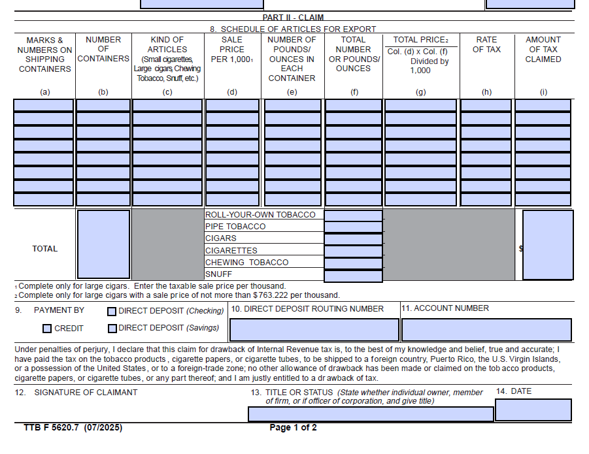
[END]

Sections 44.224 through 44.227 and 44.232 describe the procedures that claimants, customs or postal officials, or TTB officers follow to release the articles for export, certify receipt of the articles in a foreign trade zone, their export or postal shipment, and document approval or disapproval of the submitted claim.

