Data items collected by the eGov Courtesies of Port request but not collected by the DS-4285 Form;
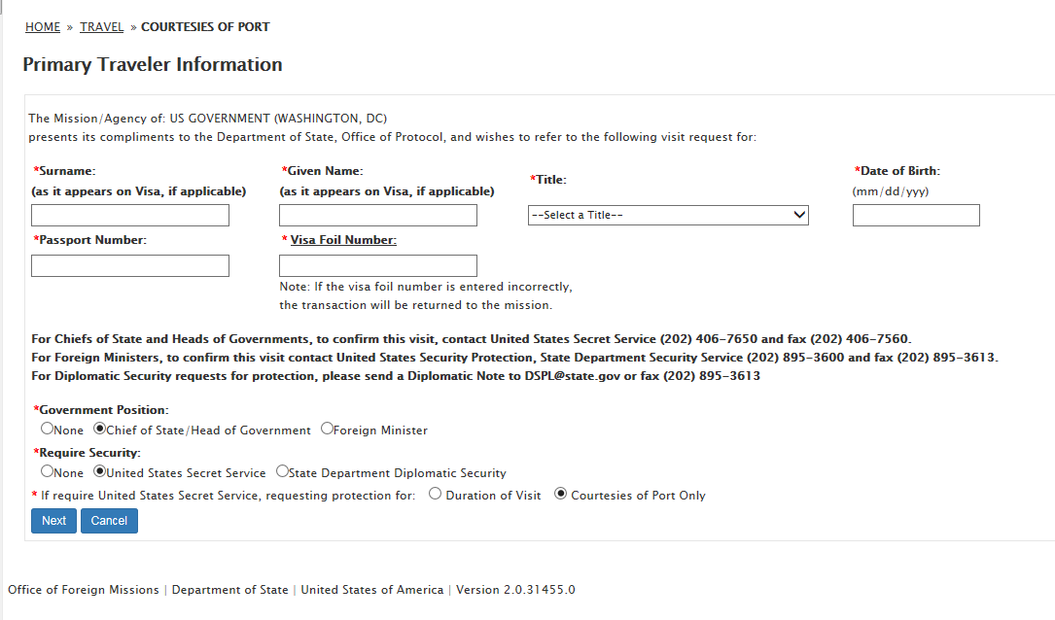
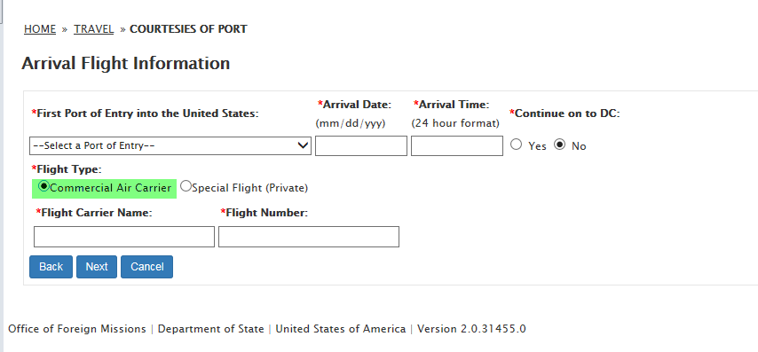
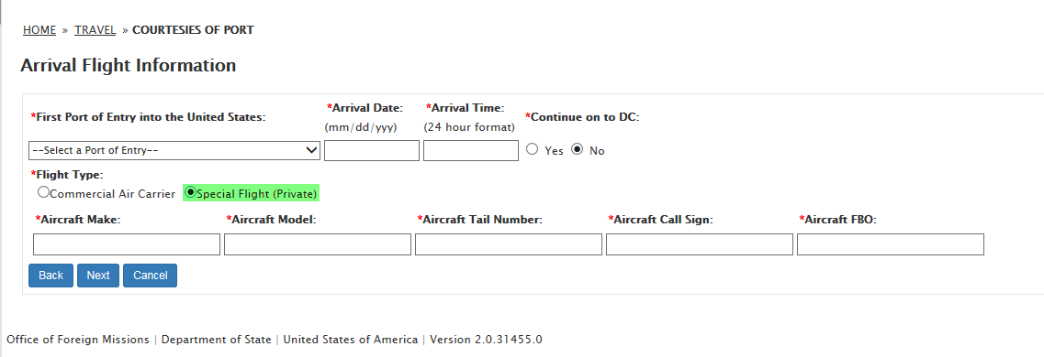
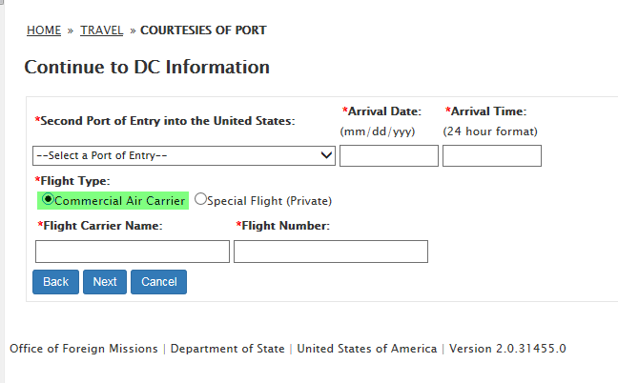
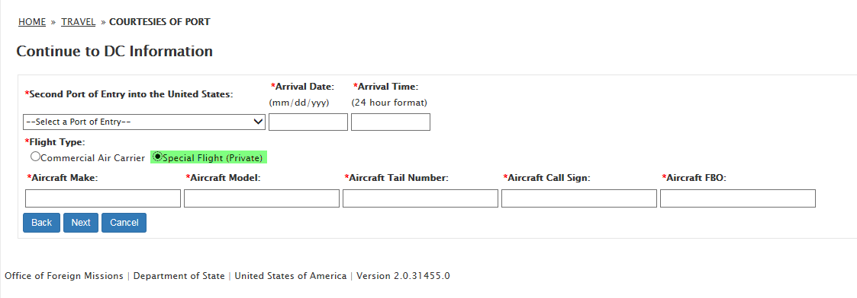
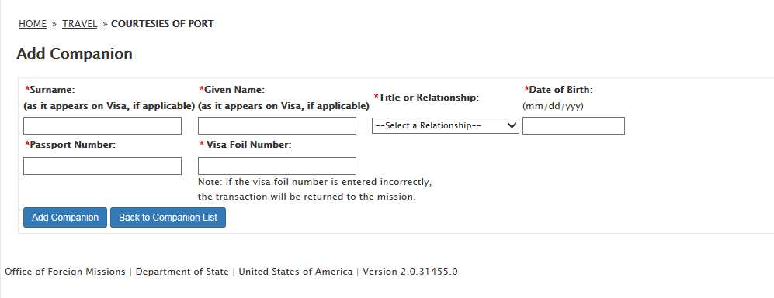
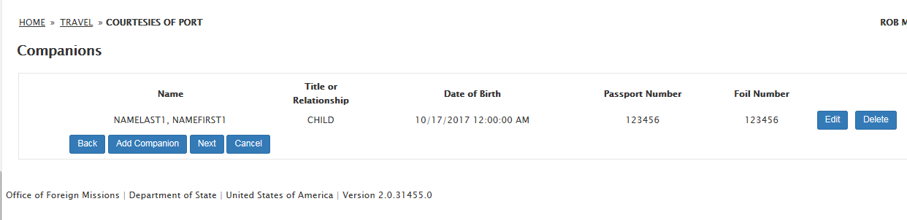
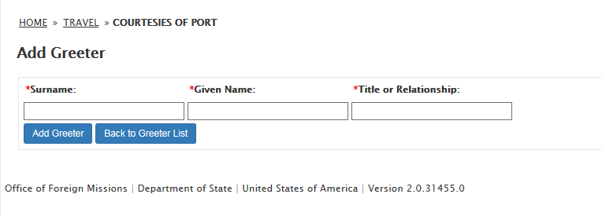
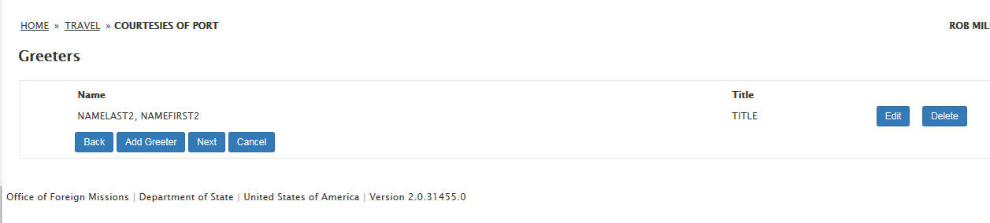

- Armed Security:
  - Visa Foil Number
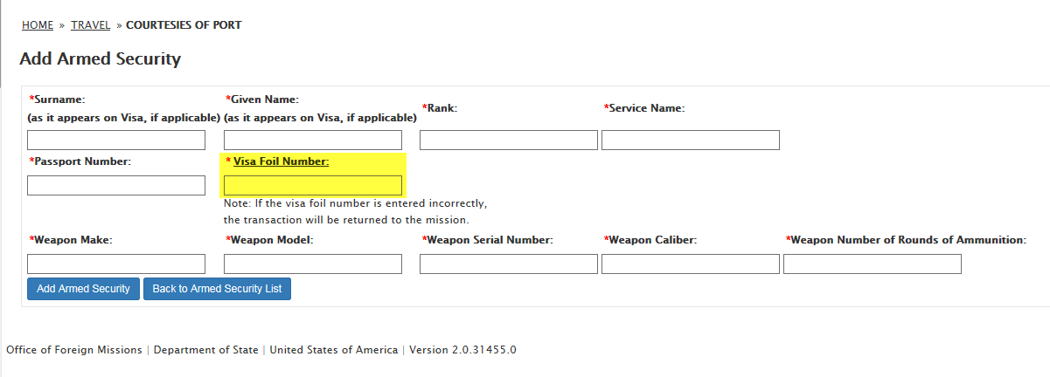
  - Statement
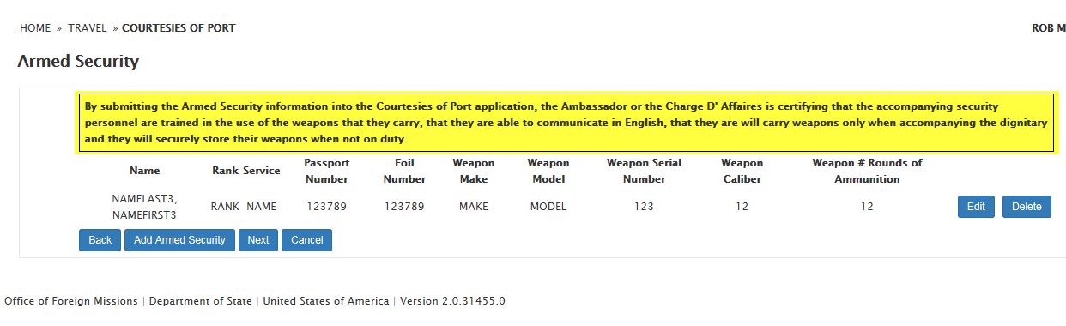

- POC and CDH Information:
  - Point of Contact Information:
    - Surname
    - Given Name
    - Title
    - Telephone Number
    - Cell Phone Number
  - Contact Document Handler Information:
    - Surname
    - Given Name
    - Telephone Number
    - Cell Phone Number
  - Enter Departure Flight Information:
    - Yes
    - No
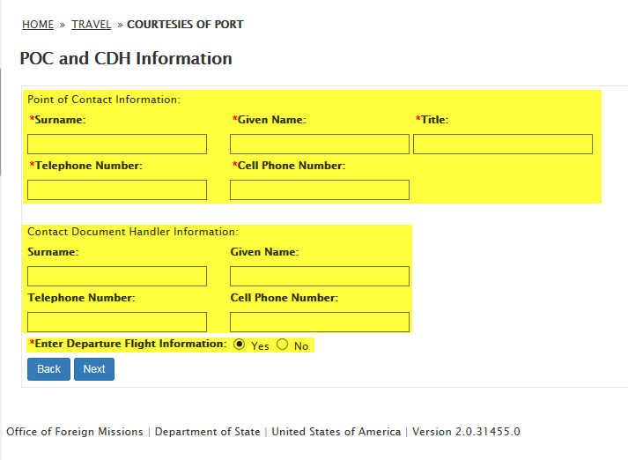
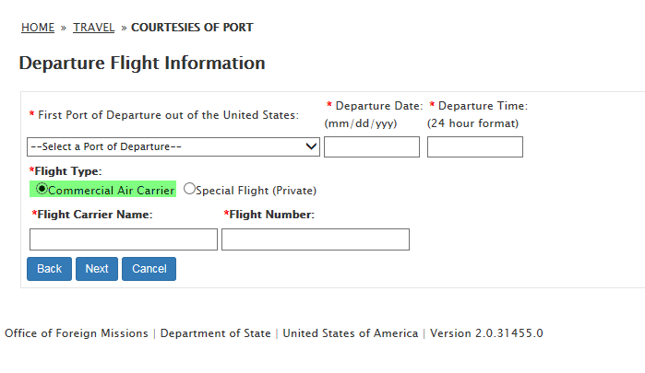
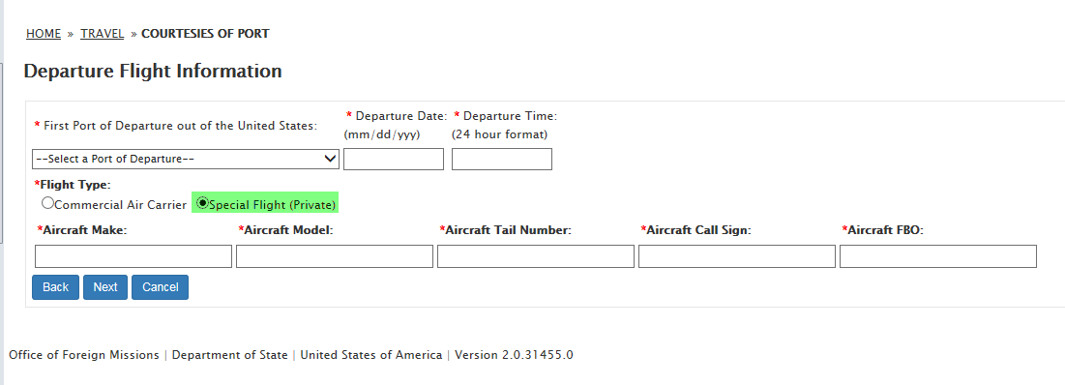

- Remark
