Follow-up Evaluation Invitation Email (sent 21 days after the completion of the post-course evaluation)

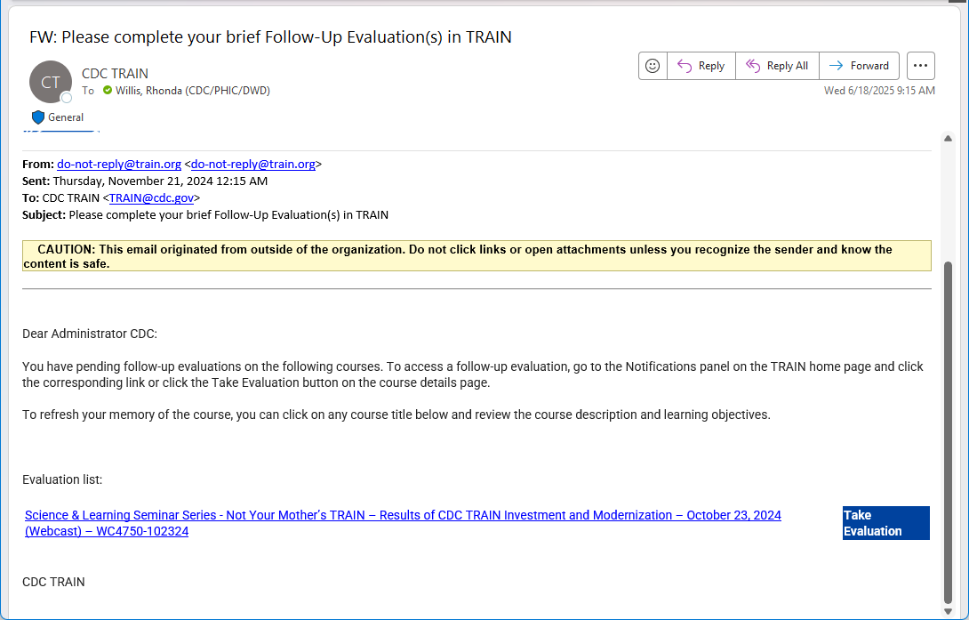

CDC TRAIN Evaluation Reminder Notifications (displayed when users log into the CDC TRAIN platform)

