Attachment 3
Information Collection Instrument,
Continuing Education (CE) Proposal

CE Proposal | 2025

Table of Contents
1. Introduction 3
2. Login Page 3
3. Activity Filter/Selection Page 4
4. Application Status Page 5
5. Practice Gap Page 7
6. Target Audience Page 8
7. Facility Page 9
8. Promo/Eval Page 10
9. Timeline Page 11
10. Summary Page 12
11. Objectives Page 13
12. Planning Tool Page 14
13. Credit Provider Page 15
14. Budget Page 16
15. Pilot Test List Page 17
16. Pilot Test Summary Page 18
17. Activity Testing Page 19
18. Activity Testing Group Page 20
19. Activity Testing Question Page 21
20. Activity Testing Answers Page 22
21. Supporting Documents Page 22
22. Activity Notes Page 23
23. Non-CDC User Page 24
24. Biography Page 25
25. Biography Degree Page 26
26. Disclosure Page 27
27. Organization Page 28

Introduction
The purpose of this document is to list the data elements collected online through the Continuing Education Online Proposal. The CE Proposal is a mechanism for course developers and CE consultants of the Centers for Disease Control and Prevention (CDC) to request and submit their educational activities for accreditation review and approval.

The major pages, sections, and subsections of the CE Proposal are detailed in this document. Following the screenshots for each section is a table that shows the display properties of the collection of data elements.

Login Page
Participants access the CE Proposal by entering their username and password on the Login page (Figure 2). Those users accessing CE Proposal for the first time must register using the “Create Account” link displayed on this page.

The legal statements regarding CDC’s privacy act information and advisement and public burden information are clearly displayed near the bottom of the Login page.

Figure 2 – Login page with legal statements

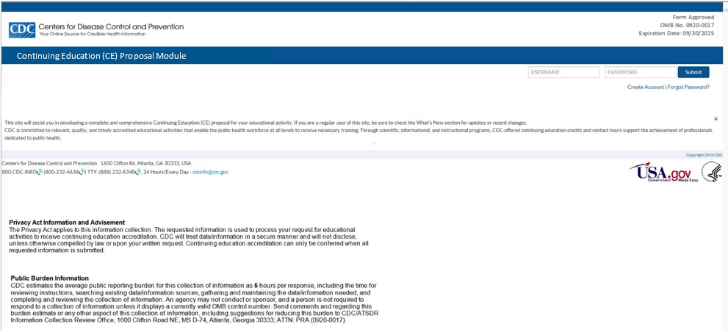

Table 2 – Login Page Data Elements
Column Label | Display property | Figure
Username | Text | 2
Password | Text | 2
Create Account / Forgot Password | Links | 2

Activity Filter/Selection Page

Figure 3 – Activity Filter/ Selection Page

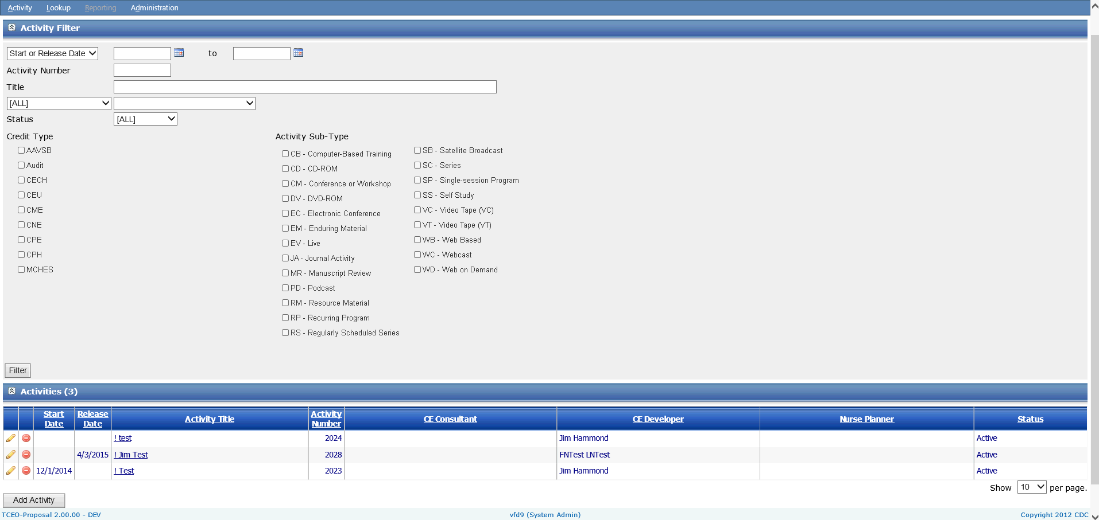

Table 3- Activity Filter/ Selection Page Data Elements
Column Label | Display property | Figure
Start Date | Numeric | 3
Activity Number | Numeric | 3
Title | Text | 3
Role | Role Drop Down | 3
User Name | Auto populate / Drop Down | 3
Status | Status Drop Down | 3
Credit Type | Multi Select- Credit Type | 3
Activity Sub-Type | Multi Select – Activity Subtype | 3

Application Status Page

Figure 4a – Application Status Page: Activity
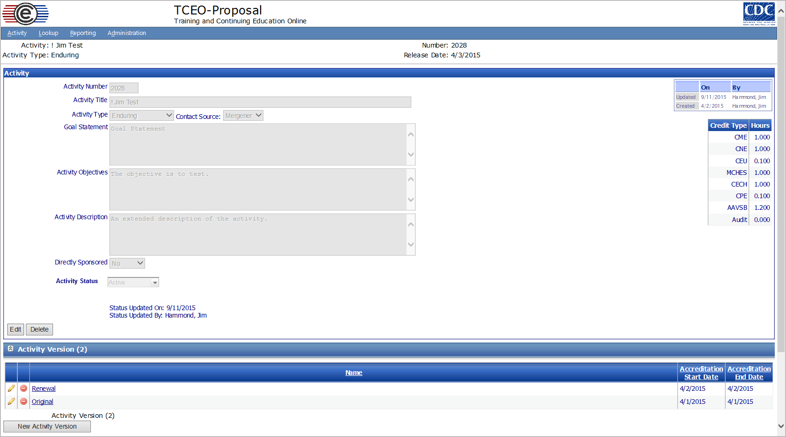

Figure 4b – Application Status Page: Activity Version
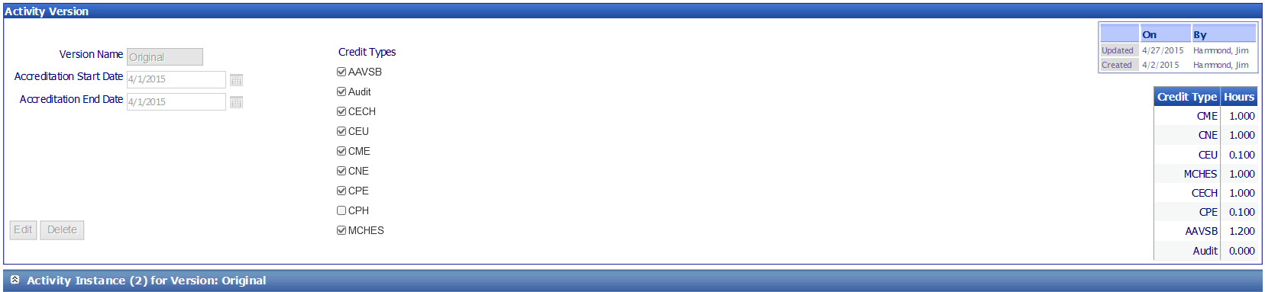

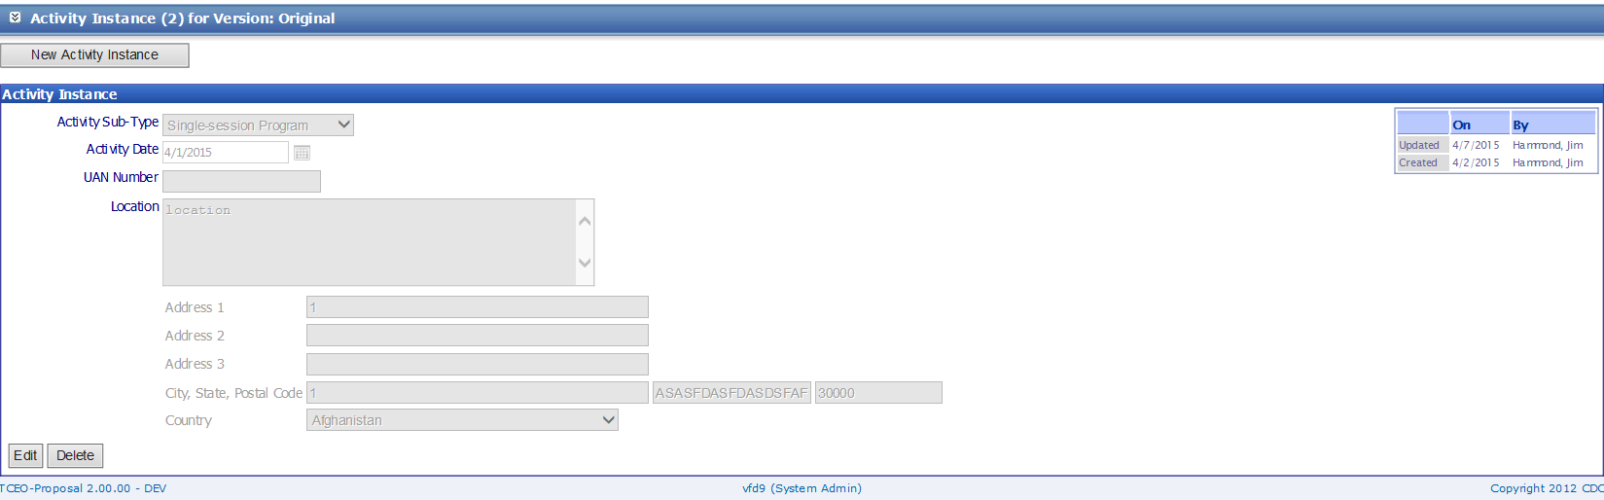

Table 4 – Application Status Page Data Elements
Column Label | Display property | Figure
Activity Number | Numeric | 4a
Activity Title | Text | 4a
Activity Type | Drop Down – Activity Type | 4a
Contact Source | Drop Down – Contact Source | 4a
Goal Statement | Text | 4a
Activity Objectives | Text | 4a
Activity Description | Text | 4a
Directly Sponsored | Yes/No | 4a
Activity Status | Drop Down – Activity Status | 4a
Version Name | AutoPopulated | 4b
Accreditation Start Date | Date/Time | 4b
Accreditation End Date | Date/Time | 4b
Credit Types | Multi-Select- Credit Types | 4b
Activity Sub-Type | Drop Down – Activity SubType | 4b
Activity Date | Date/Time | 4b
UAN Number | Text | 4b
Location | Text | 4b
Address 1 | Text | 4b
Address 2 | Text | 4b
Address 3 | Text | 4b
City | Text | 4b
State | Text or Drop Down State | 4b
Postal Code | Text | 4b
Country | Drop Down - Country | 4b

Practice Gap Page
Figure 5 – Practice Gap
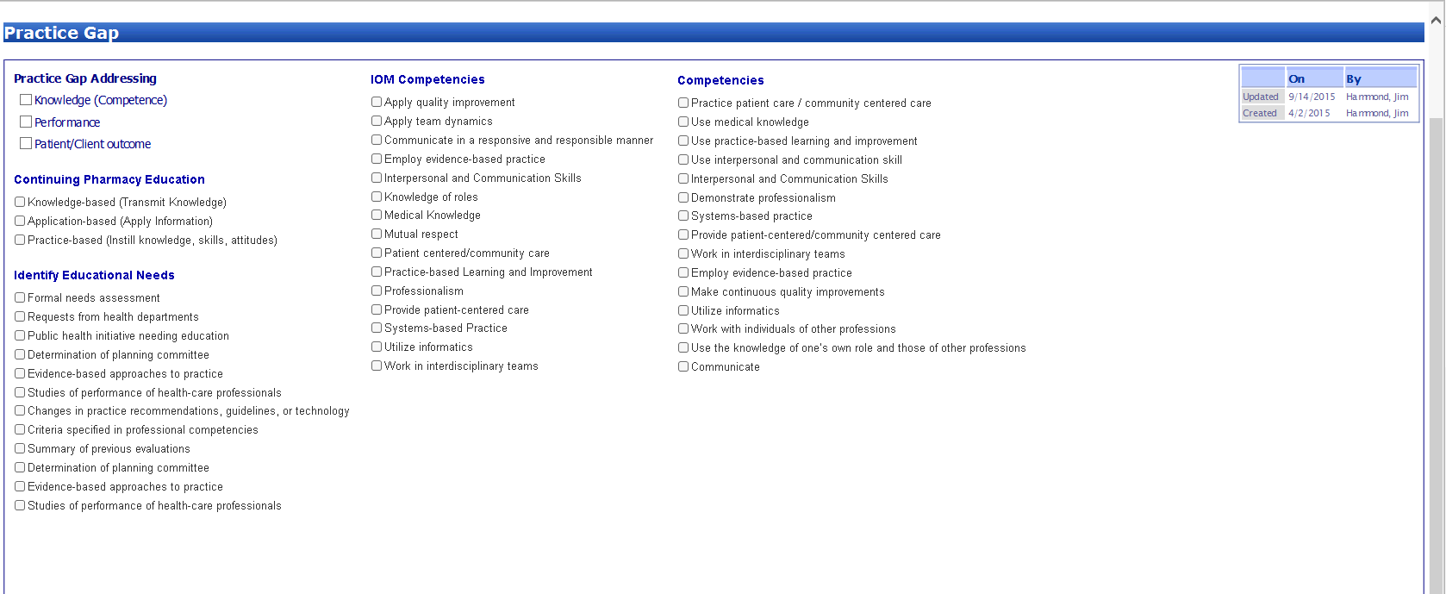
Figure 5a – Gap Description

Figure 5b – Performance Impact & Supporting Documentation
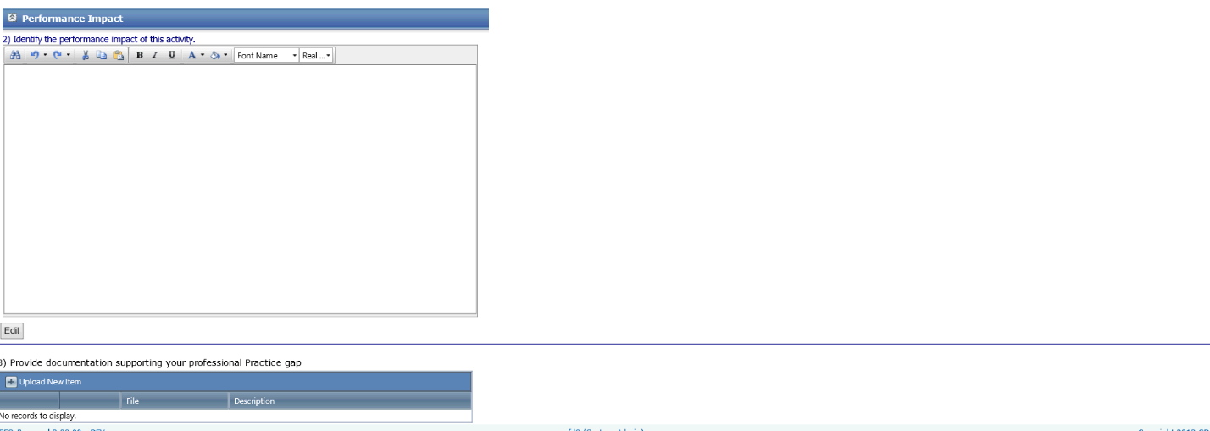

Table 5 – Practice Gap Page Data Elements
Column Label | Display property | Figure
Practice Gap Address | Multi Select – Practice Gap | 5
Continuing Pharmacy Education | Multi Select – Continuing Pharmacy Education | 5
Identify Education Needs | Multi Select - Identify Education Needs | 5
IOM Competencies | Multi Select – IOM Competencies | 5
Competencies | Multi Select - Competencies | 5
Gap Description | Text Box | 5a
Performance Impact | Text Box | 5b
Supporting Documents | Document Upload | 5b

Target Audience Page

Figure 6 – Target Audience Page
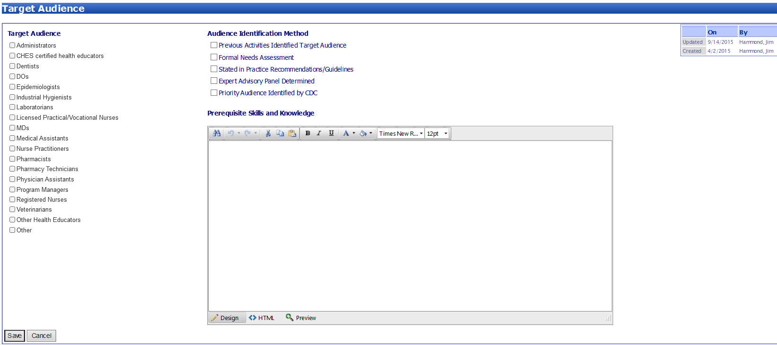

Table 6 – Target Audience Page Data Elements
Column Label | Display property | Figure
Target Audience | Multi Select - Target Audience | 6
Audience Identification Method | Multi Select – Audience Identification Method | 6
Prerequisite Skills and Knowledge | Text Box | 6

Facility Page

Figure 7 – Facility Page
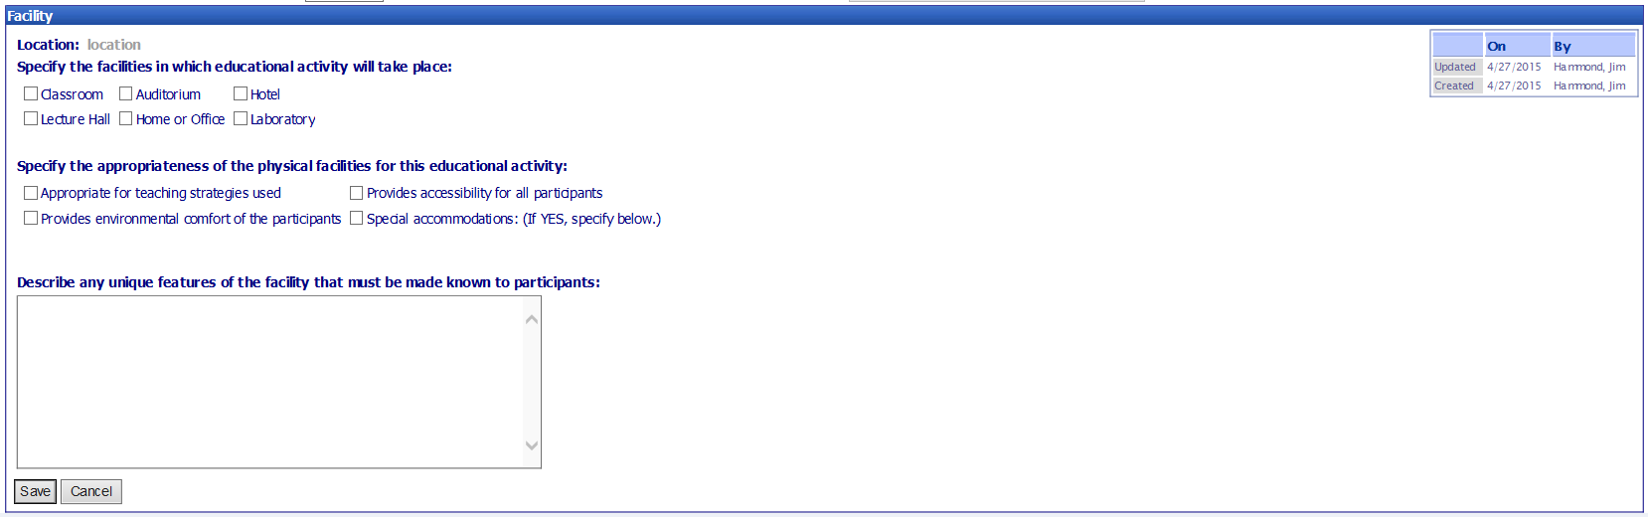

Table 7 – Facility Page Data Elements
Column Label | Display property | Figure
Facility in which the education takes place | Multi Select Facility in which the education takes place | 7
Appropriateness of Physical facilitates | Multi Select –Appropriateness of physical facilities | 7
Prerequisite Skills and Knowledge | Text Box | 7

Promo/Eval Page
Figure 8 – Promo / Eval Page
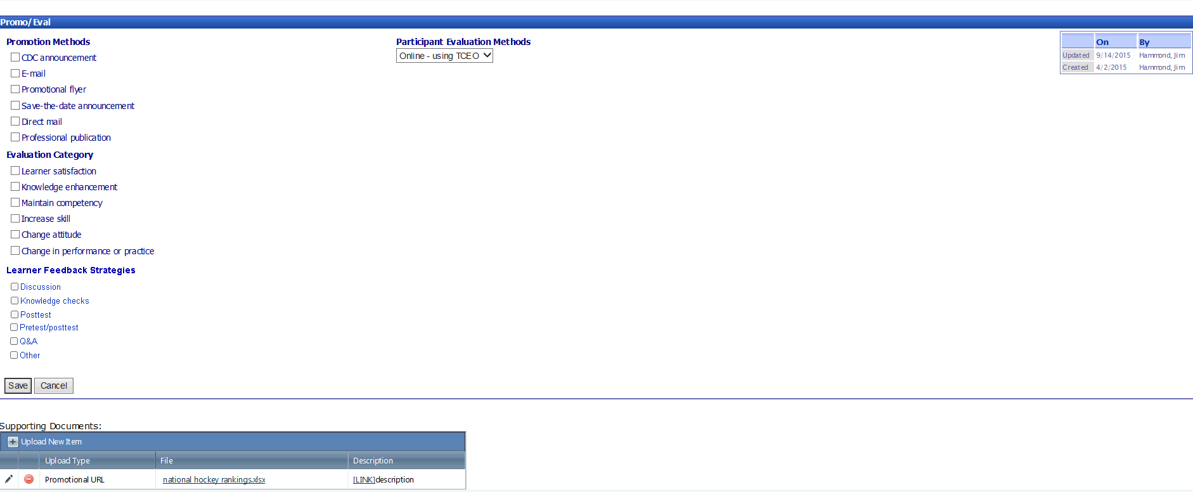

Table 8 - Promo / Eval Page Data Elements
Column Label | Display property | Figure
Promotion Methods | Multi Select – Promotion Methods | 8
Evaluation Categories | Multi Select –Evaluation Categories | 8
Learner Feedback Strategies | Multi Select – Learner Feedback Strategies | 8
Participant Evaluation Methods | Drop Down-Participant Evaluation Methods | 8

Timeline Page

Figure 9 – Timeline Page
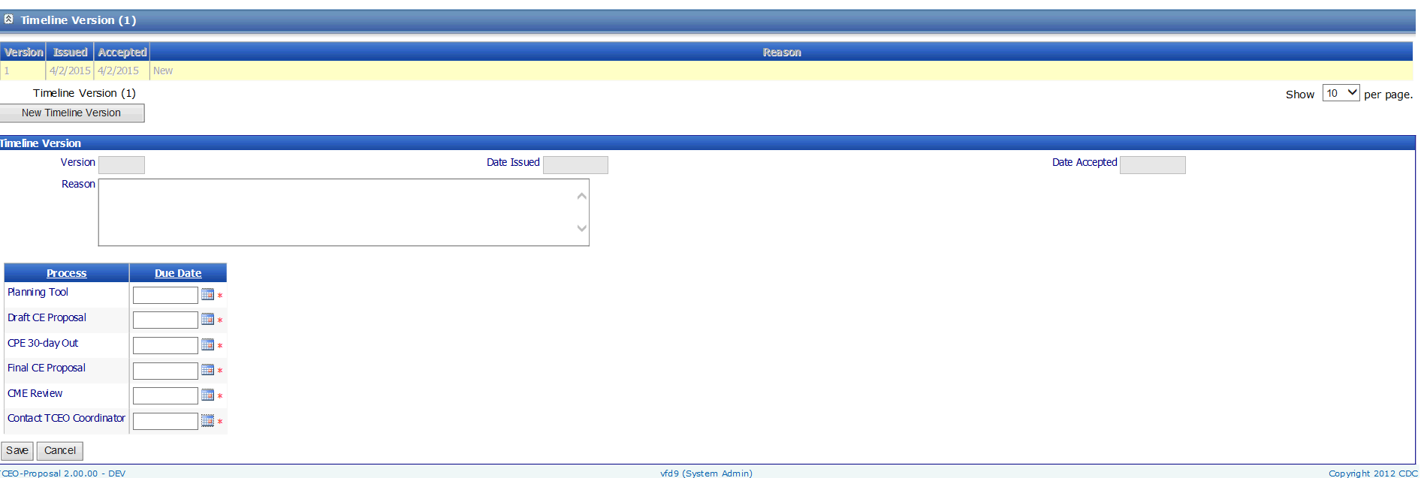

Table 9 – Timeline Page Data Elements
Column Label | Display property | Figure
Version | Read only | 9
Date Issued | Read only | 9
Date Accepted | Read only | 9
Reason | Text Box | 9
Planning Tool | Date Field | 9
Draft CE Proposal | Date Field | 9
Final CE Proposal | Date Field | 9
CME Review | Date Field | 9
Contact CE Coordinator | Date Field | 9

Summary Page

Figure 10 – Summary Page
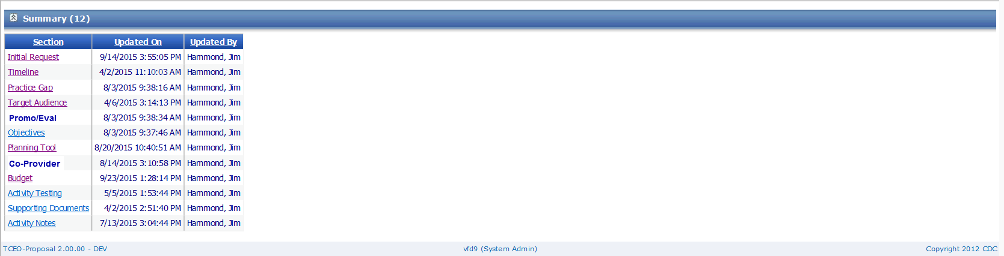

Table 10 – Summary Page Data Elements
Column Label | Display property | Figure
Section | Read only | 10
Updated on | Read only | 10
Updated by | Read only | 10

Objectives Page

Figure 11 – Objectives Page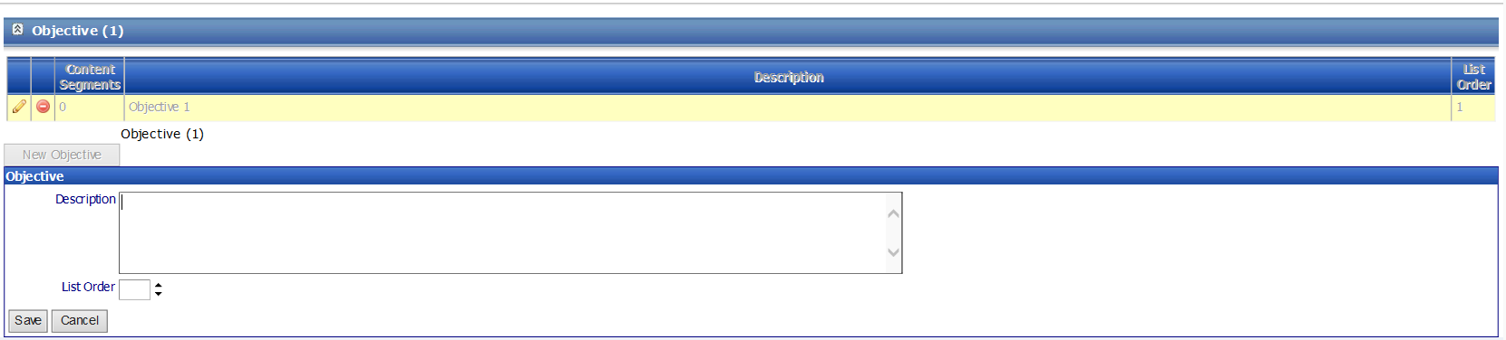

Table 11 – Objectives Page Data Elements
Column Label | Display property | Figure
Description | Text Field | 11
List Order | Numeric | 11

Planning Tool Page

Figure 12 – Planning Tool Page
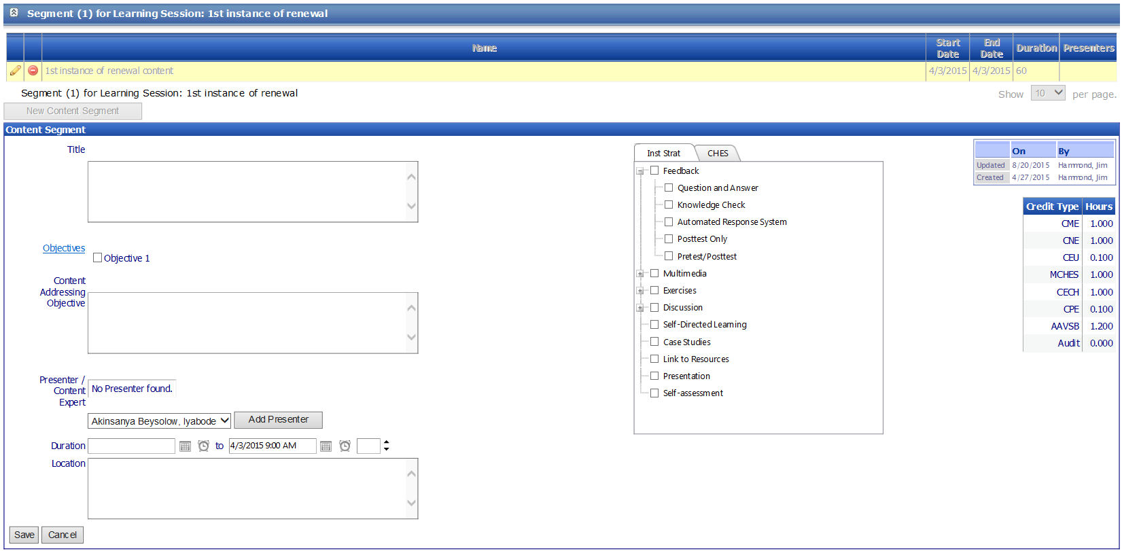

Table 12 – Planning Tool Page Data Elements
Column Label | Display property | Figure
Session Title | Text Field | 12
Session Description | Text Field | 12
Segment Title | Text | 12
Objectives | Multi Select (list is generated from Objective screen) | 12
Content Addressing Objective | Text Field | 12
Presenter/Content Expert | Drop Down – List is generated from Personnel screen | 12
Duration Start | Time and Date | 12
Duration End | Time and Date | 12
Duration | Numeric | 12
Location | Text | 12
Instructional Strategies | Multi Select –Instructional strategies | 12
CHES | Multi Select – CHES Competencies | 12

Credit Provider Page

Figure 13 – Credit Provider Page
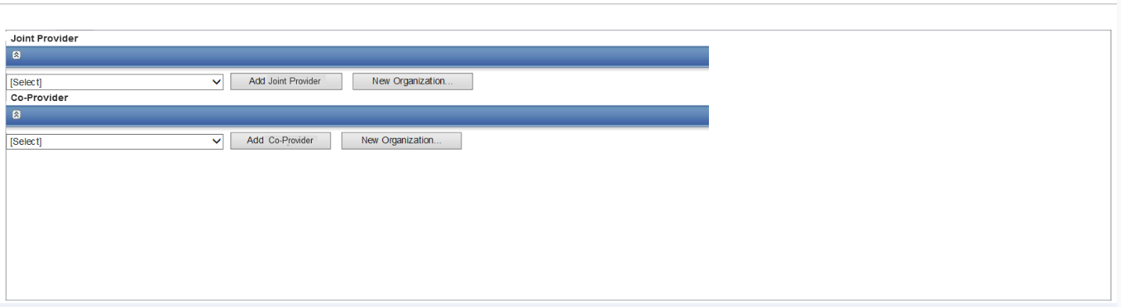

Table 13 – Credit Provider Page Data Elements
Column Label | Display property | Figure
Joint Provider | Drop Down – List of Organizations that have been added CE application | 13
Co-Provider | Drop Down – List of Organizations that have been added CE application | 13

Budget Page

Figure 14 – Budget Page
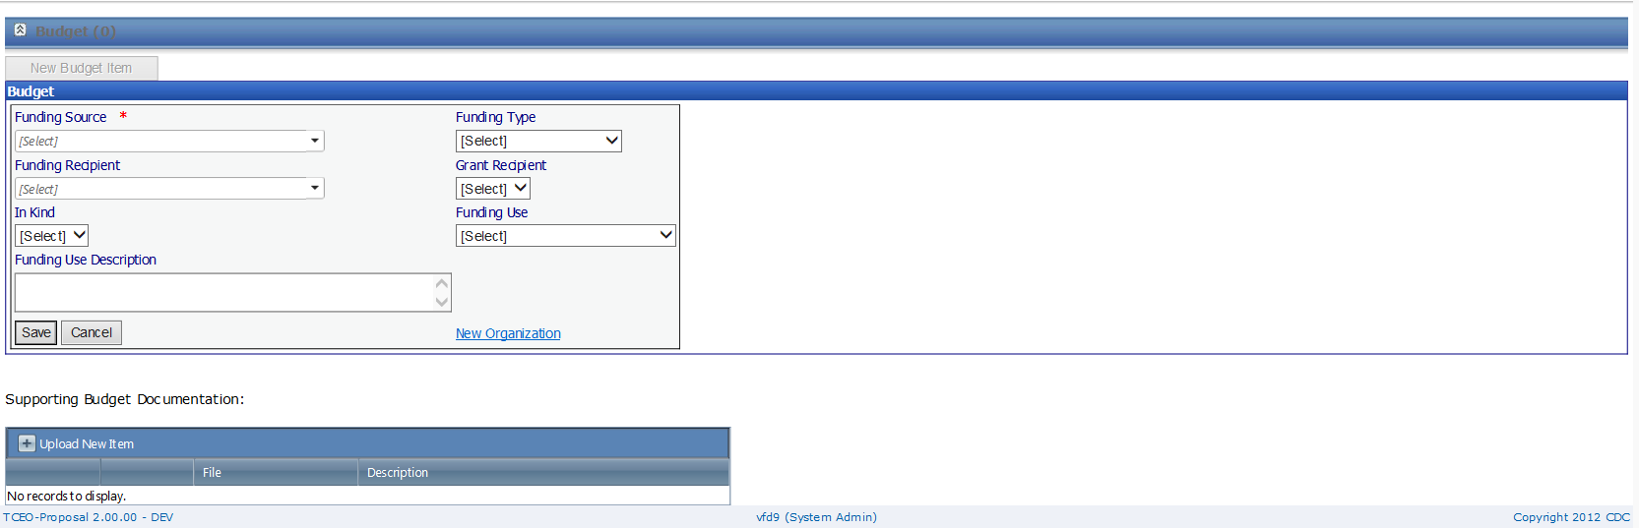

Table 14 – Budget Page Data Elements
Column Label | Display property | Figure
Funding Source | Drop Down – List of Organizations that have been added CE application | 14
Funding Recipient | Drop Down – List of Organizations that have been added CE application | 14
In Kind | Drop Down – Yes/No | 14
Funding User Description | Text Box | 14
Funding Type | Drop Down –Funding Types | 14
Grant Recipient | Drop Down – Yes / No | 14
Funding User | Drop Down – Funding Use | 14
New Organization | Hyperlink | 14
Upload New Item | Button | 14
File | Browse and Select File | 14
Description | Text Box | 14

Pilot Test List Page

Figure 15 – Pilot Test List Page
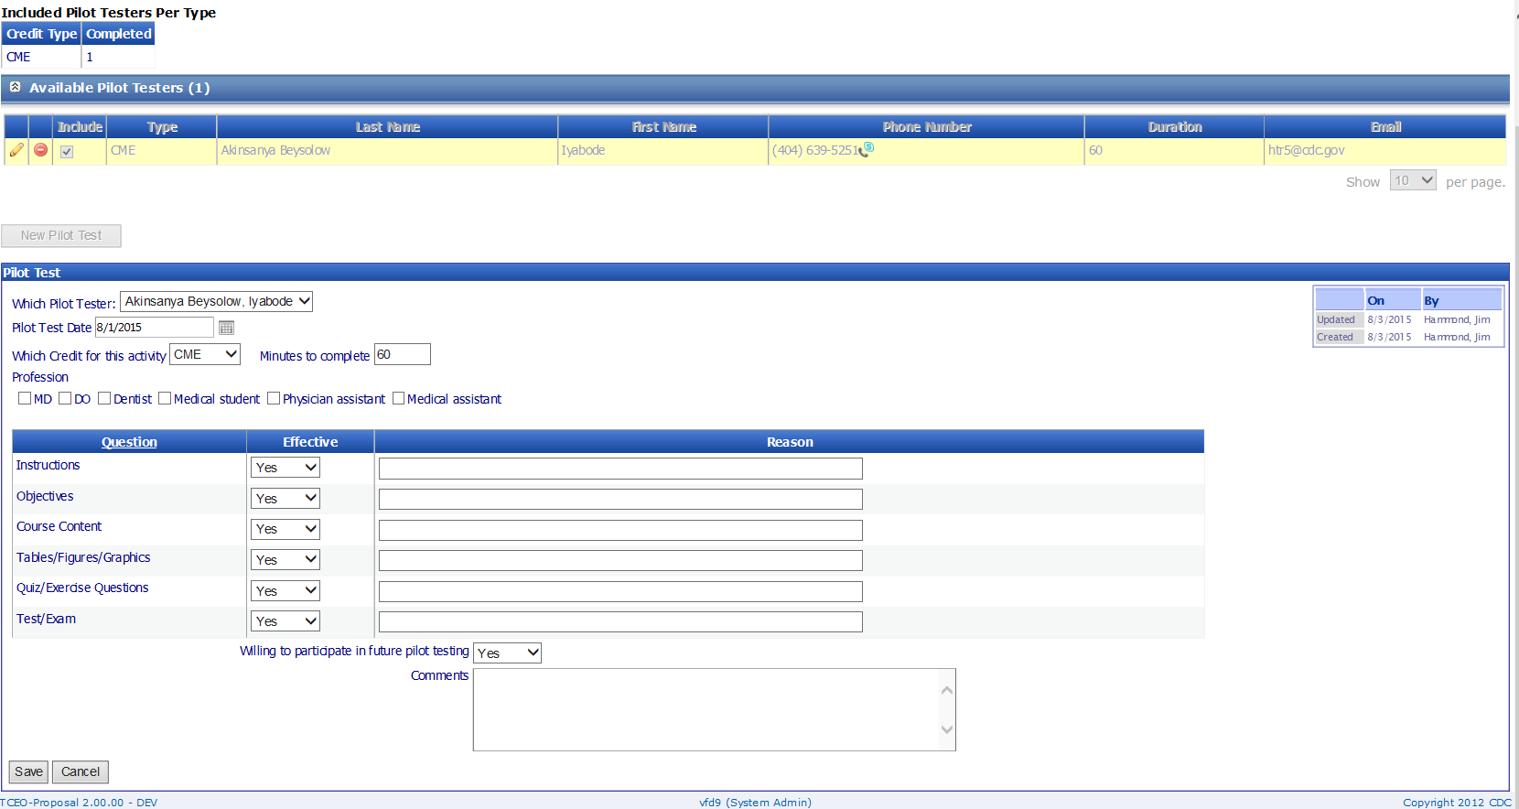
Table 15 – Pilot Test List Page Data Elements
Column Label | Display property | Figure
Include | Checkbox | 15
Which Pilot Tester | Drop Down – List of Pilot Testers that have been added CE application | 15
Pilot Test Date | Date Field | 15
Which Credit for this activity | Drop Down – Available Credit Types | 15
Minutes to complete | Numeric | 15
Profession | Multi Select – Profession specific to selected Credit Type | 15
Instructions Effective | Drop Down – Yes/No | 15
Objectives – Effective | Drop Down – Yes/No | 15
Course Content – Effective | Drop Down – Yes/No | 15
Tables/Figures/Graphics – Effective | Drop Down – Yes/No | 15
Quiz/Exercise Questions – Effective | Drop Down – Yes/No | 15
Text/Exam | Drop Down – Yes/No | 15
Instructions – Reason | Text Box | 15
Objectives – Reason | Text Box | 15
Course Content – Reason | Text Box | 15
Tables/Figures/Graphics – Reason | Text Box | 15
Quiz/Exercise Questions – Reason | Text Box | 15
Text/Exam – Reason | Text Box | 15
Willing to participate in future pilot testing | Drop Down – Yes/No | 15
Comments | Text Box | 15

Pilot Test Summary Page

Figure 16 – Pilot Test Summary Page
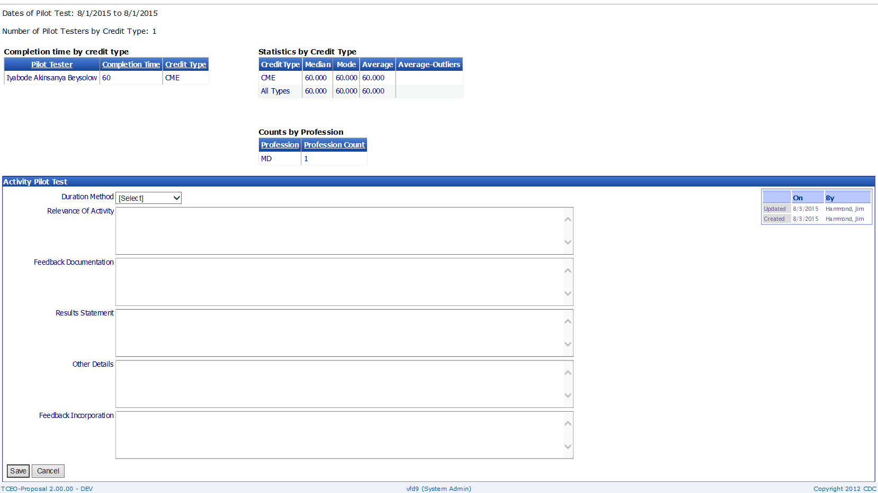

Table 16 – Pilot Test Summary Page Data Elements
Column Label | Display property | Figure
Duration Method | Drop Down List – Duration Method | 16
Relevance of Activity | Text Box | 16
Feedback Documentation | Text Box | 16
Results Statement | Text Box | 16
Other Details | Text Box | 16
Feedback Incorporation | Text Box | 16

Activity Testing Page

Figure 17 – Activity Testing Page
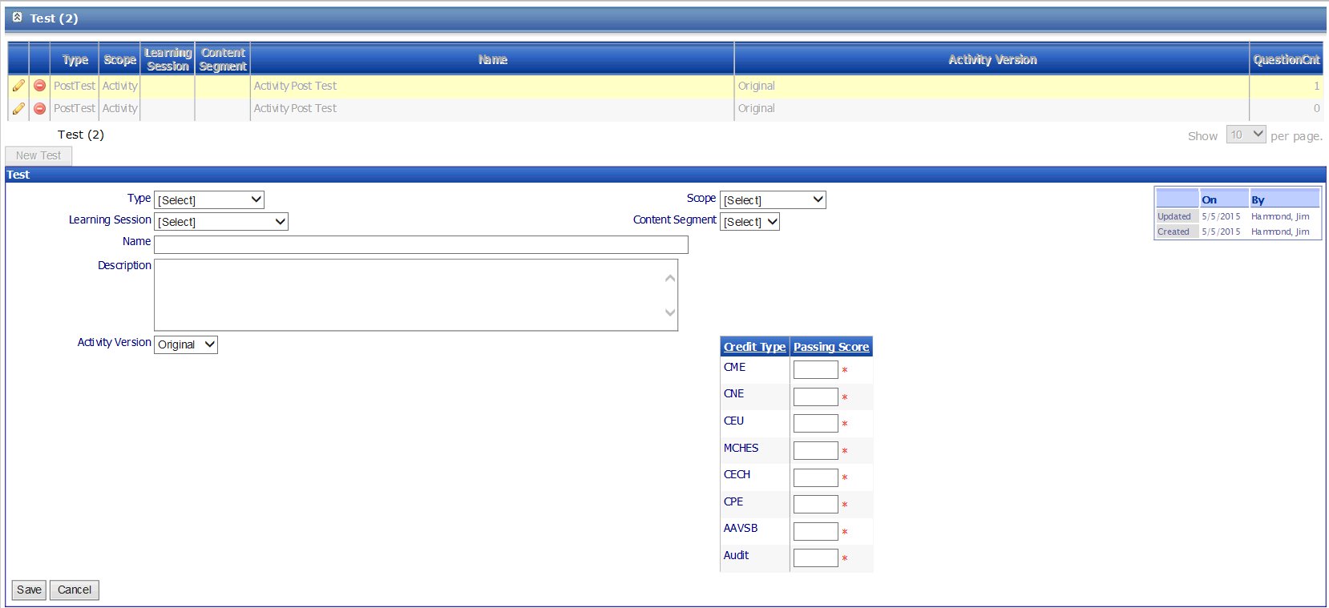

Table 17 – Activity Testing Page Data Elements
Column Label | Display property | Figure
Type | Drop Down List –  Test Type | 17
Scope | Drop Down List – Scope | 17
Learning Session | Drop Down List – Activity’s Sessions | 17
Content Segment | Drop Down List – Activity’s Segments | 17
Name | Text Box | 17
Activity Version | Drop Down List – Activity’s Versions | 17
Passing Score | Numeric Field for each selected Credit Type | 17

Activity Testing Group Page

Figure 18 – Activity Testing Group Page
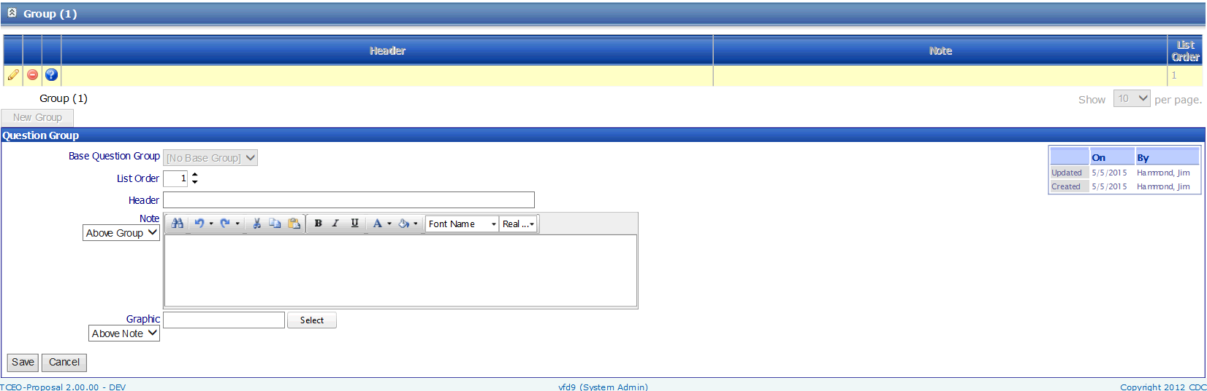

Table 18 – Activity Testing Group Page Data Elements
Column Label | Display property | Figure
List Order | Numeric | 18
Header | Text Box | 18
Note | Text Box | 18
Note Position | Drop Down – Above/Below | 18
Select Graphic | Button / Browse | 18
Graphic Position | Drop Down List – Above / Below | 18

Activity Testing Question Page

Figure 19 – Activity Testing Question Page
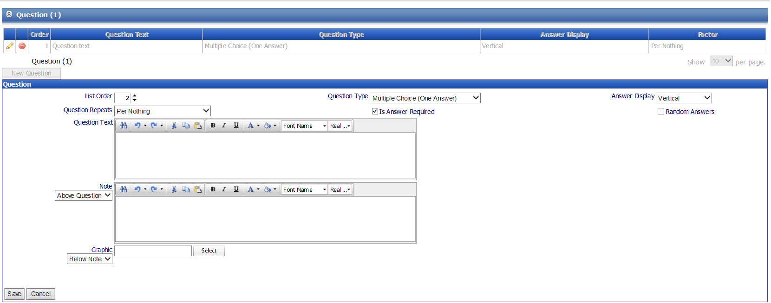

Table 19 – Activity Testing Question Page Data Elements
Column Label | Display property | Figure
List Order | Numeric | 19
Question Type | Drop Down – Question Type | 19
Question Display | Drop Down- Vertical / Horizontal / Drop Down List | 19
Random Answers | Checkbox | 19
Question Repeats | Drop Down List –Per Nothing /Per Objective / Per Presenter | 19
Answer Required | Checkbox | 19
Question Text | Text Box | 19
Note | Text Box | 19
Note Position | Drop Down – Above / Below | 19
Graphic Select | Button / Browse | 19
Graphic Position | Drop Down – Above / Below | 19

Activity Testing Answers Page

Figure 20 – Activity Testing Answers Page
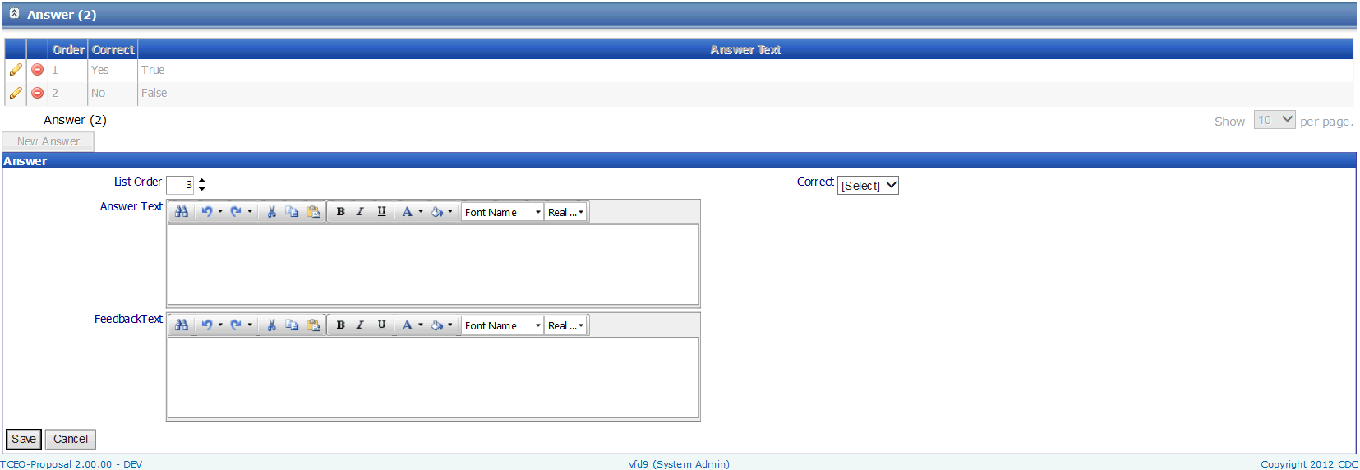

Table 20 – Activity Testing Answers Page Data Elements
Column Label | Display property | Figure
List Order | Numeric | 20
Correct | Drop Down –Yes/No | 20
Answer Text | Text Box | 20
Feedback Text | Text Box | 20

Supporting Documents Page

Figure 21 – Supporting Documents Page
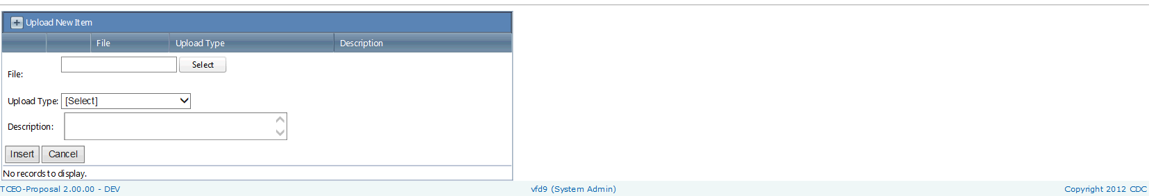

Table 21 – Supporting Documents Page Data Elements
Column Label | Display property | Figure
Select File | Button / Select | 21
Upload Type | Drop Down List – Document Type | 21
Description | Text | 21

Activity Notes Page
Figure 22 – Activity Notes Page

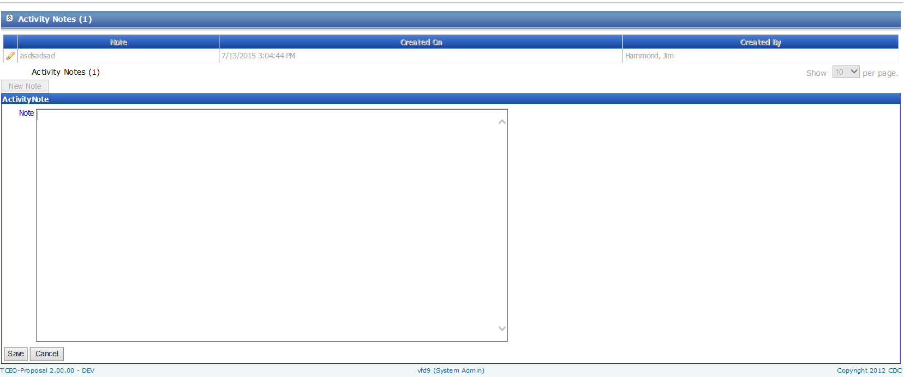

Table 22 – Activity Notes Page Data Elements
Column Label | Display property | Figure
Notes | Text Box | 22

Non-CDC User Page

Figure 23 – Non-CDC User Page
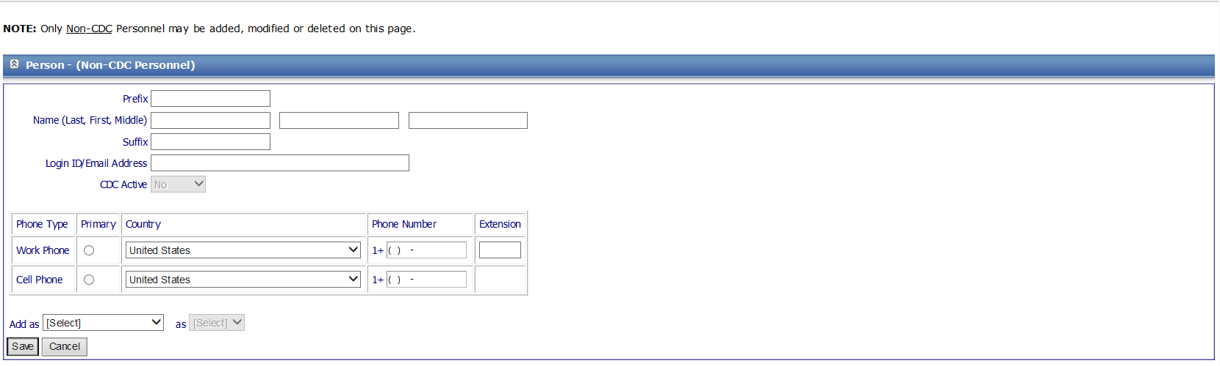

Table 23 – Non-CDC User Page Data Elements
Column Label | Display property | Figure
Prefix | Text Box | 23
Last Name | Text Box | 23
First Name | Text Box | 23
Middle Name | Text Box | 23
Suffix | Text Box | 23
Login id / email Address | Text Box | 23
Primary Work Phone | Radio Button | 23
Work Phone Country | Drop Down - Country | 23
Work Phone – Phone Number | Numeric | 23
Work Phone – Phone Number Extension | Numeric | 23
Cell Phone – Primary | Radio Button | 23
Cell Phone – Country | Drop Down - Country | 23
Add as Role | Drop Down – Activity Role / System Role | 23
Role | Drop Down –  Role | 23

Biography Page
Figure 24 – Biography Page

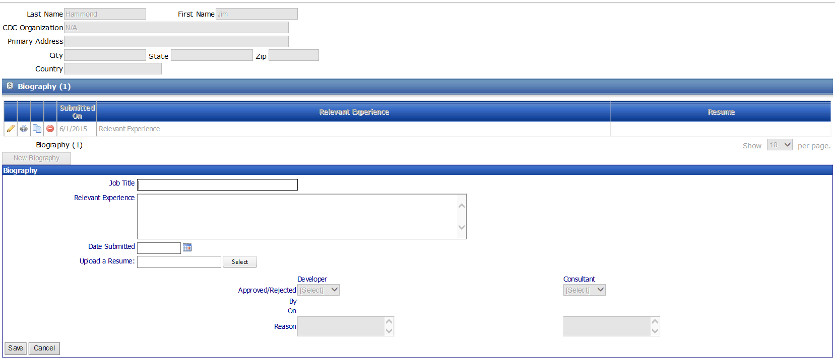

Table 24 – Biography Page Data Elements
Column Label | Display property | Figure
Job Title | Text Box | 24
Relevant Experience | Text Box | 24
Date Submitted | Date field | 24
Resume Select | Button / Browse | 24
Approved/Rejected | Drop Down – Approved / Rejected | 24
Reason | Text Box | 24

Biography Degree Page

Figure 25 – Biography Degree Page
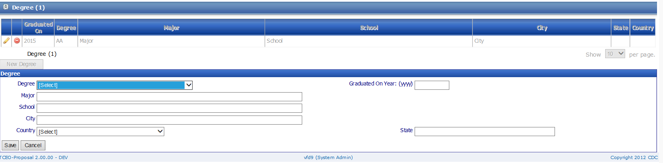

Table 25 – Biography Degree Page Data Elements
Column Label | Display property | Figure
Degree | Drop Down - Degree | 25
Major | Text Box | 25
School | Text Box | 25
City | Button / Browse | 25
Country | Drop Down – Country | 25
State | Drop Down - State | 25
Graduation Year | Date Field | 25

Disclosure Page

Figure 26 – Disclosure Page
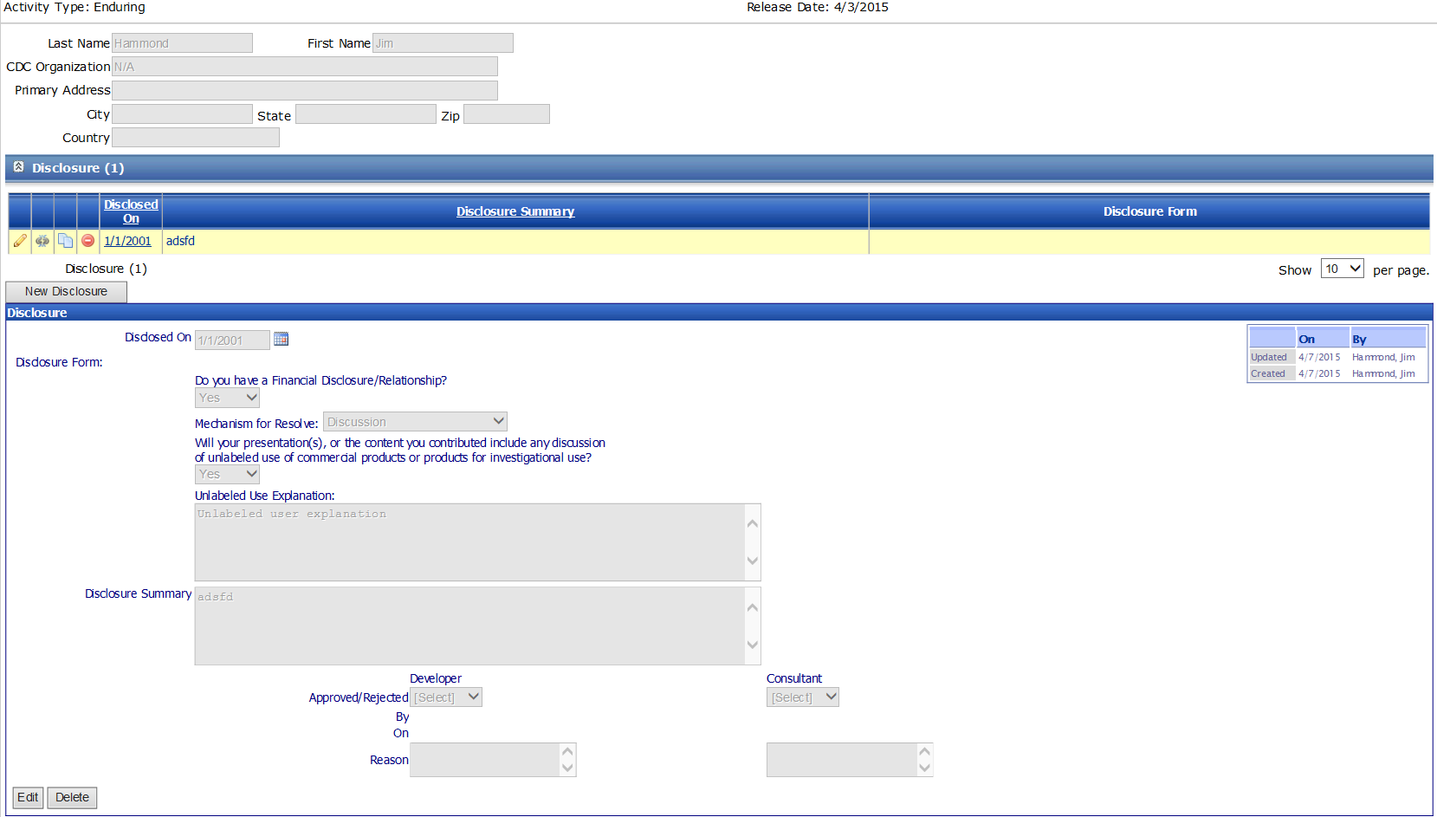

Table 26 – Disclosure Page Data Elements
Column Label | Display property | Figure
Disclosed on | Date Field | 26
Financial Relationship | Drop Down – Yes/No | 26
Mechanism to Resolve | Drop Down – Discussion / Review /Planning Committee Review | 26
Unlabeled Use | Drop Down – Yes/ No | 26
Disclosure | Button / Browse | 26
Disclosure Summary | Text Box | 26
Approved/Rejected | Drop Down – Approved / Rejected | 26
Reason | Text Box | 26

Organization Page

Figure 27 – Organization Page
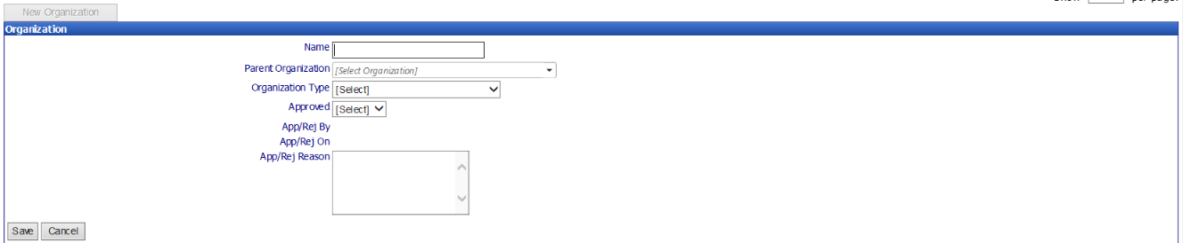

Table 27 – Organization Page Data Elements
Column Label | Display property | Figure
Name | Text Box | 27
Parent Organization | Drop Down – Organizations previously entered | 27
Organization Type | Drop Down – Organization Types | 27
Approved | Drop Down – Yes/ No | 27
Reason | Text Box | 27

