Screenshots of Submission Instructions for DD Form 293

Army Discharge Review Board Portal Application for DD Form 293

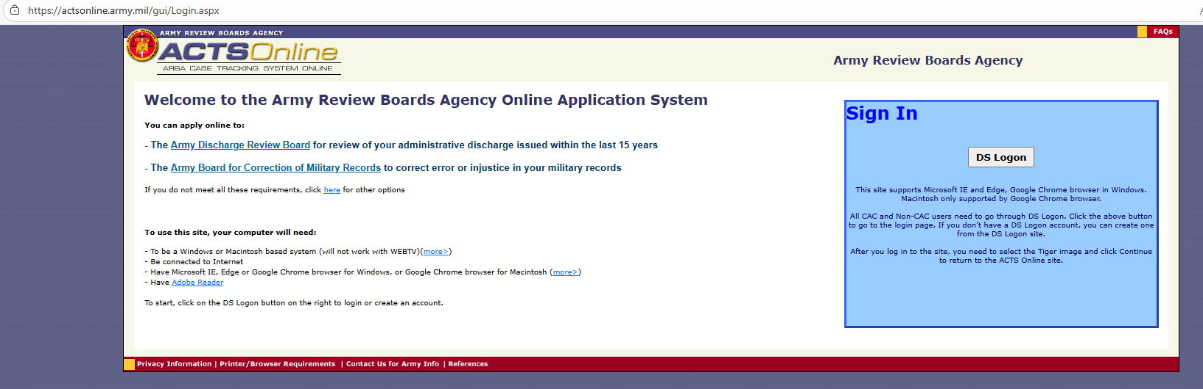

Air Force Discharge Review Board Portal Application for DD Form 293

