Screenshots of Submission Instructions for DD Form 149

Army Board of Corrections Portal Application for DD Form 149

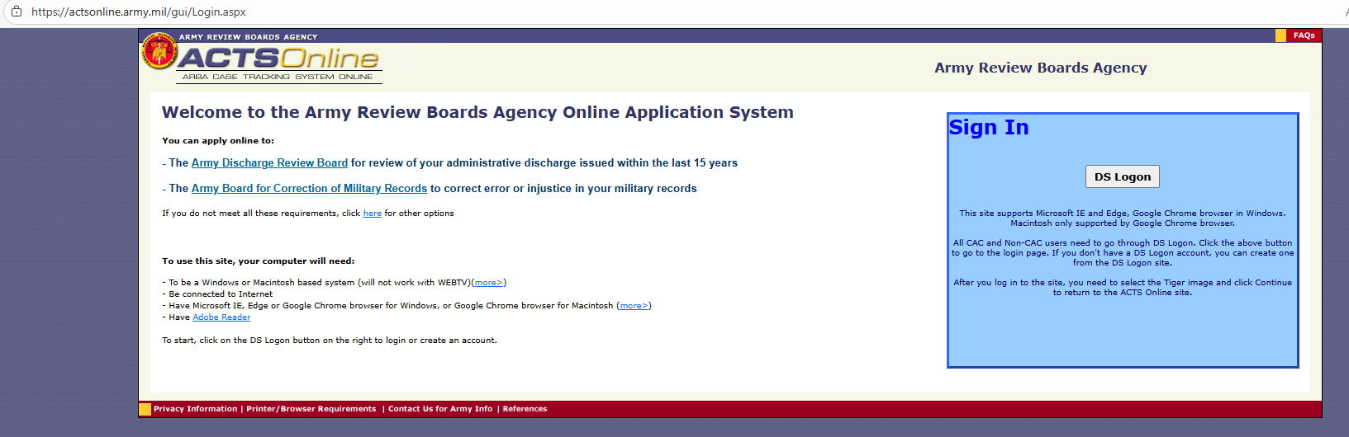

Air Force Board of Corrections Portal Application for DD Form 149

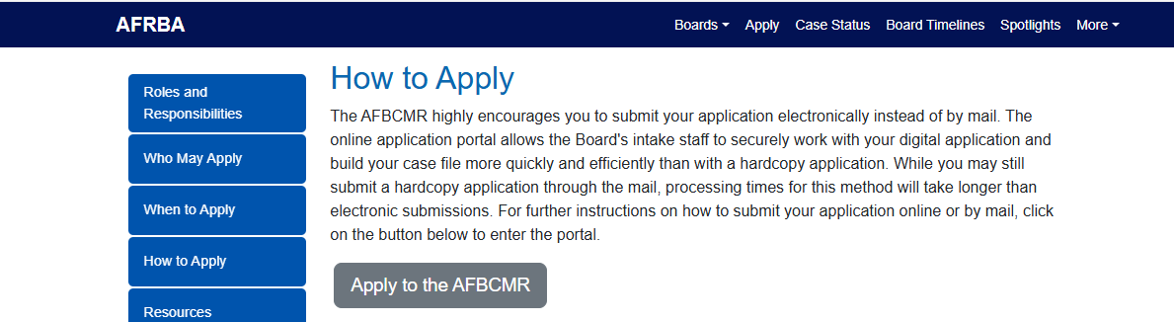

Navy Board of Corrections Submission Instructions for DD Form 149

