Attachment F:

2023 AIES Websites for Testing

Interactive Content Selection Tool
https://www.census.gov/aies/questionspreview/

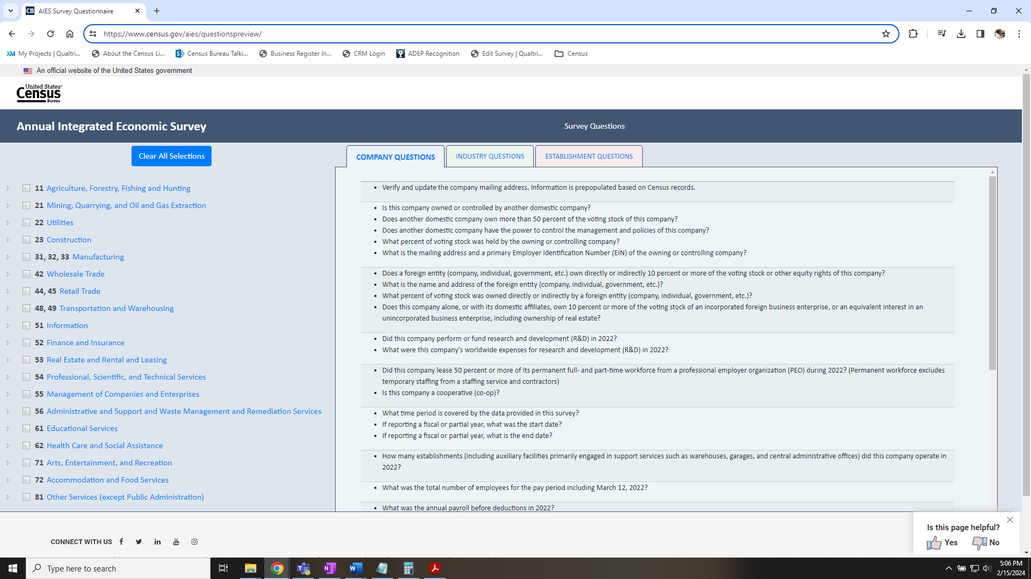

_{AIES Landing Page}
https://www.census.gov/programs-surveys/aies.html

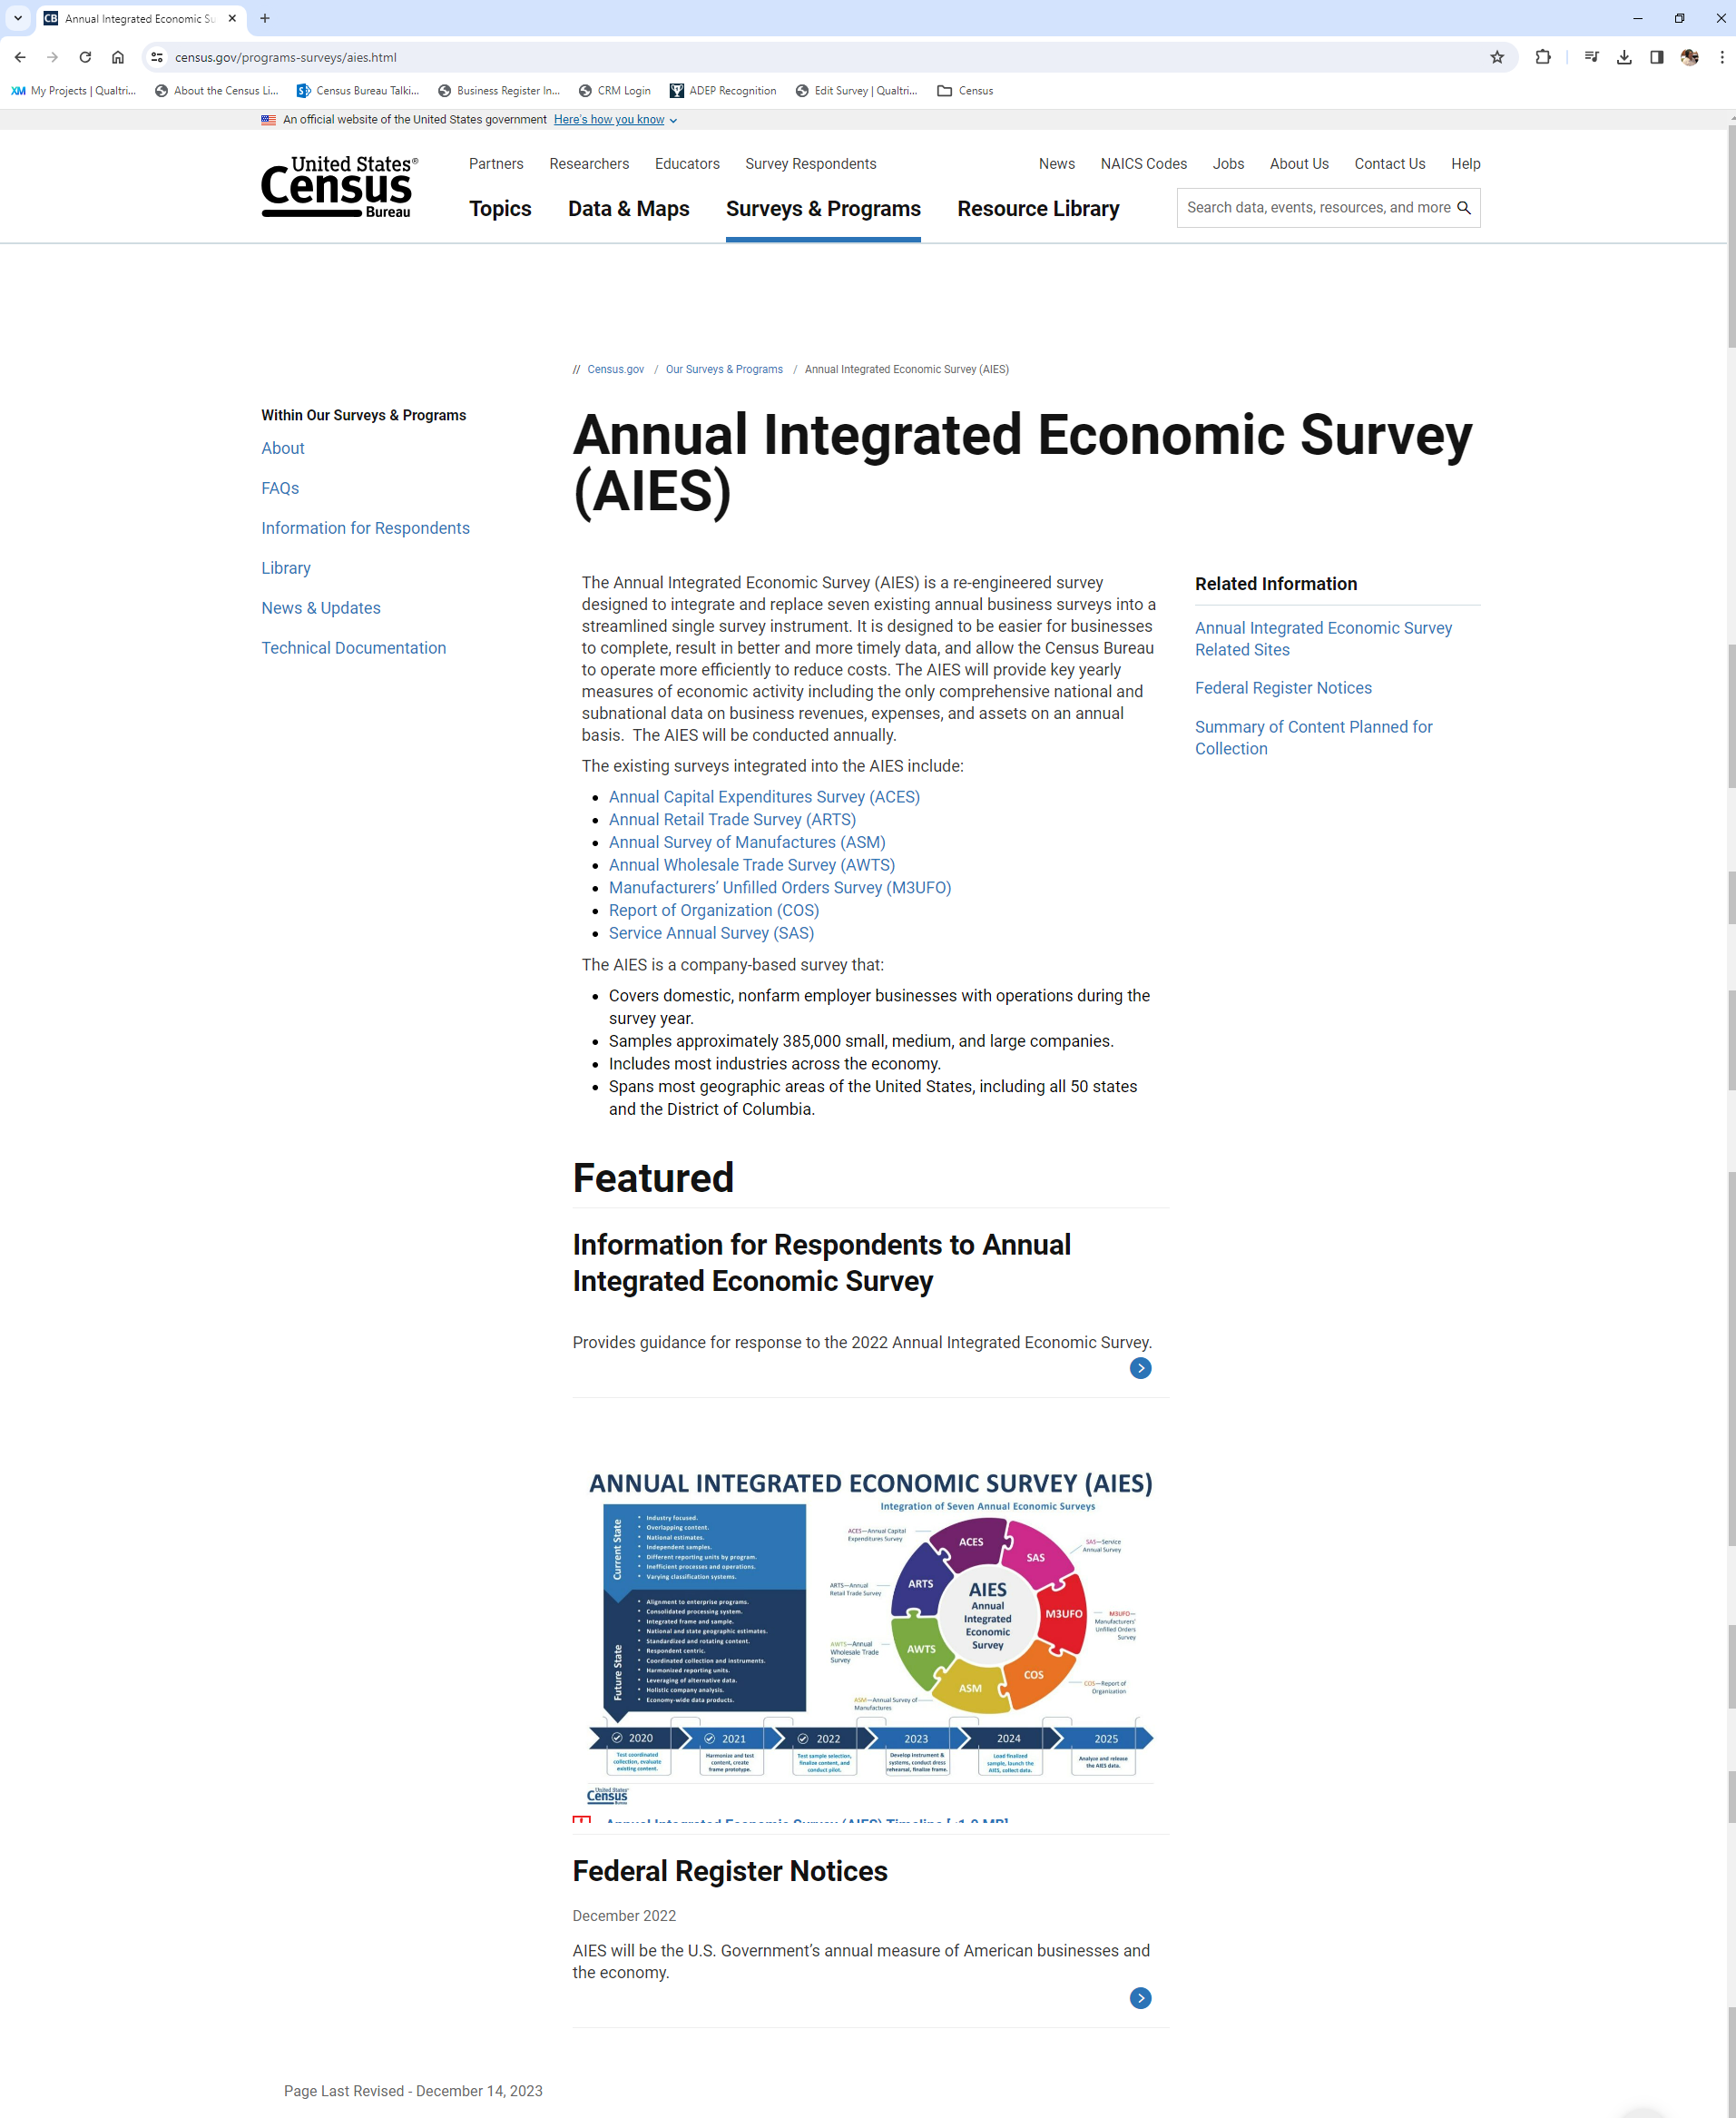
_{AIES FAQ Page}
https://www.census.gov/programs-surveys/aies/faq.html
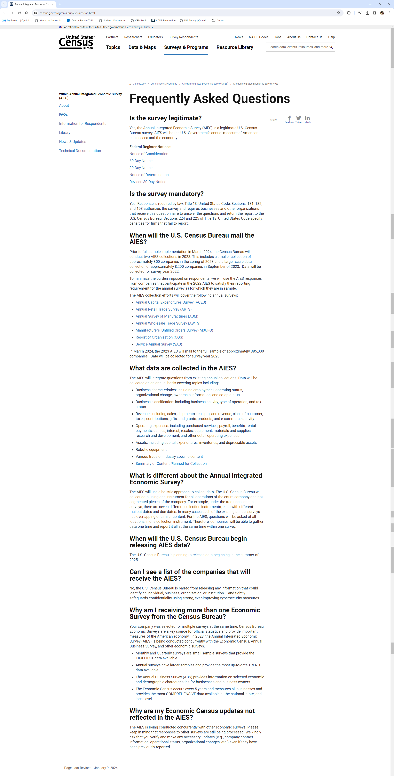
AIES Information for Respondents Page
https://www.census.gov/programs-surveys/aies/information.html
