Commodity Flow Survey Screenshots
Production 2022

Contents
Commodity Flow Survey Screenshots 1
Login Screen 2
Pre Screener Reporting Choice 3
Main Menu 4
Item A: Company Information 5
Item A: Shipping Location Information 6
Item B: Total Annual Value of Shipments 7
Item C: Operating Status 7
Item D: Total Number and Value of Outbound Shipments 8
Item E: HAZMAT 8
Item F1: Shipment Reporting Options 8
Upload Shipments: Spreadsheet Path 9
Item F1: Shipment Reporting Options 9
Item F3: Shipment Characteristics 10
Item F: Enter Shipments 11
Item G1: Shipment Validation 11
Item G1: Shipment Validation, Overlay 12
Item G2: Product Code Validation 12
Shipment Validation: ML Overlay 13
Review Responses 14
Item I: Time to complete 14
Item J: Remarks 14
Submit Responses 15

Login Screen
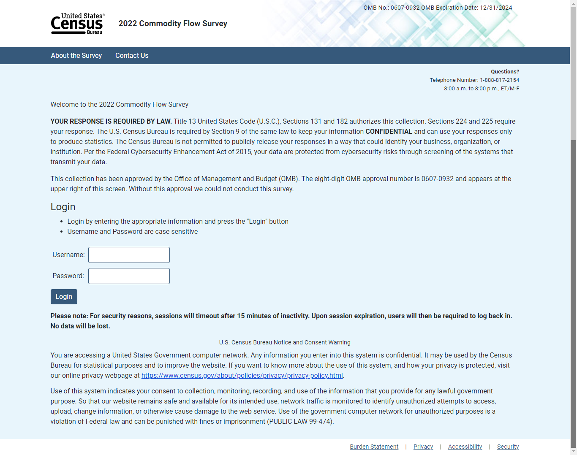

Pre Screener Reporting Choice
(Select MU’s only)
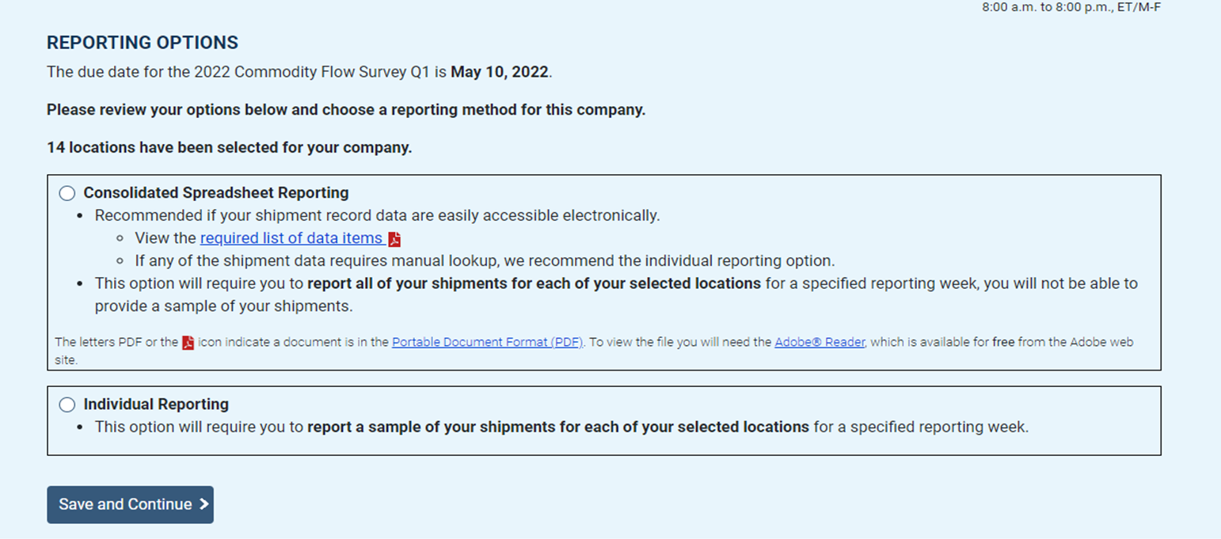

Main Menu
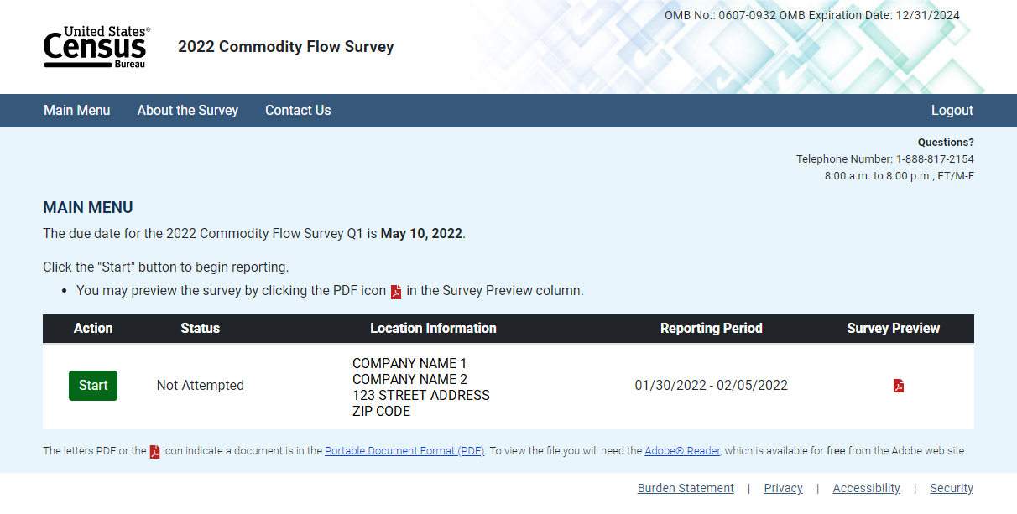

Item A: Company Information
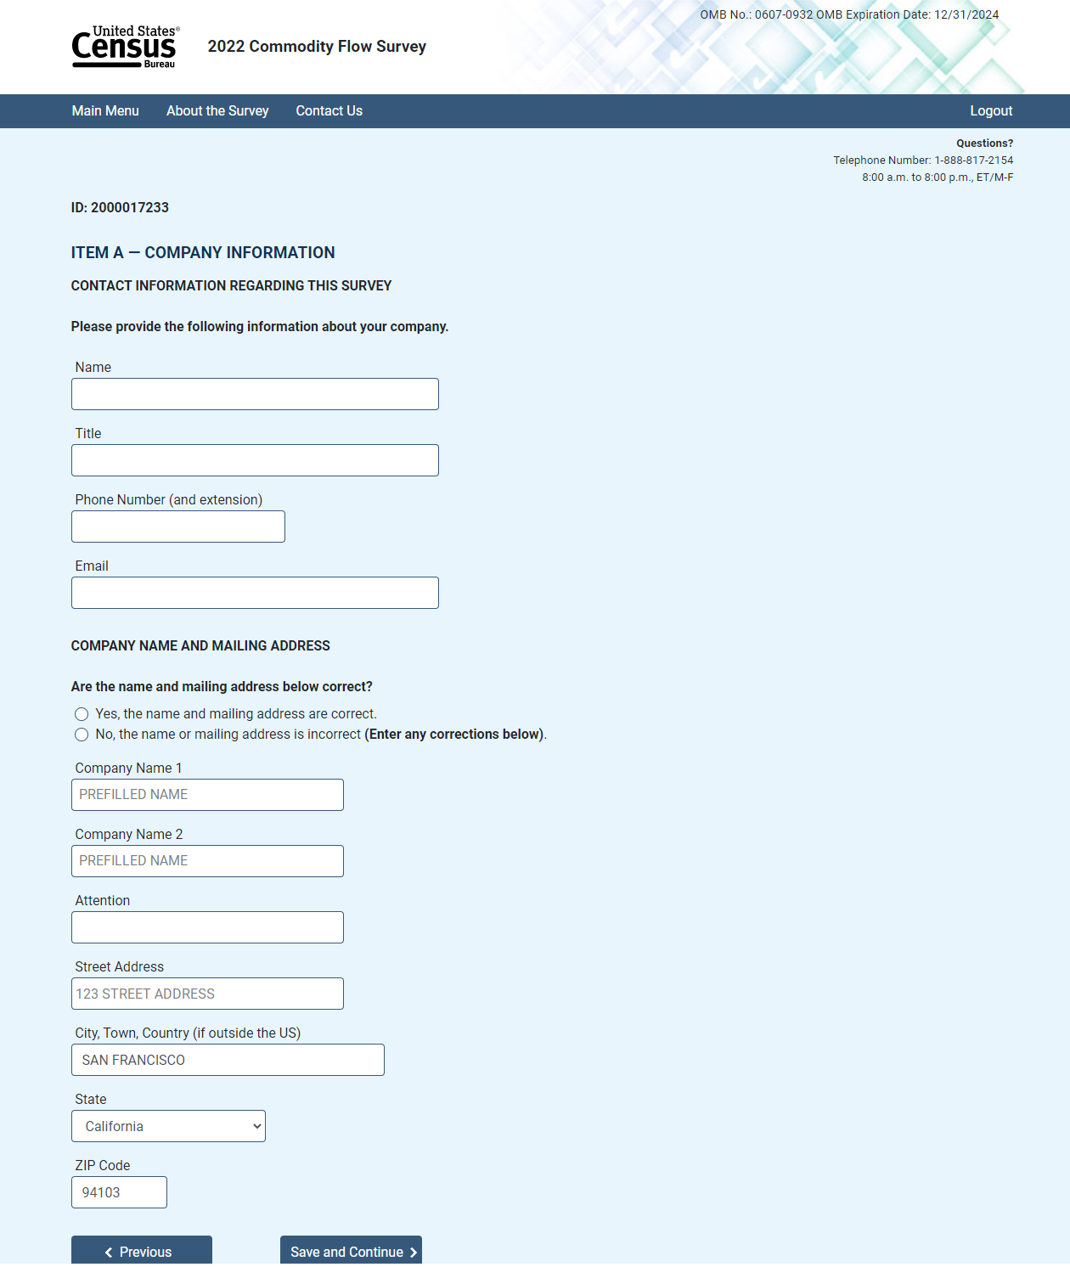

Item A: Shipping Location Information
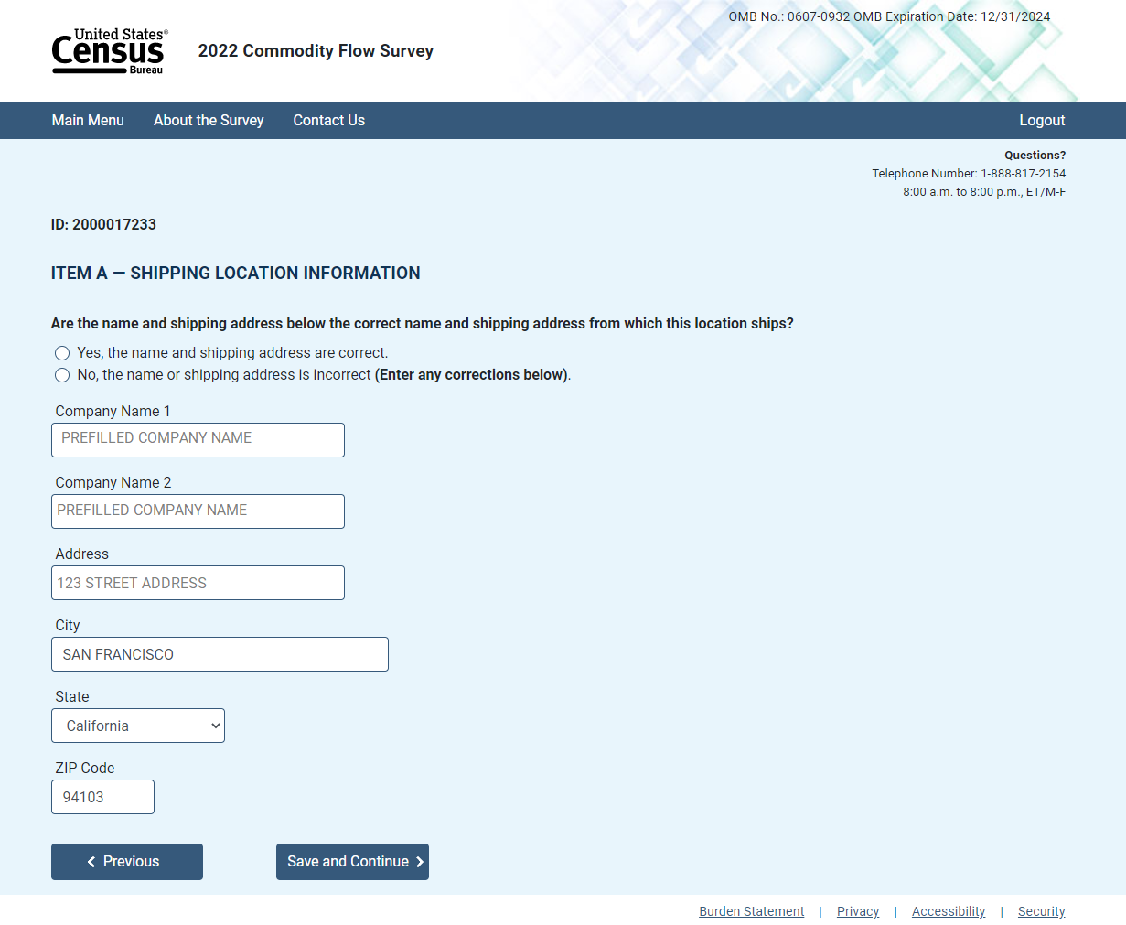

Item B: Total Annual Value of Shipments
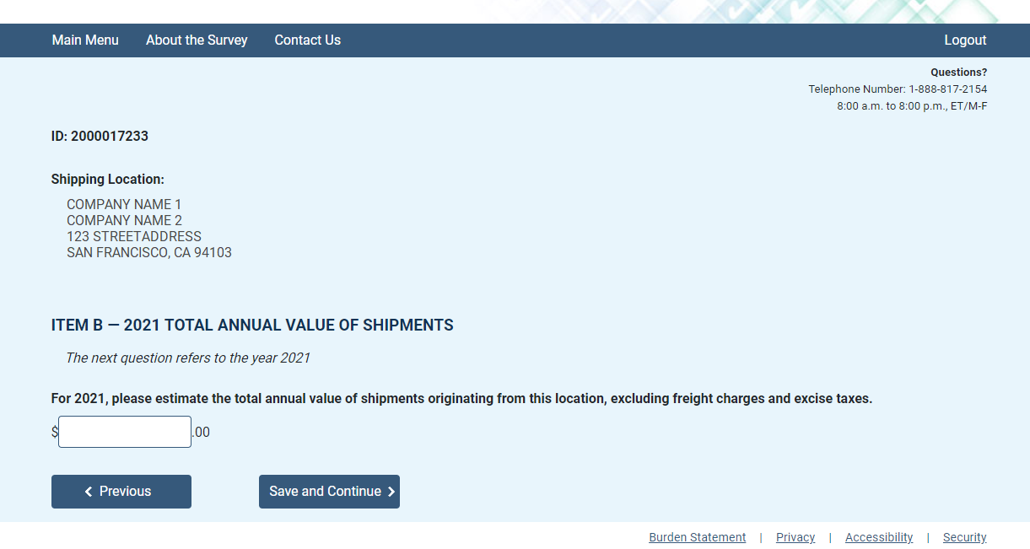

Item C: Operating Status
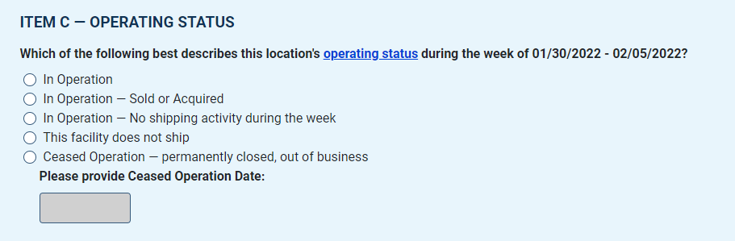

Originating Shipments Statement
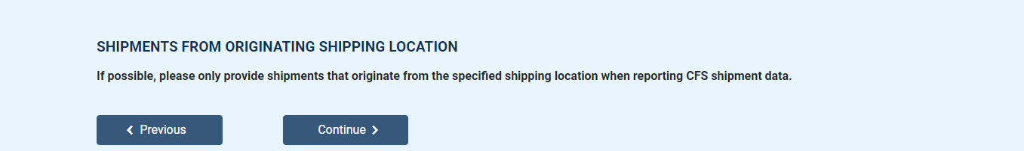

Item D: Total Number and Value of Outbound Shipments
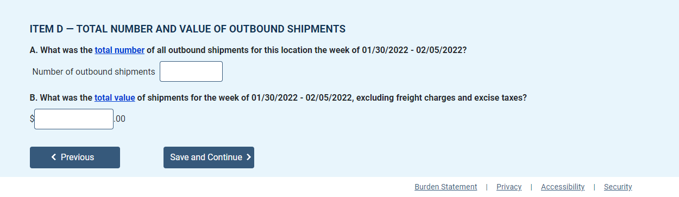

Item E: HAZMAT
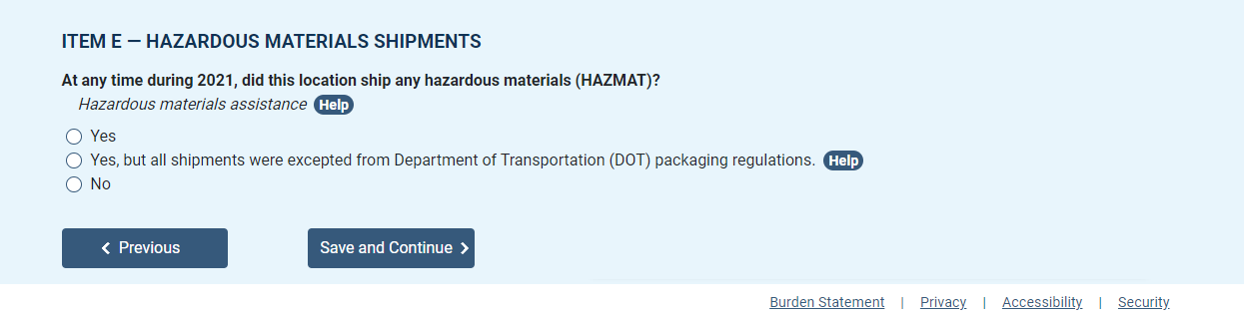

Item F1: Shipment Reporting Options
Path A: Below 50 Shipments or Consolidated Reporter
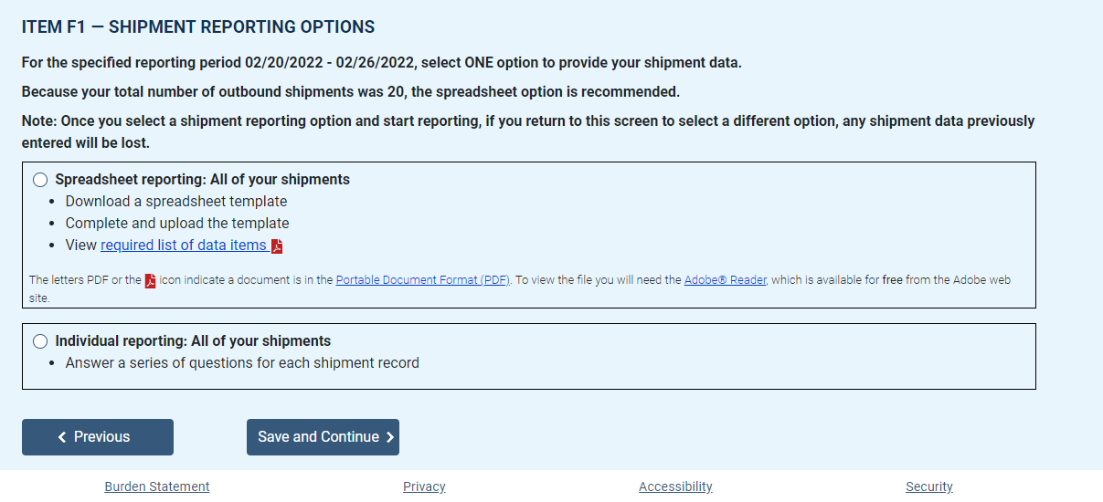

Upload Shipments: Spreadsheet Path
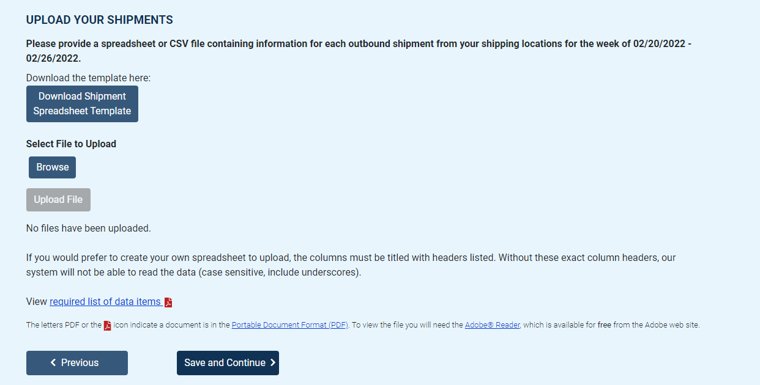

Item F1: Shipment Reporting Options
Path B: Above 50 Shipments or Individual Reporter
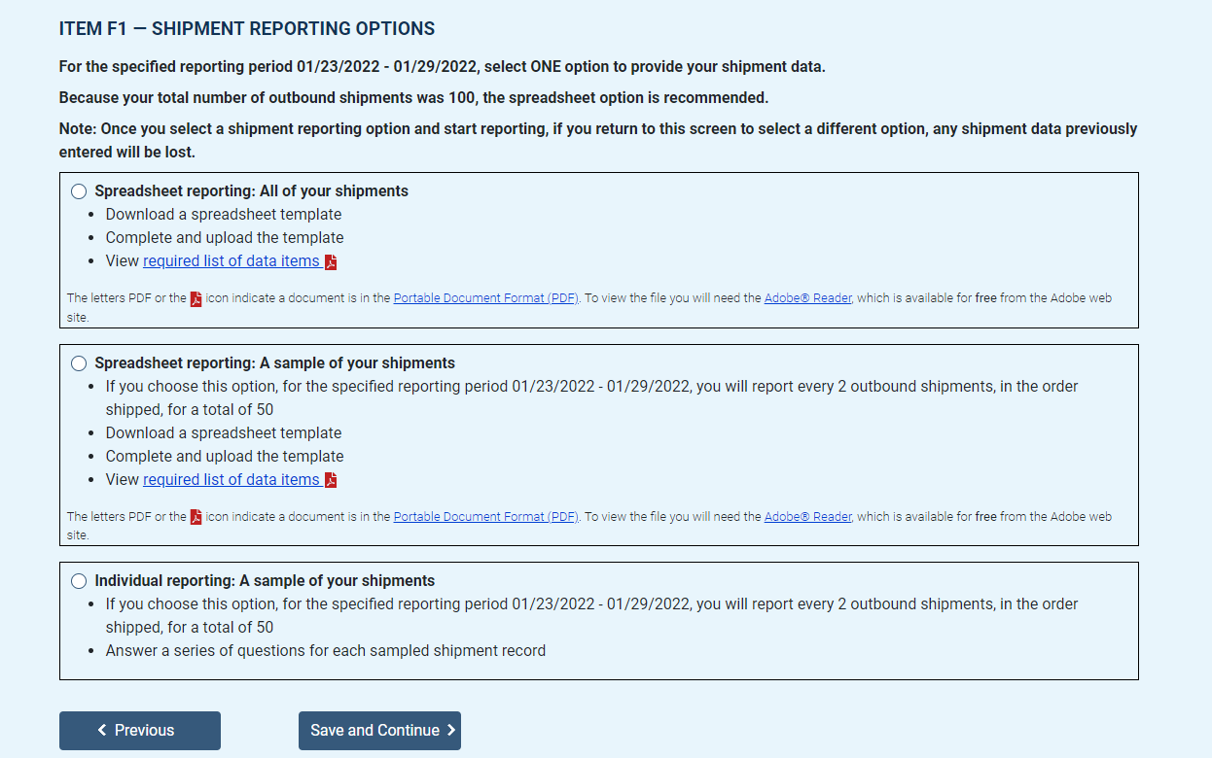

Item F3: Shipment Characteristics
Individual shipment reporting
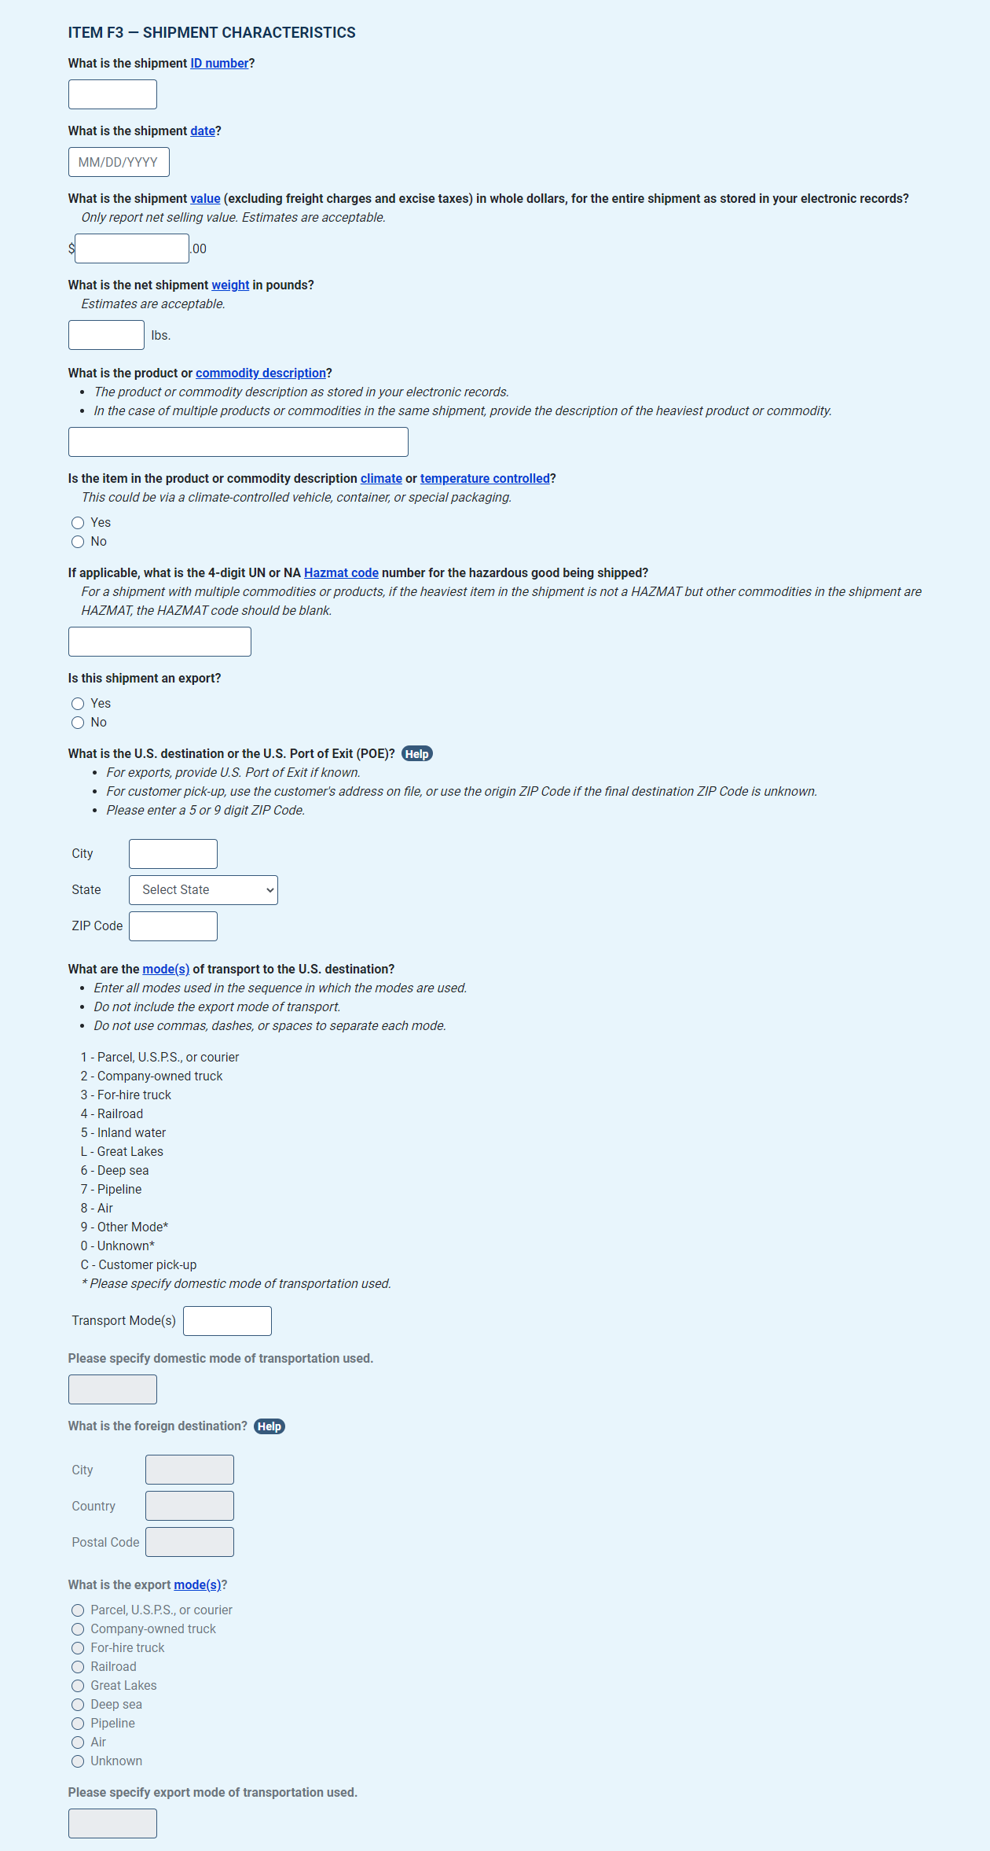

Item F: Enter Shipments
Individual shipment reporting
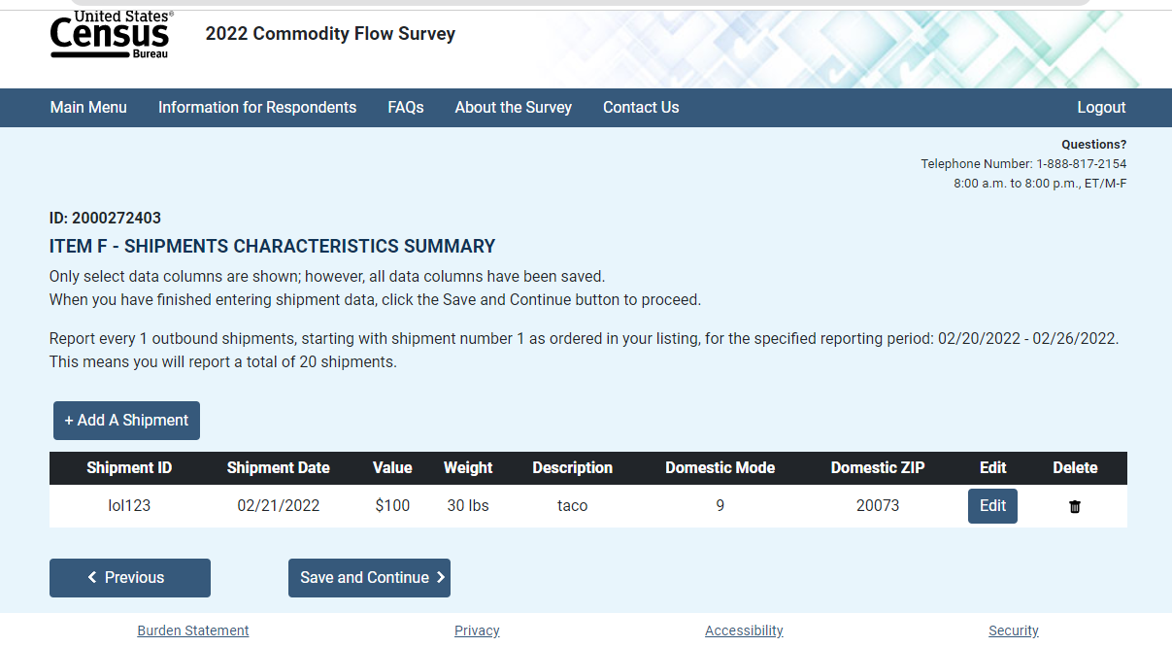

Item G1: Shipment Validation
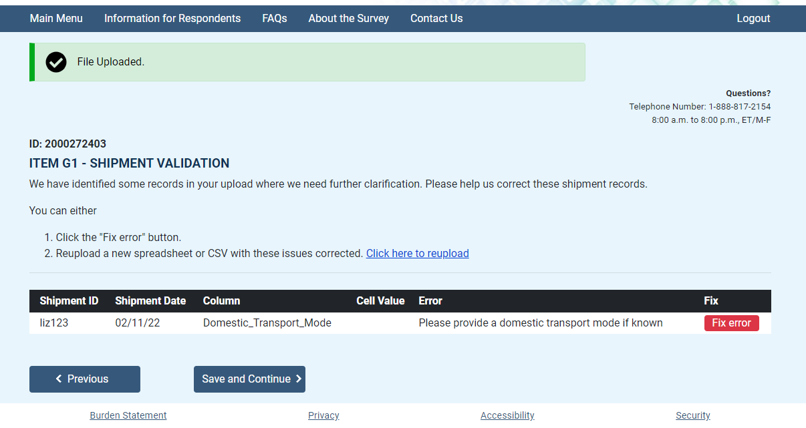

Item G1: Shipment Validation, Overlay
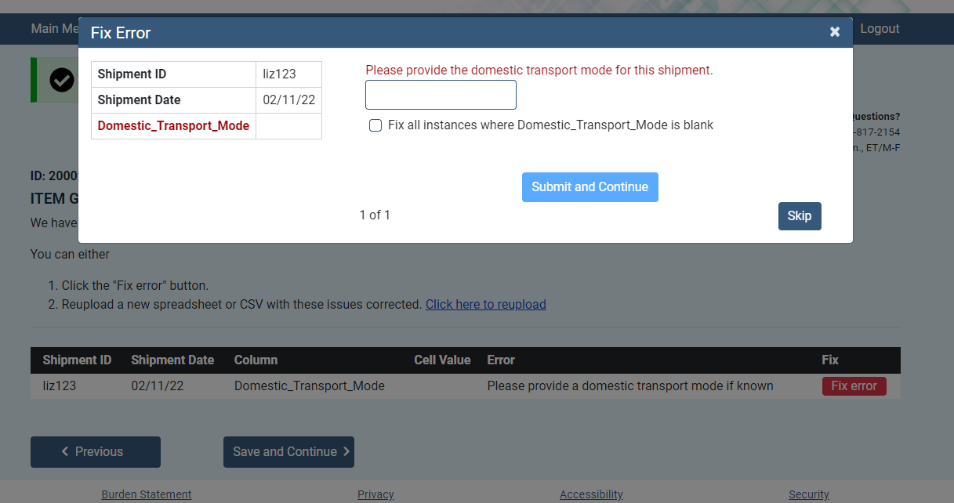

Item G2: Product Code Validation
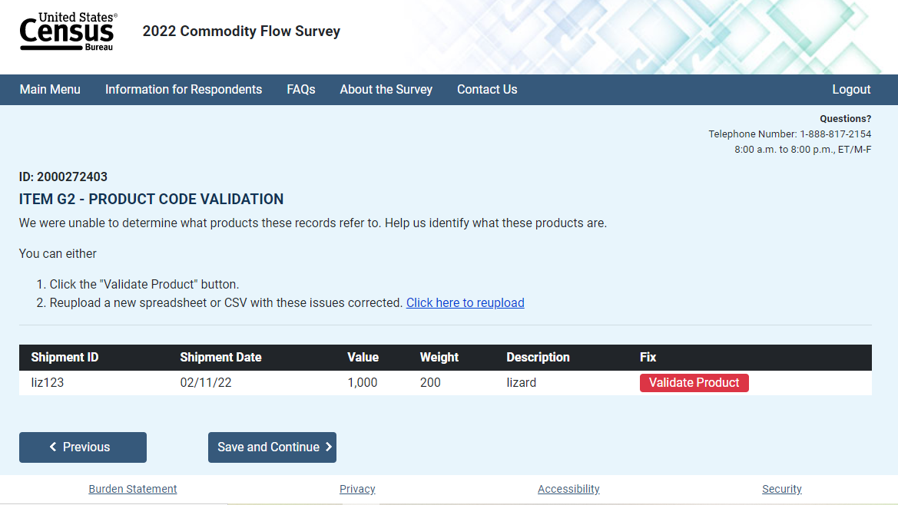

Shipment Validation: ML Overlay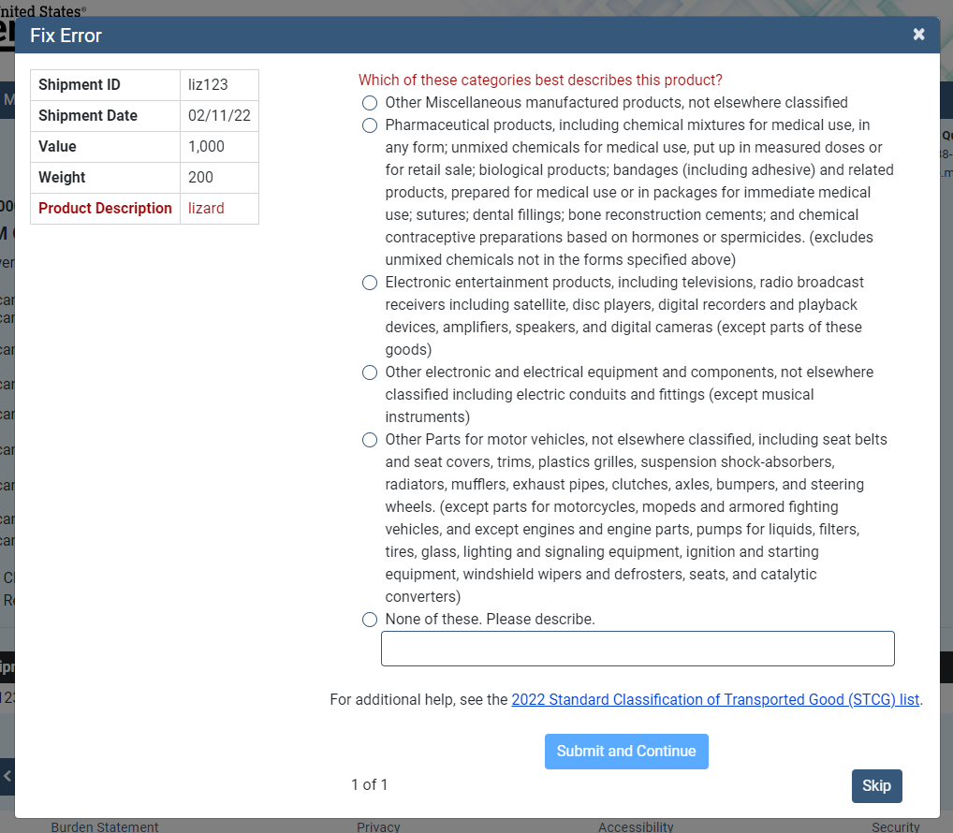

Note: HAZMAT Section begins here if respodent selected ‘Yes’ for Item E

Review Responses
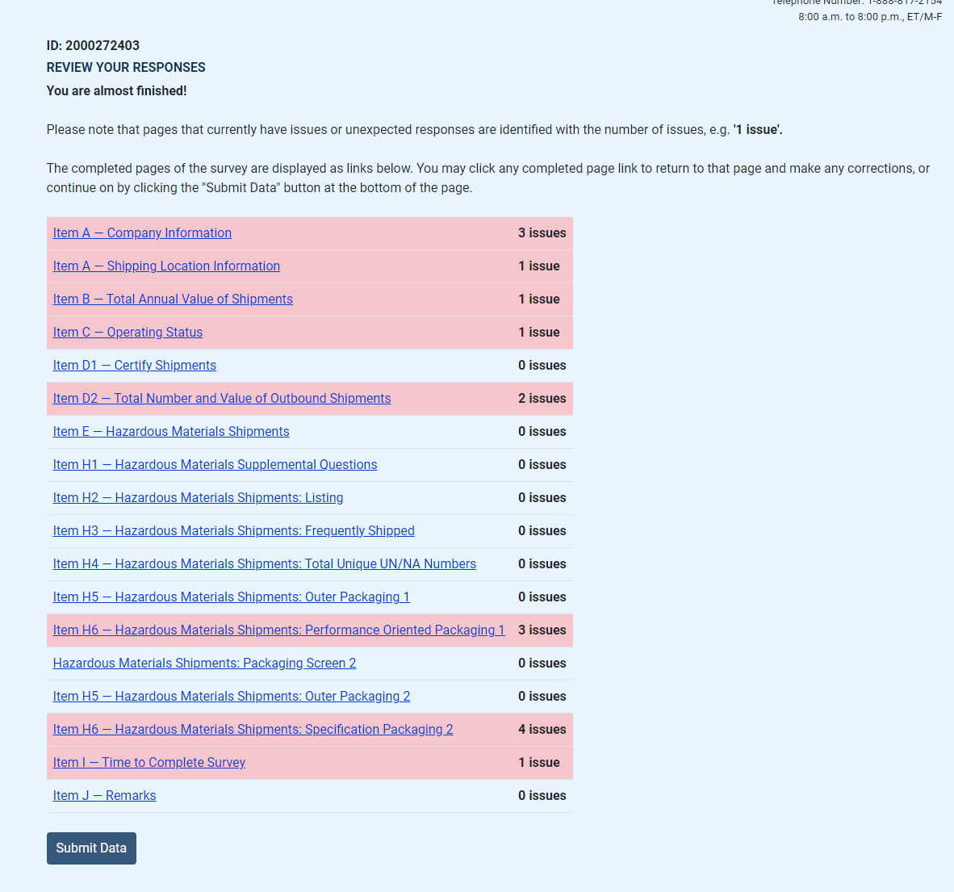

Item I: Time to complete
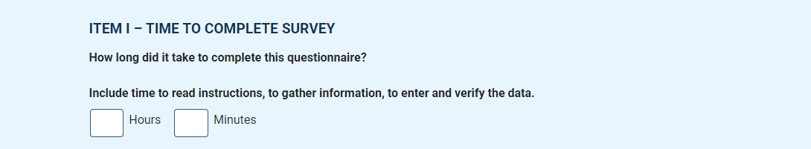

Item J: Remarks
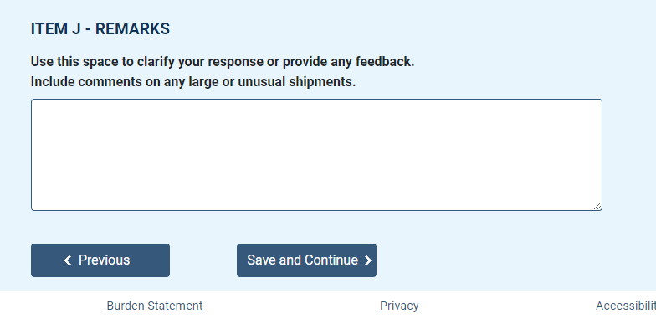

Submit Responses
