Appendix P: Quiz for Training Assessment

Quiz for Training Assessment
Note: For evaluator use
Video #1: Q1-10
Video #2: Q11-14
Video #3: Q15-17
Video #4: Q18-24
Video #5: Q25-26
Video#6: Q27-29

Video #1
(1) What tasks will you do in the next seven days using the FoodLogger?
- Report foods and drinks received in the next seven days
- Complete the profile questionnaire
- Complete the income questionnaire
- All of the above

(2) You should log all foods and drinks you purchase or get for free, including those acquired before the start of the study.
- True
- False

(3) The primary respondents can report food and drinks for
- Themselves
- Household members at least 11 years old
- Household members under 11 years old
- All of the above

(4) I need to report the following types of foods that are acquired during the 7-day study period. (Check all that apply)
- Groceries bought at a supermarket
- Takeout from a restaurant
- Food delivered to your home
- A meal received from a soup kitchen
- Food at a friend’s house
- Free food from a food pantry
- Coffee from a breakroom at work

(5) During the seven days of the study, everyone in the household should report foods and drinks every day.
- True
- False

(6) You went to a friend’s house. Two of you shared a pizza she ordered. Should you log this event?
- Yes
- No

(7) Food you buy for other people should be reported in the FoodLogger.
- True
- False

(8) Can I switch to a different smartphone to report your food and drinks during the study?
- Yes
- No

(9) What will happen when GPS location services is turned off in the FoodLogger app?
- The FoodLogger app will not track your location.
- Your Stops screen will not have a list of places.
- You will have to enter each place where you got food one place at a time.
- All of the above.

(10) If FoodLogger does not capture a stop where I get food, I won’t be able to add that stop.
- True
- False

Video #2
(11) A food event is
- An event when you get food and drink for free
- An event when you get food and drink for purchase
- An event when you get food and drink for purchase or for free
- None of the above

(12) When you report a food event, you will provide information including…
- where you got the food and/or drink.
- how the food and/or drink was consumed.
- Who paid for the food and/or drink.
- all of the above.

(13) Which is an image of a PLU code?
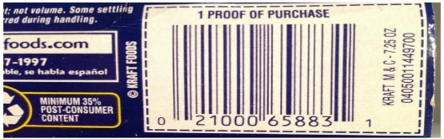
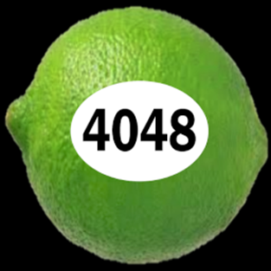

(14) What can be reported as a combo meal?
- Individual items that I pay for separately
- The entire meal I paid for
- Food and drinks sold together for a single price

Video #3
(15) I need to report foods and drinks I got for…
- Myself
- Other members of my household
- People outside of my household

(16) Which is the best way to add foods to the Foodlogger to reduce the number of detailed questions?
- Type in the name
- Scan its UPC barcode or type in its PLU code
- Take a picture of the item

(17) You can upload a paper receipt within the FoodLogger.
- Yes
- No

Video #4
(18) If you bought a coffee for $3 and got one for free during a 2 for 1 promotion, how should you enter it?
- Enter 1 coffee for $3
- Enter 2 coffees, one for $3 and the other for $0
- Enter 2 coffees and $3 for each

(19) Each item in a combo meal has a price.
- True
- False

(20) In the image below, there is a red exclamation point next to the item “6 piece chicken nugget happy meal.”
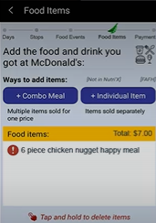
What should you do if you see a red exclamation point next to the name of an item?
- Ignore it
- Tap the name to go back to the questions
- Restart Foodlogger
- None of the above

(21) I bought a Happy Meal at McDonald’s with a 10% discount. According to the training video, I am supposed to report the regular price before discount.
- True
- False

(22) I grabbed 2 packs of ketchup after buying a Happy Meal at McDonald’s. Because the ketchup is not part of the Happy Meal, I don’t need to report it in FoodLogger.
- True
- False

(23) If you order food for delivery, do you need to add a food/drink stop?
- Yes
- No

(24) You ordered a combo at a restaurant, but you dropped the drink before being able to drink any of it. Should you still report it?
- Yes
- No

Video #5
(25) Each person in your household should complete the profile questionnaire and the income questionnaire.
- True
- False

(26) The primary respondent should complete the profile questionnaire and the income questionnaire on behalf of children under 11 years old.
- True
- False
Video #6
(27) The Day Overview should be completed …
- On the day of the Day Overview
- On the day after the Day Overview
- Any day during the 7-day study period
- The last day during the 7-day study period

(28) I can add missed food items during the Day Overview.
- True
- False

(29) Because I didn’t get any food or drink yesterday, I don’t need to complete the Day Overview for that day.
- True
- False

