SUPPORTING STATEMENT - PART A
Request for Restoration of Entitlement due to Facility Closure, Program of Training or Course Disapproval (Chapter 31 Veteran Readiness and Employment)– 2900-0923

Summary of Changes from Previously Approved Collection
- On page three the instructions were amended to remove expired dates.
- 1 comment received during the 60-Day period.

1. Need for the Information Collection

The Department of Veterans Affairs (VA) through its Veterans Benefits Administration (VBA) administers an integrated program of benefits and services, established by law, for Veterans, service personnel, and their dependents and/or beneficiaries. Title 38 U.S.C. 501(a) provides VA the authority to collect this information. VA Form (VAF) 28-10281, Request for Restoration of Entitlement Due to Facility Closure, Program of Training or Course Disapproval, collects information that the Veteran Readiness and Employment (VR&E) program needs to verify if a Service member or Veteran meets the criteria for restoration of entitlement when there is a facility closure or program of training or course disapproval (38 USC 3699(c)(2)).

2. Use of the Information

VA Form 28-10281 is used by a Service member or Veteran to request restoration of entitlement due to effects of a facility closure or program of training or course disapproval. The VR&E program subsequently uses the information on this form to determine if a Service member or Veteran qualifies for restoration of entitlement under 38 U.S.C 3699 (b)(1)(A). Without the information, restoration of entitlement under Chapter 31 could not be determined. Veterans and Service members are able to access and complete the VA Form 28-10281 by using the VA Forms external website “Find a Form” and submit the completed and signed form one of the following ways: by mail, email to their assigned Vocational Rehabilitation Counselor (VRC), in-person to a VA Regional Office, or VR&E out-based location.
The Veteran or Service member receives a notification letter if their request for restoration of entitlement is granted or denied by their assigned VRC.

3. Use of Information Technology

VA Form 28-10281 is available on https://www.va.gov/find-forms/ website in a fillable electronic format. VBA is currently hosting this form on a secure server and does not currently have the technology in place to allow for the complete submission of the form. Validation edits are performed to assure data integrity. There currently is no utility process in place that will allow the data submitted on the form to be incorporated with an existing centralized legacy database.

4. Non-duplication

The information obtained through this collection is unique and is not already available for use or adaptation from another cleared source.

5. Burden on Small Businesses

This information collection does not impose a significant economic impact on a substantial number of small businesses or entities.

6. Less Frequent Collection

A Service member or Veteran will use VAF 28-10281 to request restoration of entitlement due to a facility closure or program of training or course disapproval. The VR&E program subsequently uses the information on this form to determine if a Service member or Veteran qualifies for restoration of entitlement. Without the information gathered on this form, the VR&E program would be unable to verify that the Service member or Veteran meets the criteria for restoration of entitlement. Furthermore, the VR&E program requests approval of this information collection in order to carry out the implementation of the law which requires VA to immediately accept applications to restore education benefits for Facility closures and program of training or course disapprovals.

7. Paperwork Reduction Act Guidelines
This collection of information does not require collection to be conducted in a manner inconsistent with the guidelines delineated in 5 CFR 1320.5(d)(2).
8. Consultation and Public Comments
Part A: PUBLIC NOTICE
A 60-Day Federal Register Notice (FRN) for the collection published on Tuesday, January 6, 2026. The 60-Day FRN citation is 91 FRN 389.
1 comment received during the 60 day comment period.
A 30-Day Federal Register Notice for the collection published on Monday, March 23, 2026. The 30-Day FRN citation is 90 FRN 13931.

Part B: CONSULTATION
No additional consultation apart from soliciting public comments through the Federal Register was conducted for this submission.
9. Gifts or Payment

No payments or gifts are being offered to respondents as an incentive to participate in the collection.

10. Confidentiality

The records are maintained in the appropriate Privacy Act System of Records identified as “Compensation, Pension, Education, and Veteran Readiness and Employment Records-VA (58VA21/22/28),” published at 74 FR 29275 on June 19, 2009, and last amended at 87 FR 8740 (February 16, 2022).

11. Sensitive Questions

No questions considered sensitive are being asked in this collection.

12. Respondent Burden and its Labor Costs

- Number of Respondents: 144,630 per year
- Number of Responses Per Respondent: on occasion
- Annual burden hours are: 24,105 hours
- The estimated completion time for this form is: 10 minutes
- VA cannot make further assumptions about the population of respondents because of the variability of factors such as the educational background and wage potential of respondents. Therefore, VBA uses general wage data to estimate the respondents’ costs associated with completing the information collection.

The Bureau of Labor Statistics (BLS) gathers information on full-time wage and salary workers. According to the latest available BLS data, the mean hourly wage is $31.48 based on the BLS wage code – “00-0000 All Occupations.” This information was taken from the following website: https://www.bls.gov/oes/current/oes_nat.htm.

Legally, respondents may not pay a person or business for assistance in completing the information collection. Therefore, there are no expected overhead costs for completing the information collection. VBA estimates the total cost to all respondents to be $758,825.40 (24,105 burden hours x $31.48 per hour)

13. Respondent Costs Other Than Burden Hour Costs

There are no annualized costs to respondents other than the labor burden costs addressed in Section 12 of this document to complete this collection.

14. Cost to the Federal Government

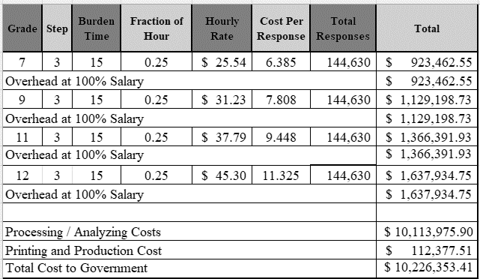

Overhead costs are 100% of salary and are the same as the wage listed above and the amounts are included in the total.

Printing and production costs approximates the cost of printing this information collection per year. (Processing/Analyzing Cost total divided by $90).

Note: The hourly wage information above is based on the hourly 2025 General Schedule (Base) Pay (SALARY TABLE 2025-GS-RUS). This rate does not include any locality adjustment as applicable.

The processing time estimates above are based on the actual amount of time employees of each grade level spend to process to completion a claim received on this form. The within-grade step (3) of each employee represents the average experience of employees within each grade.

15. Reasons for Change in Burden

The number of annal burden hours have increased since the number of Veterans in new plans of service enrollments have increased since the last approval.

16. Publication of Results

The results of this information collection will not be published.

17. Non-Display of OMB Expiration Date

We are not seeking approval to omit the display of the expiration date of the OMB approval on the collection instrument.

18. Exceptions to “Certification for Paperwork Reduction Submissions”

We are not requesting any exemptions to the provisions stated in 5 CFR 1320.9.

