Non-Substantive Change Request
OMB Control Number 1905-0092
Residential Energy Consumption Survey – Energy Supplier Survey

Summary of request: EIA would like to add clarifying instructions and revise wording on the Residential Energy Consumption Survey (RECS) Energy Supplier Survey forms EIA-457-D, E, F, G.
Background: The data collected from energy suppliers on forms EIA-457-D, E, F, G are about the energy consumption and expenditures of respondents to the Residential Energy Consumption Survey (RECS) Household Survey (Form EIA-457A). We would like to request nonsubstantive revisions to wording and add clarifying instructions to assist suppliers in reporting these data, which come from customer bills and related records. The requested changes are the result of usability testing with energy suppliers and review of post-collection processing activities. The nonsubstantive changes will improve the respondent experience and data quality.
The nonsubstantive changes include:
- Clarifying the text that describes the reporting period
- Revising “delivery address” to “service address” on the forms collecting data about propane and fuel oil or kerosene
- Clarifying the text to indicate the charges to include and exclude
- Improving measurement of whether the fuel was both sold and delivered, sold, or delivered
- Updating year format and number of characters allowed
In the following, we show the current and revised fuel forms.

Form EIA-457D current version (left) and revised version (right)
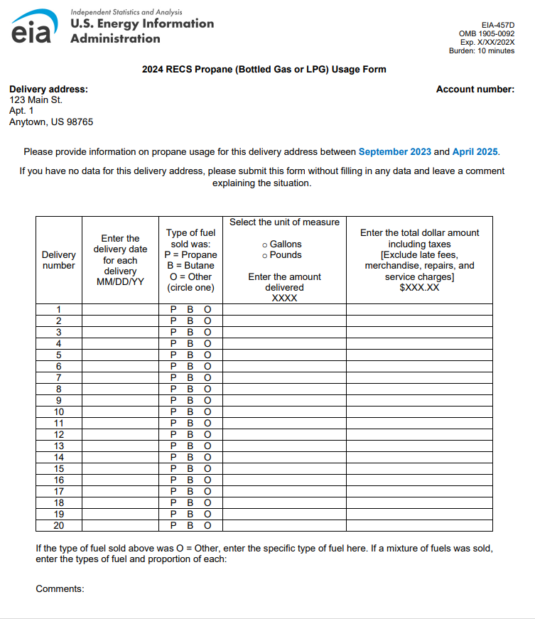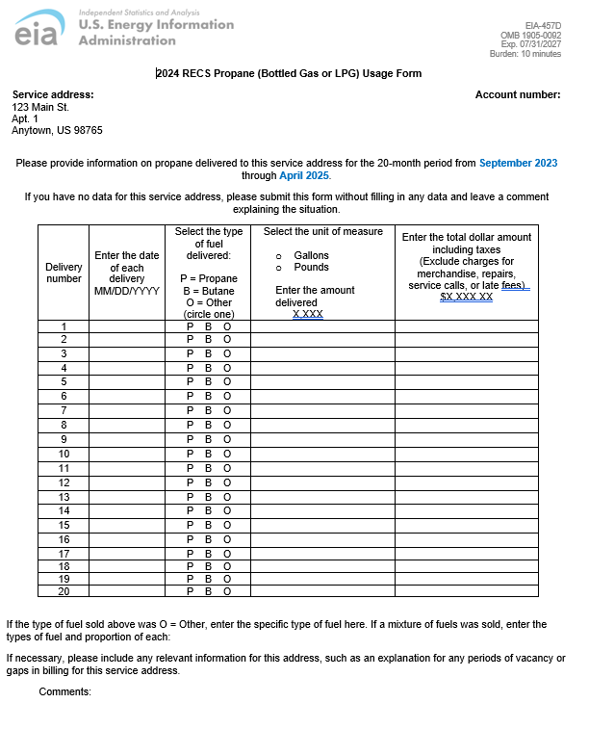

Changes to Form EIA-457D:
- Changed “Delivery address” to “Service address” in upper left corner so that all customer accounts across forms are consistently referred to with a “service address.”
  - Wording in the sentences above the table also refer to a “service address” instead of a “delivery address.”
- We found that energy suppliers were unclear that data from multiple bills, requiring multiple entries per address, is required. The wording “for the 20-month period from September 2023 through April 2025” is designed to clarify the reporting period for respondents and has been updated in the form.
- Updated column header three so that “fuel sold” is revised to “fuel delivered” because we want to be consistent in asking for data related to deliveries for propane and fuel oil.
- Suppliers indicated that bills often include many types of charges and that the forms are not clear enough about which of the billed charges should be included in reporting of consumption and expenditures of RECS households. Using subject matter expertise and questionnaire development expertise, the “Exclude” instructions in column header five were revised to clarify the types of charges that should be included or excluded.
- Updated year format to four digits and updated number of characters allowed for range edits.
- Added a sentence that will allow us to collect richer information about anomalous billing data for suppliers. This will help us with editing. The sentence is “If necessary, please include any relevant information for this address, such as an explanation for any periods of vacancy or gaps in billing for this service address.”

Form EIA-457E current version (left) and revised version (right)
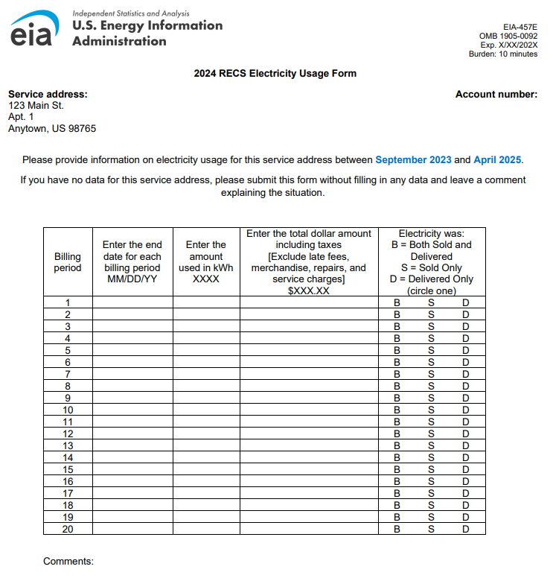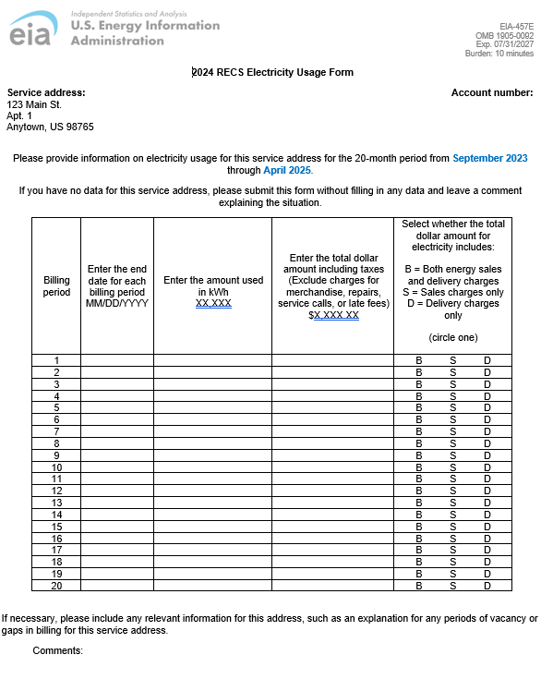

Changes to Form EIA-457E:
- We found that energy suppliers were unclear that data from multiple bills, requiring multiple entries per address, is required. The wording “for the 20-month period from September 2023 through April 2025” is designed to clarify the reporting period for respondents and has been updated in the form.
- Updated year format to four digits and updated number of characters allowed for range edits.
- Suppliers indicated that bills often include many types of charges and that the forms are not clear enough about which of the billed charges should be included in reporting of consumption and expenditures of RECS households. Using subject matter expertise and questionnaire development expertise, the “Exclude” instructions in column header four were revised to clarify the types of charges that should be included or excluded.
- Reworded the question and response options in column header five following usability testing and a review of prior editing procedures. The revision will improve clarity for the respondent and provide more accurate data, which will complement improved editing specifications for this item.
- Added a sentence that will allow us to collect richer information about anomalous billing data for suppliers. This will help us with editing. The sentence is “If necessary, please include any relevant information for this address, such as an explanation for any periods of vacancy or gaps in billing for this service address.”

Form EIA-457F current version (left) and revised version (right)
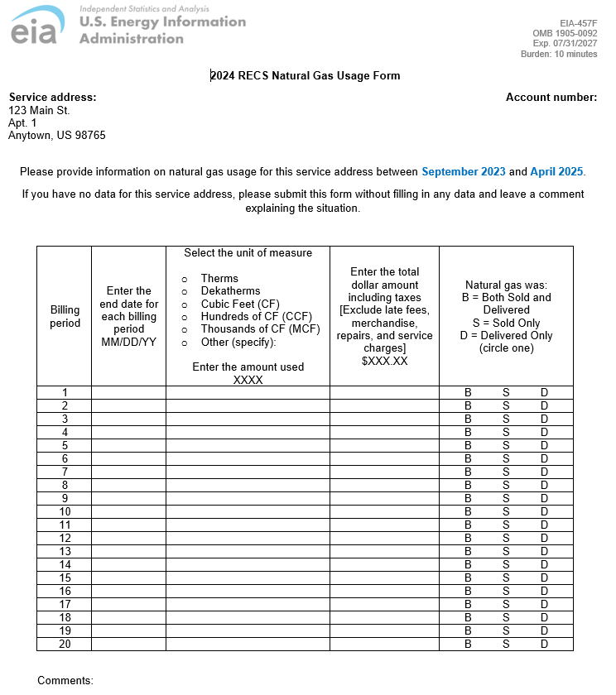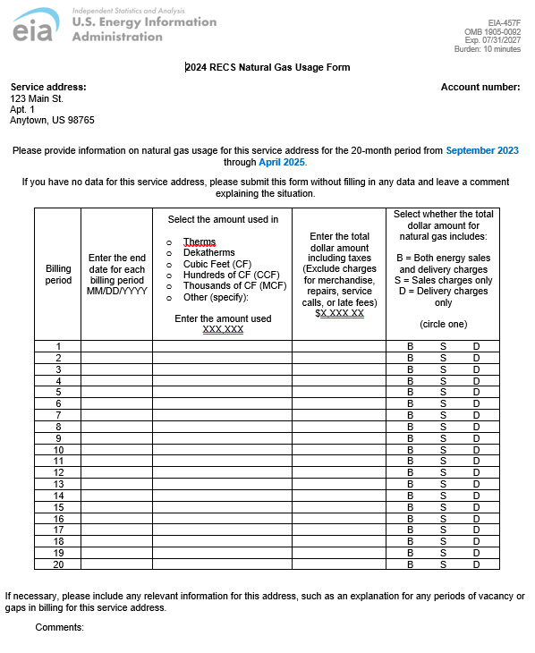

Changes to Form EIA-457F:
- We found that energy suppliers were unclear that data from multiple bills, requiring multiple entries per address, is required. The wording “for the 20-month period from September 2023 through April 2025” is designed to clarify the reporting period for respondents and has been updated in the form.
- Updated year format to four digits and updated number of characters allowed for range edits.
- Revised the wording in column header three to better match improvements to the online form wording.
- Suppliers indicated that bills often include many types of charges and that the forms are not clear enough about which of the billed charges should be included in reporting of consumption and expenditures of RECS households. Using subject matter expertise and questionnaire development expertise, the “Exclude” instructions in column header four were revised to clarify the types of charges that should be included or excluded.
- Reworded the question and response options in column header five following usability testing and a review of prior editing procedures. The revision will improve clarity for the respondent and provide more accurate data, which will complement improved editing specifications for this item.
- Added a sentence that will allow us to collect richer information about anomalous billing data for suppliers. This will help us with editing. The sentence is “If necessary, please include any relevant information for this address, such as an explanation for any periods of vacancy or gaps in billing for this service address.”

Form EIA-457G current version (left) and revised version (right)
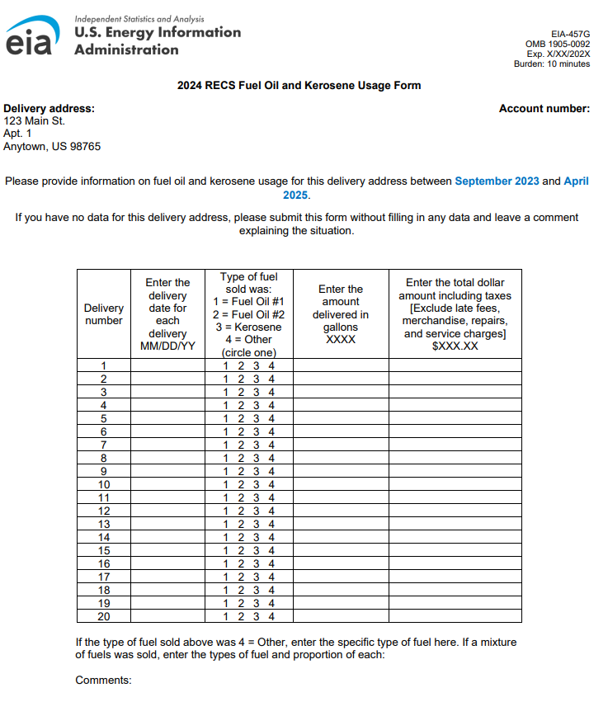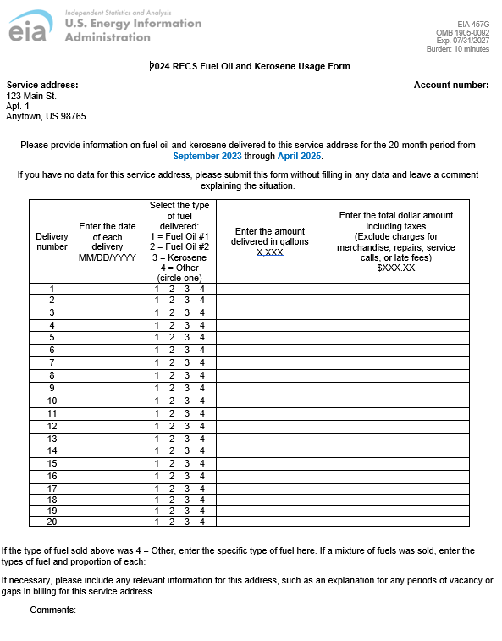

Changes to Form EIA-457G:
- Changed “Delivery address” to “Service address” in upper left corner so that all customer accounts across forms are consistently referred to with a “service address.”
  - Wording in the sentences above the table also refer to a “service address” instead of a “delivery address.”
- We found that energy suppliers were unclear that data from multiple bills, requiring multiple entries per address, is required. The wording “for the 20-month period from September 2023 through April 2025” is designed to clarify the reporting period for respondents and has been updated in the form.
- Improved readability in column header two by eliminating the redundant use of the word “delivery”
- Updated year format to four digits and updated number of characters allowed for range edits.
- Updated column header three so that “fuel sold” is revised to “fuel delivered” because we want to be consistent in asking for data related to deliveries for propane and fuel oil.
- Suppliers indicated that bills often include many types of charges and that the forms are not clear enough about which of the billed charges should be included in reporting of consumption and expenditures of RECS households. Using subject matter expertise and questionnaire development expertise, the “Exclude” instructions in column header five were revised to clarify the types of charges that should be included or excluded.
- Added a sentence that will allow us to collect richer information about anomalous billing data for suppliers. This will help us with editing. The sentence is “If necessary, please include any relevant information for this address, such as an explanation for any periods of vacancy or gaps in billing for this service address.”
Benefits:
The changes we are requesting to the items and instructions in the Energy Supplier Specialist instruments will have several benefits. They will:
- Reduce reporting error
- Clarify the reporting period
- Clarify what costs to report
- Allow EIA to collect richer information about anomalous billing data for suppliers, by adding instructions for suppliers to explain gaps in data.
We believe these changes will reduce respondent burden, reduce costs of data collection by reducing the number of telephone calls that we will need to make to correct the data, and reduce the amount of downstream editing we will need to do.

